EXAMPLE DESIGN SPECIFICATION

TABLE OF CONTENTS
Page

TABLE OF CONTENTS iii
Design Specification Example 1
1 Overview 1
2 Architecture 3
3 Design 4

Design Specification Example

Overview
The Page Object Model of test design is used in this solution, where each page has its' own functionality written in the feature files and binding files to support and map those features. As this page only contains a single page, with links to scroll down to various sections, and an API,
the testing solution only contains two feature files. Given that there would be more than one page to test, then each page, each module of a page, and each API endpoint would each need their own test feature file and class or page file.

There are two primary benefits to using the page object model over other test design models.

- All pages are easily searchable, as they are organized by page or section of a page (or API)
- Test case maintenance is easier as the way the page objects interact with the page is standardized and much less code is duplicated.
- Complexity is also reduced as one does not have to go searching for where to find a test too hard.
- As the solution and complexity grow, maintenance work using this method of test design can become a struggle and thus must be discussed with your software development or testing team to decide the best course of action.

Architecture
The high-level design of this test framework for a web server container solution with resume data works as a typical Flask directory does with the static directory (holding CSS, JS, images), and templates (generally index.html files), Dockerfile and some data used to display the resume.

The Cypress solutions feature a test/ folder on the main level of the application, within that are the feature files for the resume, and the API. Those feature files are what spell out the business requirements, in this case for the page’s validation and the API’s function. Two TypeScript page files binding the feature file steps to executable code (such as page elements, page actions, etc) are also in another directory test/resume_test within the test/ file (where only features live).

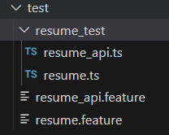

File hierarchy for Cypress tests in this solution

Design
The Cypress test framework representing this solution uses the Page Object Model. Given there are not many test cases, work for this is minimal now. It contains the following hierarchy:
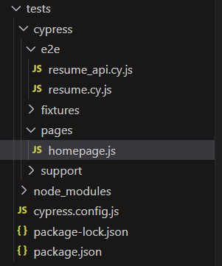
Design of the Cypress test suite and additional “framework” files

- The /tests/cypress/e2e is where the features and the binding code for them lives. These files also have references to /pages/~.js to get navigational methods, elements, and theoretically other functions like sending keys to a control, drag and drop, etc. would be added for the /homepage specifically as methods.
- The API or resume.cy.js does not any references to a /page file, as the only test cases were to validate page, and negative scenarios to validate negative situations.
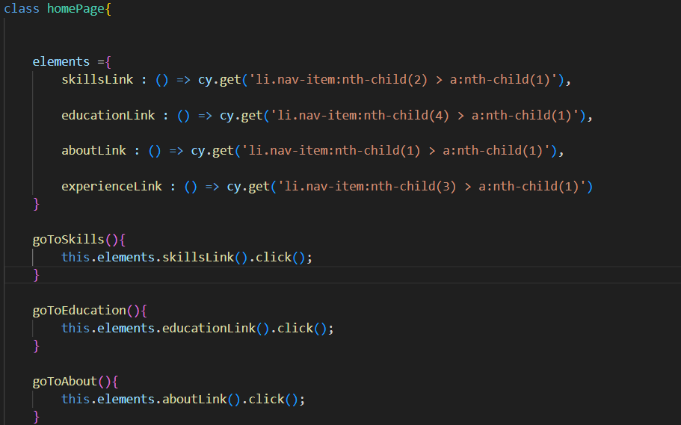

- The methods below such as goToSkills(), goToEducation(), are simply methods that pull from the elements array, and then calls some function such as click.
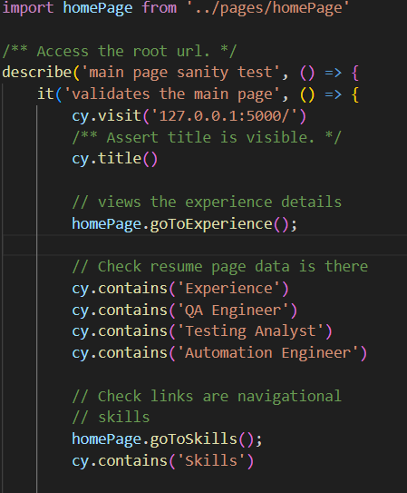

- These are binded to the feature/function file by import statement, and any of the methods outlined in /tests/pages/homepage.js can be called by performing dot notation and inserting the method. Additional page functions will resort back to the standard “cy” statement.
- Multiple pages could be added to this as long as there are separate files for these pages or modules under tests/pages/.
- The homepage method in this /pages/homepage.js file contain the links for navigation for the following pages:
- About
- Experience
- Skills
- Education

