A Look at Heart Disease and BMI, through Regression Modeling
William Muckler, wmuckler@bellarmine.edu

ABSTRACT

INTRODUCTION
Provide a one or two paragraph introduction to your project in which you describe the data set you are working with and the classification target (what are you trying to predict?) you will be pursuing.

This project began with the goal to step forward in the world of healthcare through the use of data science. The beginning goal was to create two different models to predict BMI and the presence of heart disease. Both of these statistics are important, especially for Americans. Within this country, heart disease has taken the number one spot for the cause of death. If we can create a model to help people predict whether they may have heart disease, we can catch this issue and treat it early on. To achieve this goal, Python was primarily used to create the models and conduct an exploratory data analysis.

- BACKGROUND
In this section, provide some background for the problem for which the data were collected. For example, if you were using the mushroom data set, you write up some background on what a mushroom is, why the data were originally collected, what question(s) the authors were trying to answer, etc.

BMI, or body mass index, is a measure of body composition for adults. This is calculated by dividing weight in kgs by height in meters squared. Although this is not a completely foolproof way of measuring body composition, it can give an idea of how the person lands on the scale of underweight, normal weight, or overweight. Heart disease is the leading cause of death in the United States. In 2022, there were 702,880 deaths caused by heart disease. Although heart disease is not one singular disease, it encompasses a variety of conditions that affect the heart and blood vessels. The dataset was pulled from Kaggle for the original use in health and activity. Although the original author was looking more towards activity levels, there is plenty of information to determine BMI and heart disease.

- EXPLORATORY ANALYSIS
This section will be similar to your exploratory analysis project. First, provide a summary of the data set similar to your first exploratory analysis: e.g. this data set contains 398 samples with 7 columns with various data types. In this summary, provide the data types of your columns (in a table) and then rather than providing tabular statistics and plots for each variable, provide only statistics and plots that seem unusual. For example, if one or two variables have significant missing values or the distribution of the variable is skewed or looks unusual note that. Provide the unusual statistics or plots in this section. Provide any other appropriate plots (e.g. correlation matrix, heatmaps, bar charts, etc.) that you deem necessary.

Table 1: Data Types
Variable Name | Data Type
ID | Integer
Age | Integer
Gender | Object
Height_cm | Integer
Weight_kg | Integer
BMI | Float
Daily_Steps | Integer
Calories_Intake | Integer
Hours_of_Sleep | Float
Heart_Rate | Integer
Blood_Pressure | Object
Exercise_Hours_per_Week | Float
Smoker | Object
Alcohol_Consumption_per_Week | Integer
Diabetic | Object
Heart_Disease | Object

This dataset was found within Kaggle. There are 16 total columns, 11 numeric and 5 categorical. There are 1,000 total rows of data. This was a complete dataset with no need to deal with any null values.
Most variables were reasonable in their distributions and measures of center. There were a few standouts. The average age was just under 50, which is several years older than the national average. One reason for this is that the variables would not be easily answered by children. The dataset used only adults. The average height was 174.74 cm, and weight was 84.35 kgs. This is around 5’8” and 110 pounds. Although this height is about average, the weight is below that.
I found the average BMI at 26.73, which is slightly overweight. This was interesting because of the below average weight we found. When looking at the correlation heatmap, there were surprising results. Throughout the dataset there was very little correlation. The highest that was found was .072 between sleep and heart rate.
When looking at heart disease distributions, there are a few important factors. The first comes from the chart on the left. We see that a high majority of people in the dataset do not have heart disease. This will come into play for my logistic regression model. The second is that the age distribution of people with and without heart disease is very similar. This was surprising because I had assumed the age for people with heart disease would be higher.

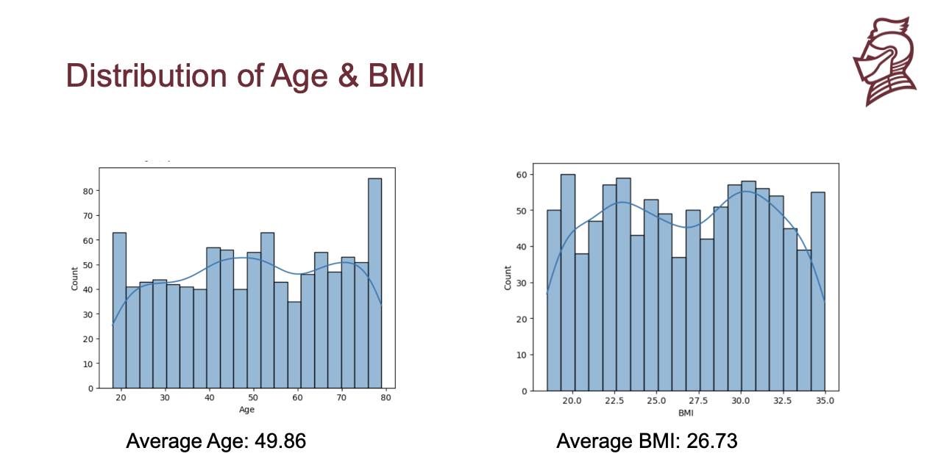

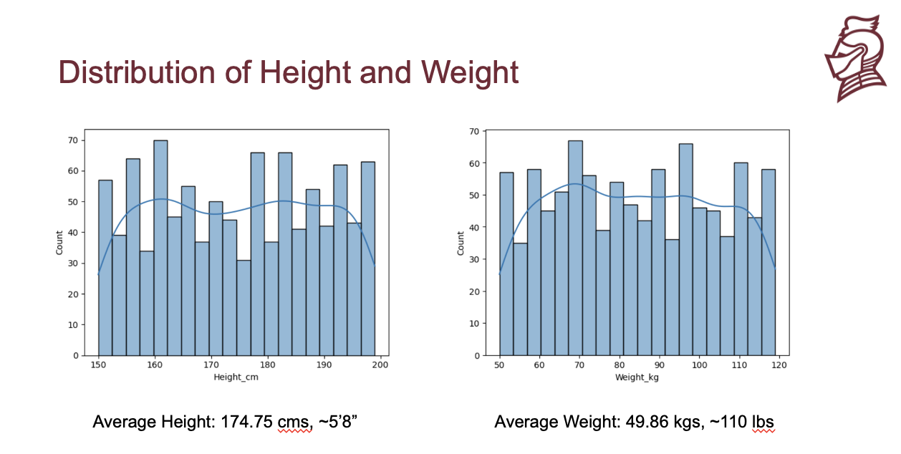

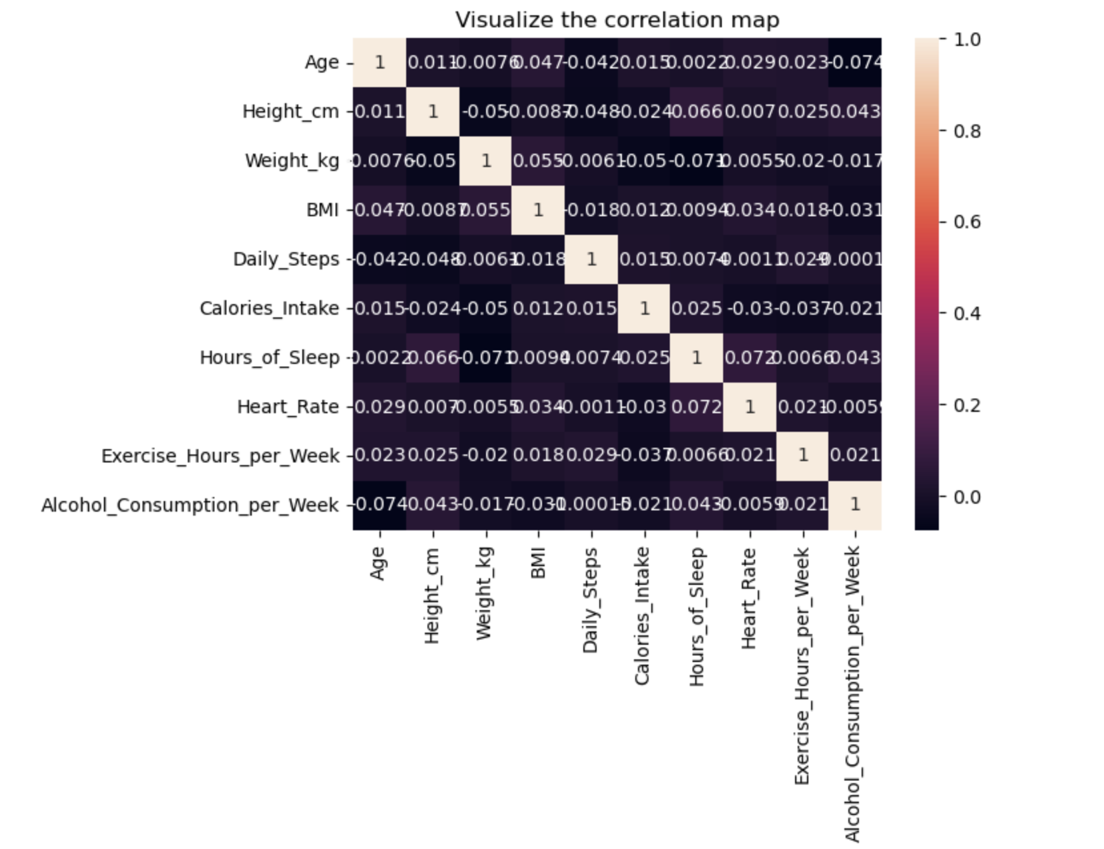

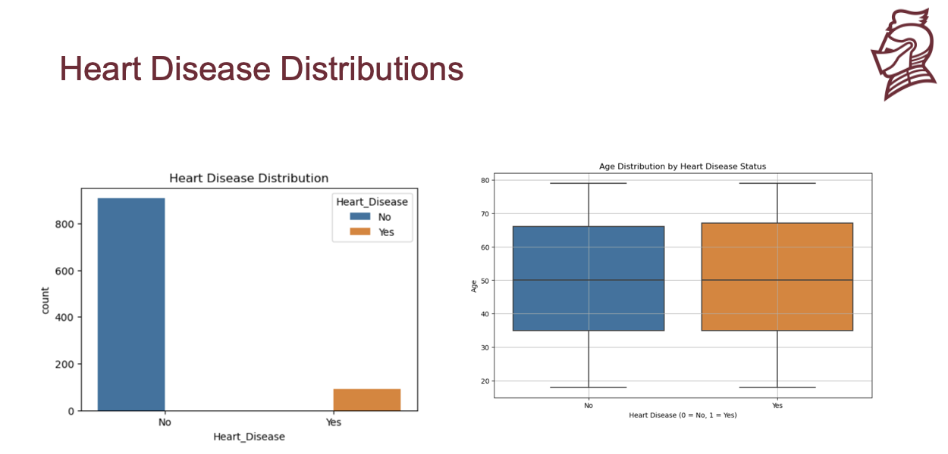

- METHODS
In this section, describe how you prepared the data for your model and performed multiple experiments using different parameters for the model(s).

  - Data Preparation
Describe how you prepared the data for your model. For example, you might need to normalize the data, so variables with wider ranges of values don’t overshadow variables with smaller ranges. If you decide to drop variables from the model or create variables from existing columns, explain the process and the reasoning behind those decisions.

For linear model #1, to prepare the data, I began by setting my x and y values. For my first linear regression model, I used BMI as my y variable, and I used Age, Gender, Daily Steps, Caloric intake, Hours of sleep, heart rate, exercise, smoker, alcohol consumption, diabetic, and heart disease as my x variables. This meant I dropped ID, height, weight, blood pressure, and BMI. I obviously had to drop BMI because that was my y variable. I dropped height and weight because I wanted to see how well the model would predict without having the inputs to the formula. The ID number was just an index and would have no bearing on the model, so I dropped it. I dropped my blood pressure because of how it was set up. Blood pressure is measured in one number over another, so there are many unique combinations. Because it was an object, there were too many unique inputs to be helpful. I also encoded all the categorical variables, not including blood pressure. Most of these were yes/no, so it was very simple when it came to predicting.
For Linear Model #2: For the second linear model, I took a different approach to predict BMI. We know that there is a formula to calculate this but I wanted to see if I only gave the model height and weight if it would bring results close to the formula. For my y variable, I used BMI. For my x variable I only used height and weight. This model did not require any encoding. I split my model in train and test sets and was ready to initialize.
For Logistic Model #1: This was a simpler model than linear, but I was trying to predict a different thing. For this model, I wanted to use all of the variables that I could. This would give me an idea of which had more of an impact. For my y, I used heart disease. For my x, I used all variables except ID and Heart Disease. After this, I encoded my categorical variables so they were able to be used. Then I split data into train and test sets.
For Logistic Model #2: As I will discuss in my results, a second logistic model had to be made. This was because of an unbalanced data set. To combat this, I used SMOTE. This stands for synthetic minority oversampling technique. What this process does is duplicate the existing data and also creates new data that is very similar to the minority section. For my example, new data was created for the examples with heart disease. This required me to import a new library into my EDA. Once I had done this, I was able to copy the code found on the SMOTE website into my EDA. Then I made the necessary changed to fit it to my model.

  - Experimental Design
You will run your model several times with different parameters to see what different results you get. In a table, describe your experimental parameters. Three or four experiments are sufficient. This is where you will describe how you divided your data into train, validate and test data sets. For example:

Table X: Experiment Parameters
Experiment Number | Parameters
1 | 80/20 Split for Train/Test. Random state= 1
2 | 70/30 Split for Train/Test. Random state= 2
3 | 70/30 Split for Train/Test. Random state= 1
4 | 80/20 Split for Train/Test. Random state= 2

  - Tools Used
Describe all of the software tools you used to perform your data preparation and model implementation. For example:

For this project, I was using a MacBook Air through Apple OS. Using the Anaconda environment, I used JupyterNotebook.

My following libraries used the versions:
Python version: 3.11.5 (main, Sep 11 2023, 08:31:25) [Clang 14.0.6 ]
Pandas version: 2.0.3
NumPy version: 1.24.3
Matplotlib version: 3.7.2
Seaborn version: 0.12.2
Scikit-learn version: 1.6.1

- RESULTS
  - Classification Measures/ Accuracy measure
Provide the classification/ regression measures for each experiment. For example, you could provide a contingency table for each model to measure how well it classifies data. You could also do an ROC curve (using SciKit Learn). You need to demonstrate how you are measuring the success/failure of the models. For regression, you can calculate the RMSE and scores and compare between various models.
Linear Model #1
Experiment Number | Parameters | Results
1 | 80/20 Split for Train/Test. Random state= 1 | Linear Regression Results for BMI:  MAE: 4.261945480784528  MSE: 23.228370461797212  R2 Score: -0.022341208548640523
2 | 80/20 Split for Train/Test. Random state= 2 | Linear Regression Results for BMI:  MAE: 4.144919951524824  MSE: 22.93540889342977  R2 Score: -0.03692604281424572
3 | 70/30 Split for Train/Test. Random state= 1 | Linear Regression Results for BMI:  MAE: 4.08718492126206  MSE: 22.01664846319675  R2 Score: -0.004210243838935979
4 | 70/30 Split for Train/Test. Random state= 2 | Linear Regression Results for BMI:  MAE: 4.16185461078244  MSE: 22.891229249743926  R2 Score: -0.00796463347025278

Linear Model #2
Experiment Number | Parameters | Results
1 | 80/20 Split for Train/Test. Random state= 1 | Linear Regression Results for BMI (Only Height & Weight):  MAE: 4.2103601181008115  MSE: 22.609083814587294  R2 Score: 0.004915213092640647
2 | 80/20 Split for Train/Test. Random state= 2 | Linear Regression Results for BMI (Only Height & Weight):  MAE: 4.070524650525479  MSE: 21.975359342005568  R2 Score: 0.006478475801032557
3 | 70/30 Split for Train/Test. Random state= 1 | Linear Regression Results for BMI (Only Height & Weight):  MAE: 4.070309495151499  MSE: 21.89310009554632  R2 Score: 0.0014249706493879577
4 | 70/30 Split for Train/Test. Random state= 2 | Linear Regression Results for BMI (Only Height & Weight):  MAE: 4.142914490977631  MSE: 22.65805959525559  R2 Score: 0.00230247638036174

Logistic Model #1
Experiment Number | Parameters | Results
1 | 80/20 Split for Train/Test. Random state= 1 | Logistic Regression Results for Heart Disease:  Accuracy: 0.9  Confusion Matrix:  [[180 0]  [ 20 0]]  Classification Report:  precision recall f1-score support  No 0.90 1.00 0.95 180  Yes 0.00 0.00 0.00 20  accuracy 0.90 200  macro avg 0.45 0.50 0.47 200  weighted avg 0.81 0.90 0.85 200
2 | 80/20 Split for Train/Test. Random state= 2 | Logistic Regression Results for Heart Disease:  Accuracy: 0.895  Confusion Matrix:  [[179 0]  [ 21 0]]  Classification Report:  precision recall f1-score support  No 0.90 1.00 0.94 179  Yes 0.00 0.00 0.00 21  accuracy 0.90 200  macro avg 0.45 0.50 0.47 200  weighted avg 0.80 0.90 0.85 200
3 | 70/30 Split for Train/Test. Random state= 1 | Logistic Regression Results for Heart Disease:  Accuracy: 0.9  Confusion Matrix:  [[270 0]  [ 30 0]]  Classification Report:  precision recall f1-score support  No 0.90 1.00 0.95 270  Yes 0.00 0.00 0.00 30  accuracy 0.90 300  macro avg 0.45 0.50 0.47 300  weighted avg 0.81 0.90 0.85 300
4 | 70/30 Split for Train/Test. Random state= 2 | Logistic Regression Results for Heart Disease:  Accuracy: 0.9  Confusion Matrix:  [[270 0]  [ 30 0]]  Classification Report:  precision recall f1-score support  No 0.90 1.00 0.95 270  Yes 0.00 0.00 0.00 30  accuracy 0.90 300  macro avg 0.45 0.50 0.47 300  weighted avg 0.81 0.90 0.85 300

Logistic Model #2
Experiment Number | Parameters | Results
1 | 80/20 Split for Train/Test. Random state= 1 | Logistic Regression (With SMOTE):  Accuracy: 0.68  Confusion Matrix:  [[129 57]  [ 7 7]]  Classification Report:  precision recall f1-score support  No 0.95 0.69 0.80 186  Yes 0.11 0.50 0.18 14  accuracy 0.68 200  macro avg 0.53 0.60 0.49 200  weighted avg 0.89 0.68 0.76 200
2 | 80/20 Split for Train/Test. Random state= 2 | Logistic Regression (With SMOTE):  Accuracy: 0.655  Confusion Matrix:  [[126 60]  [ 9 5]]  Classification Report:  precision recall f1-score support  No 0.93 0.68 0.79 186  Yes 0.08 0.36 0.13 14  accuracy 0.66 200  macro avg 0.51 0.52 0.46 200  weighted avg 0.87 0.66 0.74 200
3 | 70/30 Split for Train/Test. Random state= 1 | Logistic Regression (With SMOTE):  Accuracy: 0.6366666666666667  Confusion Matrix:  [[178 92]  [ 17 13]]  Classification Report:  precision recall f1-score support  No 0.91 0.66 0.77 270  Yes 0.12 0.43 0.19 30  accuracy 0.64 300  macro avg 0.52 0.55 0.48 300  weighted avg 0.83 0.64 0.71 300
4 | 70/30 Split for Train/Test. Random state= 2 | Logistic Regression (With SMOTE):  Accuracy: 0.6566666666666666  Confusion Matrix:  [[187 83]  [ 20 10]]  Classification Report:  precision recall f1-score support  No 0.90 0.69 0.78 270  Yes 0.11 0.33 0.16 30  accuracy 0.66 300  macro avg 0.51 0.51 0.47 300  weighted avg 0.82 0.66 0.72 300

  - Discussion of Results
Discuss which of your models provided the best classification (or some other outcome if not classification). Explain why you think your best model was the best and why your worst model was the worst.

Linear Regression Model #1: The classification that found the best outcome was #3. Although all of the R^2 scores were negative, this was the highest. Although this model is the best, the R^2 score is still negative, so it is a pretty bad model. The worst model was #2 because it had the lowest R^2.

Linear Regression Model #2: For the second linear model, the #2 had the best score. On this model, all R^2 were positive so it is most likely better than the first. The worst model was #3 which had the lowest score.

Logistic Regression Model #1: On the first regression model, I believe #1,3,4 were the best classifications. Although they were all at 90% accuracy, the third and fourth models used more values in the confusion matrix. All models had 0s on the right on the confusion matrix. This will be solved in the second logistic regression model. The worst experiment was number 2. This had the lowerst accuracy and a small confusion matrix.

Logistic Regression Model #2: The accuracy score in this model were lower but we saw improvement in the confusion matrix. The best experiment was #1. This experiment found the highest accuracy. The worst was #3 with the lowest accuracy. All experiments were similar.

  - Problems Encountered
No project goes perfectly smooth. Discuss any problems you had with obtaining the data, preparing the data, implementing the model, or evaluating the model. It would be highly unusual to indicate that you had no problems.

There were several problems I ran into with this project. The first major problem occurred in the linear regression models. I was not able to achieve a high R^2 score no matter what variables went in. One possible explanation of this is that it is not a good fit for linear regression. There are many regression models to use, a different will most likely work better.
The second problem I ran into was with my confusion matrices in logistic regression. Notice the first model. All values on the right side of the matrix are 0. This means false and true positives. There were several false negatives, though. This means the system was saying everything was negative. Although this brought a higher accuracy, the chance of catching a person with heart disease is 0%. The solution to this problem was found with SMOTE. This allowed the model to actually predict when someone could potentially have heart disease. Although accuracy dropped, this model served my initial purpose to help find people who could have heart disease.

  - Limitations of Implementation
Discuss the limitations of your model(s). Are there reasons your models might not be the best way to predict the target data? What other models might work better?
For my first model, there is most likely a better model to achieve the result. Because my model had a very low R^2 value, it most likely does not work with linear regression. I believe that the second model works well.

  - Improvements/Future Work
What would you like to do to improve your model in future work? Some items you might consider discussing are performing more experiments, using different models, adding or removing variables, finding a different data set, etc.

- CONCLUSION
Finish up with a paragraph or two of summarizing your problem, the results and your conclusions (good model, bad model, needs more work, etc.).

Overall, I would consider this project a success. Although I did not achieve all of my goals, there was significant progress towards them. The second logistic model was a success and can definitely help to detect heart disease in some people. This could be potentially life-saving. When looking at my first problem, it wasn’t a success, but it led me to new ideas that would work. Expanding my knowledge of modeling will help to create a model that can predict BMI. Another easy way to solve that problem is to simply create a calculator using Python.

REFERENCES

List any websites, books, articles, etc. that you found useful while you worked on this project. It is not necessary to cite the references in the paper unless you specifically mention it in the text.

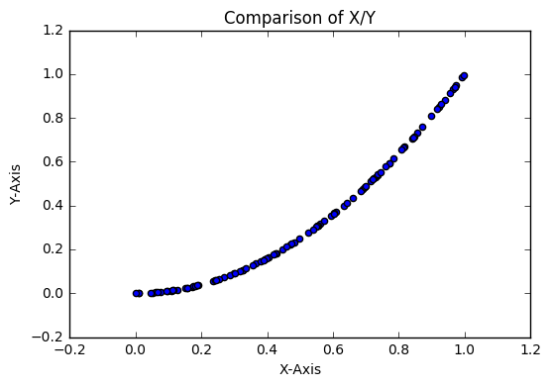  Figure 1: Comparison of X/Y from dataset (single plot) (8 pt.) | 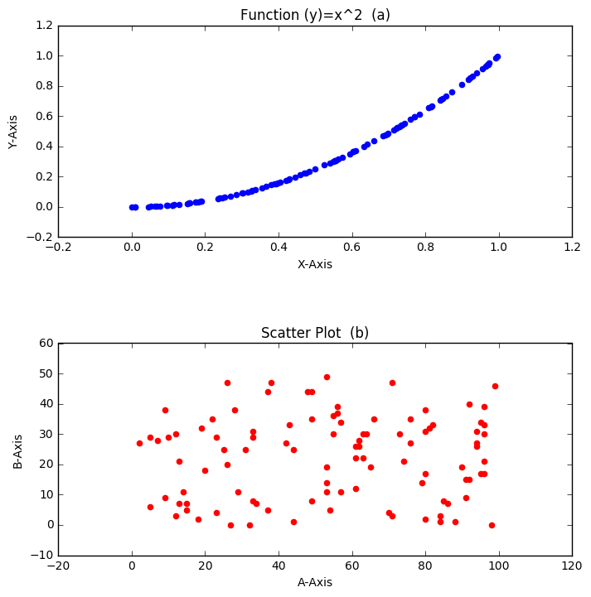  Figure 2: (a) Function Output (b) A against B (multiple plots) (8 pt.)

