**RMI vs UDP**

When we are using RMI no packets are discarded, which is what we were expecting as the transport protocol used is TCP(which is connection-oriented). Despite being faster than TCP, UDP has the disadvantage of providing a less reliable transmission of the message for a large number of packets.

In *Graph1* we see the time taken to transmit the packages in each case:

1) Lab computers one next to each other, empty lab (orange line)

2) Lab computers far from each other, empty lab (blue line)

3) UDP (grey line)

*Graph 1 Transmission time for RMI*

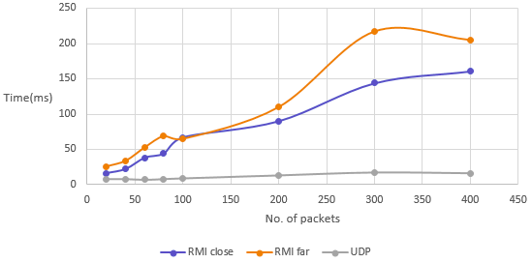

The error rate is 0 for RMI, so all we can say about it is that the transmission time is affected by the number of packets transmitted and the distance between the server and client. The grey line representing UDP was included in the graph to show the huge difference in speed, as transmission time for UDP is in the range of 7 to 20 ms for less than 400 packets.

The following graph illustrates the dependency between the number of lost packets (with UDP) and the total number of packets transmitted. We repeated the measurements at different times of the day, when the lab was busy and when it was almost empty, in order to see how the activity of other users connected to the same network might affect the interaction of the client with the server. We also varied the physical distance between the two, thus obtaining the 4 cases presented below.

We tested UDP 4 times in different conditions:

1) Lab computers next to each other, empty lab (blue line)

2) Lab computers far from each other, empty lab (orange line)

3) Lab computers next to each other, busy lab (grey line)

4) Lab computers far from each other, busy lab (yellow line)

G*raph 2 : Error rate(Y-axis) vs No. of transmitted packets(X-axis)*

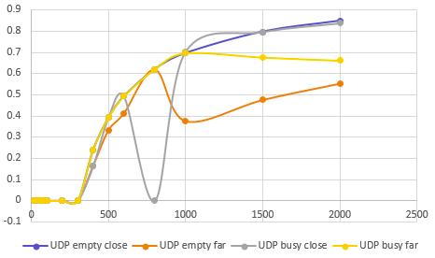

In case 1) we observed an interesting fact: when we were transmitting 305 packets or more, only the first 304 packets were being successfully received no matter what the total number of packets was. It seems like the system was setting a limit of packets for us and it was able to maintain it every time.

In 2) we saw an unpredictable variation in the number of successfully received packets for more than 304 messages, which suggests that the system was less efficient in monitoring our activity and limiting us.

Seeing how similar 3) and 1) we can conclude that the number of users present in the lab does not considerably affect the error rate. This contradicts what we were initially expecting as we thought that while the network is busy the limit of successfully transmitted messages should be lower than when the lab is almost empty.

In 4) we witnessed again an unpredictable variation in the success rate, as we repeated some of the measurements and got different results each time. This means that physical distance is a factor that affects the error rate.

As we can infer from the graphs, the number of packets and the distance between the server and client are influencing the results while the number of active users does not seem to matter that much.

d) The easier one to program seems to be RMI being more intuitive, as it has a higher level of abstraction due to the use of the remote interface for the transmission of the message. With RMI we do not need to deal with ports or sockets anymore. Another reason why RMI is easier to program is that the code for UDP is larger so there are higher chances of making mistakes.