**最短路徑問題**

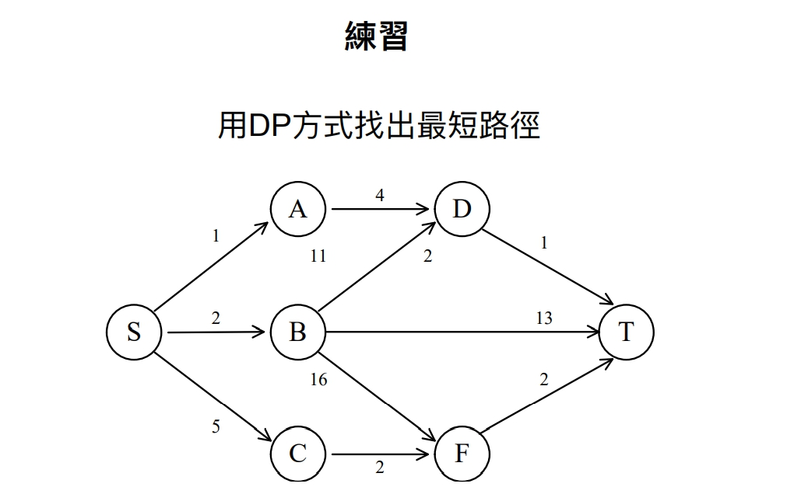

d(S,D) = min{d(S,A)+d(A,D), d(S,B)+d(B,D)}

= min{1+d(A,D), 2+d(B,D)}

= min{1+4, 2+11}

= 5

d(D,T) = 1

d(S,B) = 2

d(B,T) = 13

d(S,F) = min{d(S,B)+d(B,F), d(S,C)+d(C,F)}

= min{2+d(B,F), 5+d(C,F)}

= min{2+16, 5+2}

= 7

d(F,T) = 2

d(S,T) = min{d(S,D)+d(D,T), d(S,B)+d(B,T), d(S,F)+d(F,T)}

= min{5+1, 2+13, 7+2}

= 6

**鐵條切割問題**

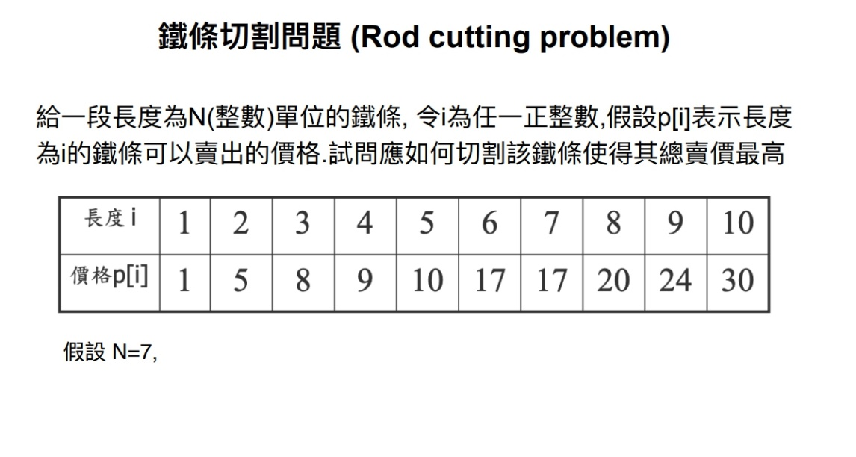

(長度：價格)

6+1：17+1 = 18

3+2+2：8+5+5 = 18

7：17

1+1+5：1+1+10 = 17

3+4：8+9 = 17