1.

CREATE (nAlice:User {name: 'Alice', seed: 42}),

(nBridget:User {name: 'Bridget', seed: 42}),

(nCharles:User {name: 'Charles', seed: 42}),

(nDoug:User {name: 'Doug'}),

(nMark:User {name: 'Mark'}),

(nMichael:User {name: 'Michael'}),

(nAlice)-[:LINK {weight: 1}]->(nBridget),

(nAlice)-[:LINK {weight: 1}]->(nCharles),

(nCharles)-[:LINK {weight: 1}]->(nBridget),

(nAlice)-[:LINK {weight: 5}]->(nDoug),

(nMark)-[:LINK {weight: 1}]->(nDoug),

(nMark)-[:LINK {weight: 1}]->(nMichael),

(nMichael)-[:LINK {weight: 1}]->(nMark);

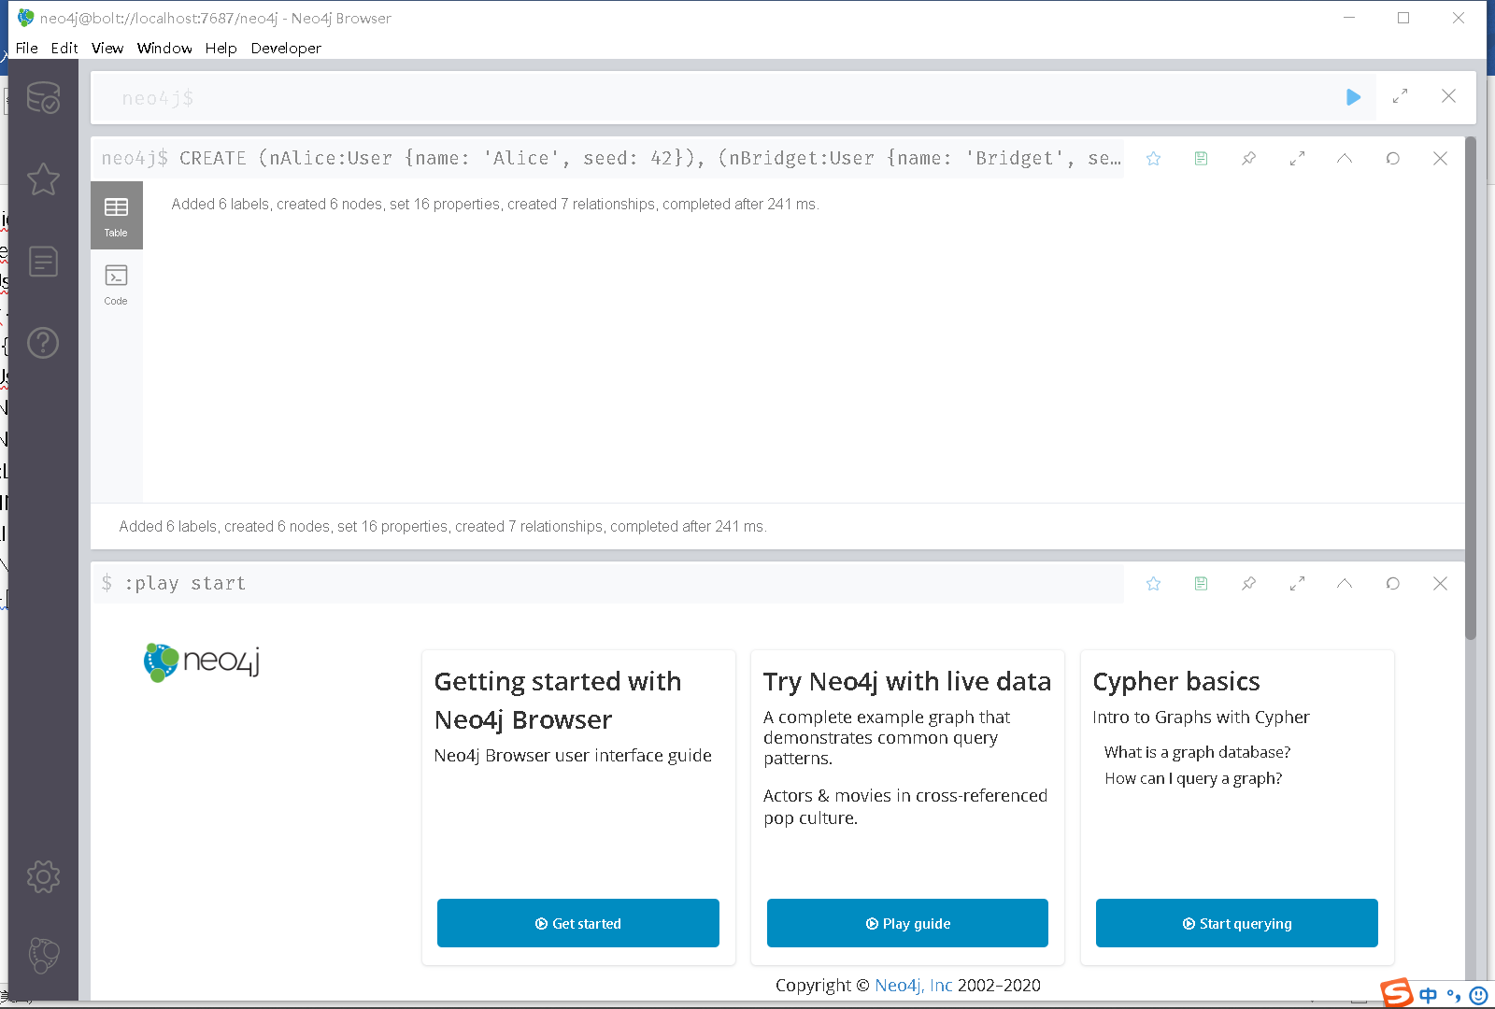

2. CALL gds.graph.create(

'myGraph',

'User',

{

LINK: {

orientation: 'UNDIRECTED'

}

},

{

nodeProperties: 'seed',

relationshipProperties: 'weight'

}

)

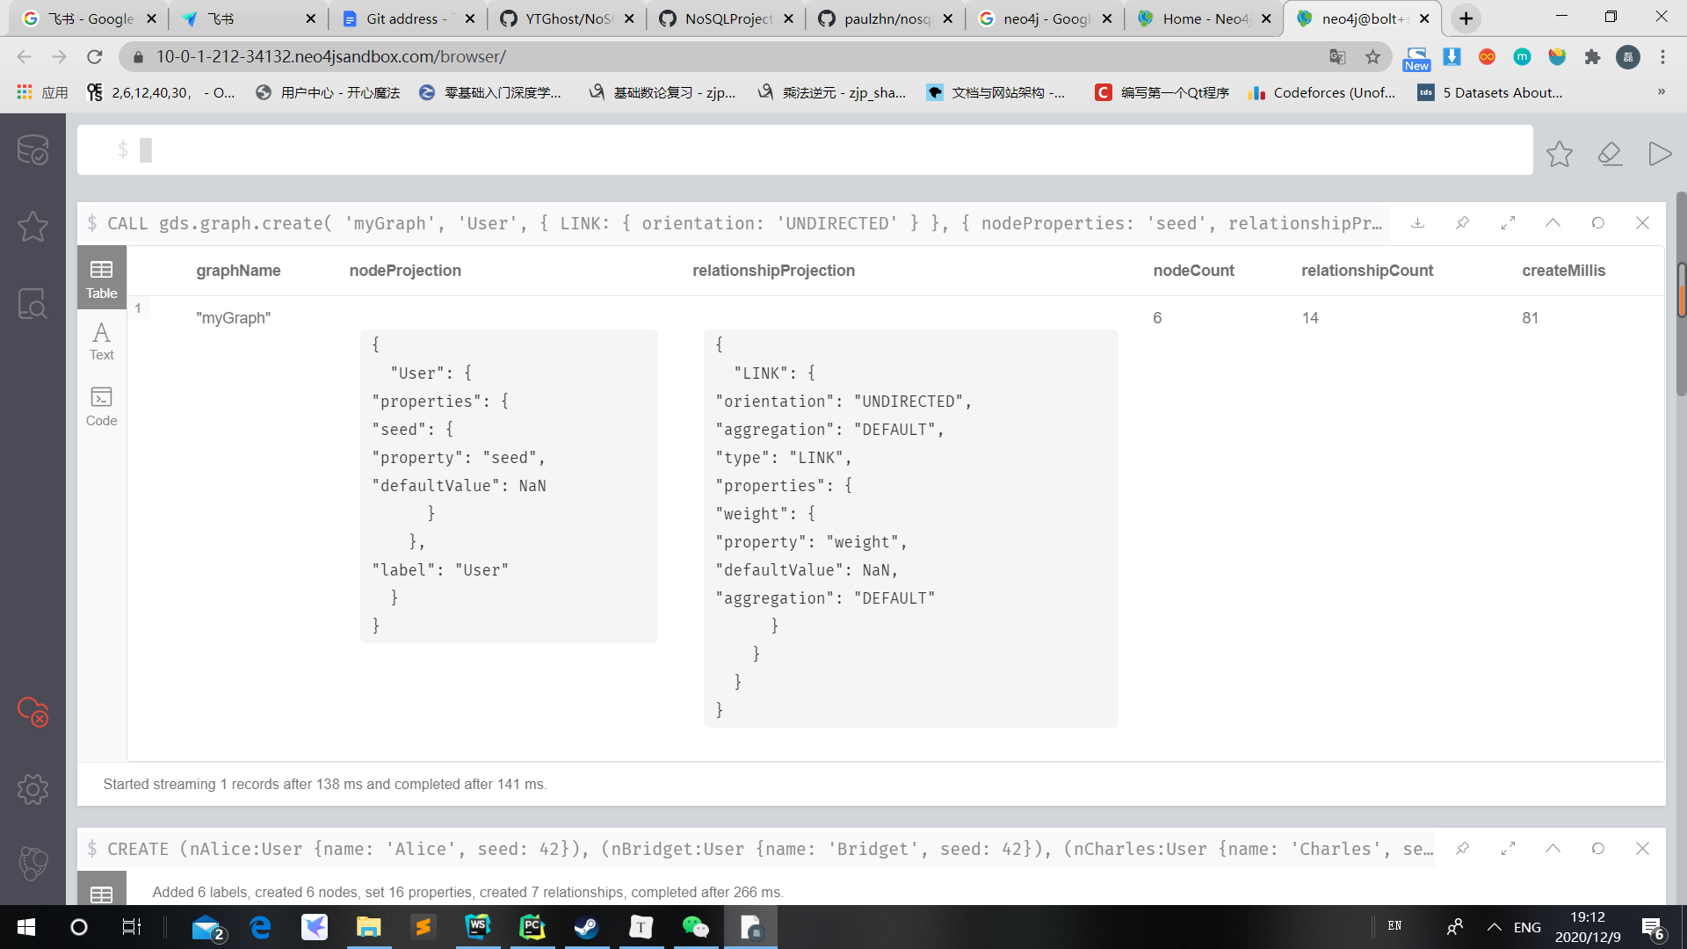

3.

CALL gds.louvain.stream('myGraph')

YIELD nodeId, communityId, intermediateCommunityIds

RETURN gds.util.asNode(nodeId).name AS name, communityId, intermediateCommunityIds

ORDER BY name ASC

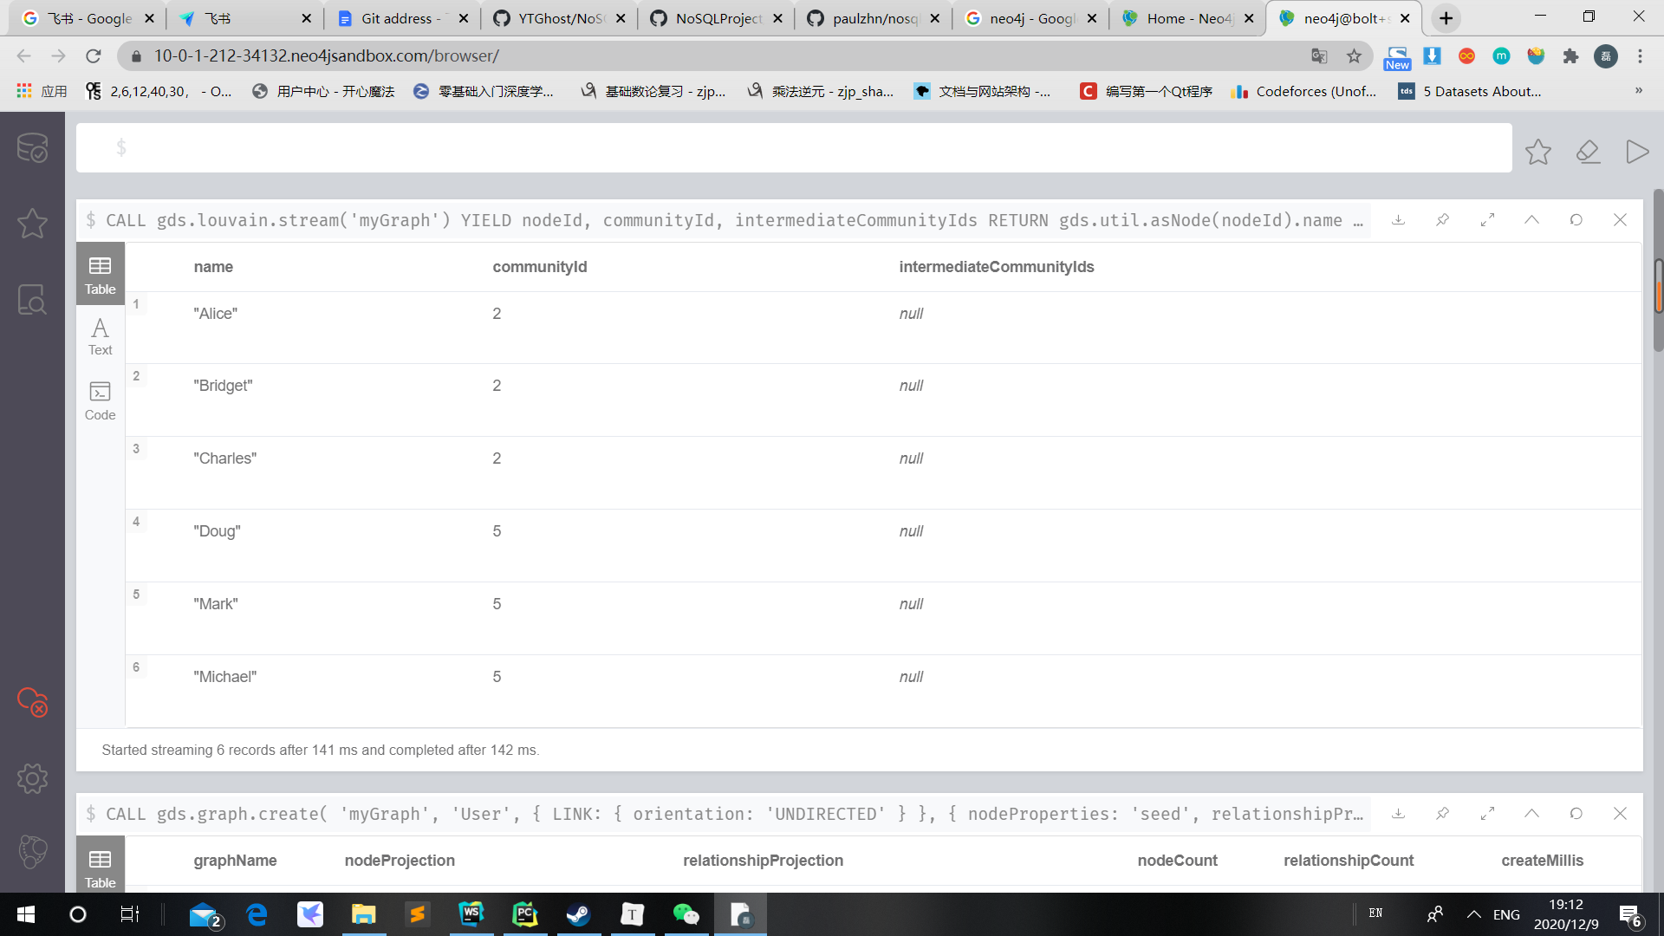

4.

CALL gds.louvain.stats('myGraph')

YIELD communityCount

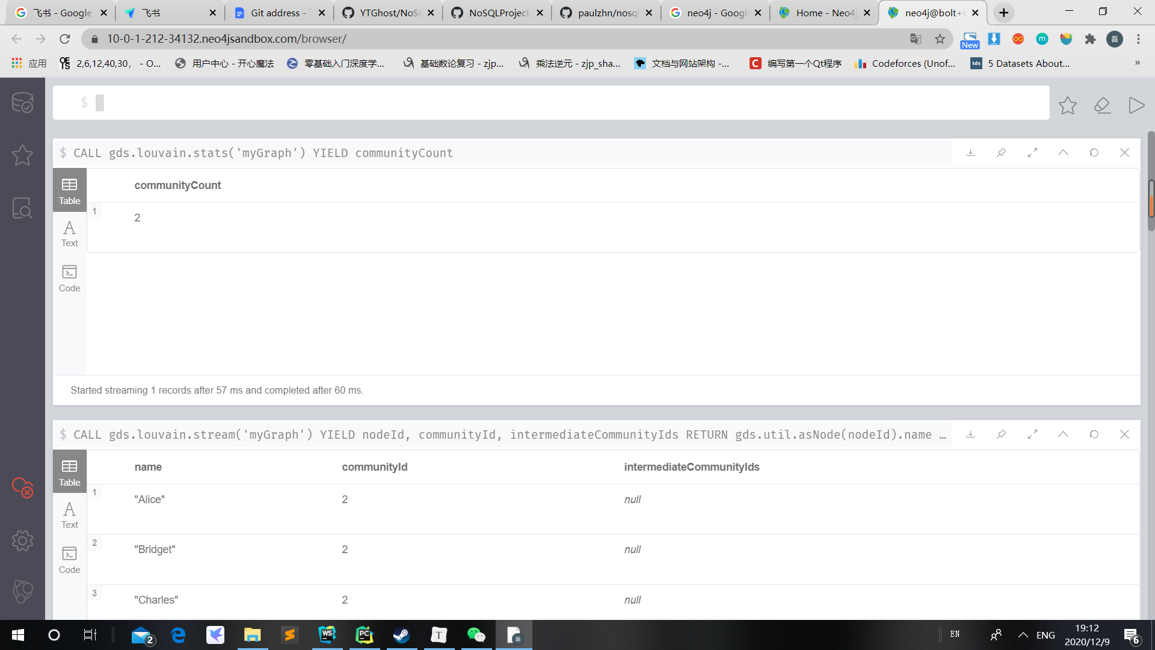

5. CALL gds.louvain.mutate('myGraph', { mutateProperty: 'communityId' })

YIELD communityCount, modularity, modularities

