This is a basic report of the Employee API developed by Waseem Nader. The source code for it is located at: <https://github.com/wnader52/spring-boot-employee-rest-api>

The following tools & frameworks are needed to build and run this API:

1. Java 17
2. Spring Boot 3.2.3
3. IntelliJ or Eclipse or any other IDE used for developing Java Spring Boot APIs
4. Please look at the README.md file for usage information

Download the API from the above location and build it so that it can run locally. Once fully built using either Eclipse or IntelliJ IDE, you would be able to run it. Once you run it, access the local URL as shown below via Chrome or any other browser.

Go to <http://localhost:8082/swagger-ui/index.html> to see the swagger schema for its usage.

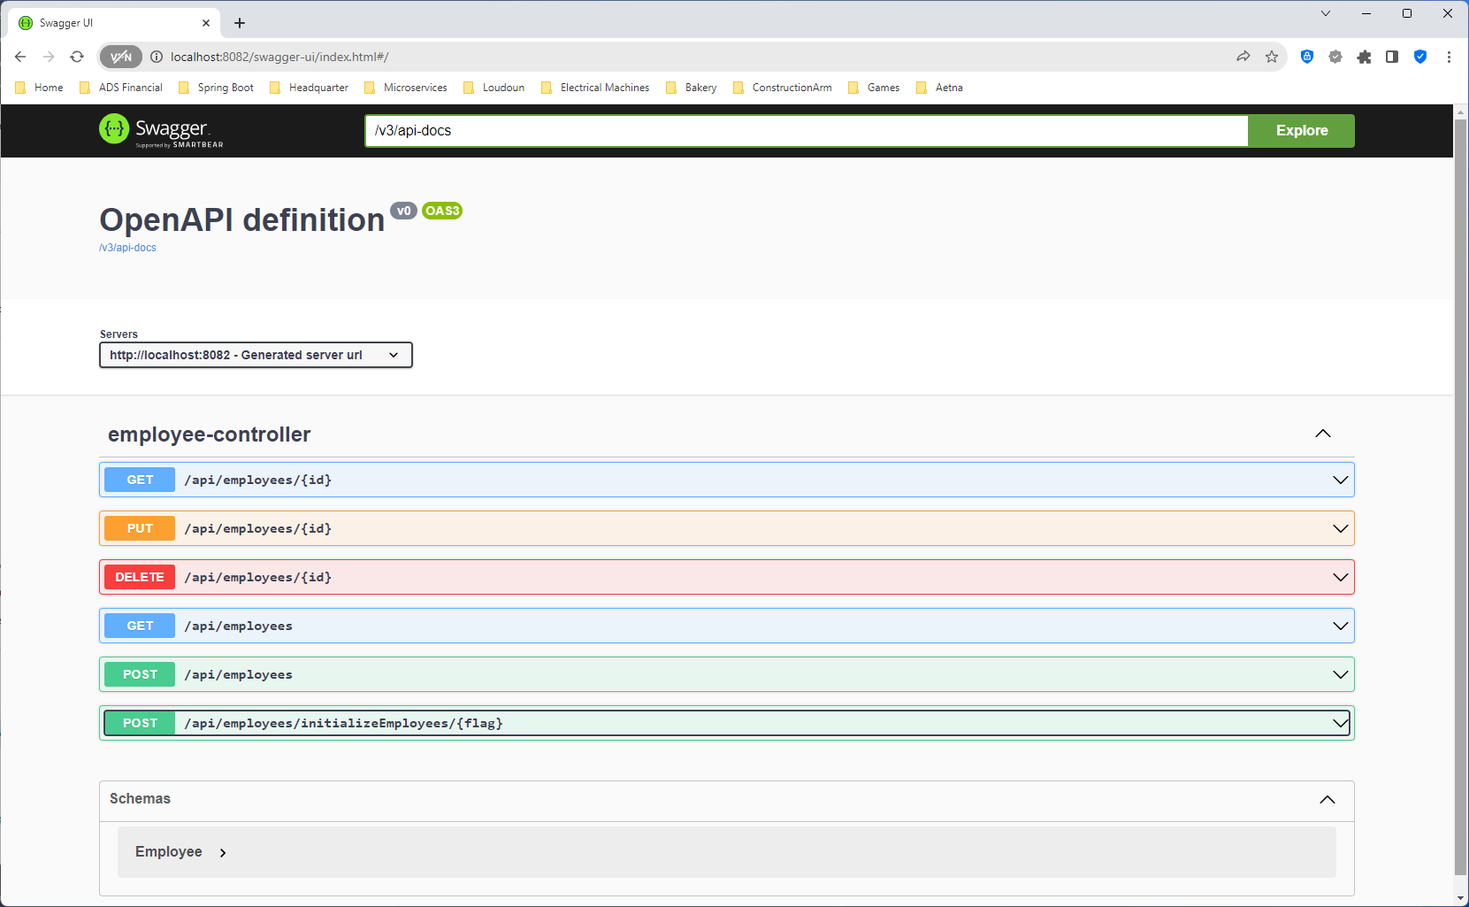

You need to run the ../api/initializeEmployees/{flag} first so that some dummy data can be generated and stored in memory. Then all subsequent operations can be performed.

1. Running the ../api/initializeEmployees/true command (create dummy employee objects)

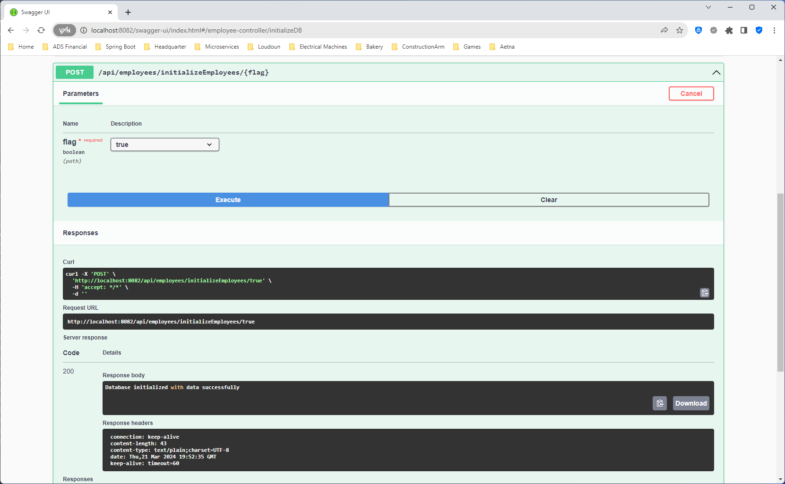

1. Executing ../api/employees (fetch all employees using HTTP GET)

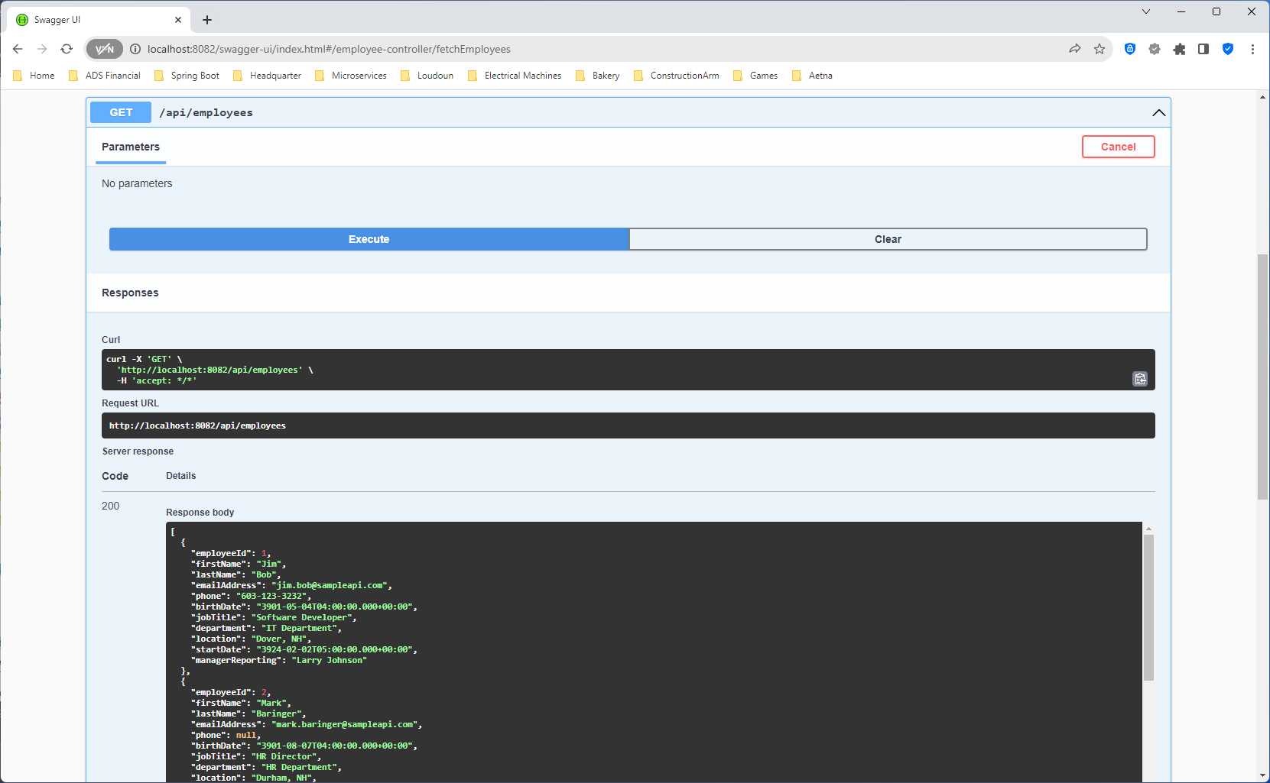

1. Executing ../api/employees/1 (fetch individual employee by Id using HTTP GET)

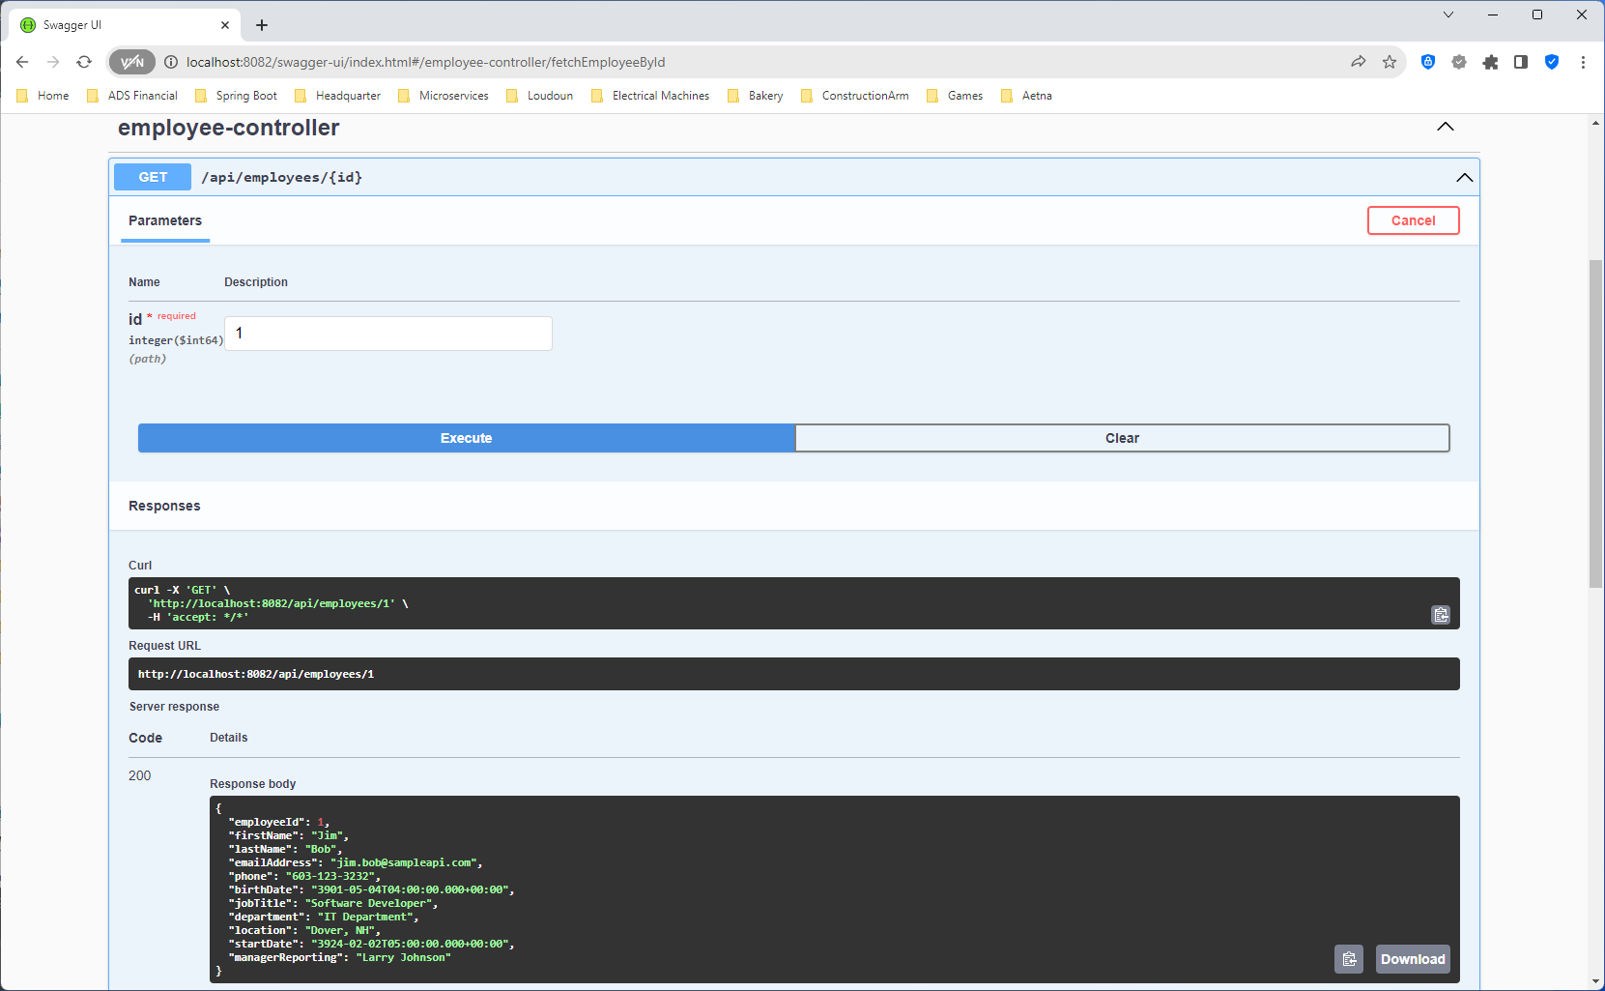

1. Executing ../api/employees/1 (update using HTTP PUT)

1. Executing ../api/employees (creating employee object and saving using HTTP POST)

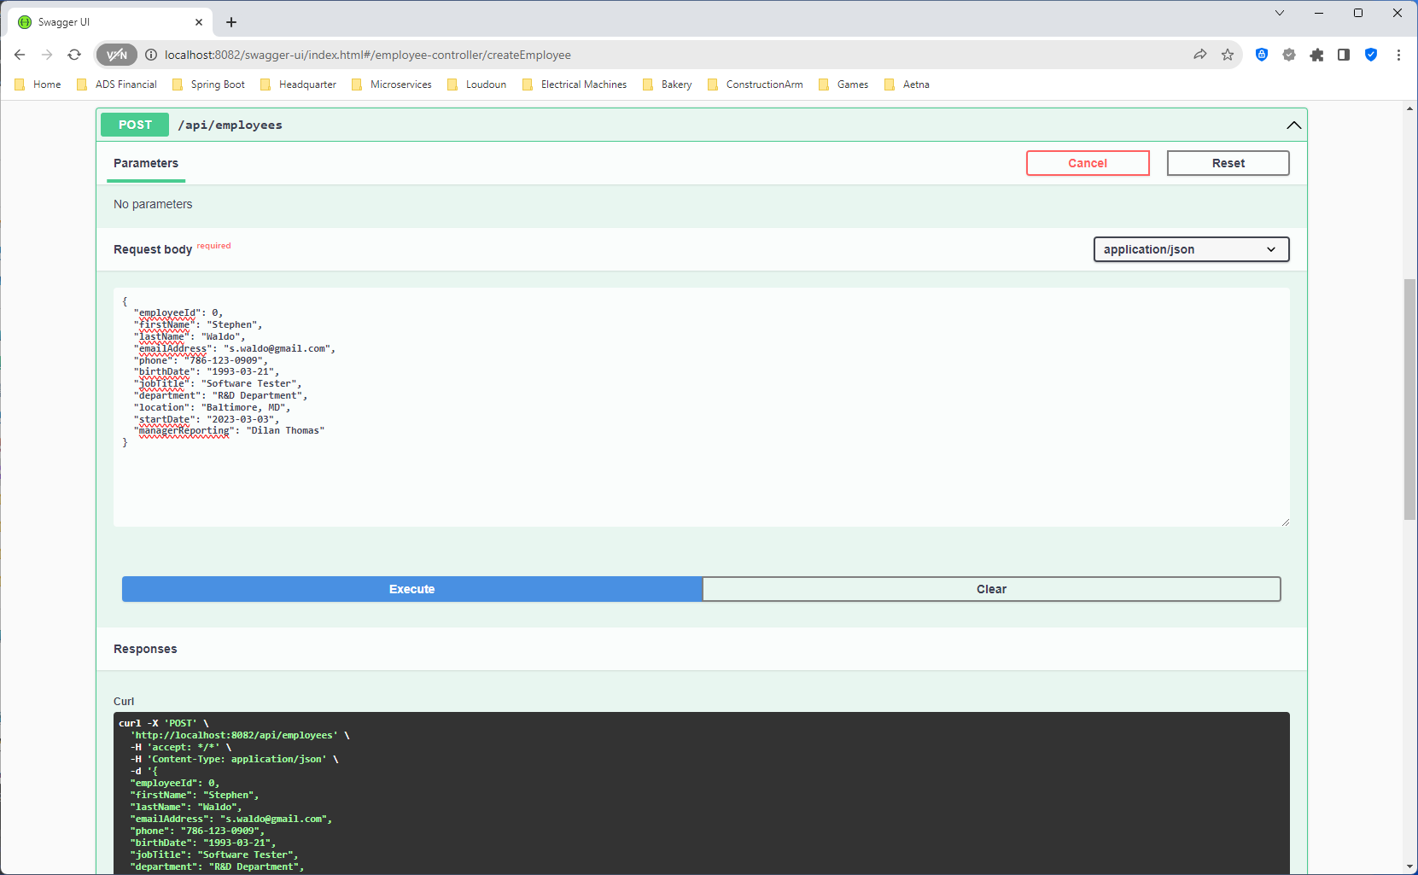

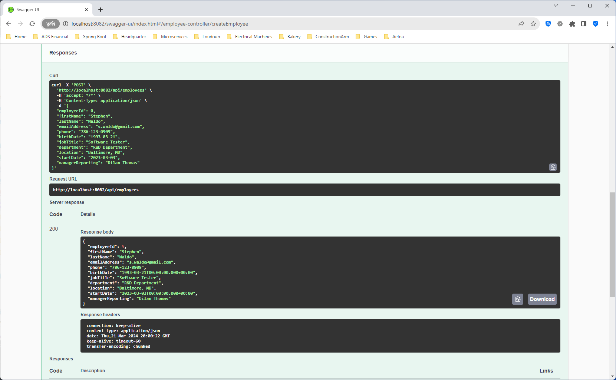

1. Executing ../api/employees/1 (deleting employee by Id using HTTP DELETE)

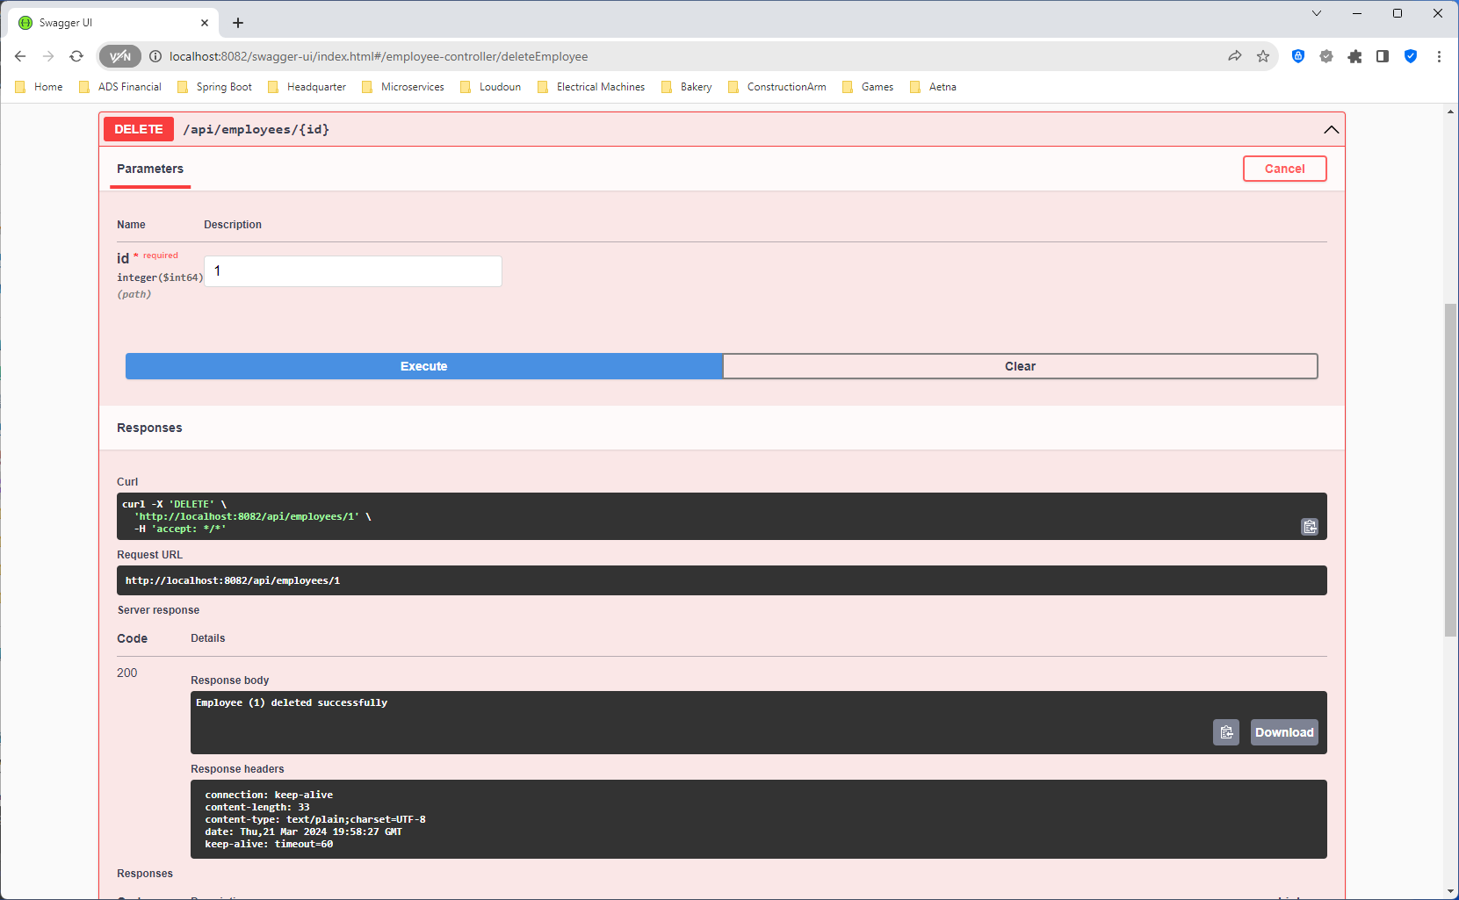

The Employees API also has some Junit 5 tests that can be executed as shown below.

