Exploring data using R

Kamarul Imran Musa, Wan Nor Arifin

Draft updated 04 November 2018

Contents

Preface iv

Introduction to R 1

Installing and starting R 1

Installing R 1

Starting R 3

Installing and starting RStudio 5

Installing RStudio 5

Starting RStudio 6

Why RStudio? 7

RStudio IDE interface 8

Entering the codes in RStudio 9

Functions and objects 12

Functions 12

Objects 12

Packages 13

base packages 14

user-contributed packages 14

Installing packages 16

Using function 16

Using Packages tab 16

Loading packages 18

Working directory 20

Creating a new project 20

Setting a working directory 21

Getting help 22

Upgrading R 22

Summary 23

Data management 24

Reading, viewing and exporting data 24

The datasets 24

Reading dataset 24

Viewing dataset 24

Exporting dataset from R 25

Built-in datasets in R 26

Data structure 26

Variable types 26

Containers 27

Subsetting 28

Selecting a column (variable) or a row (observation) 29

Selecting columns and rows 30

Selecting based on logical expressions 34

Sorting data 40

Editing data 44

Creating a new variable 44

Recoding into new variables 44

Removing variables and observations 45

Direct data entry 46

Miscellaneous 48

Sums of the existing variables 48

Handling missing observations (NA/not available) 49

Handling duplicates 51

Summary 52

Descriptive statistics 54

One variable 54

A numerical variable 55

A categorical variable 56

Two variables and more 57

Numerical variables 57

Categorical variables 59

Groups and cross-tabulations 63

By groups 63

Cross-tabulation 69

Customizing text outputs 71

cbind() and rbind() 72

data.frame() and matrix() 74

paste0() 75

cat() 76

Summary 76

Visual exploration 78

Introduction to visualization 78

History of data visualization 78

Processes and objectives of visualization 78

What makes good graphics 78

Graphics packages in R 79

Questions to ask before plotting graphs 79

Using the graphics package 79

Plotting a numerical variable 81

Plotting relationship between numerical variables 86

Plotting a categorical variable 89

Saving plots in R 93

Using the lattice package 94

Histogram, density and box-and-whisker plots 94

Histogram, density and box-and-whisker plots by group 96

Scatter plot 101

Bar chart 103

Histograms and box-and-whisker plots 107

Using the ggplot2 package 109

Plotting a numerical variable 109

Plotting a categorical variable 112

Plotting a numerical variable and a categorical variable 114

Saving plots in ggplot2 119

Summary 119

Bibliography 120

Index 121

# Preface

This is a book on getting started with R and doing data exploration in R. The focus of this book is mainly on the basics of R, data entry and management, descriptive statistics and graphical exploration of the data. To help new R users pick important and necessary skills to use R, we use RStudio; a well-known IDE for R.

We do not cover basic statistical analyses, for examples *t*-test and chi-squared test, instead we focus on the basics of data preparation and exploration. By limiting the scope to these two areas, we are confident this book will quickly help new R user work with R with less hassles.

All in all, we hope you enjoy this book!

**Kamarul Imran Musa (** [drkamarul@usm.my](mailto:drkamarul@usm.my) **)**

**Wan Nor Arifin (** [wnarifin@usm.my](mailto:wnarifin@usm.my) **)**

School of Medical Sciences,

Universiti Sains Malaysia,

Health Campus,

16150 Kubang Kerian, Kelantan

# Introduction to R

This chapter introduces the basics R and how to get started with R quickly. We start the chapter with steps to take to install R and RStudio. We then explain about the basics of R syntax, how to install R packages and how to set up the working directory.

## Installing and starting R

### Installing R

As on the date of this writing, the latest version of R is R version 3.5.1 (2018-07-02), Feather Spray. The R software will be regularly updated. R can run on Windows OS, Mac OS and Linux distribution.

To work with R, you first need to download the R installation files from <https://cran.r-project.org/>. You can install as many versions of R as you like in one single machine. There is no need to uninstall previous R installation if you want to upgrade your R software.

The size of installation files as of today 2018-11-04 is about 80 megabytes. But the size will grow as you work with R. This happens because you will install new packages to your R and enable you work with data analysis.

The download and install R, follow the steps below:

1. If you are using Windows OS, go to <https://cran.r-project.org/bin/windows/>. Then, click base subdirectories and click Download R

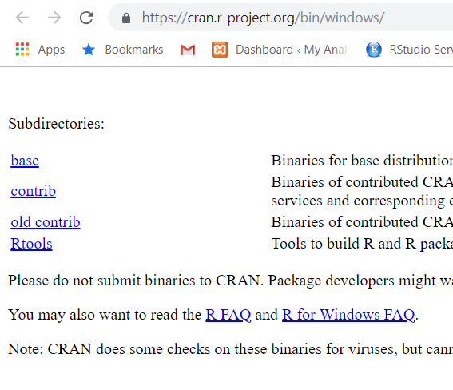

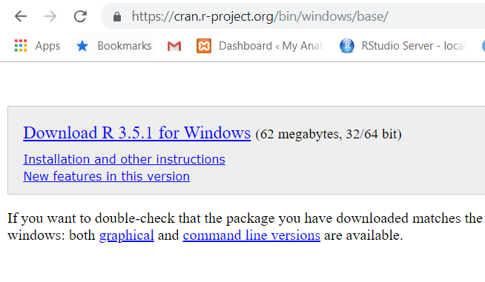

1. If your machine use Mac OS, then go to <https://cran.r-project.org/bin/macosx/>. Then, click the filename ending with .pkg. Next, follow the installation instruction in Mac OS

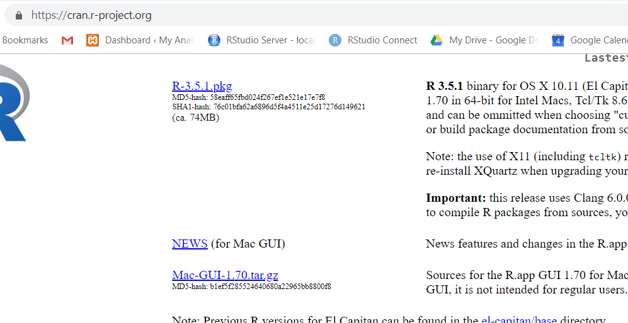

1. For Linux OS is <https://cran.r-project.org/bin/linux/> . Then browse to correct Linux distro. Then follow the instruction.

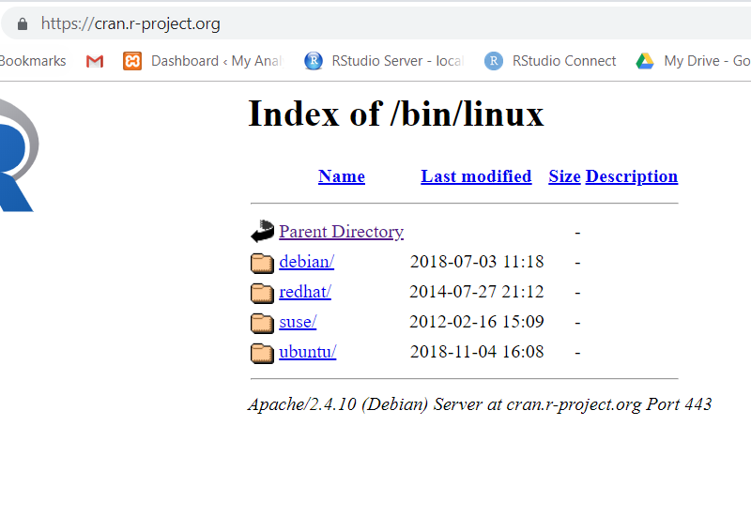

### Starting R

You can start R software like starting any other software.

In Windows, double click on R icon on the Start page and you should get this:

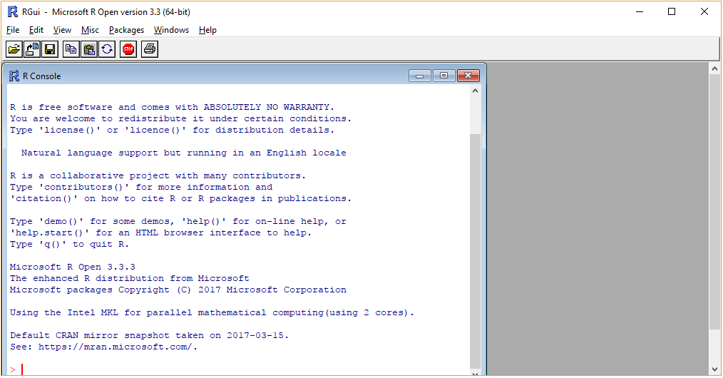

**R console**

If you can see the R GUI, you are good to go. In the figure, I am using the Microsoft R Open version 3.3.3. In your case, the R will be shown as just R version R version 3.5.1 (2018-07-02), Feather Spray (see image below).

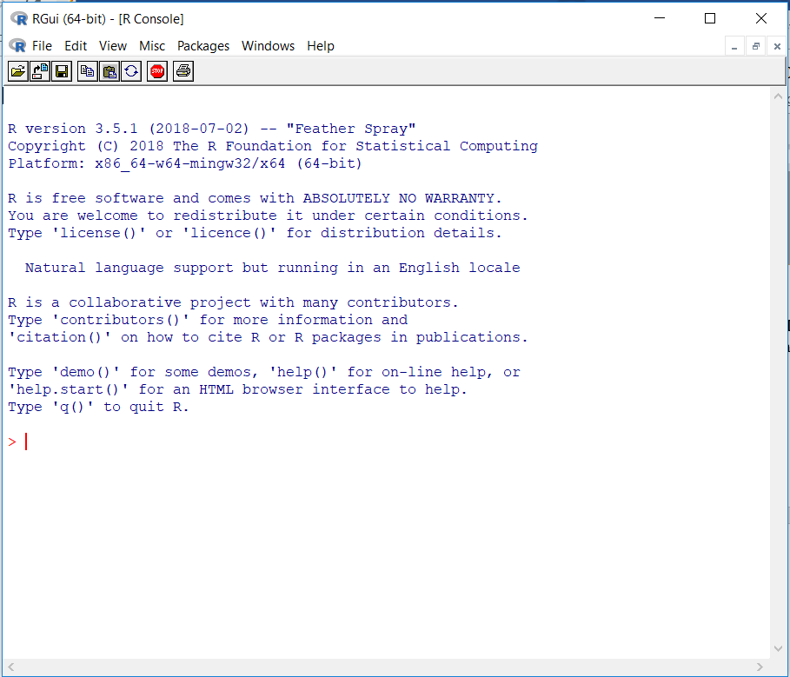

**R console**

## Installing and starting RStudio

### Installing RStudio

After you have completed the installation of R, we encourage you to install RStudio in your machine.

In the RStudio website (<https://www.rstudio.com/>), the company describes RStudio as follows:

***RStudio is an integrated development environment (IDE) for R. It includes a console, syntax-highlighting editor that supports direct code execution, as well as tools for plotting, history, debugging and workspace management.***

The full information about RStudio can be found here <https://www.rstudio.com/products/rstudio/>.



RStudio is available in open source and commercial editions. It runs on the desktop with Windows OS, Mac OS, and Linux OS. It can also run in a browser connected to RStudio Server or RStudio Server Pro.

RStudio installation files can be downloaded from <http://www.rstudio.com/products/rstudio/download/>.

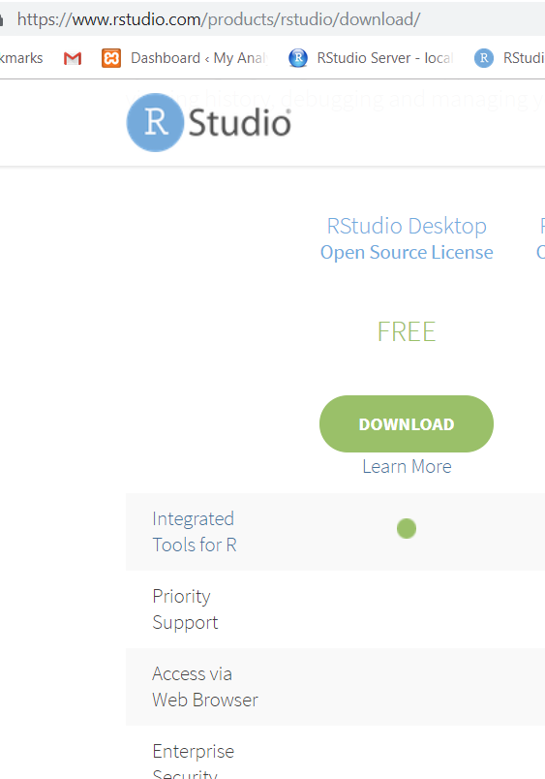

Again, take note that it is recommended that you, firstly install R before you install RStudio. In the download link, choose the Free RStudio Desktop and click the download button. From there, you can a list of downloadable RStudio depending on the supported platforms.

Next, download the installation files. Once the download has finished, follow the simple instructions. Accept all the defaults.

### Starting RStudio

You can double click on RStudio icon in the menu or your start page on your computer desktop and you will see the RStudio interface.

Take note of the R version in the RStudio Console, most probably on the right-hand side of the computer screen.

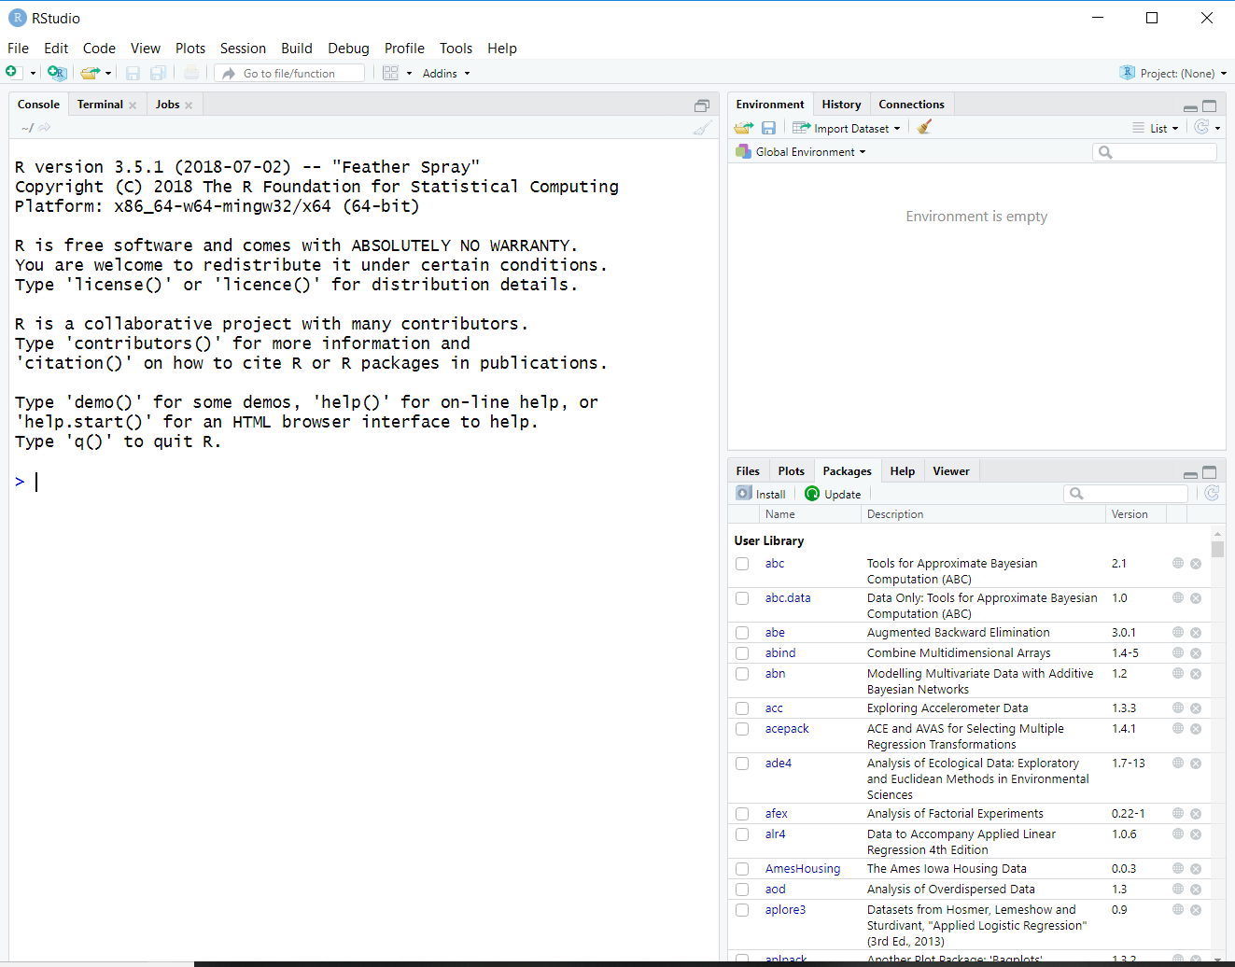

**RStudio**

### Why RStudio?

Based on our experience and the experience of others, we feel working with RStudio helps new users learn R quicker in the beginning.

The `green` R GUI is way too intimidating to new users especially to those with no experience with programming language. What we want to say is that, working with R console is alright, but for majority of new users, they prefer to communicate with R using the RStudio IDE interface.

RStudio is more than a GUI. It is an integrated development environment (IDE) for R. Other R IDEs includes Microsoft R Open. To learn more about R IDE and GUI, check out these links:

1. RStudio at <https://www.rstudio.com/>
2. Microsoft R Open at <https://mran.microsoft.com/open>



1. Tinn-R at <https://sourceforge.net/p/tinn-r/wiki/Home/>

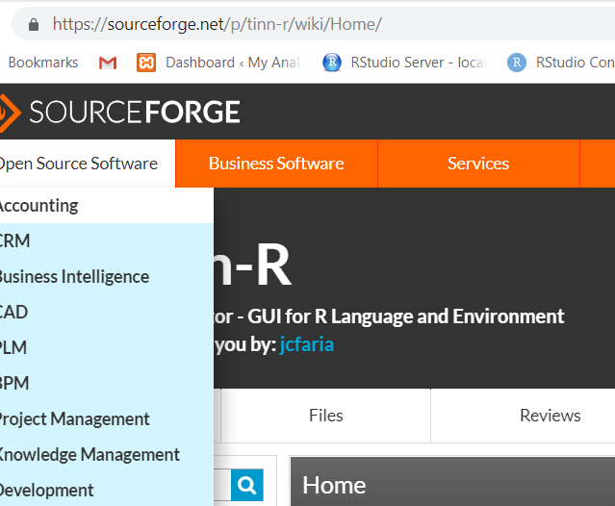

### RStudio IDE interface

You should be able to see 3 or 4 panes in the layout. They are:

1. Console pane - on the left side of your computer screen. It tells you about your R, when you first start RStudio.
2. Source pane - on the upper left side of your computer screen. This will show the R script, R markdown files and other active files. The first time you start RStudio, this pane is not shown.
3. Environment and History panes - on the upper right side of your computer screen. It is where you can see the objects created by R, the codes that you have run and the connections to data sources such as databases.
4. Miscellaneous - on the lower right screen of your computer. It contains smaller tabs, Files, Plots, Packages, Help and Viewer. This tabs can list file names, show plots, show packages, display help document and view outputs.

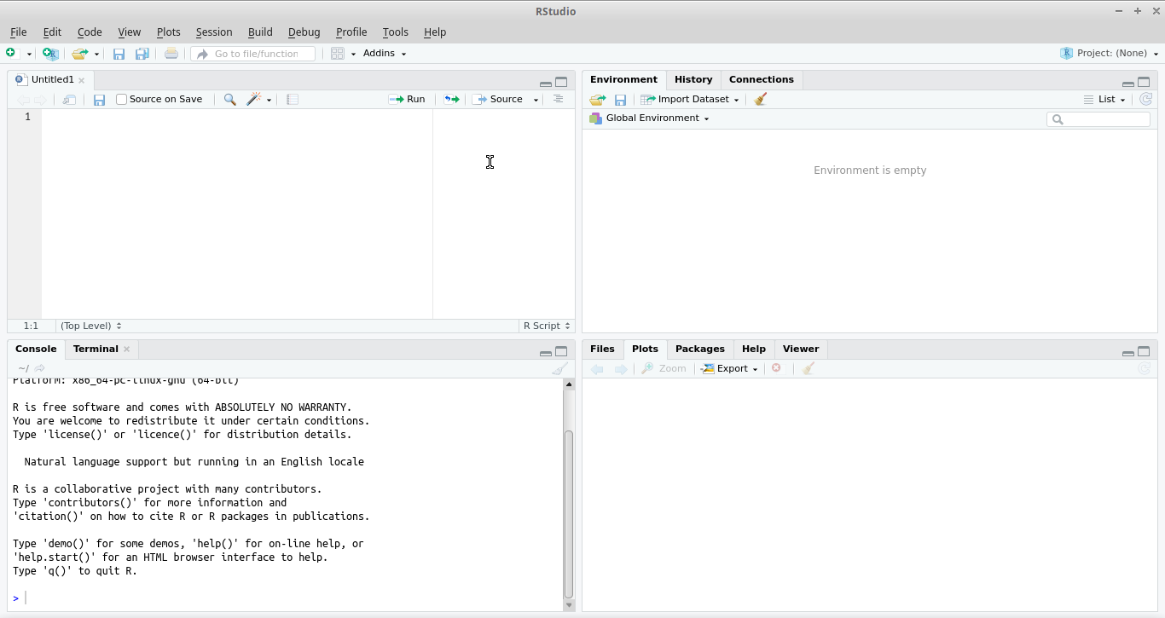

**Panes in RStudio**

### Entering the codes in RStudio

To start using R, you need to open up an R script. In RStudio, click **File > New File > R Script**, or click on the icon  and choose **R Script** from the dropdown menu.

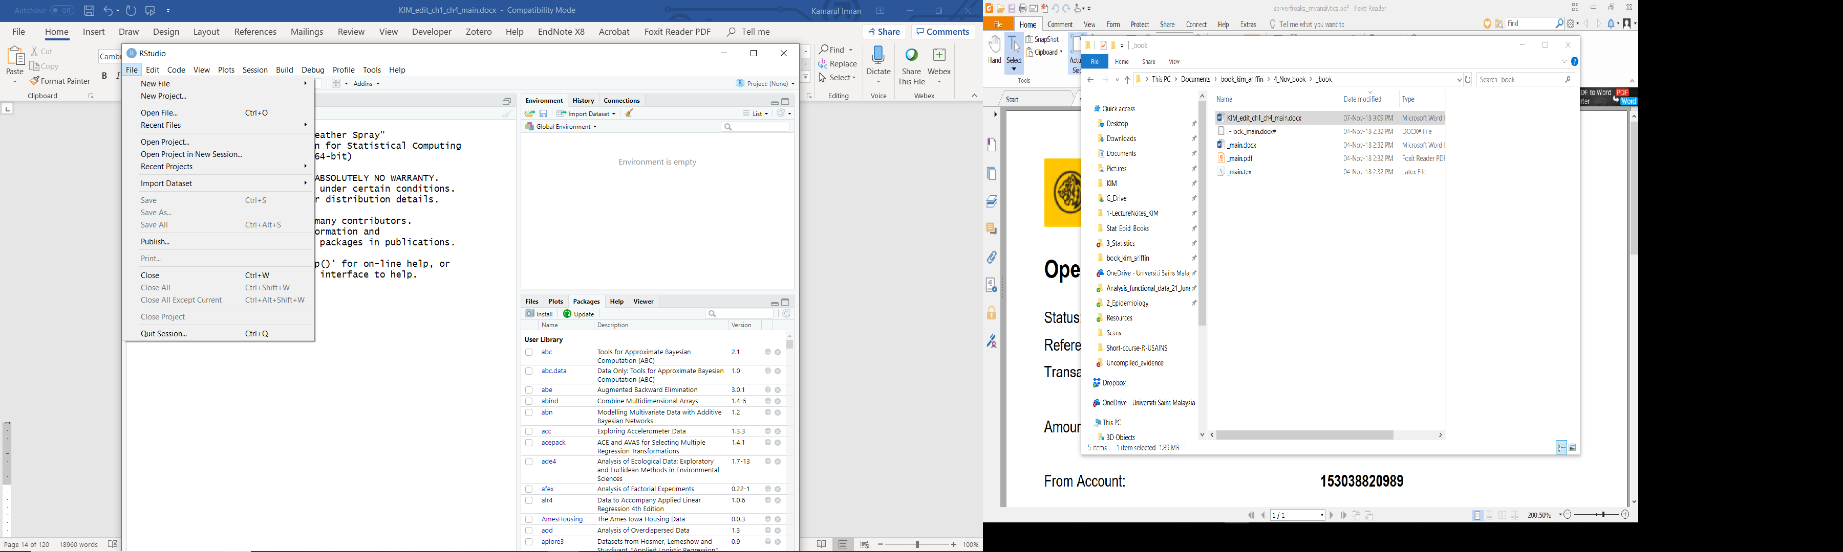

You may also type the shortcut **Ctrl+Shift+N**. You should be able to get RStudio interface similar to the image above (four panes view).

Each line of code can be run by placing the cursor on any specific line, followed by **Ctrl+Enter** for **Windows OS** or **Cmd+Enter** for **Mac OS**. You may also run several lines of codes by highlighting the lines followed by **Ctrl+Enter (Windows OS)** or **Cmd+Enter (Mac OS)**. And, you may even run a small part in a line by selecting the part only, and **Ctrl+Enter**.

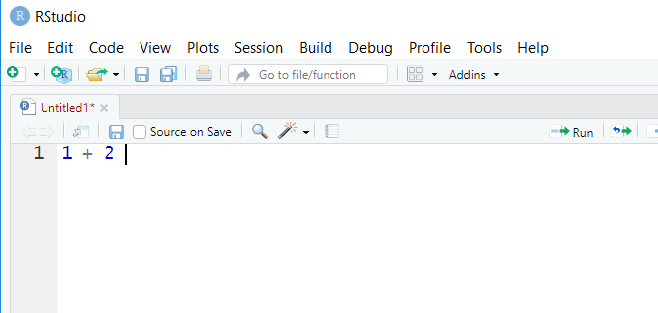

Later, you will notice some codes have hashes # in the codes (for starter, in the next section). # marks specific parts of codes as comments. These parts will not be run by R for analysis.

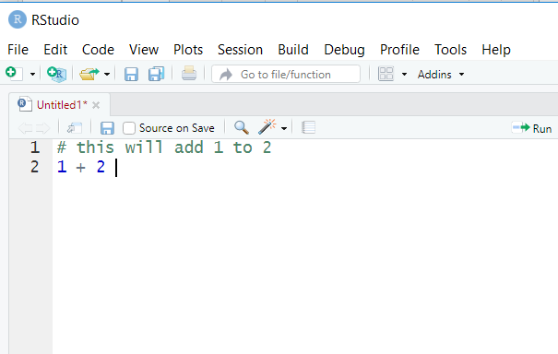

R will recognize the lines/parts marked with # as comments. This is very important in any programming language. Because may end up having to deal with long lines of codes, it will be helpful to comment parts of codes to describe what the codes do. This is very advantageous to us, because we can nicely document our codes and describe whatever we do during the analysis.

Think of hashtag for the social media! # can be used to comment the whole line or for a short comment at the end of a line.

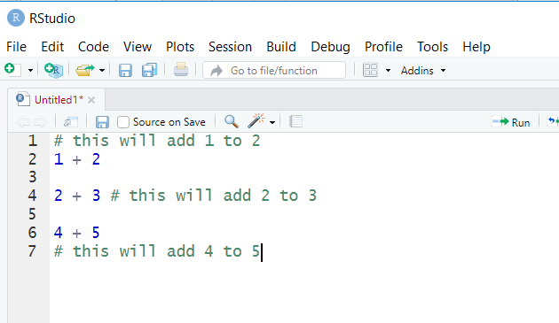

## Functions and objects

Before we start, there are several basics that you must know to understand the syntax in R. These are functions and objects.

### Functions

R commands are in the form of function(argument = value, argument = value, ...). If you are familiar with MS Excel, think of MS Excel **functions**.

Inside a function function(), there will be a number of **arguments**. For each argument, you may need to provide the **values**. We will see this as we go through examples later.

### Objects

Object is like a container. You assign an object by giving it a name on left side of <- or =. For the sake of consistency, we will use <- throughout, although = is perfectly fine (some might argue about this though).

# try these three lines of codes  
x <- 1  
y = 2  
z <- x + y # sum up x and y

Type the object name x, y, and z, you’ll get the value,

x

## [1] 1

y

## [1] 2

z

## [1] 3

Now you will notice that the = symbol is used to set the value (or parameter) for the argument of a function, i.e. inside the bracket after the function’s name. For example, function(argument1 = value, argument2 = value, ...). Thus, some people prefer using <- to avoid confusion with = for setting the values for the arguments.

## Packages

R runs on packages. In each package, there are function. This can be represented as **package::function()**. These packages will be installed in your home directory. To know where this directory is located, type .libPaths().

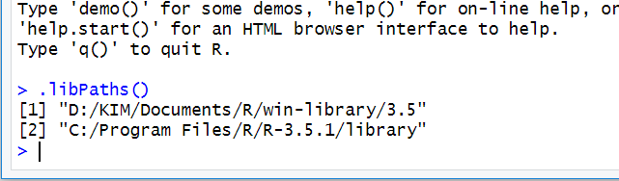

There are two packages in R:

1. base packages
2. user-contributed packages

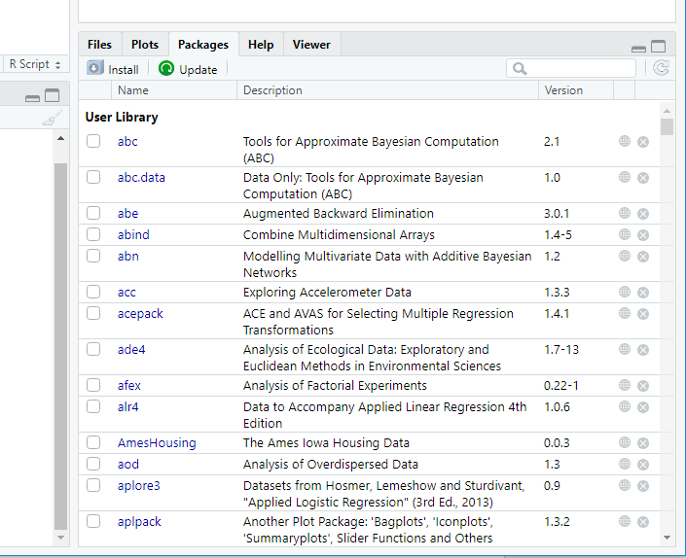

### base packages

The base packages come with the installation of R. They provide basic but adequate functions to perform many standard data management, visualization and analysis.

### user-contributed packages

However, in many situations, user needs to install user-contributed packages to deal with their data. These user-contributed packages are necessary to perform tasks that are not available in the base packages.

User-contributed packages allow users to perform more advanced and more complicated functions and they are contributed by R users all over the world. There are more than 12000 packages as of April 2018

For a complete list of packages, see <https://cran.r-project.org/web/packages/>. The packages name can be found here <https://cran.r-project.org/web/packages/available_packages_by_name.html>.

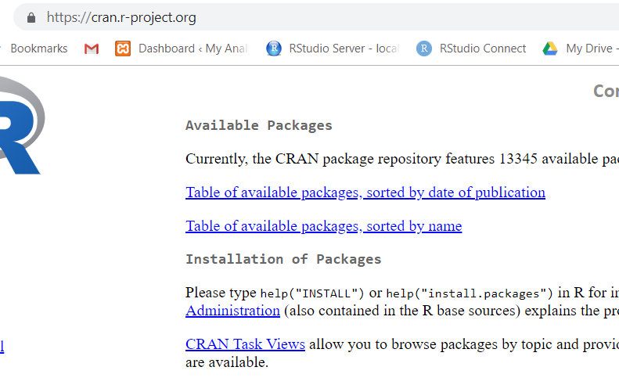

CRAN Task Views (<https://cran.r-project.org/web/views/>) aggregated all the packages according to their main tasks for examples packages to deal with:

1. *Clinical Trials*: Clinical Trial Design, Monitoring and Analysis <https://cran.r-project.org/web/views/ClinicalTrials.html>
2. *MetaAnalysis*: <https://cran.r-project.org/web/views/MetaAnalysis.html>
3. *SocialSciences*: Statistics for Social Sciences <https://cran.r-project.org/web/views/SocialSciences.html>
4. *Spatial*: Analysis of Spatial data <https://cran.r-project.org/web/views/Spatial.html>

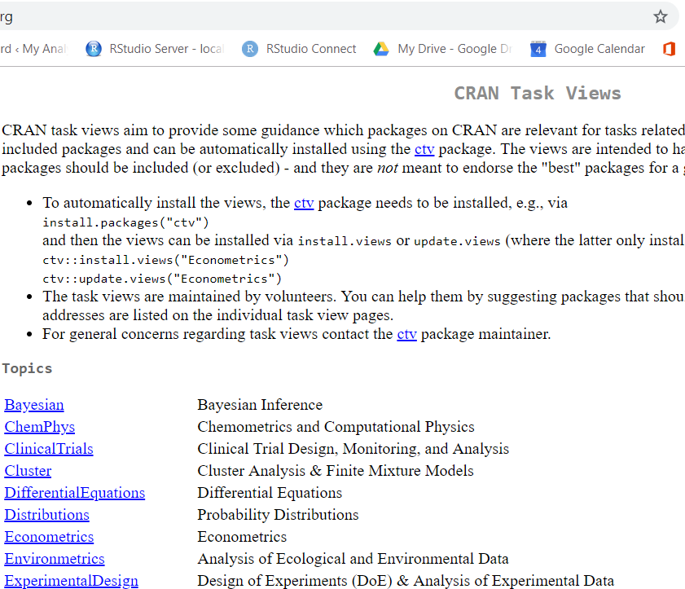

### Installing packages

You can install user-contributed packages through:

1. Internet (from CRAN repository).
2. Local .zip or tar.gz files.
3. Github packages.

We will now learn to install a package. You must have an active internet connection.

### Using function

Basically, a function to install a package looks like this:

install.packages("package.name")

To install a package, say car,

1. put your cursor in the CONSOLE pane
2. type the codes below

install.packages("car")

1. press Ctrl + ENTER

You can also install multiple packages, for example car and plyr,

install.packages(c("car", "plyr"))

### Using Packages tab

It is easier to install in RStudio. Click on **Packages > Install**. You can install many packages in one go, with the package names separated by space or comma.

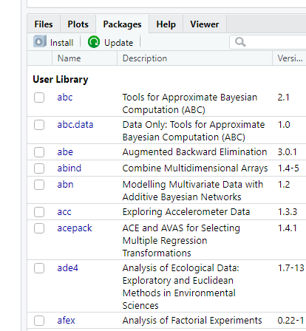

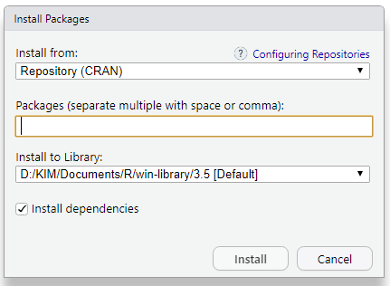

In addition, you can click on **Install from:** dropdown menu and install from downloaded files (.zip, .tar.gz) by selecting **Package Archive File**.

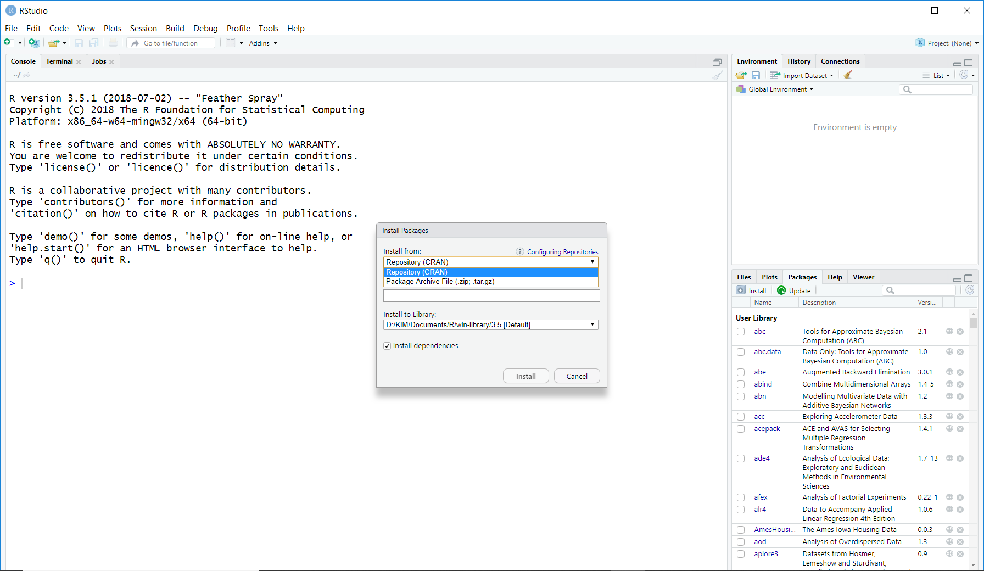

### Loading packages

Basically, to utilize a package, it has to be loaded using library() function,

library("package.name")

For example, we load the newly installed car package

library("car")

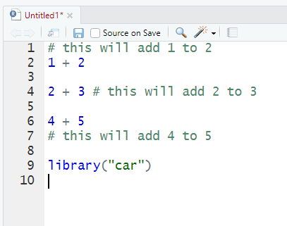

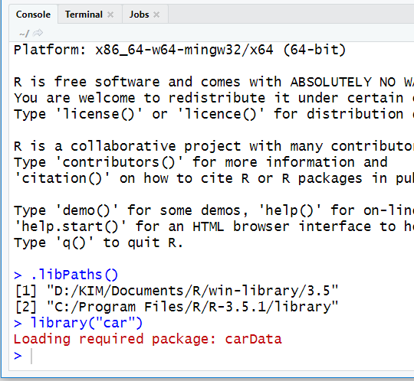

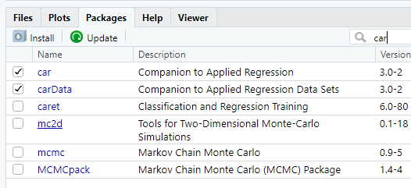

## Working directory

In general, R reads and saves data and other files into a working directory. Therefore, a user must create or specify the working directory to work with R. This is a good practice.

A working directory:

1. stores all the outputs such as the plots, html files, pdf files
2. contains your data

Creating a working directory is a simple BUT an important step.

Unfortunately, many users do not pay attention to this and forget to set it. So, remember, this is a very important step to work in R.

### Creating a new project

To set your working directory, the recommended way is to create a new project

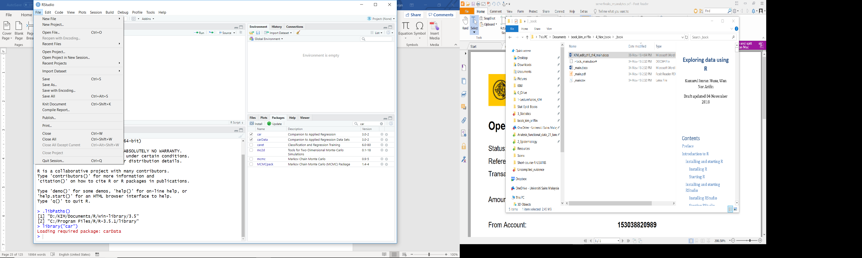

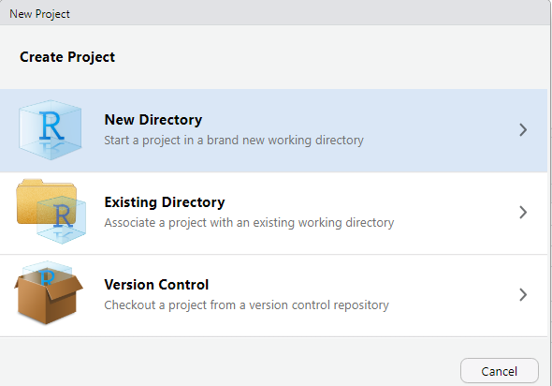

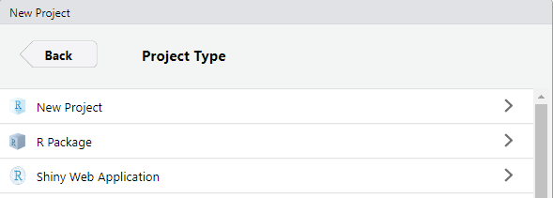

### Setting a working directory

Or follow these steps:

1. Go back to RStudio’s Miscellaneous pane.
2. In the Files tab, click *…*
3. Navigate to the folder containing your data or any folder you want to work in.
4. Click *More*
5. Click *Set as working directory*

or simply use setwd function to do so.

setwd("path to your folder")

for example in Windows

setwd("C:/myfolder")

or in Mac OS/Linux

setwd("~/myfolder")

## Getting help

We can easily access the documentation for any package or function by appending ? before its name, for example, for help on car package,

?car

or for help on mean() function,

?mean

If you are not very sure of the exact name of the function, you may also search the documentation by keywords, for example to search functions that can obtain mean,

??mean

## Upgrading R

You can upgrade R by at least 2 methods.

1. Download and install the latest R on top of the current R. Do not worry, your machine can run multiple R versions.
2. Using packages designed to assist with the upgrade – the recommended method.

For the recommended method, choose the package suitable to your machine OS:

1. For Window OS: we highly recommend that you use the **installr** package. Install the package and load the library to run the upgrading process. You can read more about the **installr** package here <https://github.com/talgalili/installr/>
2. For Mac OS: you can use the **updateR** package. The package is not available from CRAN. You must install it from GitHub using the **devtools** package. More information about the package here <https://github.com/AndreaCirilloAC/updateR>

We also highly recommend you copy and transfer the current library to the current R folder during the upgrade.

## Summary

In this chapter, we installed R and R Studio. We also learned a little bit about functions and objects. We should also be able to install and load packages. Lastly, we set up the working directory.

In the next chapter, we are going to learn about loading datasets into R, managing the loaded data and some basics on direct data entry.

# Data management

In this chapter, we will learn how to deal with data in R. We will learn how to load, view and export data. We will also learn about selecting subsamples from the data and editing the data (creating new variables, recoding). The basics of direct data entry for tables will also be introduced.

## Reading, viewing and exporting data

### The datasets

For the purpose of doing analysis in this chapter and the rest of this book, you can download the datasets from <https://wnarifin.github.io/>.

### Reading dataset

The easiest way to read a dataset into R is from .csv file,

data <- read.csv("cholest.csv")

For SPSS and STATA files, we need foreign package,

library("foreign")  
data <- read.spss("cholest.sav", to.data.frame = TRUE)  
data <- read.dta("cholest.dta", convert.factors = TRUE)

For Excel file, we need readxl package,

library("readxl")  
data <- read_excel("cholest.xlsx", sheet = 1)

### Viewing dataset

This is very easy in R, just type the name,

data

For a nicer view of the dataset, using View()

View(data)

We can also view only the first six observations,

head(data)

## chol age exercise sex categ  
## 1 6.5 38 6 1 0  
## 2 6.6 35 5 1 0  
## 3 6.8 39 6 1 0  
## 4 6.8 36 5 1 0  
## 5 6.9 31 4 1 0  
## 6 7.0 38 4 1 0

and the last six observations.

tail(data)

## chol age exercise sex categ  
## 75 9.4 45 4 0 2  
## 76 9.5 52 4 0 2  
## 77 9.6 35 4 0 2  
## 78 9.8 43 3 0 2  
## 79 9.9 47 3 0 2  
## 80 10.0 44 3 0 2

We can view the dimension of the data (row and column),

dim(data)

## [1] 80 5

Here, we have 80 rows (observations) and 5 columns (variables).

Next, view the names of the five variables,

names(data)

## [1] "chol" "age" "exercise" "sex" "categ"

Using str(), in one go we can view these details of the data,

str(data)

## 'data.frame': 80 obs. of 5 variables:  
## $ chol : num 6.5 6.6 6.8 6.8 6.9 7 7 7.2 7.2 7.2 ...  
## $ age : int 38 35 39 36 31 38 33 36 40 34 ...  
## $ exercise: int 6 5 6 5 4 4 5 5 4 6 ...  
## $ sex : int 1 1 1 1 1 1 1 1 1 1 ...  
## $ categ : int 0 0 0 0 0 0 0 0 0 0 ...

### Exporting dataset from R

You can also export data into various formats using these packages.

For example,

1. to export data into a *comma separated version* (.csv) file, we can use write.csv function.
2. to export data into stata format, we can use write.dta function

write.csv(data, 'data.csv')  
write.dta(data, 'data.dta')

## Built-in datasets in R

R also have a number of built-in datasets (some are also provided by loaded packages). The datasets are often used for teaching purposes in learning new statistical analyses. You can view the available datasets by

data()

## Data sets in package ‘datasets’:  
  
## AirPassengers Monthly Airline Passenger Numbers 1949-1960  
## BJsales Sales Data with Leading Indicator  
## BJsales.lead (BJsales) Sales Data with Leading Indicator  
## BOD Biochemical Oxygen Demand  
## CO2 Carbon Dioxide Uptake in Grass Plants  
## ...

We can view any dataset description by appending “?” to the dataset name. For example,

?chickwts

We will use chickwts, women and infert datasets in the next chapter.

## Data structure

To completely understand the output from str() of data, there are several basics that we must understand; the variable types and the containers.

### Variable types

Again, from

str(data)

## 'data.frame': 80 obs. of 5 variables:  
## $ chol : num 6.5 6.6 6.8 6.8 6.9 7 7 7.2 7.2 7.2 ...  
## $ age : int 38 35 39 36 31 38 33 36 40 34 ...  
## $ exercise: int 6 5 6 5 4 4 5 5 4 6 ...  
## $ sex : int 1 1 1 1 1 1 1 1 1 1 ...  
## $ categ : int 0 0 0 0 0 0 0 0 0 0 ...

you will notice num and Factor. These represent the variable types:

* num = numerical variable.
* Factor = categorical variable.

Each column/variable in R is a vector, which is a collection of values of the same type. You can create the vectors as follows (pay attention to the variable type):

data_num <- c(1,2,3,4,5); str(data_num)

## num [1:5] 1 2 3 4 5

data_cat <- factor( c("M", "F", "M", "F", "M") ); str(data_cat)

## Factor w/ 2 levels "F","M": 2 1 2 1 2

c() function is used to combine several values together as a vector. You may use ; to write two lines of short codes into one line.

There are several more types of vectors, but knowing these two are sufficient for starter. You can view other types from help,

?typeof

### Containers

Based on str(data), we notice that our data is a data frame (data.frame). Basic containers that we usually use are data frame, list and matrix. These can be easily understood by examples below (utilizing our recently created vectors data_num and data_cat).

#### Data frame

Create a data frame object based on vectors data_num and data_cat,

data.frame(data_num, data_cat)

## data_num data_cat  
## 1 1 M  
## 2 2 F  
## 3 3 M  
## 4 4 F  
## 5 5 M

data_frame <- data.frame(data_num, data_cat); str(data_frame)

## 'data.frame': 5 obs. of 2 variables:  
## $ data_num: num 1 2 3 4 5  
## $ data_cat: Factor w/ 2 levels "F","M": 2 1 2 1 2

#### List

Create a list object,

list(data_num, data_cat)

## [[1]]  
## [1] 1 2 3 4 5  
##   
## [[2]]  
## [1] M F M F M  
## Levels: F M

data_list <- list(data_num, data_cat); str(data_list)

## List of 2  
## $ : num [1:5] 1 2 3 4 5  
## $ : Factor w/ 2 levels "F","M": 2 1 2 1 2

#### Matrix

Create a matrix object,

matrix(data = c(data_num, data_cat), nrow = 5, ncol = 2)

## [,1] [,2]  
## [1,] 1 2  
## [2,] 2 1  
## [3,] 3 2  
## [4,] 4 1  
## [5,] 5 2

data_matrix <- matrix(data = c(data_num, data_cat), nrow = 5,   
 ncol = 2)  
data_matrix

## [,1] [,2]  
## [1,] 1 2  
## [2,] 2 1  
## [3,] 3 2  
## [4,] 4 1  
## [5,] 5 2

str(data_matrix) # shown as numerical for both

## num [1:5, 1:2] 1 2 3 4 5 2 1 2 1 2

When vectors are combined in a matrix, the factor will be turned into numeric. Matrix can only contain one type of data only. Contrast this to list.

You may have a look at array ?array and table ?table.

## Subsetting

Subsetting means “selecting parts of data”. It allows selecting only a number of variables (columns) or observations (rows) from a data frame. There are ways to do that. Basically, we can use

* $ sign.
* [ , ] square brackets.
* subset().

Let us use cholest.sav dataset,

library(foreign) # to use `read.spss`  
data <- read.spss("cholest.sav", to.data.frame = TRUE)

str(data)

## 'data.frame': 80 obs. of 5 variables:  
## $ chol : num 6.5 6.6 6.8 6.8 6.9 7 7 7.2 7.2 7.2 ...  
## $ age : num 38 35 39 36 31 38 33 36 40 34 ...  
## $ exercise: num 6 5 6 5 4 4 5 5 4 6 ...  
## $ sex : Factor w/ 2 levels "female","male": 2 2 2 2 2 2 2 2 2 2 ...  
## $ categ : Factor w/ 3 levels "Grp A","Grp B",..: 1 1 1 1 1 1 1 1 1 1 ...  
## - attr(*, "variable.labels")= Named chr "cholesterol in mmol/L" "age in year"  
## "duration of exercise (hours/week)" "" ...  
## ..- attr(*, "names")= chr "chol" "age" "exercise" "sex" ...  
## - attr(*, "codepage")= int 65001

head(data)

## chol age exercise sex categ  
## 1 6.5 38 6 male Grp A  
## 2 6.6 35 5 male Grp A  
## 3 6.8 39 6 male Grp A  
## 4 6.8 36 5 male Grp A  
## 5 6.9 31 4 male Grp A  
## 6 7.0 38 4 male Grp A

tail(data)

## chol age exercise sex categ  
## 75 9.4 45 4 female Grp C  
## 76 9.5 52 4 female Grp C  
## 77 9.6 35 4 female Grp C  
## 78 9.8 43 3 female Grp C  
## 79 9.9 47 3 female Grp C  
## 80 10.0 44 3 female Grp C

### Selecting a column (variable) or a row (observation)

Let say, to select age, which is the second variable, first using $

data$age

## [1] 38 35 39 36 31 38 33 36 40 34 38 40 40 28 37 38 49 29 40 38 34 46 42  
## [24] 38 32 43 42 40 38 39 39 39 35 38 40 38 45 36 31 34 44 35 40 37 33 46  
## [47] 42 40 45 42 45 38 34 44 39 38 39 47 41 44 30 48 47 42 42 49 31 38 38  
## [70] 48 34 45 45 36 45 52 35 43 47 44

and column/variable number,

data[ , 2]

## [1] 38 35 39 36 31 38 33 36 40 34 38 40 40 28 37 38 49 29 40 38 34 46 42  
## [24] 38 32 43 42 40 38 39 39 39 35 38 40 38 45 36 31 34 44 35 40 37 33 46  
## [47] 42 40 45 42 45 38 34 44 39 38 39 47 41 44 30 48 47 42 42 49 31 38 38  
## [70] 48 34 45 45 36 45 52 35 43 47 44

and using the name within [],

data[ , "age"]

## [1] 38 35 39 36 31 38 33 36 40 34 38 40 40 28 37 38 49 29 40 38 34 46 42  
## [24] 38 32 43 42 40 38 39 39 39 35 38 40 38 45 36 31 34 44 35 40 37 33 46  
## [47] 42 40 45 42 45 38 34 44 39 38 39 47 41 44 30 48 47 42 42 49 31 38 38  
## [70] 48 34 45 45 36 45 52 35 43 47 44

Please keep in mind, the name is case sensitive. Thus make sure the spelling and capitalization are correct.

Then, to select the seventh observation,

data[7, ]

## chol age exercise sex categ  
## 7 7 33 5 male Grp A

We can also choose a specific combination of row and column, let say the 73rd and age,

data[73, 2]

## [1] 45

data[73, "age"]

## [1] 45

### Selecting columns and rows

Let us select chol, age and sex. We can use also square brackets

data[ , c("chol", "age", "sex")]

## chol age sex  
## 1 6.5 38 male  
## 2 6.6 35 male  
## 3 6.8 39 male  
## 4 6.8 36 male  
## 5 6.9 31 male  
## 6 7.0 38 male  
## 7 7.0 33 male  
## 8 7.2 36 male  
## 9 7.2 40 male  
## 10 7.2 34 male

## ... some data omitted.

or the column numbers

data[ , c(1:2, 4)]

## chol age sex  
## 1 6.5 38 male  
## 2 6.6 35 male  
## 3 6.8 39 male  
## 4 6.8 36 male  
## 5 6.9 31 male  
## 6 7.0 38 male  
## 7 7.0 33 male  
## 8 7.2 36 male  
## 9 7.2 40 male  
## 10 7.2 34 male

## ... some data omitted.

data[ , c(1, 2, 4)]

## chol age sex  
## 1 6.5 38 male  
## 2 6.6 35 male  
## 3 6.8 39 male  
## 4 6.8 36 male  
## 5 6.9 31 male  
## 6 7.0 38 male  
## 7 7.0 33 male  
## 8 7.2 36 male  
## 9 7.2 40 male  
## 10 7.2 34 male

## ... some data omitted.

selecting column 1 to 2, and column 4. Note the use of c() function here. It is used to combine the numbers. R needs this to let it know we want to view all these columns together. : means to. Here 1:2 means from 1 to 2.

To select seventh to 14th observations,

data[7:14, ]

## chol age exercise sex categ  
## 7 7.0 33 5 male Grp A  
## 8 7.2 36 5 male Grp A  
## 9 7.2 40 4 male Grp A  
## 10 7.2 34 6 male Grp A  
## 11 7.3 38 6 male Grp A  
## 12 7.3 40 5 male Grp A  
## 13 7.3 40 4 male Grp A  
## 14 7.3 28 5 male Grp A

Then, we want to view specific combination of rows and columns. In the example below, it can be done in several ways in R.

data[7:14, c(2, 4)]

## age sex  
## 7 33 male  
## 8 36 male  
## 9 40 male  
## 10 34 male  
## 11 38 male  
## 12 40 male  
## 13 40 male  
## 14 28 male

data[7:14, c("chol", "age")]

## chol age  
## 7 7.0 33  
## 8 7.2 36  
## 9 7.2 40  
## 10 7.2 34  
## 11 7.3 38  
## 12 7.3 40  
## 13 7.3 40  
## 14 7.3 28

data[c(1:2, 7:14), c(2, 4)]

## age sex  
## 1 38 male  
## 2 35 male  
## 7 33 male  
## 8 36 male  
## 9 40 male  
## 10 34 male  
## 11 38 male  
## 12 40 male  
## 13 40 male  
## 14 28 male

data[c(1:2, 7:14), c("chol", "age")]

## chol age  
## 1 6.5 38  
## 2 6.6 35  
## 7 7.0 33  
## 8 7.2 36  
## 9 7.2 40  
## 10 7.2 34  
## 11 7.3 38  
## 12 7.3 40  
## 13 7.3 40  
## 14 7.3 28

Quite interestingly, not only you can select specific rows/columns, you can also exclude them! For example, to select the rest of the variables, except age,

data[ , -2]

## chol exercise sex categ  
## 1 6.5 6 male Grp A  
## 2 6.6 5 male Grp A  
## 3 6.8 6 male Grp A  
## 4 6.8 5 male Grp A  
## 5 6.9 4 male Grp A  
## 6 7.0 4 male Grp A  
## 7 7.0 5 male Grp A  
## 8 7.2 5 male Grp A  
## 9 7.2 4 male Grp A  
## 10 7.2 6 male Grp A

## ... some data omitted.

using – sign before the column number. Please note that this syntax is only possible with column/row numbers, you cannot use it in reference to the names.

You can try the following,

data[-c(1:35, 40:75), ]

## chol age exercise sex categ  
## 36 8.1 38 4 male Grp B  
## 37 8.2 45 6 male Grp B  
## 38 8.2 36 4 male Grp B  
## 39 8.3 31 4 male Grp B  
## 76 9.5 52 4 female Grp C  
## 77 9.6 35 4 female Grp C  
## 78 9.8 43 3 female Grp C  
## 79 9.9 47 3 female Grp C  
## 80 10.0 44 3 female Grp C

data[-c(1:35, 40:75), -c(1:2, 4)]

## exercise categ  
## 36 4 Grp B  
## 37 6 Grp B  
## 38 4 Grp B  
## 39 4 Grp B  
## 76 4 Grp C  
## 77 4 Grp C  
## 78 3 Grp C  
## 79 3 Grp C  
## 80 3 Grp C

to exclude the specific rows and columns. This is a very important and neat syntax whenever we are want to exclude some observations or variables for during the analysis.

### Selecting based on logical expressions

Practically, we want to choose observations based on certain criteria, for example those aged more than 35 year old, only females subjects and so on. This is easy with subset(), for example age > 45,

subset(data, age > 45)

## chol age exercise sex categ  
## 17 7.4 49 5 male Grp A  
## 22 7.6 46 4 male Grp A  
## 46 8.5 46 4 female Grp B  
## 58 8.8 47 3 female Grp B  
## 62 8.9 48 3 female Grp C  
## 63 8.9 47 4 female Grp C  
## 66 9.0 49 3 female Grp C  
## 70 9.3 48 3 female Grp C  
## 76 9.5 52 4 female Grp C  
## 79 9.9 47 3 female Grp C

subset(data, sex == "female")

## chol age exercise sex categ  
## 41 8.3 44 4 female Grp B  
## 42 8.3 35 5 female Grp B  
## 43 8.4 40 4 female Grp B  
## 44 8.4 37 6 female Grp B  
## 45 8.5 33 4 female Grp B  
## 46 8.5 46 4 female Grp B  
## 47 8.5 42 5 female Grp B  
## 48 8.5 40 4 female Grp B  
## 49 8.5 45 4 female Grp B  
## 50 8.5 42 5 female Grp B

## ... some data omitted.

alternatively, we can use square brackets with a number of variants for the same subset,

data[data$age > 45, ]  
data[data[ , "age"] > 45, ]  
data[data[ , 2] > 45, ]

## chol age exercise sex categ  
## 41 8.3 44 4 female Grp B  
## 42 8.3 35 5 female Grp B  
## 43 8.4 40 4 female Grp B  
## 44 8.4 37 6 female Grp B  
## 45 8.5 33 4 female Grp B  
## 46 8.5 46 4 female Grp B  
## 47 8.5 42 5 female Grp B  
## 48 8.5 40 4 female Grp B  
## 49 8.5 45 4 female Grp B  
## 50 8.5 42 5 female Grp B

## ... some data omitted.

but the syntax it quite messy; we have to repeat data twice here, and the sysntax is difficult to grasp. But knowing the syntax is useful, just in case subset doesn’t work.

Logical expressions (or relational operators)are several, which are

* == equal.
* >= more than or equal.
* <= less than or equal.
* > more than.
* < less than.
* != not equal.

You can play around with these expressions by changing > to these expressions in the example above.

subset() has this simple syntax, subset(data, subset/row_expression, select = column). It can be used to select specific variables, for example,

subset(data, select = c("chol", "age", "sex"))  
subset(data, select = c(chol, age, sex))

## chol age sex  
## 1 6.5 38 male  
## 2 6.6 35 male  
## 3 6.8 39 male  
## 4 6.8 36 male  
## 5 6.9 31 male  
## 6 7.0 38 male  
## 7 7.0 33 male  
## 8 7.2 36 male  
## 9 7.2 40 male  
## 10 7.2 34 male

## ... some data omitted.

by omitting the subset = argument. Notice that you don’t even need to quote names using " " in select = argument parameter.

Interestingly, using subset(), you can apply : sign to names,

subset(data, select = chol:sex)

## chol age exercise sex  
## 1 6.5 38 6 male  
## 2 6.6 35 5 male  
## 3 6.8 39 6 male  
## 4 6.8 36 5 male  
## 5 6.9 31 4 male  
## 6 7.0 38 4 male  
## 7 7.0 33 5 male  
## 8 7.2 36 5 male  
## 9 7.2 40 4 male  
## 10 7.2 34 6 male

## ... some data omitted.

Now let us try this, select those aged more or equal to 45, and age, sex variables,

subset(data, age >= 45, select = c(age, sex))

## age sex  
## 17 49 male  
## 22 46 male  
## 37 45 male  
## 46 46 female  
## 49 45 female  
## 51 45 female  
## 58 47 female  
## 62 48 female  
## 63 47 female  
## 66 49 female  
## 70 48 female  
## 72 45 female  
## 73 45 female  
## 75 45 female  
## 76 52 female  
## 79 47 female

Then try with a combination of expressions to select rows, for example those aged less or equal to 35 and/or female, and chol, age and sex variables,

subset(data, age <= 35 & sex == "female", select = c(age, sex))

## age sex  
## 42 35 female  
## 45 33 female  
## 53 34 female  
## 61 30 female  
## 67 31 female  
## 71 34 female  
## 77 35 female

subset(data, age <= 35 | sex == "female", select = c(age, sex))

## age sex  
## 2 35 male  
## 5 31 male  
## 7 33 male  
## 10 34 male  
## 14 28 male  
## 18 29 male  
## 21 34 male  
## 25 32 male  
## 33 35 male  
## 39 31 male  
## 40 34 male  
## 41 44 female  
## 42 35 female  
## 43 40 female  
## 44 37 female  
## 45 33 female  
## 46 46 female  
## 47 42 female  
## 48 40 female  
## 49 45 female  
## 50 42 female  
## 51 45 female  
## 52 38 female  
## 53 34 female  
## 54 44 female  
## 55 39 female  
## 56 38 female  
## 57 39 female  
## 58 47 female  
## 59 41 female  
## 60 44 female  
## 61 30 female  
## 62 48 female  
## 63 47 female  
## 64 42 female  
## 65 42 female  
## 66 49 female  
## 67 31 female  
## 68 38 female  
## 69 38 female  
## 70 48 female  
## 71 34 female  
## 72 45 female  
## 73 45 female  
## 74 36 female  
## 75 45 female  
## 76 52 female  
## 77 35 female  
## 78 43 female  
## 79 47 female  
## 80 44 female

Notice we used logical operators & for AND and | for OR in between the expressions.

Run levels() to remind us the available factor levels for sex,

levels(data$sex)

## [1] "female" "male"

For the sake of completeness, you can try the following codes using [ , ] and $ in place of subset(),

data[data$age <=35 & data$sex == "female", c("age", "sex")]

## age sex  
## 42 35 female  
## 45 33 female  
## 53 34 female  
## 61 30 female  
## 67 31 female  
## 71 34 female  
## 77 35 female

data[data$age <=35 | data$sex == "female", c("age", "sex")]

## age sex  
## 2 35 male  
## 5 31 male  
## 7 33 male  
## 10 34 male  
## 14 28 male  
## 18 29 male  
## 21 34 male  
## 25 32 male  
## 33 35 male  
## 39 31 male  
## 40 34 male  
## 41 44 female  
## 42 35 female  
## 43 40 female  
## 44 37 female  
## 45 33 female  
## 46 46 female  
## 47 42 female  
## 48 40 female  
## 49 45 female  
## 50 42 female  
## 51 45 female  
## 52 38 female  
## 53 34 female  
## 54 44 female  
## 55 39 female  
## 56 38 female  
## 57 39 female  
## 58 47 female  
## 59 41 female  
## 60 44 female  
## 61 30 female  
## 62 48 female  
## 63 47 female  
## 64 42 female  
## 65 42 female  
## 66 49 female  
## 67 31 female  
## 68 38 female  
## 69 38 female  
## 70 48 female  
## 71 34 female  
## 72 45 female  
## 73 45 female  
## 74 36 female  
## 75 45 female  
## 76 52 female  
## 77 35 female  
## 78 43 female  
## 79 47 female  
## 80 44 female

data[data$age <=35 & data$sex == "female", ]$age # view `age` only

## [1] 35 33 34 30 31 34 35

# using [ , ] and $ combination.

Actually, the most important reason why we bother with subsetting is that we can easy assign a subset of the dataset to a new data object. This will make our analysis easier when we deal with large datasets. For example,

data_short <- data[1:20, c("age", "sex")]  
data_short

## age sex  
## 1 38 male  
## 2 35 male  
## 3 39 male  
## 4 36 male  
## 5 31 male  
## 6 38 male  
## 7 33 male  
## 8 36 male  
## 9 40 male  
## 10 34 male  
## 11 38 male  
## 12 40 male  
## 13 40 male  
## 14 28 male  
## 15 37 male  
## 16 38 male  
## 17 49 male  
## 18 29 male  
## 19 40 male  
## 20 38 male

( data_short <- data[1:20, c("age", "sex")] )

## age sex  
## 1 38 male  
## 2 35 male  
## 3 39 male  
## 4 36 male  
## 5 31 male  
## 6 38 male  
## 7 33 male  
## 8 36 male  
## 9 40 male  
## 10 34 male  
## 11 38 male  
## 12 40 male  
## 13 40 male  
## 14 28 male  
## 15 37 male  
## 16 38 male  
## 17 49 male  
## 18 29 male  
## 19 40 male  
## 20 38 male

str(data_short)

## 'data.frame': 20 obs. of 2 variables:  
## $ age: num 38 35 39 36 31 38 33 36 40 34 ...  
## $ sex: Factor w/ 2 levels "female","male": 2 2 2 2 2 2 2 2 2 2 ...

There’s a new trick here. If we want to view the assigned data in one step, include ( ) the assignment codes in between the round brackets.

## Sorting data

At times, we want to view the data in ascending or descending order, especially for numerical variables. Let us start with sort(). sort() is used on a vector, for example here the vector of age,

sort(data$age) # values in ascending order

## [1] 28 29 30 31 31 31 32 33 33 34 34 34 34 34 35 35 35 35 36 36 36 36 37  
## [24] 37 38 38 38 38 38 38 38 38 38 38 38 38 38 39 39 39 39 39 39 40 40 40  
## [47] 40 40 40 40 40 41 42 42 42 42 42 42 43 43 44 44 44 44 45 45 45 45 45  
## [70] 45 46 46 47 47 47 48 48 49 49 52

sort(data$age, decreasing = TRUE) # values in descending order

## [1] 52 49 49 48 48 47 47 47 46 46 45 45 45 45 45 45 44 44 44 44 43 43 42  
## [24] 42 42 42 42 42 41 40 40 40 40 40 40 40 40 39 39 39 39 39 39 38 38 38  
## [47] 38 38 38 38 38 38 38 38 38 38 37 37 36 36 36 36 35 35 35 35 34 34 34  
## [70] 34 34 33 33 32 31 31 31 30 29 28

Next, order() is used on data frame. order() gives the ordering index in ascending order. This can be used to provide the row number whenever we use [ , ] to subset the data. Here we order by age,

order(data$age) # gives the index in ascending order  
data[order(data$age), ] # rows follow the index

## [1] 14 18 61 5 39 67 25 7 45 10 21 40 53 71 2 33 42 77 4 8 38 74 15  
## [24] 44 1 6 11 16 20 24 29 34 36 52 56 68 69 3 30 31 32 55 57 9 12 13  
## [47] 19 28 35 43 48 59 23 27 47 50 64 65 26 78 41 54 60 80 37 49 51 72 73  
## [70] 75 22 46 58 63 79 62 70 17 66 76

## chol age exercise sex categ  
## 14 7.3 28 5 male Grp A  
## 18 7.4 29 5 male Grp A  
## 61 8.8 30 3 female Grp C  
## 5 6.9 31 4 male Grp A  
## 39 8.3 31 4 male Grp B  
## 67 9.1 31 2 female Grp C  
## 25 7.8 32 5 male Grp A  
## 7 7.0 33 5 male Grp A  
## 45 8.5 33 4 female Grp B  
## 10 7.2 34 6 male Grp A

## ... some data omitted.

data[order(data$age, decreasing = TRUE), ] # descending order

## chol age exercise sex categ  
## 76 9.5 52 4 female Grp C  
## 17 7.4 49 5 male Grp A  
## 66 9.0 49 3 female Grp C  
## 62 8.9 48 3 female Grp C  
## 70 9.3 48 3 female Grp C  
## 58 8.8 47 3 female Grp B  
## 63 8.9 47 4 female Grp C  
## 79 9.9 47 3 female Grp C  
## 22 7.6 46 4 male Grp A  
## 46 8.5 46 4 female Grp B

## ... some data omitted.

Now, we want to order by age and exercise. The ordering starts from the last variable in the list (data$age) to the first variable in the list (data$exercise),

order(data$exercise, data$age) # order by age, then exercise  
data[order(data$exercise, data$age), ] # ascending order

## [1] 67 61 53 33 68 69 55 57 19 78 80 72 73 58 79 62 70 66 5 39 45 71 77  
## [24] 38 74 6 16 24 34 36 56 9 13 43 48 59 64 65 26 41 54 60 49 51 75 22  
## [47] 46 63 76 14 18 25 7 21 40 2 42 4 8 15 20 29 52 30 31 32 12 28 35  
## [70] 23 27 47 50 17 10 44 1 11 3 37

## chol age exercise sex categ  
## 67 9.1 31 2 female Grp C  
## 61 8.8 30 3 female Grp C  
## 53 8.6 34 3 female Grp B  
## 33 8.0 35 3 male Grp B  
## 68 9.2 38 3 female Grp C  
## 69 9.2 38 3 female Grp C  
## 55 8.7 39 3 female Grp B  
## 57 8.7 39 3 female Grp B  
## 19 7.5 40 3 male Grp A  
## 78 9.8 43 3 female Grp C

## ... some data omitted.

data[order(data$exercise, data$age, decreasing = TRUE), ] # descending order

## chol age exercise sex categ  
## 37 8.2 45 6 male Grp B  
## 3 6.8 39 6 male Grp A  
## 1 6.5 38 6 male Grp A  
## 11 7.3 38 6 male Grp A  
## 44 8.4 37 6 female Grp B  
## 10 7.2 34 6 male Grp A  
## 17 7.4 49 5 male Grp A  
## 23 7.6 42 5 male Grp A  
## 27 7.8 42 5 male Grp B  
## 47 8.5 42 5 female Grp B

## ... some data omitted.

data[order(data$exercise, data$age, decreasing = c(TRUE, FALSE)), ]  
# age ascending order, exercise descending order

## chol age exercise sex categ  
## 10 7.2 34 6 male Grp A  
## 44 8.4 37 6 female Grp B  
## 1 6.5 38 6 male Grp A  
## 11 7.3 38 6 male Grp A  
## 3 6.8 39 6 male Grp A  
## 37 8.2 45 6 male Grp B  
## 14 7.3 28 5 male Grp A  
## 18 7.4 29 5 male Grp A  
## 25 7.8 32 5 male Grp A  
## 7 7.0 33 5 male Grp A

## ... some data omitted.

Now, we will use arrange() from plyr package. Make sure you installed plyr beforehand. arrange() has a simpler syntax, arrange(dataset, variables), and can be applied easily as shown below,

library(plyr)  
arrange(data, exercise, age) # all ascending

## chol age exercise sex categ  
## 1 9.1 31 2 female Grp C  
## 2 8.8 30 3 female Grp C  
## 3 8.6 34 3 female Grp B  
## 4 8.0 35 3 male Grp B  
## 5 9.2 38 3 female Grp C  
## 6 9.2 38 3 female Grp C  
## 7 8.7 39 3 female Grp B  
## 8 8.7 39 3 female Grp B  
## 9 7.5 40 3 male Grp A  
## 10 9.8 43 3 female Grp C

## ... some data omitted.

arrange(data, desc(exercise), age) # age ascending order,   
# exercise descending order

## chol age exercise sex categ  
## 1 7.2 34 6 male Grp A  
## 2 8.4 37 6 female Grp B  
## 3 6.5 38 6 male Grp A  
## 4 7.3 38 6 male Grp A  
## 5 6.8 39 6 male Grp A  
## 6 8.2 45 6 male Grp B  
## 7 7.3 28 5 male Grp A  
## 8 7.4 29 5 male Grp A  
## 9 7.8 32 5 male Grp A  
## 10 7.0 33 5 male Grp A

## ... some data omitted.

## Editing data

Using the same dataset cholest.sav, we want to add new variables based on the existing variables.

### Creating a new variable

It is easy to create a new variable in R. We only have to decide on a name for the new variable, and the include it with $name to the data frame.

For example, to create age in months age_month, we multiply the existing variable age in years age by 12, then assign the values to `data$age_month as follows,

data$age_month <- data$age * 12  
data$age_month

## [1] 456 420 468 432 372 456 396 432 480 408 456 480 480 336 444 456 588  
## [18] 348 480 456 408 552 504 456 384 516 504 480 456 468 468 468 420 456  
## [35] 480 456 540 432 372 408 528 420 480 444 396 552 504 480 540 504 540  
## [52] 456 408 528 468 456 468 564 492 528 360 576 564 504 504 588 372 456  
## [69] 456 576 408 540 540 432 540 624 420 516 564 528

### Recoding into new variables

#### From a numerical variable

From the numerical age variable, let say we want to break into three groups: less than 40, 40-50 and more than 50.

data$age_cat <- cut(data$age, breaks = c(-Inf, 40, 50, Inf),  
 labels = c("< 40", "40-50", "> 50"))

What is meant by breaks = c(-Inf, 40, 50, Inf) here is “from minus infinity to below 40, between 40 to 50, from above 50 to infinity”.

table(data$age_cat)

##   
## < 40 40-50 > 50   
## 51 28 1

str(data$age_cat)

## Factor w/ 3 levels "< 40","40-50",..: 1 1 1 1 1 1 1 1 1 1 ...

#### From a categorical variable

Using the recently created age_cat variable,

levels(data$age_cat)

## [1] "< 40" "40-50" "> 50"

table(data$age_cat)

##   
## < 40 40-50 > 50   
## 51 28 1

Only one observation is labeled as > 50. We want to combine 40-50 with > 50. Make sure you installed car package to use recode() function in the codes below.

library(car)  
data$age_cat1 <- recode(data$age_cat,   
 "c('40-50','> 50') = '40 & above'")

Pay attention to the use of "" and '' in recode().

levels(data$age_cat1)

## [1] "< 40" "40 & above"

table(data$age_cat1) # combined

##   
## < 40 40 & above   
## 51 29

### Removing variables and observations

You can easily remove variables and observations by using subsetting method above. Here we want to consider another approach to do this in R. For example you only need to remove one variable, let say age_month, you can assign the variable to NULL,

data$age_month <- NULL  
names(data)

## [1] "chol" "age" "exercise" "sex" "categ" "age_cat"   
## [7] "age_cat1"

then let say we want to remove exercise and categ,

data[c("exercise", "categ")] <- NULL  
names(data)

## [1] "chol" "age" "sex" "age_cat" "age_cat1"

We can also easily select which subjects we want to keep or remove in the data object. Let say we want to remove subject number 20, 39 and 71 from our data frame, we assign NA (not available) to the data belonging to these observations,

dim(data)

## [1] 80 5

data[c(20, 39, 71), ] <- NA

then we use na.omit() to remove the observations,

data <- na.omit(data)  
dim(data)

## [1] 77 5

We will learn more about handling missing observations (NA) below.

But this approach of using NA is not as good as subsetting, which is simpler,

dim(data)

## [1] 77 5

data <- data[-c(20, 39, 71), ]  
dim(data)

## [1] 74 5

## Direct data entry

We can enter short data directly using read.table(). This is very useful whenever we want to analyze data from tables, for example those obtained from research articles, and also data provided in textbooks.

For example, you can easily create a standard data frame, consisting of patient’s ID, group and BMI for six patients,

|  |  |  |
| --- | --- | --- |
| ID | Group | BMI |
| 1 | Fat | 30 |
| 2 | Fat | 31 |
| 3 | Fat | 32 |
| 4 | Thin | 20 |
| 5 | Thin | 19 |
| 6 | Thin | 18 |

data_frame <- read.table(header = TRUE, text = "  
ID Group BMI  
1 Fat 30  
2 Fat 31  
3 Fat 32  
4 Thin 20  
5 Thin 19  
6 Thin 18  
")  
str(data_frame)

## 'data.frame': 6 obs. of 3 variables:  
## $ ID : int 1 2 3 4 5 6  
## $ Group: Factor w/ 2 levels "Fat","Thin": 1 1 1 2 2 2  
## $ BMI : int 30 31 32 20 19 18

data_frame

## ID Group BMI  
## 1 1 Fat 30  
## 2 2 Fat 31  
## 3 3 Fat 32  
## 4 4 Thin 20  
## 5 5 Thin 19  
## 6 6 Thin 18

Recall what you learned in **Containers** section, we combined numerical num_data and factor cat_data vectors into a data frame namely data_frame right? As you might have guessed, you can also create the data frame by combining the vectors,

ID <- 1:6  
Group <- c("Fat", "Fat", "Fat", "Thin", "Thin", "Thin")  
BMI <- c(30, 31, 32, 20, 19, 18)  
data_frame <- data.frame(ID, Group, BMI)  
str(data_frame)

## 'data.frame': 6 obs. of 3 variables:  
## $ ID : int 1 2 3 4 5 6  
## $ Group: Factor w/ 2 levels "Fat","Thin": 1 1 1 2 2 2  
## $ BMI : num 30 31 32 20 19 18

data_frame

## ID Group BMI  
## 1 1 Fat 30  
## 2 2 Fat 31  
## 3 3 Fat 32  
## 4 4 Thin 20  
## 5 5 Thin 19  
## 6 6 Thin 18

However, we find this approach less intuitive because we have to enter by variables/vectors. Take note that we used a shortcut here to generate numbers from one to six for ID. So instead of ID <- c(1, 2, 3, 4, 5, 6), we can just write ID <- 1:6.

You can also easily enter tabulated data in R, as shown below,

|  |  |  |
| --- | --- | --- |
|  | Cancer | No Cancer |
| Smoker | 80 | 10 |
| Non-smoker | 5 | 100 |

data_table <- read.table(header = FALSE, text = "  
80 10  
5 100  
 ")  
colnames(data_table) <- c("Cancer", "No Cancer")  
rownames(data_table) <- c("Smoker", "Non-smoker")  
str(data_table) # data_table is a data frame

## 'data.frame': 2 obs. of 2 variables:  
## $ Cancer : int 80 5  
## $ No Cancer: int 10 100

The numbers are separated by space. We set the row and column names by rownames() and colnames() respectively. This will create a data frame.

However, to create a proper table in R, we need a few more steps. We need to convert the data frame to a matrix. Remember, a matrix container will force the data to be of the same type only. Then, we will turn the matrix into a proper table. The steps are shown below,

data_table <- as.matrix(data_table) # convert data_table to matrix  
data_table <- as.table(data_table) # then to table  
str(data_table) # data_table is now a table

## 'table' int [1:2, 1:2] 80 5 10 100  
## - attr(*, "dimnames")=List of 2  
## ..$ : chr [1:2] "Smoker" "Non-smoker"  
## ..$ : chr [1:2] "Cancer" "No Cancer"

data_table

## Cancer No Cancer  
## Smoker 80 10  
## Non-smoker 5 100

## Miscellaneous

Next, we will go through a number of additional important data management skills.

### Sums of the existing variables

Among the most important functions in R are related to obtaining sums. Here, we load mtf.csv dataset (Arifin & Yusoff, 2017). The dataset consists of two multiple true-false questions, with five independent statements each. The correct answers are awarded one (coded as 1) mark each, and incorrect answers are awarded zero (coded as 0) mark each.

mtf <- read.csv("mtf.csv")

The basic sum() works on a vector, e.g. mtf$Q1A,

sum(mtf$Q1A)

## [1] 111

It gives the total number of correct answers for question 1A.

Next, we obtain the total number of correct answers for all respondents, i.e. by rows. Hence we use rowSums(),

rowSums(mtf)

## [1] 3 5 5 7 8 8 6 7 7 8 8 8 8 8 5 10 5 4 4 7 9 1 9  
## [24] 7 5 4 7 3 7 0 6 5 6 7 7 8 10 7 8 6 6 8 9 10 3 6  
## [47] 6 9 6 6 5 7 8 6 10 4 8 9 8 9 9 5 10 5 5 9 5 6 7  
## [70] 5 6 6 9 3 7 10 5 6 7 7 7 8 6 9 7 6 6 9 6 7 7 10  
## [93] 0 5 10 9 6 6 3 7 10 3 6 9 6 6 7 8 8 6 6 6 8 7 9  
## [116] 7 4 8 8 9 8 8 5 8 6 10 7 6 5 3 6 7 7 6 9 6 8 7  
## [139] 7 7 6 5 5 8 10 8 8 6 5 6 8 7 6 10 6 7 6 6 4 2

While sum() gives use the total per vector, we can easily obtain for all questions (columns) by colSums(),

colSums(mtf)

## Q1A Q1B Q1C Q1D Q1E Q2A Q2B Q2C Q2D Q2E   
## 111 119 100 95 134 120 117 105 84 83

We can also easily create new variables total_mark and percent as follows,

mtf$total_mark <- rowSums(mtf[ , 1:10])  
mtf$percent <- (mtf$total_mark/10)*100  
head(mtf)

## Q1A Q1B Q1C Q1D Q1E Q2A Q2B Q2C Q2D Q2E total_mark percent  
## 1 1 0 0 0 0 0 1 1 0 0 3 30  
## 2 1 0 0 0 1 0 0 1 1 1 5 50  
## 3 0 1 0 0 1 1 0 1 1 0 5 50  
## 4 1 1 0 1 1 0 1 0 1 1 7 70  
## 5 1 1 1 0 1 1 1 1 1 0 8 80  
## 6 0 1 1 1 1 0 1 1 1 1 8 80

### Handling missing observations (NA/not available)

We start by generating a data frame with NA and " " (empty entry),

data_na <- read.table(header = T, sep = ",", text = "  
ID, age, gender  
8110, 20, M  
8110, 20, M  
1627, 30,   
1234, 23, F  
4567, , F  
4567, 12, F  
") # we use comma separated values in this example  
str(data_na); data_na

## 'data.frame': 6 obs. of 3 variables:  
## $ ID : int 8110 8110 1627 1234 4567 4567  
## $ age : int 20 20 30 23 NA 12  
## $ gender: Factor w/ 3 levels " "," F"," M": 3 3 1 2 2 2

## ID age gender  
## 1 8110 20 M  
## 2 8110 20 M  
## 3 1627 30   
## 4 1234 23 F  
## 5 4567 NA F  
## 6 4567 12 F

There will be a NA in age and " " category in gender,

summary(data_na) # NA in age, " " category in gender

## ID age gender  
## Min. :1234 Min. :12 :1   
## 1st Qu.:2362 1st Qu.:20 F:3   
## Median :4567 Median :20 M:2   
## Mean :4702 Mean :21   
## 3rd Qu.:7224 3rd Qu.:23   
## Max. :8110 Max. :30   
## NA's :1

We now verify whether there is NA in the data frame,

anyNA(data_na)

## [1] TRUE

TRUE, yes there is a NA, it is located in,

is.na(data_na)

## ID age gender  
## [1,] FALSE FALSE FALSE  
## [2,] FALSE FALSE FALSE  
## [3,] FALSE FALSE FALSE  
## [4,] FALSE FALSE FALSE  
## [5,] FALSE TRUE FALSE  
## [6,] FALSE FALSE FALSE

and you notice here " " is treated as a category, not NA for categorical variable gender.

First we omit the observation containing NA,

dim(data_na) # 6 observations

## [1] 6 3

data_na_clean <- na.omit(data_na)  
dim(data_na) # 5 observations

## [1] 6 3

summary(data_na_clean)

## ID age gender  
## Min. :1234 Min. :12 :1   
## 1st Qu.:1627 1st Qu.:20 F:2   
## Median :4567 Median :20 M:2   
## Mean :4730 Mean :21   
## 3rd Qu.:8110 3rd Qu.:23   
## Max. :8110 Max. :30

Now we handle " " by excluding the observation containing empty gender information,

data_na_cleaner <- data_na_clean[data_na_clean$gender != " ", ]  
data_na_cleaner

## ID age gender  
## 1 8110 20 M  
## 2 8110 20 M  
## 4 1234 23 F  
## 6 4567 12 F

### Handling duplicates

Let say we have this [data:](data:\index%7bdata!duplicated%7d)

duplicate <- read.table(header = T, text = "  
ID age gender  
8110 20 M  
8110 20 M  
1627 30 M  
1234 23 F  
4567 12 F  
4567 12 F  
")  
str(duplicate); duplicate

## 'data.frame': 6 obs. of 3 variables:  
## $ ID : int 8110 8110 1627 1234 4567 4567  
## $ age : int 20 20 30 23 12 12  
## $ gender: Factor w/ 2 levels "F","M": 2 2 2 1 1 1

## ID age gender  
## 1 8110 20 M  
## 2 8110 20 M  
## 3 1627 30 M  
## 4 1234 23 F  
## 5 4567 12 F  
## 6 4567 12 F

We use and anyDuplicated() and duplicated(), functions in base R,

anyDuplicated(duplicate) # 2 duplicates

## [1] 2

and we found two duplicates.

We check for duplicated ID,

dupli <- duplicate[duplicated(duplicate), "ID"]  
dupli

## [1] 8110 4567

view the duplicated entries,

duplicate[duplicate$ID == dupli, ]

## ID age gender  
## 1 8110 20 M  
## 6 4567 12 F

and view entries minus the duplicated ones by,

duplicate[duplicate$ID != dupli, ]

## ID age gender  
## 2 8110 20 M  
## 3 1627 30 M  
## 4 1234 23 F  
## 5 4567 12 F

or this way,

duplicate[!duplicated(duplicate), ]

## ID age gender  
## 1 8110 20 M  
## 3 1627 30 M  
## 4 1234 23 F  
## 5 4567 12 F

Then you can easily keep data frame with the unduplicated entries,

noduplicate <- duplicate[data$ID != dupli, ]

## Summary

In this chapter, we learned how to handle data in R, which is very flexible. We learned how load, view and export data. We also learned how select subsamples from the data, and how to edit the data (creating new variables, recoding). Then we learned some basics on direct data entry for tables.

In the next chapter, we are going to learn about how to explore the variables by means of basic descriptive statistics.

# Descriptive statistics

In this chapter, we will learn how to obtain a number of important descriptive statistics. The statistics will be obtained based on the variable types and groups. We will also learn how to perform cross-tabulation. In addition, we will learn how to combine outputs into custom made tables and texts.

## One variable

We will start by using chickwts dataset that contains both numerical (weight) and categorical (feed) variables. We view the first six observations,

head(chickwts)

## weight feed  
## 1 179 horsebean  
## 2 160 horsebean  
## 3 136 horsebean  
## 4 227 horsebean  
## 5 217 horsebean  
## 6 168 horsebean

the last six observations.

tail(chickwts)

## weight feed  
## 66 352 casein  
## 67 359 casein  
## 68 216 casein  
## 69 222 casein  
## 70 283 casein  
## 71 332 casein

Next, view the details of the data,

str(chickwts)

## 'data.frame': 71 obs. of 2 variables:  
## $ weight: num 179 160 136 227 217 168 108 124 143 140 ...  
## $ feed : Factor w/ 6 levels "casein","horsebean",..: 2 2 2 2 2 2 2 2 2 2 ...

Here we have 71 rows (71 subjects) and two columns (two variables). weight is a numerical variable and feed is a factor, i.e. a categorical variable. feed consists of six categories or levels.

We can view the levels in feed,

levels(chickwts$feed)

## [1] "casein" "horsebean" "linseed" "meatmeal" "soybean" "sunflower"

### A numerical variable

A numberical variable is commonly described by several descriptive statistics below.

To judge the central tendency of the weight variable, we obtain its mean,

mean(chickwts$weight)

## [1] 261.3099

and median,

median(chickwts$weight)

## [1] 258

To judge its spread and variability, we can view its minimum, maximum and range

min(chickwts$weight)

## [1] 108

max(chickwts$weight)

## [1] 423

range(chickwts$weight)

## [1] 108 423

and obtain its standard deviation (SD)

sd(chickwts$weight)

## [1] 78.0737

variance,

var(chickwts$weight)

## [1] 6095.503

quantile,

quantile(chickwts$weight)

## 0% 25% 50% 75% 100%   
## 108.0 204.5 258.0 323.5 423.0

and interquartile range (IQR)

IQR(chickwts$weight)

## [1] 119

There are nine types of quantile algorithms in R (for quantile() and IQR), the default being type 7. You may change this to type 6 (Minitab and SPSS),

quantile(chickwts$weight, type = 6)

## 0% 25% 50% 75% 100%   
## 108 203 258 325 423

IQR(chickwts$weight, type = 6)

## [1] 122

In addition to SD and IQR, we can obtain its median absolute deviation (MAD) ,

mad(chickwts$weight)

## [1] 91.9212

It is actually simpler to obtain most these in a single command,

summary(chickwts$weight)

## Min. 1st Qu. Median Mean 3rd Qu. Max.   
## 108.0 204.5 258.0 261.3 323.5 423.0

even simpler, obtain all of the statistics using describe() in the psych package

install.packages("psych")

library(psych)  
describe(chickwts$weight)

## vars n mean sd median trimmed mad min max range skew kurtosis  
## X1 1 71 261.31 78.07 258 261 91.92 108 423 315 -0.01 -0.97  
## se  
## X1 9.27

### A categorical variable

A categorical variable is described by its count, proportion and percentage by categories.

We obtain the count of the feed variable,

summary(chickwts$feed)

## casein horsebean linseed meatmeal soybean sunflower   
## 12 10 12 11 14 12

table(chickwts$feed)

##   
## casein horsebean linseed meatmeal soybean sunflower   
## 12 10 12 11 14 12

both summary() and table() give the same result.

prop.table gives the proportion of the result from the count.

prop.table(table(chickwts$feed))

##   
## casein horsebean linseed meatmeal soybean sunflower   
## 0.1690141 0.1408451 0.1690141 0.1549296 0.1971831 0.1690141

the result can be easily turned into percentage,

prop.table(table(chickwts$feed))*100

##   
## casein horsebean linseed meatmeal soybean sunflower   
## 16.90141 14.08451 16.90141 15.49296 19.71831 16.90141

To view the count and the percentage together, we can use cbind(),

cbind(n = table(chickwts$feed),   
 "%" = prop.table(table(chickwts$feed))*100)

## n %  
## casein 12 16.90141  
## horsebean 10 14.08451  
## linseed 12 16.90141  
## meatmeal 11 15.49296  
## soybean 14 19.71831  
## sunflower 12 16.90141

We need the quotation marks " " around the percentage sign %, because % also serves as a mathematical operator in R.

## Two variables and more

Just now, we viewed all the statistics as applied to a variable. In this part, we are going to view the statistics on a number of variables. This includes viewing a group of numerical variables or categorical variables, or a mixture of numerical and categorical variables. This is relevant in a sense that, most of the time, we want to view everything in one go (e.g. the statistics of all items in a questionnaire), compare the means of several groups and obtain cross-tabulation of categorical variables.

### Numerical variables

Let us use women dataset and explore the dataset,

head(women)

## height weight  
## 1 58 115  
## 2 59 117  
## 3 60 120  
## 4 61 123  
## 5 62 126  
## 6 63 129

tail(women)

## height weight  
## 10 67 142  
## 11 68 146  
## 12 69 150  
## 13 70 154  
## 14 71 159  
## 15 72 164

str(women)

## 'data.frame': 15 obs. of 2 variables:  
## $ height: num 58 59 60 61 62 63 64 65 66 67 ...  
## $ weight: num 115 117 120 123 126 129 132 135 139 142 ...

which consists of weight and height numerical variables.

The variables can be easily viewed together by summary(),

summary(women)

## height weight   
## Min. :58.0 Min. :115.0   
## 1st Qu.:61.5 1st Qu.:124.5   
## Median :65.0 Median :135.0   
## Mean :65.0 Mean :136.7   
## 3rd Qu.:68.5 3rd Qu.:148.0   
## Max. :72.0 Max. :164.0

even better using describe() from psych package,

library(psych)  
describe(women)

## vars n mean sd median trimmed mad min max range skew  
## height 1 15 65.00 4.47 65 65.00 5.93 58 72 14 0.00  
## weight 2 15 136.73 15.50 135 136.31 17.79 115 164 49 0.23  
## kurtosis se  
## height -1.44 1.15  
## weight -1.34 4.00

### Categorical variables

Let us use infert dataset,

head(infert)

## education age parity induced case spontaneous stratum pooled.stratum  
## 1 0-5yrs 26 6 1 1 2 1 3  
## 2 0-5yrs 42 1 1 1 0 2 1  
## 3 0-5yrs 39 6 2 1 0 3 4  
## 4 0-5yrs 34 4 2 1 0 4 2  
## 5 6-11yrs 35 3 1 1 1 5 32  
## 6 6-11yrs 36 4 2 1 1 6 36

str(infert)

## 'data.frame': 248 obs. of 8 variables:  
## $ education : Factor w/ 3 levels "0-5yrs","6-11yrs",..: 1 1 1 1 2 2 2 2 2 2 ...  
## $ age : num 26 42 39 34 35 36 23 32 21 28 ...  
## $ parity : num 6 1 6 4 3 4 1 2 1 2 ...  
## $ induced : num 1 1 2 2 1 2 0 0 0 0 ...  
## $ case : num 1 1 1 1 1 1 1 1 1 1 ...  
## $ spontaneous : num 2 0 0 0 1 1 0 0 1 0 ...  
## $ stratum : int 1 2 3 4 5 6 7 8 9 10 ...  
## $ pooled.stratum: num 3 1 4 2 32 36 6 22 5 19 ...

We notice that induced, case and spontaneous are not yet set as categorical variables, thus we need to factor() the variables. We view the value labels in the dataset description,

?infert

We label the values in the variables according to the description as

infert$induced <- factor(infert$induced, levels = 0:2,   
 labels = c("0", "1", "2 or more"))  
infert$case <- factor(infert$case, levels = 0:1,   
 labels = c("control", "case"))  
infert$spontaneous <- factor(infert$spontaneous,   
 levels = 0:2,   
 labels = c("0", "1", "2 or more"))  
str(infert)

## 'data.frame': 248 obs. of 8 variables:  
## $ education : Factor w/ 3 levels "0-5yrs","6-11yrs",..: 1 1 1 1 2 2 2 2 2 2 ...  
## $ age : num 26 42 39 34 35 36 23 32 21 28 ...  
## $ parity : num 6 1 6 4 3 4 1 2 1 2 ...  
## $ induced : Factor w/ 3 levels "0","1","2 or more": 2 2 3 3 2 3 1 1 1 1 ...  
## $ case : Factor w/ 2 levels "control","case": 2 2 2 2 2 2 2 2 2 2 ...  
## $ spontaneous : Factor w/ 3 levels "0","1","2 or more": 3 1 1 1 2 2 1 1 2 1 ...  
## $ stratum : int 1 2 3 4 5 6 7 8 9 10 ...  
## $ pooled.stratum: num 3 1 4 2 32 36 6 22 5 19 ...

and we now all these variables are turned into factors.

Again, the variables can be easily viewed together by summary(),

summary(infert[c("education", "induced", "case", "spontaneous")])

## education induced case spontaneous   
## 0-5yrs : 12 0 :143 control:165 0 :141   
## 6-11yrs:120 1 : 68 case : 83 1 : 71   
## 12+ yrs:116 2 or more: 37 2 or more: 36

We do not use table() here in form of table(infert[c("education", "induced", "case", "spontaneous")]) because table() used in this form will give us 3-way cross-tabulation instead of count per categories. Cross-tabulation of categorical variables will be covered later.

To obtain the proportion and percentage results, we have to use lapply(),

lapply(infert[c("education", "induced", "case", "spontaneous")],   
 function(x) summary(x)/length(x))

## $education  
## 0-5yrs 6-11yrs 12+ yrs   
## 0.0483871 0.4838710 0.4677419   
##   
## $induced  
## 0 1 2 or more   
## 0.5766129 0.2741935 0.1491935   
##   
## $case  
## control case   
## 0.6653226 0.3346774   
##   
## $spontaneous  
## 0 1 2 or more   
## 0.5685484 0.2862903 0.1451613

lapply(infert[c("education", "induced", "case", "spontaneous")],   
 function(x) summary(x)/length(x)*100)

## $education  
## 0-5yrs 6-11yrs 12+ yrs   
## 4.83871 48.38710 46.77419   
##   
## $induced  
## 0 1 2 or more   
## 57.66129 27.41935 14.91935   
##   
## $case  
## control case   
## 66.53226 33.46774   
##   
## $spontaneous  
## 0 1 2 or more   
## 56.85484 28.62903 14.51613

because we need lappy() to obtain the values for each of the variables. lapply() goes through each variable and performs this particular part,

function(x) summary(x)/length(x)

function(x) is needed to specify some extra operations to any basic function in R, in our case summary(x) divided by length(x), in which the summary results (the counts) are divided by the number of subjects (length(x) gives us the “length” of the variable).

Now, since we already learned about lapply(), we may also obtain the same results by using summary() (within lapply()), table() and prop.table().

lapply(infert[c("education", "induced", "case", "spontaneous")],   
 summary)

## $education  
## 0-5yrs 6-11yrs 12+ yrs   
## 12 120 116   
##   
## $induced  
## 0 1 2 or more   
## 143 68 37   
##   
## $case  
## control case   
## 165 83   
##   
## $spontaneous  
## 0 1 2 or more   
## 141 71 36

lapply(infert[c("education", "induced", "case", "spontaneous")],   
 table)

## $education  
##   
## 0-5yrs 6-11yrs 12+ yrs   
## 12 120 116   
##   
## $induced  
##   
## 0 1 2 or more   
## 143 68 37   
##   
## $case  
##   
## control case   
## 165 83   
##   
## $spontaneous  
##   
## 0 1 2 or more   
## 141 71 36

lapply(infert[c("education", "induced", "case", "spontaneous")],   
 function(x) prop.table(table(x)))

## $education  
## x  
## 0-5yrs 6-11yrs 12+ yrs   
## 0.0483871 0.4838710 0.4677419   
##   
## $induced  
## x  
## 0 1 2 or more   
## 0.5766129 0.2741935 0.1491935   
##   
## $case  
## x  
## control case   
## 0.6653226 0.3346774   
##   
## $spontaneous  
## x  
## 0 1 2 or more   
## 0.5685484 0.2862903 0.1451613

lapply(infert[c("education", "induced", "case", "spontaneous")],   
 function(x) prop.table(table(x))*100)

## $education  
## x  
## 0-5yrs 6-11yrs 12+ yrs   
## 4.83871 48.38710 46.77419   
##   
## $induced  
## x  
## 0 1 2 or more   
## 57.66129 27.41935 14.91935   
##   
## $case  
## x  
## control case   
## 66.53226 33.46774   
##   
## $spontaneous  
## x  
## 0 1 2 or more   
## 56.85484 28.62903 14.51613

Notice here, whenever we do not need to specify extra operations on a basic function, e.g. summary() and table(), all we need to write after the comma in lapply() is the basic function without function(x) and (x).

## Groups and cross-tabulations

We intentionally went through the descriptive statistics of a variable, followed by a number of variables of the same type. This will give you the basics in dealing with the variables. Most commonly, the variables are described by groups or in form cross-tabulated counts/percentages.

### By groups

To obtain all the descriptive statistics by group, we can use by() with the relevant functions. Let say we want to obtain the statistics by case and control (case). We start with numerical variables

by(infert[c("age", "parity")], infert$case, summary)

## infert$case: control  
## age parity   
## Min. :21.00 Min. :1.000   
## 1st Qu.:28.00 1st Qu.:1.000   
## Median :31.00 Median :2.000   
## Mean :31.49 Mean :2.085   
## 3rd Qu.:35.00 3rd Qu.:3.000   
## Max. :44.00 Max. :6.000   
## --------------------------------------------------------   
## infert$case: case  
## age parity   
## Min. :21.00 Min. :1.000   
## 1st Qu.:28.00 1st Qu.:1.000   
## Median :31.00 Median :2.000   
## Mean :31.53 Mean :2.108   
## 3rd Qu.:35.50 3rd Qu.:3.000   
## Max. :44.00 Max. :6.000

by(infert[c("age", "parity")], infert$case, describe)

## infert$case: control  
## vars n mean sd median trimmed mad min max range skew kurtosis  
## age 1 165 31.49 5.25 31 31.34 5.93 21 44 23 0.23 -0.72  
## parity 2 165 2.08 1.24 2 1.88 1.48 1 6 5 1.32 1.42  
## se  
## age 0.41  
## parity 0.10  
## --------------------------------------------------------   
## infert$case: case  
## vars n mean sd median trimmed mad min max range skew kurtosis  
## age 1 83 31.53 5.28 31 31.39 5.93 21 44 23 0.21 -0.77  
## parity 2 83 2.11 1.28 2 1.90 1.48 1 6 5 1.32 1.34  
## se  
## age 0.58  
## parity 0.14

We can also use describeBy(), which is an the extension of describe() in the psych package.

describeBy(infert[c("age", "parity")], group = infert$case)

##   
## Descriptive statistics by group   
## group: control  
## vars n mean sd median trimmed mad min max range skew kurtosis  
## age 1 165 31.49 5.25 31 31.34 5.93 21 44 23 0.23 -0.72  
## parity 2 165 2.08 1.24 2 1.88 1.48 1 6 5 1.32 1.42  
## se  
## age 0.41  
## parity 0.10  
## --------------------------------------------------------   
## group: case  
## vars n mean sd median trimmed mad min max range skew kurtosis  
## age 1 83 31.53 5.28 31 31.39 5.93 21 44 23 0.21 -0.77  
## parity 2 83 2.11 1.28 2 1.90 1.48 1 6 5 1.32 1.34  
## se  
## age 0.58  
## parity 0.14

which gives us an identical result.

If you want to obtain results using the basic functions (i.e. mean(), median(), quantile(), IQR() and mad()), you need to use lappy() within by(), because they could not handle many variables, for example for mean() and IQR(),

by(infert[c("age", "parity")], infert$case,   
 function(x) lapply(x, mean))

## infert$case: control  
## $age  
## [1] 31.49091  
##   
## $parity  
## [1] 2.084848  
##   
## --------------------------------------------------------   
## infert$case: case  
## $age  
## [1] 31.53012  
##   
## $parity  
## [1] 2.108434

by(infert[c("age", "parity")], infert$case,   
 function(x) lapply(x, IQR))

## infert$case: control  
## $age  
## [1] 7  
##   
## $parity  
## [1] 2  
##   
## --------------------------------------------------------   
## infert$case: case  
## $age  
## [1] 7.5  
##   
## $parity  
## [1] 2

For categorical variables, using summary()

by(infert[c("education", "induced", "spontaneous")], infert$case,   
 summary)

## infert$case: control  
## education induced spontaneous   
## 0-5yrs : 8 0 :96 0 :113   
## 6-11yrs:80 1 :45 1 : 40   
## 12+ yrs:77 2 or more:24 2 or more: 12   
## --------------------------------------------------------   
## infert$case: case  
## education induced spontaneous  
## 0-5yrs : 4 0 :47 0 :28   
## 6-11yrs:40 1 :23 1 :31   
## 12+ yrs:39 2 or more:13 2 or more:24

by(infert[c("education", "induced", "spontaneous")], infert$case,   
 function(x) lapply(x, function(x) summary(x)/length(x)))

## infert$case: control  
## $education  
## 0-5yrs 6-11yrs 12+ yrs   
## 0.04848485 0.48484848 0.46666667   
##   
## $induced  
## 0 1 2 or more   
## 0.5818182 0.2727273 0.1454545   
##   
## $spontaneous  
## 0 1 2 or more   
## 0.68484848 0.24242424 0.07272727   
##   
## --------------------------------------------------------   
## infert$case: case  
## $education  
## 0-5yrs 6-11yrs 12+ yrs   
## 0.04819277 0.48192771 0.46987952   
##   
## $induced  
## 0 1 2 or more   
## 0.5662651 0.2771084 0.1566265   
##   
## $spontaneous  
## 0 1 2 or more   
## 0.3373494 0.3734940 0.2891566

by(infert[c("education", "induced", "spontaneous")], infert$case,   
 function(x) lapply(x, function(x) summary(x)/length(x)*100))

## infert$case: control  
## $education  
## 0-5yrs 6-11yrs 12+ yrs   
## 4.848485 48.484848 46.666667   
##   
## $induced  
## 0 1 2 or more   
## 58.18182 27.27273 14.54545   
##   
## $spontaneous  
## 0 1 2 or more   
## 68.484848 24.242424 7.272727   
##   
## --------------------------------------------------------   
## infert$case: case  
## $education  
## 0-5yrs 6-11yrs 12+ yrs   
## 4.819277 48.192771 46.987952   
##   
## $induced  
## 0 1 2 or more   
## 56.62651 27.71084 15.66265   
##   
## $spontaneous  
## 0 1 2 or more   
## 33.73494 37.34940 28.91566

or by using table()

by(infert[c("education", "induced", "spontaneous")], infert$case,   
 function(x) lapply(x, table))

## infert$case: control  
## $education  
##   
## 0-5yrs 6-11yrs 12+ yrs   
## 8 80 77   
##   
## $induced  
##   
## 0 1 2 or more   
## 96 45 24   
##   
## $spontaneous  
##   
## 0 1 2 or more   
## 113 40 12   
##   
## --------------------------------------------------------   
## infert$case: case  
## $education  
##   
## 0-5yrs 6-11yrs 12+ yrs   
## 4 40 39   
##   
## $induced  
##   
## 0 1 2 or more   
## 47 23 13   
##   
## $spontaneous  
##   
## 0 1 2 or more   
## 28 31 24

by(infert[c("education", "induced", "spontaneous")], infert$case,   
 function(x) lapply(x, function(x) prop.table(table(x))))

## infert$case: control  
## $education  
## x  
## 0-5yrs 6-11yrs 12+ yrs   
## 0.04848485 0.48484848 0.46666667   
##   
## $induced  
## x  
## 0 1 2 or more   
## 0.5818182 0.2727273 0.1454545   
##   
## $spontaneous  
## x  
## 0 1 2 or more   
## 0.68484848 0.24242424 0.07272727   
##   
## --------------------------------------------------------   
## infert$case: case  
## $education  
## x  
## 0-5yrs 6-11yrs 12+ yrs   
## 0.04819277 0.48192771 0.46987952   
##   
## $induced  
## x  
## 0 1 2 or more   
## 0.5662651 0.2771084 0.1566265   
##   
## $spontaneous  
## x  
## 0 1 2 or more   
## 0.3373494 0.3734940 0.2891566

by(infert[c("education", "induced", "spontaneous")], infert$case,   
 function(x) lapply(x, function(x) prop.table(table(x))*100))

## infert$case: control  
## $education  
## x  
## 0-5yrs 6-11yrs 12+ yrs   
## 4.848485 48.484848 46.666667   
##   
## $induced  
## x  
## 0 1 2 or more   
## 58.18182 27.27273 14.54545   
##   
## $spontaneous  
## x  
## 0 1 2 or more   
## 68.484848 24.242424 7.272727   
##   
## --------------------------------------------------------   
## infert$case: case  
## $education  
## x  
## 0-5yrs 6-11yrs 12+ yrs   
## 4.819277 48.192771 46.987952   
##   
## $induced  
## x  
## 0 1 2 or more   
## 56.62651 27.71084 15.66265   
##   
## $spontaneous  
## x  
## 0 1 2 or more   
## 33.73494 37.34940 28.91566

Please note that simply replacing table() for summary() as in by(infert[c("education", "induced", "spontaneous")], infert$case, table) will not work as intended. education will be nested in induced, which is nested in spontaneous, listed by case instead. And yes, to obtain the proportions and percentages, it gets slightly more complicated as we have to specify function() twice in by().

### Cross-tabulation

As long as the categorical variables are already factored properly, there should not be a problem to obtain the cross-tabulation tables. For example between education and case,

table(infert$education, infert$case)

##   
## control case  
## 0-5yrs 8 4  
## 6-11yrs 80 40  
## 12+ yrs 77 39

We may also include row and column headers, just like cbind(),

table(education = infert$education, case = infert$case)

## case  
## education control case  
## 0-5yrs 8 4  
## 6-11yrs 80 40  
## 12+ yrs 77 39

Since we are familiar with the powerful lappy(), we can use it to get cross-tabulation of all of the factors with case status,

lapply(infert[c("education", "induced", "spontaneous")],   
 function(x) table(x, infert$case))

## $education  
##   
## x control case  
## 0-5yrs 8 4  
## 6-11yrs 80 40  
## 12+ yrs 77 39  
##   
## $induced  
##   
## x control case  
## 0 96 47  
## 1 45 23  
## 2 or more 24 13  
##   
## $spontaneous  
##   
## x control case  
## 0 113 28  
## 1 40 31  
## 2 or more 12 24

We may also view subgroup counts (nesting). Here, the cross-tabulation of education and case is nested within induced

table(infert$education, infert$case, infert$induced)

## , , = 0  
##   
##   
## control case  
## 0-5yrs 4 0  
## 6-11yrs 57 21  
## 12+ yrs 35 26  
##   
## , , = 1  
##   
##   
## control case  
## 0-5yrs 0 2  
## 6-11yrs 16 11  
## 12+ yrs 29 10  
##   
## , , = 2 or more  
##   
##   
## control case  
## 0-5yrs 4 2  
## 6-11yrs 7 8  
## 12+ yrs 13 3

which will look nicer if we apply by()

by(infert[c("education", "case")], infert$induced, table)

## infert$induced: 0  
## case  
## education control case  
## 0-5yrs 4 0  
## 6-11yrs 57 21  
## 12+ yrs 35 26  
## --------------------------------------------------------   
## infert$induced: 1  
## case  
## education control case  
## 0-5yrs 0 2  
## 6-11yrs 16 11  
## 12+ yrs 29 10  
## --------------------------------------------------------   
## infert$induced: 2 or more  
## case  
## education control case  
## 0-5yrs 4 2  
## 6-11yrs 7 8  
## 12+ yrs 13 3

## Customizing text outputs

Text outputs will look nicer by combining every bits and parts of the outputs into custom-made texts and tables. There are a number of ways to achieve this. We will do this by utilizing basic functions.

We again use cholest.sav from previous chapter. Load the dataset as cholest,

library(foreign)  
cholest <- read.spss("cholest.sav", to.data.frame = TRUE)

str(data)

## 'data.frame': 80 obs. of 5 variables:  
## $ chol : num 6.5 6.6 6.8 6.8 6.9 7 7 7.2 7.2 7.2 ...  
## $ age : num 38 35 39 36 31 38 33 36 40 34 ...  
## $ exercise: num 6 5 6 5 4 4 5 5 4 6 ...  
## $ sex : Factor w/ 2 levels "female","male": 2 2 2 2 2 2 2 2 2 2 ...  
## $ categ : Factor w/ 3 levels "Grp A","Grp B",..: 1 1 1 1 1 1 1 1 1 1 ...  
## - attr(*, "variable.labels")= Named chr "cholesterol in mmol/L" "age in year"  
## "duration of exercise (hours/week)" "" ...  
## ..- attr(*, "names")= chr "chol" "age" "exercise" "sex" ...  
## - attr(*, "codepage")= int 65001

### cbind() and rbind()

We were introduced to cbind() earlier in this chapter. We will further use cbind() to customize our outputs. In addition, we will use its sibling, rbind().

Let say we want to view mean, standard deviation (SD) and sample size (n) together,

mean(cholest$age)

## [1] 39.475

sd(cholest$age)

## [1] 5.128661

length(cholest$age)

## [1] 80

First utilize the basic cbind(),

cbind(mean = mean(cholest$age), sd = sd(cholest$age),   
 n = length(cholest$age))

## mean sd n  
## [1,] 39.475 5.128661 80

and then we can give it a proper row name,

chol_c <- cbind(mean = mean(cholest$age), sd = sd(cholest$age),   
 n = length(cholest$age))  
rownames(chol_c) <- "Cholestrol"  
chol_c

## mean sd n  
## Cholestrol 39.475 5.128661 80

Compare cbind() with rbind(). rbind() combines the values by row, while cbind() combines the values by column. Thus, you can customize the outputs based on your preference.

rbind(mean = mean(cholest$age), sd = sd(cholest$age),   
 n = length(cholest$age))

## [,1]  
## mean 39.475000  
## sd 5.128661  
## n 80.000000

chol_r = rbind(mean = mean(cholest$age), sd = sd(cholest$age),   
 n = length(cholest$age))  
colnames(chol_r) <- "Cholestrol"  
chol_r

## Cholestrol  
## mean 39.475000  
## sd 5.128661  
## n 80.000000

Now we can add in lappy() to come up with vectors of mean and SD for the selected variables. cbind() and rbind() can also combine vectors,

mean_cholest <- lapply(cholest[, c("chol", "age", "exercise")], mean)  
sd_cholest <- lapply(cholest[, c("chol", "age", "exercise")], sd)  
cbind(mean = mean_cholest, SD = sd_cholest,   
 n = lengths(cholest[, c("chol", "age", "exercise")]))

## mean SD n   
## chol 8.23 0.8386849 80  
## age 39.475 5.128661 80  
## exercise 4.225 0.9136794 80

rbind(mean = mean_cholest, SD = sd_cholest,   
 n = lengths(cholest[, c("chol", "age", "exercise")]))

## chol age exercise   
## mean 8.23 39.475 4.225   
## SD 0.8386849 5.128661 0.9136794  
## n 80 80 80

Now, we can edit the variable names to make the results more presentable,

names(mean_cholest) <- c("Cholestrol", "Age", "Exercise")  
cbind(mean = mean_cholest, SD = sd_cholest,   
 n = lengths(cholest[, c("chol", "age", "exercise")]))

## mean SD n   
## Cholestrol 8.23 0.8386849 80  
## Age 39.475 5.128661 80  
## Exercise 4.225 0.9136794 80

rbind(mean = mean_cholest, SD = sd_cholest,   
 n = lengths(cholest[, c("chol", "age", "exercise")]))

## Cholestrol Age Exercise   
## mean 8.23 39.475 4.225   
## SD 0.8386849 5.128661 0.9136794  
## n 80 80 80

Now, let us try cbind() and rbind() on categorical variables, sex and categ,

count_cholest <- sapply(cholest[c("sex", "categ")], summary)  
count_cholest

## $sex  
## female male   
## 40 40   
##   
## $categ  
## Grp A Grp B Grp C   
## 25 33 22

perc_cholest <- sapply(cholest[c("sex", "categ")], function(x) summary(x)/length(x)*100)  
perc_cholest

## $sex  
## female male   
## 50 50   
##   
## $categ  
## Grp A Grp B Grp C   
## 31.25 41.25 27.50

then we list down by variables,

list(Sex = cbind(n = count_cholest$sex, "%" = perc_cholest$sex),  
 Category = cbind(n = count_cholest$categ,   
 "%" = perc_cholest$categ))

## $Sex  
## n %  
## female 40 50  
## male 40 50  
##   
## $Category  
## n %  
## Grp A 25 31.25  
## Grp B 33 41.25  
## Grp C 22 27.50

### data.frame() and matrix()

These two functions work like cbind(). They are very handy to present results to look like a nice table.

Using data.frame(),

data.frame(mean = mean_cholest, SD = sd_cholest,   
 n = lengths(cholest[, c("chol", "age", "exercise")]))

## mean.Cholestrol mean.Age mean.Exercise SD.chol SD.age  
## chol 8.23 39.475 4.225 0.8386849 5.128661  
## age 8.23 39.475 4.225 0.8386849 5.128661  
## exercise 8.23 39.475 4.225 0.8386849 5.128661  
## SD.exercise n  
## chol 0.9136794 80  
## age 0.9136794 80  
## exercise 0.9136794 80

Using matrix(),

matrix(c(mean_cholest, sd_cholest,   
 n = lengths(cholest[, c("chol", "age", "exercise")])),   
 nrow = 3, ncol = 3,  
 dimnames = list(names(cholest[, c("chol", "age", "exercise")]),  
 c("mean", "SD", "n")))

## mean SD n   
## chol 8.23 0.8386849 80  
## age 39.475 5.128661 80  
## exercise 4.225 0.9136794 80

### paste0()

We can also use the table() and paste0() as follows,

tab_categ = table(Category = cholest$categ)  
per_categ = prop.table(tab_categ)*100  
cell_categ = paste0(tab_categ, " (", per_categ, "%)")  
tab_per_categ = tab_categ # just to set the dimension of `tab_per_categ`  
tab_per_categ[] = cell_categ[]  
tab_per_categ

## Category  
## Grp A Grp B Grp C   
## 25 (31.25%) 33 (41.25%) 22 (27.5%)

In another example for cross-tabulation,

tab = table(Category = cholest$categ, Gender = cholest$sex); tab # count

## Gender  
## Category female male  
## Grp A 0 25  
## Grp B 18 15  
## Grp C 22 0

per = prop.table(table(Category = cholest$categ, Gender = cholest$sex))*100  
per # %

## Gender  
## Category female male  
## Grp A 0.00 31.25  
## Grp B 22.50 18.75  
## Grp C 27.50 0.00

cbind(tab, per)

## female male female male  
## Grp A 0 25 0.0 31.25  
## Grp B 18 15 22.5 18.75  
## Grp C 22 0 27.5 0.00

addmargins(tab) # marginal counts

## Gender  
## Category female male Sum  
## Grp A 0 25 25  
## Grp B 18 15 33  
## Grp C 22 0 22  
## Sum 40 40 80

# nicer view  
cell = paste0(tab, " (", per, "%)")  
str(tab)

## 'table' int [1:3, 1:2] 0 18 22 25 15 0  
## - attr(*, "dimnames")=List of 2  
## ..$ Category: chr [1:3] "Grp A" "Grp B" "Grp C"  
## ..$ Gender : chr [1:2] "female" "male"

tab1 = tab  
tab1[] = cell[]  
tab1

## Gender  
## Category female male   
## Grp A 0 (0%) 25 (31.25%)  
## Grp B 18 (22.5%) 15 (18.75%)  
## Grp C 22 (27.5%) 0 (0%)

ftable(tab1) # nicer 'flat' view

## Gender female male  
## Category   
## Grp A 0 (0%) 25 (31.25%)  
## Grp B 18 (22.5%) 15 (18.75%)  
## Grp C 22 (27.5%) 0 (0%)

### cat()

Lastly, cat() can be used to write combine relevant outputs in text format.

cat("For cholestrol, the mean was ", round(mean(cholest$chol), 2),   
 " (SD = ", round(sd(cholest$chol)), ") in a sample of ",  
 length(cholest$chol), " subjects.", sep = "")

## For cholestrol, the mean was 8.23 (SD = 1) in a sample of 80 subjects.

## Summary

In this chapter, we learned about how to handle numerical and categorical variables and obtain the basic and relevant descriptive statistics. We also learned how to combine outputs into custom made tables and texts.

In the next chapter, we are going to learn about how to explore the variables visually in form of the relevant graphs and plots.

# Visual exploration

In this chapter, we will learn how to explore and understand the data by generating graphs.

We will first use the base graphics package to come up with the graphs. Then, we will go through a number of powerful R packages to generate visually pleasant graphs to explore and summarize the data.

## Introduction to visualization

Data visualization is essentially “information that has been abstracted in some schematic form, including attributes or variables for the units of information” (Friendly, 2009).

For further reading, you may read these sources:

1. Wikipedia entry on data visualization (<https://en.m.wikipedia.org/wiki/Data_visualization>).
2. Milestones in the history of thematic cartography, statistical graphics, and data visualization (<http://www.math.yorku.ca/SCS/Gallery/milestone/milestone.pdf>).

### History of data visualization

In his 1983 book *The Visual Display of Quantitative Information* (Tufte, 1983), the author Edward Tufte defines *graphical displays* and the principles for effective graphical displays. The book defines “excellence in statistical graphics consists of complex ideas communicated with clarity, precision and efficiency”.

### Processes and objectives of visualization

Visualization is the process of representing data graphically and interacting with these representations. The main objective is to gain insight into the data (<http://researcher.watson.ibm.com/researcher/view_group.php?id=143>)

### What makes good graphics

You may require these to make good graphics:

* Data.
* Substance rather than about method, graphic design, technology of graphic production or something else.
* No distortion to what the data has to say.
* Presence of many numbers in a small space.
* Coherence for large data sets.
* Encourage the eye to compare different pieces of data.
* Reveal the data at several levels of detail, from a broad overview to the fine structure.
* Serve a reasonably clear purpose: description, exploration, tabulation or decoration.
* Be closely integrated with the statistical and verbal descriptions of a data set.

## Graphics packages in R

There are a number of graphics packages in R. A few of the packages are aimed to perform tasks related with graphs. Some provide graphics for certain analyses.

The popular general graphics packages in R include:

1. **graphics**
2. **lattice**
3. **ggplot2**

Some examples of other more specific packages aimed to run graphics for certain analyses include:

1. ggsurvlot() in survminer package to plot survival probability.
2. sjPlot package to plot mixed models results.

## Questions to ask before plotting graphs

You must ask yourselves these questions:

1. Which variable or variables do I want to plot?
2. What is (or are) the type of the variable?
   * + Are they factor (categorical) variables?
     + Are they numerical variables?
3. Am I going to plot
   * + a single variable?
     + two variables together?
     + three variables together?

## Using the graphics package

We start with the graphics package that comes with the basic R installation. So graphics package is the base package.

For this, we will use a dataset named cholest.dta which is in STATA format.

The steps we are taking below can be summarized as:

1. Load foreign library to read STATA data
2. Use the function read.dta() to read data
3. Function str() to quickly view type of variables
4. Function head() to list the first 6 observations
5. Function tail() to list the last 6 observations
6. Function summary() to summarize data

library(foreign)  
cholest <- read.dta("cholest.dta")

str(cholest)

'data.frame': 80 obs. of 5 variables:  
 $ chol : num 6.5 6.6 6.8 6.8 6.9 7 7 7.2 7.2 7.2 ...  
 $ age : num 38 35 39 36 31 38 33 36 40 34 ...  
 $ exercise: num 6 5 6 5 4 4 5 5 4 6 ...  
 $ sex : Factor w/ 2 levels "female","male": 2 2 2 2 2 2 2 2 2 2 ...  
 $ categ : Factor w/ 3 levels "Grp A","Grp B",..: 1 1 1 1 1 1 1 1 1 1 ...  
 - attr(*, "datalabel")= chr ""  
 - attr(*, "time.stamp")= chr ""  
 - attr(*, "formats")= chr "%10.0g" "%10.0g" "%10.0g" "%10.0g" ...  
 - attr(*, "types")= int 255 255 255 255 255  
 - attr(*, "val.labels")= chr "" "" "" "sex" ...  
 - attr(*, "var.labels")= chr "cholesterol in mmol/L" "age in year"   
 "duration of exercise (hours/week)" "" ...  
 - attr(*, "version")= int 8  
 - attr(*, "label.table")=List of 2  
 ..$ sex : Named int 0 1  
 .. ..- attr(*, "names")= chr "female" "male"  
 ..$ categ: Named int 0 1 2  
 .. ..- attr(*, "names")= chr "Grp A" "Grp B" "Grp C"

head(cholest); tail(cholest)

## chol age exercise sex categ  
## 1 6.5 38 6 male Grp A  
## 2 6.6 35 5 male Grp A  
## 3 6.8 39 6 male Grp A  
## 4 6.8 36 5 male Grp A  
## 5 6.9 31 4 male Grp A  
## 6 7.0 38 4 male Grp A

## chol age exercise sex categ  
## 75 9.4 45 4 female Grp C  
## 76 9.5 52 4 female Grp C  
## 77 9.6 35 4 female Grp C  
## 78 9.8 43 3 female Grp C  
## 79 9.9 47 3 female Grp C  
## 80 10.0 44 3 female Grp C

summary(cholest)

## chol age exercise sex categ   
## Min. : 6.50 Min. :28.00 Min. :2.000 female:40 Grp A:25   
## 1st Qu.: 7.60 1st Qu.:36.00 1st Qu.:4.000 male :40 Grp B:33   
## Median : 8.30 Median :39.00 Median :4.000 Grp C:22   
## Mean : 8.23 Mean :39.48 Mean :4.225   
## 3rd Qu.: 8.80 3rd Qu.:43.25 3rd Qu.:5.000   
## Max. :10.00 Max. :52.00 Max. :6.000

### Plotting a numerical variable

#### Histogram

We create histograms with hist(x, breaks, freq) function. In the function,

1. the argument x is a numeric vector of values to be plotted.
2. the argument option freq = FALSE plots probability densities instead of frequencies.
3. the argument option breaks = controls the number of bins.

The basic one can be run with x alone, in our case cholest$chol,

hist(cholest$chol)

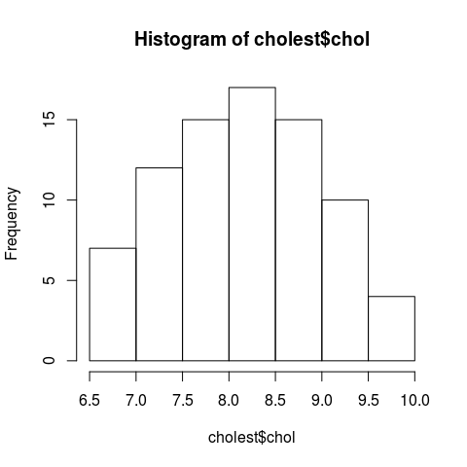

Now, to refine the hist() function, we will:

1. set the color col = argument to red,
2. set the argument for the number of bins to 8 bins breaks = 10,
3. label the x-axis using xlab = "label",
4. the plot title is set by main = "title of plot".

hist(cholest$chol, breaks = 10, col = "red",  
 main = "Cholesterol (mmol/l) distribution", xlab = "Cholesterol (mmol/l)")

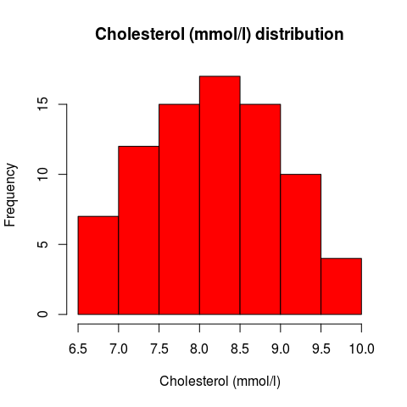

#### Kernel density plot

Kernel density plots are usually a much more effective way to view the distribution of a numerical variable.

This can be done using plot(density(x)). In the function, the argument for x is a numeric vector.

Below, we

1. create the density data and named it as d.plot,
2. next, we plot d.plot.

d.plot <- density(cholest$chol) # returns the density data   
plot(d.plot, main = "Kernel Density of Serum Cholesterol") # plots the results

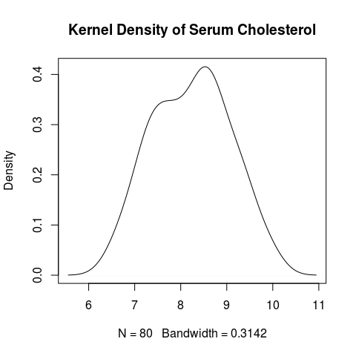

plot() is a generic function for X-Y axes plotting. It accepts data frame and density objects and choose suitable plot automatically. You can view the details about ?plot in the help.

#### Combining the histogram and density curve

We can combine these plots in one single plot. Here, we will

1. plot the histogram with density (instead of frequency),
2. overlay the density curve on top of the histogram. To do that we need to use lines() in place of plot(). plot() will create a new plot, but lines() will overlay line(s) on top of any plot.

hist(cholest$chol, breaks = 10, freq = FALSE, col = "red",  
 main = "Cholesterol (mmol/l) distribution", xlab = "Cholesterol (mmol/l)")  
lines(density(cholest$chol, adjust = 1.5))

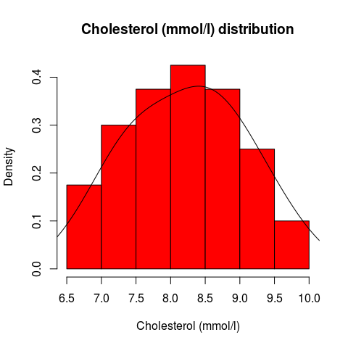

Notice that you can adjust = the density bandwidth relative to the default bandwidth. Here we use adjust = 1.5.

#### Box-and-whisker plot

We can easily obtain box-and-whisker plot using boxplot(),

boxplot(cholest$chol, main = "Cholesterol (mmol/l) distribution",  
 ylab = "Cholesterol (mmol/l)")

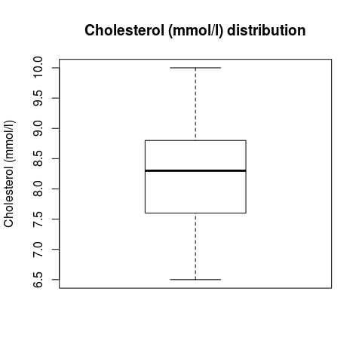

Here we include ylab, which stands for y-axis label.

boxplot() can easily handle many variables (of the same scale), for example we use attitude dataset,

boxplot(attitude, col = rainbow(7))

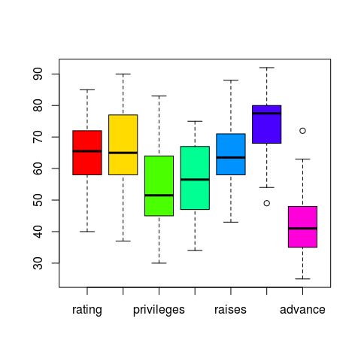

We leave it to you to discover what rainbow() does.

### Plotting relationship between numerical variables

We can plot two numerical variables simultaneously. From such plot, we can see the association or relationship between the two variables.

#### Scatter plot

Scatter plot is one of the most common plots to display the association between two numerical variables. The function is basically specified as plot(x, y).

Now we plot age on x-axis and chol on y-axis,

plot(cholest$age, cholest$chol, main = "Scatterplot",  
 xlab = "Age", ylab = "Cholestrol", pch = 19)  
abline(line(cholest$age, cholest$chol))

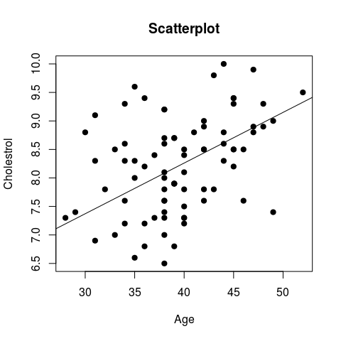

Here we include a new argument, plotting character pch. Here we use 19 (see help ?points). We can included a regression line, by combining abline() and line(). abline() gives you the straight line, while line() feeds the data of robust line fitting to abline().

You can always personalize the graphical parameters such as parameters for fonts, colours, lines and symbols. You can find the details in the graphics package documentation and help ?par. In addition, this website summarizes the parameters in a very nice way: <http://www.statmethods.net/advgraphs/parameters.html>

We can also plot a number of scatter plots simultaneously to explore the relationship between several numerical variables, for example using iris data set,

str(iris)

## 'data.frame': 150 obs. of 5 variables:  
## $ Sepal.Length: num 5.1 4.9 4.7 4.6 5 5.4 4.6 5 4.4 4.9 ...  
## $ Sepal.Width : num 3.5 3 3.2 3.1 3.6 3.9 3.4 3.4 2.9 3.1 ...  
## $ Petal.Length: num 1.4 1.4 1.3 1.5 1.4 1.7 1.4 1.5 1.4 1.5 ...  
## $ Petal.Width : num 0.2 0.2 0.2 0.2 0.2 0.4 0.3 0.2 0.2 0.1 ...  
## $ Species : Factor w/ 3 levels "setosa","versicolor",..: 1 1 1 1 1 1 1 1 1 1 ...

plot(iris[1:3])

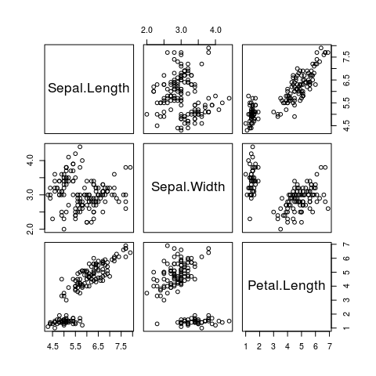

and attitude data set,

str(attitude)

## 'data.frame': 30 obs. of 7 variables:  
## $ rating : num 43 63 71 61 81 43 58 71 72 67 ...  
## $ complaints: num 51 64 70 63 78 55 67 75 82 61 ...  
## $ privileges: num 30 51 68 45 56 49 42 50 72 45 ...  
## $ learning : num 39 54 69 47 66 44 56 55 67 47 ...  
## $ raises : num 61 63 76 54 71 54 66 70 71 62 ...  
## $ critical : num 92 73 86 84 83 49 68 66 83 80 ...  
## $ advance : num 45 47 48 35 47 34 35 41 31 41 ...

plot(attitude)

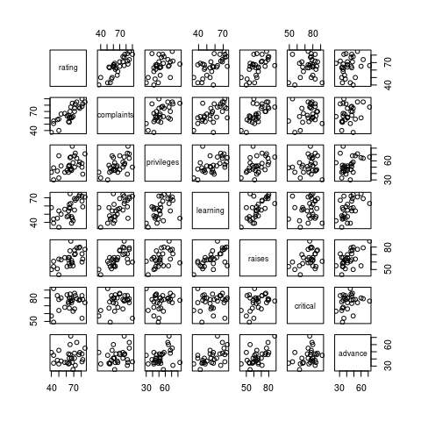

### Plotting a categorical variable

Fora categorical variable, we can plot a bar chart to display the frequencies of the data.

Create a frequency table of intervention groups categ and name it as counts:

counts <- table(cholest$categ)  
counts

##   
## Grp A Grp B Grp C   
## 25 33 22

Now, plot the frequencies for the counts object created above,

barplot(counts, main="Frequency by intervention group",   
 ylab = "Intervention group", xlab = "Frequency",  
 col = rainbow(3, alpha = 0.5))

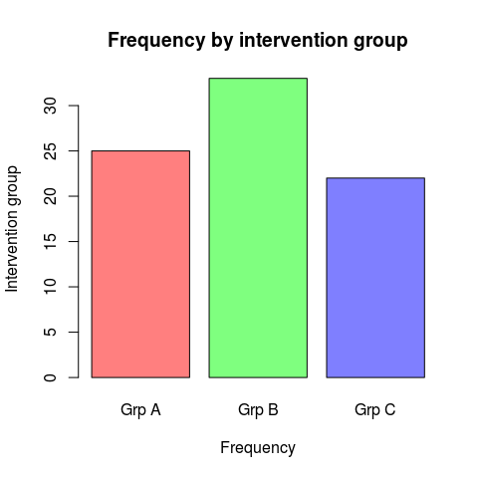

Here we give rainbow() a bit twist by adding alpha = 0.5 argument and value.

We can make the plot look nicer by adding sample sizes to the bars,

barplot(counts, main="Frequency by intervention group",   
 xlab = "Intervention group", ylab = "Frequency",  
 col = rainbow(3, alpha = 0.5), ylim = c(0, 40)) -> bplot_setting  
text(bplot_setting, counts + 5, paste0("n = ", counts))

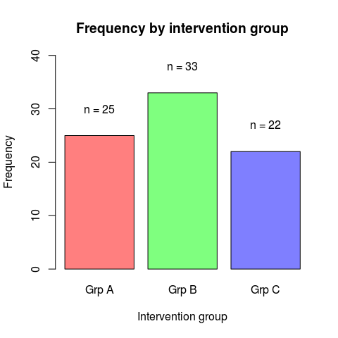

Notice -> assignment sign, which is just the reverse of <- sign we are used to. We can also write the object name on the right hand side of the assignment arrangement. Here we intentionally do so to emphasize the barplot() codes. bplot_setting gives text() the x coordinates, and counts + 5 gives it the y coordinates.

To make things more complicated (a.k.a more interesting in R), we plot a stacked bar chart. We need age categories to demonstrate a nice looking stacked bacrchart, and we create age_cat,

# group `age` into `age_cat` = `< 35`, `35-45`, `> 45`  
cholest$age_cat <- cut(cholest$age,  
 breaks = c(-Inf, 35, 45, Inf),  
 labels = c("<35", "35-45", ">45"))

Then we obtain the cross-tabulated counts between sex and age_cat,

cross <- table(cholest$sex, cholest$age_cat)  
addmargins(cross) # just to get an overview of the height of the bars

##   
## <35 35-45 >45 Sum  
## female 7 25 8 40  
## male 11 27 2 40  
## Sum 18 52 10 80

Plot our nice stacked bar chart,

barplot(cross, main = "Frequency by age group",  
 xlab = "Age group", ylab = "Frequency",  
 col = rainbow(2, alpha = 0.5), ylim = c(0, 60),  
 legend = rownames(cross)) -> bplot_setting  
text(rep(bplot_setting, each = 2), c(4, 12, 12, 39, 4, 9),  
 paste0("n = ", cross)) # adjust y coordinates to your liking

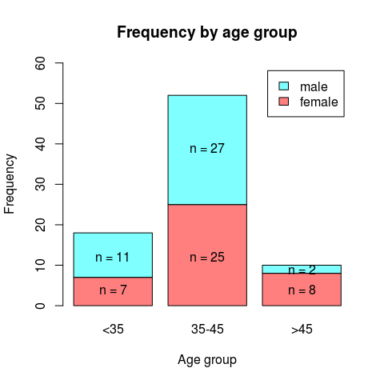

Note how we use rep() to repeat x coordinates twice for each age category.

### Saving plots in R

We can save the generated plots. In RStudio, under **Plots** tab, yiou can click on the **Export** button to save the plots as image of PDF. Alternatively, we can automaticaly save the plots (without viewing the plots). The examples below will save the plot as image and PDF formats.

Here we save as an image .png,

png(file = "hist.png")  
hist(cholest$chol)  
dev.off()

## png   
## 2

png() opens creates an empty file namely airmiles.png, while dev.off() closes the file and save whatever plot you have in between these two lines (limited to the last one if you specified several plots).

You can also specify the width = and height = of the image. View the help for ?png. The help also lists functions for the rest of image formats such as bmp, jpeg and tiff.

Now, we can also save as PDF,

pdf("plots.pdf")  
hist(cholest$chol, freq = FALSE)  
lines(density(cholest$chol))  
barplot(table(cholest$sex))  
plot(cholest$chol, cholest$age)  
dev.off()

## png   
## 2

The advantage of saving as PDF is because we can save many plots in a single PDF file as demonstrated here. The quality of the saved plots is also very good as compared to saving as images.

## Using the lattice package

lattice package can create beautiful plots too. Its main emphasis is on the visualization of multivariate data, thus it is very useful for plotting multiple plots, for example histograms of questionnaire items. It is also easy to visualize the data by groups in lattice as we will show in examples below. A very useful introduction to lattice package by the package developer can be found here <http://lattice.r-forge.r-project.org/Vignettes/src/lattice-intro/lattice-intro.pdf>.

### Histogram, density and box-and-whisker plots

Load the lattice package,

library(lattice)

Plot a histogram for variable chol and label the x-axis

histogram(~ chol, data = cholest, xlab = 'Cholesterol level')

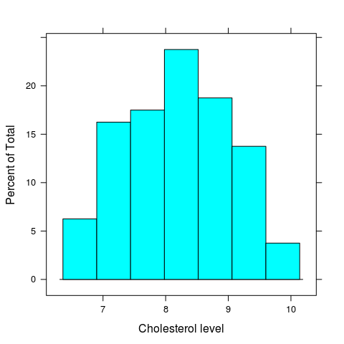

Now we plot a density plot for variable chol,

densityplot(~ chol, data = cholest, xlab = 'Cholesterol level')

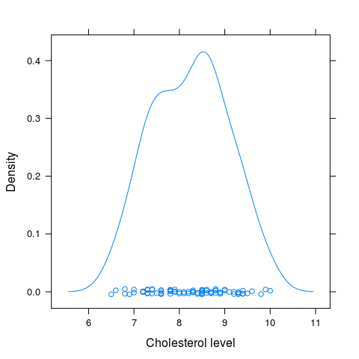

followed by a box-and-whisker plot for the variable,

bwplot(~ chol, data = cholest, xlab = 'Cholesterol level')

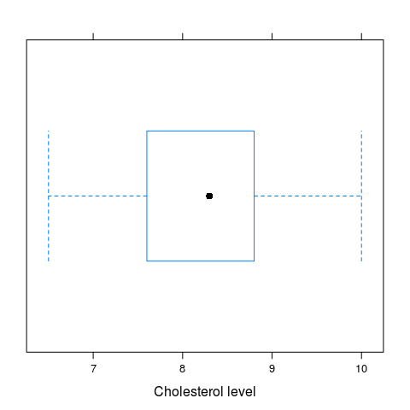

### Histogram, density and box-and-whisker plots by group

It is easy to plot these plots by group in lattice, making it a quick data visualization package.

Histograms,

histogram(~ chol | sex, data = cholest, xlab = 'Cholesterol level')

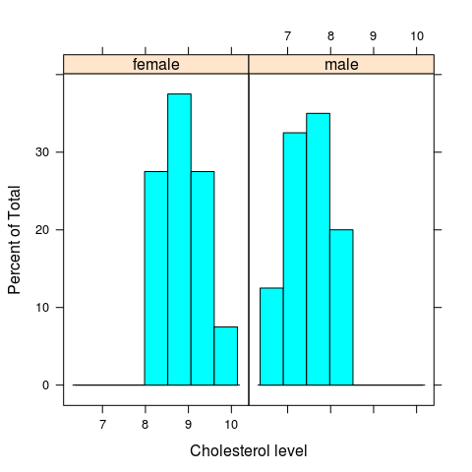

histogram(~ chol | sex, data = cholest, layout = c(1, 2), xlab = 'Cholesterol level')

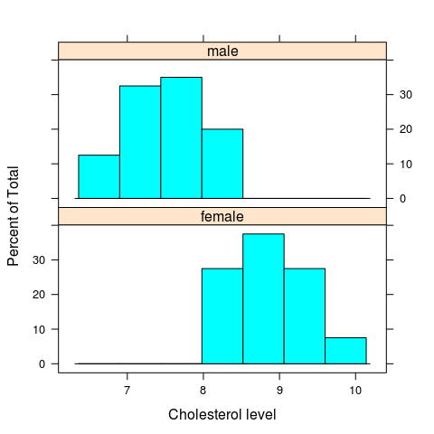

Here, we use layout = c(1, 2) for lattice argument. This means “1” column (over the x-axis) and “2” rows (along the y-axis).

Density plots,

densityplot(~ chol | sex, data = cholest, xlab = 'Cholesterol level')

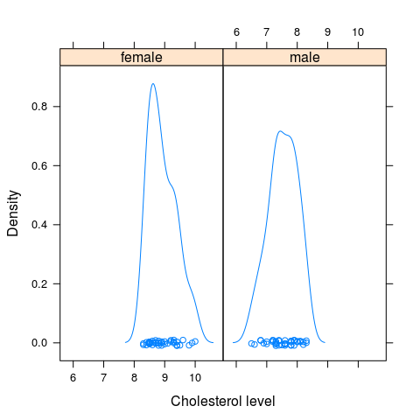

densityplot(~ chol | sex, data = cholest, layout = c(1, 2), xlab = 'Cholesterol level')

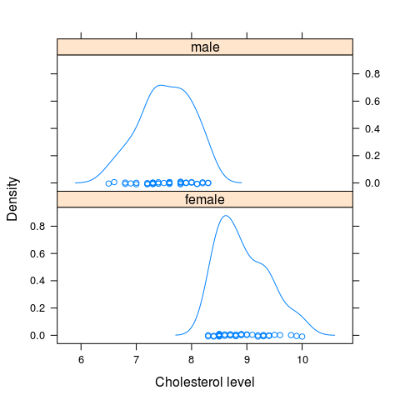

Boxplots,

bwplot(chol ~ sex, data = cholest, ylab = 'Cholesterol level')

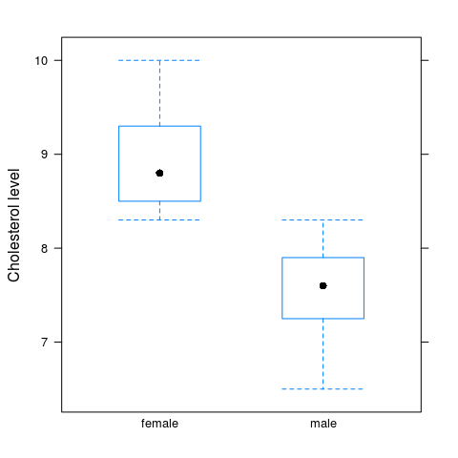

bwplot(sex ~ chol, data = cholest, ylab = 'Cholesterol level') # note the change in x-y axis.

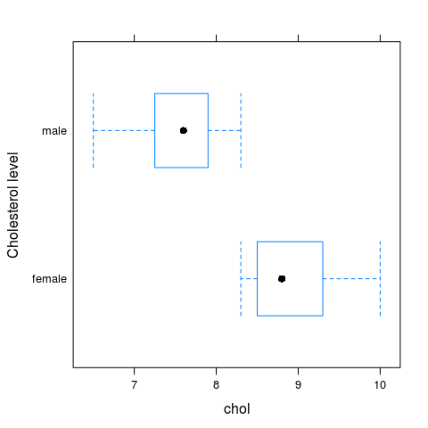

bwplot(~ chol | sex, data = cholest, layout = c(1, 2), xlab = 'Cholesterol level')

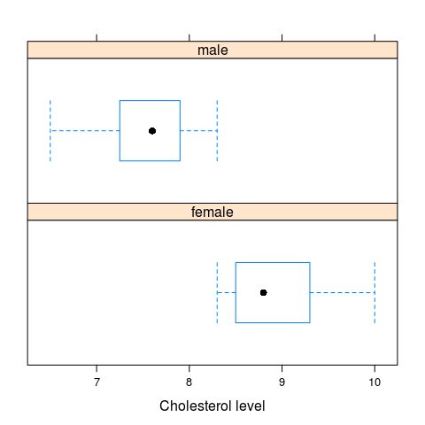

Then we add an extra grouping layer (age_cat) to the boxplots. Remember that we created age_cat in the previous section and added it to cholest data frame.

bwplot(age_cat ~ chol | sex, data = cholest, layout = c(2, 1))

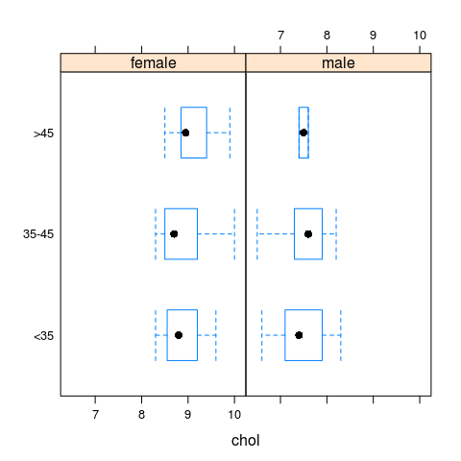

### Scatter plot

We can also plot scatter plot easily in lattice,

xyplot(chol ~ age, data = cholest)

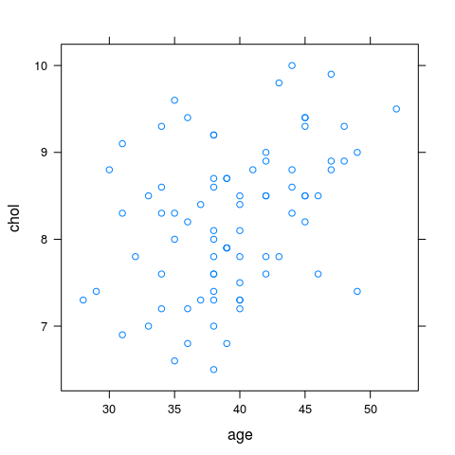

However, to add the line is a bit tricky as shown below,

xyplot(chol ~ age, data = cholest,  
 panel = function(x, y) {  
 panel.xyplot(x, y)  
 panel.abline(line(x, y))  
 })

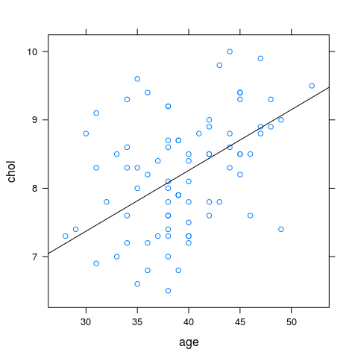

We find it easier to do this by graphics package.

Despite this slight “trickiness”, it is relatively easily to obtain scatter plots by group,

xyplot(chol ~ age | sex, data = cholest,  
 panel = function(x, y) {  
 panel.xyplot(x, y)  
 panel.abline(line(x, y))  
 })

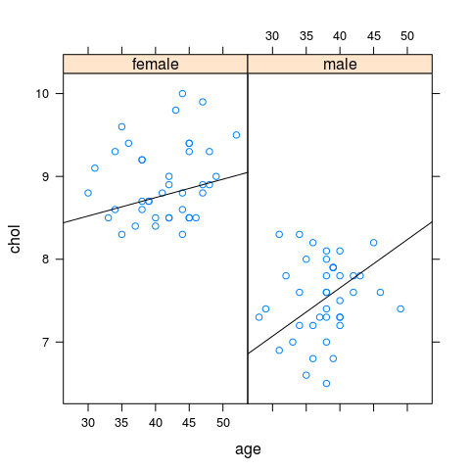

### Bar chart

For categorical variables, we can easily plot bar charts in lattice. We generate the count per group for the categorical variable, for example categ:

counts <- table(cholest$categ)  
counts

##   
## Grp A Grp B Grp C   
## 25 33 22

Now, plot the frequencies for the counts object,

barchart(counts, ylab = "Intervention group", xlab = "Frequency",   
 col = rainbow(3))

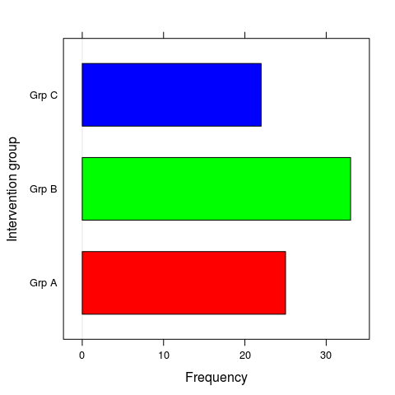

We can also have stacked bar chart based on counts from cross-tabulation of sex and age_cat,

cross <- table(cholest$sex, cholest$age_cat)  
barchart(cross, auto.key = T, ylab = "Sex", xlab = "Frequency")

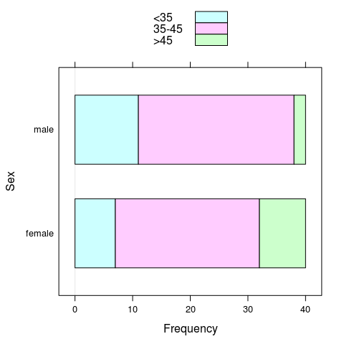

barchart(t(cross), auto.key = T, ylab = "Age group", xlab = "Frequency")

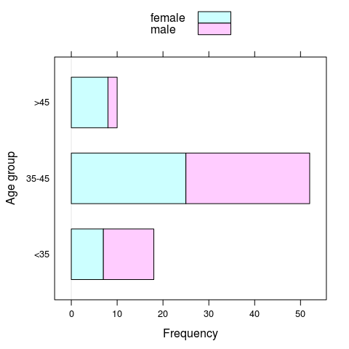

auto.key automatically gives us the legend. This is a special feature of lattice. With auto.key it is better to leave the color choice to the function. We also use t() transpose function. Because barchart() treat counts from cross object by row instead of by column, we need to transpose the arrangement of the row and column to replicate barplot() behavior (i.e. in the previous section).

For a more flexible chart setting, convert the count table to a data frame,

counts_df <- as.data.frame(counts)  
colnames(counts_df) <- c("Category", "Count") # set the column names  
counts_df

## Category Count  
## 1 Grp A 25  
## 2 Grp B 33  
## 3 Grp C 22

Then, we can plot with Category as x-axis and Count on y-axis,

barchart(Count ~ Category, data = counts_df,  
 col = rainbow(3, alpha = 0.5), ylim = c(0, 40))

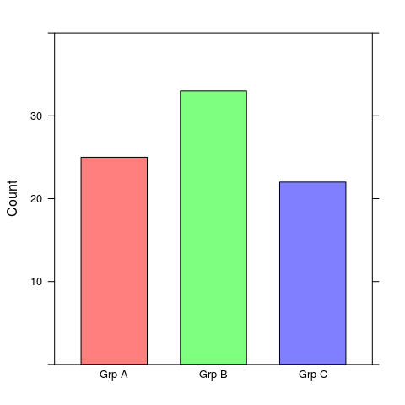

We can also plot bar charts by group using our cross-tabulated counts, cross object.

Convert the table format into a data frame,

cross_df <- as.data.frame(cross) # save as data frame  
colnames(cross_df) <- c("Sex", "Age_Group", "Count") # give proper names  
cross_df

## Sex Age_Group Count  
## 1 female <35 7  
## 2 male <35 11  
## 3 female 35-45 25  
## 4 male 35-45 27  
## 5 female >45 8  
## 6 male >45 2

Then, plot the bar charts,

barchart(Count ~ Sex | Age_Group, data = cross_df,   
 ylim = c(0, 30), col = rainbow(2, alpha = 0.5),  
 xlab = "Sex", layout = c(3, 1))

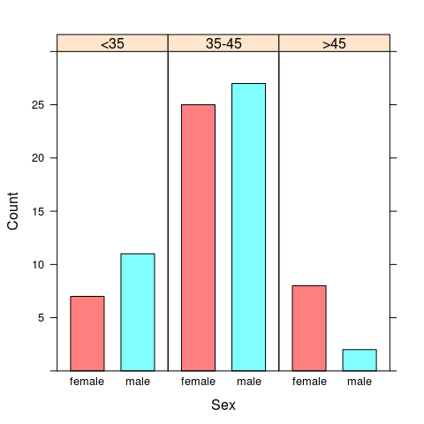

barchart(Count ~ Age_Group | Sex, data = cross_df,   
 ylim = c(0, 30), col = rainbow(3, alpha = 0.5),  
 xlab = "Age Group", layout = c(2, 1))

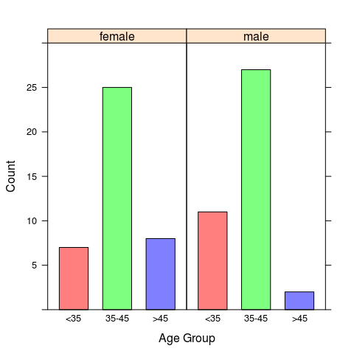

### Histograms and box-and-whisker plots

The beauty of lattice is in the visualization of multivariate data. We use attitude questionaire data set to demonstrate this point.

Obtain the list of variables, separated by " + “. This is easily done by cat(),

cat(names(attitude), sep = " + ")

## rating + complaints + privileges + learning + raises + critical + advance

Plot histograms. Copy-paste from our output of cat just now,

histogram(~ rating + complaints + privileges + learning + raises + critical   
 + advance, data = attitude)

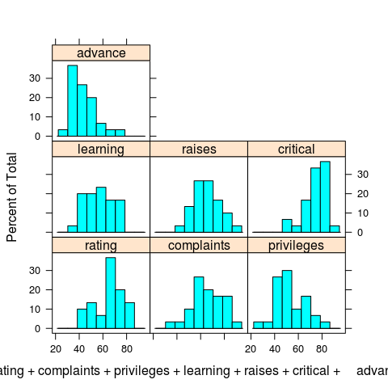

Multiple histogram using lattice is meant for numerical variables with same scales, in our case here, percentages.

Plot density plots,

densityplot(~ rating + complaints + privileges + learning + raises + critical   
 + advance, data = attitude, auto.key = T)

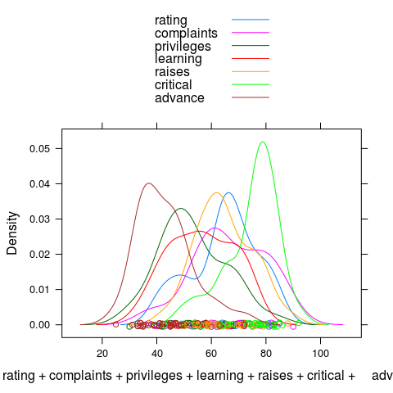

However, it is not practical to obtain box-and-whisker plots for variables using bwplot(), because lattice requires outcome and group variables to plot (i.e. as bwplot(group ~ numerical))

## Using the ggplot2 package

The official website for ggplot2 is here <http://ggplot2.org/>. In their own words, the package is described as

*ggplot2 is a plotting system for R, based on the grammar of graphics, which tries to take the good parts of base and lattice graphics and none of the bad parts. It takes care of many of the fiddly details that make plotting a hassle (like drawing legends) as well as providing a powerful model of graphics that makes it easy to produce complex multi-layered graphics.*

### Plotting a numerical variable

Plot distribution of values of a numerical variable.

#### Histogram

Load the ggplot2 package,

library(ggplot2)

In ggplot2,

1. type ggplot(data = X) function to choose the dataset,
2. the aes() for variable or variables to be plotted,
3. then we use geom_X to specify the geometric (X) form of the plot.

myplot <- ggplot(data = cholest, aes(x = chol))  
myplot + geom_histogram(binwidth = 0.5)

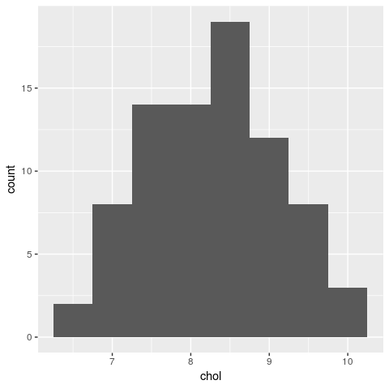

ggplot2 has lots of flexibility and personalization. For example, we can set the line color and fill color, the theme, the size, the symbols etc.

ggplot(cholest, aes(x = chol)) + geom_histogram(binwidth = 0.5,   
 colour = "black", fill = "white")

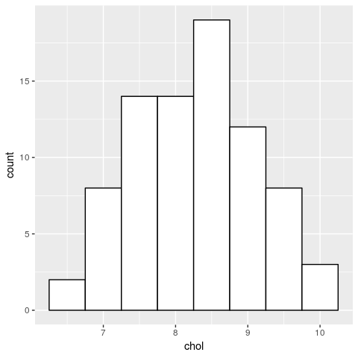

#### Density curve

Density is useful to examine the distribution of observations.

ggplot(data = cholest, aes(x = chol)) + geom_density()

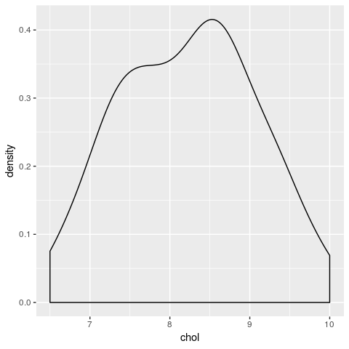

#### Combining the histogram and the density curve

ggplot2 allows plot to be displayed together. We can combine multiple plots in one single plot by overlaying multiple plots on one another.

Here, we will

1. create a histogram plot,
2. create a density curve plot,
3. overlay both (the density curve + the histogram).

To do this we need to specify a histogram with density instead of count on y-axis

ggplot(data = cholest, aes(x = chol)) +   
 geom_histogram(aes(y = ..density..), binwidth = 0.5, colour = "black", fill = "white") +  
 geom_density(alpha = .2, fill = "#FF6666")

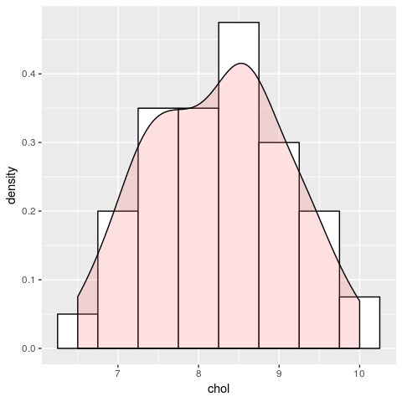

### Plotting a categorical variable

Now, let us create a basic bar chart using ggplot2::geom_bar()

sex_bar <- ggplot(data = cholest, aes(sex))  
sex_bar + geom_bar()

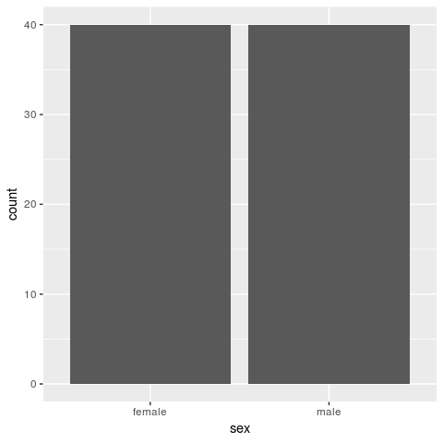

The bar chart looks OK, but we want to personalize it more - make it prettier and more presentable:

1. Add labels to x and y axes xlab() and ylab().
2. Add the title ggtitle().

ggplot(data = cholest, mapping = aes(sex, fill = sex)) +   
 geom_bar() + xlab('Sex') + ylab('Freq') +  
 ggtitle('Freq of male and female')

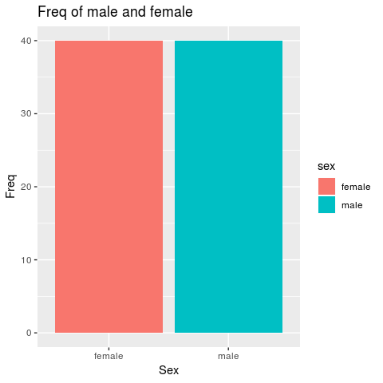

In addition, there is an excellent resource from this website on ggplot2: <http://www.cookbook-r.com/Graphs/Bar_and_line_graphs_(ggplot2)/>

### Plotting a numerical variable and a categorical variable

Now, examine the distribution of a numerical variable (rating) in two groups (A and B) of the variable cond by

1. overlaying two histograms,
2. interleaving two histograms,
3. overlaying two density curve.

#### Overlaying histograms

ggplot(cholest, aes(x = chol, fill = sex)) +  
 geom_histogram(binwidth = .5, alpha = .5, position = "identity")

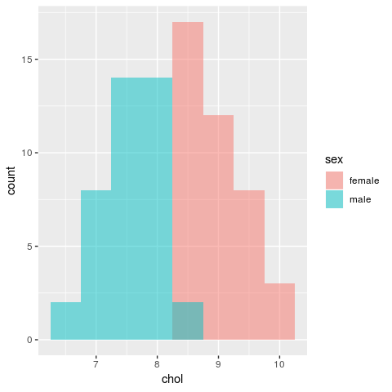

#### Interleaving histograms

ggplot(cholest, aes(x = chol, fill = sex)) +  
 geom_histogram(binwidth = .5, position = "dodge")

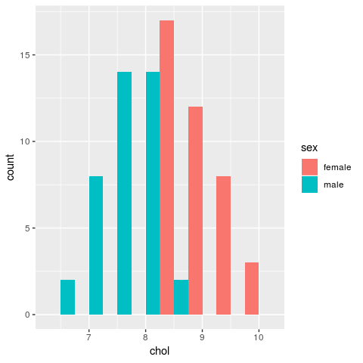

#### Overlaying density plots

Full transparent

ggplot(cholest, aes(x = chol, colour = sex)) + geom_density()

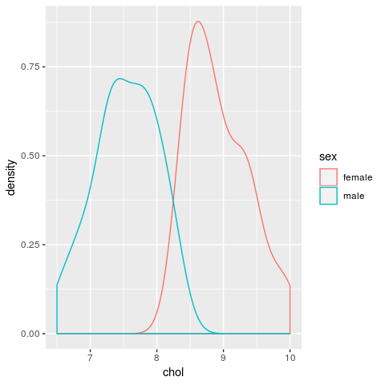

Now, try set the transparency at

# Density plots with semi-transparent fill  
ggplot(cholest, aes(x = chol, colour = sex, fill = sex)) + geom_density(alpha = .3)

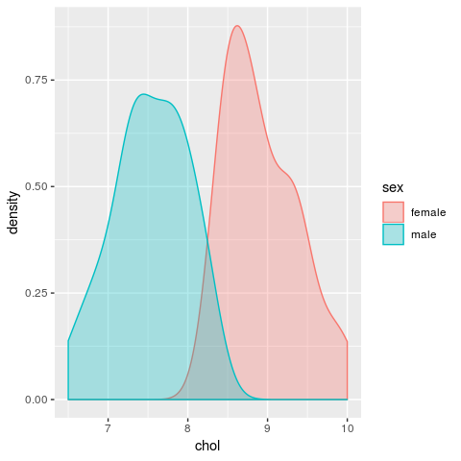

#### Using facets

We use facet_grid() to split the plot. There are two types of facetting the plot:

1. Vertical facet.
2. Horizontal facet.

The vertical facets

ggplot(data = cholest, aes(x = chol)) +   
 geom_histogram(binwidth = .5, colour = "black", fill = "white") +   
 facet_grid(sex ~ .)

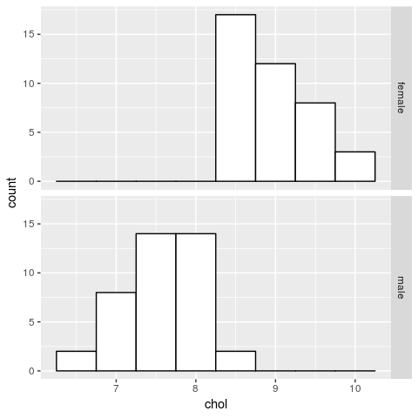

The horizontal facets:

ggplot(data = cholest, aes(x = chol)) +   
 geom_histogram(binwidth = .5, colour = "black", fill = "white") +   
 facet_grid(. ~ sex)

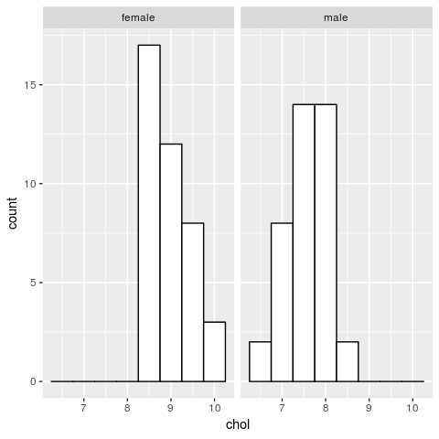

### Saving plots in ggplot2

This will save the last plot as .png and .pdf formats,

ggsave("myhistogram.png", width = 5, height = 5)  
ggsave("myhistogram.pdf", width = 5, height = 5)

## Summary

In this chapter, we learned to plot graphs in R, using the built-in functions and additional packages. We also learned how powerful R can be to generate visually beautiful graphs and how customizable the graphs are. This chapter concludes our short journey of exploring data in R.

# Bibliography

Arifin, W. N., & Yusoff, M. S. B. (2017). Item response theory for medical educationists. *Education in Medicine Journal*, *9*(9), 69–81.

Fox, J., Weisberg, S., & Price, B. (2018). *Car: Companion to applied regression*. Retrieved from <https://CRAN.R-project.org/package=car>

Friendly, M. (2009). Milestones in the history of thematic cartography, statistical graphics, and data visualization. Retrieved from <http://www.math.yorku.ca/SCS/Gallery/milestone/milestone.pdf>

R Core Team. (2017). *R: A language and environment for statistical computing*. Vienna, Austria: R Foundation for Statistical Computing. Retrieved from <https://www.R-project.org/>

R Core Team. (2018). *Foreign: Read data stored by ’minitab’, ’s’, ’sas’, ’spss’, ’stata’, ’systat’, ’weka’, ’dBase’, ...* Retrieved from <https://CRAN.R-project.org/package=foreign>

Revelle, W. (2018). *Psych: Procedures for psychological, psychometric, and personality research*. Retrieved from <https://CRAN.R-project.org/package=psych>

Sarkar, D. (2017). *Lattice: Trellis graphics for r*. Retrieved from <https://CRAN.R-project.org/package=lattice>

Tufte, E. (1983). *The visual display of quantitative information*. Graphics Press. Retrieved from <https://books.google.com.my/books?id=BHazAAAAIAAJ>

Wickham, H. (2016). *Plyr: Tools for splitting, applying and combining data*. Retrieved from <https://CRAN.R-project.org/package=plyr>

Wickham, H., Chang, W., Henry, L., Pedersen, T. L., Takahashi, K., Wilke, C., & Woo, K. (2018). *Ggplot2: Create elegant data visualisations using the grammar of graphics*. Retrieved from <https://CRAN.R-project.org/package=ggplot2>

Xie, Y. (2015). *Dynamic documents with R and knitr* (2nd ed.). Boca Raton, Florida: Chapman; Hall/CRC. Retrieved from <http://yihui.name/knitr/>

# Index

arguments, 17, 18

arrange, 48

bar chart, 95, 97, 109, 118, 119

box-and-whisker plot, 91

column bind, 77

combine, 32

combine text, 81

concatenate, 81

containers, 32

count, 61, 65, 68

CRAN, 20

cross-tabulation, 68, 74, 80

data

direct entry, 51

duplicated, 56

editing, 49

missing, 55

structure, 31

tabulated, entry, 53

data frame, 32, 51, 79

dataset

built-in, 31

exporting, 30

reading, 29

subset, 33

viewing, 29

descriptive statistics, 59

by group, 68

by group, categorical, 70

by group, numerical, 68

categorical, 61, 64

numerical, 60, 62

directory, 18, 25

download, 6, 10, 11

factor level, 43

functions, 17, 19, 27, 28, 66, 99, 125

ggplot2, 84, 115, 116, 118, 120, 125, 126

graphics, 83, 84, 93, 108, 115, 126

graphs, 83

GUI, 9, 12

histograms, 86, 100, 113, 120, 121

install R and RStudio, 6

installation, 6, 7, 10, 11, 19, 84

interquartile range, 60

IQR, 60

Kernel density, 88

lattice, 84, 100, 102, 103, 107, 109, 111, 113, 114, 115, 126

Linux, 6, 8, 10, 27

list, 32

logical expression

combination, 41

list, 40

logical operator, 43

Mac, 6, 7, 10, 15, 27, 28

MAD, 61

marginal total, 80

matrix, 32, 33, 79

maximum, 60

mean, 60

median, 60

median absolute deviation, 61

Microsoft R Open, 12

minimum, 60

missing value, 51, 55

object, 17, 18, 96, 97, 109, 111, 112

dimension, 30

name, 30

subset, 33

Object, 17

observation

deleting, 50

removing, 50

order, 46, 48

output customization, 76

package, 18, 21, 23, 27, 28, 83, 84, 93, 100, 102, 108, 115, 126

packages, 6, 14, 18, 19, 20, 21, 23, 27, 28, 83, 84, 125

panes, 13, 14, 15

paste, 80

percentage, 61, 65, 68

project, 25

proportion, 61, 65

quantile, 60, 61

range, 60

relational operator, 40

row bind, 77

RStudio, 10

Scatter plot, 92

script, 14

SD, 60

sort, 46, 48

stacked bar chart, 98

standard deviation, 60

subsetting, 33

column, 34

column and row, 35

logical expression, 39

observation, 34

row, 34

subsetting variable, 34

sum, 54

tar.gz, 21, 22

Tinn-R, 13

upgrade, 27

variable

categorical, 31

creating new, 49

deleting, 50

factor, 31

numerical, 31

recoding, 49

recoding, categorical, 50

recoding, numerical, 49

removing, 50

type, 31

variance, 60

vector, 31

version, 9, 11, 85

visualization, 83

Windows, 6, 8, 10, 15, 26

working directory, 6, 25, 26, 28

zip, 21, 22