***KAMPOOSA BOG***

The Kampoosa Bog, located in the towns of Lee and Stockbridge, is approximately 1,350 acres (5.5 km2) in size it is part of the larger Housatonic River watershed (Figure 1). Kampoosa Bog is a wetland complex comprised of red maple calcareous swamp, an open pond, a graminoid fen and a shrub fen. Massachusetts Turnpike (I90) crosses the northern edge of the wetland, and State Route Rt. 7 crosses the southern edge of the wetland. The primary inlet stream to the wetland is Marsh Brook, which is renamed Kampoosa Brook after it flows beneath the Interstate I90 and enters the wetland complex. Kampoosa Brook flows south through the fen, the open pond, and eventually beneath Rt. 7. A second, unnamed inlet stream enters the wetland through the red maple swamp in the southeastern region of the complex and flows southwest, parallel with Rt. 7, before entering Kampoosa Bog drainage basin.

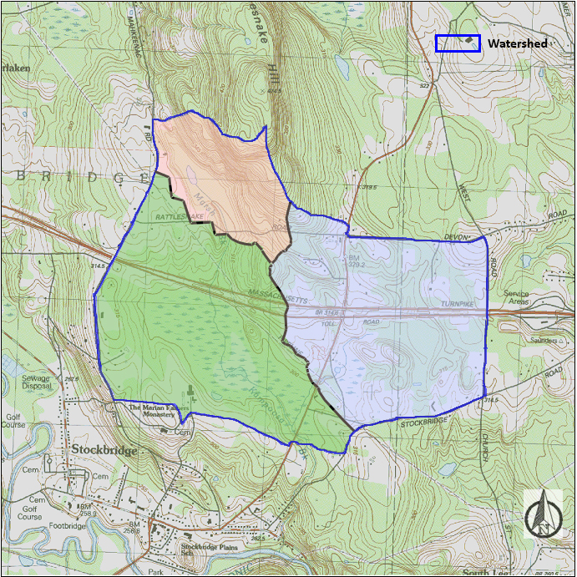

Figure 1 – Kampoosa Bog Topographic Map, Lee and Stockbridge, MA. The drainage basin of the fen is delineated by the blue line.

As outlined in Figure 1, the Kampoosa Bog watershed is divided into three sub-watersheds. The northwestern sub-watershed which drains into Marsh Brook, represents 17% of the drainage basin and it is comprised by the area upstream of MB-100 which is unaffected by de-icing agents application on Interstate I90. The southwestern sub-watershed drains into Kampoosa Brook and includes the fen and the open pond. This section represents 47% of the total watershed and receives runoff from approximately 1.4 Km (0.87 mi) of Interstate I90. The eastern sub-watershed, which does not drain through the herbaceous fen, drains into an unmamed tributary. It represents 35% of the Kampoosa Bog watershed and receives runoff from approximately 1.5 km (0.93 mi) of Interstate I90 and aproximately 1.7 km (1.06 mi) of State Route 7.

**Ion Concentrations in Surface and Groundwater at Kampoosa Bog**

On a monthly basis, UMASS personnel collects 7 surface water quality samples and 9 groundwater samples located within Kampoosa Bog (Figure 2). Groundwater samples are collected from monitoring wells installed in the open fen. Monitoring wells are grouped in 3 clusters, each cluster comprised of 3 wells installed at 1.52, 3.05 and 4.57 m (5, 10 and 15 ft) depths. Wells were constructed from 2-inch PVC pipe with a one-foot length screen.

Water on the surface of the floating peat mat is also sampled near each well cluster. Marsh Brook is sampled upstream of the Interstate I90, near Rattlesnake Mountain Rd. at a relatively undisturbed location (MB-100). Kampoosa Brook is sampled at the culvert near Rt. 7 (KB-100) and at the culvert near Interstate I90, north of the wetland (KB-300). The unnamed tributary is sampled at the culvert where it flows beneath Rt. 7 (KB-150). When possible, a sample (KB-160) is collected from an actively flowing side stream into the unnamed tributary at KB-150 location.

Groundwater samples are collected using a 1-m bailer after purging one well volume. Water samples are collected with no head space in 120 ml HDPE bottles after rinsing the bottle twice with the sample water. The samples are analyzed for anions by ion chromatography, for cations by an inductively coupled plasma spectrophotometer and for bicarbonate by total organic carbon analyzer by UMASS investigators.

Figure 2 displays chloride concentrations observed in Kampoosa Bog monitoring wells from November 2017 to March 2020 The depth of each well is indicated parenthetically. Note that well cluster A is the closest to Interstate I90, while well cluster C is the furthest away from Interstate I90 (see also Figure 3).

**Kampoosa Bog Surface Water Quality Stations**

UMASS monitors the 4 surface water quality stations within the wetland (at KB-100, KB-150, KB-300 and MB-100 locations). Each station is equipped with a HOBO U20-001-04 water level data logger for stage measurement, and a HOBO U24-001 conductivity data logger (Onset Computer Corporation; Bourne, MA). The stations monitor water level, specific conductivity, water temperature and air temperature. These data are logged every 15 minutes, downloaded in the field using a HOBO Waterproof Shuttle and transferred to a computer using HOBOware Pro 3.7.20 software. Precipitation data is downloaded from the precipitation station MA-BE-3 (<https://www.cocorahs.org>) located in Stockbridge, near the research site.

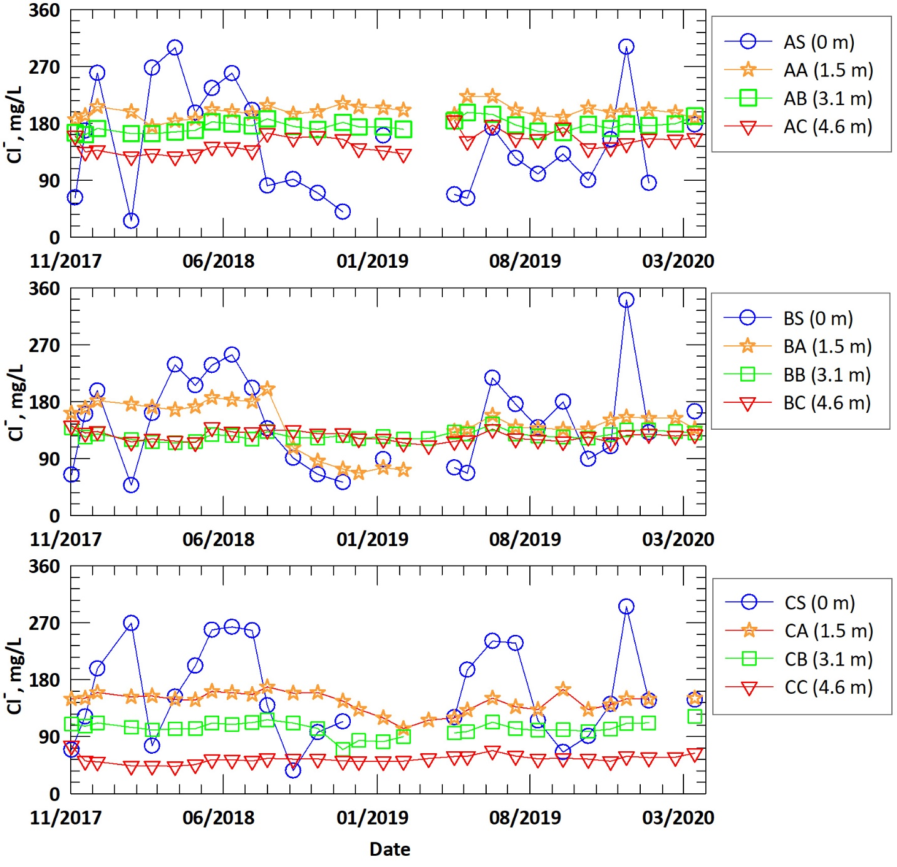

Figure 2 – Chloride Concentrations in Monitoring Wells at Kampoosa Bog

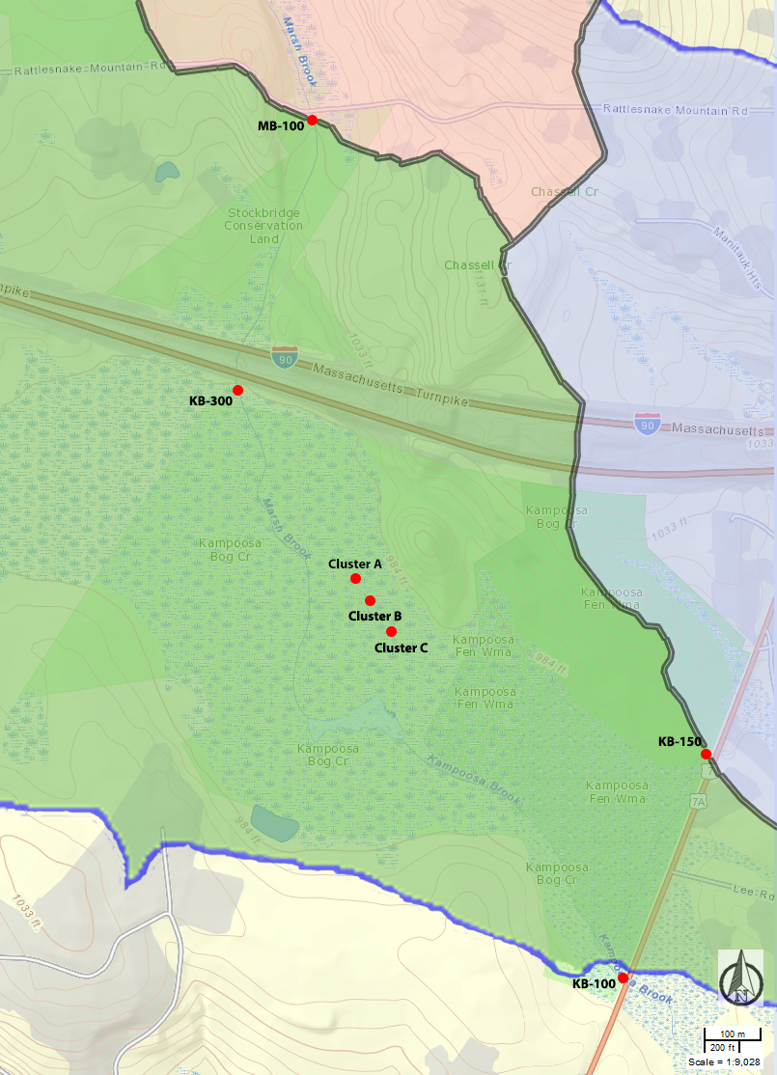

Figure 3 – Location of surface and groundwater samples, Kampoosa Bog

UMASS personnel measured the streamflow (discharge) at each monitoring station. . The stream flow was measured at the pipes which carry Marsh Brook/Kampoosa Brook water under the road (Interstate I90, Rt. 7 and Rattlesnake Mountain Rd.) by measuring the water velocity at several points yielding a flow velocity cross section map. The Rt. 7 and Interstate I90 pipes at KB-100, KB-150 and KB-300 locations have a diameter of 48 in, while the pipe at the MB-100 location has a diameter of 24 in. The water velocity was measured with a FH950 portable velocity meter (Hach Company; Loveland, CO) at the center of the pipe at three depths when viable.

A relation between channel-geometry dimensions and flow was determined for each monitoring station.

(1)

(2)

(3)

(4)

where *Q* is streamflow (GPM) and * *is stream stage (ft).

We used a polynomial regression to calibrate chloride and equivalent road salt (NaCl) concentrations (cCL, cNaCl) based on specific conductivity kSTREAM (measured in mS/cm) observed in the water samples collected near the four surface water station locations between May 2017 and April 2019.

(5)

(6)

with regression coefficients in . Equations 5 and 6 facilitate an estimate of the monthly average amount of chloride and the equivalent salt passing the monitoring stations in Kampoosa Bog, based on observed flow and conductivity. The monthly amount of salt (NaCl) discharged at Kampoosa Bog monitoring stations was estimated assuming that the only source of chloride was road salt (NaCl). The average chloride concentration at each monitoring station was calculated as the ratio of *FCl* to *Q.*

We plot the temporal variation of the monthly average chloride concentration from December 2017 through May 2020 for the four monitoring stations in Kampoosa Bog on Figure 4.

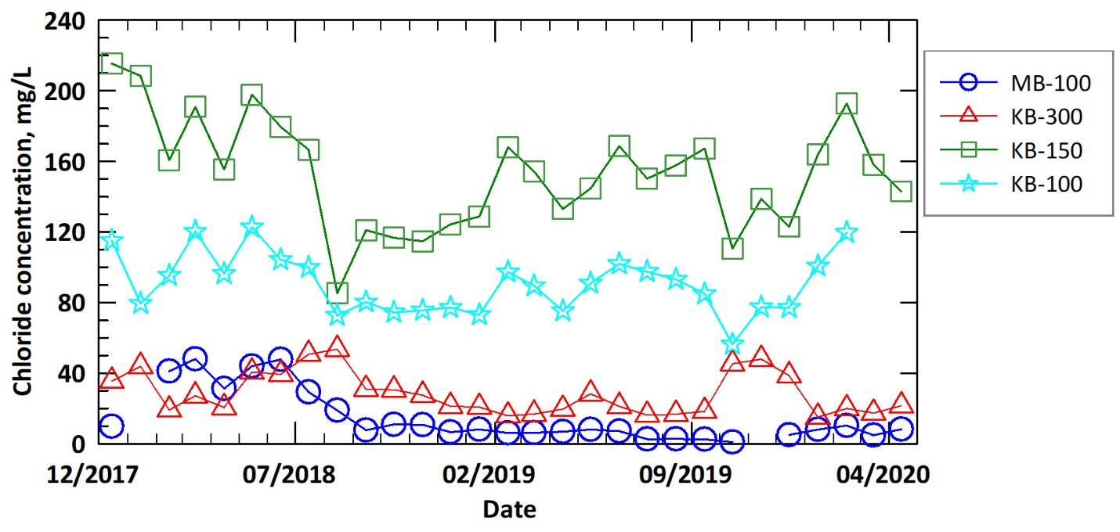

Figure 4 – Monthly Average Chloride Concentrations at Kampoosa Bog Monitoring Stations

An example of the chloride (*FCl*) and the equivalent salt (*FNaCl*) masses passing the monitoring stations installed in Kampoosa Bog during April 2020 is presented in Figure 5.

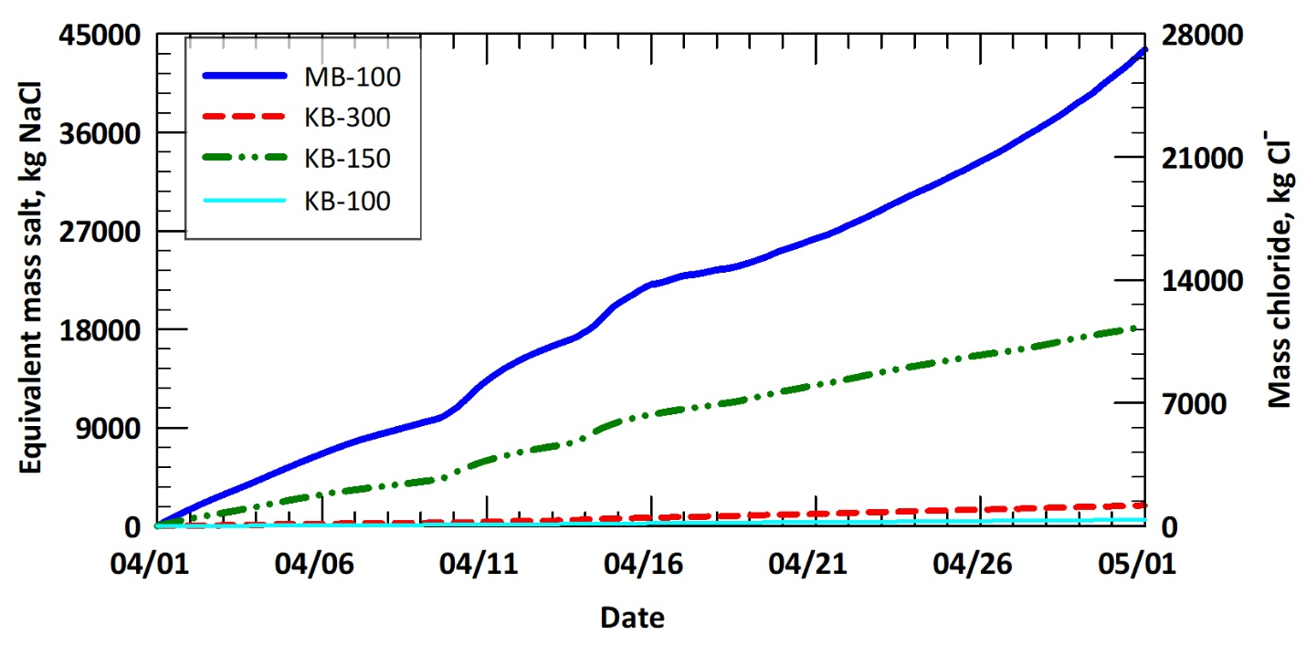

Figure 5 - Mass Chloride and Equivalent NaCl Discharged at Kampoosa Bog Monitoring Stations in April 2020