Beating Them at Their Own Game: Artificial Intelligence
for Fire Emblem 7

William Newbury and Chris Eriksen
CS 151 Spring 2014
wnewbury@g.hmc.edu, ceriksen@g.hmc.edu

Abstract
The following document describes the work and research done by Chris Eriksen and Will Newbury in implementing an AI for the game Fire Emblem. The team has created a fully functioning implementation of a Fire Emblem level including terrain, unique characters, movement, and conflict. The team has created a feature-based evaluation function to govern AI decision making. As this evaluation function depends on weights for the various features, the team has also tested the efficacy of manually inputted weights and those trained via reinforcement learning. In total, we find that our feature-based evaluation function provides a reasonable approach for playing the game. Using manual weights, our AI wins 84% of its games. When the AI is trained using reinforcement learning, the results are less spectacular and are on par with the enemy AI playing against itself. When trained with a learning rate decaying regularly over time from .7 to .3, an exploration rate decaying regularly from 1 to 0, and a discount factor of .99, our AI wins 56 % of its games when weights are initialized to our originally manually set weights, and the AI wins 54% when the weights are initialized to 0.
Background and Problem Statement

Turn based strategy (TBS) games provide an interesting yet accessible problem for AI design. As opposed to real-time strategy (RTS) games, successful play in TBS games is centered more with correct decision making than the speed or precision of reactions. This provides an interesting challenge to AI agents, as they must try to imitate human cognitive approaches rather than leverage their ability to precisely execute a pre-defined task. The discrete sequencing of actions in TBS games also makes them easy to model, which makes for a more feasible semester project.

Our project is centered on creating an AI that play one of the games from the famous Fire Emblem Series. The Fire Emblem games incorporate a 2-d grid in which the player is given control over a set of characters with which he must complete a specific task, usually involving conflict with a set of computer-controlled enemy characters. Each grid tile has a specific type (e.g. forest, plain, mountain) that provides a set of combat affecting parameters, while each character has a specific combination of character statistics, weapons, and class. The game features a weapon triangle where axes have increased hit rate and damage against lances, lances similarly dominate swords and swords dominate axes. These variations allow for a wide diversity in combat decisions, providing a challenging opportunity in which the AI must incorporate a diverse set of factors as it attempts to execute successful combats. At the same time, since game play in evolves solely around combat and combat takes place in a limited grid and turn based environment, Fire Emblem maintains a limited scope that is more suitable for a semester based project.

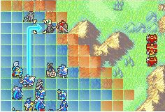
Sample map from Fire Emblem 7. Player is given a set of characters that he takes turns moving (shown above) and attacking computer-controlled enemies.

Our specific task is to create an agent that can successfully play through the third level of Fire Emblem 7. In this level, the player is given 5 characters with which he must fight through 8 enemy units and kill their leader, Migal. Game play occurs in a series of turns, where the player takes an action (move/fight) for each of his characters, followed by a set of actions by the computer-controlled enemy. Each player-controlled character is unique and brings its own set of advantages and difficulties. Lyn is the player-controlled lord. Lyn has decent stats and wields a sword. If Lyn dies, though, the player loses. Wil is an archer, which means he can attack enemies that are two spaces away, but is helpless against adjacent enemies. Florina is a Pegasus Knight, which means she can fly over most types of terrain, but takes increased damage from bows. Florina also has generally low defenses and wields a lance. Finally, the player is given two defensive, horse-riding knights (Kent and Sain) who wield swords and lances. The enemy characters, with the exception of the boss, have generally inferior stats to the player characters, but can overwhelm the player if he is not careful. The enemy consists of two archers, 3 sword users, and 4 axe users, each occupying a different role in the weapon triangle.
The level has additional intricacies that we have opted to remove for sake of simplicity, as they do not add too much strategic value to the level. To this end, we have removed the use of items, the ability to enter buildings, as well as the ability for characters to rescue (pick up) allies. We also start the level half way between the first turn, as the first couple actions are for tutorial purposes, involving recruiting the fifth player character. In addition to this, while the player is normally allowed to move his characters in any order, we have imposed a strict ordering of character activations so as to limit the decision space the player AI has to deal with.
While this level does not pose a great challenge for most human players, the diversity of characters and weapons creates an ample opportunity for failure if the player does not act correctly. To this end, we judge that this level provides an adequate testing ground for our artificial agent.
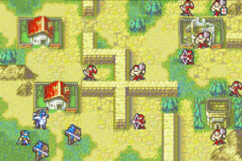

Map for the third level of Fire Emblem 7. The characters in blue (one missing) represent the player-controlled units. Game play occurs in a sequence of turns, in which the player moves each character once. The level ends when either the boss is killed or the lord, Lyn, dies.
Literature Review
One of the more popular approaches to TBS game playing AI centers on variants of the classic Civilization series of games by Sid Meier. In Civilization, players are presented the task of managing a large set of resources as they are placed in competition with competing nations. For instance, players must simultaneously manage various subtasks such as expansion and placement of new cities, resource gathering, building and unit production, scientific advancement, and tactical combat. One such approach is presented by Sanchez-Ruiz et.al. in which they describe storing and retrieving basic strategies for different configurations of the environment. The authors describe maintaining a library of known strategies for facing various kinds of situations. When presented with a new world state, the AI compares what it sees to similar configurations it has seen in the past and finds the strategies that were effective in solving similar problems. This approach is useful given the large set of states the game can take and allows the AI to reason over a specific permutation of environmental factors based on generic understanding of what it has seen before. While approaches like this are helpful for reasoning over large, complex games like Civilization, our game has far less environment parameters and possible decisions. Instead of trying to provide a generic way or reasoning over such a large state space, we propose a more narrow evaluation of the specific options available to a player at a given time.

In their paper, Bergsma and Spronck propose an AI for playing the TBS Advance Wars game. More so than Civilization, Advance Wars is a game very similar to Fire Emblem, as the game centers on combat between different types of units in a similar 2-d grid. Unlike Fire Emblem, though, Advance Wars has the added complexity of unit production and money generation through the capturing of specific tiles. In the paper, the authors describe breaking their AI down into smaller units that are each responsible for a certain sub-task, such as unit production, money generation, combat, etc. For each possible player action, the sub-modules will compute the provided utility of the action that best suits their sub-task. An overseer agent will then choose the action with the highest utility. Since Fire Emblem has only one sub-task (combat), this part of the paper is not really applicable to our project. However, the authors also describe their approach for the specific sub-task of combat.

To this end, the authors describe using what they call influence maps to determine character actions. Given a proposed character location, the influence maps determines the amount of tactical influence the character will have on each other tile in the map, given that position. Characters will then move to the position so as to maximize their tactical influence over the map.

Tactical influence is computed using a neural network that gives an influence score based on environmental factors and a set of weights. The authors propose learning these weights using a genetic algorithm, where the fitness of a given set of weights is determined by playing the game a certain amount of times.

Avery et.al. provide a similar influence map approach as applied to a sample RTS game. In the game, the player is given a set of ships that he must coordinate in real time to capture a flag protected by a set of enemy ships. Game play involves the player shooting the enemy ships and positioning his own ships effectively to make a rush for the enemy flag. Similar to Bergsma and Spronck, influence maps are calculated at each time step for each of the player ships such that the ships will move toward the spot from which they can exact the most influence. Similar to Bergsma and Spronck, the authors also describe using a genetic algorithm to generate the parameters that are used to determine influence values. Using this approach, the authors describe their success in generating cooperative strategies amongst player boats that were effective captured the enemy flag, given a variety of starting scenarios.

As in the problems approached by both these sets of authors, a Fire Emblem AI requires spatial reasoning and planning over a set of player characters such that each character acts cooperatively to meet a desired goal. Similar to the influence map approach, we propose calculating a tactical value for available action for each player character. This tactical value will be a weighted sum of features that reflects the various considerations that go into human contemplation of actions. The characters will then move to the space from which they can exact the most tactical influence given the game state. As characters complete various sub goals (such as defeating individual enemies), new locations will have comparatively larger tactical value, which reflects the formation of new sub goals.

In order to determine the weights for our action evaluation function, we propose first manually setting weight values that we feel reasonably account for the importance of factors a human player takes into account when playing the game. Similar to Bergsma and Spronck as well as Avery et.al., we then propose learning these weights though repeated trials of the game. Instead of genetic programming, however, we have opted to use a simple reinforcement learning strategy instead.

While our game does not involve the complexities of unit production or real time decision making, this approach should reflect a solution to a similar problem that governs a set of cooperative actions over a set of player units.
Approach
This section will detail approach that the team took toward the problem statement, any design decisions, and any algorithms or techniques used to approach the problem.
Game Design
Many projects undertaken by fellow students in CS 151 followed a similar interest in video game design and application of artificial intelligences, and in fact many of them proposed games from the same platform as ours.
Many of these teams, decided to interface with the game via an emulator, playing a complete version of the game, accessing memory by hand, and simulating button presses as if there was an outside party playing the game itself. Our team decided that this extra layer of abstraction was something that we wanted to avoid, and chose to instead re-implement the game as a whole, or at least one level of it and the parts that we needed. This decision came with a number of tradeoffs. Firstly, a great deal more work was required in order to build the entire framework for what is essentially the framework of an industry video game, taking up a good amount of effort over the course of our project. Secondly, the visual presentation of our implementation is significantly less impressive when compared to those running on emulators, as ours is limited to a simple ASCII output, rather than the full and original graphics of the game.

Despite these drawbacks, building the game also gave us a few important positive factors as well. Because we build the game from the ground up, the team was able to be fully confident and knowledgeable about the workings of the game, as well as integrate our artificial intelligence directly into the inner workings of the game, meaning we were able to access information in our AI easier than we would have if using an emulator. Additionally, our approach allowed us to have a good measure of control over the complexity of the problem itself, abstracting some details of a Fire Emblem experience that would not be dealt with or included in our analysis of the game. The exact mechanics of this will be gone into in more detail in our discussion of the results of our implementation. Finally, both members of the team found that despite the extra work inherent in building the game from the ground up, the experience was rewarding both from a pedagogical and personal accomplishment point of view. We are proud of our recreation of one of our favorite games.
Artificial Intelligence
In addition to the game itself, the team also designed an artificial intelligence capable of intelligently playing the Fire Emblem map in some manner that attempts to mirror the logic of a human player playing the game. There are a couple areas in which the elements of AI discussed in class this semester came into play.

While not explicitly one of the artificial intelligence goals that the team set out to solve or implement at the start of the project, during construction of the game, the team found that the A* search explored earlier in the class was of great use due to the mechanics of range and movement in the game. There are a number of different terrain types and unit types in the game, and these factors combine to make a relatively complicated calculation of how far a character can move on a given turn. Furthermore, because there are these factors the specific path that is taken by an individual character has a profound effect on whether or not it can reach a given space, and if so the amount of movement range it has left. In order to account for this complexity, the team implemented A* search in order to govern movement calculations throughout the game, as well as distance and range calculations necessary when determine the best possible move in our AI.

In our literature review, we talked about an approach that was described as using influence maps. The basic idea of this is that any given character has certain locations on the map that it is more tactically effective to be located in. There can be a number of reasons why any given space might be desirable traditionally related to the locations or “influence” on enemies and allies, but in the end each location on the map is given essentially a score. The AI proposed interfaces with this map of scores for locations and attempts to move the character to locations that receive a higher positive score according to the map. In the context of our project, we make no formal representation of an influence map that is consulted, however, we use the idea of having different map areas and actions having varying attractiveness in order to determine where to move and what to do.

In order to be able use the approach outlined above to determine the best move for a given character, we had to have some way of evaluating spaces and actions in order to make out pseudo-influence map. In order to do this the team made an evaluation function for each space that accounts for all possible moves available at that location, score them, and returns the best score. Each character queries for the scores of all possible locations that are available for it to move to, and takes the position and action pair that return the best score based on the evaluation function.

A number of different elements are analyzed by this evaluation function, including:
- In Range of (1, 2, …, 5+) Enemies?
- In Range of Boss?
- Distance to Nearest Enemy
- Killed Boss?
- Killed All Enemies?
- Terrain Bonus
- Expected Damage Dealt
- Expected Damage Taken
- Expected Kill?
- Expected Death?
- In Range of Archers?
- In Range of Axe Users?
- In Range of Lance Users?
- In Range of Sword Users?

Each individual character then has a number of different sets of weights, a set of defensive and offensive weights for each weapon in its possession. The characters switch between offensive and defensive weights according to their current health, and the evaluation function scores attacking with all the weapons in the characters possession and can order a weapons switch if it is desirable. For each of the factors described above, a character has a weight, and the evaluation function calculates the appropriate factor and uses a sum of all of the weights multiplied by their factors in order to score an action at a position. The most desirable action is then returned along with its score, and the most desirable action and position pair is determined as the characters best move. Exact details and code can be seen in the github repository found in Appendix B.

All of the weights for the characters (of which there are a non-insignificant number, as can be seen above) were adjusted and created by hand by the team initially, and through experimentation and reasoning were adjusted until the we were able to achieve results detailed later in this report. However, because the complexity of the system was so high and because of the teams desire to extend the project as far as possible, the team also explored the possibility of using Reinforcement Learning in order to adjust these weights over time to optimize performance of our AI.

As part of our reinforcement learning process, we initialized character weights to our manually inputted values. For each game turn, we would calculate a reward for each player action. The reward consisted of a weighted sum of the amount of damage the character gave, damage the character took, enemies killed, whether the character died, as well as total damage taken/given, character kills and deaths amongst all player characters. Normal reinforcement learning took place using these rewards after all player characters and enemies had taken their actions. After running a certain number of game trials, the final weights would then be saved.

Finally, in previous iterations of this project and its updates, the team had talked somewhat about the ordering of characters influencing the possible outcome of a turn. Over the course of the project however, the team decided to forgo initial plans to account for this with an expectimax search, for a number of different reasons. Because the approach described above is inherently a character based AI designed to optimize individual character actions and through this the turn's outcome, we found that attempts to implement an expectimax approach were significantly more difficult than the potential benefit that they posed. This result was reinforced by the realization that in most cases there is a very specific order in which to correctly move the characters, one that does not change. Because of the mechanics of the level, moving the more resilient characters first and everyone else afterwards was almost always the right approach. This meant that the opportunity cost of iterating through all possible combinations of move order was lower than we thought. Finally, because this approach would have also made the state-space of the problem exponentially larger and slower to navigate, and also greatly complicated attempts at reinforcement learning of weights, the team decided to devote limited time to other elements of AI design.

Also of note is the fact that we implemented the AI for the enemy characters as well as those of friendly characters. In the official game the AI is fairly simplistic – it will take the most beneficial attack if it can attack anyone with a character, or otherwise approach the player controlled characters. To implement this behavior, we simplified the algorithm that was used for friendly characters to only account for attacks and the distance to a character that it can attack.
Results
This section will detail the work and results that the team has made towards the completion of our goals. This will be divided into two main parts, details on the team’s implementation of the game framework itself, and the results of team’s efforts to create an AI.

Game Implementation
Fire Emblem as a game has a very well defined set of features and characteristics that interact to create a nuanced game. Mainly, there are two main sections of the game: the map, and the characters. The map consists of a rectangular grid of terrain tiles, of different types. These terrains have different effects on characters that stand on them, or try to pass through them (a mountain will raise the ability of a character to avoid attacks, but greatly hinder anyone trying to pass over it, for instance). The second main resource in the game is characters. Each character can be thought of as a bundle of statistics – strength, speed, movement range, and weapon. Once per turn, each of the characters on a given side are given a chance to move (all characters of one side, and then all characters of the other), and potentially fight. Fights are resolved as a mathematical interaction between the two characters and their statistics – a number of statistics including damage, hit rate, evasion, change to perform a critical hit for extra damage, and more are calculated. Depending on the results of these calculation – which take into account the statistics of the characters as well as those of their weapon, a fight is played out and each character takes a certain amount of damage to their health (another statistic). While each fight has percentages associated with the equations discussed above, there is some element of random chance present in every conflict as well.

We have implemented this game system faithfully and fully according to the public mathematical formulas that govern the Fire Emblem world. There is a grid-based map system with all of the same terrain as a given level of Fire Emblem. Characters are defined as their name and all associated statistics. Characters are able to move around the board and attack in a manner identical to Fire Emblem. Instead of utilizing a graphical interface, to save time the game board is displayed as an ASCII grid, with commands input manually, rather than through manipulation of the grid itself. An example display of our implementation, with graphics updated for ease of use can be seen in Appendix A

Artificial Intelligence
While the Approach section went over the details of our implementation and algorithms for our AIs, here the results and capabilities of our system will be looked at.

The most important result for our project is the performance of the artificial intelligence itself. In order to test this, our team set up a testing system that allows the game to automatically play the two sides against each other until a resolution was reached – either the friendly Lord character perishes, the enemy Boss dies, or we reach a deadlock and turns exceed 100 turns. When we manually initialized the feature weights to what we felt would give results, our AI won 42 out of 50 trial games, or 84%.

For our reinforcement learning, we trained in two different ways. First, we started with all weights set to 0, and trained over 250 games. During training, the discount factor was set to .99, as most games run for a large number of turns and a large discount factor ensured the final rewards are propagated through correctly. In addition to this, we initialized the exploration rate to 1 and the learning rate to .7 and decreased these regularly over time to 0 and .3, respectively. Decreasing the exploration rate over time provides for a good balance between exploration and exploitation. Decreasing the learning rate over time functions as a sort of annealing where the weights are able to jump around in the beginning and thus not get caught in suboptimal local minimum before “cooling” into a more optimal, stable state. After training, we ran the final weights on 50 games and got a 54% win rate. In addition to this, we trained over 150 games with the weights initially set to those we inputted manually originally. The reason we train over more games when the waits are initialized to zero is that it gives more time for the process to settle into something reasonable, while in the other case it already starts in a reasonable state. After training with the manually initialized weights, we got a 56% win rate over 50 games.

In order to put these results into context, we also attempted to play the game using the enemy AI for friendly characters as well as the enemy characters. In this case, the friendly team won only 29 out of 50 games, or 58%. We see then, that our manually inputted weights perform significantly better than the naïve approach, while both reinforcement learning techniques got similar results as the naïve case.

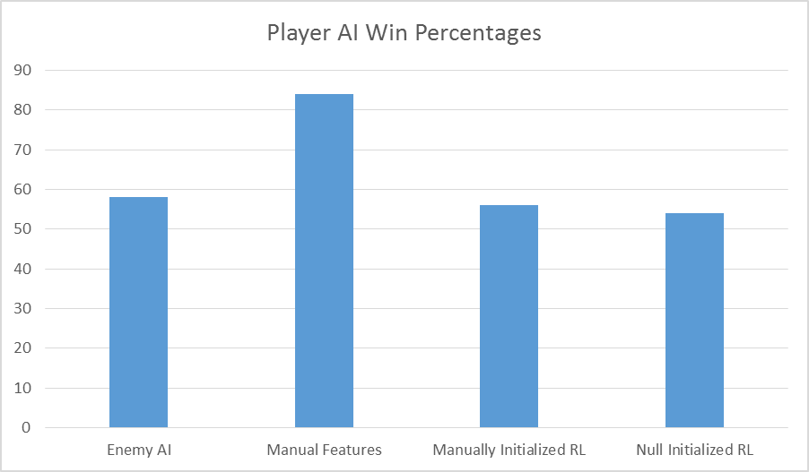

Figure 3: Win percentages of the various player AI methods. The manually inputted features perform significantly better than the naïve case (enemy AI against itself), while both reinforcement learning cases perform on par with the naïve case.

More than just winning the game however, the team also wanted to reach some milestones with regards to the performance of the algorithm in keeping characters alive in addition to winning. The strategy that has evolved out the approach that the team took, at least in the manually inputted weights case, can best be described as letting the team's high health characters engage the enemies to take and deal damage, and then mop up/whittle down the Boss with the team’s archer. This strategy, while obviously effective, often results in the meat-shields dying leaving a team that won the level but would be crippled in future engagements. Due to time constraints, little progress was able to be made by the team on this front, though it is a possible area that could be revisited by an interested team member at a later date.
Conclusion
In general, we find that the feature based evaluation function approach provides a good method for spatial reasoning in the context of Fire Emblem. While some sort of adversarial search like expectimax is often used when two players are put into competition with each other, as stated earlier, the incredibly large state space of Fire Emblem would make expectimax computationally infeasible. Our results show, however, that the evaluation function proved very successful, as our AI was able to win 84% of games using this approach, which was significantly better than the naïve approach. Our reinforcement learning was less successful however, getting results that were on par with the naïve approach. We do note, however, that due to the large amount of time training took, we were not able to train over a terribly large amount of games and did not try out vary many combinations of hyper-parameters due to time constraints. By letting the process train over more games, and by testing out various combinations of these hyper-parameters, we guess that our reinforcement learning approach could perform in a manner more on par with the manually inputted weights case.

Finally, while we acknowledge that having an AI that did not let any of the player characters die would be desirable, we feel that our current win percentages are satisfactory and show that evaluation functions provide an effective method for playing a game such as Fire Emblem.
Future Work
While the team is satisfied with the results from the manually inputted weights case, we note a number of factors that could be improved upon to improve our game playing agent. The first of these would be to continue to work on the reinforcement learning, as it did not quite give the results we expected. By trying out different hyper-parameters and training over more games, we feel more reasonable behavior might emerge. In addition to this, while expectimax would be computationally infeasible, we could implement some sort of look ahead into our evaluation function. To this effect, we could have calculated expected damage taken if all enemies in range would attack. This one step look-ahead could have made our characters much more careful in choosing movement locations. Due to time constraints, however, we did not add this feature in. Another feature we could add is health potions. While this would probably improve the win rate, it does little to affect the actual AI strategy. In addition to this, the team feels health potions are unnecessary, as most human players are able to make due in this simple level without them.

Bibliography
[1] Sanchez-Ruiz, et. All. Game AI for a Turn-based Strategy Game with Plan Adaptation and Ontology-based retrieval. Dep. Of Computer Science and Engineering, Lehigh University, PA, USA, and Dep. Of Computer Science and Engineering, Universidad Compultsense de Madrid, Spain (2008)
http://www.eecs.ucf.edu/~gitars/cap6671-2008/Papers/adaptation.pdf

[2] Bergsma, M; Spronck, P. Adaptive Spatial Reasoning for Turn-based Strategy Games. Tillburg centre for Creative Computing, Tillburg University, The Netherlands (2008)
http://www.aaai.org/Papers/AIIDE/2008/AIIDE08-027.pdf

[3] Avery, P; et all. Evolving Spatial Tactics using Influence Maps. University of Nevada, Reno, Nevada (2009)
http://www.cse.unr.edu/~sushil/pubs/newestPapers/2009/cig09/CIG2009/cig09.pdf

Appendix A
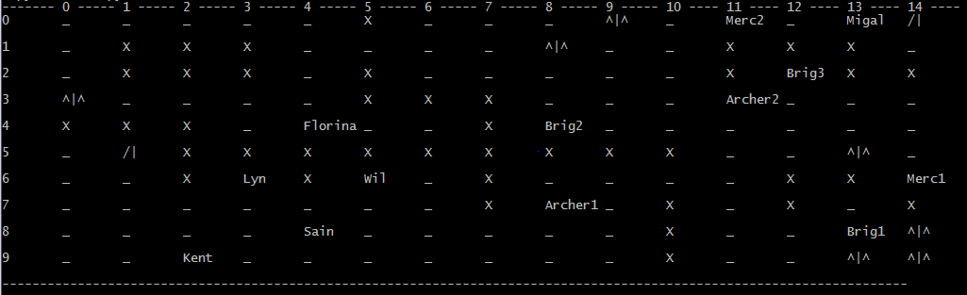
Note: the screenshot above shows an example state of our game. In this screen shot a space containing a name contains that character. A space with an underscore has no character in it and generic terrain – no effects. X indicates impassable terrain, /| mountains, and ^|^ indicates trees, which hamper movement in exchange for increased defenses.

Appendix B

If you want to look at the code itself, there is a public github repo located here: https://github.com/wnewbury/151FinalProject

