Statistics Survey

Ju Ho Yoon

07/06/15

Statistics Survey

1. What is the difference between mean, median, and mode?

-Mean measures the average value of the total sum. Median measures the middle value after putting all the values in an order. Mode is the most common value in that there could be more than one mode value.

1. Define variance. How is this related to the standard deviation?

-Variance measures the difference of individuals to the mean. Variance is the squared value of standard deviation.

1. What is a random variable?

-Random variables are variables that may occur due to chance. It can be determined by the outcome of statistical experiment.

1. What is a probability distribution? Draw a normal distribution. Label the following: mean, median, mode, standard deviation, IQR.

-Probability distribution is a distribution of a set of numbers with its probability of occurrence. Normal distribution graph will look like the following with its labels:

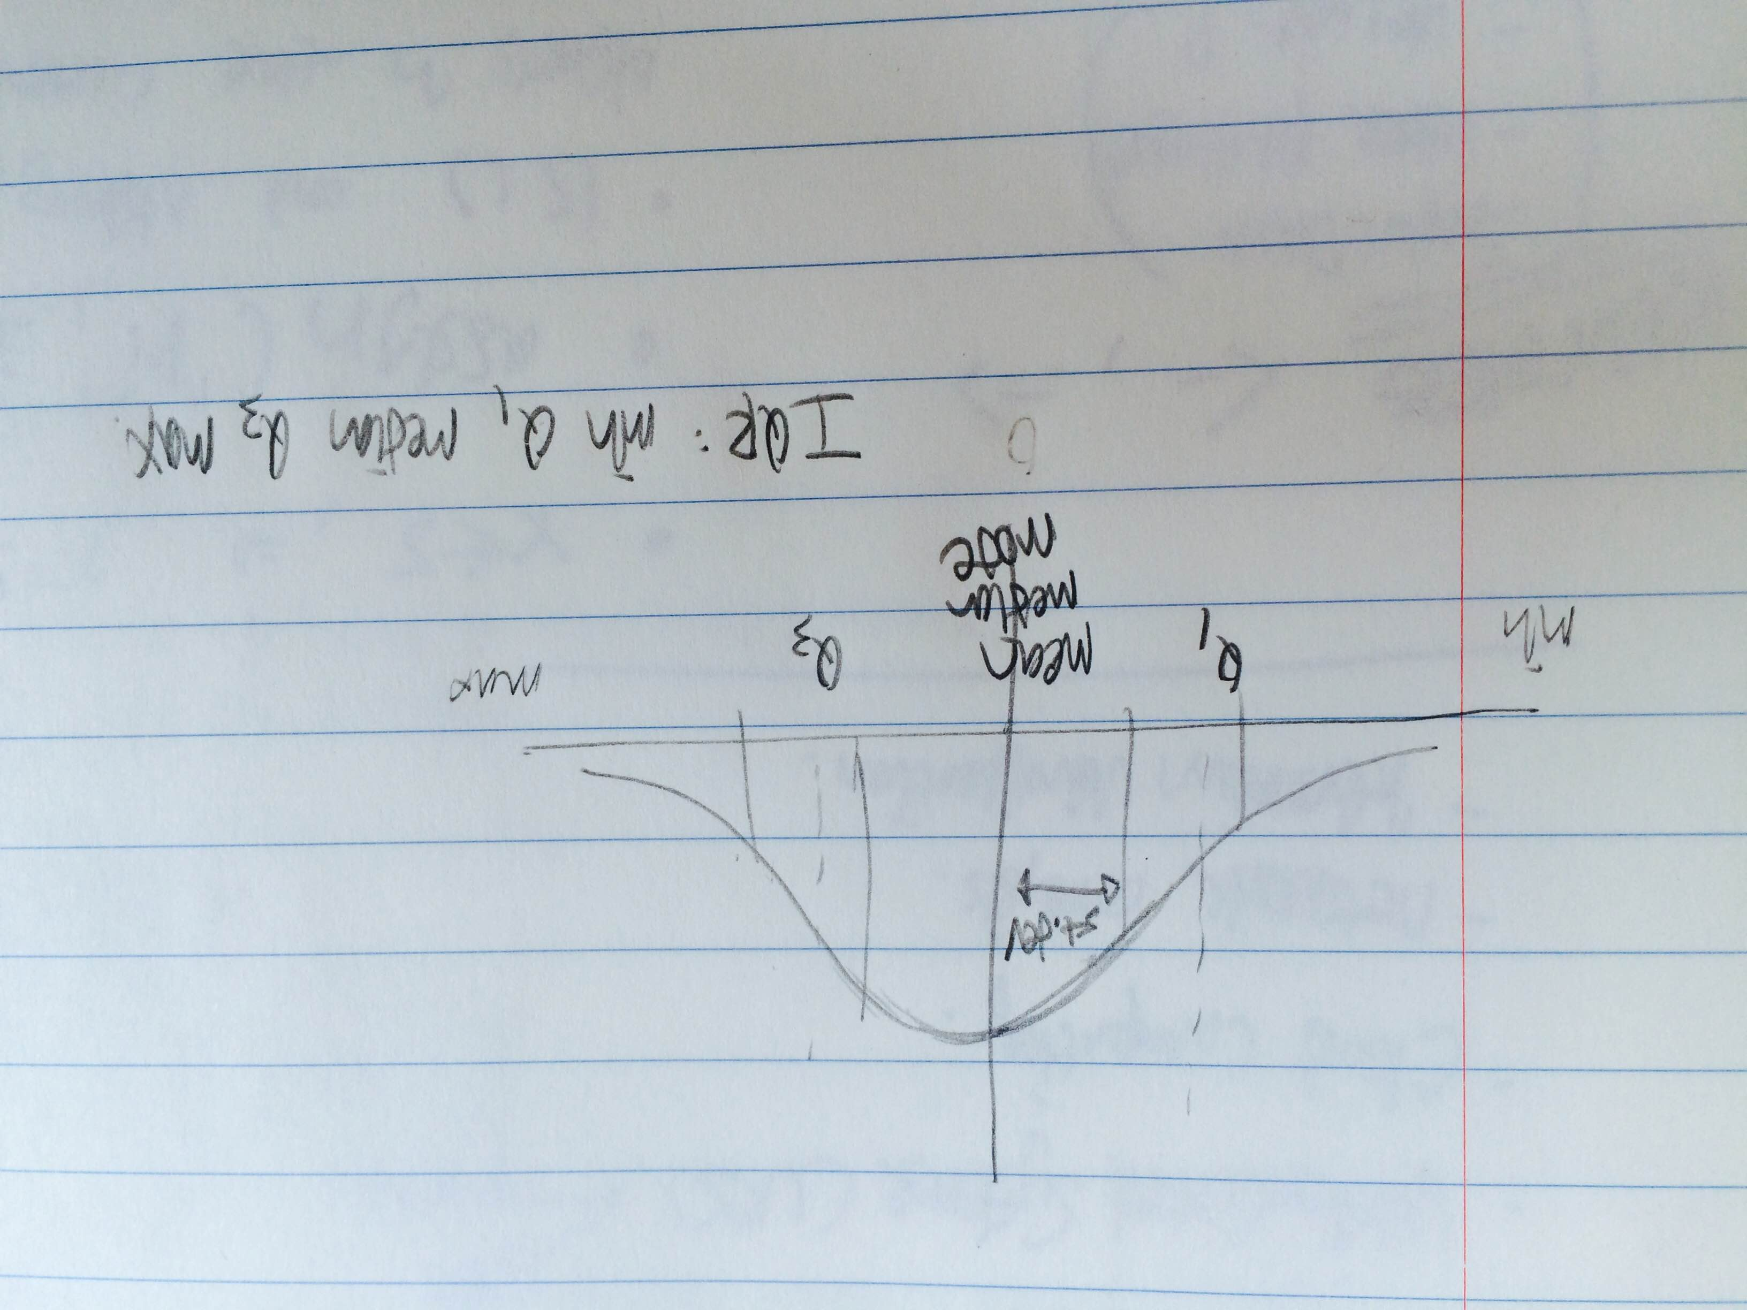

1. What is a t-test? When would you use it and why? What are the assumptions of this statistical test?

-T-test will be used to determine the p-value, which can be used to determine whether to reject or fail to reject the null hypothesis.

1. What is a chi-square test? When would use it and why? What are the assumptions of this statistical test?

-Chi-squared test… I forgot.

1. What is a null hypothesis?

-Null hypothesis is your initial hypothesis, or H0.

1. What is regression? When should you use it?

-Regressions are used to check the relationship of correlations.