Using OpenSim to Generate Hip Torque References

Xuanpeng Wang

Introduction (Heading 1)
Wearable hip exoskeleton systems require an effective strategy for generating assistive torque that is both biomechanically appropriate and responsive to user motion. While early-stage systems may rely on discrete control strategies (e.g., binary assist activation based on movement classification), more advanced approaches aim to provide continuous, state-dependent torque that better aligns with natural joint dynamics.
To design such control strategies, it is necessary to understand the underlying biomechanics of the human hip joint during locomotion. In particular, the relationship between joint kinematics (position and velocity) and the net joint moment required to produce observed motion is of interest. Access to biologically consistent hip torque profiles can inform controller design, torque magnitude limits, polarity switching behavior, and potential impedance-based control laws.
OpenSim [1][2] is an open-source musculoskeletal simulation platform capable of computing joint moments through physics-based inverse dynamics. Given motion data and external force measurements, OpenSim can estimate the net joint torque required to reproduce observed movement. While OpenSim is not intended for real-time deployment in embedded control systems, it may serve as an offline biomechanical analysis tool for generating reference torque profiles.
The objective of this report is to evaluate the feasibility of using OpenSim to generate biologically grounded hip torque references and to assess how such references may support the development of torque-based control strategies for a bidirectional hip exoskeleton system.

Materials and Methods

Software Platform
All biomechanical simulations were conducted using OpenSim (version 4.5). The gait2354 muskuloskeletal model was used for analysis. This model represents a full lower-limb musculoskeletal system with 23 degrees of freedom and 54 musculotendon actuators.
The analysis workflow followed the standard OpenSim pipeline for scaling, inverse kinematics, and inverse dynamics.
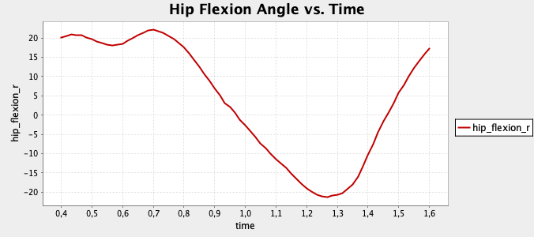

Inverse Kinematics
Inverse kinematics (IK) was performed to compute joint angle trajectories that best matched the experimental motion data.
Inputs to IK included:
- Marker trajectory data from a walking trial
- The gait2354 musculoskeletal model
The IK algorithm minimized the weighted squared error between experimental marker positions and virtual model marker positions.
The primary output of interest was the hip flexion/extension angle over time.

Inverse Dynamics
Inverse dynamics (ID) was performed to compute the net hip joint moment required to reproduce the observed motion.
Inputs to ID included [3]:
- Joint angle trajectories from IK
- Segment inertial properties defined in the model
- Ground reaction force data associated with the walking trial
Using Newton–Euler rigid body dynamics, OpenSim computed the net joint moment at each time step.

Data Extraction and Processing
The following variables were extracted from the simulation results:
- Hip flexion angle ($θ$)
- Hip flexion moment ($τ$)
Angular velocity ($\dot{θ}$) was computed from the time derivative of the hip angle trajectory.
These variables were used to analyze the relationship between hip joint kinematics and net joint torque during walking.

Results
The hip flexion angle during the analyzed gait cycle ranged from –22.113° (extension) to +22.068° (flexion), resulting in a total range of motion of approximately 44°. The trajectory was smooth and periodic, consistent with normal walking behavior. Maximum hip extension occurred at t=1.267 s, while peak flexion occurred at t=0.700 s.
- Hip flexion angle during walking (gait2354 model).
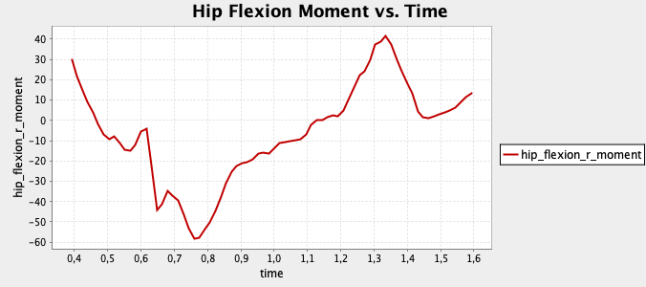

- Net hip flexion/extension moment computed via inverse dynamics.
The net hip flexion/extension moment computed via inverse dynamics exhibited substantial variation across the gait cycle. Peak extension moment reached –58.253 Nm, while peak flexion moment reached +41.425 Nm. The joint moment crossed zero during the transition between stance and swing phases, indicating a required reversal in torque direction.
The magnitude and polarity change of the hip moment indicate that continuous, bidirectional torque modulation is required to replicate biological joint behavior. Comparison of hip angle and hip moment trajectories suggests a strong dependence of joint torque on motion state, with large extension moments occurring near peak extension and flexion moments dominating during forward swing.
Further analysis of the torque–angle relationship reveals that the mapping between hip angle and joint moment is nonlinear and exhibits a loop-like structure over the gait cycle.
This nonlinear relationship indicates that joint torque is not solely determined by instantaneous position, but is influenced by additional dynamic variables such as angular velocity and phase-dependent external forces. Therefore, while hip torque can be modeled as a function of motion state, a simple linear stiffness model ($τ=kθ$) is insufficient to fully capture biological joint behavior.
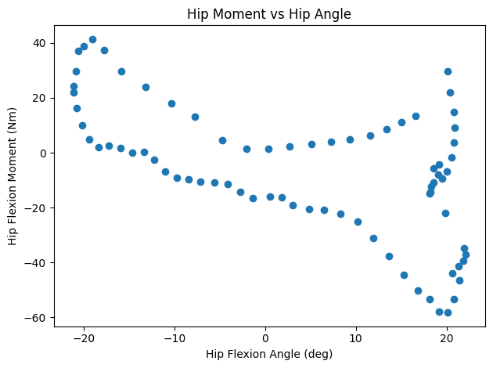
- Scatter plot of hip flexion moment versus hip flexion angle.

Discussion
The results demonstrate that biological hip joint torque during walking exhibits substantial magnitude variation and polarity reversal across the gait cycle. The observed peak extension (–58 Nm) and flexion (+41 Nm) moments confirm that a hip exoskeleton must support continuous, bidirectional torque modulation to replicate natural joint behavior.
The nonlinear, loop-like torque–angle relationship further indicates that hip joint torque cannot be accurately represented by a simple proportional stiffness model. Instead, torque depends on a combination of joint position, velocity, and phase-dependent external forces. This suggests that state-dependent modeling approaches are necessary to capture the complexity of biological joint dynamics.
In this context, OpenSim provides a valuable offline biomechanical analysis tool. By computing net hip joint moments from motion and force data via inverse dynamics, OpenSim enables the generation of biologically grounded torque reference profiles. These torque trajectories may serve as supervised learning targets for data-driven models.
A potential control architecture would involve training a neural network or regression model to map wearable sensor inputs (e.g., IMU orientation, angular velocity, encoder signals) directly to predicted hip assistive torque [4]. During deployment, the model would estimate continuous torque in real time without requiring OpenSim computation. OpenSim would therefore function exclusively as an offline reference generator during dataset preparation.
This approach offers several advantages over discrete classification-based assist strategies. Continuous torque prediction may improve biomechanical consistency, reduce abrupt torque transitions, and enhance user comfort by more closely matching natural joint loading patterns. Furthermore, once a biologically informed torque dataset has been established, the training–deployment pipeline can be iteratively refined without additional simulation effort.
However, practical implementation requires access to reliable ground reaction force data and accurate subject anthropometry to ensure high-quality torque labels. The feasibility of this approach therefore depends on the availability of appropriate experimental infrastructure.

Conclusion
This study evaluated the feasibility of using OpenSim to generate biologically grounded hip joint torque references for exoskeleton control development. Inverse dynamics analysis of the gait2354 model demonstrated that hip torque during walking exhibits significant magnitude variation, polarity reversal, and nonlinear dependence on motion state.
The torque–angle relationship was found to be nonlinear and phase-dependent, indicating that simple proportional stiffness models are insufficient to accurately reproduce biological joint behavior. These findings support the need for state-dependent or data-driven torque generation strategies.

OpenSim is not suitable for real-time deployment within embedded exoskeleton control systems. However, it serves as a powerful offline biomechanics tool capable of producing high-quality torque reference profiles. These profiles can be used as supervised learning targets for training models that map wearable sensor inputs directly to continuous assistive torque outputs.
The results support the feasibility of transitioning from discrete classification-based assist control to data-driven torque prediction models. Such an approach may improve biomechanical consistency, smoothness of assistance, and adaptability across users and movement conditions.

References
- S. L. Delp et al., “OpenSim: Open-Source Software to Create and Analyze Dynamic Simulations of Movement,” IEEE Transactions on Biomedical Engineering, vol. 54, no. 11, pp. 1940–1950, Nov. 2007, doi: https://doi.org/10.1109/tbme.2007.901024.
- ‌A. Seth et al., “OpenSim: Simulating musculoskeletal dynamics and neuromuscular control to study human and animal movement,” PLOS Computational Biology, vol. 14, no. 7, p. e1006223, Jul. 2018, doi: https://doi.org/10.1371/journal.pcbi.1006223.
- ‌D. A. Winter, Biomechanics and motor control of human movement, 4th ed. Hoboken, N.J.: Wiley, 2009.
- S. Luo et al., “Experiment-free exoskeleton assistance via learning in simulation,” Nature, vol. 630, no. 8016, pp. 353–359, Jun. 2024, doi: https://doi.org/10.1038/s41586-024-07382-4.

