Use Case Diagram
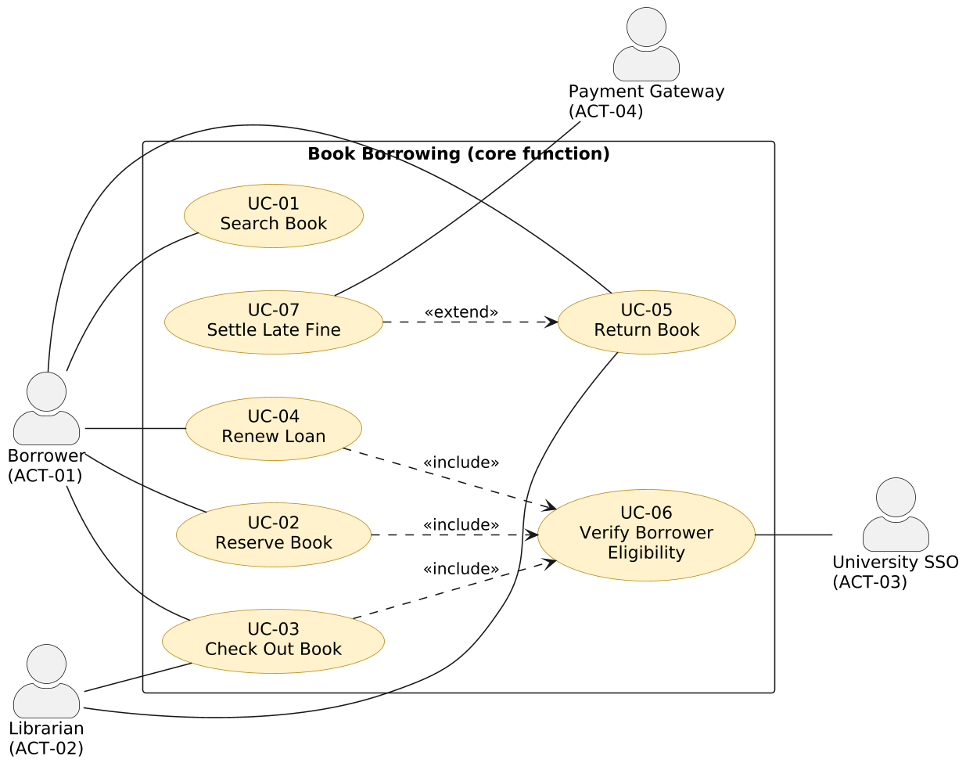

UC-03 Check Out Book
ID / Name | UC-03 Check Out Book
Scope | Book Borrowing (core function)
Level | User goal
Primary actor | ACT-01 Borrower
Secondary actors | ACT-02 Librarian (desk terminal), ACT-03 University SSO (through UC-06)
Stakeholders and interests | Borrower: wants to take the book home quickly and know the due date.  Library director: wants fewer desk queues.  Librarian: wants no manual data entry.
Preconditions | The borrower has a valid student card. The copy is physically present at the kiosk or desk.
Trigger | The borrower scans the student card at the kiosk or desk terminal.
Success guarantee | A loan exists for the copy; the copy is "on loan"; the due date is set; the borrower has seen the confirmation.
Minimal guarantee | Either a complete loan exists or none does; a copy is never left "on loan" without a loan record.
Main success scenario | 1. The borrower scans the student card.  2. The system identifies the borrower by card number.  3. The system includes UC-06 Verify Borrower Eligibility.  4. The borrower scans the barcode of the copy.  5. The system confirms that the copy is available.  6. The system confirms that the borrower has fewer than 5 active loans.
Extension points | None.
Alternative flows | 3a. The borrower is not eligible (unpaid fine or inactive account):  3a.1 The system refuses the checkout and states the reason and the amount owed.  3a.2 The use case ends.  5a. The copy is on hold for another borrower:  5a.1 The system refuses the checkout and states that the copy is reserved.  5a.2 The use case ends.  5b. The copy is on hold for this borrower:  5b.1 The system marks the reservation as fulfilled.  5b.2 Return to step 6.  6a. The borrower already has 5 active loans:  6a.1 The system refuses the checkout and lists the current loans.  6a.2 The use case ends.
Exceptions | E1. The university SSO does not respond within 10 s: the system creates no loan record and asks the borrower to retry. The minimal guarantee holds.  E2. The barcode cannot be read: the system prompts for manual entry of the copy number and resumes at step 5.
Special requirements | NFR-02 (availability), NFR-03 (authentication), NFR-04 (self-service usability)
Frequency | Approximately 400 times per day; peaks before and after lectures.
Open issues | Should staff have a higher limit than 5 active loans?

UC-05 Return Book
ID / Name | UC-05 Return Book
Scope | Book Borrowing (core function)
Level | User goal
Primary actor | ACT-02 Librarian (or ACT-01 Borrower at a return point)
Secondary actors | ACT-04 Payment Gateway (through UC-07, when the return is late)
Stakeholders and interests | Borrower: wants the loan closed and to be charged correctly.  Librarian: wants the copy back in circulation fast.  Waiting borrower: wants the copy held for them.
Preconditions | The copy is physically returned. The librarian is logged in.
Trigger | The librarian scans the barcode of the returned copy.
Success guarantee | The loan is closed; the copy is "available" or "on hold" for the first queued borrower; a fine exists if the return was late.
Minimal guarantee | The loan is either fully closed or unchanged; no partial fine is ever recorded.
Main success scenario | 1. The librarian scans the barcode of the copy.  2. The system finds the open loan of the copy.  3. The system records the return date.  4. The system checks the return date against the due date.  5. The system closes the loan.  6. The system sets the copy to "available".
Extension points | late return - after step 3. UC-07 Settle Late Fine attaches here, under the condition that the return date is later than the due date.
Alternative flows | 2a. The copy has no open loan (for example returned after repair):  2a.1 The system records a status update and terminates without a fine.  6a. The reservation queue of the book is not empty:  6a.1 The system sets the copy to "on hold" for 3 days for the first borrower in the queue.  6a.2 The system notifies that borrower.  6a.3 Continue at step 7.
Exceptions | E1. The barcode cannot be read: the system prompts for manual entry of the copy number and resumes at step 2.  E2. The data cannot be saved: the system shows an error, the loan stays open, and no fine is recorded.
Special requirements | NFR-02 (availability), NFR-03 (authentication)
Frequency | Approximately 400 times per day.
Open issues | Should a fine be capped at the price of the book?

UC-02 Reserve Book
ID / Name | UC-02 Reserve Book
Scope | Book Borrowing (core function)
Level | User goal
Primary actor | ACT-01 Borrower
Secondary actors | ACT-03 University SSO (through UC-06)
Stakeholders and interests | Borrower: wants a place in the queue for a checked-out book.  Library director: wants every title to be reservable.  Other borrowers: want a fair queue order.
Preconditions | The borrower is authenticated. The book has no available copy.
Trigger | The borrower selects "Reserve" on the record of a book.
Success guarantee | A reservation exists in the queue of the book; the borrower knows the queue position. When a copy is returned it is held for the borrower for 3 days.
Minimal guarantee | Either a complete reservation exists or none does.
Main success scenario | 1. The borrower selects a book from the search results and chooses "Reserve".  2. The system includes UC-06 Verify Borrower Eligibility.  3. The system confirms that the book has no available copy.  4. The system confirms that the borrower has no active reservation for this book.  5. The system adds the reservation to the end of the queue.  6. The system displays the queue position.
Extension points | None.
Alternative flows | 2a. The borrower is not eligible (unpaid fine):  2a.1 The system refuses the reservation and states the reason.  2a.2 The use case ends.  3a. The book has an available copy:  3a.1 The system informs the borrower that the book can be checked out now.  3a.2 The use case ends.  4a. The borrower already has an active reservation for this book:  4a.1 The system shows the current queue position.  4a.2 The use case ends.
Exceptions | E1. The university SSO does not respond within 10 s: the system creates no reservation and asks the borrower to retry.  E2. The reservation cannot be saved: the system shows an error and no queue entry exists.
Special requirements | NFR-01 (search response time), NFR-03 (authentication)
Frequency | Approximately 100 times per day.
Open issues | Should the queue be limited in length per title?

