Noun Extraction
Nouns underlined in UC-01 to UC-07 and in the user stories: borrower, book, copy, loan, reservation, queue, renewal, fine, payment, loan policy, due date, category, student card, search result, notification, barcode, librarian, kiosk.
Noun | Kept / discarded | Reason
borrower, book, copy, loan, reservation, renewal, fine, payment, loan policy | kept | Each has an identity or a state the system must store.
librarian | discarded | An actor, outside the system boundary.
due date, category, barcode, student card | discarded | Attributes of Loan, Borrower, Copy and Borrower.
queue | discarded | The ordered set of Reservations of one Book, not a separate concept.
search result, kiosk | discarded | User-interface elements.
notification | discarded | A message sent by the system, not something it remembers in this core function.

Conceptual Class Diagram
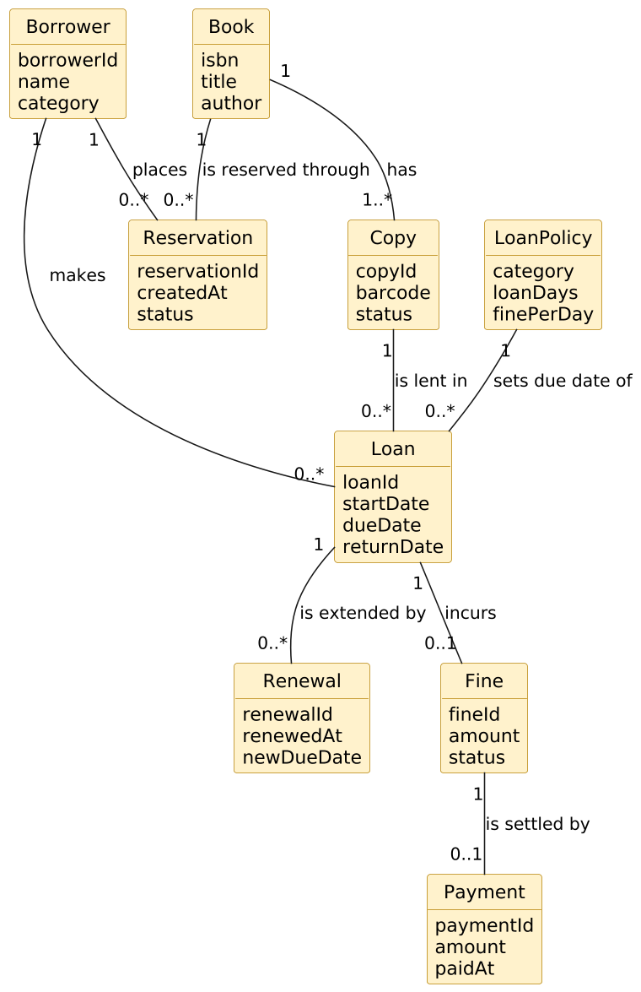

Classes and identifying attributes
Class | Attributes
Borrower | borrowerId, name, category
Book | isbn, title, author
Copy | copyId, barcode, status
Loan | loanId, startDate, dueDate, returnDate
Renewal | renewalId, renewedAt, newDueDate
Reservation | reservationId, createdAt, status
Fine | fineId, amount, status
Payment | paymentId, amount, paidAt
LoanPolicy | category, loanDays, finePerDay

Associations
From (multiplicity) | Association | To (multiplicity)
Borrower (1) | makes | Loan (0..*)
Borrower (1) | places | Reservation (0..*)
Book (1) | has | Copy (1..*)
Book (1) | is reserved through | Reservation (0..*)
Copy (1) | is lent in | Loan (0..*)
Loan (1) | is extended by | Renewal (0..*)
Loan (1) | incurs | Fine (0..1)
Fine (1) | is settled by | Payment (0..1)
LoanPolicy (1) | sets due date of | Loan (0..*)

Two checks that show the model paid for itself
- LoanPolicy appeared only in FR-13 and FR-18 and in no use case name. This shows that nobody maintains loan rules inside this core function, so policy administration is correctly out of scope; NFR-06 requires only that policy values be changeable by configuration.
- Book and Copy are kept separate. Reservations attach to the Book (a title), loans attach to the Copy (a physical item). Merging them would make US-03 (reserve a title with all copies out) impossible to express.

