**Instructions to setup the files**

**NOTE:** All reference images are located in folder “images” in the CD

1) Log onto turing.scs.ryerson.ca with your username and password

2) Move file “menu.sh” from the CD onto the server

3) Move files employee.txt, inventory.txt, maintenance.txt, tank.txt, tickets.txt from the CD onto the same directory as menu.sh was placed in from the previous step (Step 2)

4) Type the command chmod 755 menu.sh

5) Run the program with the following command: sh menu.sh

6) After running the command, the program should run and the main-menu will be shown.

Refer to file "main_menu.jpg" from

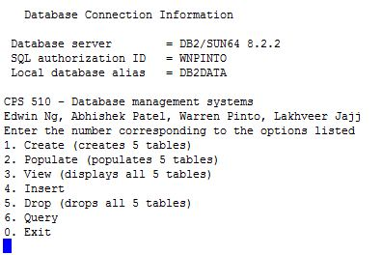

Instructions for the program menu.sh

* You will be prompted for an input after the main-menu is displayed (main_menu.jpg). Type a number from 1 to 6 to perform actions on the database.
* Type 0 to exit the program
* Type 1 to create the 5 tables. Once you press enter, 5 tables will be created.
* Once option 1 is chosen, type 2 and then press enter to populate the table.
* Once the table is populated, type 3 and then enter to view the tables. Refer to file “employee_table.jpg”. NOTE: the above mentioned files: employee.txt, inventory.txt, maintenance.txt, tank.txt, tickets.txt MUST be located in the SAME directory as menu.sh

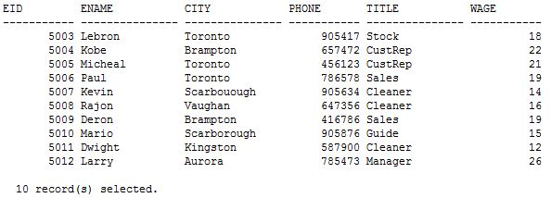

* Type 5 and then enter to drop the tables.
* Type 6 for Queries. The program will then display a list of queries. Refer to file “queries.jpg” 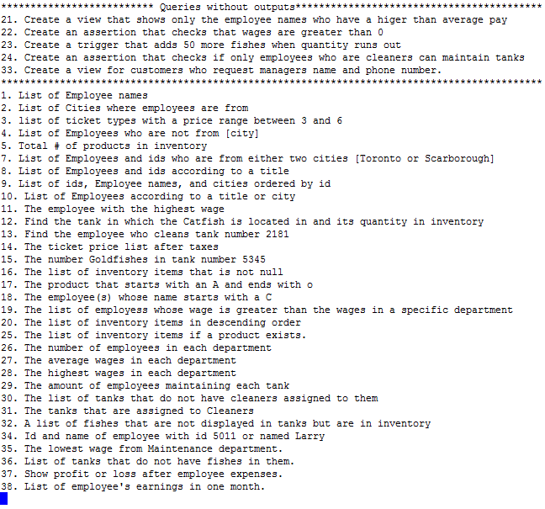
  + Type a number from 1 to 38 to perform a query.
    - Example: Type 13 to perform the query of option number 19. The output for the query will be shown. Refer to file “queries.jpg” and file “query_13.jpg”

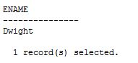

* + - Example2: Type 29 to perform the query of option number 29. The output for the query will be shown. Refer to file “queries.jpg” and file “query_29.jpg"

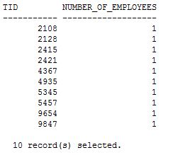

* + - From the queries submenu, type 21, then 23, then 33 to create the views and triggers