Important – remove all the hyphens and replace with commas
- Every section should fade in while moving up (opacity 0 → 1, translateY 40px → 0) as it enters the viewport. Duration: 700–900ms.
- Within each section, animate elements sequentially (heading → text → cards → button) with a 100ms delay between each for a premium feel.
- Cards should slightly lift (translateY(-6px)), increase shadow, and highlight the border on hover. Buttons should have smooth background, border, and text transitions.
- On page load, animate the hero content in sequence—headline, subheading, CTA buttons, then image/illustration—to guide user attention naturally.
- Icons can slightly scale (1 → 1.08), arrows should slide a few pixels on hover, and links should have an animated underline instead of an instant appearance.
- Use slow-moving gradients, soft glowing effects, or subtle parallax on large illustrations to add depth without distracting the user.
- Keep all animations smooth and subtle using Framer Motion (or GSAP where required). Avoid flashy effects, excessive bouncing, or long animations.
- Also keep a note of animated triggers for numbers loadings for all the stats

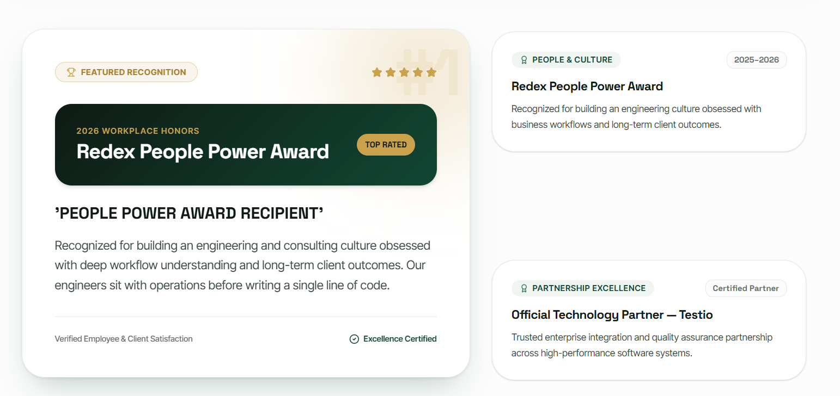
Left side card - Businesses don't fail from lack of effort—they fail from disconnected systems. When WhatsApp, Excel, emails, and scattered software become the operating model, growth slows. WnR was built to bring everything together into one intelligent system.
Alignment – “Justify”
Right side –
Redex People Power Award – Recognized for building an engineering culture focused on business outcomes and long-term relationship
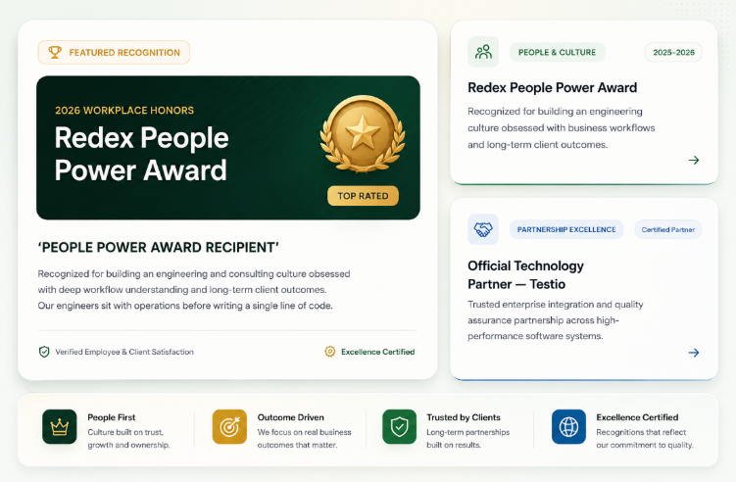
Official Technology Partner - Testio - Trusted technology partner for enterprise software systems
Alignment of the cards as to be as following

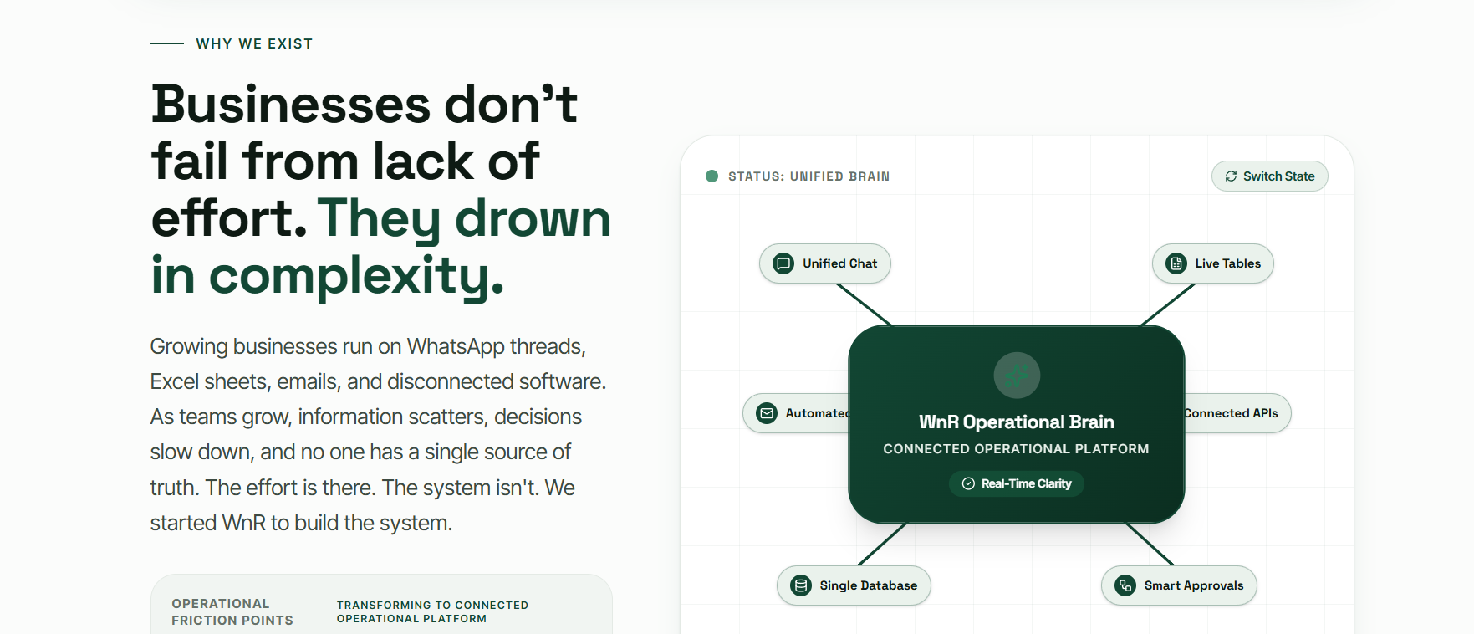
Updated content - Businesses don't fail from lack of effort—they fail from disconnected systems. When WhatsApp, Excel, emails, and scattered software become the operating model, growth slows. WnR was built to bring everything together into one intelligent system.


Edu OS content is provided separately, make use of it, we have changed the data and motives now.

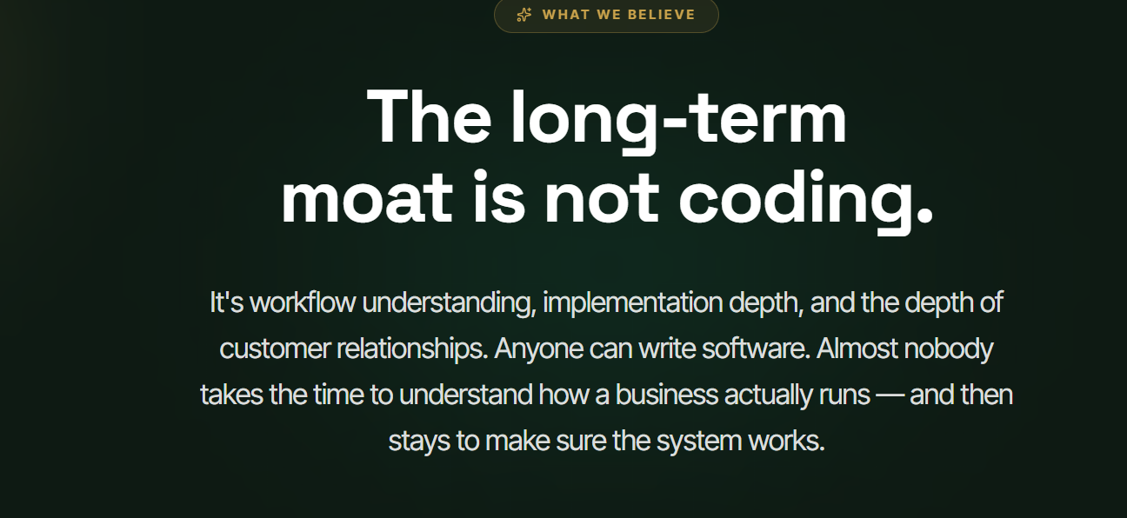
Updated content - The moat AI can't automate.
- The future doesn't belong to those who write the best code alone. Understanding a business isn't. Our advantage isn't writing code—it's understanding workflows, solving real operational problems, and staying until the solution delivers results.
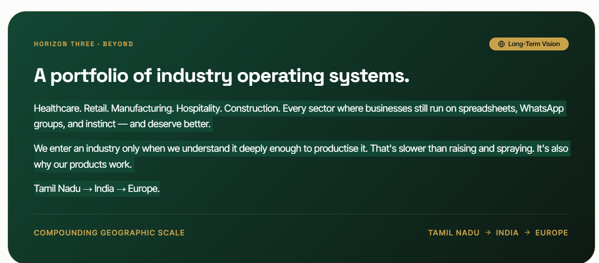
From healthcare and retail to manufacturing, hospitality, education, logistics, and financial services, every industry deserves systems built for the way it actually operates.
We don't expand into sectors—we earn the right to serve them. By deeply understanding business workflows, we create industry-specific platforms that scale across organizations, regions, and global markets.
From Neighbourhoods to Nations.

