Assignment #1. Simple Public Key System

In this presentation assignment, we are going to implement a simple java based application supporting a graphical user interface. The application should provide the following functions:

1. Message transfer/File transfer
2. RSA public key-based encryption
3. RSA digital signature

An example of UI is supported as below:

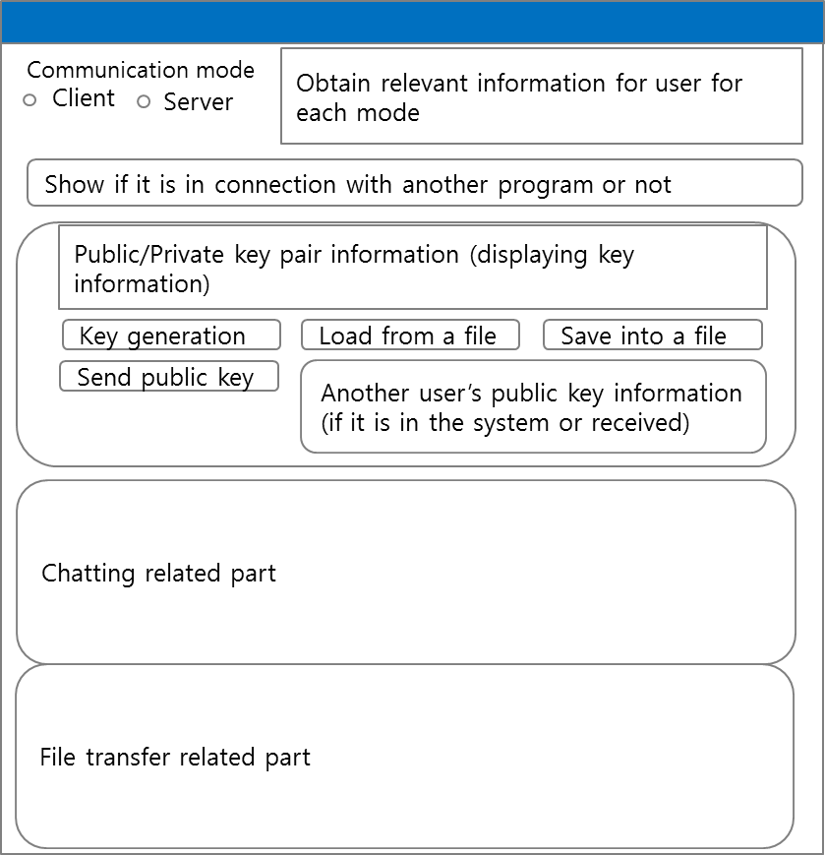

With the supplement material such as an example of executing RSA encryption/signature generation & verification, each of the students must solely implement the application. The details of the instructions and the evaluation policy is given also in the supplementary material.