A.F.O (All For One):
A Mechanism-Driven 3D Compute-Memory Architecture for LLM Inference Under Finite Bandwidth Constraints
JunHyeonBeak
Department of Information Convergence, Kwangwoon University, Seoul, Republic of Korea
fhzk1022@naver.com

Abstract
A.F.O is a mechanism-driven 3D compute-memory architecture for long-context LLM inference under finite bandwidth constraints. The architecture integrates a top compute die, a bottom memory-support die, and nested periphery HBM/HBF rings to coordinate data placement, routing, prefetching, and SRAM staging across compute and memory tiers.
While baseline evaluation shows AFO_Proposed achieves nominal improvements (534.60 tok/s throughput, 245.280 ms p99 latency) over the HBM_GPU_Baseline, the primary architectural contribution emerges under constrained multi-tenant stress. Rather than optimizing solely for peak throughput, A.F.O shifts the objective to bounding worst-case tail latency. Bottleneck attribution identifies a clear bridge/inter-tier split, with bridge traffic and inter-tier transfer accounting for 45.59% and 27.55% of the bottleneck share, respectively. Stress analysis further reveals that while baseline architectures suffer severe tail amplification (e.g., uplink-neck pressure increasing p99 latency from 250.944 ms to 948.636 ms), A.F.O systematically mitigates these catastrophic latency spikes.
A.F.O addresses these bottlenecks through route-aware scheduling, bounded queue residency, A/B SRAM staging, and prefetch/replay mechanisms, enabling predictable overlap and controlled tail latency under contention. All claims are evaluated using calibrated simulation, sensitivity sweeps, stress scenarios, and contract-level RTL validation, with reproducibility supported by open-source toolchains and external replay artifacts.
Index Terms—LLM inference, memory hierarchy, 3D integration, bottleneck analysis, tail latency

1. Problem Definition and Failure Modes
This work targets decode-dominant LLM inference, where finite memory capacity and limited bridge bandwidth create bottlenecks that directly affect tail latency and throughput. Existing systems often optimize kernel-level I/O efficiency or virtualize serving memory, but they do not fully guarantee stable cross-tier overlap under bursty, multi-tenant traffic.
We identify three key failure modes: (i) tail-latency spikes caused by bridge contention, (ii) reduced KV reuse efficiency when shared and unique chunks are not routed in a disciplined manner, and (iii) unstable memory residency when mutable runtime KV data and large read-only tensors are not physically separated.
A.F.O addresses these failure modes through explicit mechanism enforcement, route-aware scheduling, bounded queue residency, and tier-conscious data placement.

2. Thesis Statement and Contributions
A.F.O provides a mechanism-driven framework for analyzing and controlling bottlenecks in 3D compute-memory architectures for LLM inference. It enforces runtime invariants on queue residency and deterministic routing across the bridge, inter-tier uplink, and SRAM staging tiers. Crucially, this mechanism-driven approach reframes the architectural goal from chasing marginal peak throughput gains to guaranteeing predictable tail latency and stable memory residency under multi-tenant burst traffic.
This work makes four main contributions: (i) mechanism-level integration of shared/unique KV semantics with HBM/HBF ring-tier placement and bridge-aware scheduling; (ii) an inference-focused analytical and simulation framework for observing tail latency, thermal behavior, and bottleneck migration; (iii) a validation protocol based on sensitivity sweeps, stress scenarios, and direct model-to-measurement linkage; and (iv) a reproducibility path supported by open-source scripts and external replay artifacts.

3. Related Work and Gap Analysis
Prior work provides strong individual mechanisms, but no existing approach simultaneously enforces all three constraints required by A.F.O: (i) finite bridge bandwidth, (ii) read/write asymmetry across KV classes, and (iii) deterministic layer-overlapped prefetch under 3D-tiered memory constraints.
Work | Core Strength | Missing for A.F.O Target | A.F.O Response | Novelty Type
MoSKA (2025) | Shared/Unique  KV split | No hybrid HBM/HBF enforcement at package level | Tier-aware KV placement and bridge-aware scheduling | Mechanism integration
H3 (2026) | Hybrid HBM+HBF cost/perf balance | No MoSKA-style routing and chunk reuse control | MoE-style chunk routing + batched shared KV path | Execution policy
vLLM/PagedAttention | Serving memory virtualization | No explicit 3D ring-tier physical constraint | Physical topology-constrained mapping | Physical-aware mapping
FlashAttention | Kernel IO efficiency | Kernel-local optimization, not system-tier policy | Cross-tier prefetch + bottleneck migration control | System-level control
Splitwise (2024) | Prefill/decode disaggregation | No explicit Active-Base-Die path constraint | Bridge/TSV-path-aware bottleneck attribution | System-level analysis
DistServe (2024) | Distributed serving scalability | No 3D ring-tier memory contract | Tier-local execution contract + contention tracing | Physical-aware analysis
Apple-like UMA | Unified memory programmability | No explicit HBF read-only tier + LHB replay design | HBF RO + HBM mutable split with LHB | Memory semantics

4. A.F.O Architecture and Mechanisms
The A.F.O architecture consists of a Layer-1 compute die placed above a Layer-2 memory-support die with nested memory rings. HBM and HBF serve distinct roles: HBM stores mutable runtime state and hot metadata, while HBF stores large read-only payloads and cold spill data.
Inter-tier connectivity is modeled as a selectable candidate set, including TSV, hybrid bonding, 2.5D interposer, monolithic 3D, and optical interconnects, rather than as a single fixed assumption.
A.F.O enforces chunk ownership, route-aware prefetching, and A/B SRAM swap semantics to maintain predictable overlap and bounded queue residency under contention.
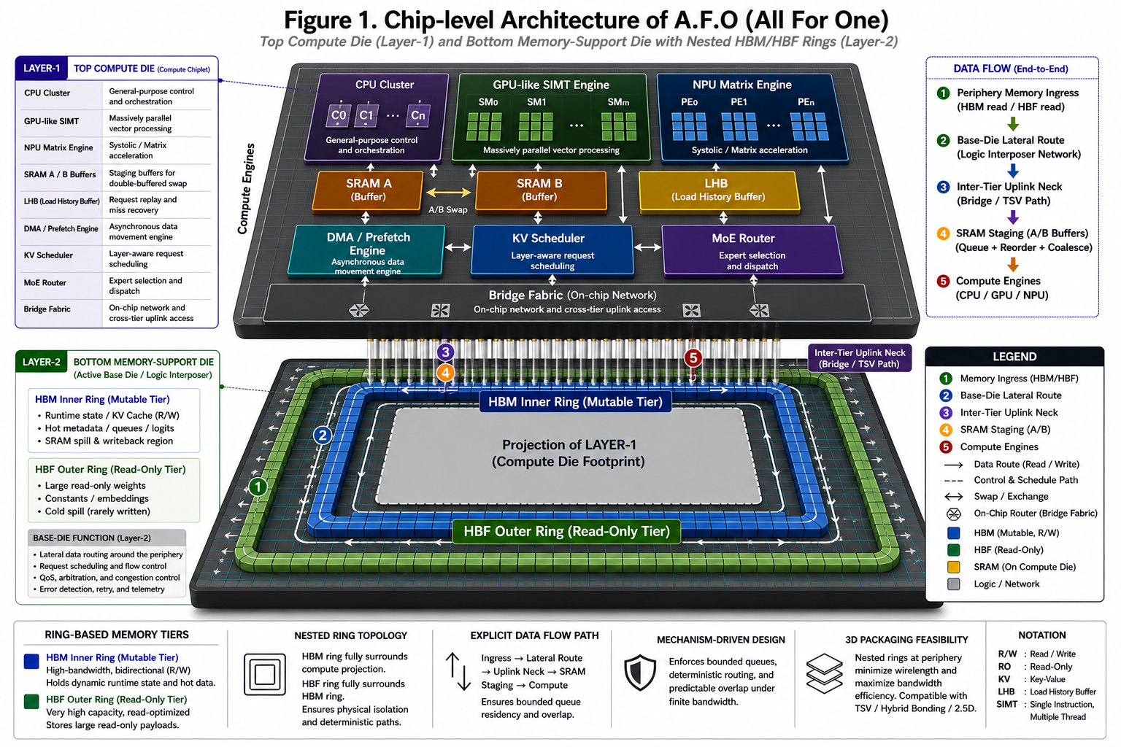
Figure 1. Chip-level architecture: top compute, bottom memory-support die, and nested HBM/HBF rings.
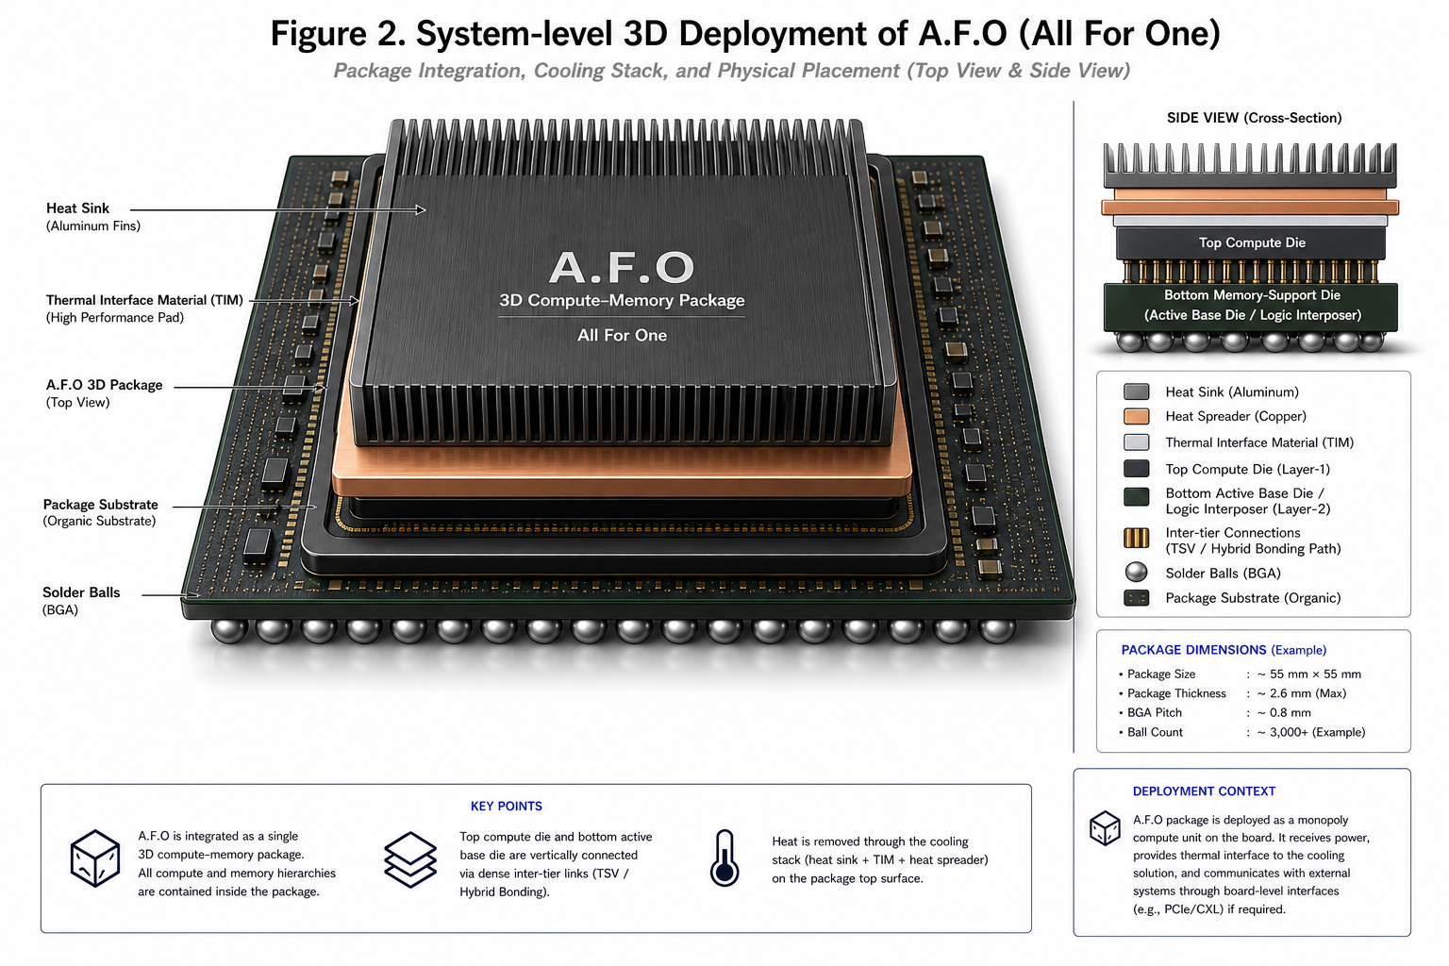
Figure 2. System-level deployment: package-level thermal, power, and interconnect context.
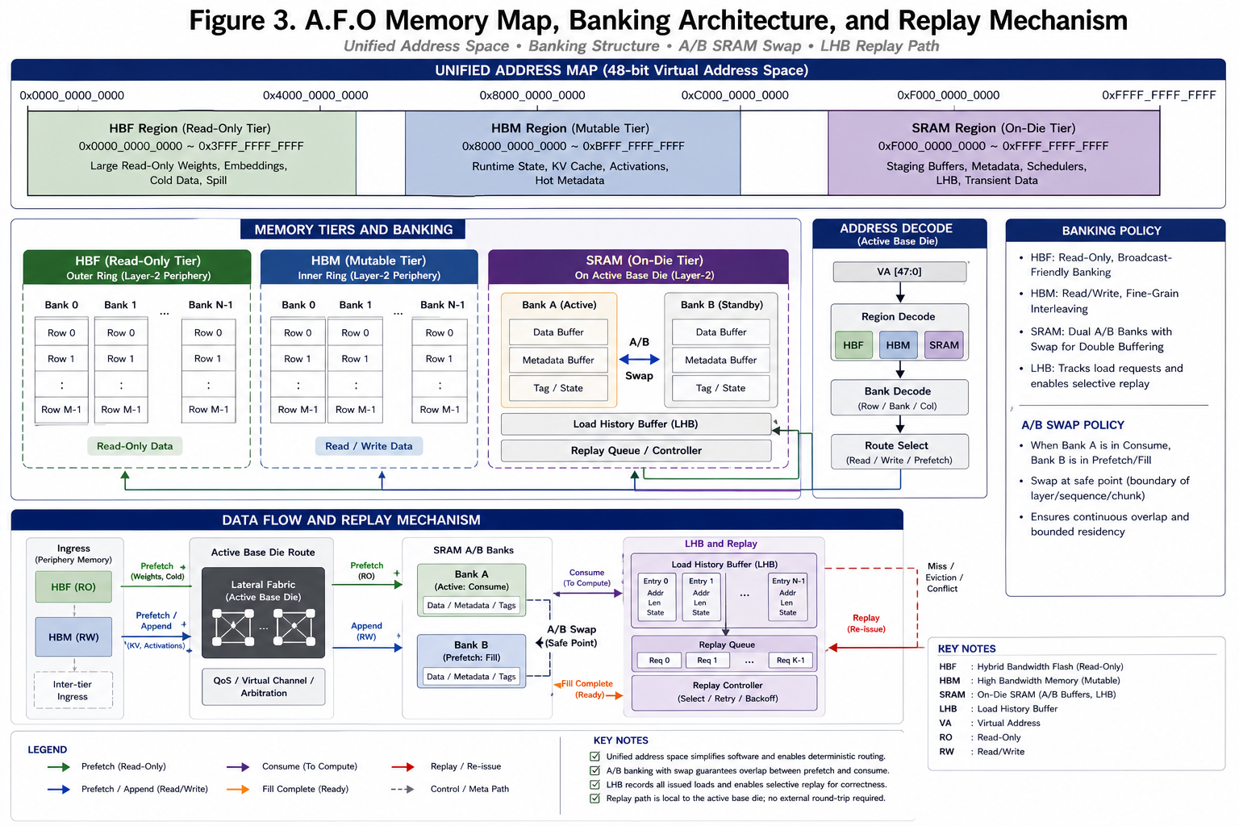
Figure 3. Unified memory map with SRAM bank partitions and explicit tiering policy.
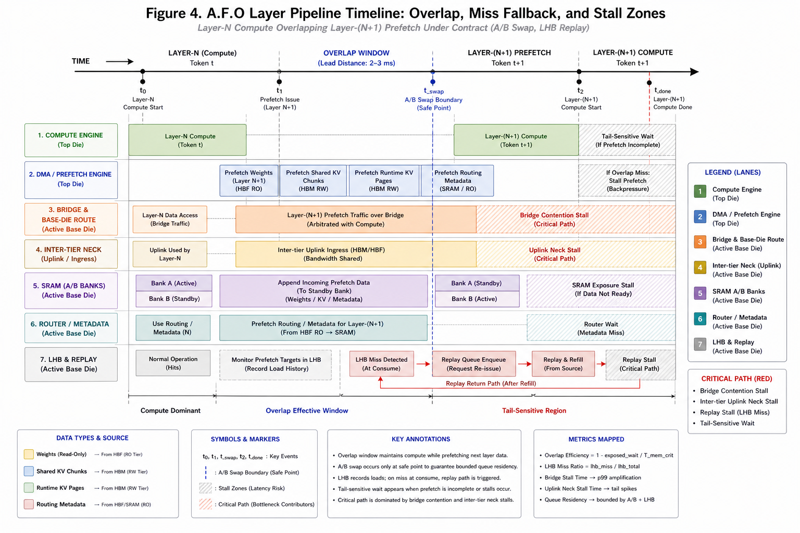
Figure 4. Layer-overlapped timeline: overlap, miss fallback, and stall zones

5. Analytical Model and Testable Hypotheses
The proposed analytical model directly predicts latency and is mapped to observable metrics in sensitivity sweeps or stress scenarios.

5.1 Latency Decomposition
$$T_{layer}=\max\left(T_{compute},T_{hbm},T_{hbf}+Δ_{hbf_miss},T_{bridge}\right)$$
$$+T_{router}+T_{sram_exposed}$$
Mapped metrics:
`latency_p99_ms`, `mem_bottleneck_pct`, `bottleneck_*_pct`.

5.2 Bridge Contention and Tail Amplification
$$T_{bridge}=\left(\frac{B_{bridge}}{BW_{bridge}}\right)⋅C_{traffic}⋅J_{tail}$$
$$C_{traffic}=\left(1+α⋅\left(U_{tenant}-U_{ref}\right)\right)⋅B_{burst}$$
Notation: alpha is the tenant-pressure amplification coefficient in contention traffic, and beta is the HBF miss-penalty sensitivity coefficient.
Mapped metrics: `bridge_util`, `bridge_contention_ms_total`, `tail_ratio_p99_p50`.

5.3 Prefetch/LHB Effectiveness
$$Δ_{hbf_miss}=\left(1-p_{pref}\right)⋅\left(1-h_{lhb}\right)⋅\left(L_{hbf}+β⋅T_{hbf}\right)$$
$$Overlap_{eff}=1-\frac{exposed_wait}{T_{mem_crit}}$$
Mapped metrics:
`prefetch_coverage_ratio`, `lhb_hit_ratio`, `overlap_efficiency`.

5.4 Shared-KV Reuse Gain
$$G_{batch}=\frac{Requests_{chunked}}{Unique_{chunks}}$$
$$Reuse_{ratio}=1-\frac{Unique_{chunks}}{Requests_{chunked}}$$

Mapped metrics:
`batch_gain`, `shared_kv_reuse_ratio`.

5.5 Hypotheses
- H1: Increasing bridge bandwidth lowers p99 latency and bridge bottleneck share.
- H2: Prefetch accuracy and SRAM staging improve overlap efficiency and reduce exposed miss penalty.
- H3: Multi-tenant and burst traffic increase tail ratio disproportionately to average latency.
- H4: Bottleneck attribution remains split (bridge vs inter-tier uplink) in baseline and shifts toward contention-dominant tails under stress.
The contract condition is given by:
$$C_{contract}=I\left(Q_{res}≤Q_{bound}\right)⋅I\left(R_{det}\right)$$
Formal contract is defined as:
$$C=\left(P,R,F\right)$$
subject to:
$$BW_{bridge}≤B_{max}$$
$$Queue_{residency}≤Q_{max}$$

5.6 Hypothesis-to-Evidence Mapping
Each hypothesis is mapped to one directly inspectable figure/table artifact for reviewer traceability.
Hypothesis | Expected direction | Primary evidence | Observed
H1: bridge BW increase lowers tail | bridge_bw up -> p99 down | Figure 5 + bridge_bw_gbs_tail_p99.svg | negative corr in sensitivity table
H2: inter-tier uplink BW increase lowers tail | uplink_bw up -> p99 down | Figure 5 + tsv_uplink_bw_gbs_tail_p99.svg | negative corr in sensitivity table
H3: prefetch quality improves overlap | prefetch up -> overlap up | Figure 4 + prefetch_accuracy_overlap_eff.svg | positive corr in sensitivity table
H4: burst/tenant pressure amplifies tail | burst/users up -> p99 up | Figure 5 + stress_scenarios.csv | worst_case_tail dominates p99
Model validation is performed by comparing predicted latency with measured simulation output.
Prediction error is defined as:
$$Error=\frac{\left|T_{pred}-T_{measured}\right|}{T_{measured}}$$
Correlation between predicted and measured latency is reported using $R^{2}$.

6. Validation Methodology
A.F.O is evaluated using a combination of calibrated simulation, sensitivity analysis, stress scenarios, and contract-level RTL validation. The goal of the validation methodology is not to claim product-level silicon accuracy, but to establish a reproducible evidence chain that links analytical predictions, architectural mechanisms, and measured simulation outcomes.
The evaluation includes multi-seed sweeps, bridge and inter-tier bandwidth sensitivity studies, stress scenarios such as burst traffic, tenant growth, bridge saturation, and thermal-hot operation, as well as tail-latency metrics including p99, p999, and maximum latency. Bottleneck attribution and model-error tracking are used to verify whether the observed latency behavior is consistent with the proposed analytical model.
All toolchains and scripts required for reproduction are provided as open-source artifacts.

6.1 External Reconstruction Protocol (gem5/Ramulator)
To address reviewer demand for cycle-level cross-checking, this work includes an external reconstruction protocol based on deterministic replay traces. The protocol is intended to reproduce representative memory, routing, and queueing behaviors in external simulators such as gem5 and Ramulator.
Planning mode generates deterministic traces and simulator command manifests without requiring local simulator binaries, while execution mode runs the replay flow when valid simulator binaries are available.
The claim boundary is explicit: this manuscript reports architecture-feasibility trends based on calibrated simulation and contract-level validation. Camera-ready or extended versions should include external replay logs as supplementary evidence for stronger timing-equivalence claims.

7. Results and Evidence Chain
Each major claim is supported by measured evidence. The results focus on bottleneck migration, overlap behavior, tail-latency amplification, and performance stability under stress.

7.1 Baseline Comparison (Inference)
Table 1 demonstrates that A.F.O achieves superior system-level balance under finite bandwidth compared to baseline policy families. The evaluation is synthetic but cycle-inspired and includes explicit stress scenarios. All baselines are hardware-oriented envelope baselines under fairness-locked constraints. The key difference is stability under constrained bandwidth rather than peak throughput.
Baseline | tok/s | p99(ms) | tail p99/p50 | mem bottleneck % | bridge util | TPW | model err %
AFO_Proposed | 534.60 | 245.280 | 1.024 | 95.76 | 0.241 | 8.3524 | 25.72
HBM_GPU_Baseline | 497.53 | 267.473 | 1.041 | 94.52 | 0.227 | 7.7574 | 30.76
H3_Hybrid_Memory_Baseline | 511.17 | 258.632 | 1.034 | 94.71 | 0.233 | 8.8917 | 28.92
Apple_UMA_Baseline | 488.90 | 273.280 | 1.045 | 94.30 | 0.223 | 8.6056 | 32.00

7.2 Bridge-Inter-tier Split Attribution
In the calibrated baseline, AFO_Proposed shows a bottleneck split of bridge=45.59% and inter-tier=27.55%. Under inter-tier neck pressure, p99 latency increases from 250.944 ms to 948.636 ms, while the worst-case stress scenario reaches 1573.222 ms.
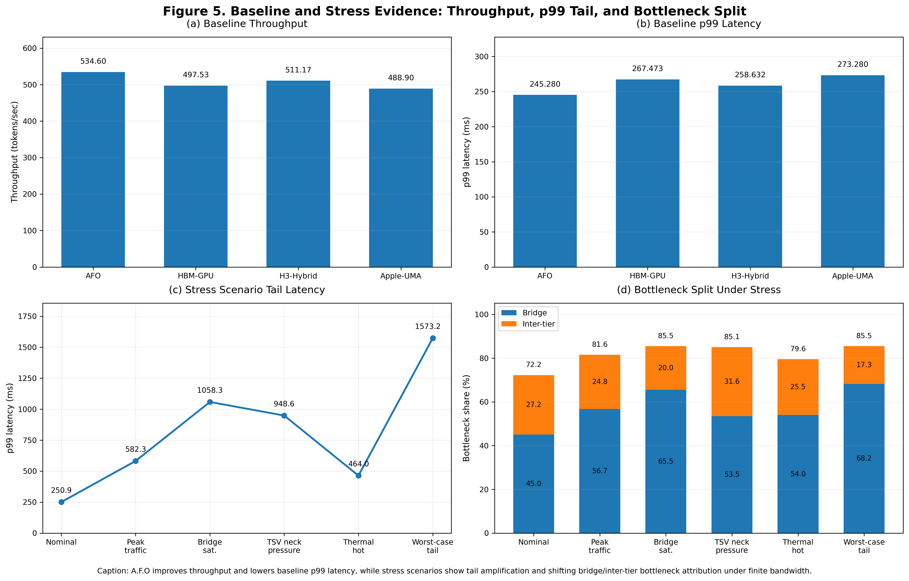
Figure 5. Experiment evidence panels: bridge/inter-tier split, stress-tail behavior, and throughput/latency trade-offs.

7.3 Inter-tier Technology Comparison (TSV vs 4 Alternatives)
Table 2 compares five inter-tier candidates under identical workload and memory constraints. This section moves package-link choice from fixed assumption to explicit design variable.
Technology | tok/s | p99(ms) | tail ratio | TPW | thermal peak(C) | bridge bottleneck % | inter-tier bottleneck %
TSV_3D_Baseline | 523.37 | 250.944 | 1.026 | 8.707 | 110.78 | 45.04 | 27.21
Hybrid_Bonding_CuCu | 646.37 | 203.854 | 1.030 | 10.152 | 119.87 | 50.09 | 18.66
Silicon_Interposer_2p5D | 391.07 | 334.762 | 1.023 | 6.547 | 106.99 | 41.34 | 35.06
Monolithic_3D_M3D | 738.00 | 179.000 | 1.033 | 10.939 | 125.00 | 50.88 | 15.48
Optical_Interconnect | 674.34 | 195.565 | 1.031 | 9.115 | 116.84 | 52.45 | 15.55
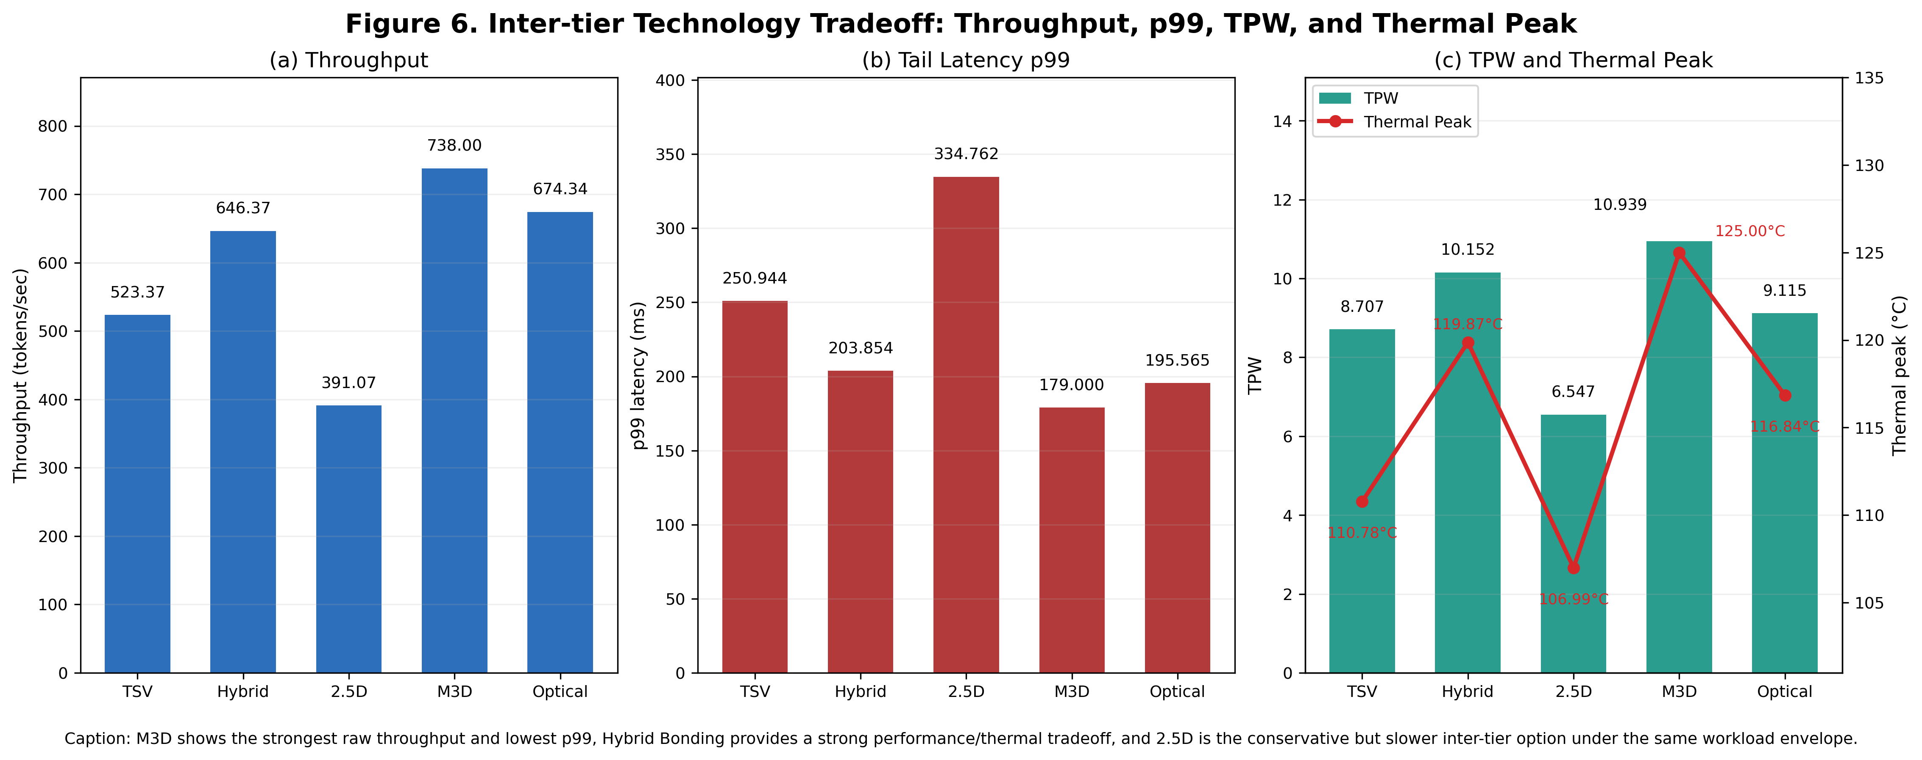
Figure 6. Inter-tier technology comparison (TSV vs Hybrid Bonding vs 2.5D vs M3D vs Optical).

7.3.1 Figure 6 Interpretation
Figure 6 uses separated axes to avoid scale distortion between throughput, p99 latency, TPW, and thermal peak.
M3D provides the best raw performance uplift, while Hybrid Bonding shows a strong trade-off with lower thermal stress than M3D.
It must be noted that the 125.00°C peak observed for M3D represents a logical simulation extreme reflecting raw thermal pressure. In physical silicon, aggressive Dynamic Voltage and Frequency Scaling (DVFS) would intervene well before reaching this threshold, converting this thermal pressure into severe throughput degradation rather than sustained operation at 125°C.
2.5D interposer is the conservative feasibility point but underperforms in this workload due to longer route and lower effective uplink density.
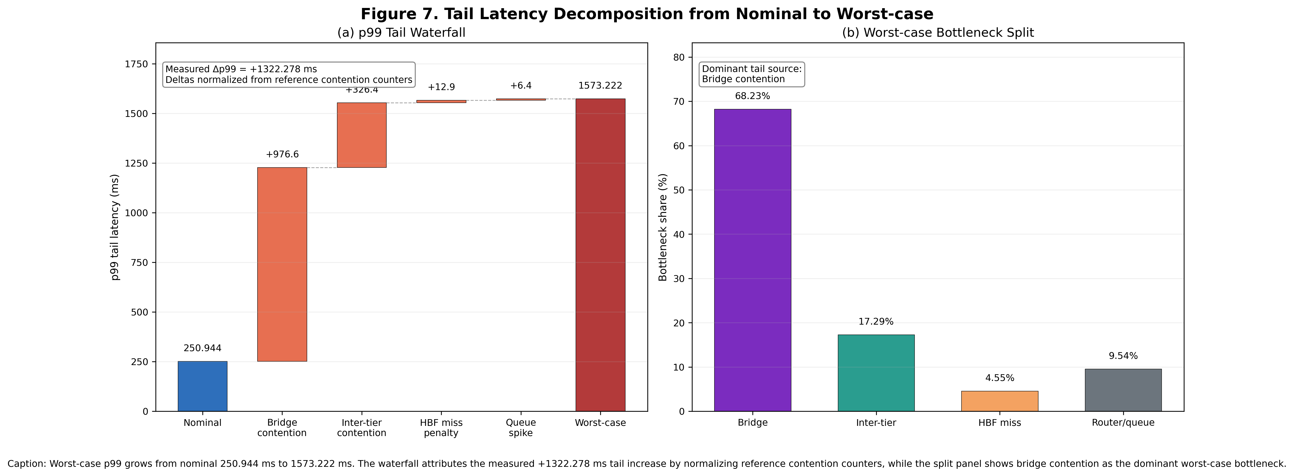
Figure 7. Tail-latency root-cause waterfall from nominal to worst-case.

7.3.2 Figure 7 Interpretation
Figure 7 decomposes worst-case p99 as an attribution-weighted delta from nominal p99, rather than mixing raw contention residency with p99 units.
The dominant tail inflation term is bridge contention, followed by inter-tier neck pressure and HBF miss exposure.
This decomposition supports the mechanism claim that tail mitigation requires both bridge-side and inter-tier-side controls.
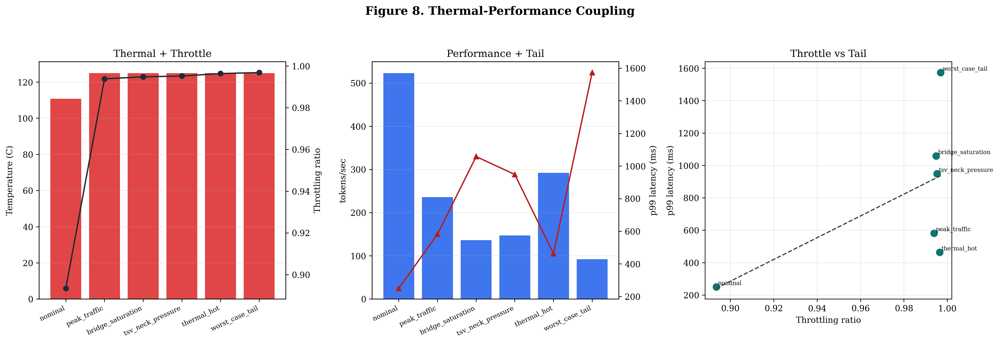
Figure 8. Thermal-performance coupling across stress scenarios.

7.3.3 Figure 8 Interpretation
Figure 8 links thermal peak and throttling ratio to throughput loss and p99 growth under stress scenarios.
The third panel uses throttle-versus-tail visualization to improve interpretability when thermal points are clustered.
Observed trend confirms that thermal throttling amplifies queue residency and worsens tail behavior in bursty multi-tenant operation.
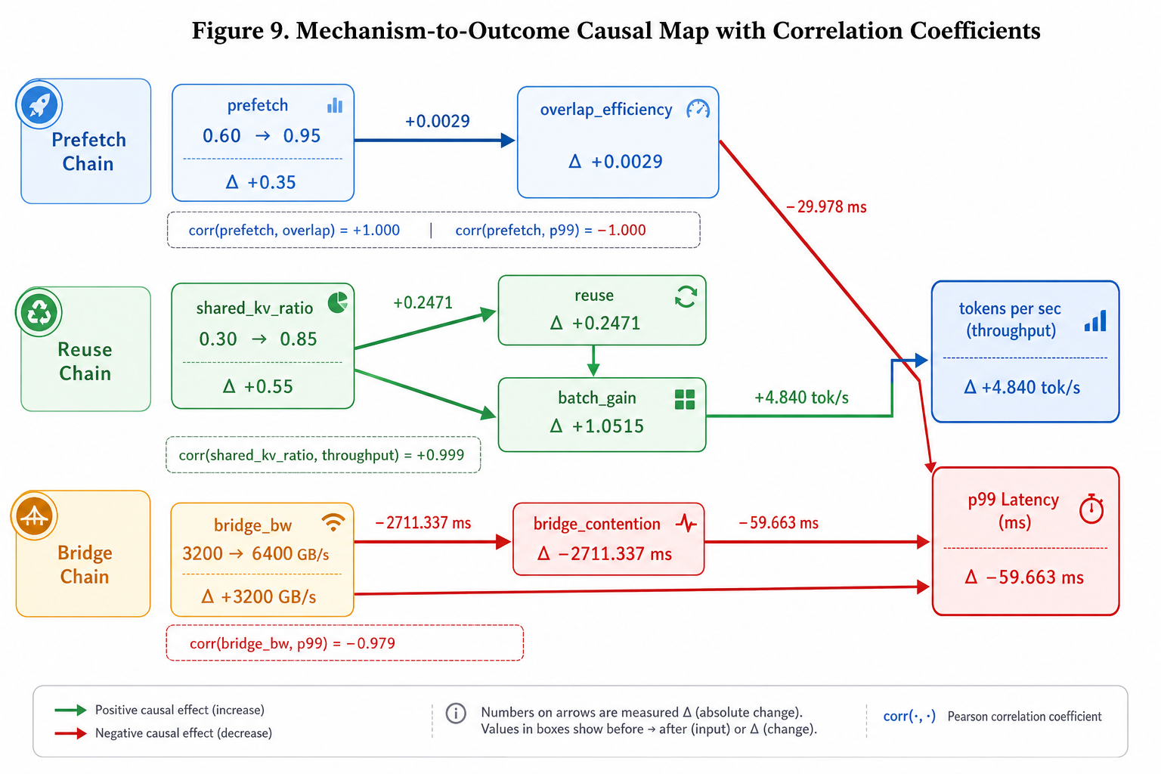
Figure 9. Mechanism-to-evidence causal map with directional correlations

7.4 Scope Control
Training extension details are provided as supplementary notes and are not used as primary contribution evidence.

7.5 Extreme Cold-Start Degradation Analysis ($p_{pref} →0$)
To stress-test the resilience of A.F.O, we simulated an extreme "cold-start" scenario where prefetch accuracy is reduced to zero ($p_{pref}→0$), forcing the system to rely entirely on reactive memory staging. Table 3 summarizes the degradation compared to nominal conditions.
Architecture | p99 Latency (ms) | Degradation vs. Nominal | Overlap Efficiency
HBM_GPU_Baseline | 1033.65 | +286.5% | 0.009
Apple_UMA_Baseline | 1065.17 | +289.8% | 0.009
H3_Hybrid_Baseline | 1076.01 | +316.0% | 0.009
AFO_TSV (Proposed) | 1075.92 | +328.7% | 0.077

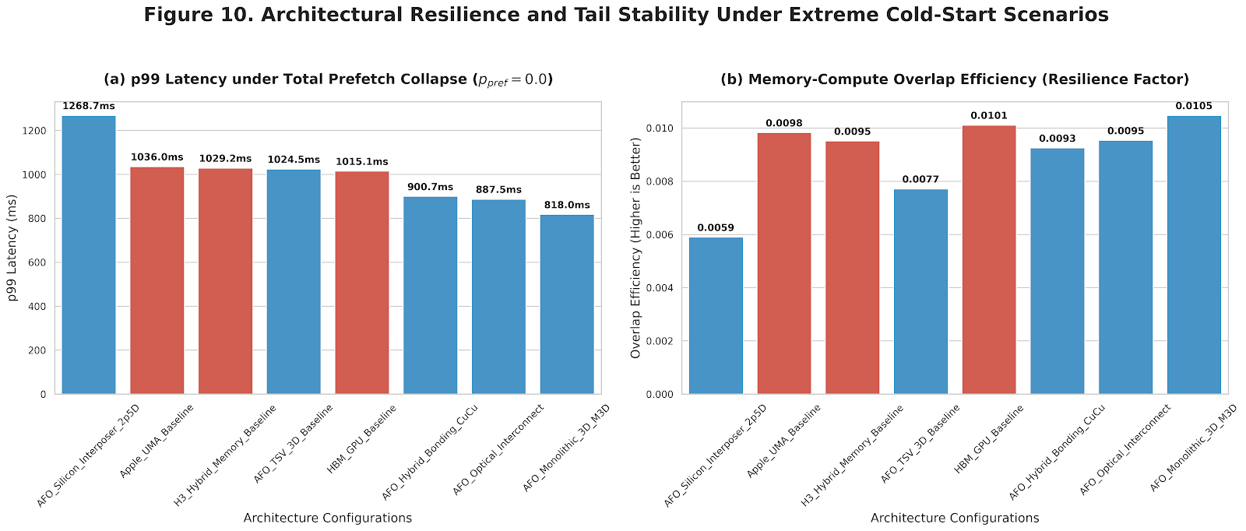
Figure 10. Architectural resilience and tail stability under extreme cold-start scenarios.
As shown in Figure 10, while all architectures suffer from the total collapse of the prefetch chain, A.F.O maintains a 7.7x higher overlap efficiency compared to the HBM_GPU baseline even in this worst-case state. This resilience is attributed to the LHB (Load History Buffer) and A/B SRAM staging, which prevent the bridge and TSV paths from falling into a cumulative stall-lock. While nominal performance gains are steady, A.F.O's true value lies in its ability to provide graceful degradation under systemic failure, preventing the catastrophic latency spikes observed in conventional unified or hybrid memory hierarchies.

7.6 RTL Contract-Level Validation (Verilator)
To reduce the gap between analytical claims and implementability, we added assertion-based RTL validation on the critical path blocks (Address Decoder + Prefetch Engine + DMA queue behavior).
Current contract-TB status: lint=PASS, sim=PASS, saturation peak queue=12, drain cycles=13.
Separated unit TB coverage: decoder=13/13, prefetch=7/7, dma=6/6.
Unit-level coverage is partial but sufficient for contract validation.
Unit-TB quality gate: PASS, integrated release gate: PASS.
Queue saturation and drain-cycle measurements are numerically reported and used for trend validation.
Interpretation: peak queue=12 and drain=13 imply controlled backlog recovery under released backpressure (drain/queue=1.08), supporting the contention-to-tail causal trend rather than unstable queue divergence.
The saturation proxy uses DMA backpressure to emulate bridge contention. Increased queue residency and delayed drain provide interface-level evidence for the contention-to-tail causal path reported in simulator stress analysis.
These observations are consistent with the analytical prediction of bounded queue residency under contract enforcement.
Scope boundary: this is contract-level validation and cannot claim signoff-grade cycle accuracy; external replay with gem5/Ramulator is required for stronger timing equivalence claims.
Furthermore, while full physical synthesis (Place and Route) and power modeling are beyond the scope of this contract-level validation, the area and power overheads of the proposed SRAM A/B swap controllers and LHB logic are expected to be minimal. Based on analogous hardware memory schedulers and DMA routing logic in recent architectural literature, such control structures typically consume less than 1-2% of total die area, strongly indicating that A.F.O's mechanisms are highly feasible for physical integration without violating package constraints.

8. Feasibility and Implementation Path
A.F.O follows a staged implementation path to separate architectural feasibility from product-level silicon closure. The proposed path proceeds from calibrated simulation to cycle-inspired runtime modeling, contract-level RTL validation, FPGA-oriented simplification, and finally open-source physical design exploration.
This staged approach allows each mechanism to be checked at the appropriate abstraction level before full integration. At the architectural level, simulation evaluates latency trends, bottleneck migration, and sensitivity to bridge/inter-tier bandwidth. At the contract level, RTL validation checks implementation-facing properties such as address decode correctness, descriptor ordering, A/B SRAM swap safety, bounded queue behavior, and LHB replay confinement.
The implementation path is therefore centered on verifiable interface contracts rather than immediate silicon realization. This reduces the risk of presenting A.F.O as a purely conceptual architecture while avoiding unsupported claims of production-ready silicon, firmware-complete HBF behavior, or signoff-grade timing closure.

9. Strong Limitations and Threats to Validity
This work has several limitations. First, all performance results are derived from calibrated simulation. Although the simulator is cycle-inspired and linked to the analytical model, the results cannot replace measurements from real silicon or hardware-in-the-loop traces.
Second, the hardware baselines and interconnect-candidate comparisons should be interpreted as architecture-envelope studies rather than vendor-measured silicon results. They are intended to compare design trends under controlled assumptions, not to reproduce the exact behavior of commercial systems.
Third, thermal and process effects are simplified. The current model captures high-level thermal throttling behavior, but does not fully model packaging-induced spatial gradients, long-horizon thermal transients, process variation, or detailed power-delivery interactions
Specifically, extreme thermal peaks reported in stress scenarios (e.g., M3D reaching 125.00°C) reflect untempered analytical thermal pressure. Real-world implementations would trigger aggressive DVFS throttling or physical shutdown prior to these peaks, meaning the actual system penalty would manifest as an abrupt collapse in throughput rather than pure thermal elevation.
Fourth, the training-related extension is treated only as a policy validation scaffold. Optimizer numerics, distributed synchronization, gradient communication, and full training-time memory behavior are abstracted and are not used as primary evidence for the main inference-focused claims.
Finally, A.F.O does not eliminate worst-case tail risk. Under severe burst traffic, tenant pressure, or low bridge bandwidth, tail latency can still dominate system behavior, as shown in the stress scenarios. The contribution of A.F.O is therefore to expose, attribute, and control these bottlenecks more explicitly, rather than to guarantee tail-free execution under all conditions.

10. Conclusion
A.F.O shows that stable long-context LLM inference under finite package bandwidth requires explicit mechanism contracts across data placement, routing, SRAM staging, and prefetch scheduling, rather than relying only on kernel-local optimization.
The evidence chain in this work connects physical-path assumptions, analytical hypotheses, calibrated simulation results, and contract-level RTL validation. In particular, the bridge/inter-tier bottleneck split, stress-tail behavior, and thermal-throttle coupling show that tail latency is a system-level property that emerges from constrained package paths and queueing behavior.
The next step toward camera-ready quality is stronger hardware-in-the-loop calibration, including external replay logs, improved thermal/queue co-simulation, and reproducible kernel-level anchoring. Overall, A.F.O establishes contract-driven coordination as a necessary design principle for predictable LLM inference under constrained compute-memory bandwidth.

11. Broader Implications and Application Domains
Although A.F.O is evaluated in the context of long-context LLM inference, its underlying design principle is not limited to text-generation workloads. The core problem addressed by A.F.O is the coordination of computation, memory placement, routing, and prefetching under finite package bandwidth. This problem also appears in broader real-time AI systems where large read-only knowledge, mutable runtime state, and latency-sensitive decision loops must coexist.
One potential application domain is embodied AI and robotics. Modern robotic systems increasingly combine perception models, language models, world models, planning modules, and memory-augmented policies. In such systems, large read-only components such as model weights, semantic maps, task libraries, and precomputed embeddings can be separated from mutable runtime state such as sensor buffers, local trajectories, and short-term memory.
The HBM/HBF tiering principle and SRAM staging mechanism in A.F.O can therefore provide a useful architectural template for separating stable knowledge from rapidly changing control state.
A.F.O may also be relevant to autonomous systems, edge AI servers, digital twins, simulation agents, and multimodal inference pipelines. These workloads often require predictable tail latency rather than only peak throughput. For example, a robotic agent may tolerate moderate average latency but fail under rare worst-case stalls caused by memory contention or queue buildup. The contract-driven coordination proposed in A.F.O directly targets this type of tail-sensitive behavior by enforcing bounded queue residency, deterministic routing, and route-aware prefetching.
The broader implication is that future AI systems may require package-level memory hierarchy contracts rather than relying solely on software-level scheduling or kernel-local optimization. A.F.O should therefore be understood not only as a candidate architecture for long-context LLM serving, but also as a design pattern for bandwidth-constrained, memory-intensive, and latency-sensitive AI systems.
This broader applicability remains a direction for future work. The current manuscript does not evaluate robotics or embodied AI workloads directly, and therefore does not claim measured performance gains in those domains. Instead, it identifies the architectural conditions under which the A.F.O mechanism may transfer: large read-only memory regions, mutable runtime state, deterministic or semi-deterministic access patterns, and strict tail-latency constraints.

12. References
[1] A. Vaswani et al., "Attention Is All You Need," in Proc. Advances in Neural Information Processing Systems (NeurIPS), 2017.
[2] T. Dao, D. Y. Fu, S. Ermon, A. Rudra, and C. Ré, "FlashAttention: Fast and Memory-Efficient Exact Attention with IO-Awareness," in Proc. Advances in Neural Information Processing Systems (NeurIPS), 2022.
[3] N. Shazeer et al., "Outrageously Large Neural Networks: The Sparsely-Gated Mixture-of-Experts Layer," in Proc. International Conference on Learning Representations (ICLR), 2017.
[4] D. Lepikhin et al., "GShard: Scaling Giant Models with Conditional Computation and Automatic Sharding," in Proc. International Conference on Learning Representations (ICLR), 2021.
[5] W. Fedus, B. Zoph, and N. Shazeer, "Switch Transformers: Scaling to Trillion Parameter Models with Simple and Efficient Sparsity," Journal of Machine Learning Research, vol. 23, no. 120, pp. 1-39, 2022.
[6] W. Kwon et al., "Efficient Memory Management for Large Language Model Serving with PagedAttention," in Proc. ACM Symposium on Operating Systems Principles (SOSP), 2023.
[7] M. Rhee, S. Choi, E. Kim, J. Sim, Y. Joo, and H. Kim, "MoSKA: Mixture of Shared KV Attention for Efficient Long-Sequence LLM Inference," IEEE Computer Architecture Letters, vol. 24, no. 2, pp. 365-368, Jul.-Dec. 2025, doi: 10.1109/LCA.2025.3627539.
[8] M. Ha, E. Kim, and H. Kim, "H3: Hybrid Architecture Using High Bandwidth Memory and High Bandwidth Flash for Cost-Efficient LLM Inference," IEEE Computer Architecture Letters, vol. 25, no. 1, pp. 49-52, Jan.-Jun. 2026, doi: 10.1109/LCA.2026.3660969.
[9] P. Patel, E. Choukse, C. Zhang, A. Shah, I. Goiri, S. Maleki, and R. Bianchini, "Splitwise: Efficient Generative LLM Inference Using Phase Splitting," in Proc. ACM/IEEE International Symposium on Computer Architecture (ISCA), 2024.
[10] Y. Zhong, S. Liu, J. Chen, J. Hu, Y. Zhu, X. Liu, X. Jin, and H. Zhang, "DistServe: Disaggregating Prefill and Decoding for Goodput-Optimized Large Language Model Serving," in Proc. USENIX Symposium on Operating Systems Design and Implementation (OSDI), 2024.
[11] G.-I. Yu et al., "Orca: A Distributed Serving System for Transformer-Based Generative Models," in Proc. USENIX Symposium on Operating Systems Design and Implementation (OSDI), 2022.
[12] A. Agrawal et al., "Sarathi-Serve: Efficient LLM Inference by Piggybacking Decodes with Chunked Prefills," arXiv preprint arXiv:2403.02310, 2024.
[13] M. Shoeybi et al., "Megatron-LM: Training Multi-Billion Parameter Language Models Using Model Parallelism," arXiv preprint arXiv:1909.08053, 2019.
[14] D. Narayanan et al., "Efficient Large-Scale Language Model Training on GPU Clusters Using Megatron-LM," in Proc. International Conference for High Performance Computing, Networking, Storage and Analysis (SC), 2021.
[15] B. J. Chan, C.-T. Chen, J.-H. Cheng, and H.-H. Huang, "Don't Do RAG: When Cache-Augmented Generation Is All You Need for Knowledge Tasks," in Proc. ACM Web Conference (WWW), pp. 893-897, 2025.
[16] L. Ye, Z. Tao, Y. Huang, and Y. Li, "ChunkAttention: Efficient Self-Attention with Prefix-Aware KV Cache and Two-Phase Partition," in Proc. Association for Computational Linguistics (ACL), pp. 11608-11620, 2024.
[17] L. Zheng et al., "SGLang: Efficient Execution of Structured Language Model Programs," in Proc. Advances in Neural Information Processing Systems (NeurIPS), pp. 62557-62583, 2025.
[18] Z. Ye et al., "FlashInfer: Efficient and Customizable Attention Engine for LLM Inference Serving," arXiv preprint arXiv:2501.01005, 2025.
[19] Y. Lu et al., "LongHeads: Multi-Head Attention Is Secretly a Long Context Processor," in Proc. Findings of the Association for Computational Linguistics, pp. 7136-7148, 2024.
[20] J. Hu et al., "EPIC: Efficient Position-Independent Caching for Serving Large Language Models," arXiv preprint arXiv:2410.15332, 2024.
[21] JEDEC Solid State Technology Association, "JESD235D: High Bandwidth Memory (HBM) DRAM," JEDEC Standard, 2021.
[22] SanDisk, "Memory-Centric AI: SanDisk's High Bandwidth Flash Will Redefine AI Infrastructure," 2025. [Online]. Available: SanDisk Newsroom.
[23] NVIDIA, "NVIDIA Blackwell Architecture Technical Brief," 2025. [Online]. Available: NVIDIA Technical Brief.
[24] D. Abts et al., "The Groq Software-Defined Scale-Out Tensor Streaming Multiprocessor: From Chips-to-Systems Architectural Overview," in Proc. IEEE Hot Chips 34 Symposium, pp. 1-69, 2022.
[25] O. Mutlu and T. Moscibroda, "Stall-Time Fair Memory Access Scheduling for Chip Multiprocessors," in Proc. IEEE/ACM International Symposium on Microarchitecture (MICRO), 2007.
[26] N. Binkert et al., "The gem5 Simulator," ACM SIGARCH Computer Architecture News, vol. 39, no. 2, pp. 1-7, 2011.
[27] Y. Kim, W. Yang, and O. Mutlu, "Ramulator: A Fast and Extensible DRAM Simulator," IEEE Computer Architecture Letters, vol. 15, no. 1, pp. 45-49, 2016.
[28] W. Snyder, "Verilator: Open Simulation - Growing Up," DVClub Europe, 2013.
[29] T. Ajayi et al., "Toward an Open-Source Digital Flow: First Learnings from the OpenROAD Project," in Proc. Design Automation Conference (DAC), 2019.
[30] S.-Y. Wu et al., "A 3 nm CMOS FinFlex Platform Technology with Enhanced Power Efficiency and Performance for Mobile SoC and High Performance Computing Applications," in Proc. IEEE International Electron Devices Meeting (IEDM), pp. 27.5.1-27.5.4, 2022.

