Installation
Installation 1
Linux Debian Based 1
Windows 7 and up 2
OpenWRT Router 2
Manually Compiled Version 3

Linux Debian Based
Install pilight by using the apt repository in Debian / Ubuntu based distributions.
- Login to your computer.
- Make sure you are running as root. Run the following command and use your own password.
pi@pilight:~# sudo su
Password:
- Add the apt repository to the apt sources list:
pi@pilight:~# echo "deb http://apt.pilight.org/ stable main" > /etc/apt/sources.list.d/pilight.list
If you want to install the nightly version of pilight then also add:
root@pilight:~# echo "deb http://apt.pilight.org/ nightly main" >> /etc/apt/sources.list.d/pilight.list
- pilight uses a signed repository. This means packages get validated before installation. So, to safely download and install pilight packages the pilight key needs to be installed.
- Now update the apt package list:
root@pilight:~# wget -O - http://apt.pilight.org/pilight.key | apt-key add -
- And install pilight
root@pilight:~# apt-get update
- When no errors are shown, pilight will be installed and automatically started at boot time. To manually start pilight:
root@pilight:~# apt-get install pilight
- And to stop pilight:
root@pilight:~# service pilight start
root@pilight:~# service pilight stop

Windows 7 and up
- Go to http://download.pilight.org.
- Download the latest Windows executable called pilight-vX.0-win32.exe. Run it to install pilight.
- By default pilight will install into to c:\pilight\.
- A default configuration can also be found in that folder.
- If you want to use the pilight USB nano you can use the pilight-usb-nano.hex found in the default folder.

OpenWRT Router
- When using OpenWRT you are assumed also to know how to login to your router with SSH.
- Go to http://download.pilight.org.
- Download the latest pilight OpenWRT compilation called pilight-Atheros-AR9132-vX.0.tar.gz.
- Unpack this file like this:
- The OpenWRT package only contains pilight-daemon to save space.
root@OpenWrt:~# tar -zxvf pilight-Atheros-AR9132-vX.0.tar.gz -C /
- A default configuration is put into /etc/pilight/config.json.

Manually Compiled Version
Manually compiling pilight is also a possibility. Use this method if you are not using a Debian-based or a *BSD based operating system.
- Login to your computer.
- Make sure you are running as root. Run the following command and use your own password.
pi@pilight:~# sudo su
Password:
- Install all packages needed for manually compiling pilight. The best way to do this depends on your operating system. The packages needed for Debian based distributions are:
  - build-essential
  - cmake
  - git
  - dialog
  - libunwind-dev
  - libpcap-dev
Use “apt-get install pakagename” to install all packages.
- Then download the pilight source code from the pilight GitHub:
root@pilight:~# git clone --depth 5 -b [branch] https://www.github.com/pilight/pilight.git
root@pilight:~# cd pilight
- Replace the [branch] with either master for the latest stable version. This version is exactly the same as the stable version available through the apt repository. Or use development for the very latest developmental build. A nightly pilight version is automatically generated each night and also available through the pilight nightly apt repository. Or use rewrite for the upcoming V8 build.
- You can include or exclude the various built-in features of pilight using the setup script by selecting/deselecting the various options. This script will not only compile all modules, but install all required pilight configuration files as well:
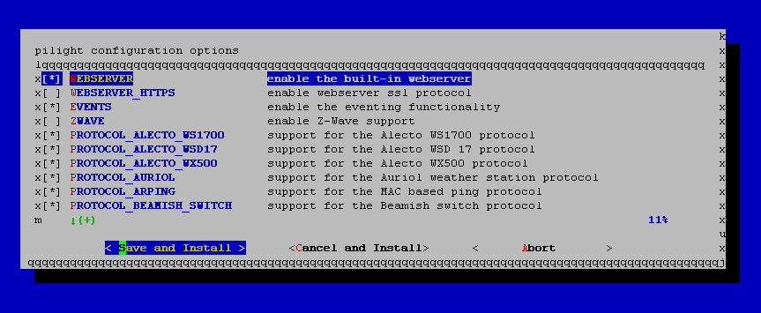
root@pilight:~/pilight# chmod +x setup.sh
root@pilight:~/pilight# ./setup.sh
- When you are thrown back into the command prompt without error(s), pilight has been installed successfully. The default configuration is installed at /etc/pilight/config.json.

- Make sure to run the following command after installation:
- pilight can now be started as a service with:
root@pilight:~/pilight# ldconfig
- For debugging purposes do not start pilight as a service, but use the following command:
root@pilight:~/pilight# service pilight start
root@pilight:~/pilight# pilight-daemon -D --debuglevel=1

