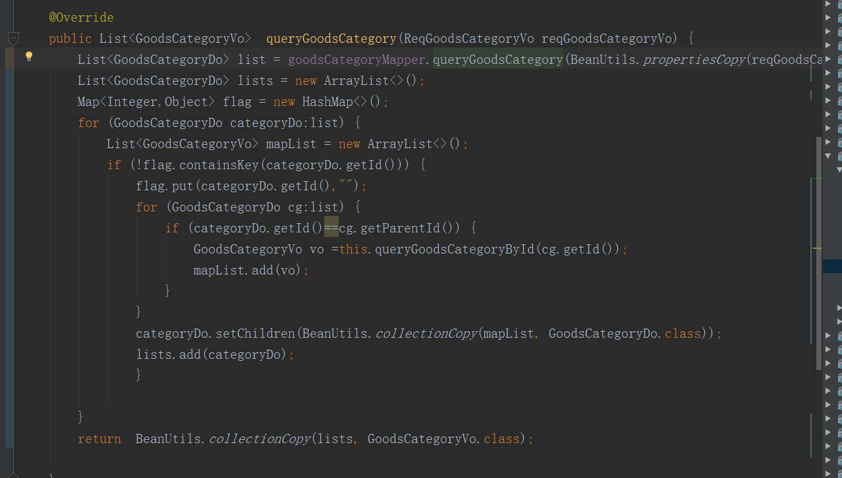

@Override  
public List<GoodsCategoryVo> queryGoodsCategory(ReqGoodsCategoryVo reqGoodsCategoryVo) {  
 List<GoodsCategoryDo> list = goodsCategoryMapper.queryGoodsCategory(BeanUtils.*propertiesCopy*(reqGoodsCategoryVo, ReqGoodsCategoryDo.class));  
 List<GoodsCategoryDo> lists = new ArrayList<>();  
 Map<Integer,Object> flag = new HashMap<>();  
 for (GoodsCategoryDo categoryDo:list) {  
 List<GoodsCategoryVo> mapList = new ArrayList<>();  
 if (!flag.containsKey(categoryDo.getId())) {  
 flag.put(categoryDo.getId(),"");  
 for (GoodsCategoryDo cg:list) {  
 if (categoryDo.getId()==cg.getParentId()) {  
 GoodsCategoryVo vo =this.queryGoodsCategoryById(cg.getId());  
 mapList.add(vo);  
 }  
 }  
 categoryDo.setChildren(BeanUtils.*collectionCopy*(mapList, GoodsCategoryDo.class));  
 lists.add(categoryDo);  
 }  
  
 }  
 return BeanUtils.*collectionCopy*(lists, GoodsCategoryVo.class);  
  
}