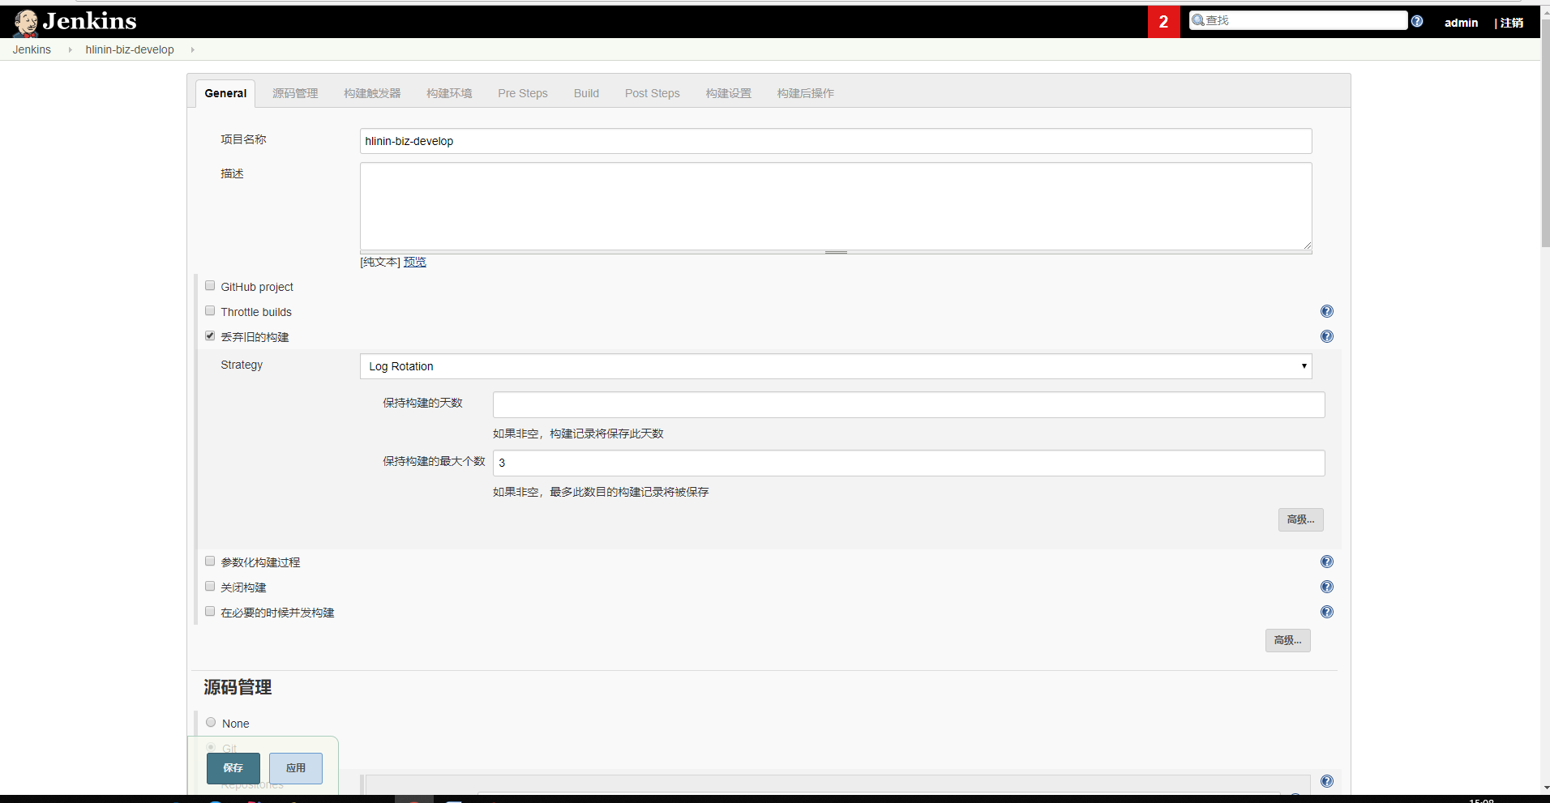

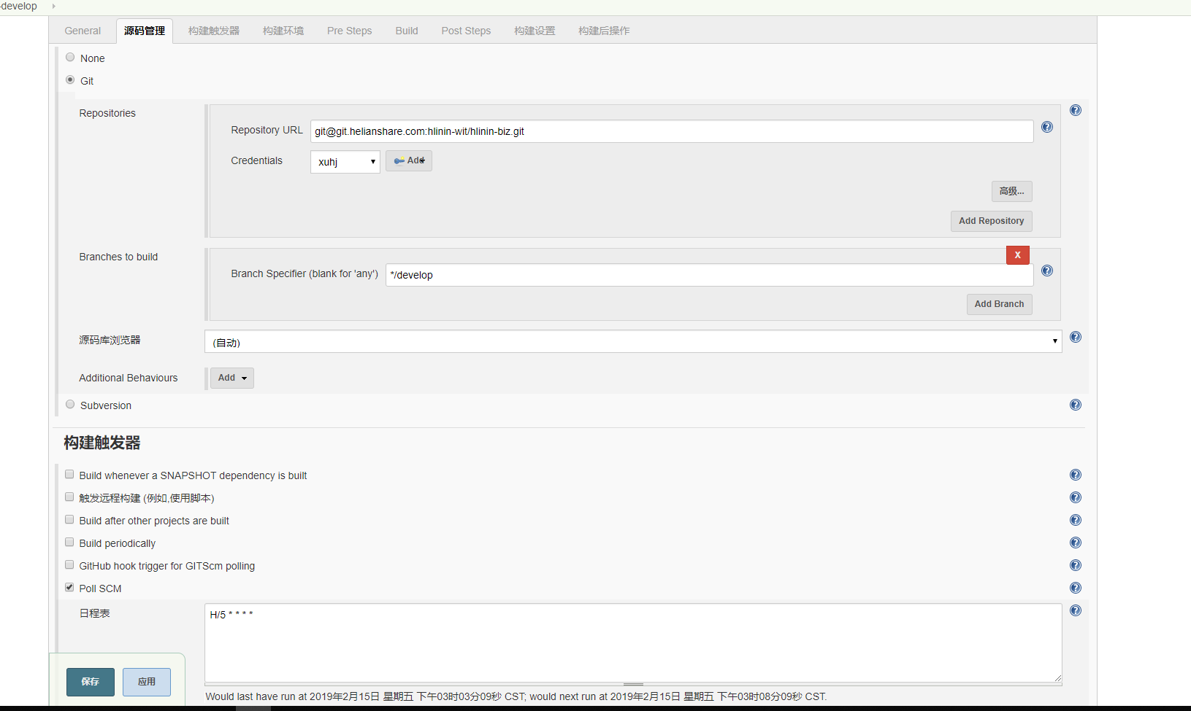

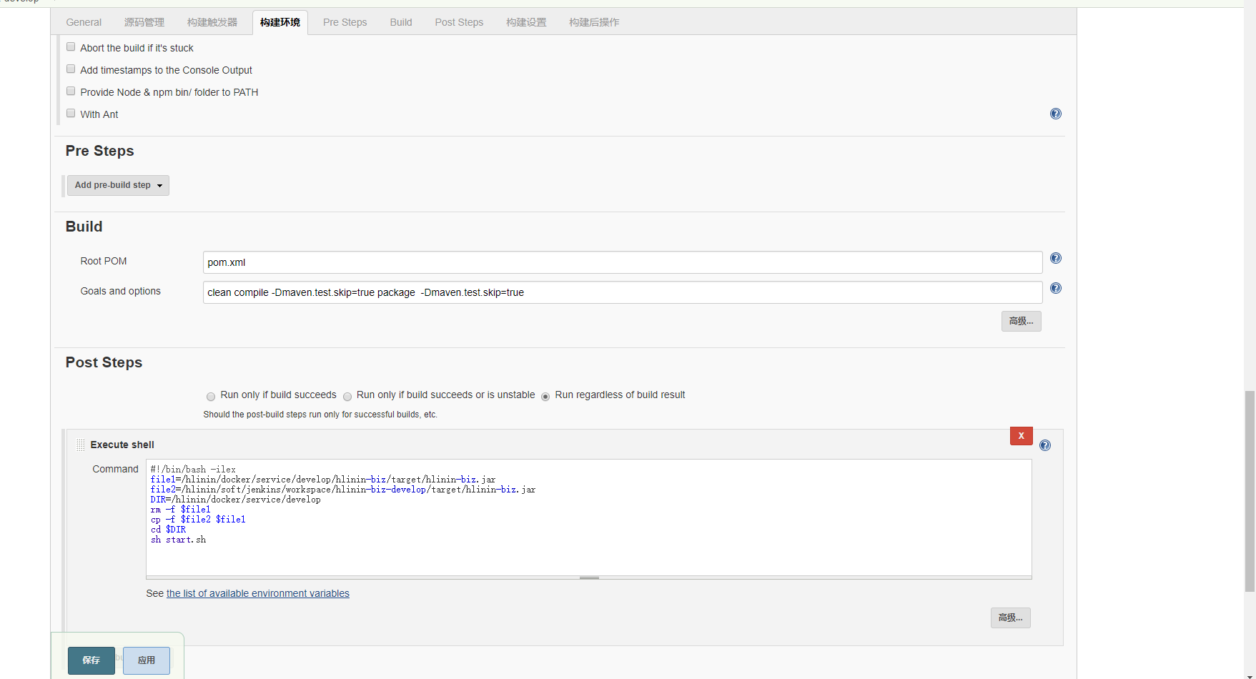

clean compile -Dmaven.test.skip=true package -Dmaven.test.skip=true  
  
#!/bin/bash -ilex

file1=/hlinin/docker/service/develop/hlinin-biz/target/hlinin-biz.jar

file2=/hlinin/soft/jenkins/workspace/hlinin-biz-develop/target/hlinin-biz.jar

DIR=/hlinin/docker/service/develop

rm -f $file1

cp -f $file2 $file1

cd $DIR

sh start.sh