1. 安装jenkins rpm -ih jenkins-2.107.2-1.1.noarch.rpm(rpm -e jenkins-2.107.2-1.1.noarch卸载服务rpm -qa|grep jenkins)
2. 修改配置文件/etc/sysconfig/jenkins中的JENKINS_HOME、JENKINS_USER=root
3. 登录密码在/var/jenkins_home/secrets/initialAdminPassword 文件中
4. 登录后安装推荐插件
5. 安装maven插件Maven Integration plugin
6. 系统管理-全局工具配置maven安装

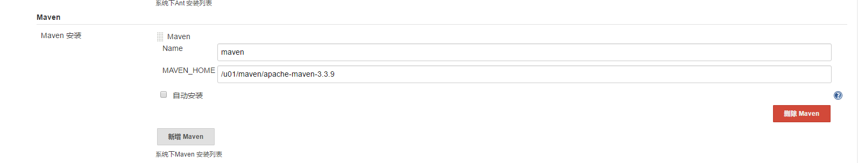

1. 安装maven,解压，配置环境变量 tar -zxvf

vim /etc/profile

export M2_HOME=/var/jenkins_home/maven/apache-maven-3.3.9

export M2=$M2_HOME/bin

export PATH=$M2:$PATH

source /etc/profile

1. 安装jdk，解压，配置环境变量

vim /etc/profile

export JAVA_HOME=/usr/local/jdk1.8.0_111

export PATH=$JAVA_HOME/bin:$PATH

export CLASSPATH=.:$JAVA_HOME/lib/dt.jar:$JAVA_HOME/lib/tools.jar

source /etc/profile

安装nodejs

tar -xvf node-v8.0.0-linux-x64.tar.xz

配置环境变量

export NODE_HOME=/usr/local/node

export PATH=$NODE_HOME/bin:$PATH

source /etc/profile

**yum -y install git**

新增java路径

vi /etc/init.d/jenkins

添加：

/usr/java/jdk1.7.0_79/bin/java jdk目录下的java可执行程序

systemctl restart jenkins

systemctl start jenkins

1. 配置git账号

ssh-keygen -t rsa // 生成 ssh key, 复制 xxx.pub 公钥到 git 服务器上即可

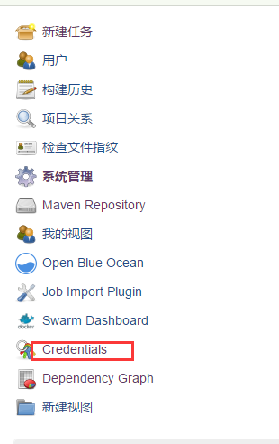

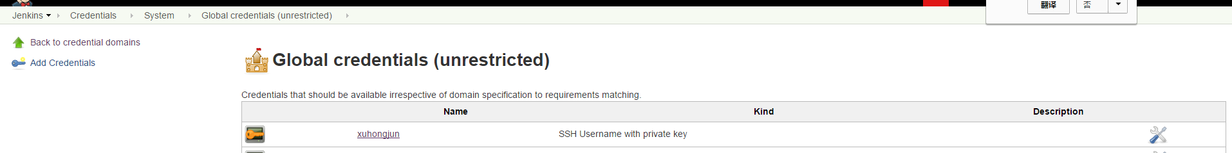

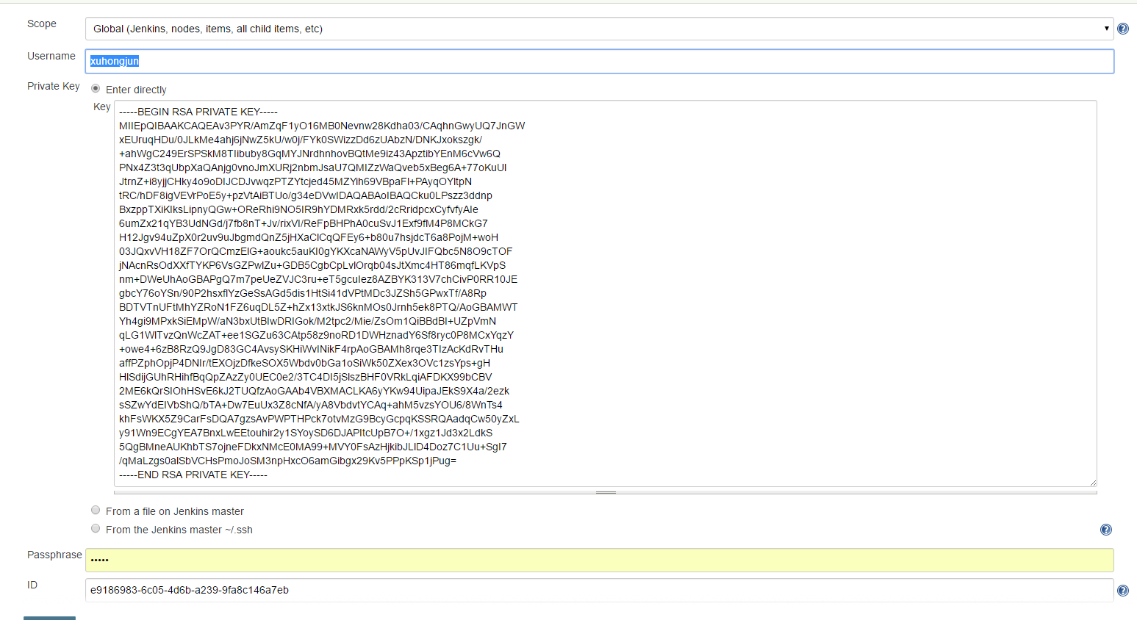

1. 新建项目的时候可以选择maven项目或者自由风格

https://blog.csdn.net/xlgen157387/article/details/50353317 Jenkins+git+maven

https://blog.csdn.net/GW569453350game/article/details/51911179

https://www.cnblogs.com/reblue520/p/7130914.html

https://www.cnblogs.com/ityouknow/archive/2017/11/26/7899349.html 发布springboot

https://blog.csdn.net/tianxiao547/article/details/77862373 linux安装

https://blog.csdn.net/dandanzmc/article/details/51935311

http://m.02405.com/wap.php?action=article&id=1168 权限