The Use of Inductively Coupled Plasma Optical Emission Spectrometry in the Multivariate Calibration of Steel Alloys: Combining Multiple Linear Regression and Ensemble Resampling Methods
Wagner Oliveira de Araujo and Cid Nelson Silva*
Instituto Federal de Educação, Ciência e Tecnologia de Goiás (IFG), Campus Anápolis, Bacharelado em Ciência da Computação, Anápolis, GO, Brazil
*cid.silva@ifg.edu.br
This study investigates the application of resampling techniques — bagging and subagging — combined with Multiple Linear Regression (MLR) for the multivariate calibration of steel alloy samples (Mn, Cr, Mo, Ni, Fe) analyzed by inductively coupled plasma optical emission spectrometry (ICP-OES)^{1, 43, 44}. The spectral dataset comprises 723 variables per sample, with 17 calibration and up to 34 test samples per element, representing a high-dimensional regime (p ≫ n) addressed via the Moore-Penrose pseudoinverse. Hyperparameter optimization was performed using 5-fold cross-validation applied exclusively to the calibration set. Results show no universally superior technique: MLR-subagging achieved the best Root Mean Square Error of Prediction (RMSEP) for Mn (0.0966) and Ni (1.6003); MLR-bagging was superior for Fe (RMSEP = 2.6406); and classical MLR performed best for Mo and Cr. All models yielded R² > 0.98. Notably, MLR-subagging was on average 3.0 times faster than MLR-bagging, establishing it as a highly balanced alternative between predictive accuracy and computational efficiency for industrial applications.
Keywords: resampling; multivariate calibration; bagging; subagging; chemometrics; steel alloys.

Introduction
Multivariate calibration plays a fundamental role in analytical chemistry and industrial quality control, enabling the extraction of quantitative information from complex spectral data¹⁻³. Statistical modeling of multivariate data has been extensively discussed in the literature,^{9, 10} and chemometric approaches have proven particularly effective for spectral quantification.⁴⁴
In spectrometric analysis, datasets frequently present a “large p, small n” problem, where the number of spectral variables (p) vastly exceeds the number of available calibration samples (n). While Partial Least Squares (PLS) is the standard approach to handle this multicollinearity, ensemble methods combined with Multiple Linear Regression (MLR) offer a compelling, computationally lightweight alternative. By aggregating multiple models trained on resampled data, bagging and subagging inherently reduce prediction variance without the need for latent variable extraction,²⁰ building on the resampling theory established by Efron.^{16, 17}
This work aims to compare classical MLR, MLR-bagging, and MLR-subagging for the multivariate calibration of steel alloy spectra. We evaluate predictive accuracy (RMSEP, MAE, R²) and computational efficiency, with hyperparameter selection conducted via rigorous 5-fold cross-validation to ensure methodological reproducibility.^{4, 5}
Experimental
Steel alloy dataset

Table 1. Dimensions of calibration and test datasets for each analyte
Element | Calibration set | Test set
Mn | Xcal (17×723), Ycal (17×1) | Xtest (34×723), ytest (34×1)
Mo | Xcal (17×723), Ycal (17×1) | Xtest (21×723), ytest (21×1)
Cr | Xcal (17×723), Ycal (17×1) | Xtest (34×723), ytest (34×1)
Ni | Xcal (17×723), Ycal (17×1) | Xtest (20×723), ytest (20×1)
Fe | Xcal (17×723), Ycal (17×1) | Xtest (34×723), ytest (34×1)
Each sample is represented by 723 spectral variables. Although the calibration set is small (n=17) relative to the number of predictors (p=723), this reflects realistic, resource-constrained industrial scenarios where obtaining certified reference materials is costly. To mitigate the inherent risk of overfitting in this p ≫ n regime, the Moore-Penrose pseudoinverse is employed, and rigorous 5-fold cross-validation is applied exclusively to the calibration set to ensure model generalization and prevent data leakage.⁴³⁻⁴⁵ Furthermore, no spectral pre-processing (e.g., baseline correction or autoscaling) was applied prior to modeling, as the ensemble aggregation inherently provides robustness against minor spectral shifts and noise.
Multiple Linear Regression
The MLR coefficients are estimated as:
β̂ = X⁺y ≜ (XᵀX)⁻¹Xᵀy (1)
This formulation provides a unique minimum-norm solution even for under-determined systems, as is inherent in high-dimensional spectrometric data.^{3, 6} When classical assumptions such as homoscedasticity and normality of residuals are violated, robust alternatives become necessary.^{7, 8}
Bagging and Subagging
The bagging prediction is formulated as:
ŷ̂bag = (1/B) ∑ᵇⁱⁱⁱᵉ ŷ̂(b) (2)
Bootstrap resampling provides the theoretical foundation for both techniques, enabling the estimation of prediction error distributions without parametric assumptions.¹⁶⁻¹⁹ Recent advances have extended bootstrap inference to functional regression,¹¹ mediation analysis,¹² multiplier bootstrap,¹³ and cross-validation for randomized ensembles.^{14, 15}
Bagging has been successfully applied to ridge regression,²⁶ PLS models in pharmaceutical analysis,^{23, 28} geospatial classification,²⁷ and calibration transfer in spectrometry.³⁰ Empirical comparisons confirm its variance-reduction effect across diverse regression tasks,^{31, 32} and chemometric applications further demonstrate the suitability of ensemble strategies for complex spectral data.²⁴
Subagging (subsampling aggregation) has been applied to extreme learning machines for spectral analysis,³⁸ Gaussian process modeling,³⁶ credit scoring,⁴⁰ network anomaly detection,³⁹ and treatment regime estimation.³⁷ Theoretical conditions for its convergence and asymptotic efficiency have been established,^{34, 42} and variance quantification under a u-statistic framework has been investigated.⁴¹ Extensions to boosted probit trees³⁵ further illustrate the versatility of subsampling aggregation strategies.
Hyperparameter selection and evaluation metrics
Model performance was evaluated using standard chemometric metrics:
RMSEP = √[ (1/n) ∑(ŷᵢ − yᵢ)² ] (3)
MAE = (1/n) ∑ |ŷᵢ − yᵢ| (4)
R² = 1 − ∑(ŷᵢ − yᵢ)² / ∑(ȳ − yᵢ)² (5)
All algorithms were implemented in Java SE-17 (Eclipse IDE 2025-09) using EJML 0.43.1 for matrix operations and JFreeChart 1.5.4 for visualization. Grid search covered the number of estimators m ∈ {5, 10, 20, 30, 50} and the subsampling fraction k ∈ {0.50, 0.60, 0.70, 0.80}.^{22, 29, 46-49}
Results and Discussion
Predictive performance
Table 2. Comparative performance of MLR, MLR-bagging and MLR-subagging for steel alloy elements. Optimized parameters: 5-fold CV (seed = 42). (*) denotes the best RMSEP per element.
Element | Technique | RMSEP | MAE | R² | Time (ms)
Mn | MLR | 0.1051 | 0.0887 | 0.9907 | 2.4
 | MLR-bagging | 0.1072 | 0.0908 | 0.9903 | 68.2
 | MLR-subagging* | 0.0966* | 0.0805* | 0.9922* | 17.1
Mo | MLR* | 0.2633* | 0.1952* | 0.9882* | 2.4
 | MLR-bagging | 0.3388 | 0.2722 | 0.9805 | 67.5
 | MLR-subagging | 0.2879 | 0.2201 | 0.9859 | 46.8
Cr | MLR* | 1.0798* | 0.8654* | 0.9938* | 2.5
 | MLR-bagging | 1.2089 | 0.9830 | 0.9922 | 44.5
 | MLR-subagging | 1.1294 | 0.9010 | 0.9932 | 46.8
Ni | MLR | 1.6043 | 1.3256 | 0.9837 | 2.3
 | MLR-subagging* | 1.6003* | 1.2409* | 0.9838* | 10.6
 | MLR-bagging | 1.7085 | 1.4122 | 0.9815 | 66.6
Fe | MLR | 2.7513 | 2.1865 | 0.9892 | 13.5
 | MLR-bagging* | 2.6406* | 2.0246* | 0.9900* | 97.2
 | MLR-subagging | 2.6509 | 2.0578 | 0.9900 | 41.2
MLR-subagging: k* = 80% (Mn, Mo, Cr, Fe), 60% (Ni). MLR-bagging: m* = 30 (all). MLR-subagging m*: 10 (Mn, Ni), 30 (Mo, Cr, Fe).
The results indicate that no single technique universally dominates across all analytes. The superior performance of classical MLR for Mo and Cr suggests that their specific emission lines in this dataset suffer from minimal spectral interference, allowing a simple, low-variance linear model to suffice. Conversely, the spectral complexity of Fe likely introduces higher multicollinearity, where the variance-reduction property of bagging provides a distinct predictive advantage.
Figure 1. Predicted vs. Reference concentration values for Mn: (a) MLR, (b) MLR-Bagging (m*=30), (c) MLR-Subagging (k*=80%, m*=10).
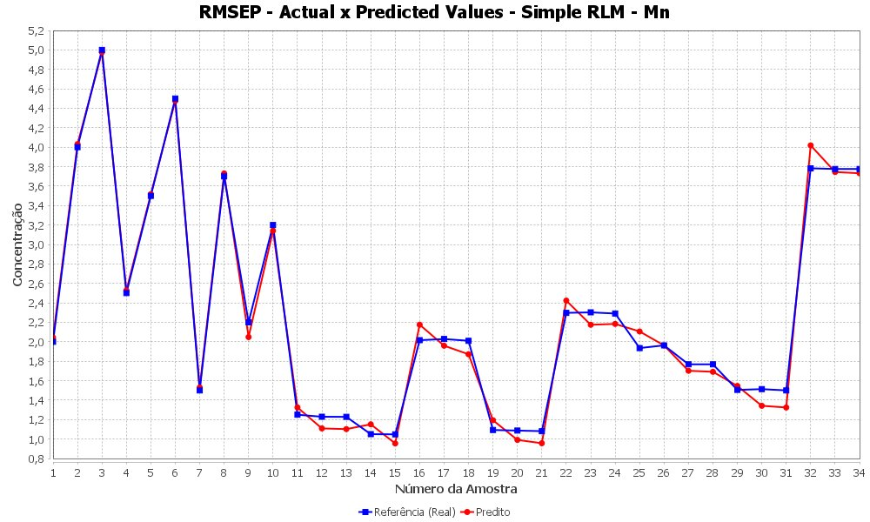
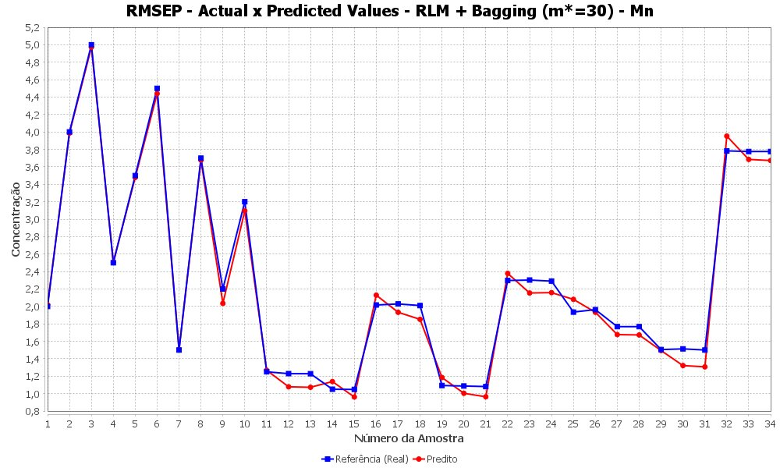
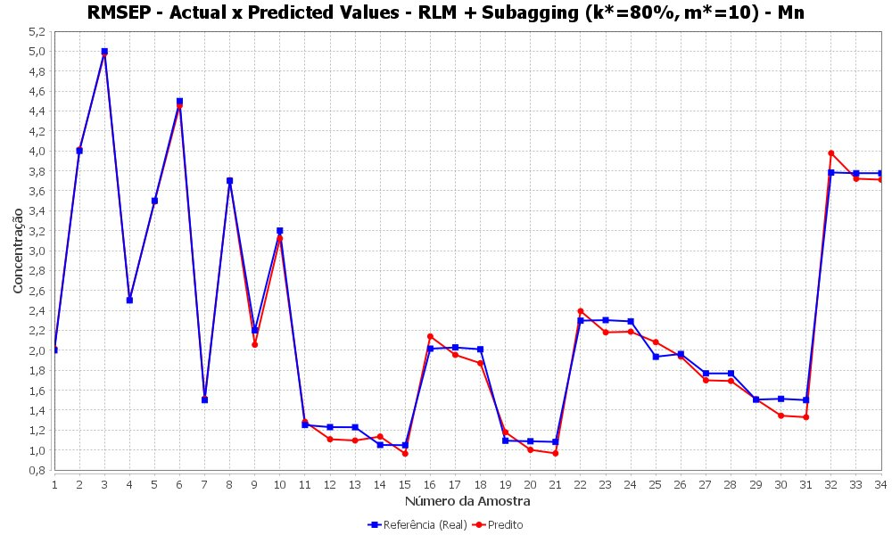
Figure 2. Predicted vs. Reference concentration values for Fe: (a) MLR, (b) MLR-Bagging (m*=30), (c) MLR-Subagging (k*=80%, m*=30).
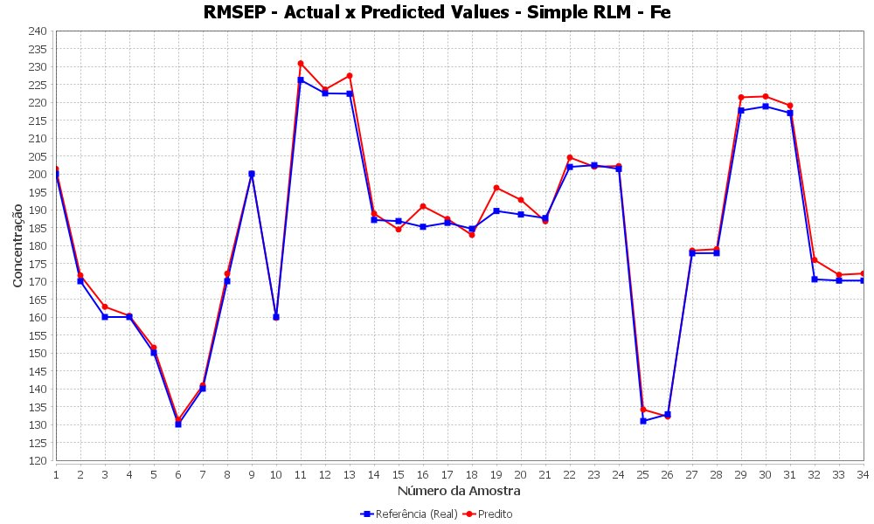

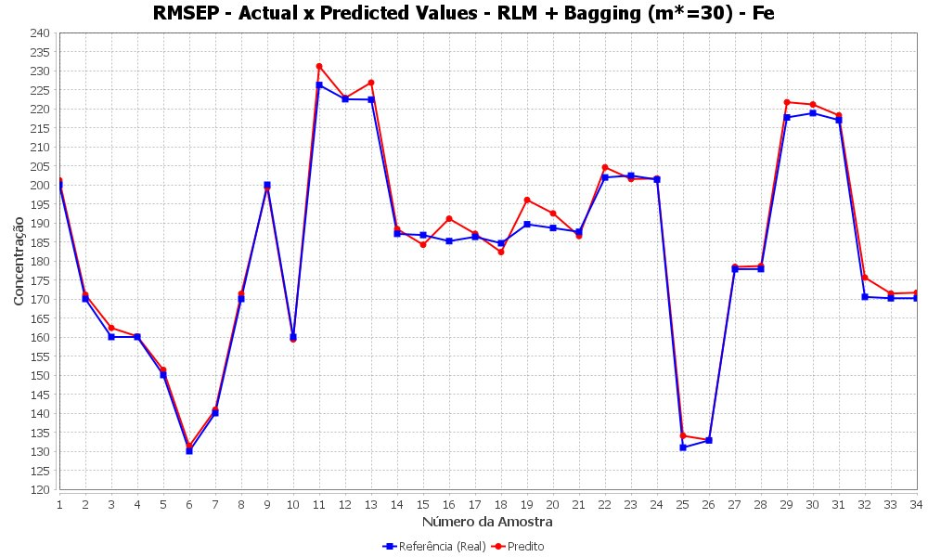
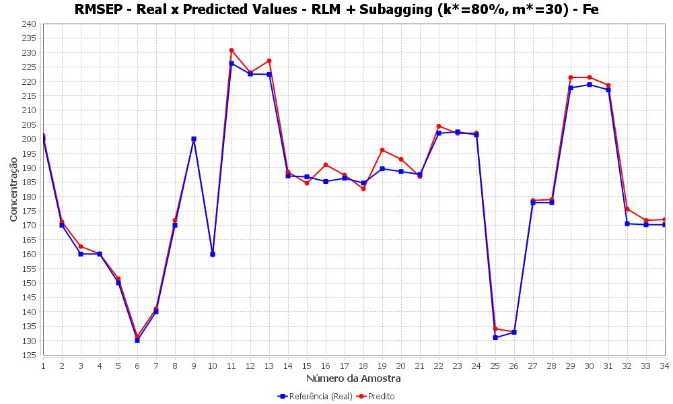
Sensitivity to bootstrap replications
For Mn, the RMSEP stabilized after approximately 15–20 bagging replicates. For Fe, oscillations persisted even at 50 replicates, suggesting greater spectral complexity and/or sensitivity to the specific composition of the calibration samples. MLR-subagging with k* = 80% proved optimal for four of the five elements, indicating that larger subsamples favor model stability in this high-dimensionality, small-sample regime.^{21, 25, 33}
Computational efficiency
While classical MLR is undeniably the fastest method (averaging ~2.4 ms per prediction), its predictive accuracy is element-dependent and lacks robustness for complex analytes like Fe. MLR-bagging, while improving accuracy for Fe, incurs a significant computational overhead due to the generation of full-size bootstrap samples (averaging ~68 ms).
MLR-subagging emerges as the optimal compromise. By utilizing a subset of the data (k* = 80%), it achieves predictive performance equal to or better than bagging for Mn and Ni, but at roughly one-third of the computational cost (e.g., 17.1 ms for Mn vs. 68.2 ms for bagging). This drastic reduction in processing time, without sacrificing predictive power, makes MLR-subagging a highly viable strategy for near real-time industrial quality control applications where both accuracy and processing speed are critical constraints.
Conclusions
This study demonstrates that no single resampling technique universally outperforms the others across all steel alloy analytes. MLR-subagging is recommended for Mn and Ni, offering improved accuracy and computational efficiency relative to MLR-bagging. MLR-bagging is preferred for Fe, where spectral complexity makes multi-model aggregation advantageous. For Mo and Cr, classical MLR remains the most appropriate choice due to its simplicity and low computational cost.^{22, 29, 46}
Overall, MLR-subagging emerges as the most balanced alternative between predictive precision and efficiency (approximately 3.0× faster than bagging on average), constituting a robust strategy for chemometric applications subject to time constraints.^{5, 21, 33} Future work should focus on validating these ensemble MLR models in real-time, on-line industrial monitoring scenarios, and expanding the dataset to include a wider variety of steel grades to further stress-test the models against complex spectral interferences.
Acknowledgments
The authors thank the Instituto Federal de Goiás (IFG), Campus Anápolis, for institutional support. No external funding was received for this research.
References
1. Skoog, D. A.; Holler, F. J.; Nieman, T. A. Principles of Instrumental Analysis, 5th ed.; Brooks Cole: USA, 1997.
2. Hardle, W.; Simar, L. Applied Multivariate Statistical Analysis, 2nd ed.; Springer-Verlag: Berlin, Germany, 2007.
3. Timm, N. H. Applied Multivariate Analysis; Springer-Verlag: Berlin, Germany, 2002.
4. Canty, A. J.; Davison, A. C. J. R. Stat. Soc. Ser. D Stat. 2001. DOI: 10.1111/1467-9884.00196.
5. Rathnayake, S.; Olive, D. DiVA Portal 2022, n. 1669623.
6. Draper, N. R.; Smith, H. Applied Regression Analysis, 3rd ed.; John Wiley & Sons: USA, 1998.
7. Alin, A.; Serneels, S. J. Chemom. 2017, 31, e2881.
8. Filzmoser, P.; Nordhausen, K. Chemom. Intell. Lab. Syst. 2013, 130, 98.
9. Johnson, R. A.; Wichern, D. W. Applied Multivariate Statistical Analysis, 5th ed.; Prentice Hall: USA, 2001.
10. Chatterjee, S.; Hadi, A. S. Regression Analysis by Example, 4th ed.; John Wiley & Sons: USA, 2006.
11. Yeon, H.; Dai, X.; Nordman, D. J. Bernoulli 2023, 29, 2599.
12. Alfons, A.; Ates, N. Y.; Groenen, P. J. F. Organ. Res. Methods 2022, 25, 591.
13. Wan, Y. et al. Proc. Mach. Learn. Res. 2023, 202, 1.
14. Du, J.-H. et al. J. Comput. Graph. Stat. 2024, 33, 1061.
15. Jensen, V.; Bianchi, F. M.; Anfinsen, S. N. IEEE Trans. Neural Netw. Learn. Syst. 2024, 35, 9014.
16. Efron, B. The Jackknife, the Bootstrap and Other Resampling Plans; Society for Industrial and Applied Mathematics: USA, 1994.
17. Efron, B.; Tibshirani, R. J. An Introduction to the Bootstrap; Chapman & Hall/CRC: USA, 1993.
18. Efron, B.; Tibshirani, R. J. J. Am. Stat. Assoc. 1997, 92, 548.
19. Fernandez, J. M. V.; Manteiga, W. G. Comput. Stat. Data Anal. 1999, 35, 211.
20. Opitz, D.; Maclin, R. J. Artif. Intell. Res. 1999, 11, 169.
21. Galvao, R. K. H.; Araujo, M. C. U.; Jose, G. E.; Pontes, M. J. C.; Silva, E. C.; Saldanha, T. C. B. Chemom. Intell. Lab. Syst. 2006, 81, 60.
22. Liu, Y. et al. J. Chemom. 2025, 39, e70036.
23. Mishra, P.; Liland, K. H. J. Chemom. 2023, e3527.
24. Styawan et al. Food Res. 2024. DOI: 10.26656/fr.2017.8(3).165.
25. Breiman, L. Mach. Learn. 1996, 24, 123.
26. Shabbir, M.; Chand, S.; Iqbal, F. Commun. Stat. Simul. Comput. 2024, 53, 3653.
27. Hong, H.; Liu, J.; Zhu, A.-X. Sci. Total Environ. 2020, 718, 137231.
28. Zhao, N. et al. Front. Chem. 2018, 6, 262.
29. Kumari, M. V. et al. Int. J. Pharm. Pharm. Sci. 2024, 9.
30. Martins, M. N. Transferência de calibração de instrumentos para análise espectrometrica empregando seleção de variáveis, reamostagem e combinação de modelos; Dissertação de Mestrado, ITA: São José dos Campos, 2006.
31. Bauer, E.; Kohavi, R. Mach. Learn. 1999, 36, 105.
32. Breiman, L. Mach. Learn. 2001, 45, 261.
33. Buhlmann, P. Bagging, Subagging and Bragging for Improving some Prediction Algorithms; Technical Report, ETH Zurich, 2003.
34. Revelas, C.; Boldea, O.; Werker, B. J. M. arXiv 2024, 2404.01832.
35. Qin, T.; Huang, W.-M. arXiv 2023, 2311.02827.
36. Zhao, Y.; Amemiya, Y.; Hung, Y. Stat. Sin. 2018, 28, 1459.
37. Shi, C.; Lu, W.; Song, R. J. Mach. Learn. Res. 2021, 22, 1.
38. Zhang, C. et al. Chemom. Intell. Lab. Syst. 2017, 161, 43.
39. Tao, X. et al. IEEE Trans. Dependable Secur. Comput. 2021, 19, 2456.
40. Paleologo, G.; Elisseeff, A.; Antonini, G. Eur. J. Oper. Res. 2020, 201, 490.
41. Wei, Y. Wellesley College Thesis, 2021.
42. Ing, C.-K.; Lai, T. L. Electron. J. Stat. 2016, 10, 121.
43. Pimentel, M. F.; Galvao, R. K. H.; Araujo, M. C. U.; Pontes, M. J. C. J. Autom. Chem. 1998, 20, 69.
44. Kramer, R. Chemometric Techniques for Quantitative Analysis; CRC Press: USA, 1998.
45. Martens, H.; Naes, T. Multivariate Calibration; John Wiley & Sons: USA, 1989.
46. Westad, F.; Flaten, G. R. Front. Anal. Sci. 2024, 4, 1393222.
47. Peris-Diaz, M. D.; Krezel, A. TrAC Trends Anal. Chem. 2021, 135, 116157.
48. Hodson, T. O. Geosci. Model Dev. 2022, 15, 5481.
49. Ezenarro, J.; Schorn-Garcia, D. J. Chemom. 2025, 39, e70036.

