See Instructions for Author guideline at http://jbcs.sbq.org.br/instr.for_authors

Template for Submission of Manuscripts to the
Journal of the Brazilian Chemical Society

Graphical Abstract (GA)

GA Figure: Paste your graphic here. The image should be up to 8 cm wide and 4 cm high, and have a 900 dpi resolution. Accepted formats are tiff, jpg and any other editable format. It should use colors as much as possible and have an artistic and imaginative idea.
GA Text: Insert here a short (1-3 lines) explanatory text about the GA Figure (style Times New Roman 12), summarizing your work.

Type the Title of Your Manuscript Here. Capitalize any Relevant Word. The Title should clear and concisely reflect the content of the manuscript. Style: Times New Roman 12P, centered, bold

Enter author names here. First name, initials and surnames. Style: Times New Roman 12P, centered, bold, italics. Use superscript letters to match affiliations with authors and an asterisk (*) for the corresponding author

ªType affiliation of authors from Institution a Style: Times NewRoman 12P, centered, italics
^{b}Type affiliation of authors belonging to Institution b

Use the same style for typing all affiliations
Affiliations: laboratory, Institutions and University from Brazil in Portuguese, a request from SciELO.

*xxx@xxxx (e-mail of the corresponding autor)
ORCID ID of at least one author

Abstract

Type here the Abstract in English (maximum 200 words in a single paragraph). Style: Times New Roman 12. Line spacing 2.0 lines. The Abstract should state the scientific problem or purpose of the research and summarize the content of the article. It must be self-consistent and informative, clearly indicating the main findings and their significance. Avoid using abbreviations and references.

Keywords: type here 3-6 keywords, in lower case letters, separeted by commas, in Times New Roman 12

Introduction

Every article should begin with an Introduction, and be organized to contain the following additional sections: Experimental, Results and Discussion, Conclusions, Supplementary Information availability notice, Acknowledgements, References and Supplementary Information data. Use Times NewRoman 12, double line spacing. Number the pages (bottom right).¹
The introduction must be clear and concise, and explain to the reader the background and nature of the problem, aided by suitable bibliography.²⁻⁵ This section cannot contain sub-items, it needs to be a continuous text. At the end of this section, the authors must state the objective and approach of the research. References should be numbered consecutively in the text, employing Arabic numbers as superscripts, placed immediately after the punctuation marks. Cited references must be collected in the References section, at the end of the manuscript.⁶
Correct the reference citations in the text, they should be typed just after punctuation (without space) as superscripts, see the example:

example 1: …of the environment.¹⁻⁸ A behavior… {1-8 as superscripts}
INSTEAD OF: … of the environment, ¹⁻⁸. A behavior… {1-8 as superscripts}
INSTEAD OF: … of the environment. ¹⁻⁸ A behavior… {1-8 as superscripts}

example 2: According to Silva et al.,¹¹ … {11 as superscript}
INSTEAD OF: According to Silva et al., ¹¹, … {11 as superscript}
INSTEAD OF: According to Silva et al., ¹¹ … {11 as superscript}

Experimental

The Experimental section may precede Results and Discussion part (Introduction, Experimental, Results and Discussion, Conclusions, Supplementary Information availability notice, Acknowledgements, References and Supplementary Information data) or follow the Conclusion (Introduction, Results and Discussion, Conclusions, Experimental, Supplementary Information availability notice, Acknowledgements, References and Supplementary Information data), but must be written as a separate section. For specific details regarding the description of equipment, procedures and new chemical structures, authors should consult the Instructions to the Authors. Critical input and output data for chemical computations and spectra used for the identification of any synthesized or identified compound must be included in the Supplementary Information section, at the end of the manuscript.

Results and Discussion

The Results and Discussion section may be organized as a single section or in two separate parts, for the Results and another for their Discussion. Self-consistent Graphics (Figures, Charts, Schemes, etc.), Tables and Equations should be added to allow a more effective, precise and meaningful presentation of the data, and to make more easily understandable the experimental setups and their results. Mere repetition of the information in text and graphics should be avoided. Graphics should use color as much as possible. Color is free of charge in the ONLINE version. Color graphics will be converted into black-and-white in the printed version, except the GA, without loss of information.
In the main document also keep tables/figures/schemes/equations and their legends as close as possible of their first citation.

Graphics should be insert in the text and also provided as separate graphic files for manuscript editing. Use slashes in X and Y axes to separate axes names from units [2θ / degrees; Temperature / ºC; Volume / Å³ ; time / min; Wavenumber / cm⁻¹, etc.]. Use parentheses only to group a set of units [Concentration / (mol L⁻¹) ; 10³ (T/K)⁻¹, etc.]. Use alternated full and open symbols (●, ○, ■, □, ▲, Δ, ♦ , ♢) or different types of graphical lines (solid, dashed, dotted, etc.), to distinguish one from the other. Colors are acceptable. Examples of graphics styles:
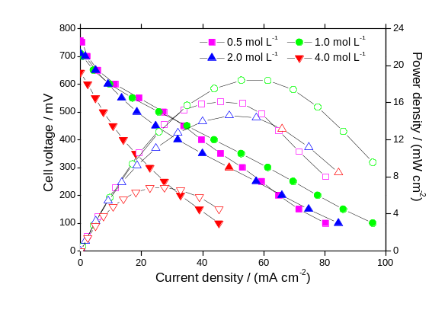
Figure 1. Type here the caption of the Figure. Style for axis titles: Arial. Text within the graphics should be easily readable and of no disproportionate size. Pay attention: units, simbols and lines.

In the submission system upload files individually. Files that should be uploaded in the system individually (step 2):
- GA image and Figure in jpg/tiff format OR cdr/cdx/cwg format (INSTEAD OF doc)
- Figure in opj/xls format (INSTEAD OF doc)
- Chemical Structure in cdr/cdx/cwg format (INSTEAD OF doc)

Editable files facilitate the correction of details out of JBCS standard. Figures from Excel/Origin programs provide pictures with higher quality in the final work (proof, in case of MS accept decision), so the upload of original xls/opj files is desirable since submission.

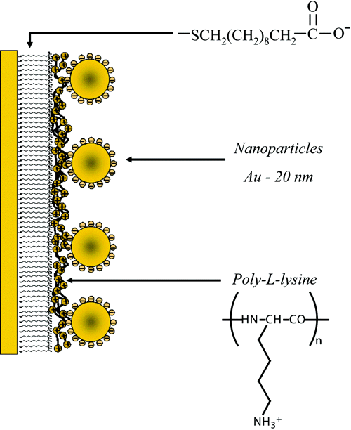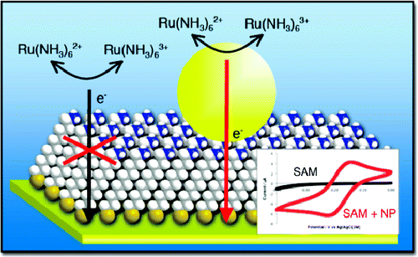
a)
(a)
(b)
Figure 2. Type here the Figure title: (a) …, (b) ….. (adapted from references 21 and 18, respectively).

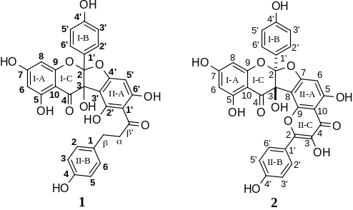
Figure 3. Type here the figure title. Chemical structures should be numbered sequentially, with boldface Arabic numbers. Colors are acceptable to highlight.

Equations: use the tool Math Type and specify every term (equations should not be added in the main text in an image format).

$\ln\left(\frac{C}{C_{0}}\right)=k´.t$ (1)

Schemes: these graphics contain the major elements of a reaction sequence. For the sake of clarity, the reagents and conditions should be consigned as a footnote to the Scheme. The chemical structures can be drawn in any chemical drawing software, employing ChemDraw (preferred style is ACS 1996) or similar. Original drawings should be no wider than 10.5 cm (22 cm for double-column).
Use the negative symbol (–) instead of the hyphen (-) for negative numbers in tables, text and equations. Only compound numbers must be in bold letter.
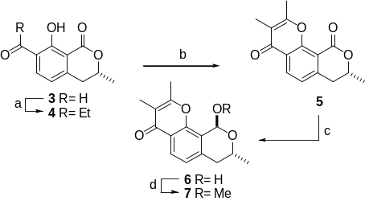
Scheme 1. (a) Reagents1, conditions1 (yield1%); (b) Reagents2, conditions2 (yield2%); (c) Reagents3, conditions3 (yield3%); d) Reagents4, conditions4 (yield4%). Colors are acceptable to highlight.

Table: specify every acronym/abbreviation/Greek symbol, etc. in the footnote, even that they have been specified in the text.
Table: add units in the header of the table (INSTEAD OF inside the table or the caption).

Table 1. Type here the title of the Table^{a,b,c}
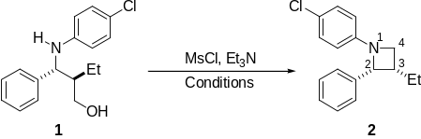
entry No.^{d} | Variable 1e | Variable 2 | Variable 3 | Result
1 | value 11 | value 21 | value 31 | result 1
2 | value 12 | value 22 | value 32 | result 2
.. | … | … | … | …
n | value 1n | value 2n | value 3n | result n
ªStyle for column text: Times New Roman 12, centered, not indented. Use horizontal lines to separate Table sections. Avoid employing vertical rulers; ^{b}style for Table footnotes: Times New Roman; ^{c}style for chemical structure graphics of Scheme-Tables: Arial; ^{d}only compound numbers must be in bold letter; ^{e}obtained from the publication Manjolin et al.¹⁰

Conclusions

This section should be inserted just after the Results and Discussion section and be dedicated to briefly summarize the main conclusions of the work.

Supplementary Information

When applicable, use this section to inform the reader that “Supplementary Information (detail here the kind of information) is available free of charge at http://jbcs.sbq.org.br”.

Acknowledgments

This section should come at the end of the article, before the References, and be used to acknowledge financing institutions and any contributions not in the nature of authorship.

Author Contributions

For manuscript with 6 or more authors, the JBCS requires the specification of the individual contribution of each author in the text. This information, according to the 14 roles from the CASRAI’s CRediT taxonomy, may be added before the Reference, named as Author Contributions.
The 14 roles according to the CASRAI’s CRediT taxonomy: Conceptualization, Data curation, Formal analysis funding acquisition, Investigation, Project administration, Resources, Software, Validation, Visualization, Writing original draft, Writing-review & editing

References

Authors are responsible for the accuracy and completeness of all references. Check periodic abbreviations at https://www.cas.org/content/references/corejournals. The JBCS rules for reference citation list must be strictly followed:
(i) General rules
(i.a) There should be a space between author name initials: “… AuthorFamilyName, C. F. D. …” (C. F. D. with space)
(i.b) There should be a semicolon (;) before journal abbreviation (…W.; Aquino, B. F.; Eng. San. Amb. …)
(i.c) There should be a semicolon (;) between the author names (…W.; Aquino, B. F.; Eng. San. Amb. …)
(i.d) There should be a comma (,) between Authorfamilyname and initials (…W.; Aquino, B. F.; Eng. …)
(i.e) There should not be comma (,) after the periodic name
(i.f) There should not be fascicle information “…J. Mater. Chem. 1995, 5(2), 331.”
(i.g) DOI number just for article in press, remove in other cases.
(i.h) There should not be comma the word "et al.", informe the complete list of the author names

Carefully see how to add the author names: ex. “Liu, W.; Liang Cheng, L.; Xinding Yao, X.;…”
ex. “Silva, M. P.; Pereira, X. M.;…”

(ii) Check blanks in the reference list like these:
“…Soc. 1996, 73, 499.” INSTEAD OF “…Soc., 1996,73,499.”
“…Alqasoumi,S. I.; Alafeefy, A. M.; Aboulmagd, S. A…” INSTEAD OF “…Alqasoumi,S. I.;Alafeefy,A. M.; Aboulmagd,S. A…”
“…Carpenter, M. A.; Am. Mineral …" INSTEAD OF “…Carpenter, M. A. ;Am. Mineral...”
“…Lan, Q.; Liu, C.; Yang, F.; Liu, S.; Xu, J.; Sun, D.; …” INSTEAD OF “…Lan, Q.;Liu, C.;Yang, F.;Liu, S.;Xu, J.;Sun, D.;…”

(iii) Pay attention in dot for periodic abbreviations:
Comput. Math. Methods Med. INSTEAD OF Comput Math Methods Med

(iv) References cannot contain sub-items like 1a, 1b, etc., instead of items use semicolon (;) to separate them, if necessary, check and correct citations in the text.

(v) Move electronic addresses to the reference list, and reorganize it.

(vi) Add reference for the program/software.

Some exemples:
(a) Journals (single and composite references):
- Flores, A. F. C.; Flores, D. C.; Oliveira, G.; Pizzuti, L.; Silva, R. M. S.; Martins, M. A. P.; Bonacorso, H. G.; J. Braz. Chem. Soc. 2008, 19, 184.
2. Marcus, R.; Gloye, E.; Florance, E.; Comput. Chem. 1977, 1, 235; Pupo, A.; Uberti, M.; Minneman, K.; Eur. J. Pharmacol. 2003, 462, 1; Alper, K.; Barry, J.; Balabanov, A.; Epilepsy Behav. 2002, 3, 13; Szeszko, P.; Bilder, R.; Dunlop, J.; Walder, D.; Lieberman, J.; Biol. Psychiat. 1999, 45, 680.
(b) Books:
3. Smith, M.; March, J.; Advanced Organic Chemistry: Reactions, Mechanisms, and Structure, Part 2, 6th ed.; Wiley, New Jersey, USA, 2007.
4. Paravidino, M.; Boehm, P.; Groger, H.; Hanefeld, U. In Enzyme Catalysis in Organic Synthesis, 3rd ed.; Drauz, K.; Groger, H.; May, O.; eds.; Wiley-VCH, Weinheim, Germany, 2012, pp. 251.
5. Kempson, J.; Li, J. J.; eds., In Name Reactions in Heterocyclic Chemistry II. Wiley, New York, USA, 2011, p. 317.
(c) Web addresses:
6. http://www.weedscience.org, accessed on February 22, 2014.
7. Cambridge Crystallographic Data Center (CCDC), 12 Union Road, Cambridge CB2 1EZ, UK, deposit@ccdc.cam.ac.uk, www.ccdc.cam.ac.uk/conts/retrieving.html, accessed on August, 2014.
8. http://www.unica.com.br, accessed in May, 2014.
(d) Patents:
9. Aloup, J.-C.; Audiau, F.; Barreau, M.; Damour, D.; Genevois-Borella, A.; Hardy, J.-C.; Jomonet, P.; Manfre, F.; Mignani, S. Bouquerel, J. C.; Nemecek, P.; Ribeil, Y.; WO pat. 97/25328, 1997 (CA 127:176439).
10. Bouwmeester, H. J.; Matusova, R.; Sun, Z.; Beale, M.; Rani, K.; US pat. 20090178158, 2009 (CA 145:331794).
11. Jones, A. D.; Mitchell, A. E.; Hammock, B. D.; Zheng, J.; US pat. 6495370, 2002 (CA 126:14753).
(e) Softwares:
12. Sheldrick, G. M.; SADABS Version 2007/2, Bruker AXS Inc., Madison, WI, USA, 2007.

(f) Unpublished material Reference: for material accepted for publication: The DOI number should be provided.
13. Torresi, R. M.; J. Electrochem. Soc., DOI: XXXX.

Dissertation/Thesis: do not use as bibliographic reference. Include only the articles that were produced from that research work.

Supplementary Information

Enter manuscript title here

Enter author names here

Type author affiliations here

This material will be available only online, in the JBCS Page as PDF file, and totally free of charge. It should contain relevant and complementary data to those presented in the manuscript. Their format can be tables, graphs, spectra, critical input and output data for chemical computations, maps, films and so on. Colors are acceptable.
Any synthesized or identified compound must be accompanied by the spectra used for such identification. This is especially important for Natural Products, Organic and Inorganic Chemistry manuscripts in which the characterization/identification techniques are part of the work.

Format for the spectroscopic (NMR, IR, etc.) and other data:
(‒)-(R)-2-(1H-Benzo[d][1,2,3]triazol-1-yl)-1-phenylethanol (21): [α]_{D}²⁵ ‒20.5 (c 1.20, CHCl₃, ee > 99%); mp 130-131 °C; UV-Vis (water) λ/nm 600, 1750; IR (KBr) ν/cm⁻¹ 3217, 2950, 2902, 2849, 1594, 1492, 1451, 1426, 1275, 1233, 1189, 1158, 1124, 1071, 1029, 883, 749, 746, 699; ¹H NMR (400 MHz, CDCl₃) δ 4.73 (dd, 1H, J 12.0, 8.0 Hz, CH₂), 4,82 (dd, 1H, J 12.0, 4.0, CH₂), 5.36 (dd, 1H, J 8.0, 4.0 Hz, CHOH), 7.28-7.30 (m, 1H, Bt-H*), 7.36-7.39 (m, 2H, Ph-H), 7.41-7.45 (m, 3H, 2Ar-H and 1H, Bt-H), 7.50 (dt, 1H, J 8.5, 0.9 Hz, Bt-H), 7.91 (dt, 1H, J 8.5 Hz, 0.9Bt-H); ¹³C NMR (100 MHz, CDCl₃) δ 55.3, 73.1, 109.8, 119.5, 123.8, 125.5, 126.0, 127.3, 128.4, 133.8, 140.5, 145.5; HRMS (FTMS + pESI) m/z, observed: 240.1134; C₁₄H₁₄N₃O [M]⁺ requires: 240.1131; *Bt−H: benzotriazole hydrogens.

Note: J (in italic, without =), δ (delta, in italic, without =) and m/z (in italic font).

Format for titles of figures and tables:
Figure S1. Mass spectrum of compound 5a.
Figure S2. ¹³C NMR spectrum (100 MHz, DMSO-d₆) of compound 4.
Figure S3. FTIR (KBr) spectrum of compound 8j.
Table S1. Title of the table

