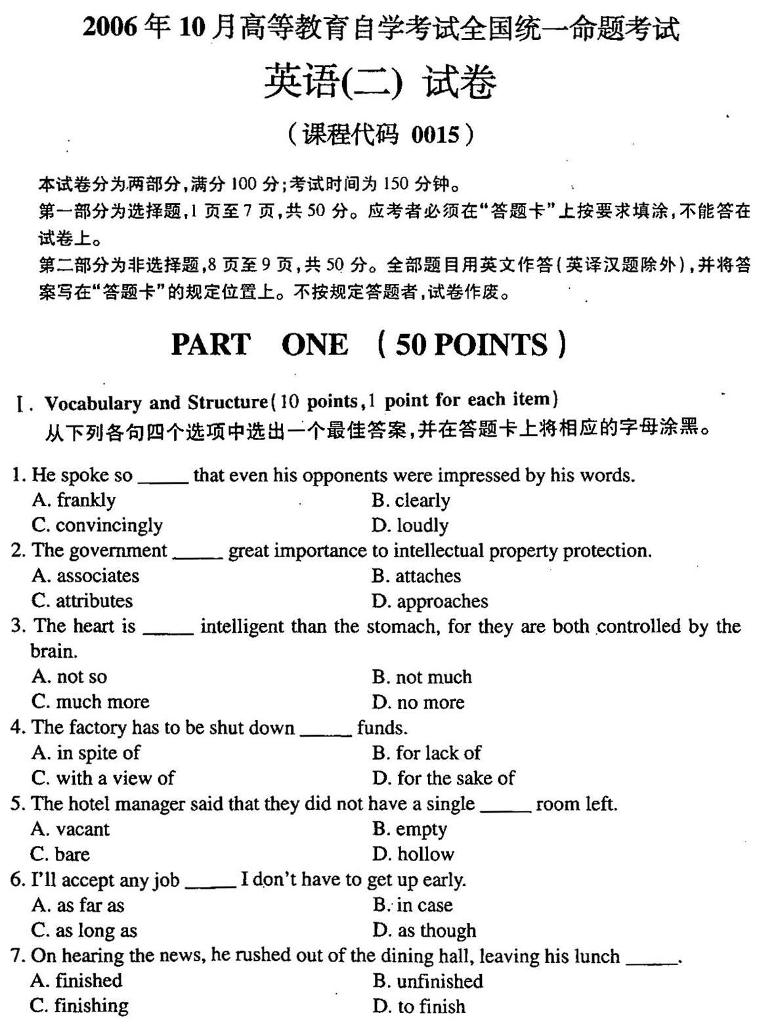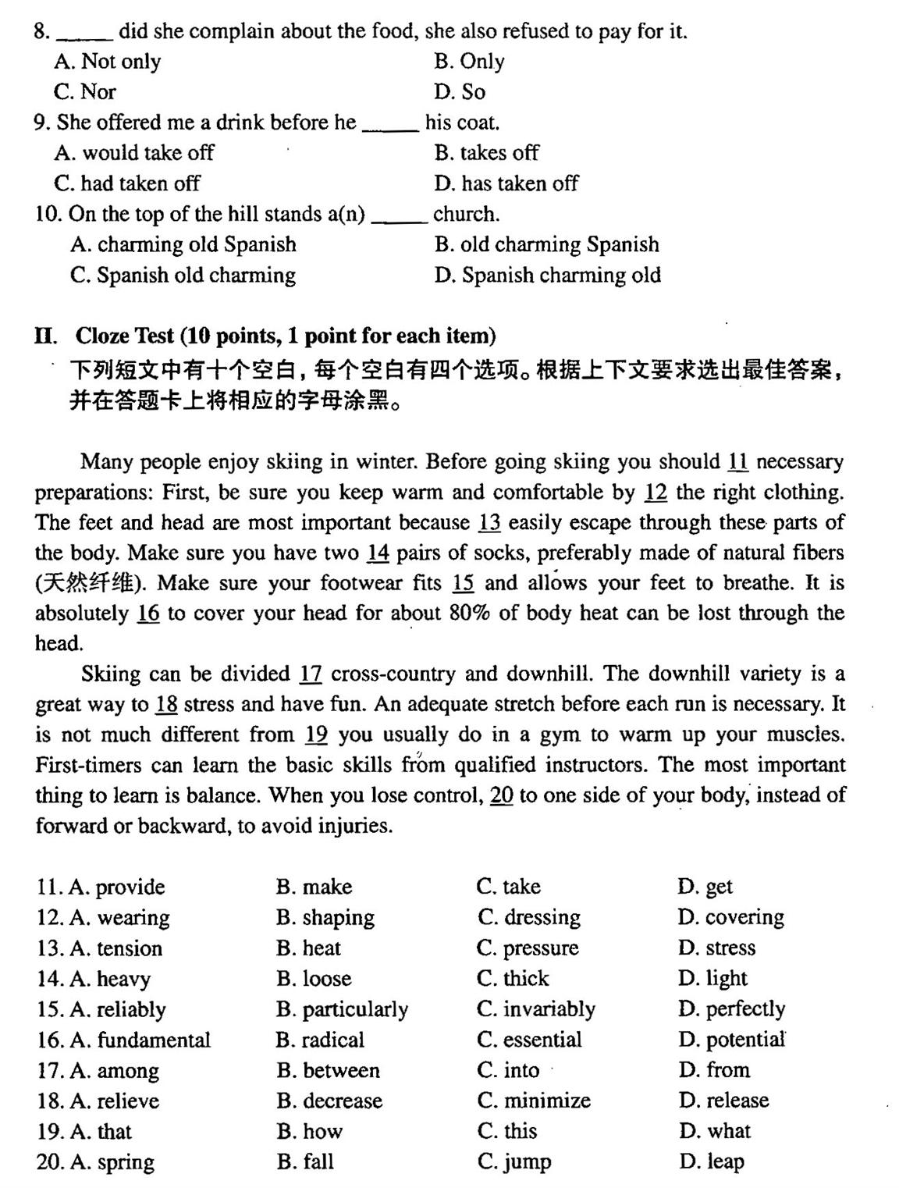
III.Reading Cmprehension(30 points,2points for each item)
从下列每篇短文的问题后所给的四个选择项中选择出一个最佳答案，并在答案卡上将相应的字母涂黑。
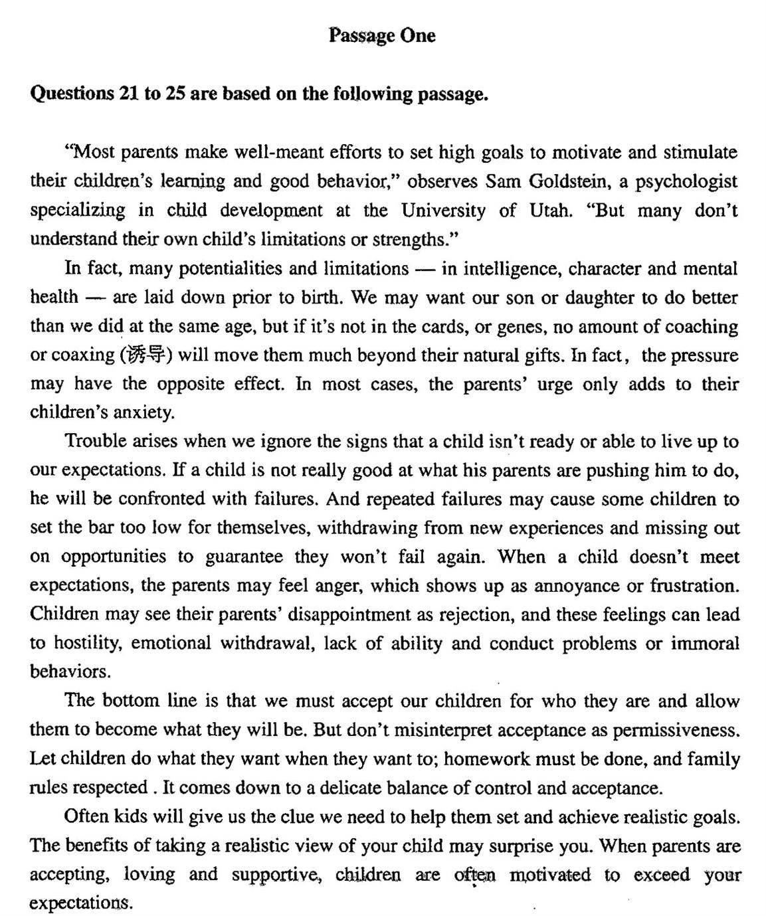

21.According to the passage,most parents tend to
A．permit children to do what they want
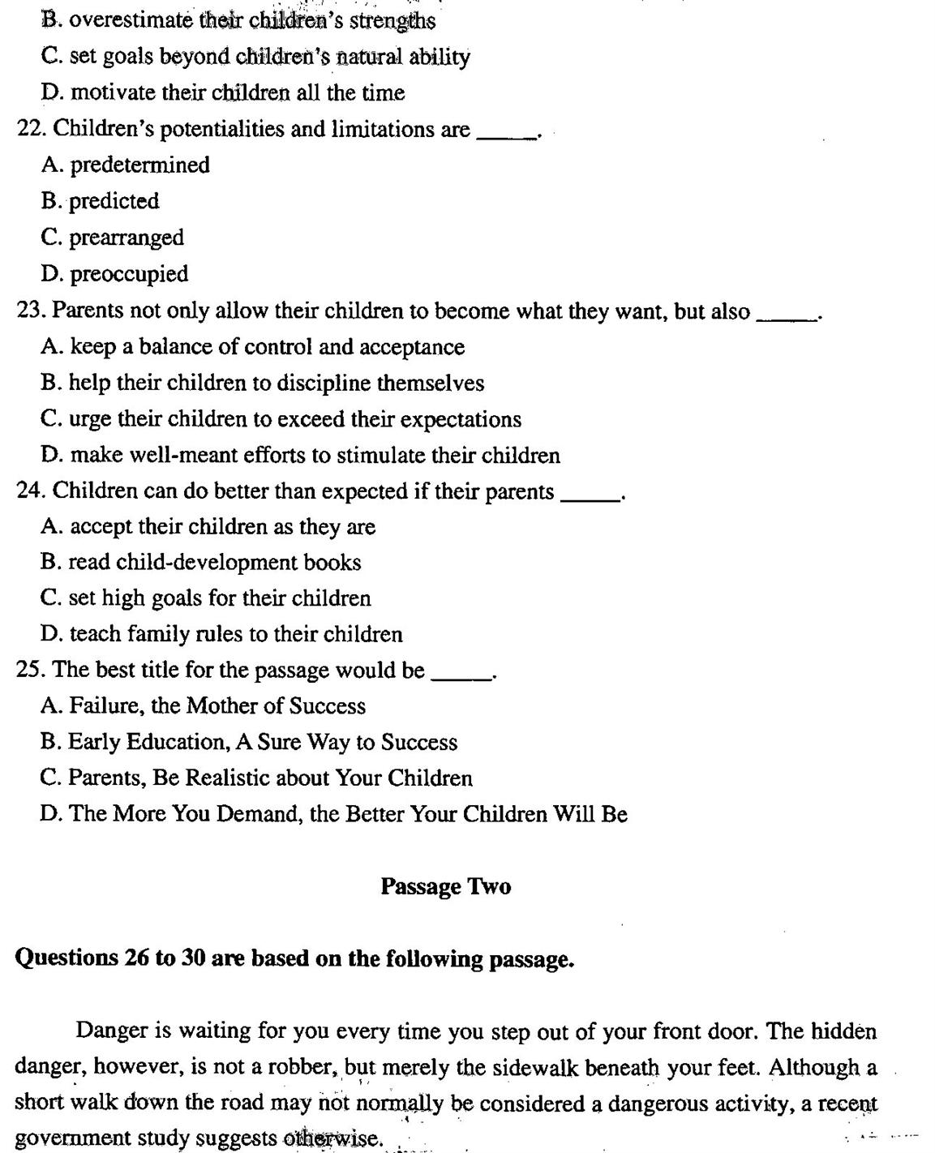
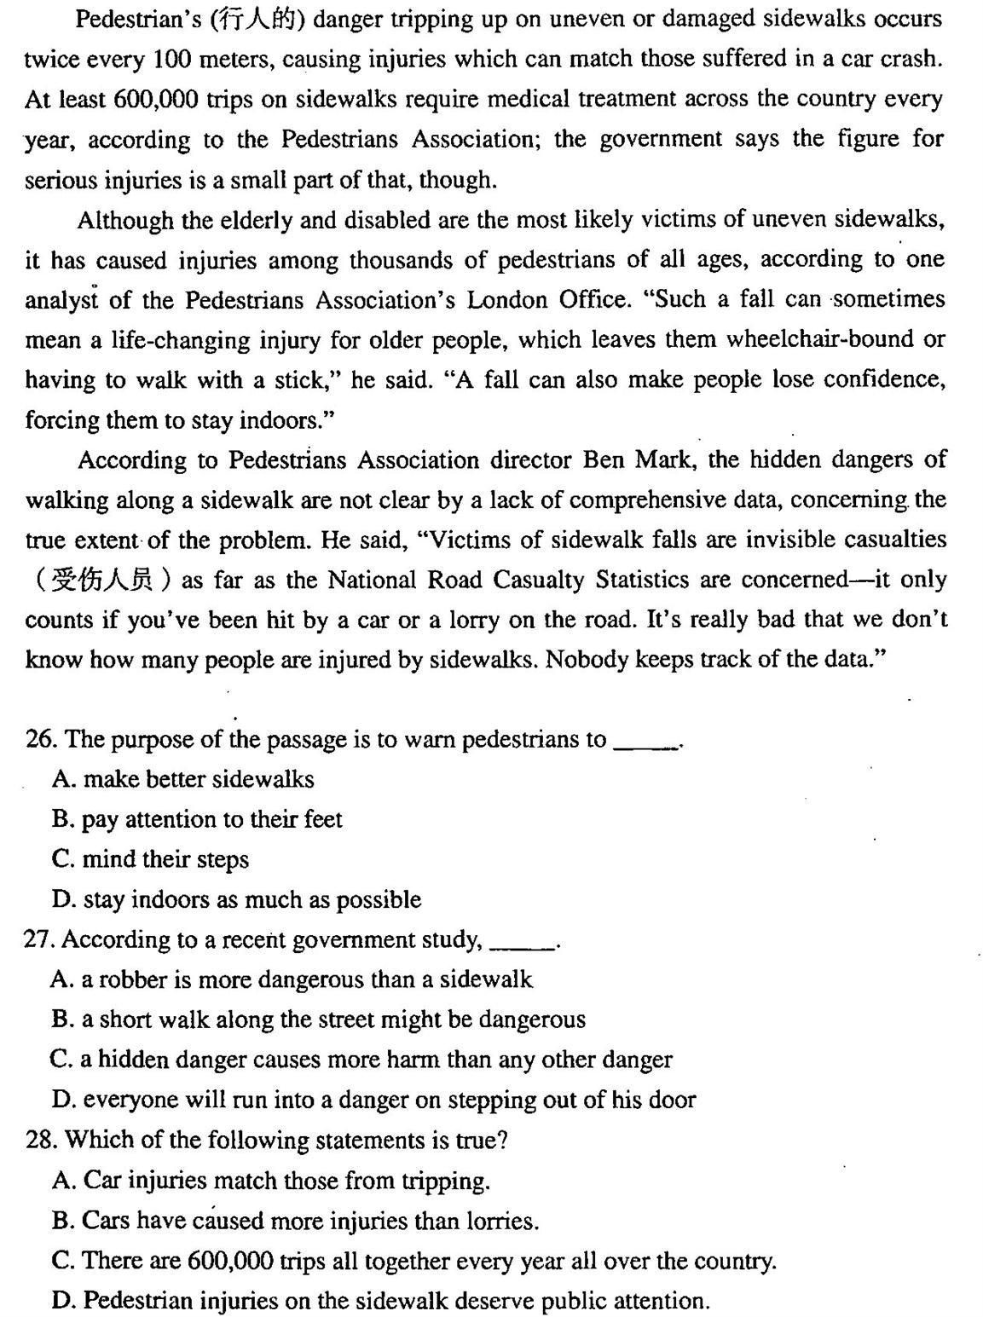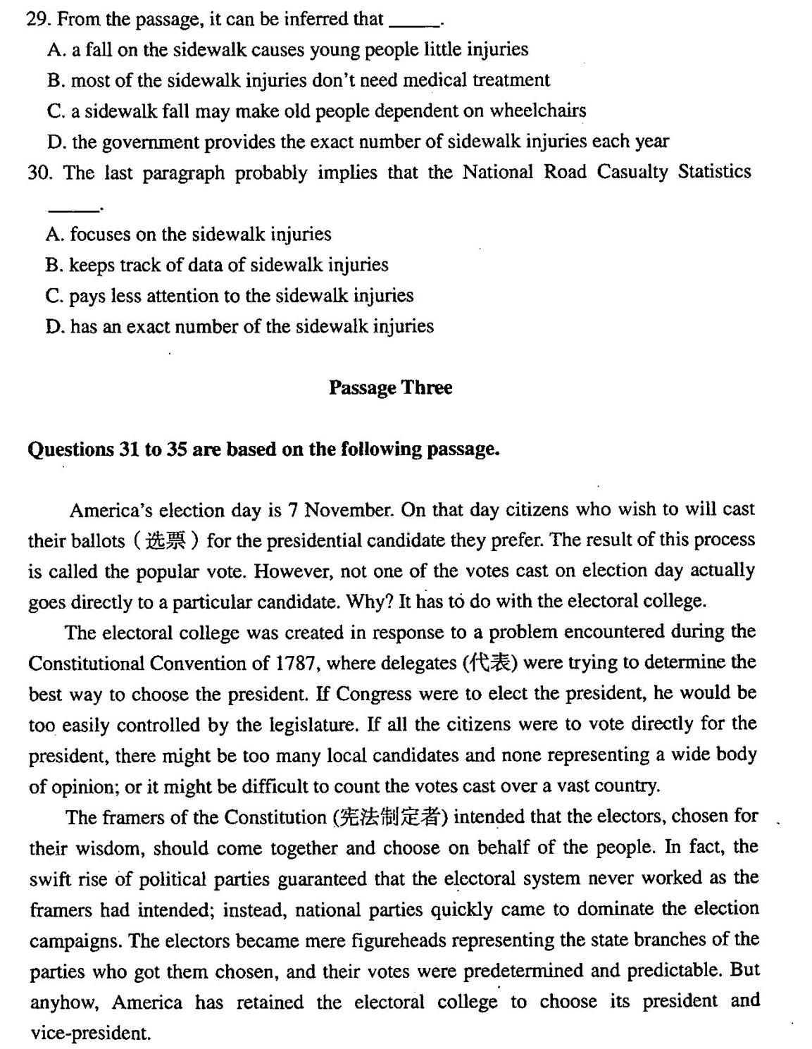

There is some variation among states in how electors are appointed, yet generally they are chosen by the popular vote. Each political party in a state chooses a list of local worthies to be members of the electoral college if the party’s presidential candidate wins
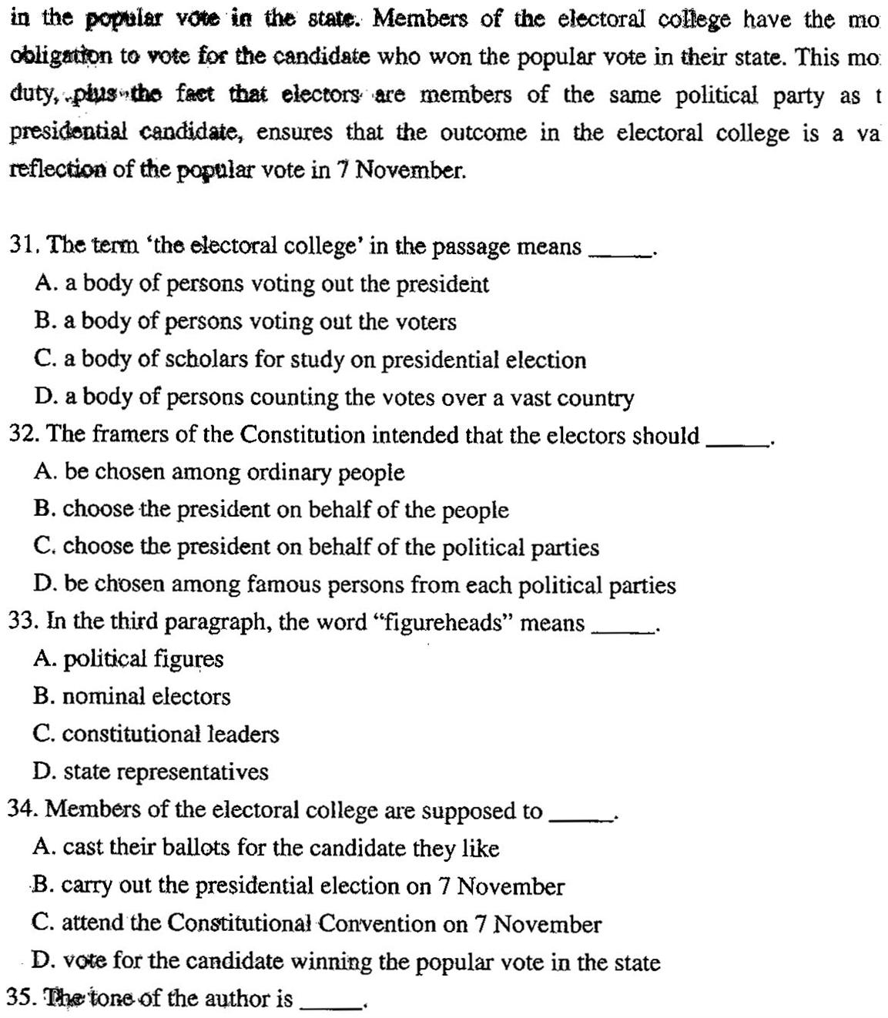
A. positive
B .negative
C. subjective
D. objective
