Running result:

Load all the files on Jupyter and running main.ipyhb, a window will pop up, which contains three scale bars and menu bar. With dragging scale bar, the value displays are changed which represents the weight for three factors (population, traffic, geographical location and the corresponding image will also be displayed in the window dynamically.

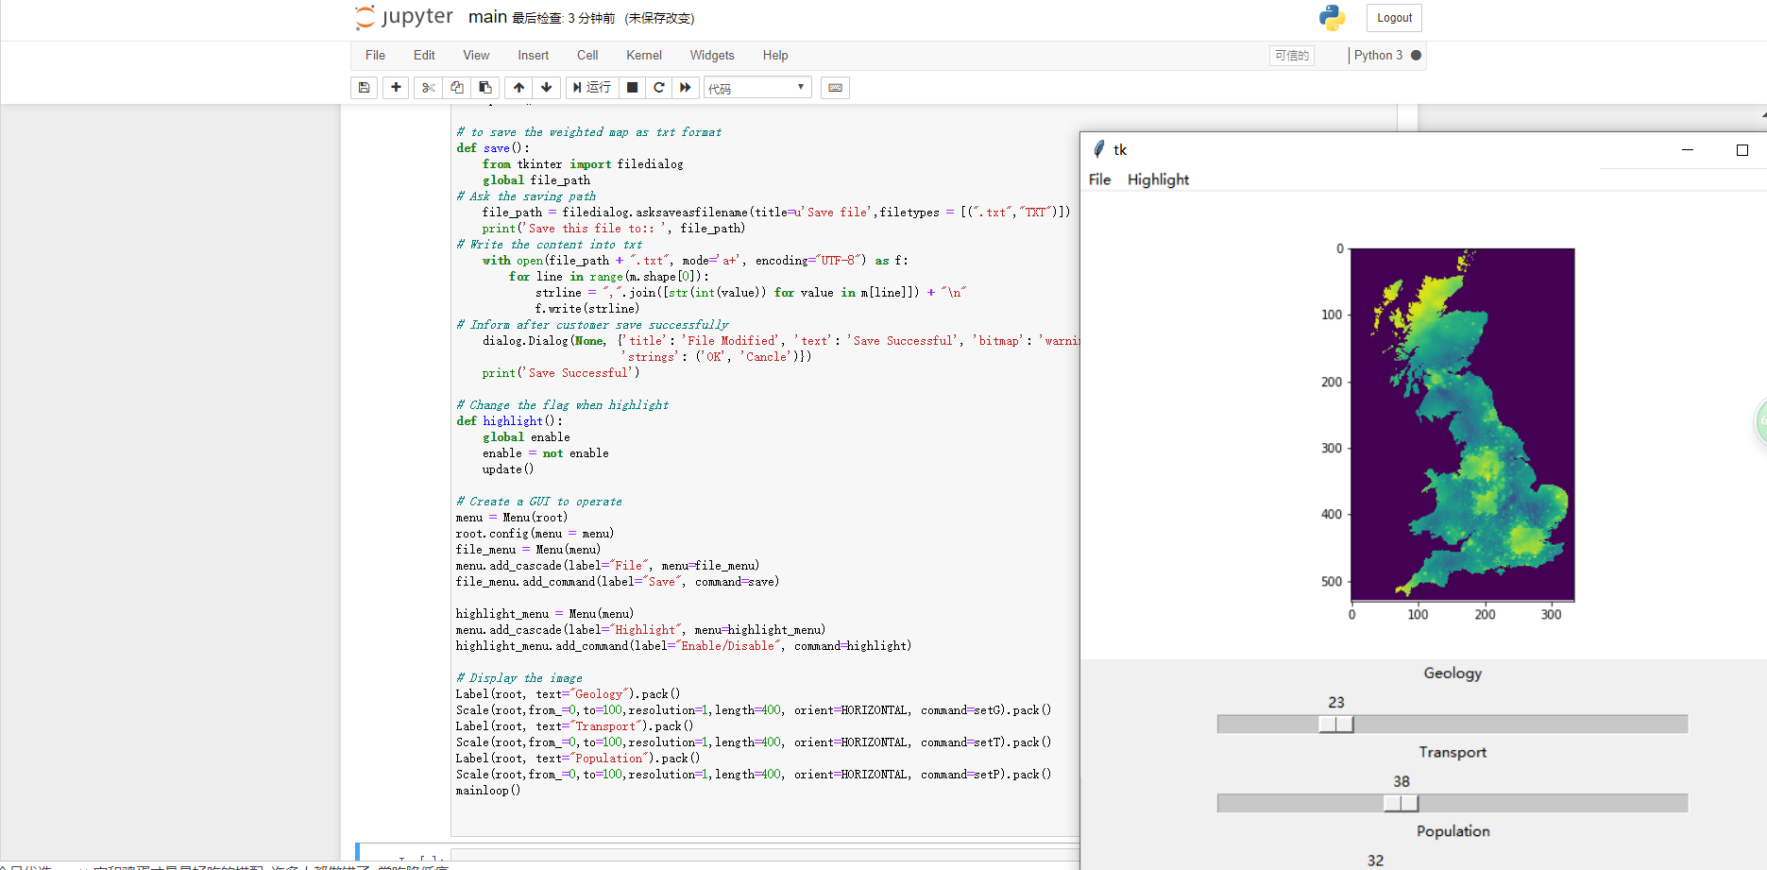

Algorithm principle:

1. The result is composed of three grid images, therefore, the image will change color with the importance of each factor.
2. Using module “numpy” to operate all the values in these documents since the data is input as matrix not list.
3. The value range of the final image must be between 0-255, the weight of each factor is that the value read from scroll bar divided by the sum of the three values, and it is used to multiply each file (matrix), that is, the pixel value of the final image can be obtained.
4. Therefore, G,T,P are the values get from scroll bar, total is denominator for weight, and “m” represents the matrix which is combined of these three factors.

Save file function:

1. There is a menu on the left-top corner, when click file > save. An window pop out to ask you selecting the path where to save the weighted map.
2. After selecting the saving path, click OK. The system will create a text document under the path, and write the values line by line in the form of a list. The number of iterations is determined by the dimension of “m”.

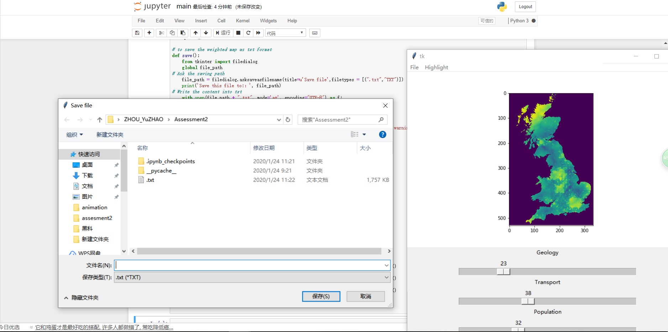

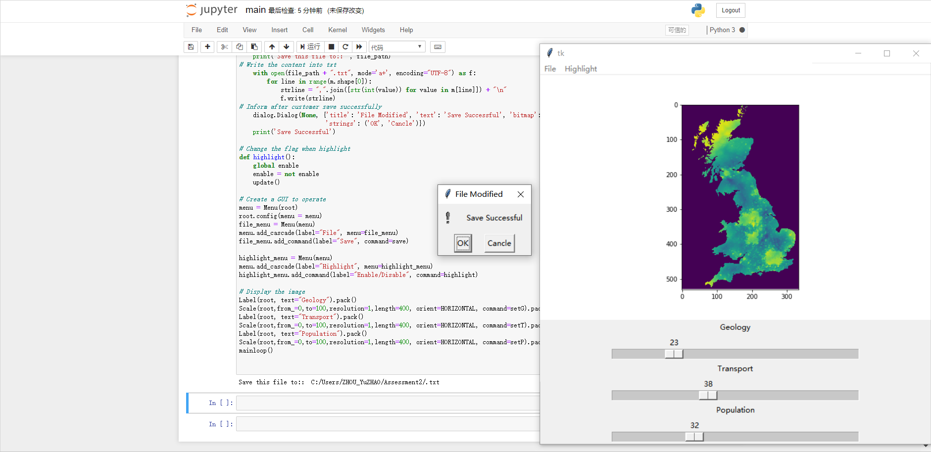

Highlight:

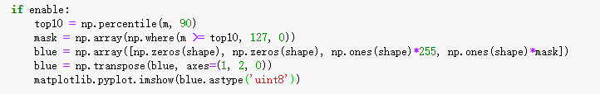

1. While click highlight on the menu, it display the top 10 percent of the areas in blue while other areas turns to gray colour.
2. However, if customer don’t want to highlight anymore, they can close it in same way.
3. The principle is create a mask to cover on the map: Firstly, find the areas whose values are top 10 in UK. Then create a mask to cover these area with 50% transparency, set the other areas with 0 transparency. Next give the mask blue colour and transpose the matrix of mask in order to multiply the matrix of output.

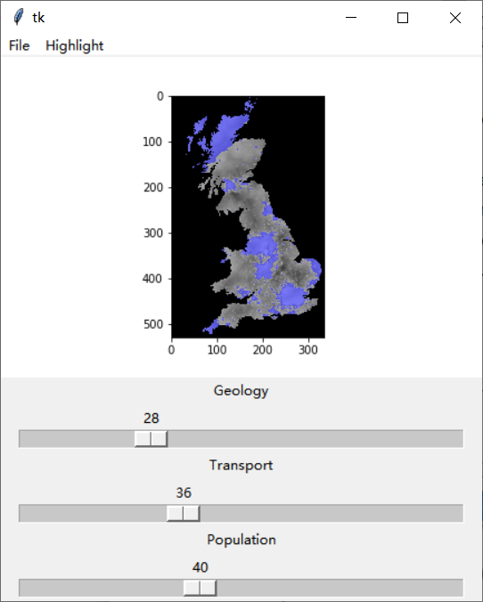

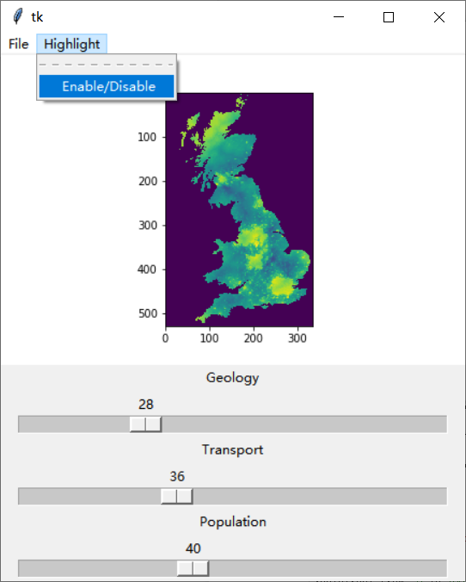

Known issues:

1. No matter whether it is saved or not, when the user clicks the Save button, the system will automatically save and pop up the window inform you have saved successfully.
2. Weight can only be set by dragging scroll bar, not manually.