This is a screen shot of the DataDesigner:

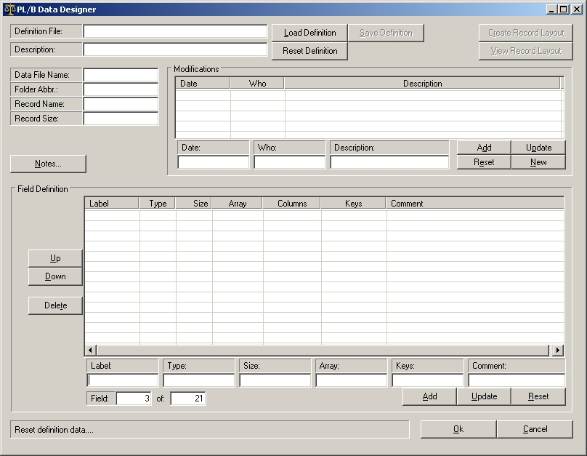

Edittext Objects:

- “Definition File” is the path and name of the record layout definition file. This file includes all fields, modification notes and other pertinent information.
- “Description” is used to describe the purpose for this record layout.
- “Data File Name” is where you enter the physical name of the Data File to be accessed.
- “Folder Abbr.” is used, in conjunction with the plbwin.ini PLBENV_ keywords, to encode the path that the OPEN verb will use to open the data file. The Open IO routine will build the file name with “$”,folder_abbr, etc. to access the value from the PLBENV_{folder_abbr} keyword in the plbwin.ini file.
- “Record Name” is the logical, unique Record Name used in I/O statements. This will become the label for the Record/Recordend definition.
- “Record Size” is the calculated sum of bytes used by the defined fields.
- Modifications:
  - “Date” is the date a particular modification was made.
  - “Who” is the person who made a particular modification.
  - “Description” describes the purpose of a modification.
- Field Definition:
  - “Label” is the field name (up to 15 characters). A single period (.) is used to indicate a comment-only entry.
  - “Type” is the data type. It allows either DIM, FORM or REC. REC is used to indicate a pre-existing record prototype. If you define a particular field as FORM, it will create the field in the record layout as a DIM but it will also create a “partner” FORM variable that can be used after the record is read. This eliminates the “Format Error” sometimes encountered when reading bad data into numeric fields. A routine in the I/O file named {record name}_Convert is used to move the DIM fields to the FORM variables. Also, the Data Designer is not programmed it to recognize any other data type (such as INTEGER).
  - “Size” is the size of the field in bytes. Up to 5 digits may be entered. When REC is used in “Type”, be sure to include the total size of the record prototype because the program cannot determine this itself.
  - “Array” is used to describe up to a 3-dimensional array for this field. The syntax is “(x,x,x)” where x is a dimension size. When REC is used in “Type”, then this entry should be the name of the record prototype.
  - “Keys” allows you to select to what keys this field belongs. Keys are defined using a 3-character string. Separate multiple keys with a comma (up to a total of 25 characters).
    - ISAM keys are designated using a ‘I1a’ code. The letter ‘I’ means that this is an ISAM key, the ‘1’ designates which ISAM key (can be 1-9, so up to 9 ISAM keys can be defined for each record layout), and the ‘a’ designates which the field order within this ISAM key (can be a-z, so up to 26 fields can be defined for each ISAM key).
    - AAM keys are designated using a ‘01X’ code. The first two numbers indicate which AAM key and the last character indicates the search-type to use (can be X, R, L, F).
    - Example: “I2b,I3a,04X” means this field is the second element of the second ISAM key, the first element of the third ISAM key and an exact match is required when accessing this fourth AAM key.
  - “Comment” is any description of this field. If a single period (.) is used in the “Label” item, this item will be a single-line comment.
  - “Field x of y” shows the currently selected field (in the listview) and the total number of defined fields.

Buttons:

- “Load Definition” will allow you to select a Definition file from the MRU (Most Recently Used”) list or open another. The default extension for a Definition file is “DDD” (DataDesigner Definition).
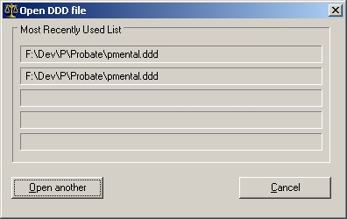
Click on one of the Definitions in the MRU list to load that file, click on the “Open another” button to navigate and select the Definition. Click on the “Cancel” button to not load a Definition.
- “Save Definition” writes the current entries to the DDD file using file name retrieved from “Definition File” edittext.
- “Reset Definition” erases all current entries in the definition from the objects. It does not delete the DDD file.
- “Create Record Layout” will create three files based on the current definition: (1) a record layout, (2) an IO file (collection of I/O routines), (3) a batch file used to create the ISAM and AAM indexes. These record layout and IO files can be included into appropriate source code, however, these files are not intended to be edited. If a record layout needs to be changed, change the Definition and then recreate these output files.
- “View Record Layout” will allow you to view the files created with the “Create Record Layout” button.
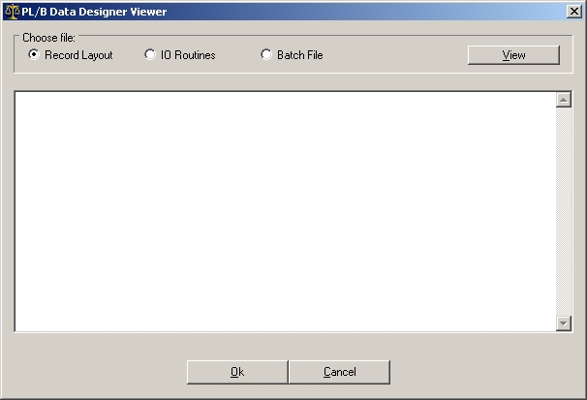
Select file to view (“Record Layout”, “IO Routines” or “Batch File”) then click on the View button. Click on Ok or Cancel to return to the main program.
- Notes… will load a dialog box to allow you to enter notes to appear at the bottom of the record layout. Each line will be preceded with a period (.) to make it a comment. Although this text is in Rich Textedit Format, the formatting will be ignored when creating this section in the record layout.
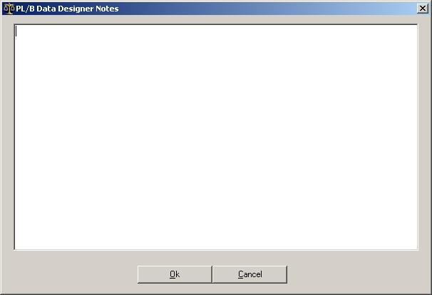
  - “Ok” will save the notes a file.
  - “Cancel” will ask whether you want to save the notes.
- Modifications:
  - “Add” will adds the entries in the editext objects into the Modification listview.
  - “Update” will put the edittext entries into the currently selected listview row.
  - “Reset” will erase the entries in the edittext objects.
  - “New” will erase the entries in the edittext objects then put the current date into Date edittext and the Windows user name into the Who edittext.
- Field Definition:
  - “Up” will move the currently selected field up in the listview.
  - “Down” will move the currently selected field down in the listview.
  - “Delete” will delete the currently selected field in the listview.
  - “Add” will adds the entries in the editext objects into the Field listview.
  - “Update” will put the edittext entries into the currently selected listview row.
  - “Reset” will erase the entries in the edittext objects.
- “OK” will end the program.
- “Cancel” will asks if you want to Quit. If so, it ends the program.

Files:

The Data Designer INI file holds the Most Recently Used list. It can be used to house other items (i.e. literals that I’m using to create the output files can become variables whose values are stored here).
The Data Designer Definition file will have a DDD extension.
The Data Designer Notes file will have a DDD.RTF extension.
The Record Layout file will have a REC.PLS extension.
The I/O file will have a IO.PLS extension.
The batch file will have a BAT extension.
All of these files will be created where you locate the DDD file and have the same base name.

