Math 142 Final Project (Group 4)

Ben Miller, Carter Dandridge, Prannay Veerabahu, Dennis Lee

Summary
This paper models how a cyclist should distribute power over a time-trial course in order to finish in the least time. The rider and bicycle are treated as a single point mass and the equations of motion are stepped forward in one-second increments, with a power-threshold rule that builds fatigue when the rider rides above a sustainable power and recovers it below. Two pacing parameters — hill_factor, the extra power added per unit of gradient, and flat_boost, the power held above baseline on flats and descents — are optimized for each rider and course with a multi-start Nelder-Mead search. We apply the model to the 2021 Tokyo Olympic and Flanders World Championship time trials and a self-designed technical loop, for time-trial specialists and climbers of both genders. The optimized model finishes within roughly 7–12% of the actual 2021 winners. A sensitivity analysis shows the result is far more exposed to wind on the flat Flanders course than on hilly Tokyo, and only mildly sensitive to realistic errors in executing the planned power.

Introduction
The Problem

This paper focuses on a central problem in bicycle road racing: what is the optimal, yet physically feasible, power distribution a cyclist can adopt over a course to achieve the fastest possible time? For experienced cyclists with similar physical capacities, one of the biggest determinants of race performance is how they choose to distribute their energy (power) across different sections of the race. A rider is unable to maintain the same static power throughout an entire course, as races often include varying features such as climbs, descents, sharp curves, flat regions, and changing wind conditions. Depending on these conditions, the same power output may produce very different effects on speed. In addition, race progress as a function of power depends on rider-specific parameters such as mass, fatigue, aerodynamic drag, and sustainable power limits.

Therefore, determining the optimal power distribution requires a model that is sensitive to both course-specific factors and rider-specific constraints. We can use this model to estimate a cyclist’s time to completion for a given power strategy while accounting for terrain, wind exposure, turns, fatigue, and physical feasibility. Once a simulation model is established, an optimization algorithm can be applied to test different power distributions, ultimately identifying the strategy that minimizes total completion time while remaining within realistic limits.

Our Approach

Since our objective is to find out how a rider should output power, we decided to model the rider’s physics of motion and fatigue throughout the race. We decided to split the course into intervals based off of gradient changes, in order to minimize any power related outliers during our calculations.

For the model that tracks the rider’s motion, we treated the rider and the bike as a single moving mass. This allowed us to track its speed along the course at every instance/interval. The rider’s power pushes them forward, while air resistance, rolling resistance and gravity push back. We then calculated the net force at each instant to find acceleration, and used small time increments to indicate a step forward. The increments allowed us to update the speed and the distance traveled. Using this approach allowed us to test different pacing strategies in order to find the optimal rider speed and total race time.

As for how we modeled fatigue, we chose to have every rider have a power threshold they can comfortably hold for a long time. Pushing above the threshold builds fatigue, and the more it builds up, the lower the rider’s maximum power becomes. When the rider eases up during the ride, they are able to recover. Since we chose to segment the course, how much power the rider expends is entirely dependent on the terrain, as they target a more steady power on a flat road, and push harder on climbs. Since the rider cannot push hard the entire distance, the model compensates for it as the effort needs to be paid back later. This ensures that the rider is spending their “energy” wisely throughout the course.

Course Parameters

In this paper, we will develop and apply our model to estimate completion times for three cycling time-trial courses under varying power distributions and rider profiles. First, we analyze the Tokyo 2020 Olympic men’s individual time trial course, which consisted of two laps of a 22.1 km circuit for a total distance of 44.2 km, while the women’s race used one lap of the same circuit. This course was hilly and technical, featuring repeated climbs, descents, speedway sections, and major elevation changes. We also apply our model to the 2021 UCI World Championships individual time trial course in Flanders. The men’s course was a 43.3 km route from Knokke-Heist to Bruges, while the women’s course was a shorter 30.3 km version. Unlike Tokyo, the Flanders course was much flatter and faster, requiring steady pacing rather than climbing ability. Lastly, we test our model on a self-designed 5 km technical loop. This course includes four sharp turns, one short steep ramp, and a return to the starting point.

For this model, we hypothesize that each course can be divided into several relatively compact race segments of variable length. Each segment is designed to have approximately homogeneous characteristics, such as elevation change, wind exposure, and curvature, while still being short enough to capture meaningful differences between different parts of the course. This segmentation allows the model to represent the course as a sequence of discrete physical environments rather than as one uniform route.

Each course segment is described by four main parameters: segment distance, grade percent, wind exposure, and turn penalty. Segment distance represents the total length of that portion of the course. Grade percent represents the steepness of the segment relative to a flat plane and is one of the most important sources of variation between segments because it directly affects the forces opposing or assisting the rider. Uphill segments require greater power to overcome gravity, while downhill segments allow gravity to contribute to forward motion. Wind exposure represents the strength of the headwind opposing the rider, which may vary throughout the course depending on weather conditions and how exposed a segment is. A stronger headwind increases aerodynamic resistance and reduces the speed gained from a given power output.

Curvature is also important because sharp turns reduce the efficiency of forward motion. When a cyclist approaches a curve, they often need to slow down before the turn and then accelerate again afterward. In a more detailed physical model, some of the rider’s effort would effectively be lost to braking, handling, and cornering rather than contributing directly to forward velocity. To simplify this effect, our model represents curvature as a fixed time penalty added to the segment. This approximates the time lost from slowing down, turning, and re-accelerating.

This simplification allows technical sections of the course to be included without requiring a full turn-by-turn dynamics model. However, it does have limitations. In reality, faster riders may lose more time in sharp curves because they must decelerate more before each turn and then spend more energy accelerating back to speed. Our model does not explicitly account for this speed-dependent cornering loss. Instead, it applies a fixed time cost for technical segments, which captures the general effect of curves while keeping the model computationally simple.

Rider Parameters

For each course, we model two rider profiles: time-trial (TT) specialists and climber specialists, with separate male and female versions of each profile. According to our project specifications, TT specialists are highly optimized for sustained speed and efficient pacing, making them generally more powerful and fatigue-resistant over flatter or faster courses. In contrast, climber specialists may have lower absolute power output, but they are better suited for courses with sustained climbs because of their lower body mass and stronger power-to-weight ratio.

To construct these rider profiles, we use several simplifying assumptions. First, TT specialists are assumed to be heavier than climber specialists, reflecting their greater absolute power and aerodynamic specialization. Second, male riders are assumed to be heavier than female riders. Across all profiles, we assume a bicycle mass of approximately 8 kg, which falls near the lower end of the sourced 7–14 kg range. Rider profiles were defined computationally using four primary parameters: combined effective mass, including both body and bike mass, threshold power, (P_threshold)​, defined as the power output above which the rider begins to experience fatigue, baseline sustainable power (P_base), ​and maximum short-term power, (P_max)​. We assumed that time-trial specialists tend to be heavier than climbing specialists due to greater muscularity and event-specific training demands, and that male riders tend to be heavier than female riders due to average biological differences in muscle mass and body size. We sourced representative W/kg values from published literature, using Valenzuela et al. (2022) for male riders and Mateo-March et al. (2022) for female riders, and multiplied these values by assumed body masses to estimate P_threshold for each rider profile. We then defined P_base as a default cruising power set slightly below threshold — the steady output the rider holds where the terrain does not call for more. This relationship was modeled as:

$$P_{\text{base}}=0.93 P_{\text{threshold}}$$
To estimate Pmax​, we assumed that maximum short-term power is approximately 1.5 times threshold power. This reflects that short-duration maximal power is well above the roughly one-hour threshold power, as seen in the record-power profiles of Valenzuela et al. (2022) and Mateo-March et al. (2022). Thus, we modeled:
$$P_{max}=1.5 P_{\text{threshold}}$$
Finally, for the corresponding female rider profiles, we scaled drag coefficient area, or CdA, values down by 10% relative to male profiles. Because measured female-specific CdA values were not available in the literature used for this model, this adjustment was used as a simplifying approximation to account for differences in body size and frontal surface area.
While these parameters vary depending on the rider profile, there are further intrinsic rider parameters that influence our model.
Since riders put more effort into climbing portions of the race, we came up with a parameter that determines how much the rider raises/lowers their target power per unit of gradient. We chose this number so we can establish a simple, linear gradient-power relationship without having to solve a complex optimization model, which is outside the scope of this class, we call this parameter hill_factor.
As a rider progresses through the duration of a course, depending on their power distribution choices, they may prioritize a gain in short-term velocity at the expense of long-term energy depletion, or fatigue. To model this, we introduced the parameters fatigue_rate and recovery_rate. The parameter fatigue_rate relates the nonlinear relationship between the extent of overexertion, defined as the deficit between P_output and P_threshold, in a timestep (dt = 1 second) and that timestep’s contribution to overall exhaustion.
As fatigue increases, the maximum power that can be outputted by the rider asymptotically decreases toward P_threshold, at a rate determined by fatigue_impact, a parameter that relates total accumulated fatigue to reduced maximal power output. After accumulating fatigue, a rider can also recover by outputting power below P_threshold, which will decrease accumulated fatigue at a rate determined by recovery_rate and the length of the timestep. We justify our parameters are correctly demonstrating the qualitative relationships seen between fatigue and recovery: Typically fatigue is related to the extent of overexertion, and is a gradual “sapping” process that occurs over time. Fatigue also tends to accumulate faster than recovery does, which is why in our model, recovery parameters are usually set to around ~20% of the fatigue parameters.
Core Assumptions
Several core assumptions were adopted to simplify the scope of our problem and produce cleaner, non-computationally intensive, and intuitive solutions:
- The interaction between the rider and the track is constant over several small segments, and as such we can completely describe the track-rider interaction by focusing on one segment at a time. We assume that the distance intervals that we use are adequate to account for the entire track, and that the conditions of the race do not change so quickly that our intervals are not good assumptions.

- There is no significant difference in the road surface conditions between different locations on the track. Our research found that generally for these road race courses the road surface is relatively standardized throughout the course. This led us to decide to describe rolling resistance as a constant throughout the race.

- We assume that each rider’s drag area CdA is constant over the course but varies by rider profile: roughly 0.20–0.23 m² for time-trial specialists and 0.24–0.27 m² for climbers, with the female values scaled about 10% below the corresponding male values. Within a profile CdA is treated as a global constant, since all riders of that type are assumed to ride in similar position and equipment.

- We assume that there is no congestion present on the track, and that all sections of the track are roughly the same size or can accommodate a flux that does not limit our rider’s velocity. In a sense, that one rider’s movement is ONLY a function of the power they exert, their biological profile, and the conditions of the course.

- Lastly, we assume that in our fatigue/recovery model, that during the duration of a course that fatigue can be fully regenerated or replenished, and that riders will never operate under a power distribution that leads to full exhaustion.

Derivation of Model

As discussed previously we model the rider as a single moving mass. We decided that the basis of the model would be velocity in discrete time-steps. At each step we find the rider’s acceleration, which multiplied by the change in time, will give the new velocity.
$$V_{k+1}=V_{k}+a Δt$$
Then to find acceleration. $$a=\frac{F}{m}$$
$$V_{k+1}=V_{k}+\frac{F}{m} Δt$$
Now that we have a this equation we want to find F for our modeling:
$$F=F_{\text{rider}}−F_{\text{drag}}−F_{\text{hill}}−F_{\text{roll}}$$
Breaking this above equation into individual equations we have 4 different ones.
Rider Force output
We will use
$$F_{\text{rider}}=\frac{P}{V}$$
Now we have the rider’s power in the model.
Wind Resistance (drag):
We use the quadratic drag equation that applies to everyday objects moving at normal speeds where the fluid flow becomes turbulent. This equation is.
$$F_{d}=1/2 ρ v^{2} C_{d}A$$
Applying this to our situation, V = V_rel = hw + V_rider and we combine CdA into one, as is common practice for the data we found online. Headwind is positive when it opposes the rider and negative when it is helping.
$$F_{\text{drag}}=1/2 ρ C_{d}A (V+h_{w})^{2}$$
Hill effects:
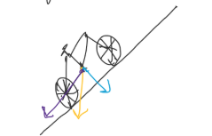
$$F_{\text{weight}}=m g$$
This can be broken up into two parts (θ is gradient of hill)
$$F_{⟂}=m gcosθ$$
$$F_{∥}=m gsinθ$$
we want F_parallel, or the force that is pulling rider down hill, so we use
$$F_{\text{hill}}=m gsinθ$$

Rolling Resistance:
By definition rolling resistance is proportional to normal force.
so $$F_{\text{roll}}=(\text{const})⋅F_{\text{normal}}$$
we let the const = Crr
$$F_{\text{roll}}=C_{rr} F_{\text{normal}}$$
From before, F_normal on a slope = F_perp = m·g·cos(θ)
$$F_{\text{roll}}=C_{rr} m gcosθ$$
Combining this together and accounting for discrete nature
$$V_{k+1}=V_{k}+\frac{Δt}{m}\left(\frac{P_{k}}{V_{k}}−1/2ρ C_{d}A (V_{k}+h_{w})^{2}−m gsinθ−C_{rr} m gcosθ\right)$$
This derivation works unit wise, as each of the Rider Force Output, Wind Resistance, Hill Effects and Rolling Resistance are in Newtons. Dividing by mass and multiplying by time is now meters/second, consistent with both velocity terms.

Model Results
We applied our model to the Tokyo 2020 Olympic men’s individual time-trial course, the Fuji Speedway Racing circuit. We ran each course for all four rider profiles (time-trial and climber specialists, with male and female versions). We only report the men’s time trial results in detail here because the qualitative behavior across profiles are quite similar. It was modeled as two laps of the 22 km circuit. In order to evaluate the optimal pacing strategy, we compared a baseline power distribution to an optimized one. The baseline used a fixed value for hill_factor of 800, with flat_boost being 0, meaning that the rider added a moderate amount of power on climbs, but held a constant baseline power of 370 W on flat and downhill sections. We then used the Nelder-Mead algorithm to find the optimal (minimized) completion time while the other course/rider parameters were fixed.

The TT men’s optimized hill_factor resulted in a value of approximately 1,180 with the flat_boost of about 90 W. With these values, the predicted completion time was reduced by about 3 minutes, from 62.1 minutes to 59.2 minutes across the two laps. The optimal hill_factor fell within our upper search bound of 2000, with the optimal flat_boost sitting well inside our 0 to 150 W search range. This is because the completion time is flat across a wide band of values near the optimum, so hill_factor and flat_boost can trade off against each other with little change in time. When the flat_boost bound was changed, it resulted in the same completion time with a lower flat_boost and a higher hill_factor. From this, we interpret this as pushing well above the baseline power on both climbs and flat sections consistently yields the fastest time.

We noticed that the improvements came from the changes involved in how the rider distributed power. When the hill_factor was increased, it more than doubled the amount of power the rider added per unit of gradient. This meant that on the rider’s steepest climbs, their output approached (~450 W) rather than being around the baseline of 370 W. They did not quite hit P_max (~600 W), as on the steepest climbs it is evident that fatigue started to affect the riders. Another factor that made major improvements was that the flat_boost added around 90 W to the flat and downhill sections, which provided that rider with more speed where terrain had little impact on resistance.

This strategy of pushing above the threshold on difficult terrain/sections only worked due to how the model handled fatigue and recovery. For the baseline run, the rider barely crosses the fatigue threshold of 400 W, meaning that fatigue barely built up over the course; however, in the optimization run, the rider had pushed above the threshold on the climbs and boosted flat areas, which allowed for fatigue to accumulate and recover on descents. Since the rider’s fatigue increased and reset on each lap, the rider was able to repeat the same strategy on the second lap without exhausting. In other words, the optimizer showed a pattern that represented that the rider was pushing on the climbs and recovering on the descent on its own.

By increasing and decreasing the rider’s parameters, we were able to re-optimize the pacing strategy each run, which allowed us to compare completion times. After changing the parameters enough, we were able to find that adjusting threshold power enabled the rider to sustain higher power levels before starting to accumulate fatigue. This allowed for the riders to finish the race much faster. Adjusting the drag coefficient and mass also had similar influential effects on rider completion time, which is obvious due to gravity and drag constantly working against the rider throughout the race. The other parameters like fatigue, recovery, and baseline power did not have much of an effect on the completion time of the race because the optimizer constantly adjusts the others to compensate, which allowed the overall time to be quite static.

As the parameters that limit the model, we noticed that if fatigue was entirely removed, that the optimized time had dropped around 2 minutes since the rider was constantly pushing high power, which showed that fatigue constrains the finishing time. We analyzed the model in its steady-state behavior, by solving the force balance at the optimized flat power yielded a result of around 50 km/hr, which showed the speed on long flat sections.

When we applied our model to the men’s Flanders course, which is essentially a flat course, pacing was entirely different. The optimized result showed that the predicted time dropped from 56.5 to 53.5 minutes, saving 3.0 minutes. The optimal flat_boost was about 60 W, and due to the course being flat, there was no effect from hill_factor. This meant that flat_boost was the only pacing parameter that mattered. We noticed that fatigue behaved differently, as it grew steadily over the course and never recovered because the rider constantly held power above the threshold, and never had a descent to recover from. This meant that the optimal Flanders strategy was sustained effort rather than pushing and recovering on certain areas like the Tokyo strategy revealed.

All rider profiles were tested on each course, but the results of men were only shown due to consistent graph behaviors across the profiles.
Results across all four riders.
All four rider profiles were run on every course. Figures 1–4 show the optimal-versus-baseline diagnostics — gradient, speed, power, fatigue and drag — for each rider on Tokyo (the men ride two laps, the women one). The qualitative strategy is identical for every rider: ride above the fatigue threshold on the climbs, bank the fatigue, then recover on the descents, holding a steady elevated power on the flats. The magnitudes differ — the two specialists hold the highest power and finish fastest, the climbers give up time on the long flats and descents because of their larger drag area, and the female riders finish a few minutes behind their male counterparts at lower absolute power.
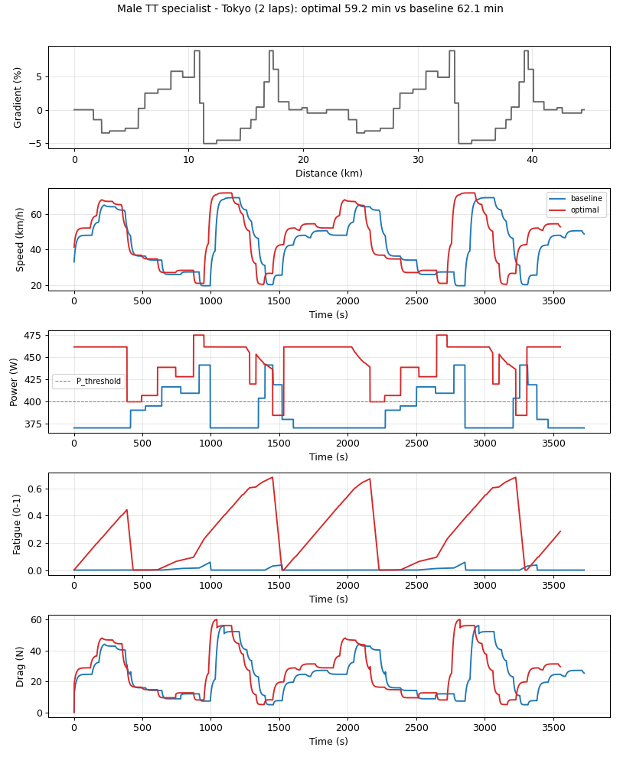
Figure 1. Male TT specialist, Tokyo (2 laps): optimal vs baseline.
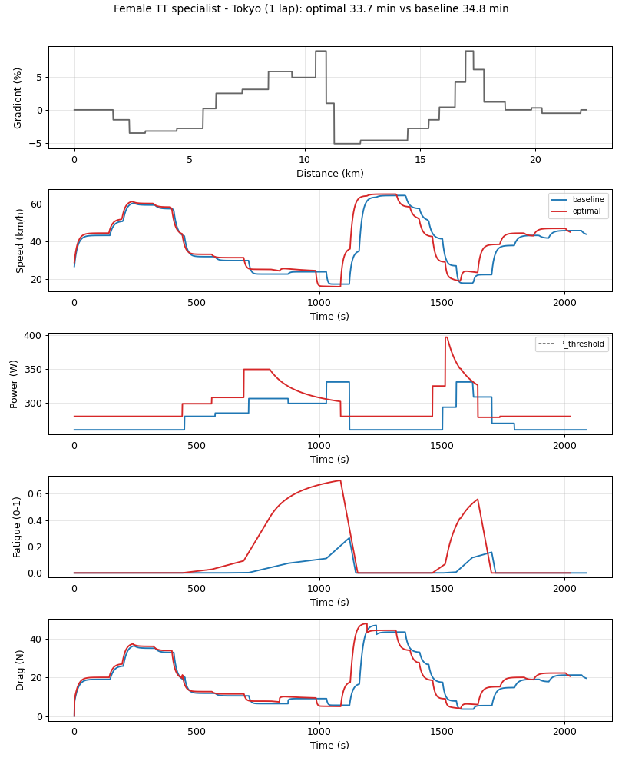
Figure 2. Female TT specialist, Tokyo (1 lap): optimal vs baseline.
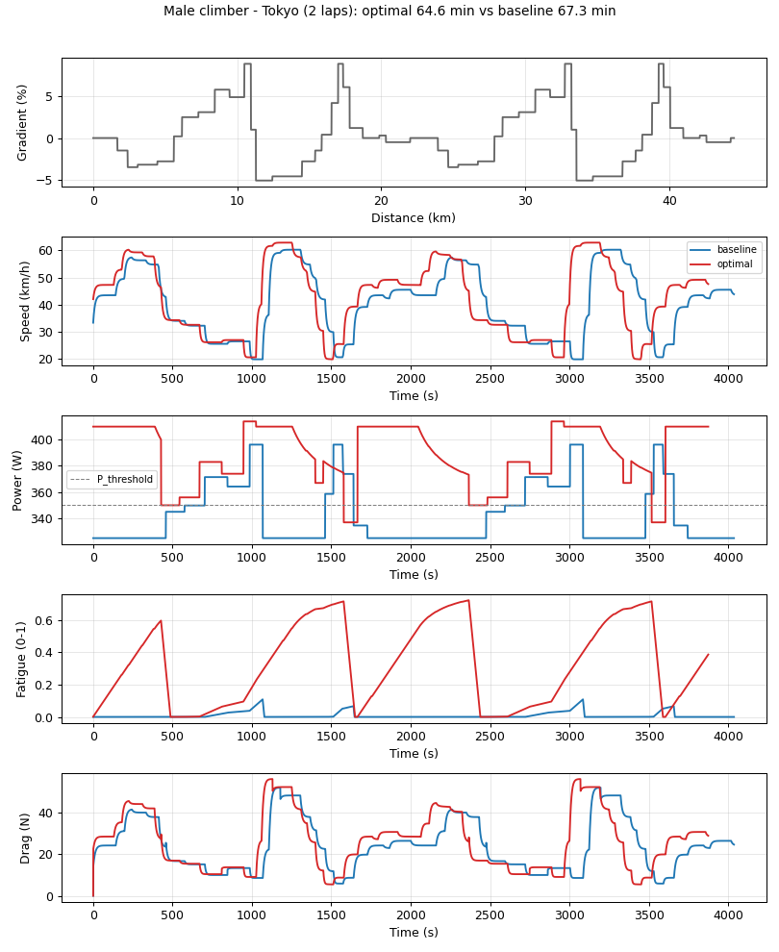
Figure 3. Male climber, Tokyo (2 laps): optimal vs baseline.
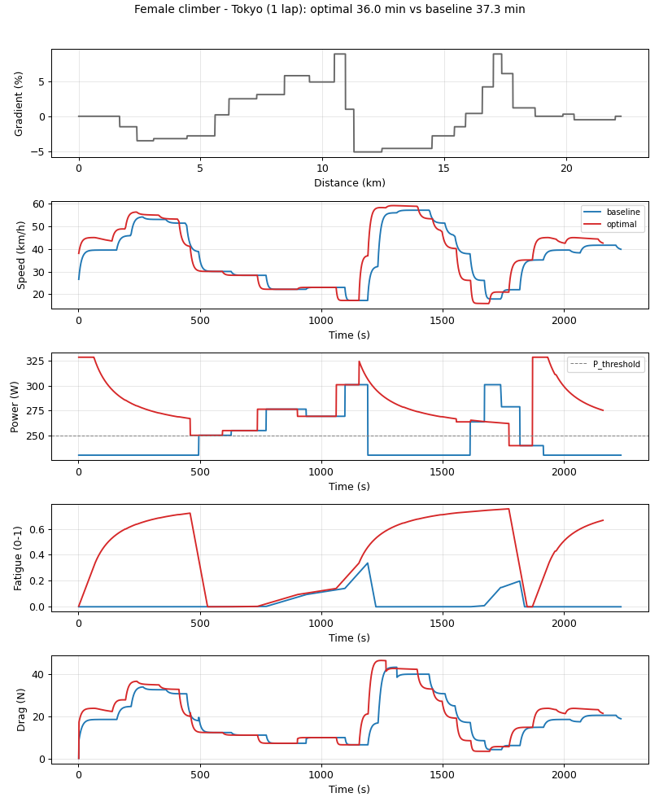
Figure 4. Female climber, Tokyo (1 lap): optimal vs baseline.
The optimization landscape itself is shown in Figure 5: completion time over the two pacing parameters, with the optimum marked. The broad dark basin confirms that hill_factor and flat_boost trade off against one another with very little change in time near the optimum, which is why the optimizer can return different (hill_factor, flat_boost) pairs at essentially the same finishing time.
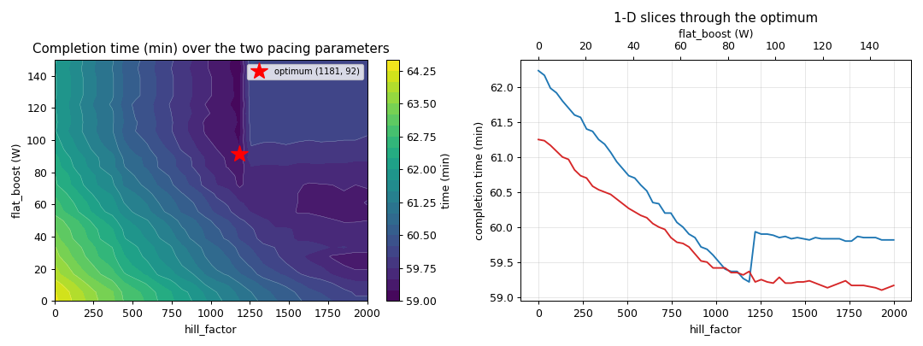
Figure 5. Completion time over (hill_factor, flat_boost) for the male specialist on Tokyo, with the optimum and 1-D slices.
Results across riders and courses.
Table 1 reports the optimized finishing time for every rider on every course, each run as a single lap so the four rider types are compared on identical terrain. On every course the male time-trial specialist is fastest and the female climber slowest, and the spread between courses simply reflects their different lengths; the same comparison is plotted in Figure 6.
Rider | Tokyo (min) | Flanders (min) | Custom (min)
Male TT specialist | 29.6 | 53.5 | 6.5
Female TT specialist | 33.7 | 59.9 | 7.3
Male climber | 32.2 | 59.3 | 7.1
Female climber | 36.0 | 65.2 | 7.9
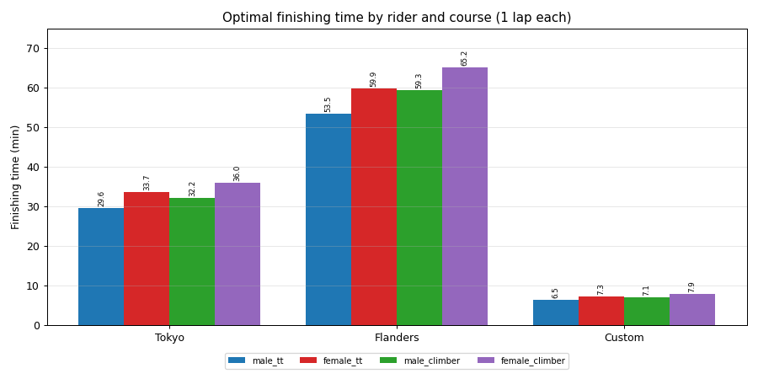
Figure 6. Optimized finishing time (minutes) by rider and course, one lap of each.
Validation against the 2021 winners.
Running each specialist at the real race configuration and comparing with the actual 2021 champions, the optimized model finishes within roughly 7–12% of the winners (Table 2 and Figure 7): the male specialist on the two-lap Tokyo course in 59.2 minutes against Roglič’s 55:04 (+7.5%), the female specialist on the one-lap Tokyo course in 33.7 minutes against van Vleuten’s 30:13 (+11.6%), and the male specialist on Flanders in 53.5 minutes against Ganna’s 47:48 (+11.9%). The remaining gap reflects that the champions are the best rides in the world on the day, together with the modelling simplifications discussed in the next section.
Race | Model (min) | Real winner | Real (mm:ss) | Error
Tokyo men (2 laps) | 59.22 | Primoz Roglic | 55:04 | +7.5%
Tokyo women (1 lap) | 33.73 | Annemiek van Vleuten | 30:13 | +11.6%
Flanders men | 53.47 | Filippo Ganna | 47:48 | +11.9%
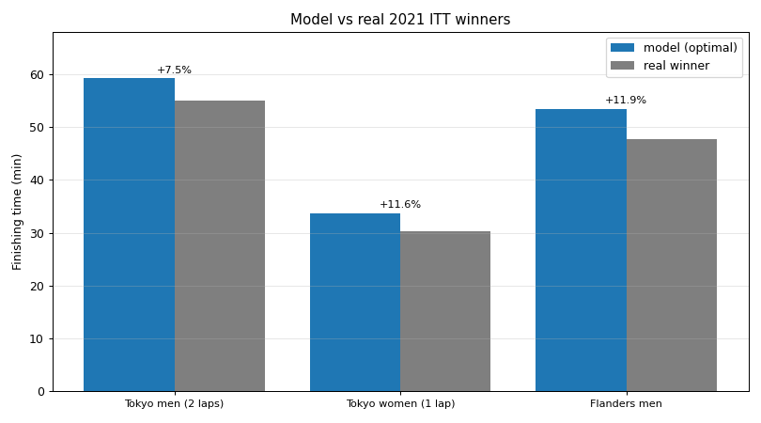
Figure 7. Optimized model finishing time versus the real 2021 winners.

Sensitivity Analysis
Weather. Wind enters the model only through the aerodynamic-drag term, so its effect grows with distance and with the share of the course spent on exposed flats. Holding each rider’s optimal plan fixed and sweeping a uniform head- or tail-wind, the finishing time on the flat Flanders course changes by about 150 seconds per metre-per-second of headwind, against roughly 70 s per m/s on Tokyo and only 16 s per m/s on the short loop (Figure 8). The model uses a scalar headwind that always opposes the rider, so it captures wind strength but not direction; a direction-dependent treatment, as in Ding et al. (2022), would be a natural refinement.
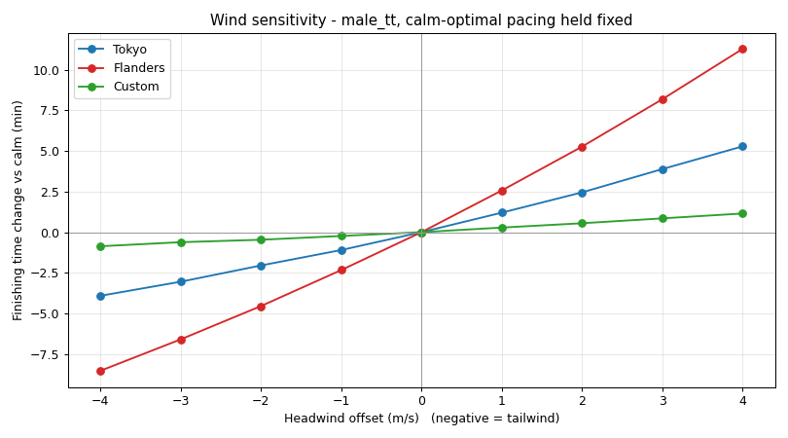
Figure 8. Finishing-time change versus a uniform head/tail wind (male specialist), calm-optimal plan held fixed.
Execution error. A rider cannot hit the planned power exactly. Scaling the whole optimal power profile by ±5, ±10 and ±15% and re-running, a 10% shortfall costs about 1.6–2.0 minutes on Tokyo while a 10% overshoot saves about 1.3–1.6 minutes (Figure 9); the penalty is mild and roughly linear, so the optimal plan is robust to ordinary pacing error.
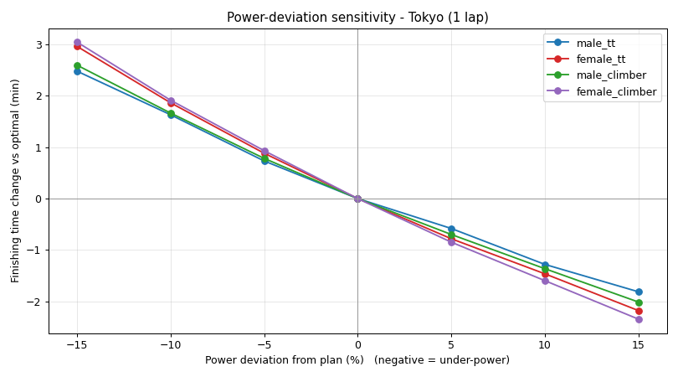
Figure 9. Finishing-time change when the rider rides ±15% off the planned power, on Tokyo.
Model parameters. Re-optimizing the male specialist on the two-lap Tokyo course while perturbing one rider parameter at a time by ±10% (Table 3) shows that finishing time is most sensitive to threshold power — a 10% higher threshold saves about two minutes — then to drag area, then to mass. This matches intuition: sustainable power and aerodynamics dominate a flat-to-rolling time trial, while a few kilograms matter mainly on the climbs.
Parameter (±10%) | −10% (min) | Baseline (min) | +10% (min)
Threshold power | 63.0 | 59.2 | 57.1
Drag area CdA | 57.4 | 59.2 | 61.0
Total mass | 58.0 | 59.2 | 60.5

Model Assessment & Alternatives
Our model deliberately trades physiological detail for transparency and speed, and several simplifications bound its accuracy. Wind is modelled as a scalar headwind that always opposes the rider, so wind strength is captured but direction is not; Ding et al. (2022), who study the same time-trial problem, instead project a wind vector onto the rider’s heading (u = u₀·cos(α − β)), so that a cross- or tail-wind can help or hurt depending on where the rider is on the course. Cornering is charged as a fixed per-segment time penalty rather than a speed-dependent braking-and-reacceleration loss, so the model does not capture that a faster rider loses more time in a tight turn. Female drag areas are scaled from male values rather than measured, because no female-specific CdA dataset was available. Finally, fatigue is captured by a single power-threshold rule rather than a physiologically detailed model.
A natural alternative is a critical-power / anaerobic-reserve (CP/W′) framework, in which the rider draws on a fixed anaerobic reserve above a critical power and refills it below. Ding et al. (2022) combine such an aerobic–anaerobic respiration model with a maximum-voluntary-contraction muscle-fatigue model and solve the resulting optimal-control problem with a greedy algorithm. That approach is more physiologically grounded but heavier to calibrate and run; our threshold model reproduces the same qualitative pacing — push above threshold on the climbs, recover on the descents, and hold a steady elevated power on the flats — and lands within roughly 7–12% of the real winners, which we judged an acceptable trade for a transparent, fast model.
Team time trial (extension). In a team time trial the squad rides together and the team’s time is taken on its fourth finisher, so the objective changes from minimizing one rider’s time to keeping at least four riders together for as long as possible. The dominant new effect is drafting: a rider in the slipstream experiences substantially lower aerodynamic drag, so the efficient strategy is a rotating paceline in which each rider takes a short, hard turn at the front and then recovers in the draft. Our single-rider model extends to this case by scaling each sheltered rider’s CdA by a position-dependent draft factor and dropping the weakest riders once four can still finish together. We leave a full implementation as future work, but the model already contains the two ingredients it needs: a per-rider drag area and a per-rider fatigue budget.

Conclusion
We modelled a cyclist as a point mass driven against drag, gravity and rolling resistance, added a power-threshold fatigue-and-recovery rule, and optimized a two-parameter pacing strategy with a multi-start Nelder-Mead search. On the 2021 Tokyo and Flanders time-trial courses and a self-designed loop, the optimizer recovers the intuitive strategy — push above threshold on the climbs, recover on the descents, and hold a steady elevated power on the flats — and finishes within roughly 7–12% of the actual winners. The result is far more sensitive to wind on the flat, exposed Flanders course than on hilly Tokyo, and only mildly sensitive to realistic execution error. The model’s main limitations — a scalar wind, a fixed cornering penalty, and a single-threshold fatigue rule — point to clear refinements (direction-dependent wind, physical cornering, and a CP/W′ fatigue model) for future work.

References
"Continental Grand Prix 5000 TT TR." Bicycle Rolling Resistance, https://www.bicyclerollingresistance.com/road-bike-reviews/continental-grand-prix-5000-tt-tr.
Cooper, R. "What is CdA? Aerodynamic Drag in Cycling Explained." Best Bike Split, https://www.bestbikesplit.com/blog/cda-aerodynamic-drag-coefficient-cycling.
"Cycling 101: Courses." NBC Olympics, https://www.nbcolympics.com/news/cycling-101-courses.
"Cycling at the 2020 Summer Olympics – Men's Individual Time Trial." Wikipedia, https://en.wikipedia.org/wiki/Cycling_at_the_2020_Summer_Olympics_%E2%80%93_Men's_road_time_trial.
"Cycling at the 2020 Summer Olympics – Women's Individual Time Trial." Wikipedia, https://en.wikipedia.org/wiki/Cycling_at_the_2020_Summer_Olympics_%E2%80%93_Women's_road_time_trial.
Ding, Li, Junlei Zhu, and Beiying Huang. "Time Trial Pacing Optimization Strategy Based on Muscle Fatigue and Aerobic and Anaerobic Respiration." Academic Journal of Science and Technology, vol. 2, no. 2, 2022, pp. 17–25.
Frattini, K. "Ellen Van Dijk Wins Elite Women's Time Trial Title at Flanders World Championships." Cyclingnews, 2021, https://www.cyclingnews.com/races/uci-road-world-championships-2021/women-elite-individual-time-trial/results/.
Horvath, et al. "Optimal Body Mass Normalization of Power Output for Accurate Prediction of Estimated Cycling Performance Over Complex Time-trial Courses." Frontiers in Sports and Active Living, 2025, https://www.frontiersin.org/journals/sports-and-active-living/articles/10.3389/fspor.2025.1599319/full.
Mateo-March, M., et al. "The Record Power Profile in Professional Female Cyclists: Normative Values Obtained From a Large Database." International Journal of Sports Physiology and Performance, vol. 17, no. 5, 2022, pp. 682–686, doi:10.1123/ijspp.2021-0372.
Ronald, I. "Filippo Ganna Wins Elite Men's Time Trial Title at Flanders World Championships." Cyclingnews, 2021, https://www.cyclingnews.com/races/uci-road-world-championships-2021/men-elite-individual-time-trial/results/.
"Segment Details for Fuji Speedway Climb." VeloViewer, https://veloviewer.com/segments/16466365.
Union Cycliste Internationale. Technical Guide: 2021 UCI Road World Championships. 2021, https://www.cyclingstage.com/world-championships-2021-flanders/route-itt-wc-2021/.
Valenzuela, P. L., et al. "The Record Power Profile of Male Professional Cyclists: Normative Values Obtained From a Large Database." International Journal of Sports Physiology and Performance, vol. 17, no. 5, 2022, pp. 701–710, doi:10.1123/ijspp.2021-0263.
Warehouse, B. "How Much Does a Bicycle Weigh?" Bicycle Warehouse, 2021, https://bicyclewarehouse.com/blogs/news/how-much-does-a-bicycle-weigh.
"World Cycling Championships 2021 Flanders: Route ITT Men." CyclingStage.com, https://www.cyclingstage.com/world-championships-2021-flanders/route-itt-wc-2021/.

Appendix
AI use:

AI was used in this project for three things.
- To turn the course data from, geographical and topological maps into CSV files, and also to turn those CSV into a format that was usable. Prompts used “Attached are a geographical and topological map for the “(insert course name, gender and data here” course. Please convert these into CSV files that we can use in the attached code” Then prompts that adjust for level of detail. “Can you split the large first descent into multiple sections based on the same data”
- To add in the optimization function to the code. Prompts used “Attached is my code for optimizing how a road cyclist can ride in different courses. I would like to use the scipy optimization library to optimize two variables over the course, the two variables are hill_factor, and flat_boost. Please do not modify any of the code other than what needs to be changed to implement this optimization”
- To help create legible plots. Multiple prompts were used here. They are.
  - “Now that we have data from the optimized version and the base version of a road cyclist, can you make 5 plots: Gradient (this will only have one line), speed vs time, power vs time, fatigue vs time, drag vs time. Each plot (except for gradient) should have the optimized version and the base version plotted together as a line but in different colors”
  - “Can you add vertical dashed lines to the plots that show when each rider finished”
  - “Can you add a legend to the charts that shows what the different color represents, only produce this legend once and put it to the right of the speed vs time plot”
  - “Can you add a P_threshold dotted line to the power vs time chart, and then an additional legend to the right of this chart that denotes what that represents”
  - “Can you reformat the charts so that the x label is visible”
  - “Can you put the large title at the top closer to the rest of the plots”
  - “Using my simulate(params, return_full=False) function, generate several plots comparing baseline and optimized strategies. Include plots that show time saved over distance, power over distance, fatigue over distance, speed vs gradient, drag vs speed, and an optimization sensitivity heatmap.”
- To translate handwriting into text. I imported photos of my notes as well as a brief sample that showed the desired formatting and said. “Can you translate these notes into docs format, similar to the attached writing style, do not change any of the words written in the notes and reproduce exactly as is”

