***Test given to 10th graders before creating multi-particle simulation***

***Midterm Exam***

*Interdisciplinary Computational Science – Grade 10*

**First question (33 points)**

Alice (Student **A**) built a computational model for a rubber ball moving inside a smooth hollow tube of length L and colliding elastically with the walls of the tube (Figure 1).

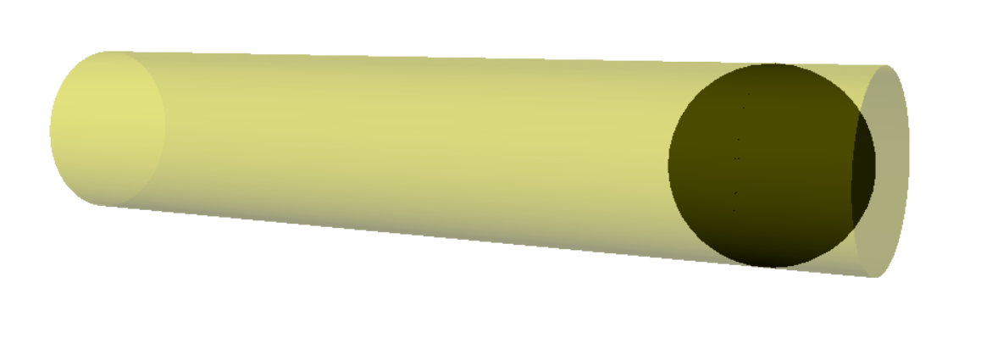

**Figure 1:** Ball moving in a hollow tube colliding with the walls

Below is the code that Alice built in Vpython:

**from visual import \***

1. **m = 2.0**
2. **f = 100.0**
3. **R = 0.5**
4. **L = 10.0**
5. **t = 0**
6. **dt = 0.001**
7. **v = vector(5.0,0,0)**
8. **tube = cylinder(pos=vector(-L/2,0,0), axis=(L,0,0), radius=R)**
9. **ball = sphere(pos=(-3.0,0,0), radius = R)**
10. **while t < 10:**
11. **rate(100)**
12. **if ball.pos.x > L/2: F1 = f*vector(-1,0,0)**
13. **else: F1 = vector(0,0,0)**
14. **if ball.pos.x < -L/2: F2 = f*vector(1,0,0)**
15. **else: F2 = vector(0,0,0)**
16. **F_net = F1 + F2**
17. **a = F_net/m**
18. **v = v + a*dt**
19. **ball.pos = ball.pos + v*dt**
20. **t = t + dt**
21. Divide the code into a number of groups according to their function in the computational model (a group doesn’t have to include consecutive lines), and briefly describe the function of each group of lines. Specify the meaning of the lines for each group. Use the following table and the example (8 pts).

|  |  |  |
| --- | --- | --- |
| **Meaning of the lines** | **Function of the group of lines** | **Group** |
| m = mass of the ball, f = force, R = radius of the ball, L = length of the tube | Defining different constants of the system | 1-4 |
|  |  |  |
|  |  |  |
|  |  |  |
|  |  |  |
|  |  |  |
|  |  |  |

1. Bob (Student **B**) proposes replacing part of the code that Alice wrote with the following lines:

**if disk.pos.x < -L/2: v.x = -v.x**

**if disk.pos.x > L/2: v.x = -v.x**

Which lines of the original code do you think can be taken out if you use Bob’s proposal? What is the function of those lines in Alice’s code? Why can they be replaced with the lines that Bob proposed? (5 pts)

תשובה:

1. For each of the two models (Alice’s and Bob’s): On which assumptions is the model based? What does the model predict about the velocity of the ball during and after a collision? (4 pts)

Answer:

1. Bob and Alice experimentally measured the position of the ball vs. time twice: With a camera taking 30 images per second, and with a camera taking 100 images per second. The results of the measurement are presented in Figure 2.

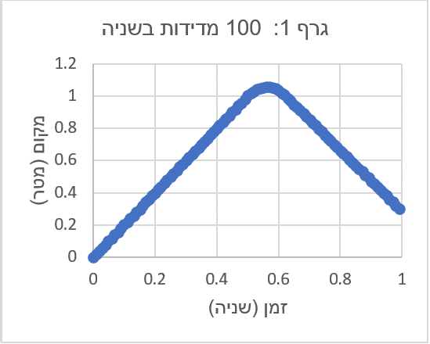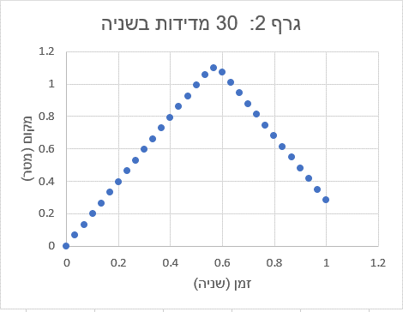

**Figure 2:** Position-time x(t) graphs obtained with a camera with different times between pictures.

Which of the measurements fits Alice’s model, and which fits Bob’s model? Explain why. (4 pts)

Answer:

1. In Figure 3 is a graph of the velocity of the ball vs. time, obtained from running the code **that Alice wrote**.

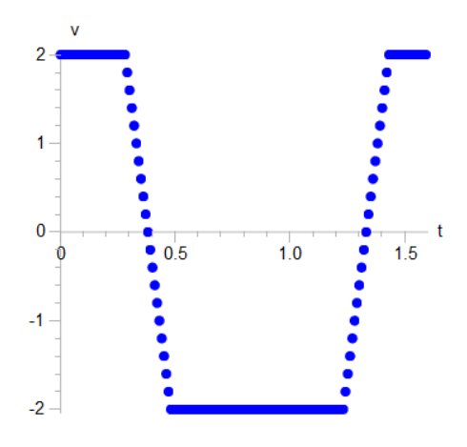

**Figure 3:** Velocity-time v(t) graph obtained from the prediction of the model

1. Describe the motion of the ball that fits the graph. (3 pts)

Answer:

1. Sketch an (approximate) acceleration-time graph that corresponds to Figure 3. (3 pts)

Answer:

1. How do you think the velocity-time v(t) graph in Figure 3 would change if Alice were to change the value of the mass of the ball to m=4.0? Add, on Figure 3, the graph that you think would be obtained as a result of the change, and explain your answer. (3 pts)

Answer (Draw your answer on this graph): Explanation:



1. How would the velocity-time graph v(t) look as obtained by running the code that **Bob proposed**? Add, on Figure 3, the graph that you think would be obtained, and explain your answer. (3 pts)

Answer (Draw your answer on this graph): Explanation:



**Second question (33 points)**

Carol (Student **C**) is interested in investigating the motion of a disk resting on an air table with metal wires on its sides. She hits the disk and gives it an initial velocity, as a result of which the disk moves to the edge of the table and hits it at an angle. Carol records the movement of the disk with her cellphone and produces a velocity-time graph from the data that he measured.

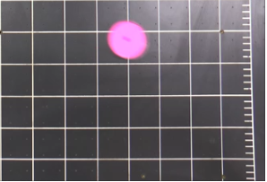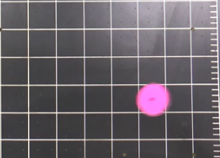

$$x$$

$$y$$

Before the collision

After the collision

**Figure 4:** The experimental system (top view): Disk on an air table, colliding at an angle with the right edge of the air table

**Building a model**

Carol builds a computational model for the collision of the disk based on two assumptions: (1) The disk moves with a fixed velocity on the table before and after the collision with the edge of the table, (2) During the collision between the edge of the table and the disk, an elastic collision occurs.

1. Sketch (from a side view) three diagrams of the forces acting on the disk: before, during, and after the collision, according to Carol’s model. (6 pts)

After

During

Before

Answer:

$$x$$

$$z$$

1. Write the equation of motion for the disk during the collision. (4 pts)

Answer:

**Predictions of the model and comparison to experiment**

1. Carol produced from the model two graphs of the components of velocity vs. time: one graph of the x component of velocity, and one graph of the y component (both graphs were produced at the same time while running the simulation). Carol forget to label the graphs – help Carol figure out which graph is for the x component of velocity and which is for the y component, and explain your answer (use the axes in Figure 5). (5 pts)

Graph 1

Graph 2

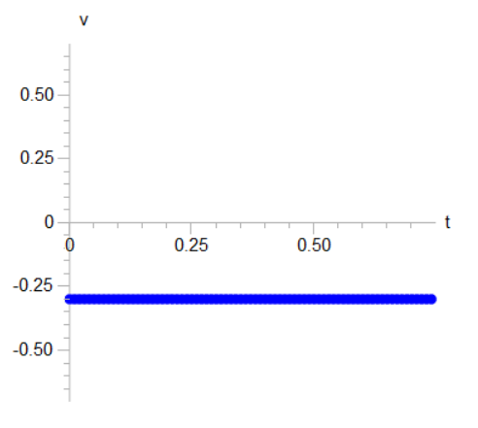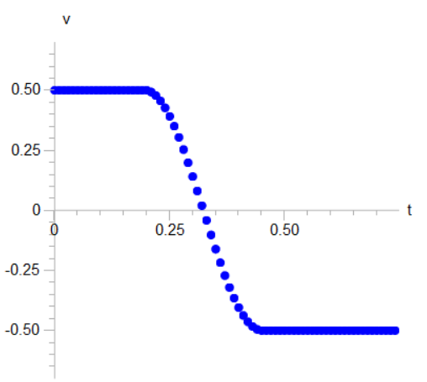

**Figure 5:** Graphs of the components of velocity vs. time obtained from running the simulation.

Answer:

1. Carol is interested in testing the assumptions of his model regarding the forces acting on the disk by comparing the velocity vs. time graphs obtained from measurement and from the model. Figure 6 presents two velocity-time graphs (of one of the components): one graph was obtained from the predictions of the model, and another graph from the results of measurement. Describe the similarities and differences between them. (6 pts)

**Figure 6:** Velocity-time graph obtained from measurement and predictions of the model

Answer:

1. Propose an explanation of the difference between the predictions of the model and the results of measurement: Which interactions (forces) exist in reality that seem to have been disregarded by Carol’s computational model? Can you see evidence of this on the graph? Explain. (6 pts)

Answer:

**Improving the model**

1. Propose an improved model: Sketch a new diagram of the forces acting on the disk before and after the collision. (6 pts)

Answer:

After

Before

$$x$$

$$z$$

1. **Optional section:** Sketch new diagrams of the forces acting on the disk at different stages **during the collision** and rewrite the equation of motion for the disk during the collision. (5 pts)

Answer:

**Third question (34 pts)**

Dan (Student **D**) decided to build a simulation for the collision of two identical (in radius and mass) billiard balls. He assumes that the balls move at fixed velocity on the table (between collisions), and that during the collision a fixed force acts between them. In the right part of Figure 7 (“Observation”), Dan sketched the trajectory of the balls before, during, and after the collision.

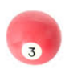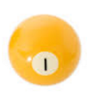

Observation

Simulation



**Figure 7:** Estimated results of the phenomenon and running the simulation

1. On the next page is the code that Dan wrote. He ran the code and discovered to his surprise that the motion of the balls doesn’t fit the observed trajectory. Read the code that Dan wrote and sketch on the left part of Figure 7 (“Simulation”) the trajectory of the balls that you estimate would be obtained from this code. (4 pts)
2. Describe the difference between the trajectory of the balls obtained in “Observation” and the estimated trajectory that you sketched in “Simulation”. (3 pts)

Answer:

**from visual import \***

1. **m1 = 1.0**
2. **m2 = 1.0**
3. **R = 1.0**
4. **L = 10.0**
5. **A = 40.0**
6. **dt = 0.001**
7. **t=0**
8. **table = box(pos=vector(0,0,0), size=(L,L,0))**
9. **ball1 = sphere(pos=vector(-2,0,0), radius = R)**
10. **ball2 = sphere(pos=vector(2,0,0), radius = R)**
11. **v1 = vector(3,3,0)**
12. **v2 = vector(-3,3,0)**
13. **while t < 1:**
14. **rate(100)**
15. **r = ball1.pos - ball2.pos**
16. **r_hat = r/mag(r)**
17. **if mag(r) < 2*R : F_net = A*r_hat**
18. **else: F_net = vector(0,0,0)**
19. **a1 = F_net/m1**
20. **v1 = v1 + a1*dt**
21. **ball1.pos = ball1.pos + v1*dt**
22. **a2 = F_net/m2**
23. **v2 = v2 + a2*dt**
24. **ball2.pos = ball2.pos + v2*dt**
25. **t = t + dt**
26. Diagnose the error in the code that Dan wrote:
    1. Copy the line(s) of code in which you think the error occurred. (2 pts)

Answer:

* 1. In which physical principles/concepts did Dan make a mistake? How was his understanding different from the accepted physical understanding? (5 pts)

תקנו את הקוד של שרית בכדי לקבל הדמיה שמתאימה לתצפית. כתבו בתשובתכם את רק את השורות המתוקנות. (5 נק')

Answer:

* 1. Fix Dan’s code in order to get a simulation that fits observation. In your answer, write only the fixed lines. (5 pts)

Answer:

1. Dan tests the simulation with a vector representation of force and velocity before and after the collision. Figure 8 shows the position and velocity of ball A before and after the collision with ball B (not shown in the figure).
2. Find **by sketching** the direction of the force vector acting on the ball. Show the stages of the solution and not only the final answer. (5 pts)

$${\vec{v}}_{i}=(3,3,0)$$

$${\vec{v}}_{f}=(-1,0.5,0)$$

A

A

Answer:

**Figure 8:** Ball A during the collision with ball B (not shown in the figure)

1. Calculate the force vector acting on ball A, if it is given that the collision lasts a tenth of a second and the mass of the ball is 150 grams. Use the data that appear on the sketch. (5 pts)

Answer:

1. What is the direction of the force acting on ball B? What physical principle can you use to figure out its direction? Calculate the unit vector that corresponds to this force. (5 pts)

Answer:

1. **Optional section:** Dan decided to test the influence of the type of interaction on the velocity vector after the collision. He built an additional simulation based on elastic interactions (in a fixed position). Do you think the velocity vector after an elastic interaction will be the same or different from what was obtained with a collision with a fixed force? If there are differences, describe them. If not, explain why. (2 pts)

Answer:

**Formula Sheet**

|  |  |
| --- | --- |
| *Physical Quantity* | *Definition* |
| Displacement | $${∆\vec{x}=\vec{x}}_{f}-{\vec{x}}_{i}$$ |
| Definition of velocity | $$\vec{v}=\frac{∆\vec{x}}{∆t}$$ |
| Definition of acceleration | $$\vec{a}=\frac{∆\vec{v}}{∆t}$$ |
| Calculating position (with the Euler approximation) | $$x_{i+1}=x_{i}+v∙dt$$ |
| Calculating velocity (with the Euler approximation) | $$v_{i+1}=v_{i}+a∙dt$$ |
| Hooke’s Law (elastic force) | $$\vec{F}=-k∆\vec{x}$$ |
| Unit vector |  |

***Newton’s Three Laws***

|  |  |  |
| --- | --- | --- |
|  | **Version in words** | **Mathematical version** |
| **1** | Objects with no external forces acting on them, or for which the external forces acting on them cancel each other so that the net force acting on them is zero, move at a constant velocity or remain at rest. | $$Σ\vec{F}=0 ⟺ \vec{v}=const$$ |
| **2** | When a net force acts on an object, then the object accelerates. The direction of the acceleration is the same as the direction of the net force, and its magnitude is proportional to the magnitude of the net force. The constant of proportionality is the inverse of the mass of the object. | $$\vec{a}=\frac{Σ\vec{F}}{m}$$ |
| **3** | When object 1 exerts a force on object 2, then object 2 also exerts a force on object 1, and the two forces are equal in magnitude and opposite in direction. | $${\vec{F}}_{1,2}={-\vec{F}}_{2,1}$$ |