

Installation Guide
Revision 3.6

© 2008-2009 Logical Objects snc, via Bonasi 2/A – 41012 Carpi Italy.
All rights reserved.
http://www.logicalobjects.it

This document is subject to change without notice.

License
This work is licensed under a GNU Free Documentation License 1.2.
http://www.gnu.org/licenses/fdl-1.2.txt

Disclaimer
Documentation is provided 'AS IS' and all express or implied conditions, representations and warranties, including any implied warranty of merchantability, fitness for a particular purpose or on-infringement, are disclaimed, except to the extent that such disclaimers are held to be legally invalid.

Contents
1 Overview 4
2 Pre-requisites 4
Memory requirements 4
3 Installation from Tomcat bundle package 5
Installation as a Windows Service 5
Test the installation 5
4 Installation from war package 5
Setup Tomcat Users 5
Test the installation 6
5 System setup 6
Some more Remarks 9
Slow Page Delivery 9
Exception During Deployment 9
Memory Requirements 10
Cookies and Multiple Sessions 10
Encryption 10
6 Upgrade from a Previous Version 10
Backup First! 10
Upgrade Procedure 11
7 Please contribute your knowledge 11

Overview

This guide describes in detail the installation process of the document management system LogicalDOC. If this is the first time you install LogicalDOC, follow the instructions provided in sections 3 or 4 dependin on what package you downloaded. If you want to upgrade from a previous version, follow the instructions in section 6.

Pre-requisites

LogicalDOC is not an application able to run on its own. Instead, it requires a Java application server supporting the servlet specification 2.4 or higher. LogicalDOC’s developers recommend to use Apache Tomcat, a reliable OpenSource servlet container. See the installation instructions of the application server package for information on how to set it up.
LogicalDOC is meant to be used with Apache Tomcat version 6 and SUN’s Java JRE version 6. Make sure to not mix the main releases of Apache Tomcat and SUN’s Java JRE. If you are using Apache Tomcat 6, you have to use SUN’s Java JRE version 6.
In addition you need a database management system. LogicalDOC supports the following systems:

- Oracle 8i/9i
- MS SQL Server 2000
- MySQL since 4.1
- HSQLDB since 1.8
- PostgreSQL since 8.0

LogicalDOC is shipped with HSQLDB. This is a very simple database management system. It stores the database directly as SQL commands on the local file system. It is a good way to start, because it makes the installation far more easier. However, it is not recommended to use this database management system for any real world purpose. If you plan to use LogicalDOC in any production setting, you should install a real database management system instead.

Memory requirements
LogicalDOC requires at least 512MB of memory assigned to the application server. With Apache Tomcat you can assign memory through the environment variable JAVA_OPTS.

for Linux:
export JAVA_OPTS="$JAVA_OPTS -Xmx512M"
for Windows:
set JAVA_OPTS=%JAVA_OPTS% -Xmx512m

Installation from Tomcat bundle package
The Tomcat bundle is a package named logicaldoc-<rel>-tomcat-bundle.zip.
This package contains both the application server and the LogicalDOC application.
Unzip the package into a folder of your hard disk, in this folder you will get a sub-dir containing the LogicalDOC distribution.
The start/stop script of the application are placed in tomcat/bin:
- startup.bat / startup.sh: starts the application
- shutdown.bat / shutdown.sh: stops the application

Installation as a Windows Service
LogicalDOC can be installed as a Windows service so that it will be launched at the machine bootstrap.
In order to install LogicalDOC as a service, you only need to open a shell in tomcat\bin and type the command service install.
A new service called LogicalDOC will be installed in your system.
If you want to remove the service, simply digit the command service remove.

Test the installation
One you have launched the application server with startup or through the Windows service, open a browser and point it to http://localhost:8080/
If you can see the login form, the installation is correct and you can proceed with the system setup.

Installation from war package

The war is a package named logicaldoc-<rel>-war.zip.
This package contains manuals and the war archive logicaldoc.war.
To deploy LogicalDOC, simply copy logicaldoc.war into webapps directory of your Tomcat distribution.

Setup Tomcat Users
LogicalDOC needs a specific Tomcat account for managing some configuration issues. This account must have the admin role.
In Apache Tomcat, you have to alter the file conf/tomcat-users.xml. First, you have to add a new role admin. You can do that by adding the following line to the file:

<role rolename="admin"/>

Now, you have to create an user with the role assigned. In the following example an user admin with the password secret and the roles admin and manager is created:

<user username="admin" password="secret" roles="manager,admin"/>

In the end, your tomcat-users.xml file should look like:

<?xml version='1.0' encoding='utf-8'?>
<tomcat-users>
<role rolename="tomcat"/>
<role rolename="role1"/>
<role rolename="manager"/>
<role rolename="admin"/>
<user username="tomcat" password="tomcat" roles="tomcat"/>
<user username="both" password="tomcat" roles="tomcat,role1"/>
<user username="role1" password="tomcat" roles="role1"/>
<user username="admin" password="secret" roles="manager,admin"/>
</tomcat-users>

You might have to restart your server so that the new user account is activated.

Test the installation
Start the Tomcat application server and point your browser at http://localhost:8080/logicaldoc. If you can see the login form the installation was correct.

System setup
Once you have installed LogicalDOC from the war archive or the Tomcat bundle, you have to do the initial setup.
Setting up LogicalDOC is easy, because a wizard will guide you through the complete setup process. Before you can start the setup wizard, you have to provide a login. This login is necessary so that later not every user can run the setup procedure. Now, navigate your browser to the setup wizard through one of the following URLs:
- http://localhost:8080/logicaldoc/setup/ if you installed from war archive
- http://localhost:8080/setup/ if you installed from Tomcat bundle

The wizard is divided into 4 steps.
In step 1 you have to specify the root of LogicalDOC working directory.
This directory will contain all document files and all logs and other resources needed by LogicalDOC. The figure below shows the default value that takes the current user home directory. Make sure that the application server you are using has write access to the directories and files!

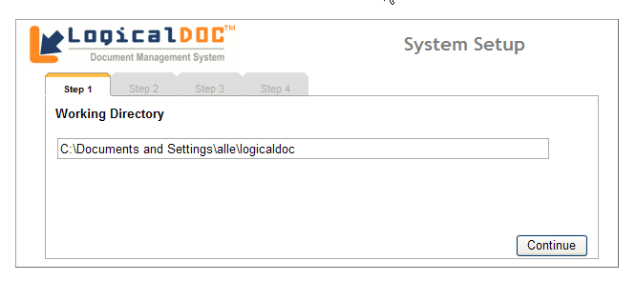Image 1: LogicalDOC's Working Directory
In step 2 you have to configure the database management system you are going to use. You have to select if you want to use the internal database management system or an external one.
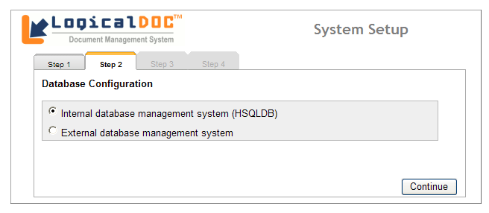Image 2: Database Configuration

In step 3 you have to configure the database connection parameters. If you select the internal dbms, you have to specify the directory where the database should be stored. This is already everything required to set up the internal database system.
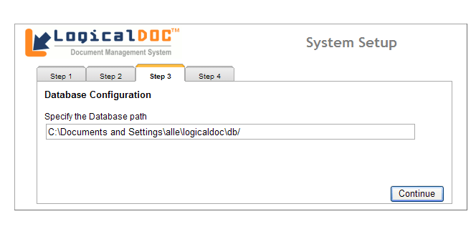Image 3: HSQLDB path
If you selected external database system as storage mechanism, you have to select the database management system to be used. Also, a you have to specify the connection details in the provided textboxes. In the example below the PostgreSQL database management system was selected. This database contains a database called logicaldoc and a user logicaldoc was created on the PostgreSQL server to access this database. Please note that you have to create the database and the database user in advance using the administration tools provided by the database management system.

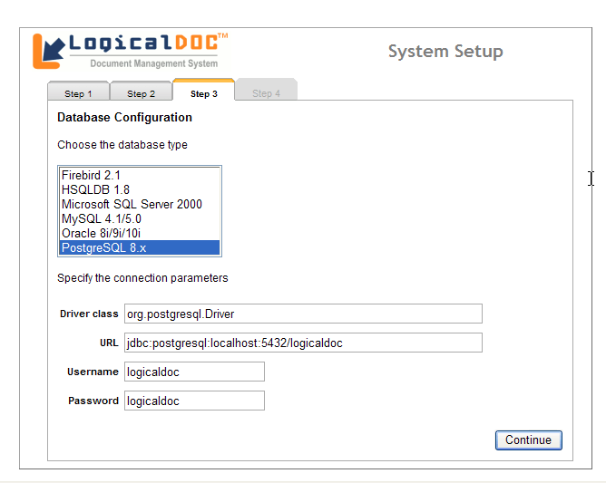Image 4: External RDBMS Configuration

If you have successfully configured the database, LogicalDOC will create all necessary tables and insert some basic data.

Step 4 is the final step. It just shows you the button to LogicalDOC’s entry page. By calling http://localhost:8080/logicaldoc/ this start page can be accessed.
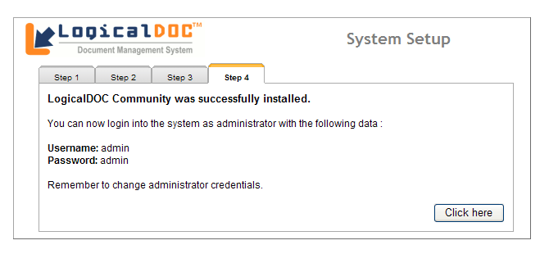Image 5: Setup completed
You should now log in using the administrator account, create some user accounts, maybe set up the initial folder structure, configure access rights to the folders, etc. You should also log in as an ordinary user and do a short test drive so that you can see if everything works as expected. Try also to shutdown and restart your application and database server, so that you see if this is also working correctly. If everything is fine, you should introduce LogicalDOC to your users. Do not forget to give them at least a short introduction to the system, so that they do not have to figure everything out by themselves!

Some more Remarks

Slow Page Delivery
There have been reports that on first usage LogicalDOC might feel a bit slow. It seems to take some time that requests get answered by the server. This is, however, just a first time effect. Internally, the application server has to compile the files send to the client on the first request. Later on, if you go to the same page again, it will load much faster. Therefore, it is a good idea that you play around a little bit with LogicalDOC before you release it to your users.

Exception During Deployment
If you deploy LogicalDOC on your servlet container, you will probably get several exceptions on Apache Tomcat’s console. The exceptions will say that Tomcat was unable to open or create certain files needed for log4j. Do not worry about those exceptions. They will go away after you successfully configured LogicalDOC. Before LogicalDOC is configured, it will try to put its log files in a default path. Usually, Tomcat has no access privileges to write to this default path and therefore the exceptions are thrown.

Memory Requirements
Since version 3.6 LogicalDOC requires more memory to run, if you are using the internal SQL engine HSQLDB. You should change the settings of your server to allocate more memory. Otherwise you will get out of memory errors and LogicalDOC won’t work. For Apache Tomcat, you can change the JAVA_OPTS environment variable in the catalina.sh/catalina.bat file. Assigning 512 MB of memory seems to work:
for Linux:
export JAVA_OPTS="$JAVA_OPTS -Xmx512M"
for Windows:
set JAVA_OPTS=%JAVA_OPTS% -Xmx512m

Make sure that you test your server to find a good value for your intended use. The memory requirement might differ according to how many users are accessing the server at the same time.

Cookies and Multiple Sessions
Each user wanting to use LogicalDOC has to authenticate using his login and password. This session handling only works, if the browser accepts cookies. It is also not possible to log in to LogicalDOC using different logins with the same browser at the same time like browsing to LogicalDOC in different tabs of your browser. If you want to use different accounts at the same time, make sure to also use different browsers, because the session information is stored in the cookie and there is only one cookies for each browser.

Encryption
Passwords are send to LogicalDOC in plain text. That is a security risk, if you are using LogicalDOC in a hostile environment. Therefore, you should configure your application server to use SSL encrypted transfer (HTTPS) instead of general HTTP. This is not something specific to LogicalDOC, however. You should also take this into account if you plan to use the web service interface. Here, it also makes sense to use HTTPS instead of HTTP.

Upgrade from a Previous Version

Backup First!
Before you upgrade an existing LogicalDOC installation, take the time to create a complete backup. There are different things you have to take care of. Before you start, you must shutdown LogicalDOC, so that no user can change any data anymore. In addition, you should shutdown also your servlet container, because some files are only written on server shutdown.
First, you have to backup your database. Unless you are using the file system based database HSQL DB, your database management system will provide some administration interface to do that. HSQL DB stores the database in a path you specified during setup. Look for the context.properties file in the WEB-INF/classes directory. You will find the path to the database in this file, just in case you do not know it anymore.
After you made a backup of the database, you should make a backup of all data files created by LogicalDOC. That includes the users’ directories, the search indexes as well as the documents (with all old versions) stored in LogicalDOC. If you do not remember the path of the directories, start LogicalDOC and log in as administrator. Now go to the settings menu and click on Directories. There you will find the directories you have to backup. Another way to find out the paths is again the context.properties file.
The third thing you have to take care of are the settings of your installation. The settings are stored on the server in the WEB-INF/classes directory. You only have to backup the context.properties file.
Now that you have a complete backup of your data, you can go on upgrading to the new version.

Upgrade Procedure
Upgrading is easy. You just have to download the latest binary package, copy the files over the old installation, restore your settings and start LogicalDOC again. Here is a step by step instruction:
- Make a backup first! For instructions see section 6.1 on page 10.
- Download the binary package of LogicalDOC from LogicalDOC’s homepage and store it on your local hard disk.
- Extract the file you downloaded. Inside, you will find a file called logicaldoc.war. You must also extract this file. To do that you can use any tool able to extract ZIP files. Or you can use the jar tool provided with the Java distribution. In that case you have to use the following command: jar xvf logicaldoc.war.
- Stop LogicalDOC and the servlet container, so that no user can access it anymore.
- Delete all LogicalDOC related files deployed in the servlet container.
- Copy all files contained in the war file you extracted to the previous location in the servlet container.
- Restore your setting file context.properties by copying it back from your backup to the WEB-INF/classes directory.
- Restart LogicalDOC and test if everything works as expected.
- If everything works fine, you can announce the upgrade to your users so that they can start using LogicalDOC again.

Please contribute your knowledge
The installation instructions are generic, so they do not cover steps for any specific platform. Please let us know, if there are any specific steps needed for the platform of your choice. Please share your knowledge and experience, so that not other users have to reinvent the wheel!

http://jarkarta.apache.org/tomcat/

