

User Manual
Version 3.6

© 2009 Logical Objects snc, via Bonasi 2/A – 41012 Carpi Italy. All rights reserved.
http://www.logicalobjects.com

This document is subject to change without notice.

License
This work is licensed under a GNU Free Documentation License 1.2.
http://www.gnu.org/licenses/fdl-1.2.txt

Disclaimer
Documentation is provided 'AS IS' and all express or implied conditions, representations and warranties, including any implied warranty of merchantability, fitness for a particular purpose or on-infringement, are disclaimed, except to the extent that such disclaimers are held to be legally invalid.

Contents
1 General Informations 4
1.1 What is LogicalDOC 4
1.2 Contacts 4
1.3 Manual layout 4
1.4 Acronyms and Abbreviations 4
2 First access 5
2.1 Login 5
2.2 Main Page 6
2.3 Documents management 6
2.4 Quick search 8
2.5 Folder deletion 9
2.6 Program exit 9
3 Administration 10
3.1 Users 10
3.2 Creation of a new user 10
3.2.1 User editing 11
3.3 Groups 11
3.3.1 Creation of a new group 11
3.3.2 Editing of an existing group 12
3.4 E-Mail boxes 12
3.4.1 Accounts configuration 12
3.5 Remote shares (Enterprise Edition only) 14
3.5.1 Configuration of remote shares 14
3.6 Scheduled Tasks 15
3.6.1 List of scheduled tasks 15
3.6.2 Scheduling 16
3.6.3 Progress status and log 17
4 Documents 18
4.1 Folders 18
4.2 Document creation 19
4.3 Document editing 19
4.4 Access rights 20
5 Personal data 21
5.1 Change the password 21
5.2 Edit of personal data 21
5.3 Send and receive messages 21
5.3.1 Sending a message 21
5.3.2 Reading received messages 22

General Informations
LogicalDOC is a system for archiving documents easy to use and designed to be inserted into any corporate network. It is ideal for saving, sharing and searching for electronic documents of any kind. This manual is dedicated to the staff responsible for the administration or use of the documents archive.

What is LogicalDOC
LogicalDOC is a system for archiving documents fully web-based. Once installed and connected to a LAN, you can use the program simply using the browser without having to install additional software.

The features made available by the system include:
- Organization of documents into folders
- Full-text indexing of documents in Office formats (PDF, Word ....)
- Editing and Cancellation of documents already imported
- Acquisition of documents from e-mail boxes
- Handling of users and access privileges
- Documents versioning after each change

This program, once installed and configured on a server connected to the network, allows access to the documents archive.

Contacts
Support e-mail: support@logicaldoc.it
Bugs and feature requests: http://www.logicaldoc.info/mantis

Manual layout
This guide is divided into 2 sections: the first comprising chapters 1, 2 and 3 provides a general description of the system and a guide for quick access, while the second part collects various chapters each devoted to a particular management area.

Acronyms and Abbreviations
DMS – Document Management System
Program that maintains and makes available the electronic documents constituents a documents archive.

First access
LogicalDOC is a web application designed to be simple to use, its online guide allows you to become familiar with the main functions in a very short time. This chapter, however, wants to be a brief introduction to the instrument, guiding the user from the system entry until the end of a generic work session.

Login
In order to log into the system you must know your access credentials: user name and password. Once in possession of this information you can access the page to enter the application by pointing your browser at the address configured during the program set-up, for example http://localhost:8080.
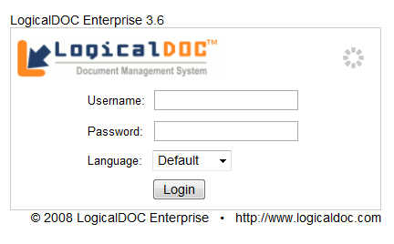Picture 1: Login Form

The form asks the user login, password, and optionally a language other than that provided for the user. Then enter the information you are in possession and confirm by pressing the "OK".
If the authentication was successful you will be taken to the main page, if the login failed you will see an error message and you will be again taken to the same form.

NOTE: Every user of the system should jealously preserve their password and should take care to change it regularly every 6 months without communicating it with anybody. The communication of the password to others undermines the security of the system.

Main Page
In the main page there are some controls placed in drop-down boxes: welcome message, notification of messages from other users (messaging features will be described in paragraph 5.3), the list of recent documents accessed, the documents downloaded, the tag cloud (which contains the used keyword).
At the top is placed the menu system that lets you access the main areas of the program. Over and above the menu, there is the text box for searching documents, on content based criteria.

Documents management
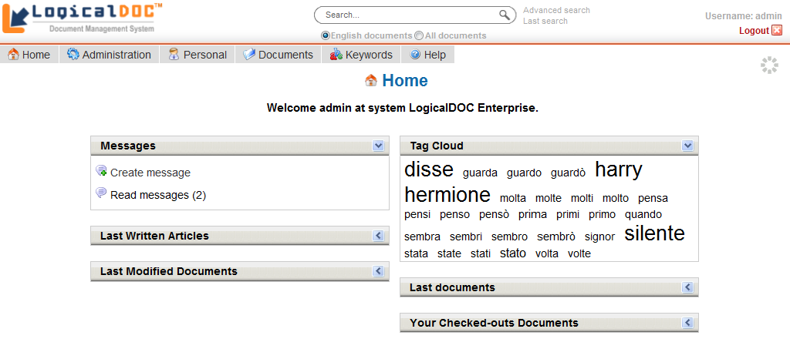Picture 2: Documents and folders
Click on Documents, the fourth item in the menu system. The central part is now occupied by the documents, they are organized into folders and sub-folders similar to what happens in a normal disk to your PC.
The navigation in folders occurs simply by clicking on the name of the folder in the list of folders on the left side. Now click on the folder 'Documents' and then on icon placed on the top of the panel containing the list of folders.
Enter "test" as name and select all the groups and checking their boxes. The group is important because it specifies what types of users can access the new folder. Pressing the Save button, a message will warn you that the new folder was created.
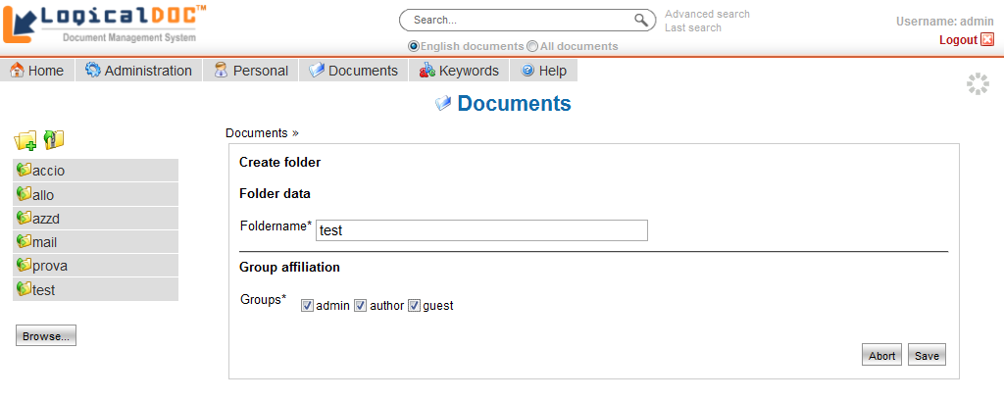Picture 3: Folder creation

You should now see the presence of the new folder, click on its name in order to enter in this empty folder. Note that at the top of the main area, it is always kept track of the route inside the folder structure (bread crumb).


Now insert a new document, to do it place the cursor on top of the list of documents and click on icon .
Initially, you are asked for the file to load and the language in which the document was written.
To specify the file simply press the button 'Browse ...', select a file on your PC and then press the button' Upload '. A progress bar will display the status of the upload process.
The language specification is done through the appropriate drop-down list and it is important because it affects the engine indexing the text content of the document.
Once the document is loaded, you can take the next step by selecting the button 'Next >>>'. Some informations are extracted, a form for document editing is displayed for a final assessment. At this stage you can change various parameters descriptive of the document, including groups it belongs to. The most important parameter is the one containing the keywords, as these can be used later for research.
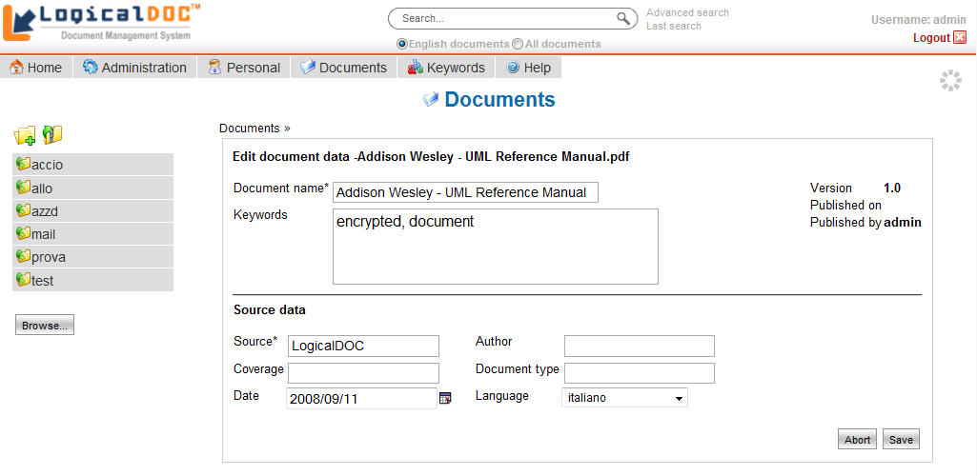Picture 4: Document's editing form
Clicking on Save, the document will be definitively stored and its content indexed. Immediately after the creation you will be redirected to the previously created folder and you will see that now it contains the document just entered. Click on document to download.
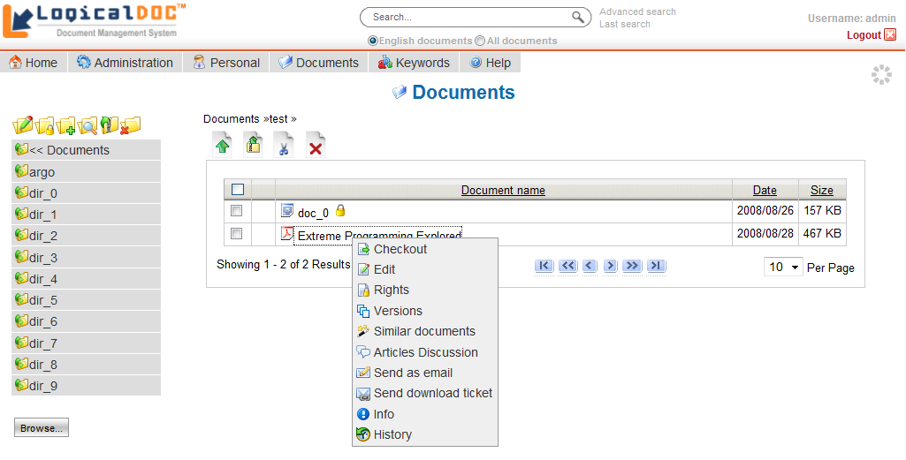Picture 5: Contextual menu
By clicking the right button on the name of the document, a context menu appears. The context menu provides access to major management functions of the single document such as modification or cancellation.

Note: you should be always very careful to erase files and folders because the removal is not a reversible process and the data will be lost forever. But you should make periodic cancellations of those documents no longer needed and that loads the system without reasons.

Quick search
If you remember some words in the text of the document that you have entered, choose one and write it in the search box at the top of the page. Pressing on you will search for the entered word.
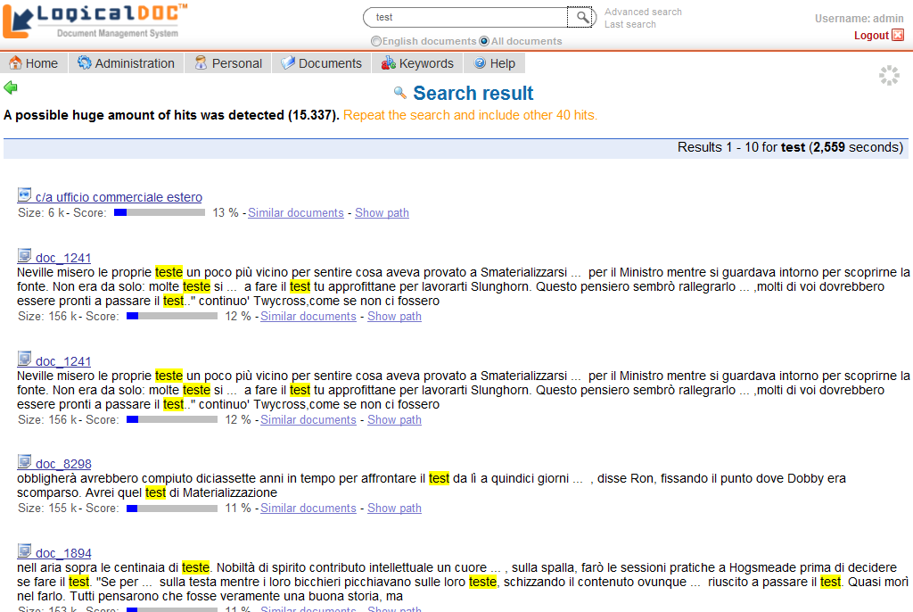Picture 6: Search result
The result is a list of documents sorted by decreasing scores. The score is the relevance of the text in connection with the search words. From this list you should be able to locate the document you've entered.

Folder deletion
Now, to become familiar with the operation of a deletion, you can proceed with the removal of the folder 'test' previously created. Move to the folder 'test' and then click on the icon above the folders list.

Program exit
Once the work session is ended, you must click the logout link at the right-top area. Pressing on this link many resources allocated for the current session are released and made available to other users. Simply closing the browser, the session remains open until the end of the timeout, unnecessarily using system resources.

Administration
This chapter will introduce the main functions of administration area. In fact, the administration of LogicalDOC is quite simple and usually is used primarily to set-up users and groups.

Users
By accessing the administration using the same name menu, you can click on the management of users (sub-menu 'User').
Once you click the menu 'User', the list of users currently loaded is displayed.

Creation of a new user
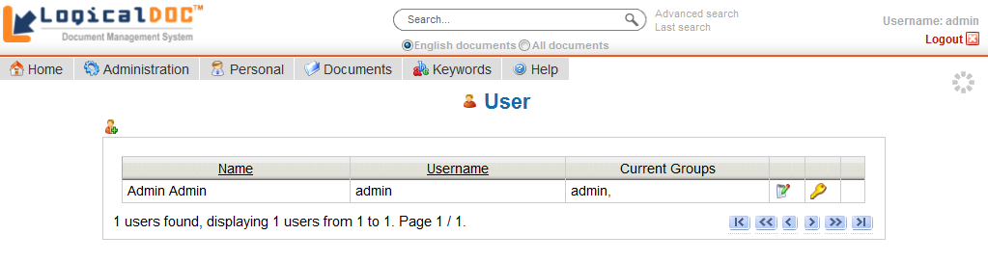Picture 7: Users administration
By selecting the icon in the upper left of the first user, you will see the new user insertion form. The form contains all the data descriptive of a particular user. Some data are required and in particular:
- Street
- Password
- First Name
- Last Name
- Language
- E-mail
- Groups
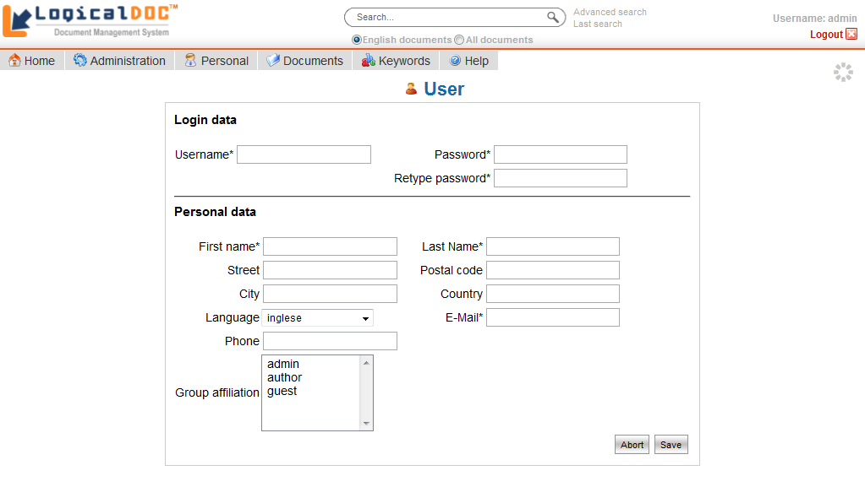Picture 8: New user creation
Each user can belong to one or more groups, the security policies are always expressed in relation to the groups and never to individual users. To select multiple groups hold down the SHIFT key while you click your groups.
Once filled all fields, by clicking on 'Save', the user is created and stored in the database.

Note: the security model implemented by LogicalDOC allows you to express security policies about the visibility and editing. These security policies are expressed only in relation to groups, so each user inherits the access privileges assigned to all groups he belongs to.

User editing
Each item in the users list owns up to three icons with which you can proceed to the editing, to change passwords or deletion.
Clicking on icon it displays the same form for creation: the only difference is that in this case the form is shown for a change instead of creation.
The icon is used to change the password for the user.
Clearly, one click on leads to the elimination of the user.

Groups
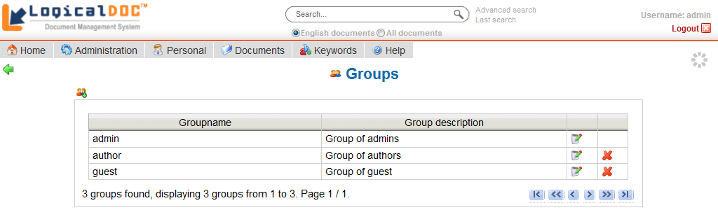Picture 9: Groups Administration
By accessing the administration, you can click on the management of the groups.
As usual the administration of the groups starts from the list of currently loaded groups.

Creation of a new group
Similarly to what happened for users, by clicking on you can create a new group by filling the fields in the editing form and confirming with the Save button. To create a new group it is sufficient to specify a name and description.
You can also specify one or more groups of belonging, in which case the read/write permissions already assigned to them will be inherited by the new group.

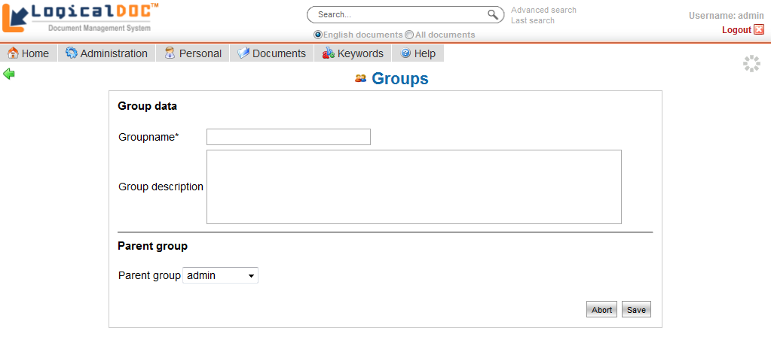Picture 10: New Group's creation

Editing of an existing group
To edit the groups applies as for users: in the list of groups you can edit any item using the icon .

Note: In LogicalDOC the group is a structural element that is used to assign access privileges. Use groups for the sole purpose of facilitating the configurations of privileges and not to carry out simple groupings of users. Out of the box there are three groups: admin, author and guest. Introduce new groups only when truly necessary.

E-Mail boxes
LogicalDOC can store e-mail and its attachment downloading them from remote e-mail accounts. You can configure a number of e-mail accounts and ensure that these are regularly inspected by the system in search of new posts to be included in as documents.

Accounts configuration
Go to the section E-Mails. In this section, select a sub-menu "E-Mail accounts" you can see the currently configured accounts.

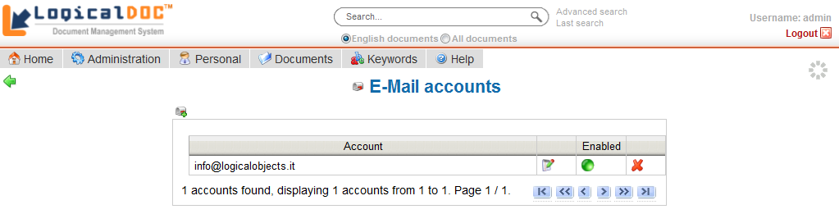Picture 11: E-mail accounts
In order to create a new account click on icon

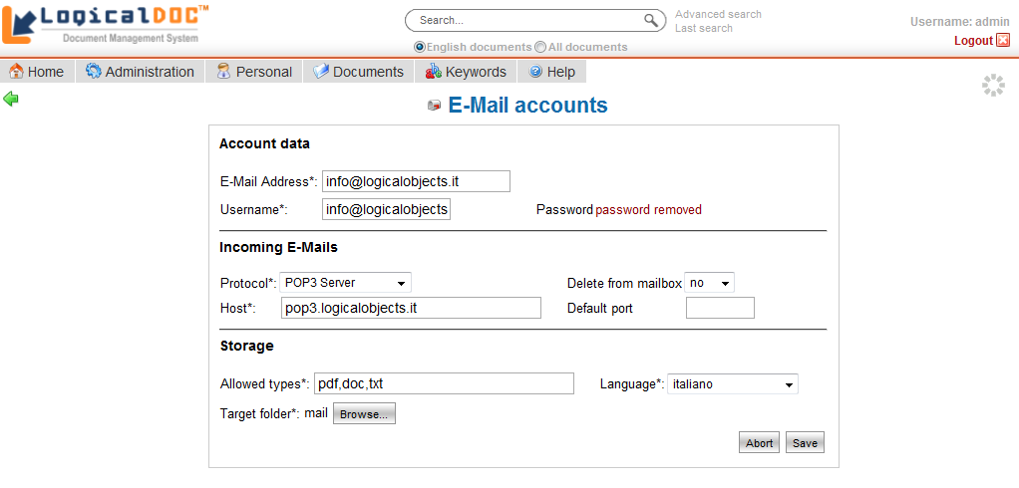Picture 12: E-mail account editing
The edit form allows you to set the normal parameters required for connecting to a POP3 e-mail box.
The section "Storage" collects all information required for processing messages in relation to the documents archive and in particular:
- Allowed types contains a comma-separated list of extensions, defining the sole types of attachment that can be downloaded
- Languages sets the language in which downloaded content will be analysed by the parser
- Target folder is the folder where the message and its attachment will be saved as documents.
New messages that arrive in your in-box will be downloaded and stored as documents in the folder. The same treatment is reserved for attachments but they will be stored as documents children of the main document containing the body of the mail message.

Note: The sole active mailboxes will be inspected at regular intervals by a process in the background.

Remote shares (Enterprise Edition only)
When LogicalDOC is installed over in network made up by other computers that share folders, you can automatically import all shared documents.
This feature works with all standard Windows shares and with al shares handled by SAMBA server that you can configure on UNIX / Linux.

Configuration of remote shares
From the administration, enter the section "Shared Folders". In this section you can see the currently configured remote folders.
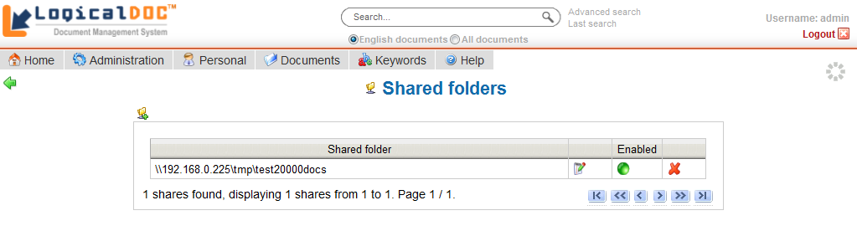
Picture 13: Remote shares
Each element contains the address of the remote folder and some controls used to edit the data.
With the icon you can edit all the information, with you can change the status in enabled/disabled and obviously with you can cancel the share. On the top left is prepared an icon to insert new folders by clicking on this icon is shown the insertion/editing form.
The upper part of the form lets you enter your connection data to the folder and in particular:
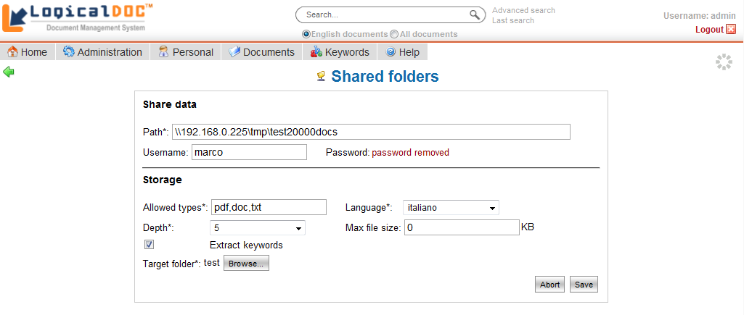Picture 14: Remote share editing
- Location on the remote computer
- Username (optional)
- Password (optional)

The remote location is the folder that is shared on the remote computer, you can make a copy and paste the path displayed in the Windows Explorer.
The figure shows an example configuration of the remote folder \\192.168.0.225\tmp\test20000docs.

If the remote folder is protected, you can also set user name and password for authentication.

The bottom part of the form allows you to set the information for the storage of documents and then:
- The allowed extensions (comma-separated list)
- The language in which documents will be imported
- The depth level
- The folder of the documents archive in which to save documents

Once the settings saved, at regular intervals the remote folder and all its sub-folders up to the level of depth, will be explored in search of documents. The only documents with allowed extension will be indexed and included in the target folder.
It is important to consider the fact that all sub-folders of the remote will be replicated also in the LogicalDOC archive.

Note: The active remote folders only will be inspected at regular intervals from a scheduled in the background.

Scheduled Tasks
In LogicalDOC there are processes that are performed during normal operation of the program even without the intervention of a user. These processes are scheduled tasks because you can schedule their execution.
The section 'Tasks' allows you to track and schedule the execution of these processes.

List of scheduled tasks
The list of scheduled tasks shows all transactions recorded in the system and for each of them see:
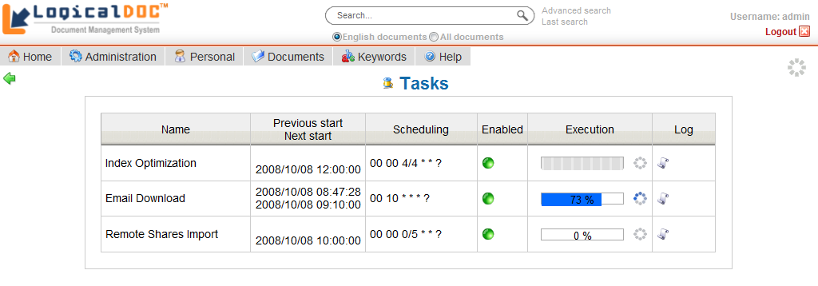Picture 15: Tasks list
- The name of the task
- The last moment of execution
- The moment of the next execution
- Indication of scheduling policy (clickable for editing)
- Enabled/disabled flag (clickable to change)
- Progress indicator
- Link to access the specific log

Each scheduled task can be enabled or disabled, so that beyond the planning, the task can be performed only if enabled.

Scheduling
Although the scheduled tasks can also be launched when you want, as the name suggests, they are generally performed on a time schedule.
Clicking on the link column 'scheduling', you can plan when to run the task.

The execution planning is done by the specification of 6 fields (as in the Unix cron command) listed below:
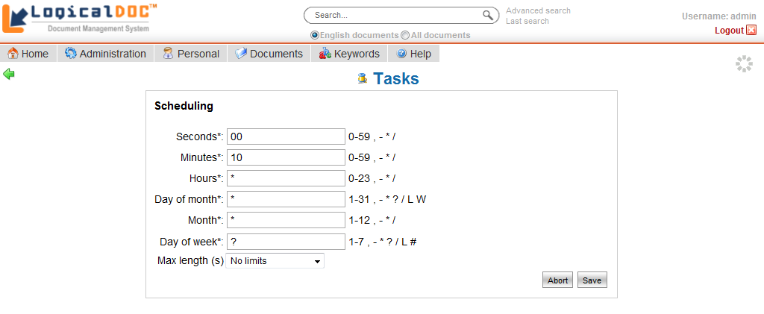Picture 16: Scheduling form

Field name | Allowed values | Special symbols
Seconds | 0-59 | , - * /
Minutes | 0-59 | , - * /
Hours | 0-23 | , - * /
Day of month | 1-31 | , - * ? / L W
Month | 1-12 | , - * /
Day of week | 1-7 (1=sunday) | , - * ? / L #

Special configurable characters take the following meanings. The character '?' is allowed on the day of the month and day of the week. It is used to define any specific day.

The character '*' is used to specify all the values. For example '*' in the minutes indicates "every minute".
The character ',' is used to specify additional values. For example 2,4,6 on the day of the week indicates "the day Monday, Wednesday and Friday."

The character '/' is used to specify increments. For example'0/15' in the second indicates "the second 0, 15, 30 and 45" and "5/15" in the same field shows "the second 5, 20, 35 and 50".

The 'L' is allowed for the day of the month and day of the week. This character has a different meaning for the two fields. On the day of the month indicates the last day of the month (January 31, February 28 ...).
When used in the days of the week, indicates the last day of the month xx such as "6L" means "the last Friday of the month."

The 'W' is allowed for the day of the week. It is used to specify the working day(Monday, Friday) closer to the specified day. For example, if you specify "15W" as a day of the month means "the working day closest to 15 of the month." So if 15 is Saturday, will be took Friday 15. If the 15 is Sunday, then will be Monday 16. If the 15 is on Tuesday, will be 15 on Tuesday.

The characters' L 'and' W 'may be combined in the days of the month and indicate the last working day of the month.

The character '#' is allowed for the day of the week. This character is used to specify the "#th day of the month." For example, the value "6#3" indicates the 3rd Friday of the month.

In addition to the descriptive parameters of scheduling, you can set the specific maximum duration of processing. If this is specified, the procedure will be automatically stopped after the configured time.

Progress status and log
If a task is running you can see it in column 'Run'. If the process is running then the progression bar will be updated constantly showing the percentage of progress.
At the side of this bar an animated icon indicates that the process is running. This icon is clickable and allows you to stop the execution.
When the task is not running, the same icon appears motionless and by clicking it the activity you can start the execution.
Each task has also a related log file that can be inspected by clicking on the links in the column 'Log'. Reading this log it is possible to understand in detail how the activity proceed.

Note: Not all tasks are able to provide the stage of processing. In these cases, the bar does not indicate the progression rate and remain undetermined.

Documents
The document management is the main feature of LogicalDOC, it offers all the tools for the creation of the archive and the search based on the text content.

Folders
LogicalDOC saves documents in folders. The idea is similar to what is being done in a local hard drive.
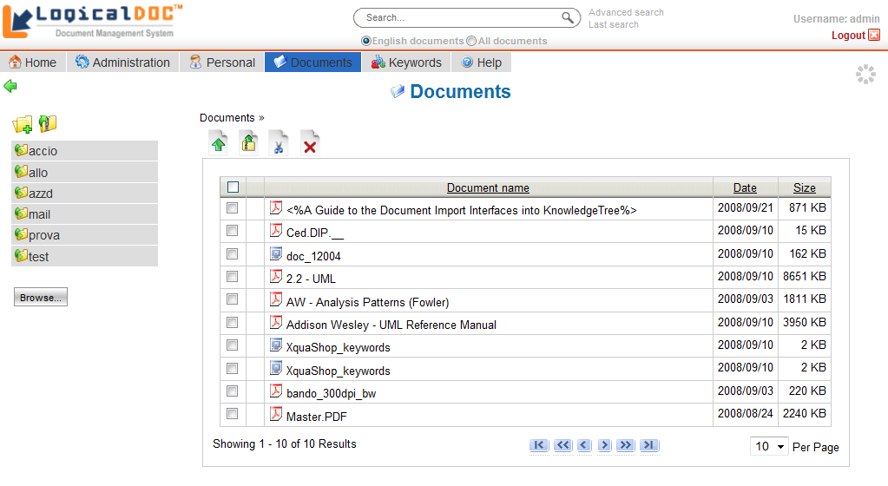Picture 17: A documents folder
To access the documents you must select the menu 'Documents', after that it will be shown the page with the tools for navigation and management of the documents archive.
On the left side it is placed the list of sub-folders of the currently selected parent, by clicking on the name of a folder, in the right panel all contained documents are shown. Each document is clickable for download.
To add a document to the current folder, click on . To add a sub-folder, click on .
In some cases it may be useful to load an entire folder with the documents. In LogicalDOC this is possible. First of all you must create the folder with documents on your PC. Subsequently you must compress the folder structure using the ZIP format. Finally, the ZIP file must be loaded into LogicalDOC. This feature can be invoked by clicking on .

The organization into folders lets you organize your documents with your own logic. At the top is always built the path followed(bread crumb) in order not to lose sight of the current position.
In addition to access an item within a folder, you can also use different actions for each element through the contextual menu accessible by right-clicking on the document's name.

This is a list of the most important commends:
- Checkout/Checkin /
- Edit
- Security
- Versions
- Similar documents
- Send as e-mail
- Send download ticket
- Discussion
- Info
- History

Document creation
To add a new document, the first thing to do is to upload a file using the button .
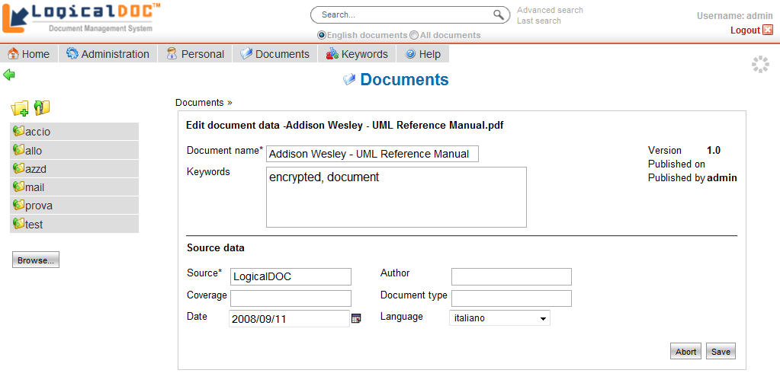Picture 18: Document creation
The upload process also requires the specification of the language. In addition, you must select the groups that have permission to read and write. You can also add other attributes. If the document doesn't specify a title, the file name is used.
Normally, all documents will be sorted by document title(upper case and lower case letters are considered different). To describe a document you can define one or more keywords, separated by a commas. The Keywords menu shows documents grouped by those keywords. You can also create a description of all versions of a document. When you add a document a version 1.0 is also created. You can also specify certain properties of the document such as Coverage, Language, Source.

Document editing
The Edit page is accessed by selecting 'Edit' contextual menu item. On this page you can edit all properties of a document. The editable properties are: title, keywords, the source, the author, date, type, the coverage, and language.
To add more keywords, you must separate each keyword with a comma.

Access rights
For each item in a folder view you can express access rights of vision and writing on any group of users.
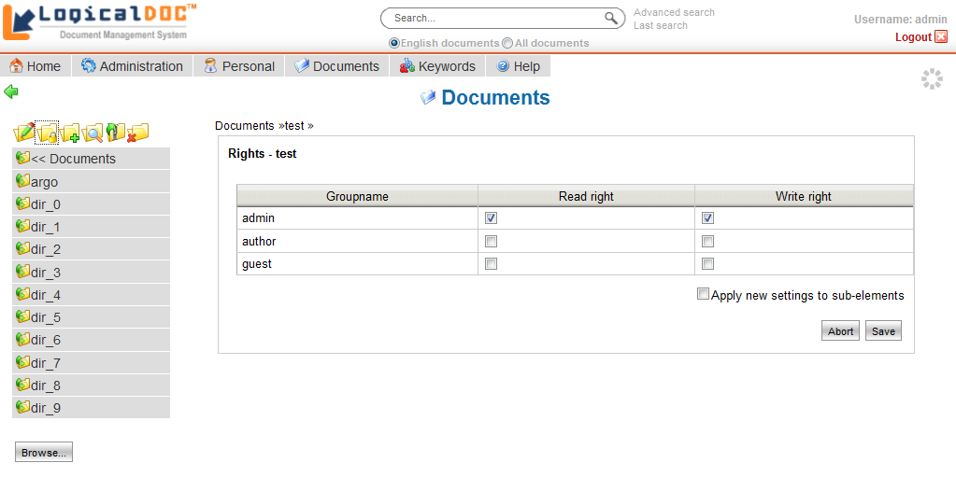Picture 19: Access rights
To access the permissions page you have to select the 'Rights' contextual menu item.

Personal data
This section of the manual deals with personal data or information or those functions closely related to the user's profile.
The Personal section of the system menu allows the user to change his data such as your password.

Change the password
Select the Change password link of Personal section. At this point a simple form appears that invites the input of the old password and the new one. Confirming the entered data, the current password will be changed with immediate effect.

For privacy issues we recommend to change passwords at least once every 90 days. Each user must store the password in a safe place and above all must not communicate it to anyone, so as not to compromise the safety of the system.

Edit of personal data
The item Edit my data is used to modify your personal data such as name, last name, and so on. A form shows the current value for each user's saved information. Each field is editable for changing and you can confirm all modifications clicking on the Save button.

Send and receive messages
LogicalDOC provides a small internal messaging system that allows users to communicate between them quickly and without the use of e-mail.

Sending a message
In order to send a message we must begin by knowing the exact user name of the recipient.
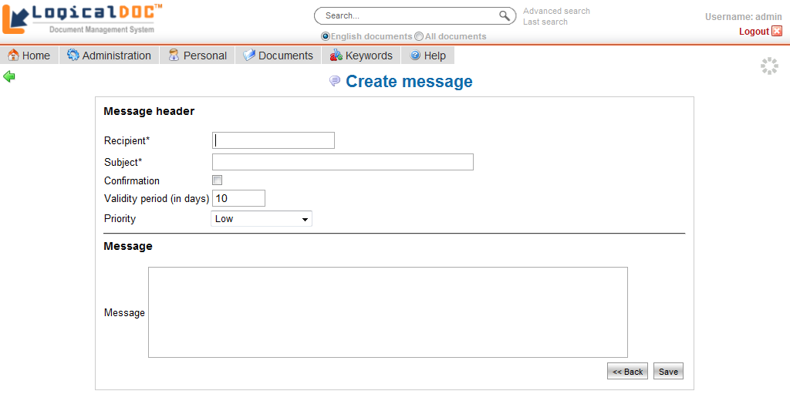Picture 20: Composition of a message
To send a message you must first select the Messages menu and then click on

The edit form is self explanatory and asks all the necessary information. The recipient is mandatory and should be compiled with the user name the user to whom the message is intended.
The field subject is mandatory and must contain a brief description about the message.
The checkbox "Confirmation" is used to request the system to notify the sender of the message when it is read by the recipient.
At the bottom of the form a large text field lets you insert the body of the message.

Reading received messages
To read your messages simply select the link Read messages in the home page Messages box. First is the brief list of messages received with the specific subject and the sender. Click on the elements to see the complete message.
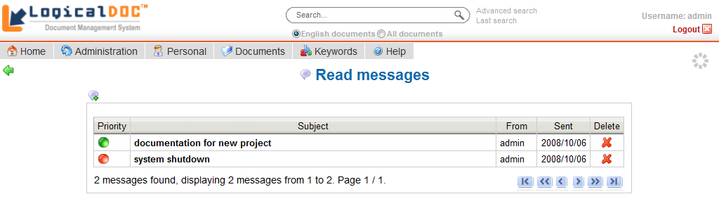Picture 21: Messages list

Note: The message system of LogicalDOC is not intended to replace the traditional e-mail, it is a simple tool designed to make quick exchange of short and concise messages. To articulate discussions with many participants it will be more appropriate to use the traditional e-mail.

