

Developer Manual
Revision 1.0

Revision | 1.0
Doc Type | development practices
Date | september 15, 2008
Written by | Marco Meschieri (Logical Objects)
Verified by
Approved by

© 2009 Logical Objects snc, via Bonasi 2/A – 41012 Carpi Italy. All rights reserved.
http://www.logicalobjects.com

This document is subject to change without notice.

License
This work is licensed under a GNU Free Documentation License 1.2.
http://www.gnu.org/licenses/fdl-1.2.txt

Disclaimer
Documentation is provided 'AS IS' and all express or implied conditions, representations and warranties, including any implied warranty of merchantability, fitness for a particular purpose or on-infringement, are disclaimed, except to the extent that such disclaimers are held to be legally invalid.

Change Log

Rev. | Date | Changes
1.0 | 09/15/2008 | Document creation

Distribution

Person | Company | Position | Contact

Contents
1 Prerequisites 5
Ant 5
Maven 5
Eclipse 5
SVN client 5
2 Workspace setup 5
Checkout a working copy of LogicalDOC CE 6
Import code templates 6
Import coding conventions 7
Setup SVN connection 7
Configure the logicaldoc-devel.properties 8
Workspace structure 8
3 Best practices 9
Coding conventions 9

Prerequisites
In order to setup a LogicalDOC CE develompent environment some tools are required, and must be installed in your system.

Ant
Make sure to have installed Ant 1.7 o greater on your system.
Open a shell and type: ant –version
If ant is correctly installed on your system you should read a line like this:
Apache Ant version 1.7.0 compiled on December 13 2006

Maven
Make sure to have installed Maven 2.0.9 o greater on your system.
Open a shell and type: mvn –version
If maven is correctly installed on your system you should read a line like this:
Maven version: 2.0.9

The Maven reference site is http://maven.apache.org/

Eclipse
LogicalDOC development team supports the Eclipse IDE only, so install Eclipse 3.3 or greater.
You can download the distribution from http://www.eclipse.org/downloads/

SVN client
Make sure to have installed a command-line SVN client on your system.
Open a shell and type: svn –version
If SVN is installed you will get a description like that:
svn, version 1.6.0 (dev build)
compiled Sep 15 2008, 00:11:13
Copyright (C) 2000-2008 CollabNet.

For Windows you can download svn.exe from: http://nightlybuilds.tortoisesvn.net/latest/win32/

it is recommended to install TortoiseSVN at:
http://tortoisesvn.net/downloads

Workspace setup

First of all we need to create an Eclipse workspace for logicaldoc, the workspace is a folder containing all develompment resources.
Open shell inside your home directory and type the folloqing command:

mvn -Declipse.workspace=workspace-logicaldoc eclipse:configure-workspace

This command creates the Eclipse workspace in the 'workspace-logicaldoc' directory, and this workspace comes up with the M2_REPO classpath variable already configured.

Checkout a working copy of LogicalDOC CE
Open a shell in the workspace directory previously created and type the folloqing commands:

svn --depth files co https://logicaldoc.svn.sourceforge.net/svnroot/logicaldoc/community community
cd community
checkout.bat
cd..

svn --depth files co https://logicaldoc.svn.sourceforge.net/svnroot/logicaldoc/build build
cd build
checkout.bat
cd..

svn --depth files co https://logicaldoc.svn.sourceforge.net/svnroot/logicaldoc/docs docs
cd docs
checkout.bat
cd..

Note: On Linux use checkout.sh instead of checkout.bat

Import code templates
Launch Eclipse and import logicaldoc code templates.
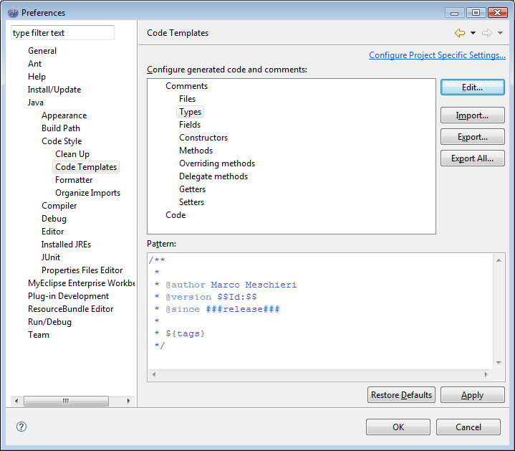Figure 1: Import of code templates
Open the Preferences window and select Java->Code Style->Code Template
Here you can click on Edit button and import the file workspace-logicaldoc/docs/devel/logicaldoc-codetemplates.xml.

Import coding conventions
Now from the Preferences window import the coding conventions.
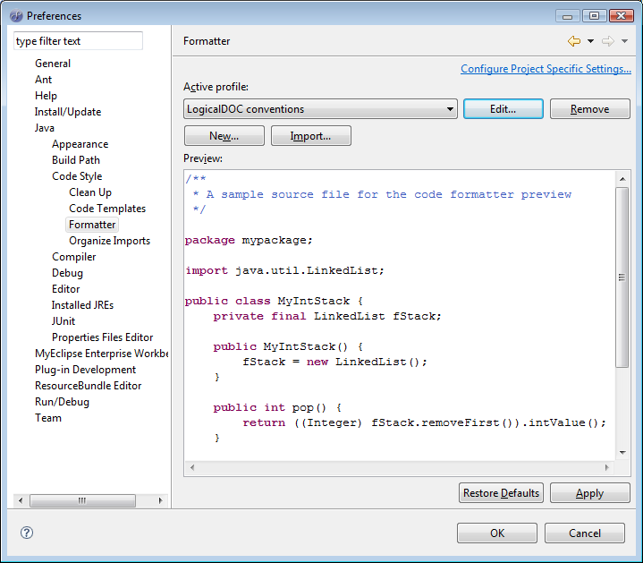Figure 2: Import of coding conventions
Open the Preferences window and select Java->Code Style->Formatter
Here you can click on Edit button and import the file workspace-logicaldoc/docs/devel/logicaldoc-conventions.xml

Setup SVN connection
First of all, in order to operate with SVN in eclipse you need to install the SubEclipse plugin. This can be done adding the update site:
http://subclipse.tigris.org/update_1.4.x
Instruction on how to install SubEclipse can be found here:
http://subclipse.tigris.org/install.html

Once you have SubEclipse installed, open the SVN Repository Exploring perspective and in the SVN Repositories view right click and select New → Repository Location. In the dialog box insert the url:
https://logicaldoc.svn.sourceforge.net/svnroot/logicaldoc
Then confirm with Finish button. This is the remote repository all resources will be committed against.

Configure the logicaldoc-devel.properties
After the checkout, copy the file workspace-logicaldoc/build/ant/logicaldoc-devel.properties into your home dir. This file contains various settings used during builds. You mus setup al least the two properties below:
- logicaldoc.devroot must point to the logicaldoc workspace dir
- logicaldoc.webroot must point to the development webapp installation

Workspace structure
One you have completed the checkout, the workspace structure layout is as follows:
Figure 3: LogicalDOC CE workspace layout

Best practices

Coding conventions
All classes and interfaces must be created in a package directly or indirectly contained in com.logicaldoc.

All classes and interfaces must be formatted using logicaldoc conventions defined in the file logicaldoc-conventions.xml.

All classes and interfaces must have a javadoc comment with the description ot that class or interface. Also in the comment must be present the author full name, te program version in which the resource has been created and the current revision number (import the file logicaldoc-codetemplates.xml).

All public method(with exclusion of banal getters/setters) must be commented with a javadoc. It is also recommended to comment even privare or protected methods.

The source code, must be clear and properly commented, so insert comment inside the code.

In any case comments or documentation can be written in any language other than english.

