

Welcome to Tinamou #33, produced by Dave Partridge, 15 Woodland Drive, Brookline NH, 03033 (email: rebhuhn@rocketmail.com ). Tinamou now appears on the web in conjunction with TAP. The web page has everything you’ll find here including maps. Go to Jim’s index page http://devel.diplom.org/DipPouch/Postal/Zines/TAP or to my site at http://david-partridge.tripod.com/tinamou and check it out, your comments and suggestions are welcome!

News:

News? Well, not a lot of it. Dave’s given up sleep again (makes it easier to crank this out on time, no sense in going to be anyway). Kathryn is now almost 2 months old and doing well. Mom and Dad are frazzled by happy. And that’s about all there’s been time for, which is plenty!

Deadlines:

Tinamou appears in every other TAP. The game deadlines are always the Monday before the appropriate TAP deadline, which is always a Saturday. See TAP for the dates.

-----------------------------------------------

Regular diplomacy: Copernicus

And another nation falls before the Russian onslaught. Thanks to Bruce for playing out the English. Russia swaps centers in the English Isles, but eliminates the English in doing so. In the interest of fairness, Germany gets an English center so everyone can have one, and Russia completes his conquest of the Balkans.

A very interesting battle shaping up here. Russia is up to 16, close to that brass ring, but there are openings in the lines on both sides, should be interesting.

England | Bruce Reiff 3668 Mariner’s Way Lewis Center OH 43035
Germany | Art Schlienkofer 3120 Holley Rd Philadelphia, PA 19154
Italy | Bob Dowrey 101 Sunset Terrace Orchard Park, NY 14127
Russia | Warren Goesle 3907 Cedar Ridge #1B Indianapolis, IN 46235

Copernicus: Summer 1910 retreats

Italy: a gre - alb

Copernicus: Fall 1911
england | f edi s g f nth
germany | f den s f nth, f nth s e f edi, a yor - lvp, a mun s i a tyr, a ber - pru, a kie - ber
italy | f lon - wal, f iri s g a yor - lvp,  a bre h, a par h, a bur h, a mar - pie , a tyr h, a ven s a tyr, a alb - tri, f eme - smy, f ion - aeg , f tys - nap
russia | a arm to smy, f aeg s a arm to smy,  a gre h, a ser s a gre, a bud s a tri  a tri h, a vie s a tri, a boh s a war - sil  a war – sil, a fin – swe, f swe - ska  f nwy – nth, f nwg - edi  f cly s f nwg – edi, a wal – yor

Copernicus: Winter 1911 retreats

Eng f edi annihilated

Copernicus Winter 1911 Adjustments
england | edi | 0, out
Germany | mun, kie, ber, bel, hol, den, lvp | 7, build 1
Italy | ven, rom, nap, mar, spa, por, par, bre, lon, smy, tun, gre | 11, remove 1
Russia | stp, mos, war, sev, swe, nwy, ank, con, bul, rum, bud, vie, tri, ser, edi, gre, lvp | 16, build 1

Press
Russia to Germany: Didn't hear back. What do you gain? Italy won't let you in the draw either. So it's I, it's R, or it's I/R.

Breaking Away: Tour de Farce. Turn 10

Conquest breaks away from the pack. A little gap at 86 keeps any big cards from showing up. Seven is the high replacement this time, and the Late Night Characters pick up 3 of them! Only two cards higher than 11 left, and War owns both of them, look out for him. The pace, slow as it is, still takes it’s toll as Jimi and Reagan both drop from the back of the pack.

Carter to Imlac: Y'all can think you're gonna win this now. We'll see. After it's all over y'all come down to Plains and we'll take ya on a snipe hunt. Trust me, you'll love it.

Clinton to Imlac: Last I checked I was ahead of you. If I'm eating your dust, it means I'm drafting. I'm not too familiar with the draft, but Jerry said it was a good thing.

Reagan to Jimi: I'll drop some bread crumbs for you to follow.

Bush to GTCo: Would you guys get UP here!

Goz to Gerald Ford: The good news is that you won't do any worse than I did when I was team manager. I may just keep you around for next time.

[Ford is startled to hear a voice from outside the game interrupt him, and he drives what's left of the chase vehicle down an embankment.

Death to Field: This pace is absolutely KILLING me!

BRICK to BOOB: I was named for my basketball shooting prowess.

BALL to BOOB: CLANG!

BRICK to BOOB: See what I mean?

CONQUEST to RASSLER and PALS: Why y'all markin' us so closely?

FIELD to ROCK STARS: We know what you're doing tomorrow night!

Conan's crew -> World: we suck!

Triumph -> TAP: to bemoan my inability to catch up to the
Philosopher Prince, I'm going to do a rendition of Adam Sandler's "Red Hooded Sweatshirt"

I love my SWEAT- SHIRT!
Red-hooded SWEAT- SHIRT!
Dip dip dip SWEAT - SHIRT!
Shamma lamma ding dong SWEAT SHIRT!

Triumph - GM, Editor: Hmm...there's an Abyssinian Prince riding in Tinamou, and a Tinamou riding in Abyssinian Prince. Doesn't this violate some kind of foundational laws of logic? What is the set of all 'zines which ride in other 'zines as a bicycle rider? This is the kind of thing which leads to paradoxes!!

(Triumph ducks as Diplomacy World passes on a moped! Gerald Ford explodes.)

See! It's starting already!

(BOOB to RACERS): NOW it is going to be a bit of a cat and mouse game. Who went for it this time, not I!

GM to BOOB: Well, that would be Conquest. But is he the cat or the mouse?

(PEKUAH to CLINTON): It has been said that I have a much fairer face than Paula Jones and a slimmer butt than Monica Lewinsky, care to catch up and try out the merchandise?? If you can, big butt.....

GM to Pekuah: If you’re going to brag you could at least market the merchandise a little better. All we know right now is that your pant size is somewhat less than 42.

(PEKUAH to STACY): I played small so that I could walk in
the valley of the shadow of DEATH..... I truly fear no evil!!!

(PEKUAH to DEATH): More limping along??? Whatsamatta, lose your scythe???

GM to Death: You know, you don’t have to take her head off with it, just the handle in the spokes would do the job….

(BOOB to TRIUMPH): You mind your own second place team.... they are ALL behind YOU as well!! I plan on using SV Clinton and Segue Sam to good purpose..... place them well!!

GM to Boob: Oh, he did. Then he 86ed your sneaky plan to gain from it!

(BOOB to DEAD ROCK STARS): If we had a little more race to go, we could drop all four of your riders. Jimi should join the virtually dropped next turn.

Square |  | Riders | Card
99 | conquest |  |  | 7
98
97
96
95
94
93
92 | rasselas |  |  | 3
91
90 | panda |  |  | 3
89 | death, pekuah |  |  | 4
88 | koala |  |  | 6
87 | bush, teddy, stacy, segue, sv-clinton |  |  | 7
86
85 | famine, imlac |  |  | 3
84 | war, carter, clinton, elvis, nekayah |  |  | 5
83
82 | moron |  |  | 3
81
------------Sprint line------------
80 | reagan |  |  | 3
79
78 | jimi |  |  | 3

The second column (to the left of the rider’s name) contains the card played this round. New cards received are in bold.

(16) The Four Horsemen (Eric Brosius: 53 Bird Street, Needham MA 02492 72060.1540@compuserve.com)
A | 10 | Conquest | 3 | 3 | 7
B | 7 | War | 12 | 15 | 5
C | 4 | Famine | 6 | 3 | 3
D | 3 | Death | 10 | 3 | 4

(16) The Goz Transportation Co. (Warren Goesle: 3907 Cedar Ridge, #1B, Indianapolis, IN 46235 gozcorp@iquest.com)
Team Manager: Gerald Ford

A | 6 | Jimmy Carter | 4 | 4 | 3 | 5
B | 5 | Ronald Reagan | Dropped out
C | 3 | George Bush | 3 | 3 | 7
D | 7 | Bill Clinton | 4 | 3 | 5

Dead Rock Stars (Phil Reynolds, 2896 Oak St., Sarasota, FL 34237-7344 preyno@yahoo.com)

A |  | Buddy | Dropped out
B | 3 | Elvis | 3 | 3 | 5
C | 3 | Jimi | Dropped out
D |  | Kurt | Dropped out

(19) Late Night Characters (Rick Desper rick_desper@yahoo.com)

Coached by Triumph, the Insult Comic Dog
A | 4 | Shirtless Moron | 4 | 4 | 6 | 3
B | 3 | Stacy Richter | 3 | 6 | 7
C | 3 | Segue Sam | 8 | 3 | 7
D | 3 | Syncro-vox Bill Clinton | 6 | 10 | 7

(26) The Abyssinian Prince, (Jim Burgess: 664 Smith Street, Providence, RI 02908-4327 burgess@world.std.com)

A | 3 | Rasselas | 3 | 8 | 9 | 3
B | 7 | Nekayah | 11 | 3 | 5
C | 3 | Pekuah | 9 | 7 | 4
D | 10 | Imlac | 11 | 3 | 3

(1) The Warm Fuzzies ( Sara Reichert, 20805 Margaret St., Carson, CA 90745-1224)

Team Leader: Sweet Sara
A | 8 |  | Teddy | 3 | 3 | 7
B | 7 |  | Panda | 5 | 3 | 3
C | 10 |  | Koala | 4 | 5 | 6
D |  | Cuddles |  | Dropped out

Woolworth II-D: Who’s Your Buddy?

Scandinavia returns home. England and the Turks leave us. Russia rampages through Germany, but despite a brief occupation by Russia and an invitation to the French to enter, Munich remains German. Germany returns the favor by invading Russian held Galacia.

Summer 1906 Retreats
Ger: f nth - ska
Rus: a sil – war

Fall 1906 Moves

england | f eng h
france | f pic – bre, a bur – swi, a par – bur, a swi – pie, a mar s swi – pie
germany | f ska – swe, f hel – kie, a sil – gal, a ruh s f a mar – mun (nso), a ber s f a mar – mun, a pie – tyo
italy | f ion s f tun, f tys s f tun, f tun s f tys, f tus – pie, a ven s f tus – pie, a ser – bul, a tri h, f aeg – gre
russia | f gob – bal, a lvn – war, a ank – con, f smy s ank – con, a pru s mun - ber, a mun – ber, a rum s i a ser – bul, a boh s war – sil (nso) , a tyo s i f tus – pie, a war h (u)
scandinavia | f nth – nwy, f lon – nth
spain | f edi hold, a naf s f wes – tun, f wes – tun, f gol – tys, f nwg – lap
turkey | f con s a bul, a bul s f con

Winter 1906 Retreats
ger: a pie annihilated
a ber – sil, otb
tur: f con – bla, mac, aeg, otb
a bul – mac, otb

Winter 1906 adjustments:
england | nwy | out
france | bre, mar, par, swi, bel | 5 even
germany | mun, kie, hol, den, swe, gal, ber | 6 build 1*
italy | ven, rom, nap, tun, cre, ser, tri, gre, bul | 9 build 1
russia | stp, mos, war, sev, con, ank, smy, bud, vie, rum, ber, gal | 11 build 1
scandinavia | lon, edi, nwy | 2 even
spain | mad, por, mor, ice, lvp, edi | 6 build 1
turkey | bul, smy | out

* germany builds one due to annihilation. If he retreats off the board he plays one short

Babble from the board:

Norse to Krauts---Dang! I kill der Angloes and now when I try to reclaim my homeland guess who is dere? Der dirty double crossin Rooskies. Now your enemy be my enemy so we be friends, JA?

Berlin - Europe: Y'know, everyone always wants to fight their battles in Germany. To that I say, welcome! Free beer for all survivors! And those busty Aryan girls in their St. Pauli outfits.

Spain to France---Your play sets a fine example. I too shall give what aid I can to Germany. If your fleet could find its' way to MAO to bolster my line, perhaps we could hold back Atilla and his lackey.

GM – Spain: Wasn’t Attilla a Hun? I thought you were supporting them?

Germany - France: Time for holding the line is over. Come on in. See my support.

GM – Germany: Well, he didn’t come in, but Russia moved out. Is that okay with you?

Spain to Germany---Well if France can cut you some slack, so can I. After all, I can't let it be said that the French are more polite than the Spanish. If ever you are in the proper position, I will support you to the centers. You need builds to replace your losses.

Germany - Spain: What? Somebody's supporting me? Ooh, I can hardly contain myself!

Spain to Vikings---Tell us, O great gasbag, how you plan to stop your eastern brother. I suggest you stop sailing in circles and at least help the Germans.

Norse to Spangloes---I tole you. I tole you. Dem Romans makin tough time in Med pond. Go home. I handle cold wastes again.

Berlin - Rome: I can't seem to get out of Italy. Maybe you can convince your Iberian ally to give me a lift?

GM – Berlin: Well, he seems to have solved that particular problem for you.

Germany - Russia: Here's a tip: no more Austrians in Germany. We czeched. We hear they're in Italy now...

Germany - France: Yeah, he won't cross the Rhine...if he can win before that.

Game Openings:

A few more players have joined the lists, but we are still woefully short of a new game. Only 7 game starts last year that Conrad registered. Come on now, prove that this hobby isn’t dying!!

Perestroika Diplomacy: Add an economic twist to the classic game. Centers generate revenue, armies and fleets must be maintained, and treasuries can be sacked! Rules are available on request.

Signed up: Art Schleinkofer, Phil Reynolds, Jack McHugh

Outpost: An economic game where you decide which resources to purchase and try to keep your colony viable. It’s a race to generate the most income, but resources are limited and you have to bid against the other players for them.
Signed up: Jack McHugh, Eric Brosius, Michael Lowrey

Standard Diplomacy: Nothing new, nothing novel. The only twist to this game is that I strongly encourage players without email to join up. The long deadlines make it easier to get those negotiations in. That is not to say that I do not want people with email joining, but please do not do so unless you are prepared to negotiate fully with those people who don’t have email and rely on the Postal Service.

Signed up: Phil Reynolds

Black Hole Diplomacy: Watch the spaces disappear and the trips to the other side of the board get shorter and shorter. No stalemate lines in this variant. Great for those who like a free for all.

Signed up: Jack McHugh

Just the results please: Don’t really know what to call this one as I just came up with it. Perhaps it’s been tried before. The twist for this variant is that each season only the ending unit positions are published, not the orders. You’ll know who went where, but not who helped whom, or want may have been tried unsuccessfully.

Signed up: Phil Reynolds

Reader’s Choice: I’m open to anything, just send me the rules and if I think I can run it, I’ll offer it.

A Cold Day in … Turn 1

BOOB TO USELESS GM: I thought this was supposed to be a test game with new rules to limit the strength of dirigibles, BUT we talked about all sorts of things, what are we actually playing with???

GM TO USELESS BOOB: Can’t read your email eh? Okay, for those who were asleep for the opening day here we go again. For the current snowball game, the base hit probability of dirigibles has been reduced from 55 to 45 percent, and dirigibles that hit from farther than 3 hexes will only do 2 points of damage.

OBSERVER TO OTHER OBSERVERS: Come on, if I can kibitz this lot of old broken down throwing arms, so can YOU!

AIRBORNE OBSERVER TO GM: No, I will NOT stop blowing up snow with my helicopter blades! Just think of it like windy weather.

GM TO AO: Hey, if you’re only blowing snow I consider myself lucky. Remember, you may be anonymous to the rest of the world, but I know who you are!

AIRBORNE OBSERVER TO SHREK: Sorry about your head, you were a little taller than the rest and I was trying to set down in that open space between the trees. I doubt you'll miss it in this crowd of losers.

GM NEWS FLASH!! Shrek is really Gerald Ford, he took a wrong turn in the Tour de Farce and wandered into ground zero!

SNOWSHOE HARE TO SNOWMASTER: That faint background music? "BA-EE-YAH-EE-YAH! wah-wah-wahhhhhhh..."

SNOWMEN WITH BOOBS: Snowshoe hare? You must be having a bad hare day!

SNOWSHOE HARE TO SNOWMAN WITH BALLS: Yeah, sure!

SNOWSHOE HARE TO SHREK THE OGRE: You're big, funny, and in a forgettable movie... are you sure you're not really Louie Anderson slumming?

SHREK: It's not easy being green... against a white backdrop. Hoots mon, where's ma trousers?

SNOWSHOE HARE TO ABOOBABLE SNOWMAN: Perhaps you meant Snow_o_man, oh Boobed One? If so, there's someone just around the corner of the shed that you'll want to meet.

SNOWSHOE HARE TO DALTON BROTHERS: I figger you oughta be tremblin' in fright 'bout now. Never seen snow before, right? Never been armed with anything less than a two-shot rifle, have ya? Well, if yer not shakin', ya will be when I get through wid ya...

DALTON BROS: Hare hare!

SNOWSHOE HARE TO JIM-BOOB: I know you're watching, even if that doesn't turn out to be you behind the "Aboobable" nom de guerre. You have *no* idea what has invaded your zine through this little back door. You've been through almost everything in your (eons-long) publishing life, but nothing could have prepared you for HARE EVERYWHERE!

GM TO ALL: Okay, anyone who wants to register a guess as to who’s who send it to me and I’ll reveal them at the end. Anyone gets them all right and I’ll be suing you for reading my email!

DALTON BROTHER DOLT TO SILLY LITTLE MAN NAMED REB, SO HIS WIFE CAN CALL HIM "REB, HUN . . .": Either correct the spelling of the Dalton Demons and the Dalton Dirigibles or recognize that you are dealing with Dalton Brother Dolt. On the other hand, you could keep the spelling of the Dolton Demons and the Dolton Dirigibles and change my name to Dalt, or rather, Dolton Brother Dalt. Nah, that doesn't work. How about change our name to Dolton Brothers Dolt and Dal(ber)t.

GM TO DB: About the only thing I understood out of that is that I can call you a dolt. Consider it done!

DOLTON BROTHER DOLT TO UDDER PLAYERS: You are not dealing with just any Dolt here, I am famous. Remember the movie with Jim Carey, it is really about me. They were going to call it "Dolt and Dolter," but my lawyer wanted them to protect the innocence. In-a-sense, the innocents. My hint for the game, "Don't lick any metal parts of ski lifts when going over the shed roof."

Dolton Brother Dal(ber)t: Please disregard anything Dolt says during the game. I am the one who knows how to turn on the computer and type. I send in the orders. I am the nice brother. I am a cop. A nice cop. Or, for this game, an ice cop.

SHREK: Listen to those two rabbiting on. Why do the Dalton brothers look like one guy, and an Amish at that? Split personality?

ABOOBABLE TO SNOWMAN WITH BALLS: Do you know the difference between a snow man and a snow woman?

ABOOBABLE TO SHREK: We all know you are make believe. Celluloid. Now we know that Lochie is the earth farting during quakes. But, I, the Aboobable, am real and lurking. I will shred you to pieces and turn you into a whimpering little mommy's milk and cookies lover.

SNOWSHOE HARE TO COLD DAYERS: Howdy. Hop on over, anytime. Glad to make your acquaintances. Hop this game is hare raising good.

SNOWSHOE HARE TO MIKEY THE MYSTERY WRITER: "It was a cold day. A very cold day. Ivan Ivanovich saw his breath freeze before it got out of his mouth. The men around him were slow in the movements, huddling in the ragged coats and hands wrapped in more rags. One man was breathing on the pole that held the thermometer. Using his elbow to rub the ice off the cracked glass. "Forty four below" he yelled out. It was, it was a cold day. The coldest day of the winter. And barely beyond breakfast. The man were already slow and cold. Their production was down. The guards would be mad, would punish them. Ivan sped up, and as happens in all great novels, decided not to have a wall building contest with the other team of prisoners here in Siberia, but he decided to have a snowball contest. "Men, gather the snow into balls" he yelled, startling even himself, but much more so Alexander's editor. And the battle was on.

BOOB TO GM: If you tell me SB's balls.... well, that must be you, not me.

GM TO BOOB: If you want to go check SB for balls, that’s your decision. I’m not going to be any part of it!

BOOB TO DALTON BROTHERS: Since there are more than one of you, I pay you SPECIAL attention in Turn 1.

DALTON BROTHERS TO AS: Go ahead draw.

ABOOBABLE SNOWMAN: I can be made into a Boob, I can, I can, but not if you are hitting me with snowballs.

BOOB TO SNOWMAN WITH BALLS: We'll have those balls now, right now.

GM TO USELESS GM: What's wrong with impersonating YOU!!! It isn't like you know anything that can help any of us.

USELESS GM TO GM: I can impersonate me all I want.

BOOB TO USELESS: Who am I playing with anyway???? I must have missed something. I know who I am, of course, that is obvious, but the rest are a bit misty.

GM TO BOOB: Bonus points if you can figure it out.

 | 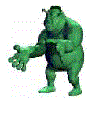 | 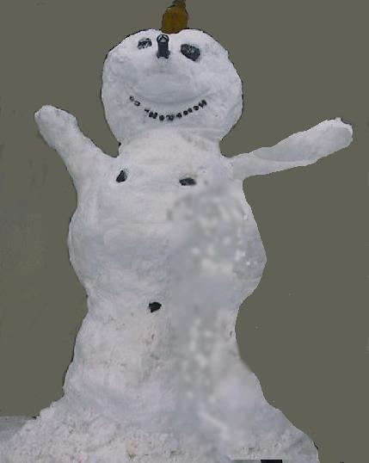 | 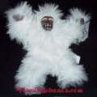 | 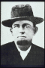 | 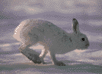
Player | Shrek the Ogre | Snowman with Balls | Aboobable Snowman | Dalton Brothers | Snowshoe Hare
Symbol | SO | SB | AS | DB | SH
Start Pos | O3 | I9 | K15 | W15 | W9
Seg 1 | RR @ SB (,02) | Stroll to L6 | Barnard Bolero @DB (,72) and SB (,46) | Run to Snowman . . . B O I | Run to Snowman  N G . . .
Seg 2 | RR @ SB (,27) | RR @ SO (,37) | +DI | Dalton Demon @ SH (,59) | RR @ SB (,59)
Seg 3 | +DI | RR @ SO (,18) | DI @ DB (,77) | +DI | RR @ DB (,80)
End pos | O3 | L6 | K15 | S13 | S11
SB/DI | 0/1 | 0/0 | 2/0 | 1/1 | 0/0
HP | 8 | 8 | 10 | 10 | 10
VP | 2 | 2 | 0 | 0 | 0

A Cold Day In …. Turn 1
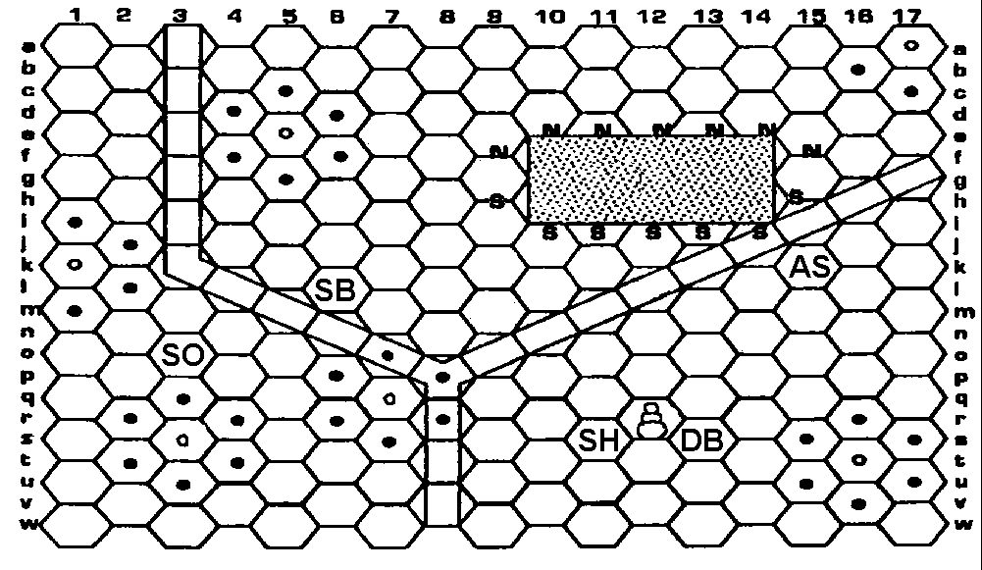

Copernicus Fall 1911
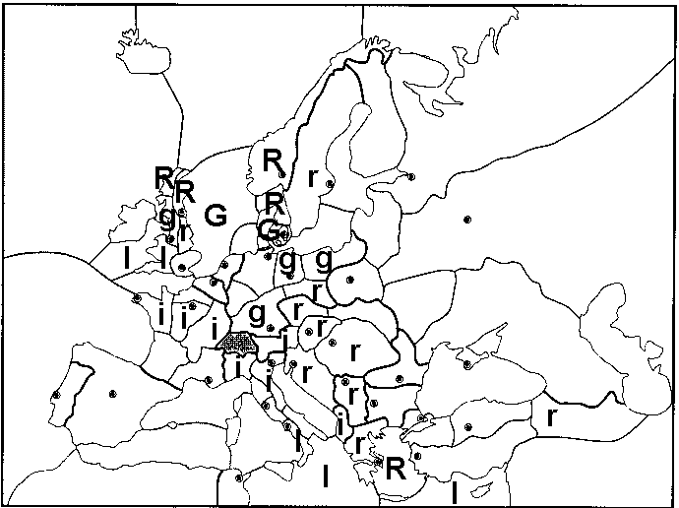

Who’s Your Buddy Fall 1906

