#!/usr/bin/env python3  
# -*- coding: utf-8 -*-  
  
  
if __name__ == '__main__':  
 with open("file1.txt", 'w') as fileptr:  
 fileptr.write(  
 "Lorem ipsum dolor sit amet, consectetur adipiscing elit. Aenean vitae fermentum lectus.\n"  
 "Cras et nulla elit. Curabitur rhoncus ipsum nisl, in rutrum ante mattis ac."  
 )

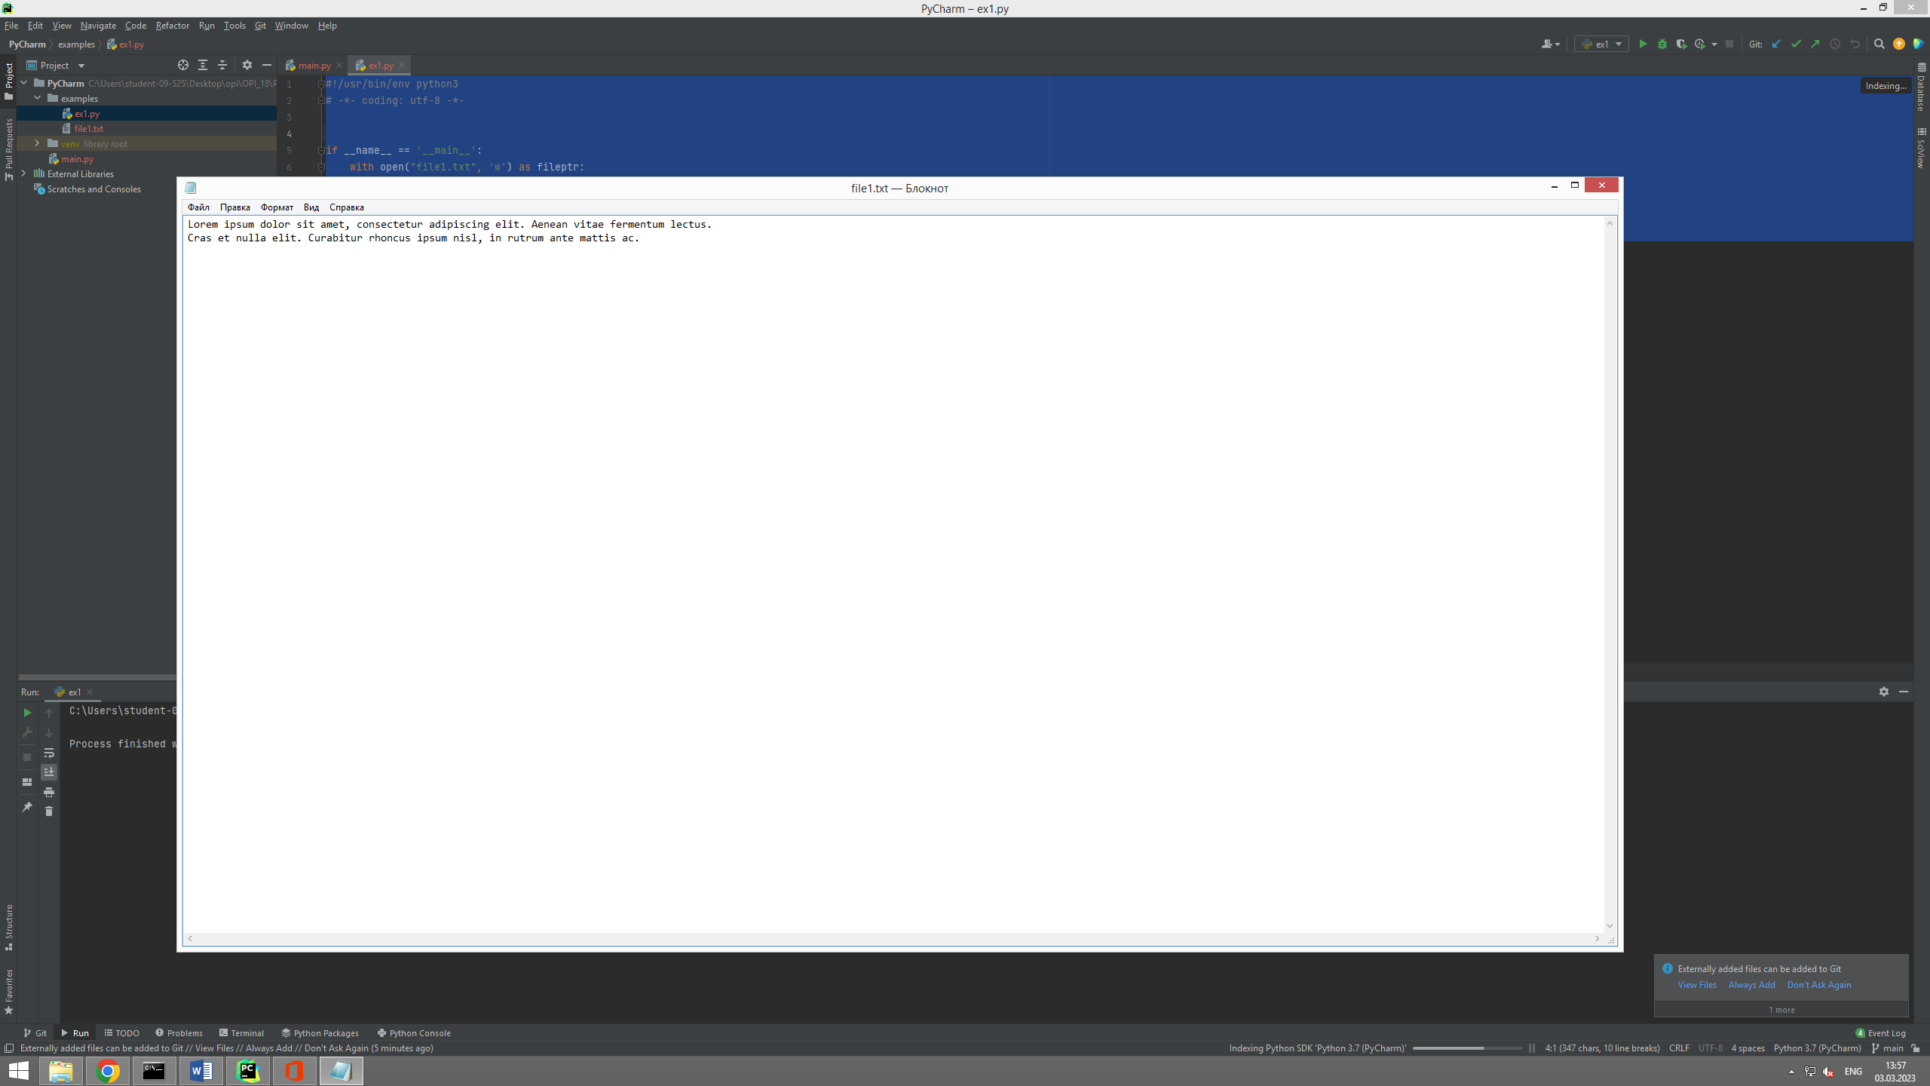

#!/usr/bin/env python3  
# -*- coding: utf-8 -*-  
  
if __name__ == '__main__':  
 with open("file1.txt", 'a') as fileptr:  
 fileptr.write("\nThis text fragment was added here.")

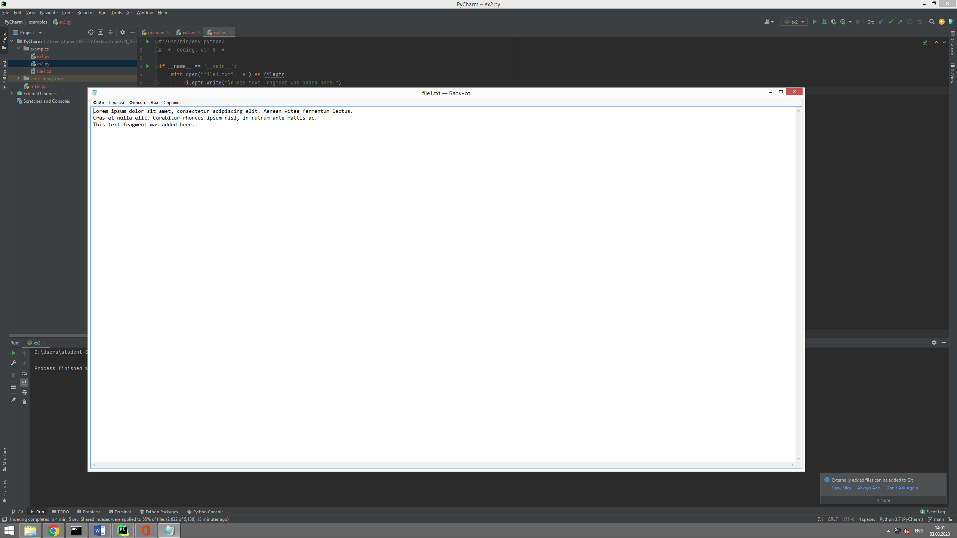

#!/user/bin/env python3  
# -*- coding: utf-8 -*-  
  
  
if __name__ == '__main__':  
 with open("file1.txt", 'r') as fileptr:  
 content1 = fileptr.readline()  
 content2 = fileptr.readline()  
  
 print(content1)  
 print(content2)

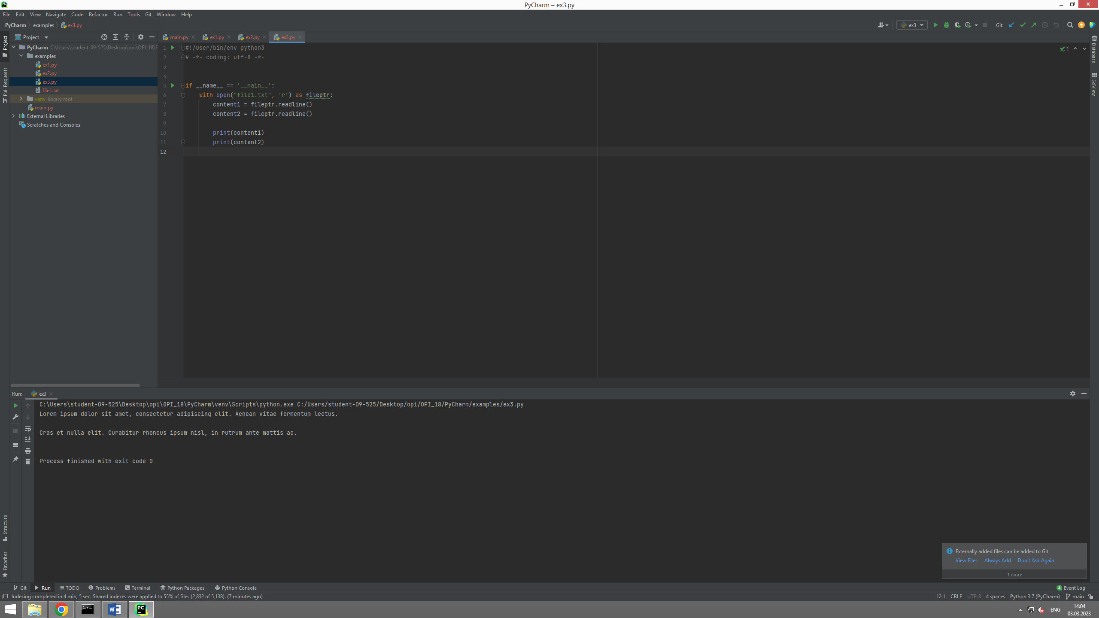

#!/user/bin/env python3  
# -*- coding: utf-8 -*-  
  
  
if __name__ == '__main__':  
 with open("file1.txt", 'r') as fileptr:  
 content = fileptr.readlines()  
  
 print(content)

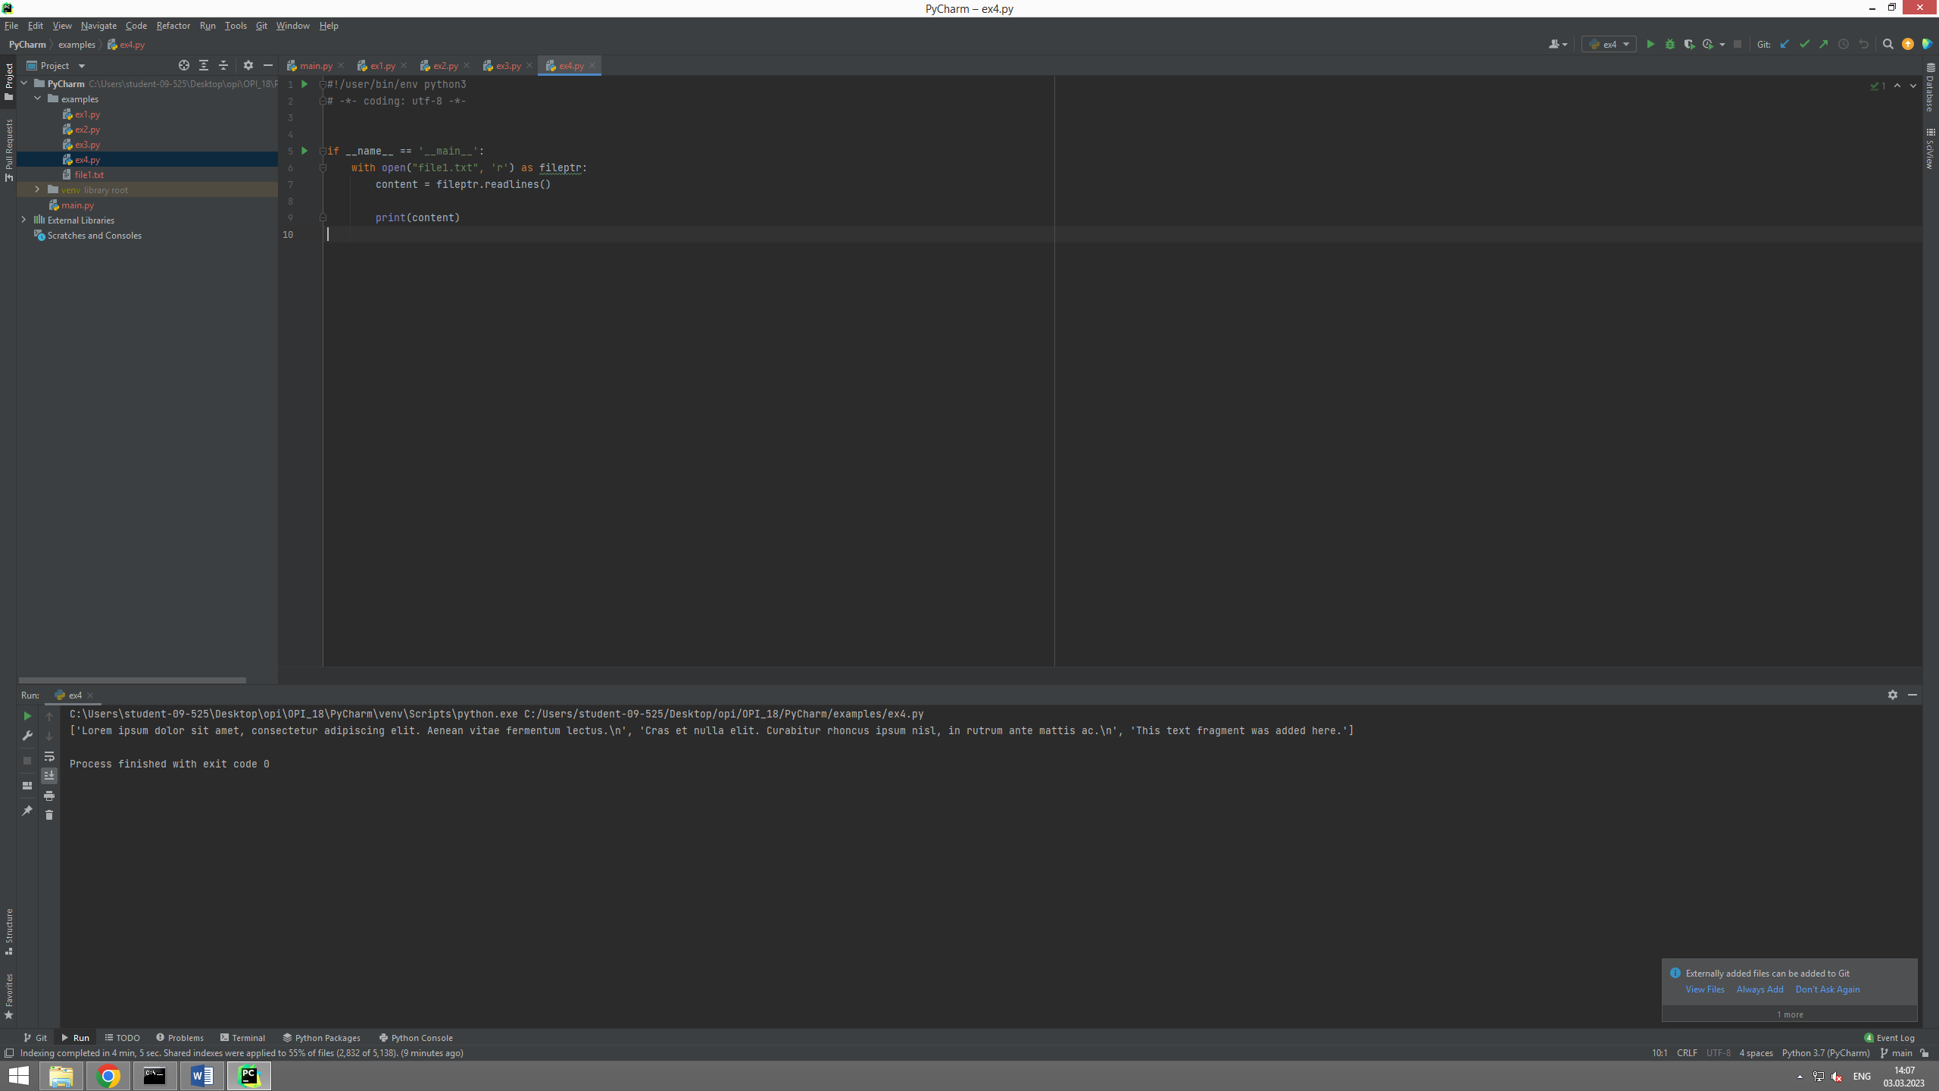

#!/user/bin/env python3  
# -*- coding: utf-8 -*-  
  
  
if __name__ == '__main__':  
 with open("file2.txt", 'x') as fileptr:  
 print(fileptr)  
  
 if fileptr:  
 print("File created successfully!")

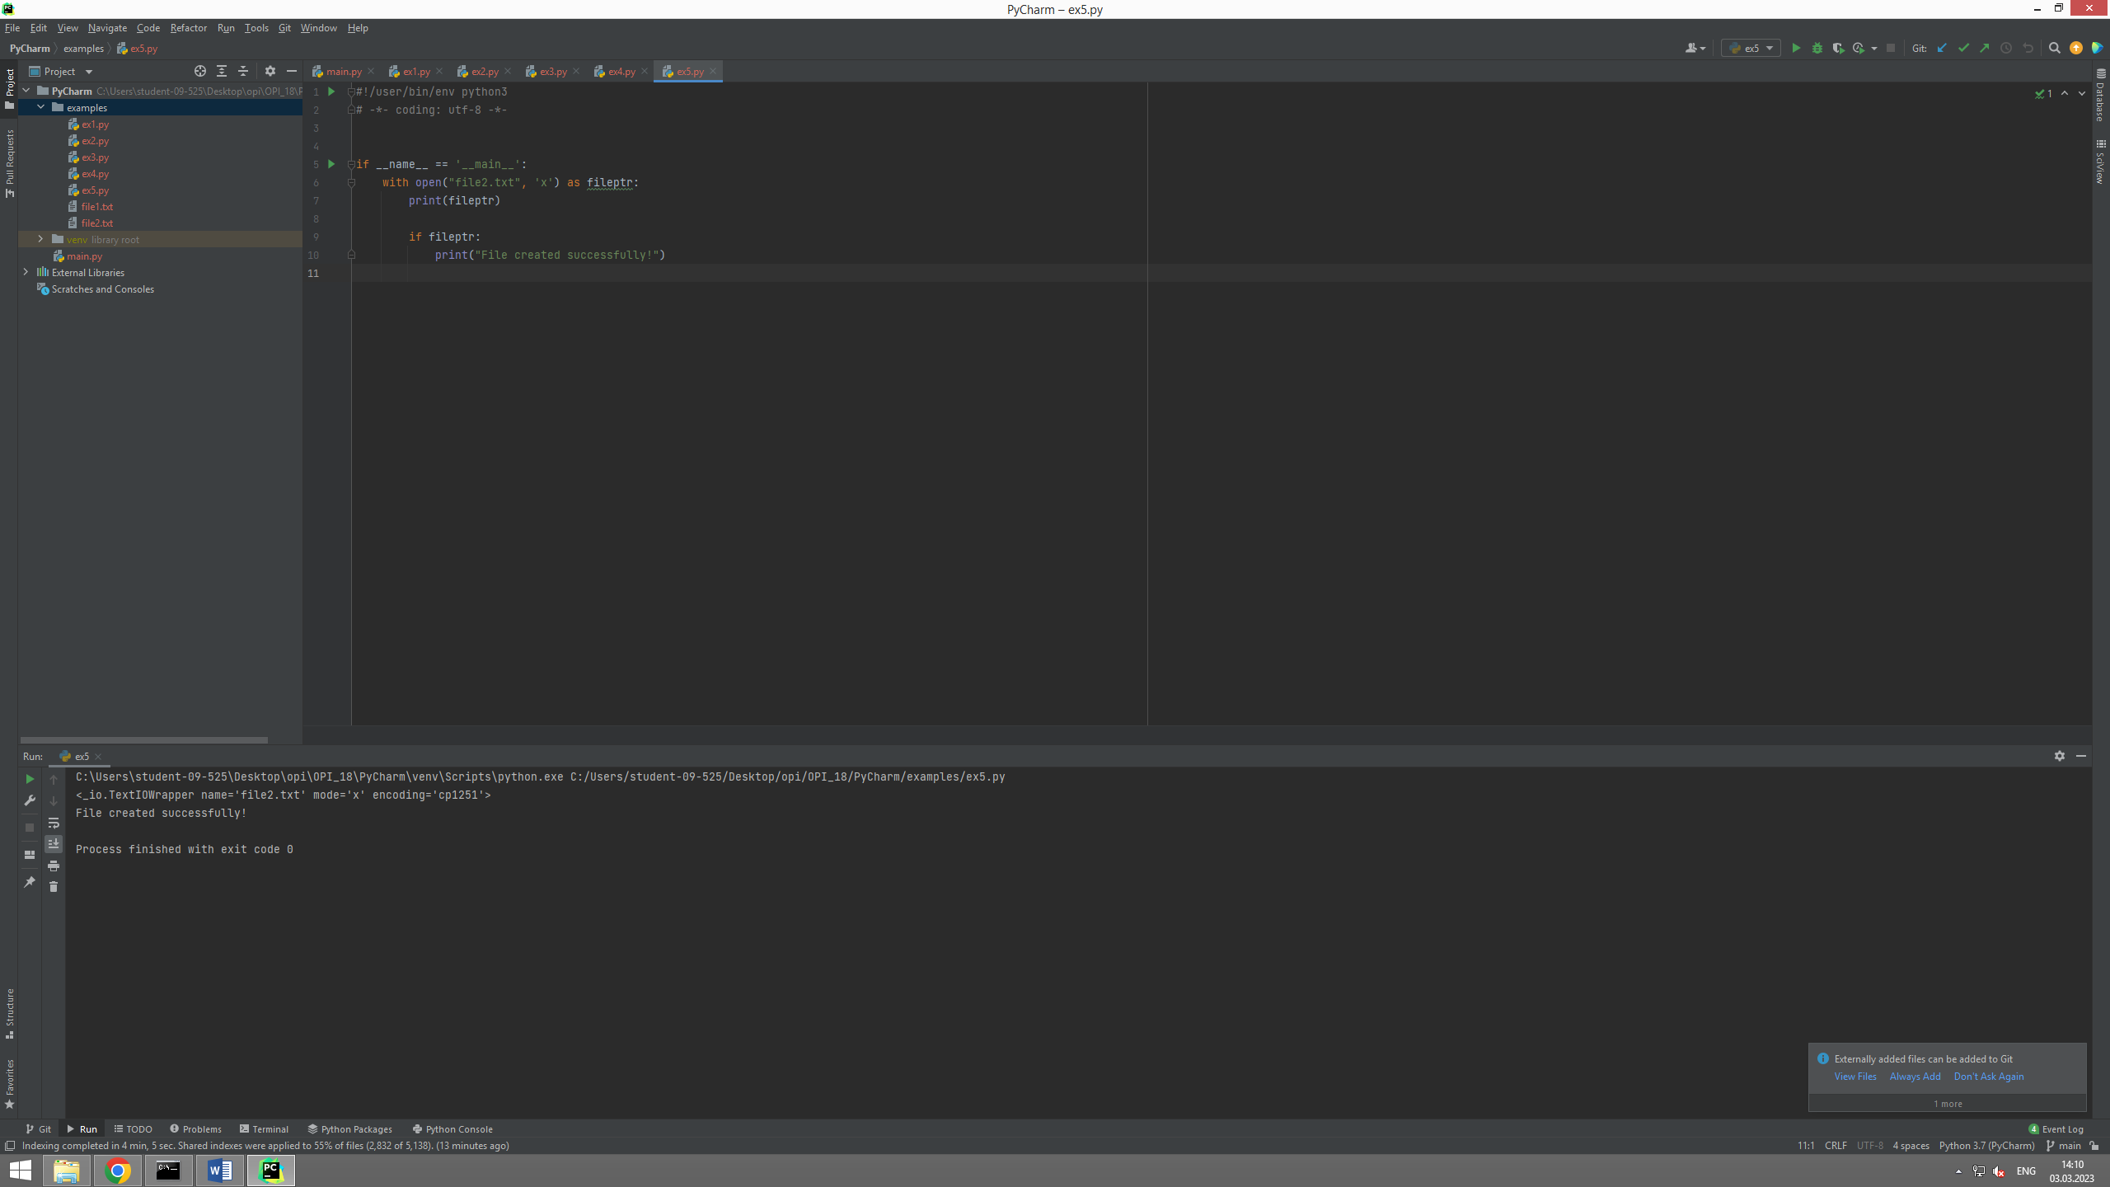

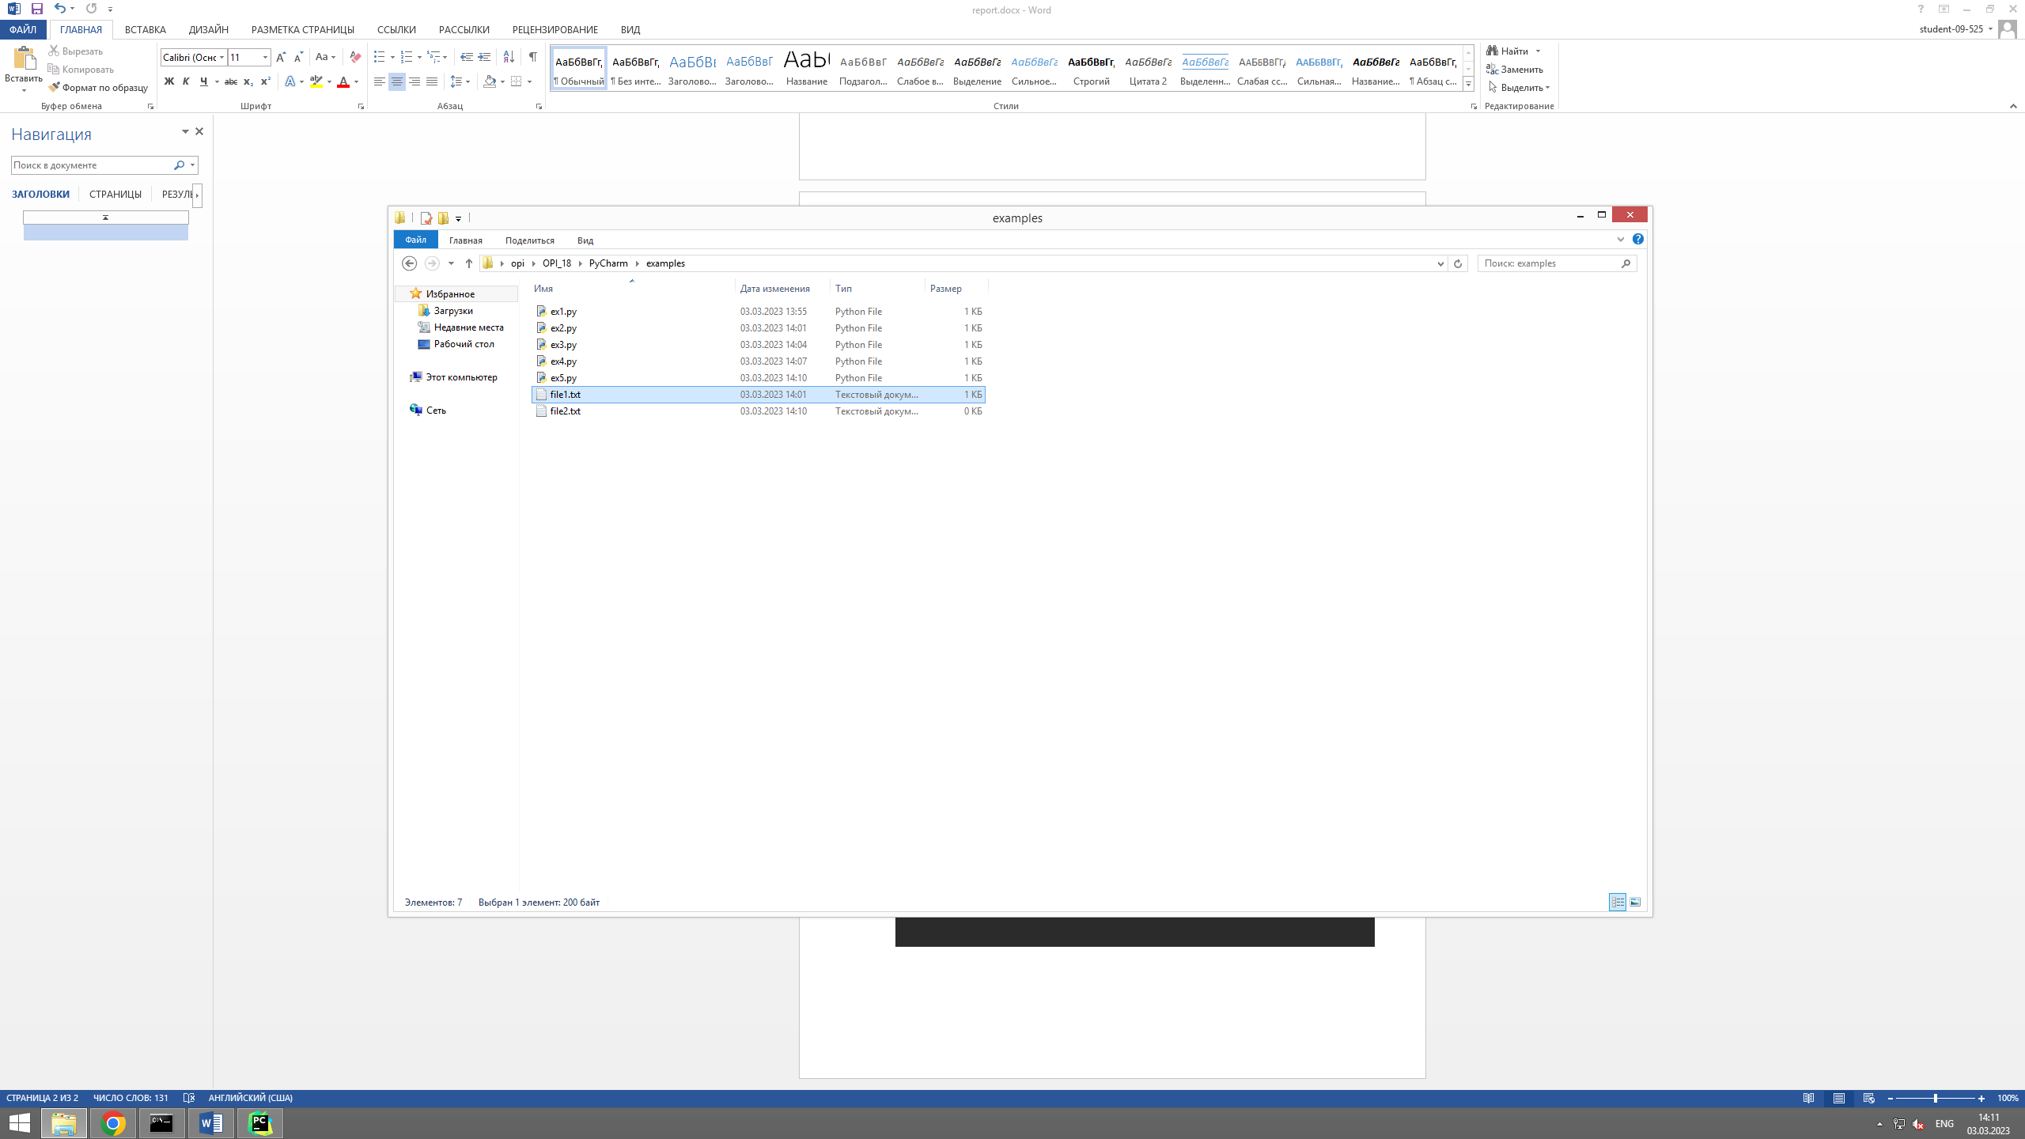

#!/user/bin/env python3  
# -*- coding: utf-8 -*-  
  
  
if __name__ == '__main__':  
 with open("file3.txt", 'w') as fileptr:  
 print("UTF-8 is a variable-width character encoding used for electronic communication.", file=fileptr)  
 print("UTF-8 is capable of encoding all 1,112,064 valid character code points.", file=fileptr)  
 print("In Unicode using one to four one-byte (8-bit) code units.", file=fileptr)

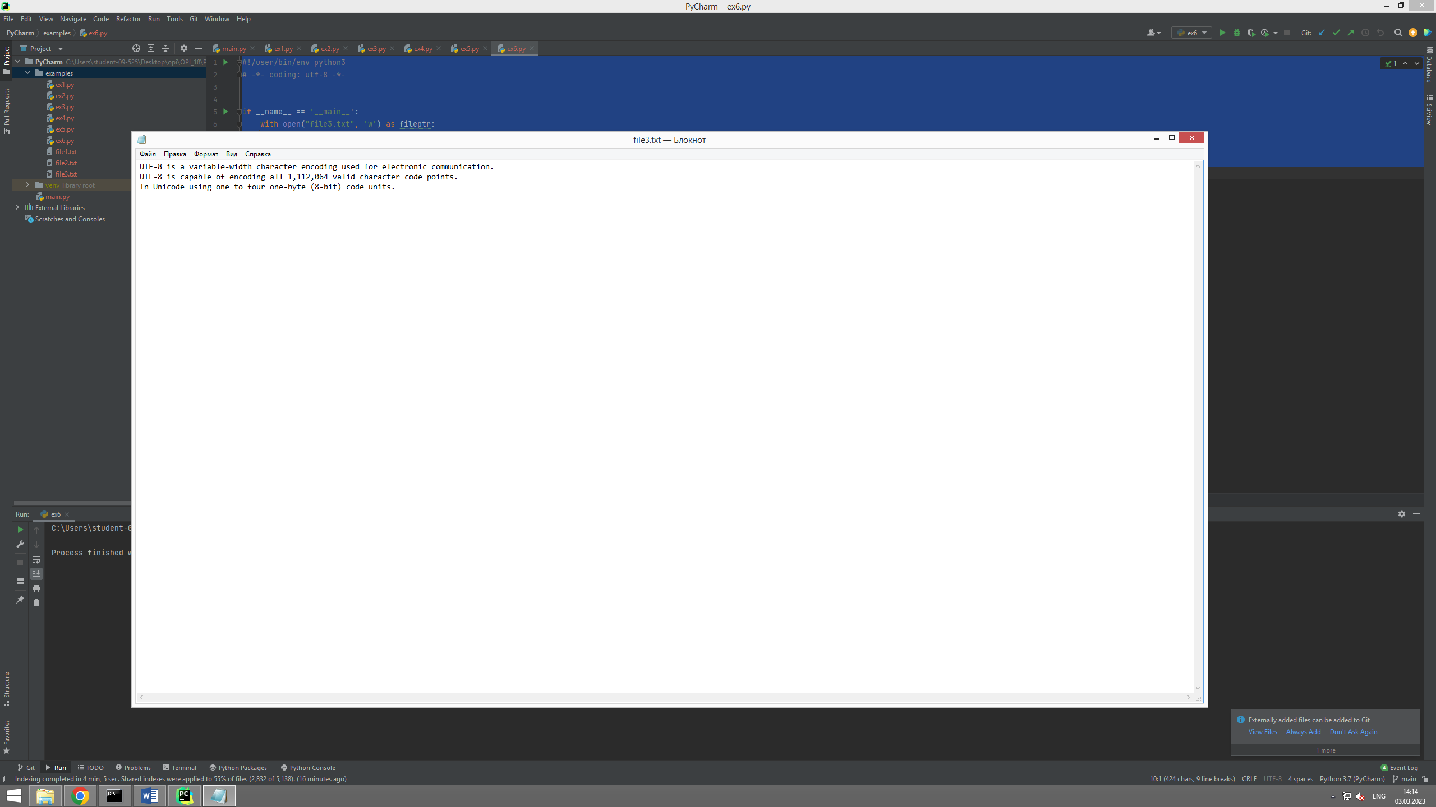

#!/user/bin/env python3  
# -*- coding: utf-8 -*-  
  
  
if __name__ == '__main__':  
 with open("file3.txt", 'r') as fileptr:  
 sentences = fileptr.readlines()  
  
 for sentence in sentences:  
 if ',' in sentence:  
 print(sentence)

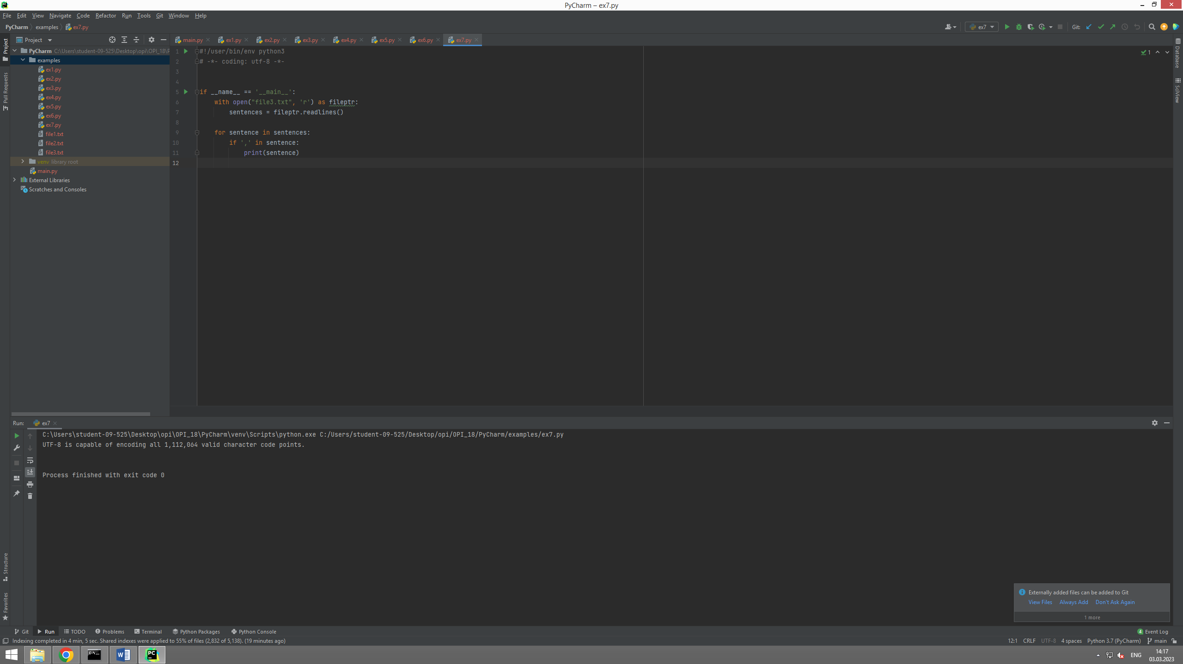

#!/user/bin/env python3  
# -*- coding: utf-8 -*-  
  
  
if __name__ == '__main__':  
 with open("file1.txt") as fileptr:  
 print("The filepointer is at byte: ", fileptr.tell())  
  
 fileptr.seek(10)  
  
 print("After reading, the filepointer is at: ", fileptr.tell())

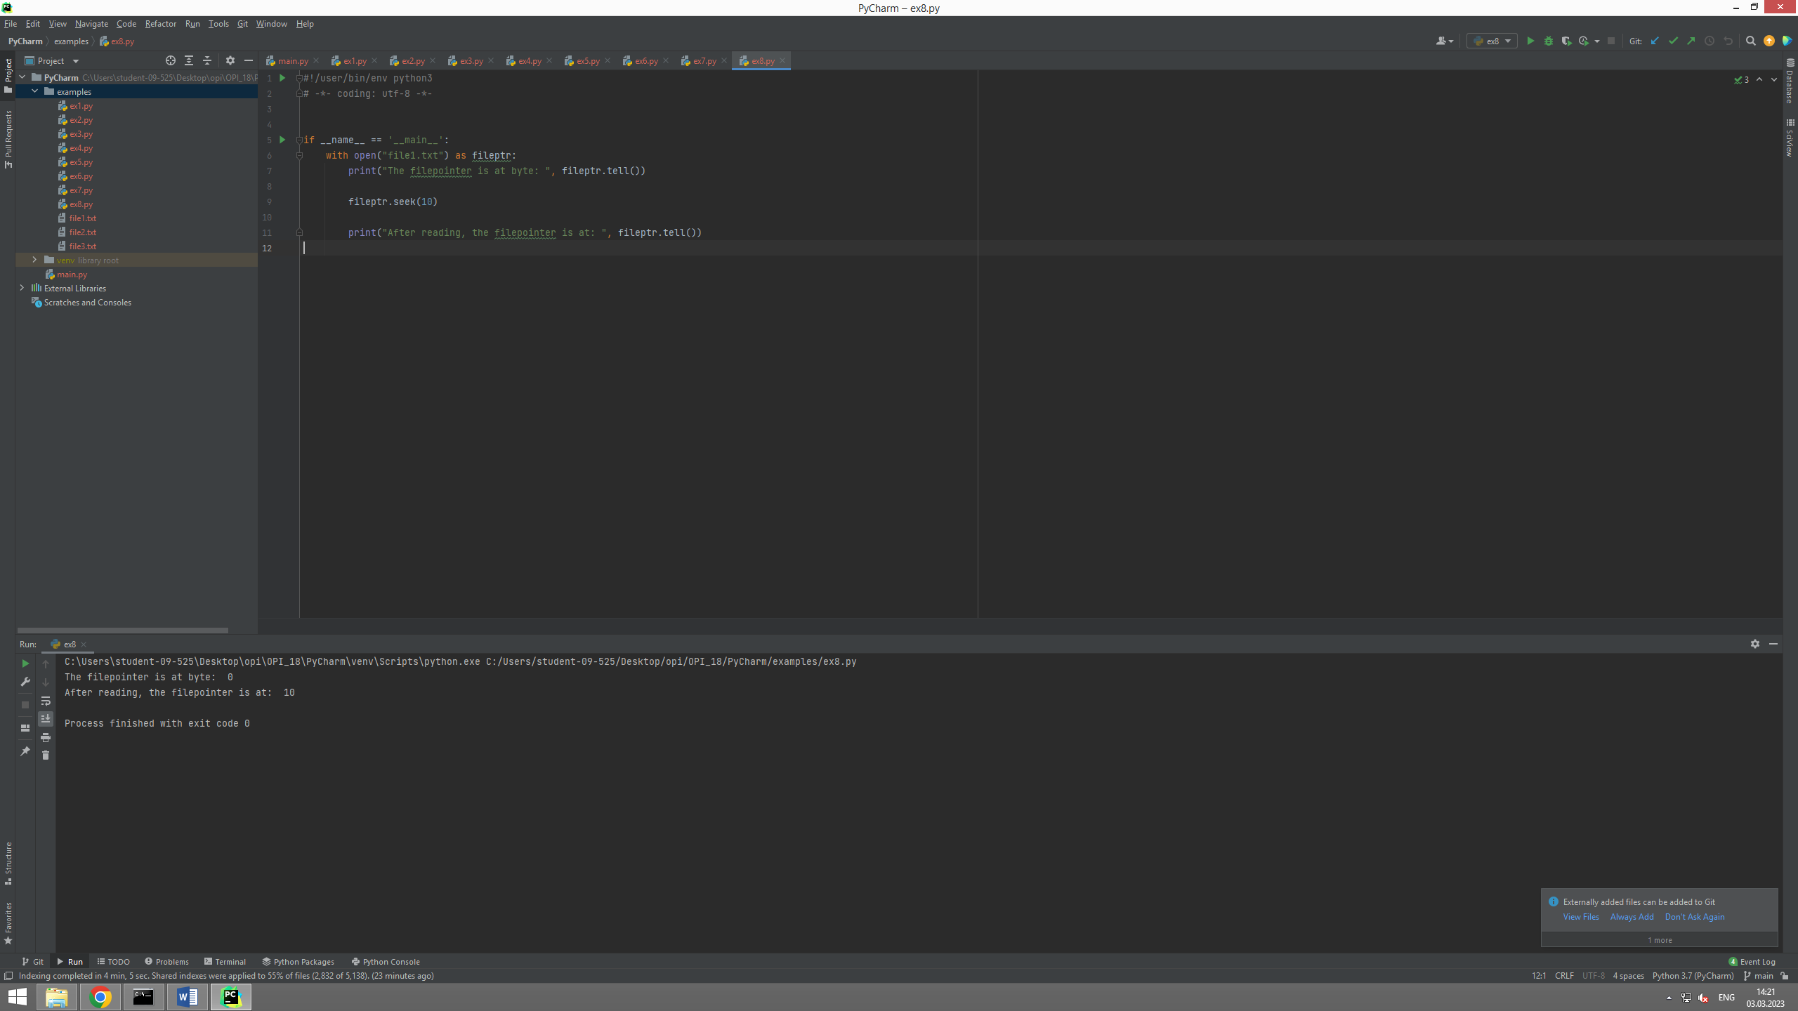

#!/user/bin/env python3  
# -*- coding: utf-8 -*-  
  
import os  
  
if __name__ == '__main__':  
 os.rename("file1.txt", "file1_renamed.txt")

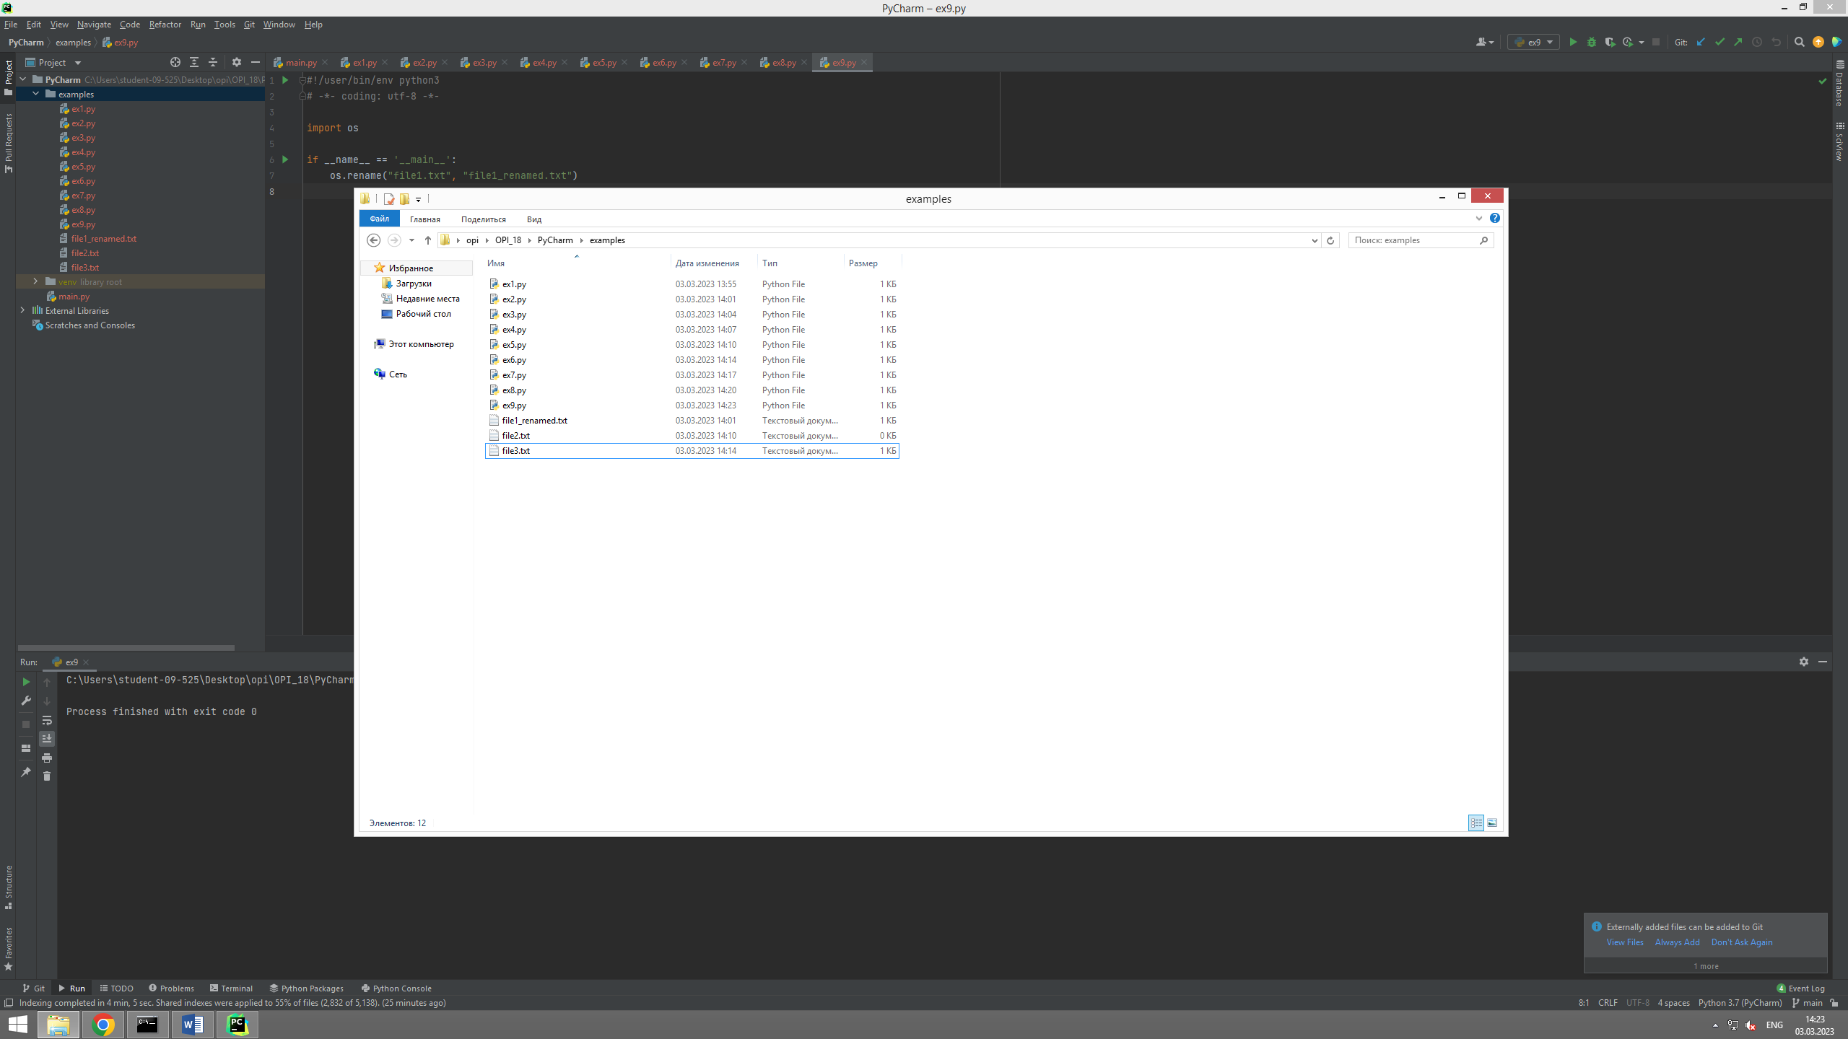

#!/user/bin/env python3  
# -*- coding: utf-8 -*-  
  
import os  
  
if __name__ == '__main__':  
 os.remove("file2.txt")

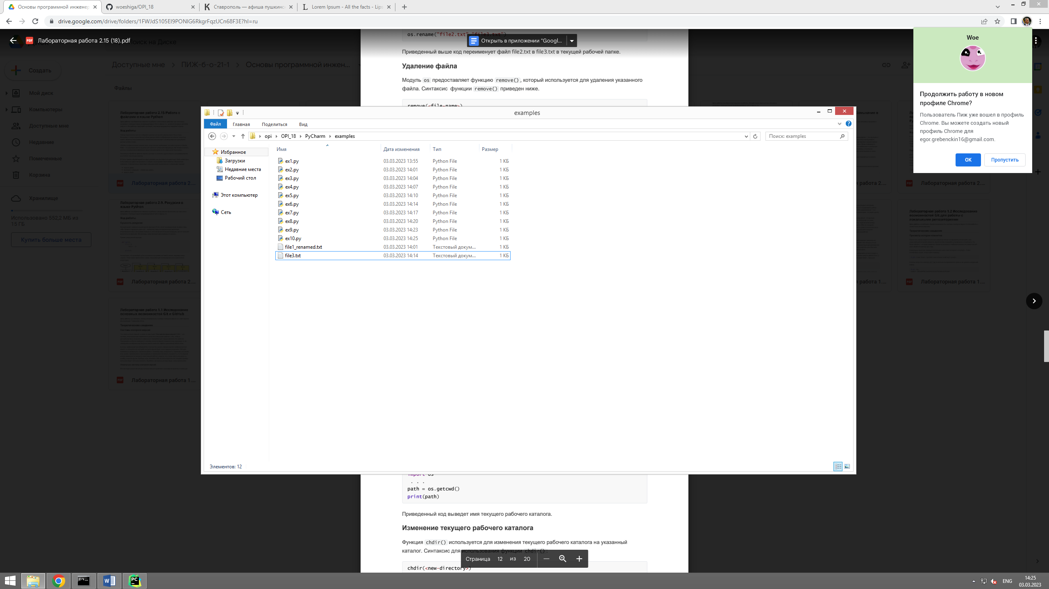

#!/user/bin/env python3  
# -*- coding: utf-8 -*-  
  
import os  
  
if __name__ == '__main__':  
 os.mkdir("new")

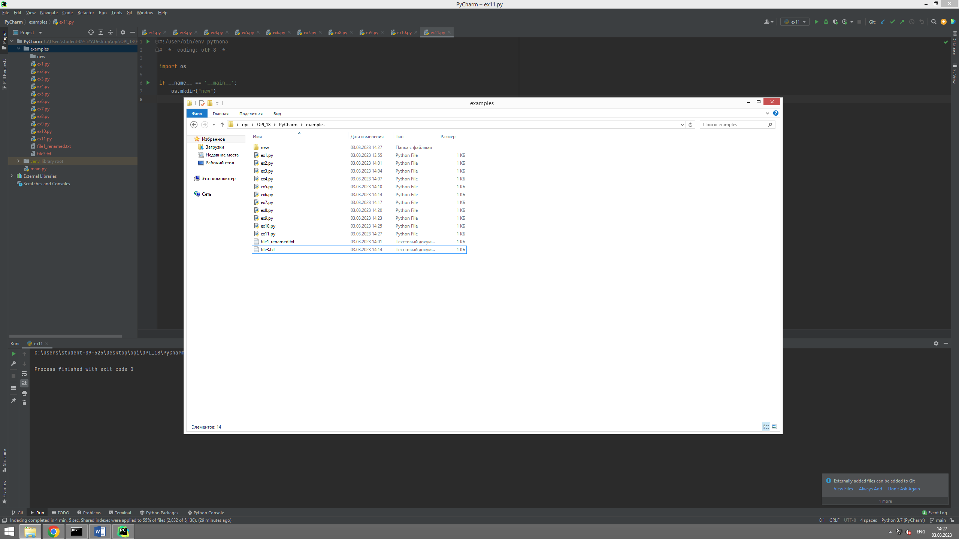

#!/user/bin/env python3  
# -*- coding: utf-8 -*-  
  
import os  
  
if __name__ == '__main__':  
 path = os.getcwd()  
  
 print(path)

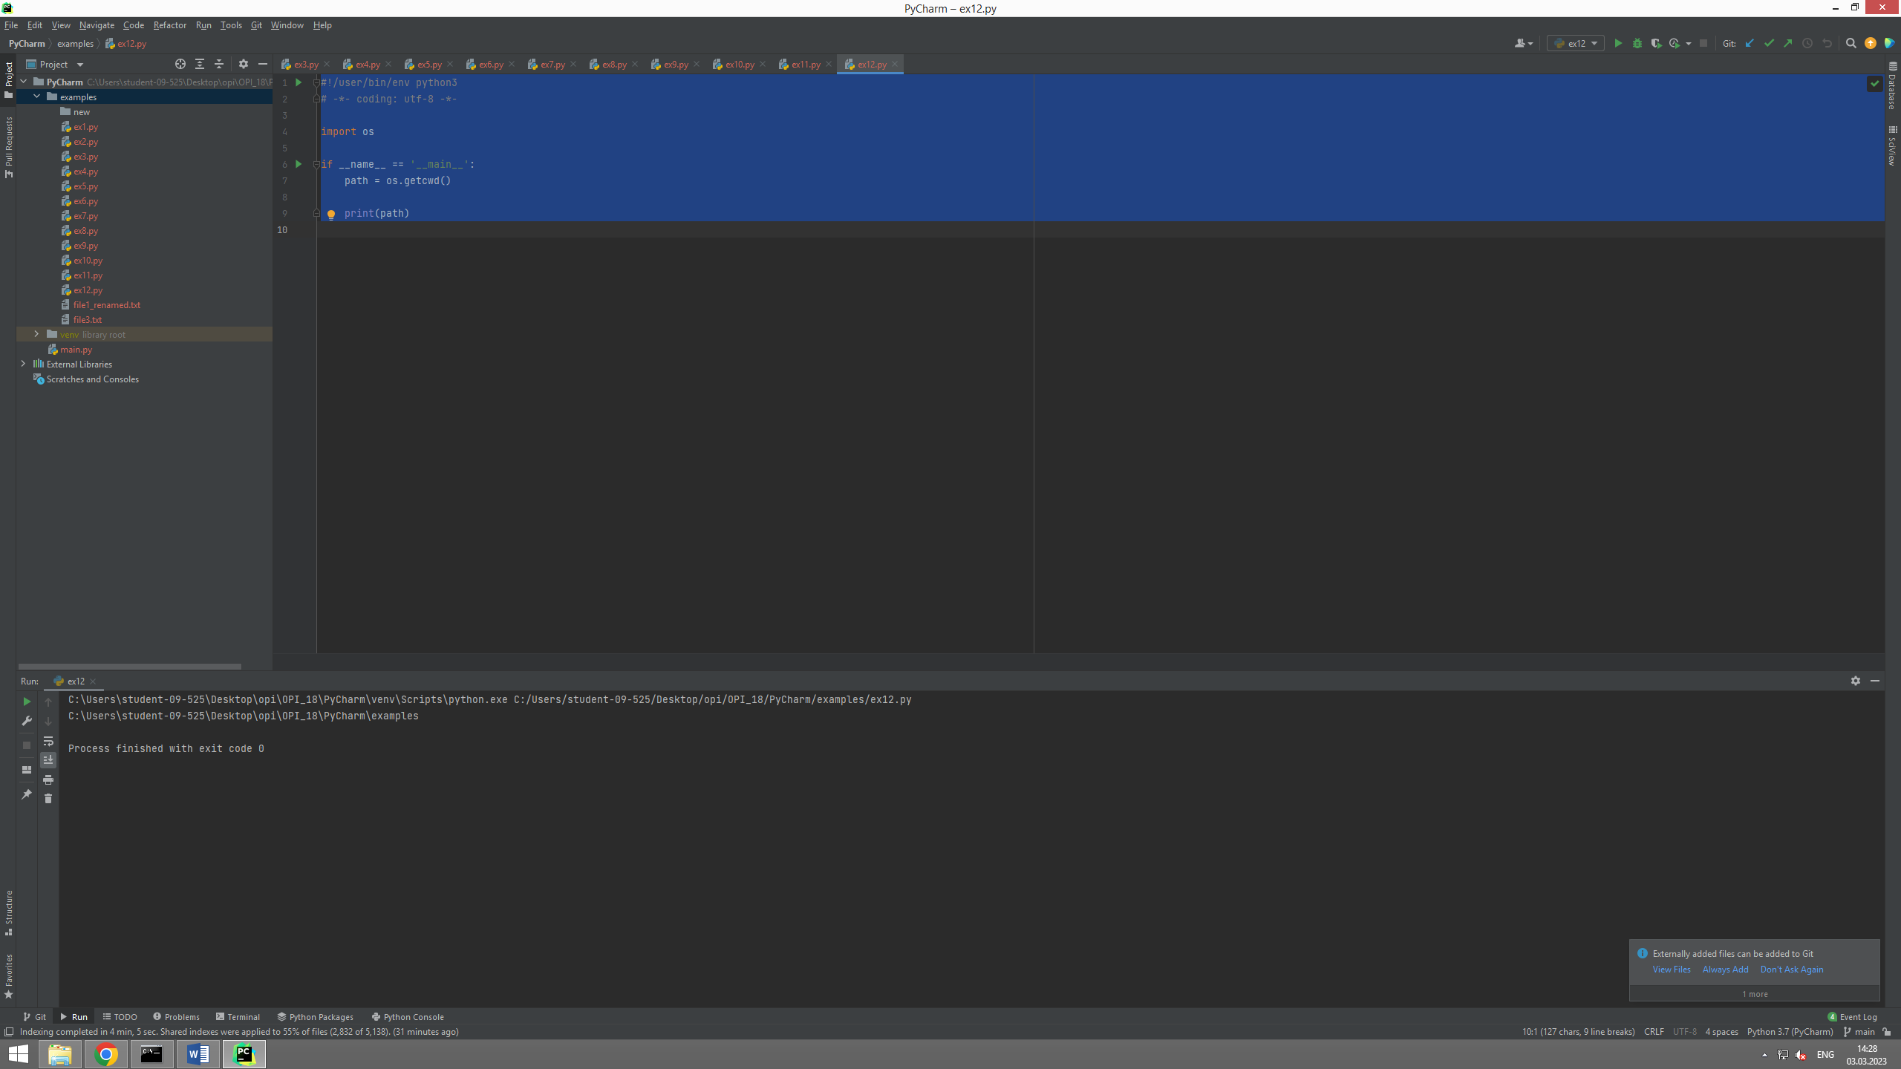

#!/user/bin/env python3  
# -*- coding: utf-8 -*-  
  
import os  
  
if __name__ == '__main__':  
 os.chdir("C:\\Windows")  
  
 print(os.getcwd())

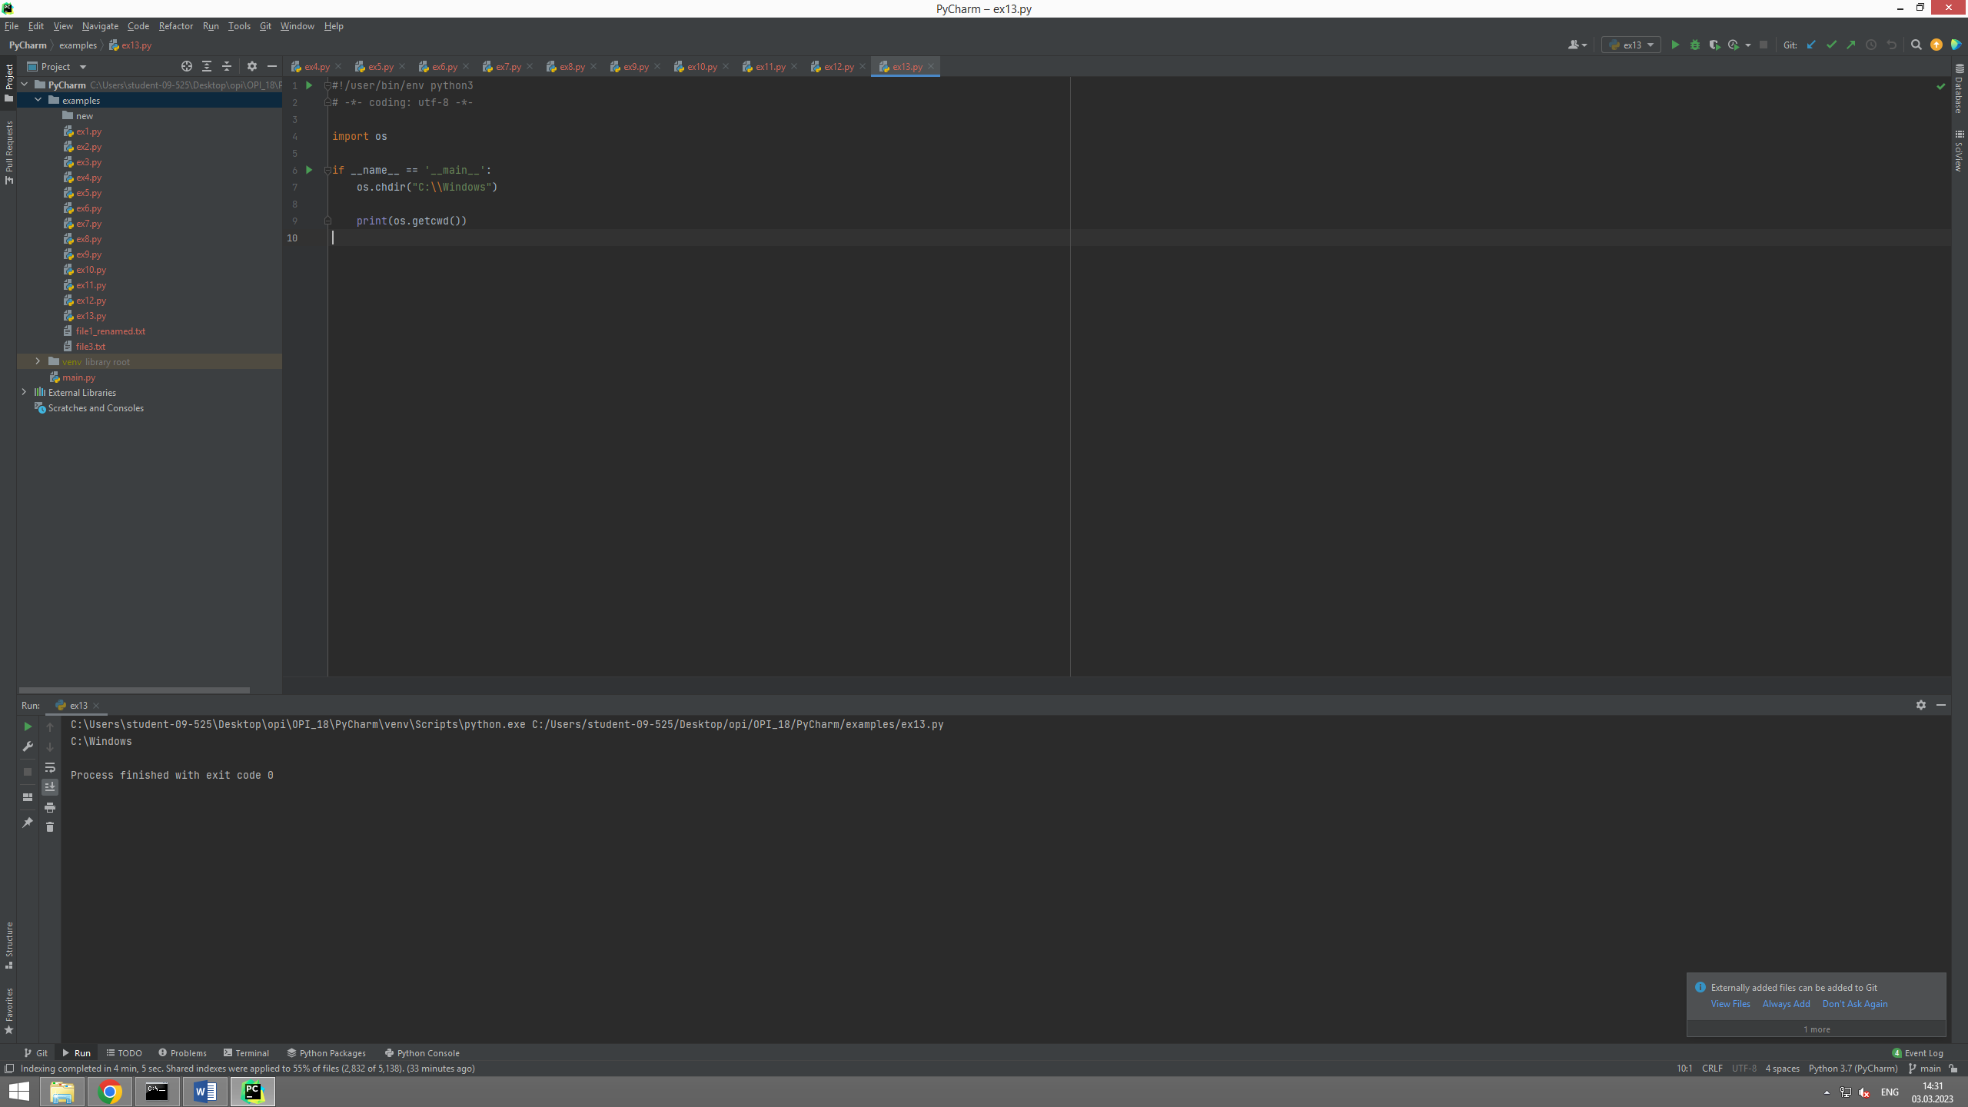

#!/user/bin/env python3  
# -*- coding: utf-8 -*-  
  
import os  
  
if __name__ == '__main__':  
 os.rmdir("new")

#!/user/bin/env python3  
# -*- coding: utf-8 -*-  
  
import sys  
  
if __name__ == '__main__':  
 print("Number of arguments: ", len(sys.argv), "arguments")  
 print("Argument list: ", str(sys.argv))

#!/usr/bin/env python3  
# -*- coding: utf-8 -*-  
  
import sys  
  
if __name__ == "__main__":  
 for idx, arg in enumerate(sys.argv):  
 print(f"Argument #{idx} is {arg}")  
 print("No. of arguments passed is ", len(sys.argv))

#!/usr/bin/env python3  
# -*- coding: utf-8 -*-  
  
import secrets  
import string  
import sys  
  
if __name__ == "__main__":  
 if len(sys.argv) != 2:  
 print("The password length is not given!", file=sys.stderr)  
 sys.exit(1)  
  
 chars = string.ascii_letters + string.punctuation + string.digits  
 length_pwd = int(sys.argv[1])  
 result = []  
  
 for _ in range(length_pwd):  
 idx = secrets.SystemRandom().randrange(len(chars))  
 result.append(chars[idx])  
  
 print(f"Secret Password: {''.join(result)}")