Supplementary figures and text:
Supplementary Figure 1 | Gel image of library fragments [JL&GQ]
Supplementary Figure 2 | Library insert sizes after mapping [OK]
Supplementary Figure 3 | Test 1 of various library inserts sequenced in one lane [OK]
Supplementary Figure 4 | Test 2 of various library inserts sequenced in one lane [OK]
Supplementary Figure 5 | Number of reads used in assemblies of CS reads [OK]
Supplementary Figure 6 | Coverage of reference genome dm3 by CS reads [OK]
Supplementary Figure 7 | Length distribution of insertions and deletions [OK]
Supplementary Figure 8 | Comparison of coverage in repetitive and non-repetitive regions [OK]
Supplementary Figure 9 | Comparison of coverage in coding and non-coding regions [OK]
Supplementary Figure 10 | Comparison of three types of reads on GC bias [OK]
Supplementary Table 1 | Summary of CS reads [OK]
Supplementary Table 2 | Assemblies of simulations [OK]
Supplementary Note 1 | Suggestions on various fragment sizes sequencing [OK]
Supplementary Note 2 | Estimated cost of CS reads [GQ]
Supplementary Protocol 1 | [GQ&JL]
Supplementary Protocol 2 | [GQ&JL]

Supplementary Figure 1. Gel image of library fragments

Supplementary Figure 2. Library insert sizes after mapping
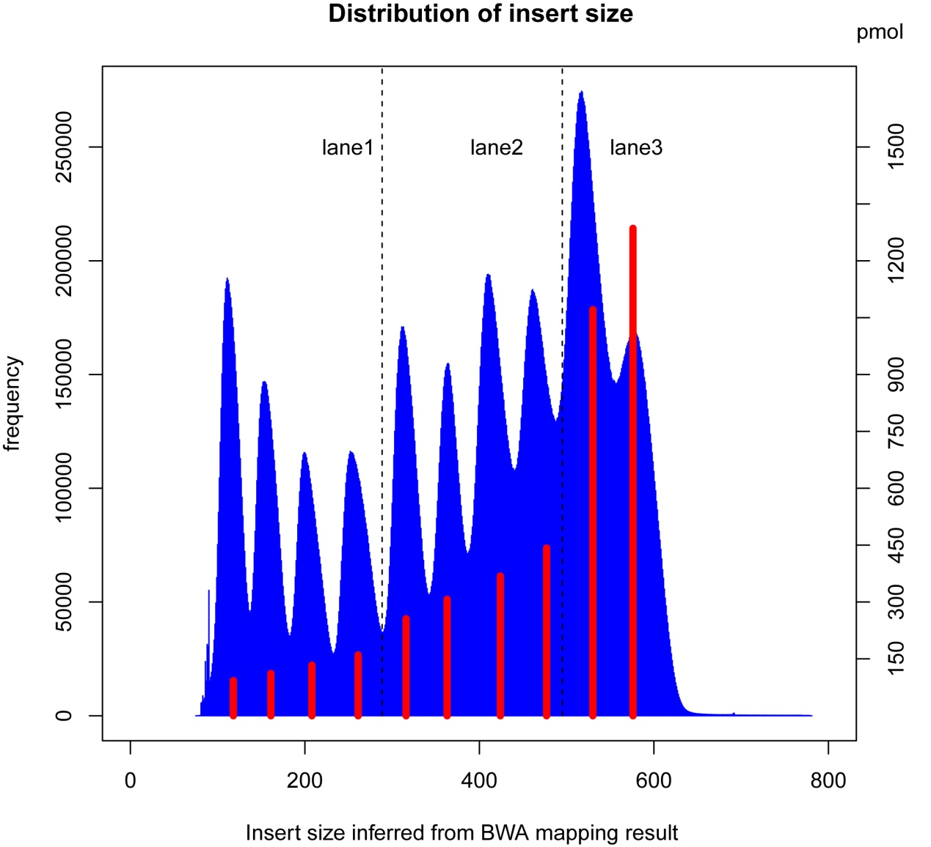
10 sub-libraries were quantified using Agilent Bioanalyzer 2100. All the fragments were sequenced in three lanes: insert size of 100-300 bp in Lane 1, insert size of 300-500 bp in Lane 2, and insert size of 500-600 bp in Lane 3. Each red bar represents pmols of fragments subjected to cluster generation from each sub-library. Sequenced reads were mapped to the reference with BWA. Inferred from the mapping result, insert size distribution (blue) was nearly even.
我们建成10个library,insert size从大约125开始，到大约575bp止，间隔50bp左右。分为3个lane测序。lane1为insert size为100－300的4个library混合在一起，
混合的分子数比例为（1:1.2:1.44:1.728)，lane2为insert size为300－500的4个library同样操作，最后两个libraray，insert size为500－600，按照分子数为（1:1.2）混合组成lane3, 进行测序。
测序得到的数据，用bwa map 到dm3的reference上，由mapping结果得出所有数据insert size的distribution,由图看出，我们得到了近乎均匀的结果。每个library insert size 峰值处的红线表示，用于生长cluster时最终上样的分子数量，单位为pm。

Supplementary Figure 3. Test 1 of various library inserts sequenced in one lane
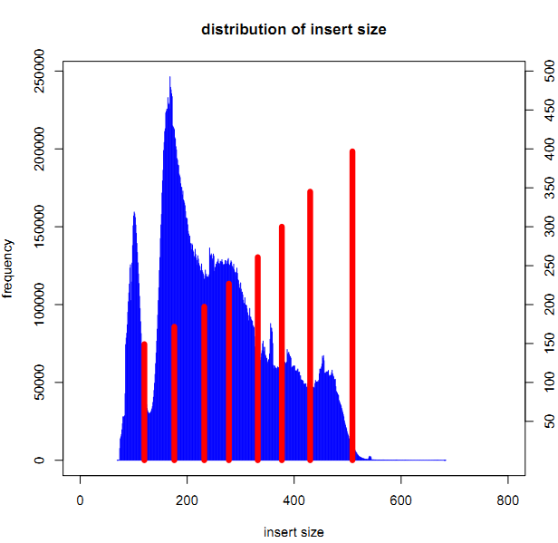

Supplementary Figure 4. Test 2 of various library inserts sequenced in one lane
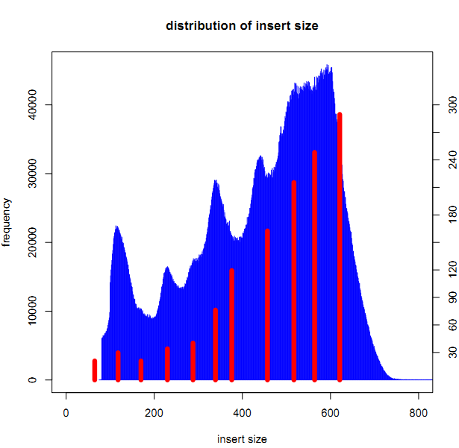

Supplementary Figure 5. Number of reads used in assemblies of CS reads
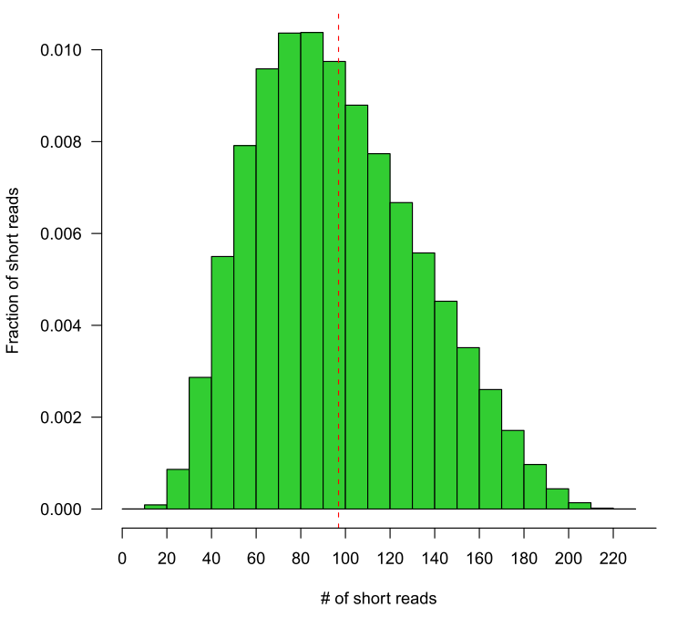
The distribution of number of short reads that were used to generate CS read. The mean number of short reads that constituted to a CS read is 97.

Supplementary Figure 6. Coverage of reference genome dm3 by CS reads
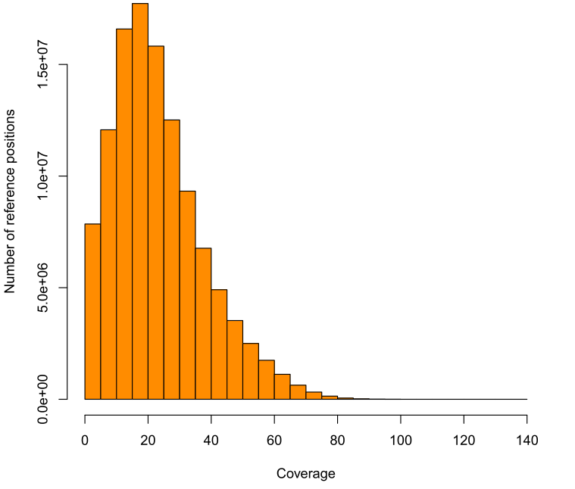
Coverage distribution of the D.mel reference by the mapped CS reads (bin size 5 bp). About 99.98% of the total CS reads were mapped to reference for this analysis using BWASW. The mean coverage of CS reads when mapped to reference is ~20X.

Supplementary Figure 7. Length distribution of insertions and deletions
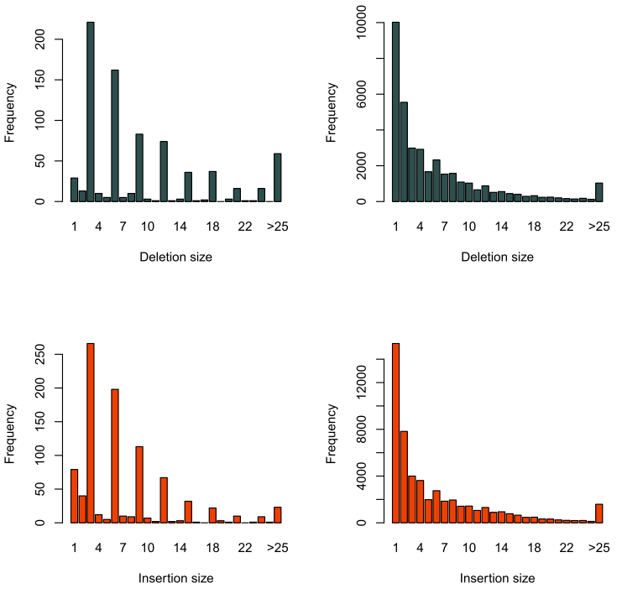
Deletion (darkslategray) and insertion (orangered) size distribution in CDS (left two) and non-coding (right two) regions. Deletions and insertions were called by SAMtools after mapping CS reads to D.mel reference using bwasw. A striking pattern of sizes of multiple three in coding region and a geometric like distribution of sizes in non-coding regions suggest a high accuracy of CS reads. The comparable number of insertions and deletions suggests a similar evolutionary rate of insertions and deletions diverge from common ancestor.

Supplementary Figure 8. Comparison of coverage in repetitive and non-repetitive regions
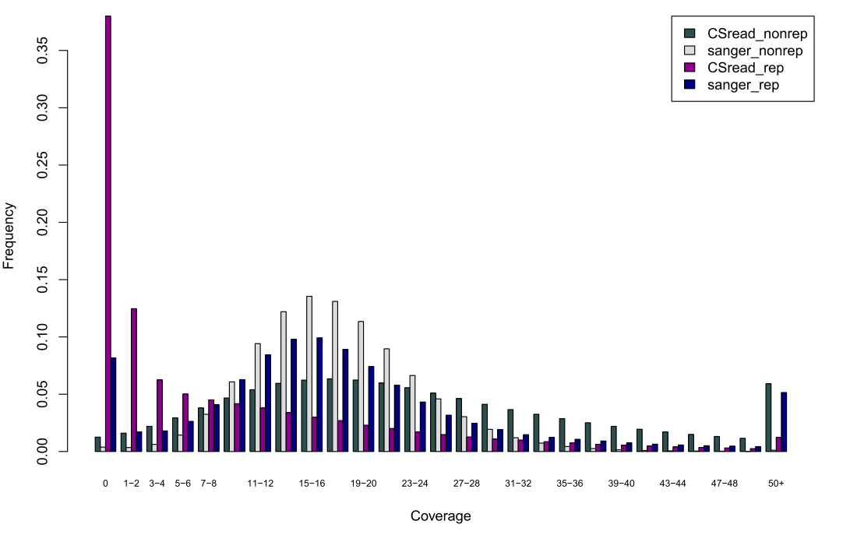
Distribution of coverage of the D.mel reference by the mapped CS reads and Sanger reads in repeat and non-repeat regions. About 60% of repeat regions could be covered by CS reads. The uncovered region is mainly due to a larger repeat that cannot be spanned by SR2 reads. The larger variance of CS reads for the distribution in repeat regions is due to the uneven distribution of number of reads sequenced in different repeat length, because a too much number of clustered reads are computationally time consuming, which are omitted in our current algorithm implementation.

Supplementary Figure 9. Comparison of coverage in coding and non-coding regions
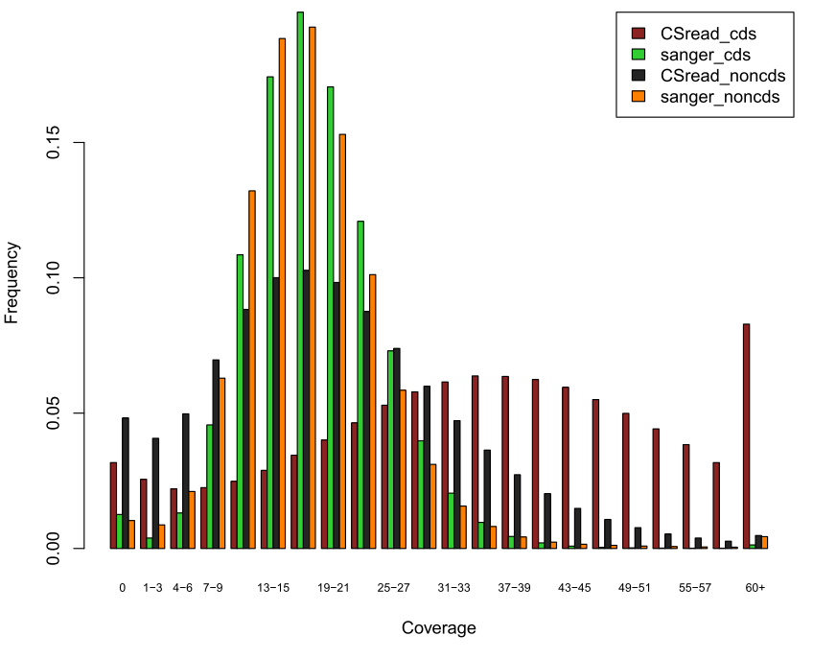
Distribution of coverage of the D.mel reference by the mapped CS reads and Sanger reads in CDS and noncoding regions (bin size 3 bp). In non-coding, the distribution of CS reads is comparable to Sanger reads. The larger variance in CDS may arise from the higher GC content in these regions.

Supplementary Figure 10. Comparison of three types of reads on GC bias
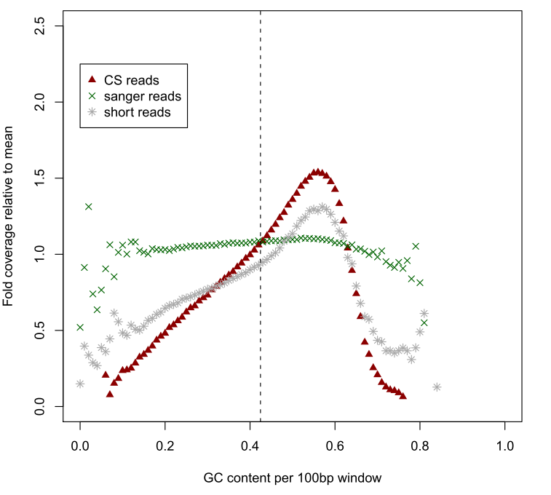
Average GC content per 100bp along the reference versus the corresponding relative coverage (normalized by the mean coverage) by the CS reads, the Sanger reads and the SR2 short reads. Apparent bias of coverage can be seen when GC content increases comparing to Sanger sequences. This may due to the system bias of PCR amplification of library construction and sequencing procedure in next-generation sequencing technology. This bias could be alleviated through a PCR-free protocol.

Supplementary Table 1. Summary of CS reads

Number of SR2 pairs ª | 7,869,143
Number of CS reads | 5,204,833
Total bases (bp) | 2,822,891,216
Mean length (bp) | 542.4
Median length (bp) | 537
Min length (bp) | 400
Max length (bp) | 842
a 7,869,143 large read pairs were used to assemble CS reads

Supplementary Table 2. Assemblies of simulations
 | Simu1.1 | Simu1.2 | Simu2.1 | Simu2.2 | Simu3.1 | Simu3.2
Organism | D. melanogaster
Chromosomes | chrX, chr2L, chr2R, chr3L, ch3R, chr4, chrM
Genome Length (kp) | 120,401
Library (bp) | 120-570 ª | 570 | 120-570 | 570 | 120-570 | 570
Standard deviation | 20 bp
Coverage | 50x
Seq. error rate | 0.01
Heterozygousity | 0.001 |  | 0.01 |  | 0.02
Software | anytag + PCAP | velvet | anytag + PCAP | velvet | anytag + PCAP | velvet
Runtime parameters | default | -k=25,27,29,31 –exp_cov=50 | default | -k=25,27,29,31 –exp_cov=50 | default | -k=25,27,29,31 –exp_cov=50
Long reads statistics

Total length (kp) | 197,879 | - | 191,194 | - | 192,865 | -
Average length (bp) | 570 | - | 570 | - | 570 | -
Coverage | 12.4x | - | 12.3x | - | 12.1x | -
Mappable^{b} (%) | 98.7 | - | 98.2 | - | 98.1 | -
Contig statistics
(>=100bp)
Total size (kp) | 123,054 | 113,412 | 124,326 | 111,401 | 126,724 | 110,713
Maximum length (kp) | 849.6 | 93.8 | 804.7 | 20.9 | 576.0 | 13.0
Contig N50 size (kp) | 150.08 | 16.88 | 135.92 | 3.48 | 125.60 | 1.81
Contig N90 size (kp) | 14.11 | 4.46 | 11.09 | 1.11 | 6.54 | 0.56
a libraries insert sizes were 120,170,220,270,320,370,420,470,520,570 bp

Supplementary Note 1. Mixture of sub-libraries of different insert sizes
The range of insert size of each sub-library should not exceed 50 bp. For a large genome, we suggest that each sub-library be sequenced in separated lanes. When this method is applied to a genome of size less than 500 Mbp, different sub-libraries may need to be mixed to obtain desired amount to sequence data. However, bridge PCR, the major process during the Illumina GA-II sequencing reaction, is tend to be more efficient to generate pair-end short reads from shorter library fragments. Therefore, to obtain nearly even distribution of insert sizes from 100-600 bp, we mixed more molars of longer fragments in each sequencing lanes (Online Method; Supplementary Protocols). Specifically, we added an increased molar amount of 20% when the average insert size of sub-libraries increased by 50 bp (Supplementary Fig XX). Based on our experience, we suggest that the increased molar amount be larger than 20% for insert size smaller than 300 bp, while smaller than 20% for insert size larger than 300 bp.
Supplementary Note 2. Estimated cost of CS reads

Supplementary Protocol 1.

