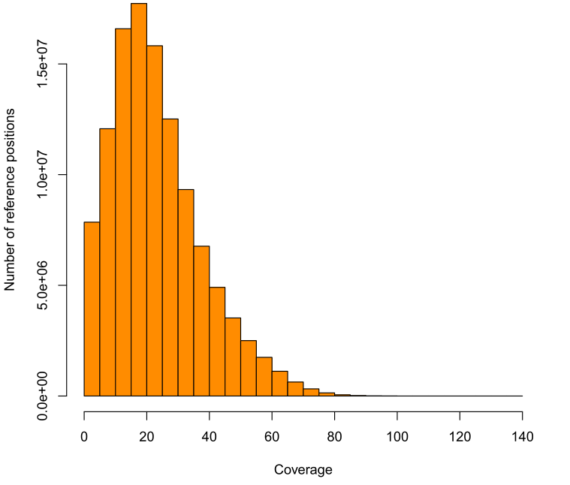
Coverage distribution of the D.mel reference by the mapped CS reads (bin size 5 bp). About 99.98% of the total CS reads were mapped to reference for this analysis using BWASW. The mean coverage of CS reads when mapped to reference is ~20X.

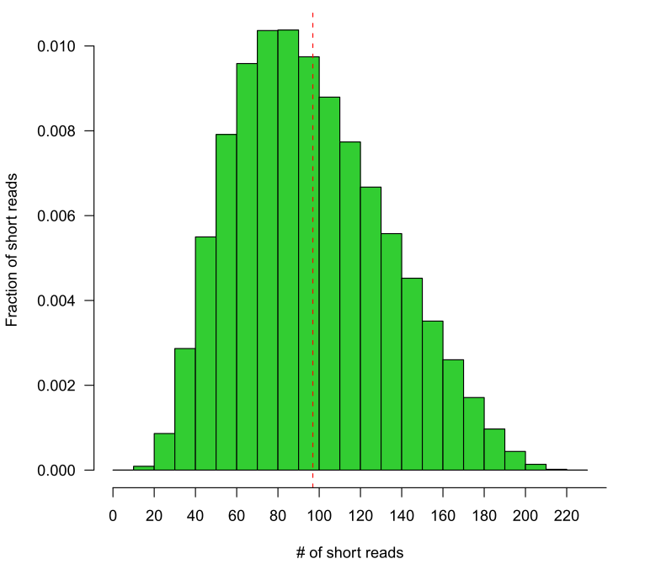
The distribution of number of short reads that were used to generate CS read. The mean number of short reads constitute a CS read is 97.

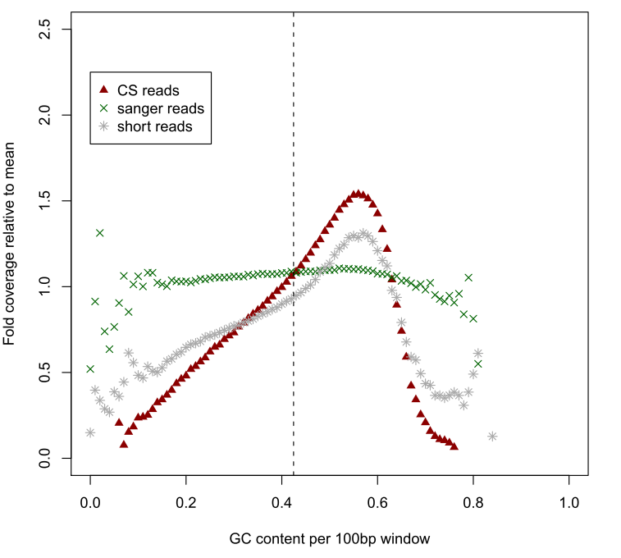
Average GC content per 100bp along the reference versus the corresponding relative coverage (normalized by the mean coverage) by the CS reads, the Sanger reads and the SR2 short reads. Apparent bias of coverage can be seen when GC content increases comparing to Sanger sequences. This may due to the system bias of PCR amplification of library construction and sequencing procedure in next-generation sequencing technology. This bias could be alleviated through a PCR-free protocol.

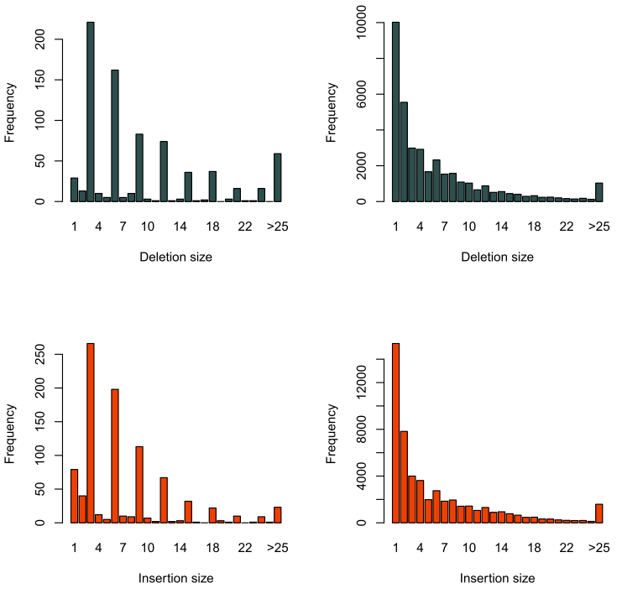
Deletion (darkslategray) and insertion (orangered) size distribution in CDS (left two) and non-coding (right two) regions. Deletions and insertions were called by SAMtools after mapping CS reads to D.mel reference using bwasw. A striking pattern of sizes of multiple three in coding region and a geometric like distribution of sizes in non-coding regions suggest a high accuracy of CS reads. The comparable number of insertions and deletions suggests a similar evolutionary rate of insertions and deletions diverge from common ancestor.
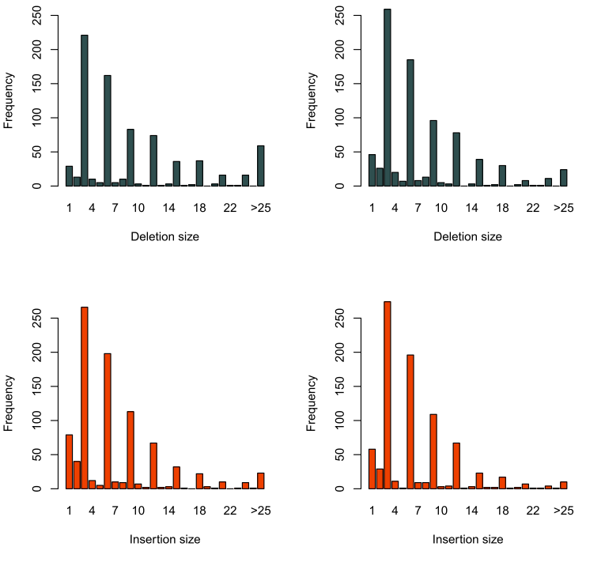
Comparison of deletion and insertion distribution in CDS region by CS reads (left two) and short SR reads (right two). Indels were called by SAMtools after mapping CS reads by bwasw and short reads by bwa. A similar pattern of small indel (<25 bp) variants called from CS and short reads indicates that the accuracy of CS reads for indel calling competes that of short reads which use multiple reads for verification. Besides, an elevated bar of over 25 bp suggests CS reads’ potential for longer indel calling, which could be hardly detected by resequencing analysis for short reads.
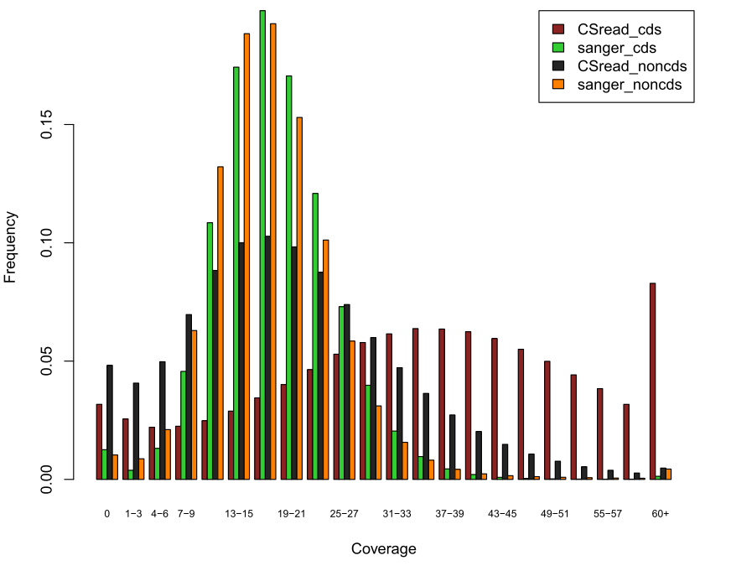
Distribution of coverage of the D.mel reference by the mapped CS reads and Sanger reads in CDS and noncoding regions (bin size 3 bp). In non-coding, the distribution of CS reads is comparable to Sanger reads. The larger variance in CDS may arise from the higher GC content in these regions.

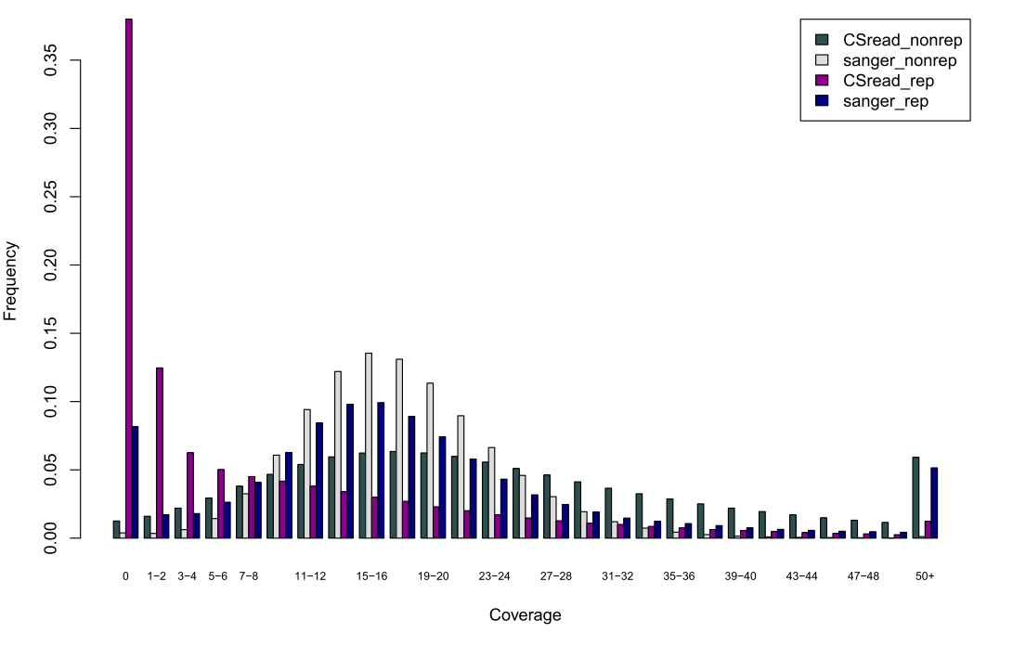
Distribution of coverage of the D.mel reference by the mapped CS reads and Sanger reads in repeat and non-repeat regions. About 60% of repeat regions could be covered by CS reads. The uncovered region is mainly due to a larger repeat that cannot be spanned by SR2 reads. The larger variance of CS reads for the distribution in repeat regions is due to the uneven distribution of number of reads sequenced in different repeat length, because a too much number of clustered reads are computationally time and space consuming, which are omitted in our current algorithm implementation.

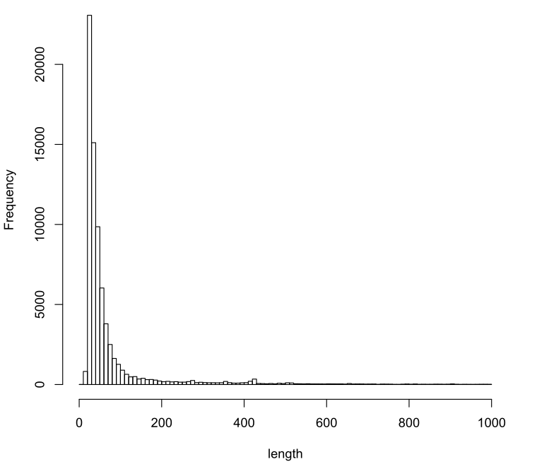
The reference repeat length (less than 100 bp were showed) distribution. Most repeats are of size shorter than 200 bp. Annotation was downloaded from UCSC.

