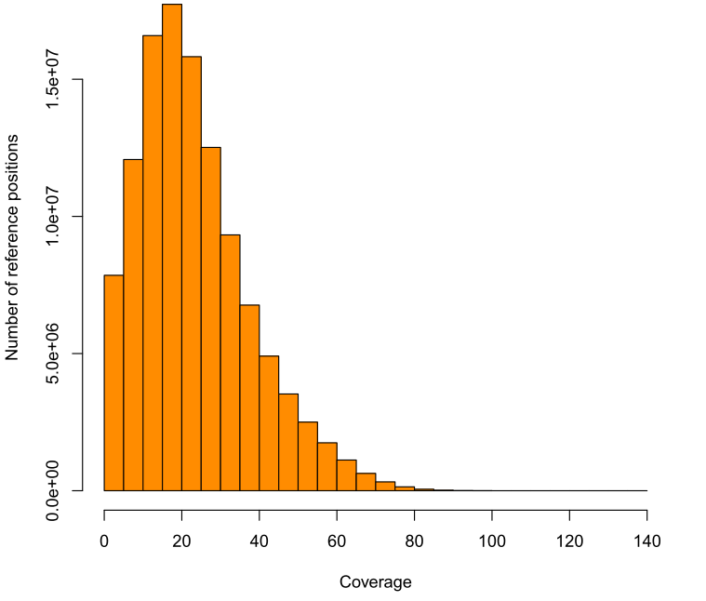
Coverage of the D.mel reference by the mapped CS reads (bin size 5 bp)

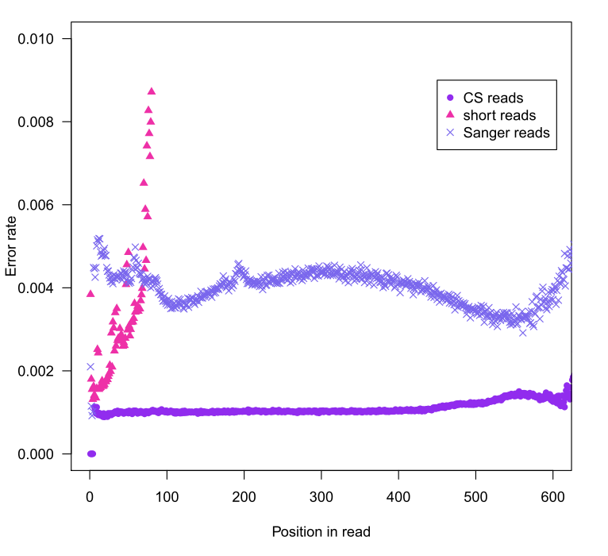
Error rate of base calls of CS reads, short reads, and Sanger reads as read positions.

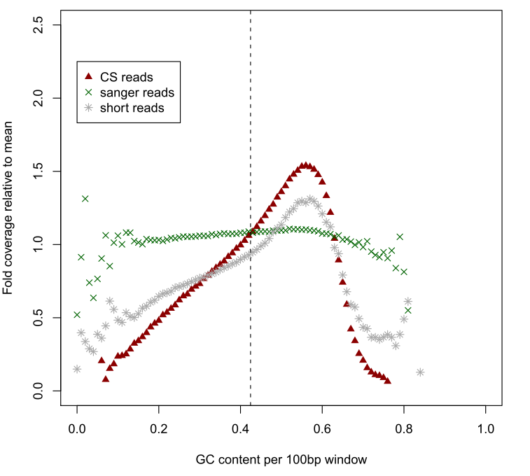
Average GC content per 100bp along the reference versus the corresponding relative coverage (normalized by the mean coverage) by the CS reads, the Sanger reads and the SR2 short reads.

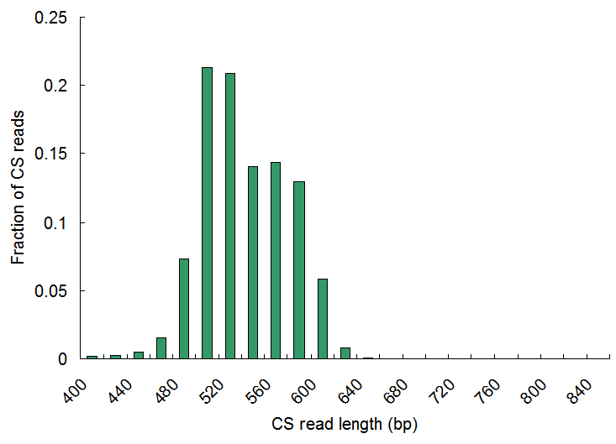

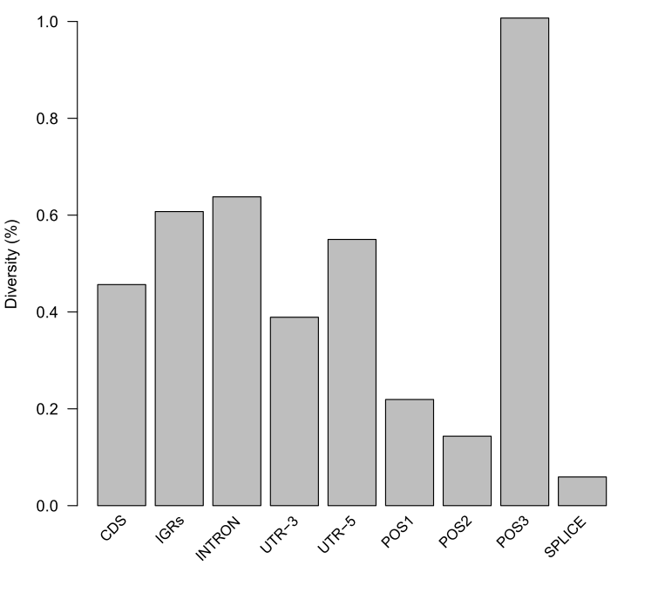
The diversity of sequenced w1118 D.mel line as different genomic regions. The results are concordant with previous papers [cite]. They are estimated by mapping the CS reads to the D.mel reference using bwasw.

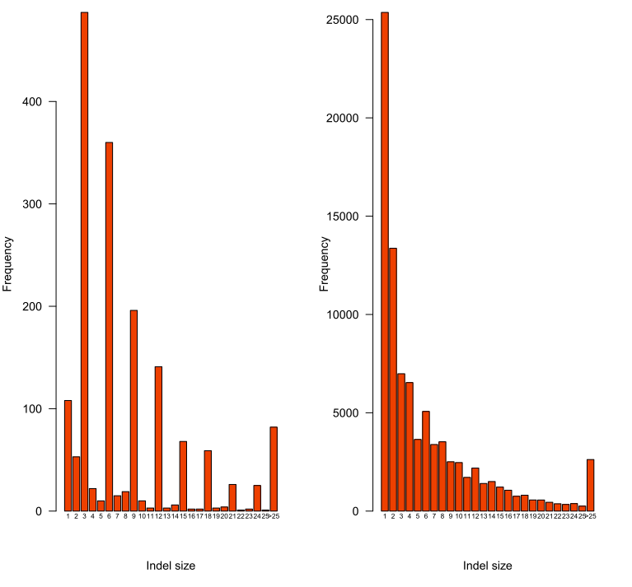
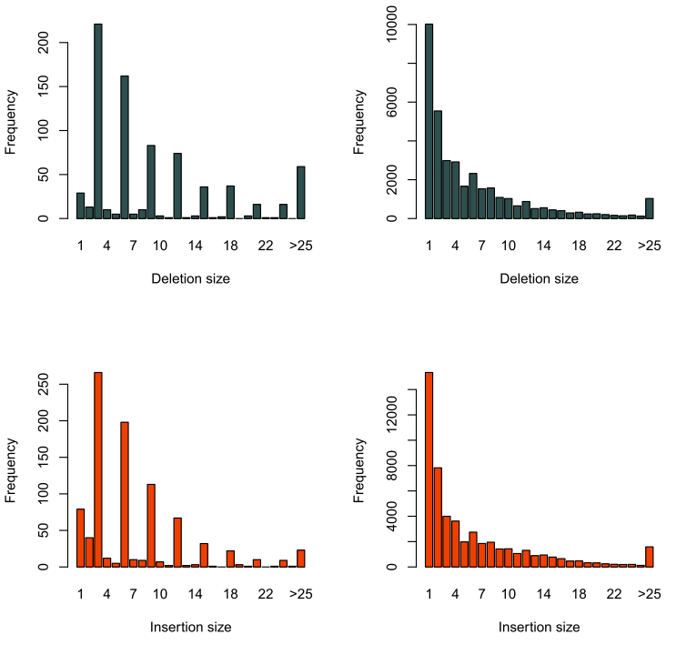
Deletion (darkslategray) and insertion (orangered) size distribution in CDS (left two) and noncoding (right two) regions. Deletions and insertions are called by Samtools after mapping CS reads to D.mel reference using bwasw.

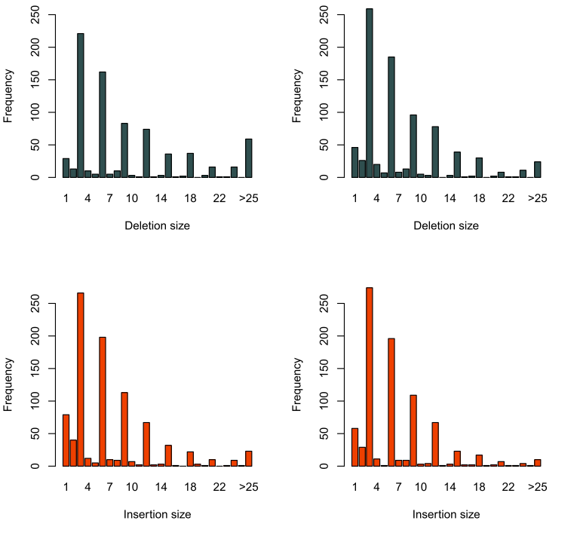
Comparison of deletion and insertion distribution in CDS region by CS reads (left two) and short SR reads (right two). Indels are called by Samtools after mapping CS reads by bwasw and short reads by bwa.

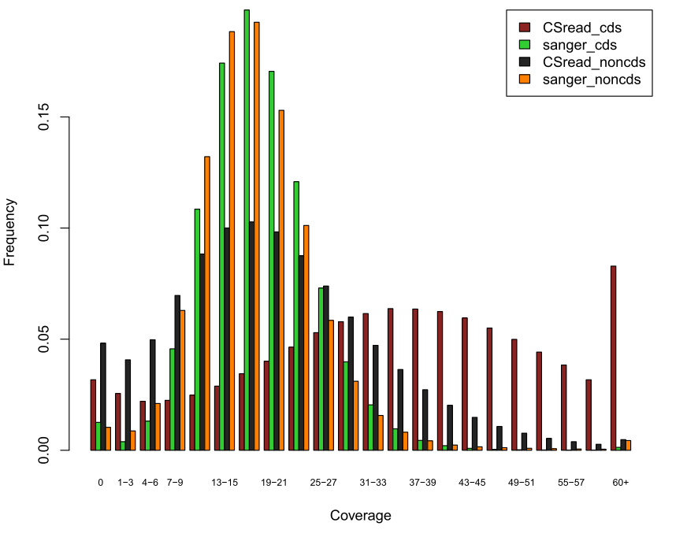
Distribution of coverage of the D.mel reference by the mapped CS reads and Sanger reads in CDS and noncoding regions (bin size 3 bp).

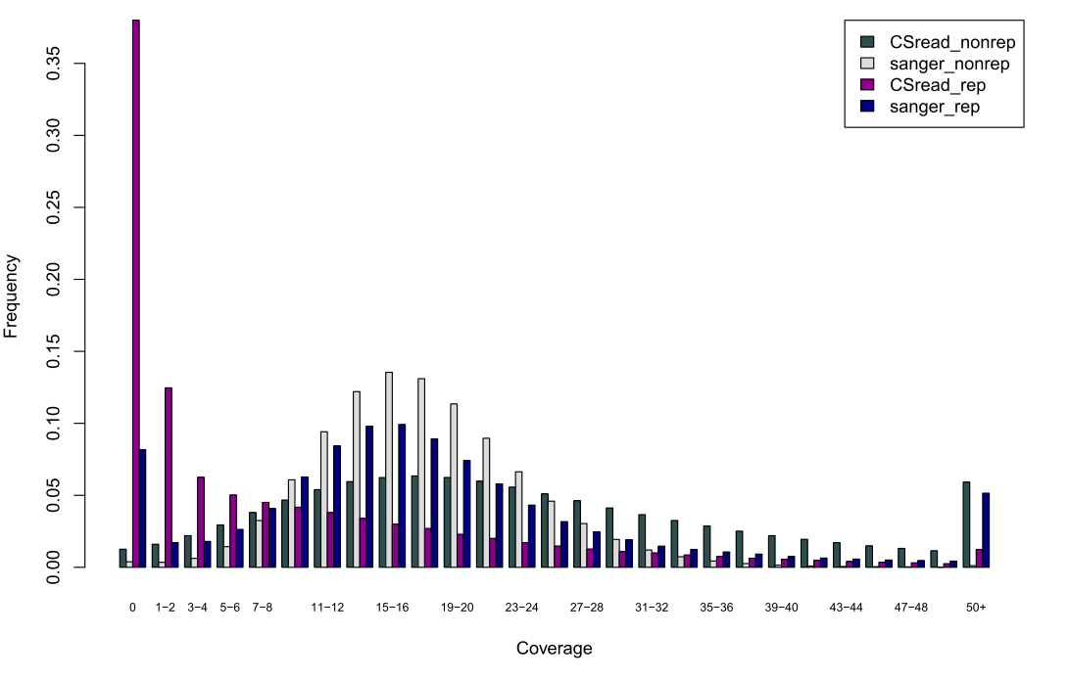
Distribution of coverage of the D.mel reference by the mapped CS reads and Sanger reads in repeat and non-repeat regions.

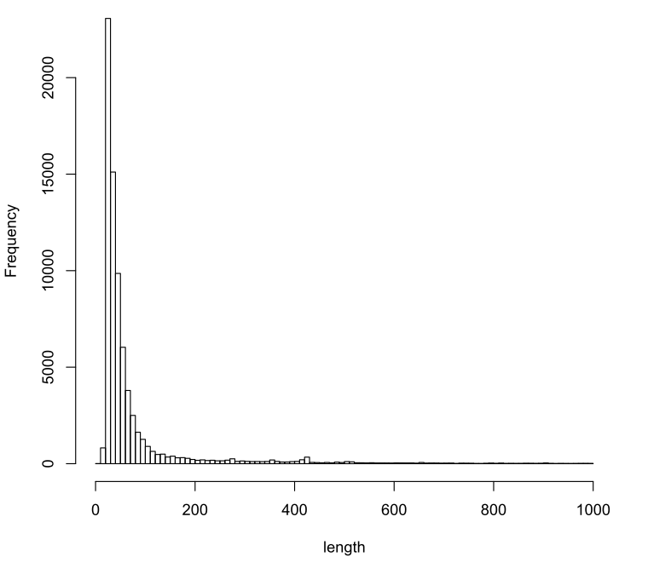
The reference repeat length (less than 100 bp were showed) distribution. Note that, most repeats are of size shorter than 200 bp. Annotation was downloaded from UCSC.

