EasyRecipes

To do and how to

1. Database Design: Given all the conditions backend is our main priority. Design database according to the ERD.
2. Programming Convention: We will be following the functional approach for this project due to it’s easy to implement characteristic.
3. Naming convention: For any end we will be using custom naming convention. This goes as follows
   1. Any class names for any container shall start with the term ‘container’ followed by ‘-‘ followed by the name according to the context.
   2. Any class names for any child shall contain the class name for that child’s parent container followed by the child’s contextual name or if it is another container then the same for container naming.
   3. Function and variable names will have to be descriptive so that from one read it is clear what the function or variables purpose is.
   4. Formatting shall be done automatically by prettier.
   5. Variables will be named using CamelCase.
   6. Class, id and file names should not contain any uppercase rather all lowercase.
   7. Snake_case will only be used on special purpose classes like a dedicated generalized class or variable.

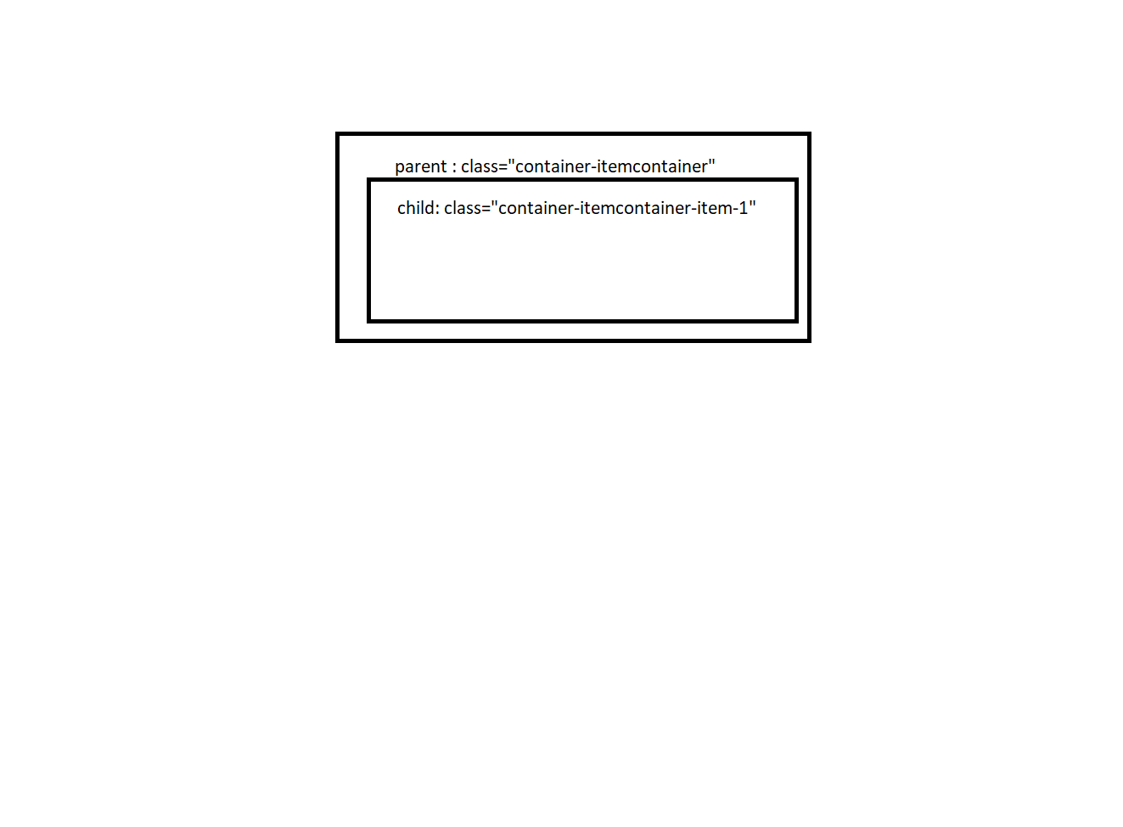

1. We will try our best to avoid any deeply nested coding structures and keep the code as readable as possible.