Daniela Mondello APD — Website Design Concepts
Homepage Visual Design Options
These are four alternative visual designs for the homepage — same content and copy as the current live site, just different colour, type and layout treatments to consider. Nothing here has been published; the live site at danielamondello.com.au is unchanged. If one of these directions appeals, we can rebuild the full site to match it.

Concept A — Citrus Bright
A fresh, energetic direction built around a hand-drawn citrus-slice motif — literally a cut orange, echoing the brief for something that evokes positive, vibrant feelings. Warm and a little playful, while staying clean and credible.
Palette
Cream #FFFBF2 · Orange #F0782E · Yellow #F7B733 · Deep leaf green #1F3D26 · Soft pith cream #FFF6E9
Typography
Fraunces (bold display, warm and characterful) paired with Work Sans for body copy
Signature element
An illustrated citrus-slice “sunburst” used in the hero and echoed as a small recurring dot motif throughout the page
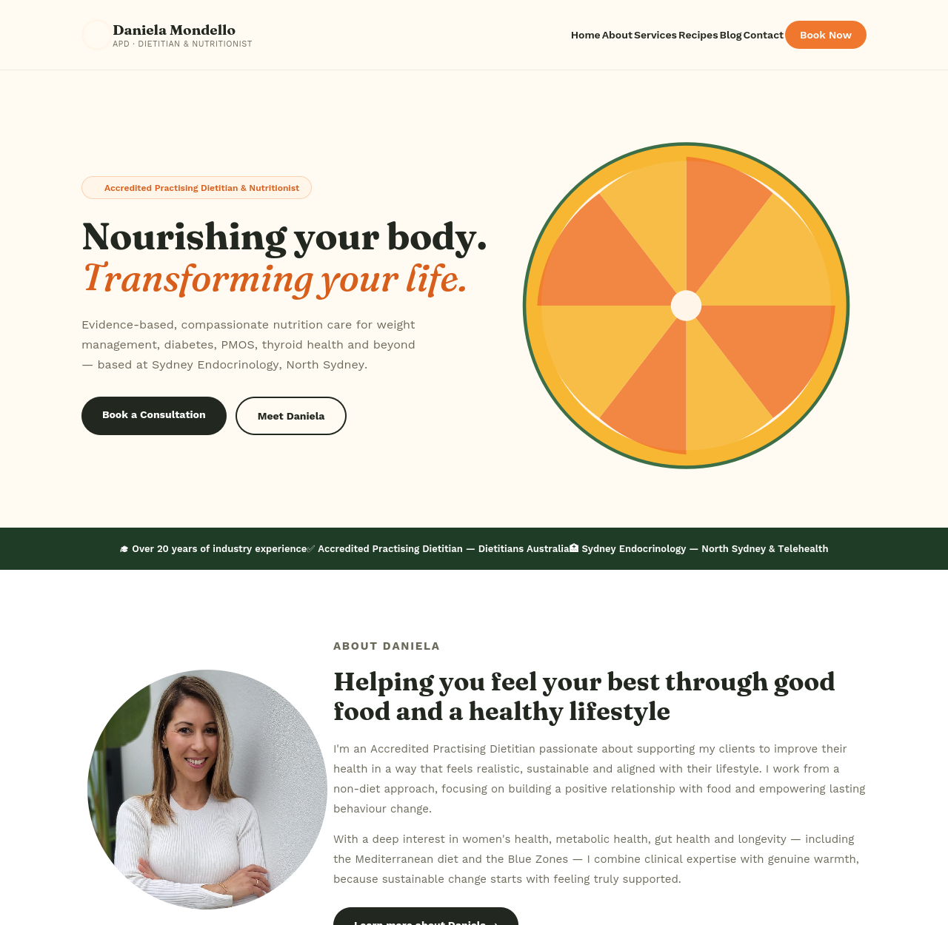
Top of page (hero through trust bar)
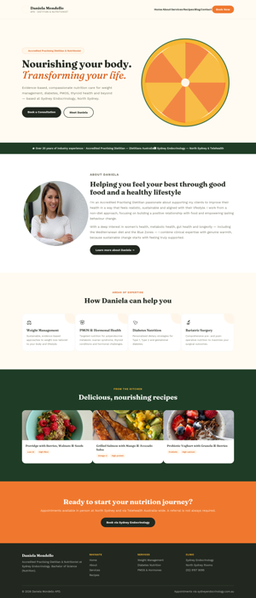
Full page preview

Concept B — Editorial
A sophisticated, magazine-style direction — muted stone tones, an italic serif display face, and hairline rules instead of boxes. Reads as premium and trustworthy, closer to a considered feature article than a typical clinic site.
Palette
Parchment #F8F6F0 · Stone #EDE8DE · Deep ink #20241E · Dusty clay #B4694F · Soft sage #748C73
Typography
Instrument Serif italic for headings, DM Sans for body — an editorial pairing with lots of breathing room
Signature element
A magazine-style pull-quote beside the hero headline, and numbered section markers (01, 02, 03…) used the way a print feature would
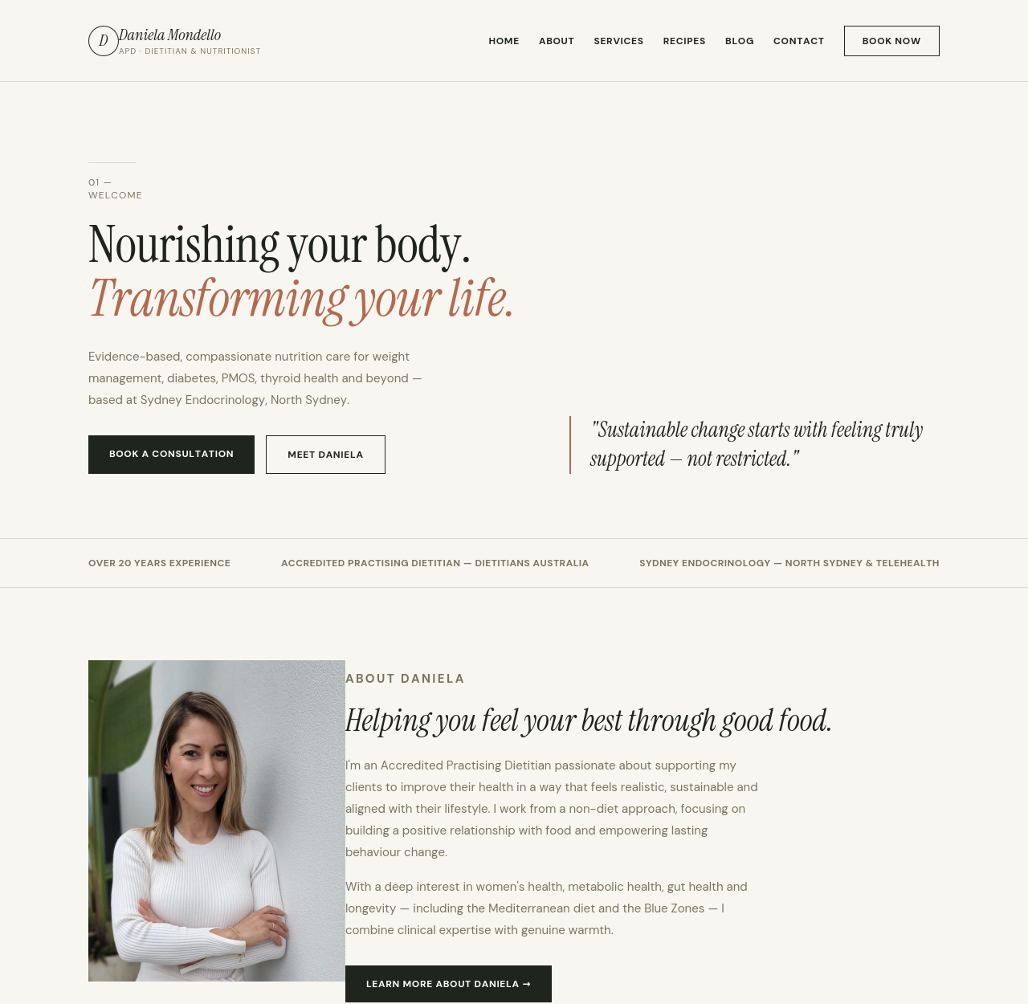
Top of page (hero through trust bar)
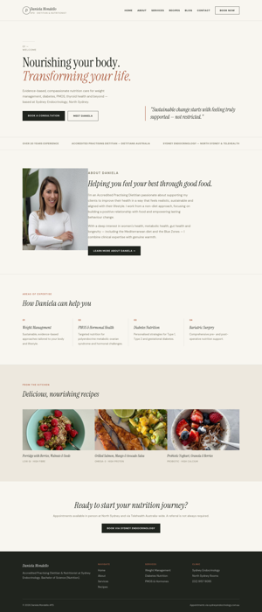
Full page preview

Concept C — Bold Modern
A high-contrast, contemporary direction aimed at a younger, energetic feel — dark sections, a single vivid coral accent, and a chunky all-caps display face. The most confident and “clinic-meets-startup” of the four options.
Palette
Near-black ink #14201A · Vivid coral #FF5A3C · Sage #5C8A6A · Warm paper #FAF8F3
Typography
Archivo Black for headings (bold, uppercase), Work Sans for body copy
Signature element
Full-bleed dark sections alternating with bright coral blocks, and a cropped hero photo with a dark gradient fade
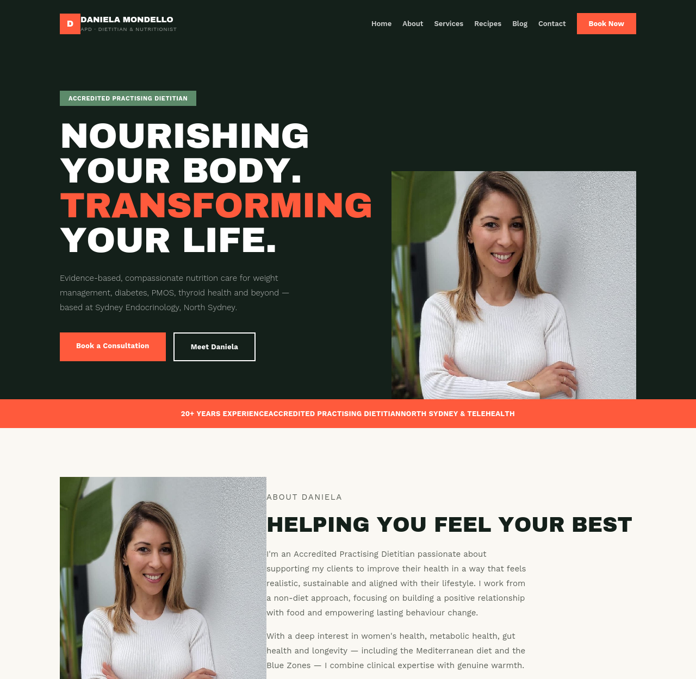
Top of page (hero through trust bar)
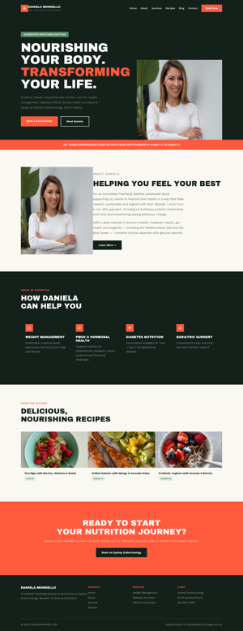
Full page preview

Concept D — Soft Botanical
A calm, gentle direction with rounded cards, a delicate serif, and small hand-drawn botanical line accents. The softest and most “wellness spa” of the four — leans into warmth and care rather than clinical confidence.
Palette
Blush cream #FBF3EC · Terracotta #D98B6C · Sage #7C9473 · Soft sage-tint #E8EDE3 · Warm ink #3A362F
Typography
Cormorant Garamond (elegant, romantic serif) for headings, DM Sans for body copy
Signature element
A rounded “card within a card” hero panel, a circular framed portrait, and delicate botanical sprig line-art details
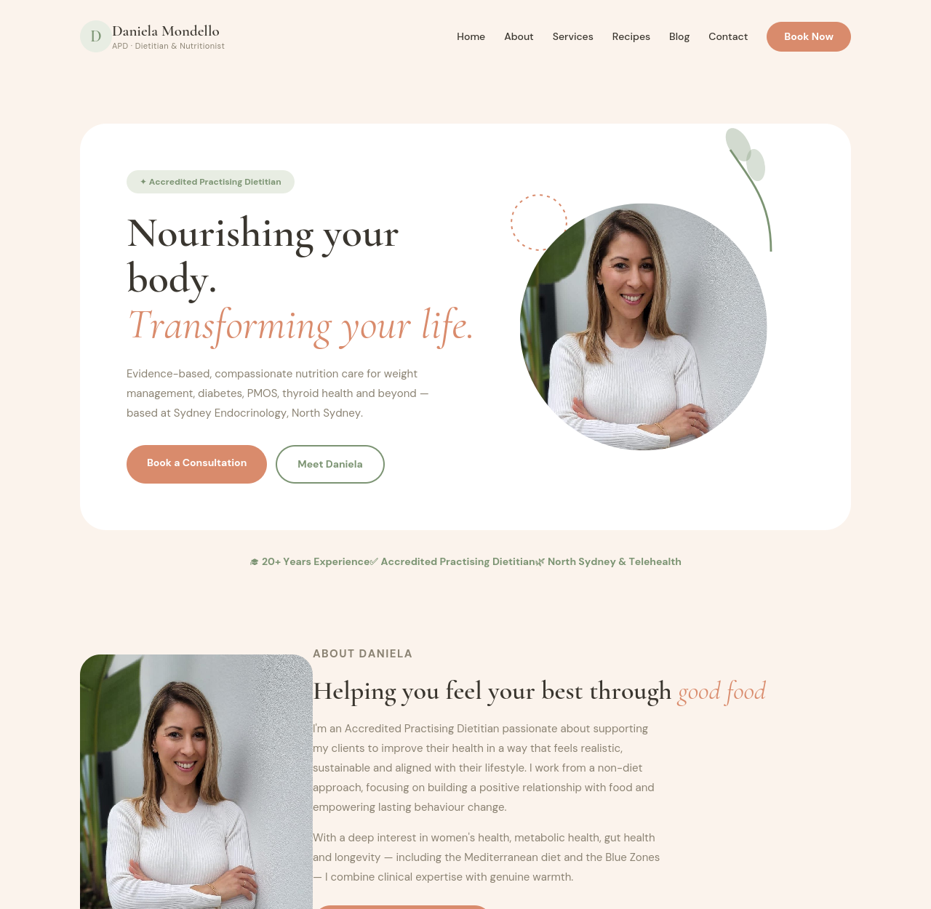
Top of page (hero through trust bar)
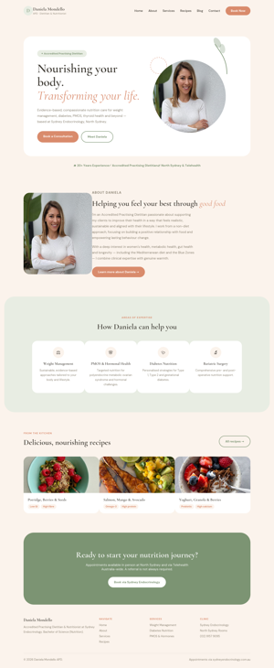
Full page preview

Prepared via Claude for danielamondello.com.au — for review only, not yet built or published.

