|  |  |
| --- | --- |
| ***Space Frequency***  ***Coordination Group*** | SFCG_Logo_2006_Color_FINAL_PNG.png |

# Recommendation SFCG 22-1R2

**FREQUENCY ASSIGNMENT GUIDELINES FOR COMMUNICATIONS IN THE MARS REGION**

The SFCG,

CONSIDERING

1. that a regional communication network can be expected in the foreseeable future at Mars as missions to Mars increase in number and variety;
2. that frequencies for direct communication between a spacecraft at Mars and an Earth station are provided in the existing allocations to the space research service (SRS);
3. that separate frequencies are needed in the Mars region for compatible local communications between a surface vehicle and an orbiter, between surface vehicles, and between orbiters;
4. that major criteria for allocating frequencies include RF compatibility, technology availability and performance, operation scenarios, cost to the missions, and ability to conduct testing and emergency support from the Earth;
5. that, without sufficient frequency separation, a Mars vehicle receiving signals from the Earth can be easily interfered by a signal transmitted by itself or by a local Mars vehicle, and a Mars vehicle transmitting to the Earth can easily interfere with a local receiver;
6. that lower frequency provides better SNR performance for a communication link between two vehicles using low gain broad beam antennas, such as between a rover and a low orbiter;
7. that higher frequency provides better performance between two vehicles employing high gain antennas, such as between a large lander and an orbiter with accurately pointed antennas;
8. that testing Mars local link radios with signals transmitted from an earth station is allowed only if it does not interfere with Earth-based radio systems operating in accordance with provisions of the Radio Regulations; and that techniques such as self-test on board are available to minimize the need for testing with Earth-based signals;
9. that the SFCG has resolved to provide assistance to member agencies in coordinating frequency assignment for deep space missions, including missions to Mars (see RES SFCG A21‑1);
10. that Mars missions need interoperable relay links to maintain communication with the Earth; and that such links in the UHF band have been defined in the CCSDS Proximity 1 standard;
11. that passive observations in space need to be protected to the extent provided in the Radio Regulations, particularly the quiet zone in the shielded area of the Moon.

RECOGNISING

1. that Mars local links must not interfere with the direct communication links between space and the Earth using frequencies provided in the ITU Radio Regulation;
2. that multiple frequency bands are needed for missions to meet various communications requirements and satisfy cost, mass and performance objectives.

RECOMMENDS

1. that agencies select frequencies from Table 1 for communications in the Mars region according to the specific applicability and precautions recommended in Table 2,
2. that testing Mars local links in flight with signals transmitted from an Earth station be minimized and strictly non-interfering to the Earth-based radio systems operating under the provisions of Radio Regulation;
3. that assignment of Mars local link frequencies be coordinated within the SFCG in accordance with RES A21-1.

Table 1: Summary of Frequency Bands for Communications in the Mars Region

|  |  |
| --- | --- |
| **Link** | **Frequency** |
| Space-to-Earth: | 2290-2300 MHz  8400-8450 MHz  31.8-32.3 GHz |
| Earth-to-space : | 2110-2120 MHz  7145-7190 MHz  34.2-34.7 GHz |
| Orbit-to-surface: | 435-450 MHz  2025-2110 MHz  7190-7235 MHz  14.5-15.35 GHz  22.55-23.55 GHz |
| Surface-to-orbit: | 390-405 MHz  2200-2300 MHz  8450-8500 MHz  16.6-17.1 GHz  25.5-27 GHz |
| Surface-to-surface: | 435-450 MHz  390-405 MHz  902-928 MHz  2025-2120 MHz  2200-2300 MHz |
| Orbit-to-orbit: | 435-450 MHz  390-405 MHz  2025-2120 MHz  2200-2300 MHz  7190-7235 MHz  8450-8500 MHz  22.55-23.55 GHz  25.5-27 GHz |
| Approach Navigation &  Atmosphere Radio Science: | 8400-8450 MHz |

Multiple frequency bands are provided in Table 1 for each communication link. Table 2 presents specific recommendations on the use of these bands, including the merits and precautions that should be considered before choosing a band.

Figure 1 presents a graphic illustration of the vehicles and communication links, and a conceptual future scenario with frequency bands chosen from Table 1.

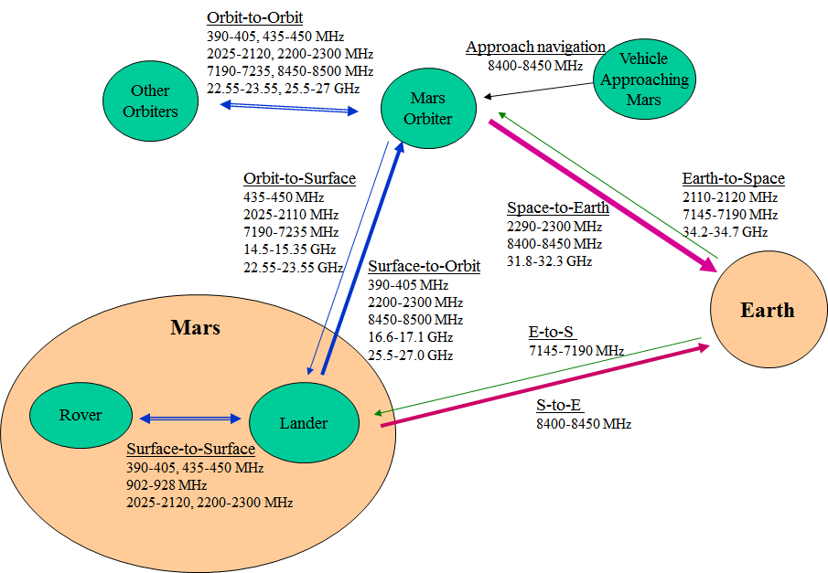

## Figure 1. Conceptual Mars Communications Frequency Scenario

|  |  |  |  |  |  |  |  |  |
| --- | --- | --- | --- | --- | --- | --- | --- | --- |
| *Table 2: Notes on the Mars Frequencies Recommended in Table 1* | | | | | | | | |
| General Comments: | | | | | | | | |
| 1. A few missions also carry S-Band S-to-E or E-to-S links. The use of the S-Band uplink is restricted by IMT2000. | | | | | | | | |
| 2. For all frequencies on this table, technology or equipment is available in the industry. | | | | | | | | |
| 3. Saturation or jamming refers to strong interfering signal overwhelming the receiver operating in the same band or adjacent band. For missions at Mars saturation happens only on the same vehicle; it is not likely between vehicles because of the large distance between them. | | | | | | | | |
| 4. Cross interference refers to interference from one vehicle to another. For Mars missions, such interference is not likely to occur in the adjacent band. | | | | | | | | |
|  | **Data Rate Performance** | **Accurate Antenna Pointing for Performance** | **Mass and Volume** | **Possible Equipment Sharing with Deep Space Space-Earth Links** | **Self-Interference with Deep Space Space-Earth Links** | **Cross Interference with Deep Space Space-Earth Links** | **Testing with Signals Transmitted from an Earth Station** | **Comments** |
| **1.0 Space-to-Earth (S-to-E)** |  |  |  |  |  |  |  | Per ITU-R RR |
| **2.0 Earth-to-Space (E-to-S)** |  |  |  |  |  |  |  | Per ITU-R RR |
| **3.0 Orbit-to-Surface (Command)** |  |  |  |  |  |  |  |  |
| 3.1 435-450 MHz | Best at low rate, with LGA | Not required with LGA | Large | none | None | None | Only on non-interfering basis (NIB) | For low rate links |
| 3.2 2025-2110 MHz | High rate, with MGA/HGA | Required with small beamwidth (A) | Small | If the lander carries an S-Band E-S receiver (Note: Deep space E-to-S is restricted by IMT2000) it is possible to modify the receiver to operate at extended frequencies. | If the orbiter carries S-Band E-S, the S-Band local link transmitter could saturate the S-Band E-S receiver unless there is adequate isolation. | None | Coordination is easier, as the band is allocated to SRS E-S, near Earth, where similar transmissions operate, although at lower power. | For high rate links. Can't share X-Band equipment. |
| 3.3 7190-7235 MHz | Higher rate, with HGA | Required with smaller beamwidth (1/4 A) | Smaller | Possible to modify the X-Band E-to-S receiver to operate at extended frequencies. | The orbiter X-Band local link transmitter could saturate an orbiter X-Band E-S receiver unless there is adequate isolation. | None | High power transmission in urban area is restricted to protect fixed and mobile services. A lesser problem in rural areas. | For high rate links. Can share X-Band equipment. Must avoid self-interference to the X-Band E-to-S link |
| 3.4 14.5-15.35 GHz | Higher rate than X-Band, with HGA | Required with even smaller angle (1/8 A) | Smaller than X-Band | None | None | None | NIB | For high rate links |
| 3.5 22.55-23.55 GHz | Very high rates, with HGA | Required with even smaller angle (1/12 A) | Smaller than Ku-Band | None | None | None | Coordination is easier, as the 22.55-23.15 GHz band is allocated to SRS E-S | For very high rate links |
| **4.0 Surface-to-Orbit (Telemetry)** |  |  |  |  |  |  |  |  |
| 4.1 390-405 MHz | see 3.1 | see 3.1 | see 3.1 | None | None | None | NIB | For low rate links |
| 4.2 2200-2290 MHz | see 3.2 | see 3.2 | see 3.2 | If the lander carriers S-Band S-E transmitter (2290-2300 MHz), it is possible to modify the transmitter to operate at extended frequencies. | An orbiter S-Band S-to-E transmitter could saturate the orbiter local link receiver unless there is adequate isolation. | None | NIB | For high rate links. Not as good as 4.4 which allows X-Band equipment sharing. |
| 4.3 2290-2300 MHz | see 3.2 | see 3.2 | see 3.2 | If the lander carries S-Band S-to-E transmitter, the local link can share the transmitter without modification. | An orbiter S-Band S-E link transmitter will saturate the orbiter S-Band local link receiver. | An orbiter with S-Band S-to-E link could interfere with the local link receiver if the latter is in its antenna beam. | NIB | For high rate links. Not as good as 4.4 which allows X-Band equipment sharing. |
| 4.4 8450-8500 MHz | see 3.3 | see 3.3 | see 3.3 | Possible to share a lander X-Band S-to-E transmitter modified to operate at extended frequencies. | Orbiter X-Band S-to-E transmitter could saturate the orbiter local link receiver unless there is adequate isolation. | None | NIB | For high rate links |
| 4.5 16.6-17.1 GHz | see 3.4 | see 3.4 | see 3.4 | None | None | None | Already allocated to SRS, deep space, E-to-S, secondary | For higher rate links |
| 4.6 25.5-27.0 GHz | see 3.4 | see 3.4 | see 3.4 | None | None | None | NIB | For very high rate links |
| **5.0 Surface-to-Surface** |  |  |  |  |  |  |  |  |
| 5.1 435-450 MHz and 390-405 MHz | see 3.1 | see 3.1 | see 3.1 | None | None | None | NIB | For low rate links |
| 5.2 902-928 MHz | see 3.1 | see 3.1 | see 3.1 | None | None | None | NIB | For low rate links |
| 5.3 2025-2110 MHz and 2200-2290 MHz | Low rate with LGA. Higher rate possible with MGA. | LGA does not require pointing. MGA does. | see 3.2 | If lander carries S-Band space-Earth equipment, it is possible to modify it to operate at extended frequencies. | If the lander uses S-Band for space-Earth links, there will be self-jamming between the space-Earth and the local links unless there is adequate isolation. | None | Testing in the 2025-2110 MHz band can be coordinated, as it is in SRS E-S band. Testing in the 2290-2300 MHz band is on NIB. | For higher rate link with line of sight. |
| 5.4 2110-2120 MHz and 2290-2300 MHz | see 5.2 | see 5.2 | see 3.2 | If a lander carries an S-Band space-Earth transmitter or receiver, it can be used for local link. | If the lander uses S-Band space-Earth links, there will be self-jamming between the space-Earth and the local links. | A third vehicle using S-Band space-Earth links may interfere with the local link receiver if it is near the local link receiver, or there is not enough antenna discrimination between the Earth link transmitter and the local link receiver. | The 2110-2120 MHz band is already allocated to SRS, deep space, E-to-S. Testing the 2290-2300 MHz is on NIB. | For higher rate link with line of sight. |

|  |  |  |  |  |  |  |  |  |
| --- | --- | --- | --- | --- | --- | --- | --- | --- |
| **6.0 Orbit-to-Orbit** |  |  |  |  |  |  |  |  |
| 6.1 435-450 MHz and 390-405 MHz | see 3.1 | see 3.1 | see 3.1 | none | none | None | NIB | For low rate links |
| 6.2 2025-2110 MHz and 2200-2290 MHz | see 3.2 | see 3.2 | see 3.2 | If an orbiter uses S-Band space-Earth link, it is possible to modify space-Earth link equipment to operate at extended frequencies. | If an orbiter uses S-Band space-Earth links, there will be self-jamming between the space-Earth and the local links unless there is adequate isolation. | None | Testing in the 2025-2110 MHz band can be coordinated, as it is in SRS E-S band. Testing in the 2290-2300 MHz band is on NIB. | For high rate links. Less likely to share equipment. |
| 6.3 2110-2120 MHz and 2290-2300 MHz | see 3.2 | see 3.2 | see 3.2 | If orbiter carries an S-Band space-Earth link, the local link can share the same equipment. | If one vehicle uses S-Band space-Earth links, there will be self-jamming between the space-Earth and the local links on the vehicle. | see 5.3 | The 2110-2120 MHz band is already allocated to SRS, deep space, E-to-S. Testing the 2290-2300 MHz is on NIB. | For high rate links. Can not share equipment with X-Band S-E links. |
| 6.4 7190-7235 MHz and 8450-8500 MHz | see 3.3 | see 3.3 | see 3.3 | Possible to modify the X-Band space-Earth link equipment to operate in the extended frequency range. | The X-Band transmitter could saturate the X-Band receiver on the same vehicle unless there is adequate isolation. | None | Testing in the 7190-7235 MHz band can be coordinated, as it is in SRS band. Testing in the 8450-8500 MHz band is on NIB. | For high rate links. Possible to share equipment with X-Band S-E link. |
| 6.5 22.55-23.55 GHz and 25.5-27.0 GHz | see 3.5 | see 3.5 | see 3.5 | none | none | None | Testing in the 22.55-23.15 GHz band can be coordinated, as it is in SRS band. Testing in the 23.15-23.55 and 25.5-27.0 GHz band is on NIB. | For very high rate links |

|  |  |  |  |  |  |  |  |  |
| --- | --- | --- | --- | --- | --- | --- | --- | --- |
| **7.0 Mars Approach Navigation and Atmosphere Radio Science** |  |  |  |  |  |  |  |  |
| 7.1 8400-8450 MHz | Radio metric measurement | Accurate pointing as existing on spacecraft for Earth link. | see 3.3 | Sharing equipment with the X-Band S-to-E transmitter | Orbiter doing approach navigation should not operate the Earth link at the same time. Orbiter X-Band S-to-E transmitter will saturate the orbiter local link receiver. However, no simultaneous operation of the Earth link with local link is planned for approach navigation. | Cross interference will not occur with approach navigation. It may happen with occultation radio science when receiver is in the beam of another orbiter transmitting the S-E link. | NIB |  |