“Venera-D” Risks summary

|  |  |  |  |  |  |  |
| --- | --- | --- | --- | --- | --- | --- |
| **Likelihood** | 5 |  |  |  |  |  |
| 4 |  |  |  |  |  |
| 3 |  |  |  |  |  |
| 2 |  |  |  |  |  |
| 1 |  |  |  |  |  |
|  | 1 | 2 | 3 | 4 | 5 |
|  | **Consequences** | | | | | |

|  |  |
| --- | --- |
| **Trend:**   * ⇓ Decreasing L × C; * ⇑ Increasing L × C; * ⇒ Unchanged; * ♦ New since las period; * ☆ Escalated. | **Actions:**   * Watch. * Mitigate. * Escalate. |

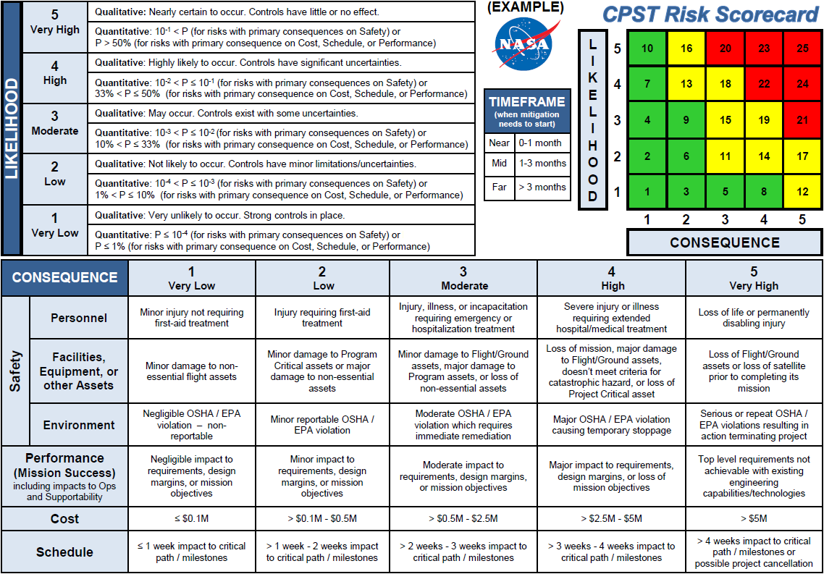

| **№** | | **L × C** | **Trend** | **Risks description** | **Owner** |
| --- | --- | --- | --- | --- | --- |
|  | VD-RS-001 | **1 × 3** | ♦ |  |  |
|  | VD-RS-002 | **1 × 4** | ♦ |  |  |
|  | VD-RS-003 | **2 × 4** | ♦ |  |  |
|  | VD-RS-004 | **5 × 2** | ♦ |  |  |
|  | VD-RS-005 | **4 × 4** | ♦ |  |  |