“Venera-D” Risks summary

|  |  |  |  |  |  |  |
| --- | --- | --- | --- | --- | --- | --- |
| **Likelihood** | 5 |  | **004** | **007** |  |  |
| 4 |  |  | **011, 015, 024** | **005, 006, 008** |  |
| 3 |  | **021** | **009, 010, 016, 018, 019, 020** | **012, 022, 023** |  |
| 2 |  |  |  | **003, 013, 014, 017** |  |
| 1 |  |  | **001** | **002** |  |
|  | 1 | 2 | 3 | 4 | 5 |
|  | **Consequences** | | | | | |

|  |  |
| --- | --- |
| **Trend:**   * ⇓ Decreasing L × C; * ⇑ Increasing L × C; * ⇒ Unchanged; * ♦ New since las period; * ☆ Escalated. | **Actions:**   * Watch. * Mitigate. * Escalate. |

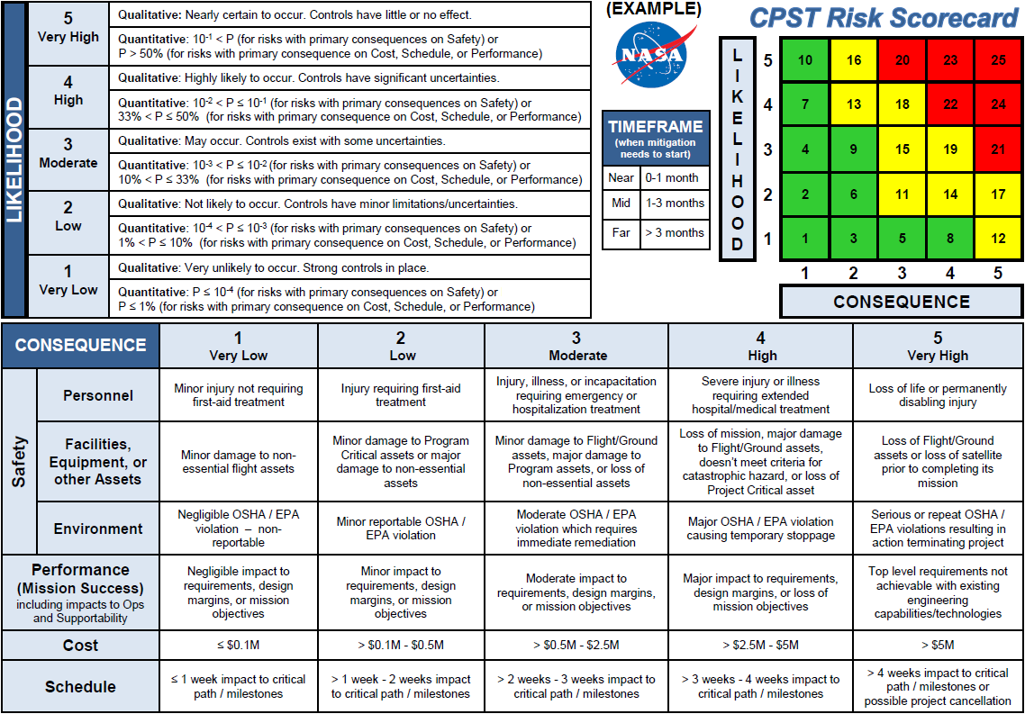

| **№** | | **L × C** | **Trend** | **Risks description** | **Owner** |
| --- | --- | --- | --- | --- | --- |
|  | VD-RS-001 | **1 × 3** | ♦ | Angara-А5 with KVTK may not be ready for 2026 . Watch. | *A. Martynov* |
|  | VD-RS-002 | **1 × 4** | ♦ | Ka–band russian ground stations may not be ready for 2026 . Watch. | *A. Martynov* |
|  | VD-RS-003 | **2 × 4** | ♦ | Lander’s medium-gain antenna may not be ready with other components of SC. Analysis study is needed at the phase A or earlier. Watch. | *A. Martynov* |
|  | VD-RS-004 | **5 × 2** | ♦ | Composition, specifications and cyclogram of payload are not fully specified. Mitigate. | *J. Hall* |
|  | VD-RS-005 | **4 × 4** | ♦ | The operational condition of LAV high–pressure chamber is not confirmed. Mitigate. | *A. Martynov* |

**Table of proposed risks**

| **№** | | **L × C** | **Trend** | **Description**  **of proposed risks** | **Owner** |
| --- | --- | --- | --- | --- | --- |
|  |  |  |  | The lander science payload is not well defined to achieve the desired science. Most of the proposed science payload was developed for missions with completely different requirements and operating condition. Mitigation: increase the effort to demonstrate the ability to achieve the desired science under expected conditions on the surface. | *T. Economou* |
|  |  |  |  | The number of considered science instruments on past Soviet and Russian space missions is much larger than on similar NASA missions. As a consequence of this there is not sufficient time and funding for proper qualification and testing. Mitigation: at some time (sooner than latter) start to limit the number of considered science lander payload and build a realistic mission. | *T. Economou* |
|  |  |  |  | New VAMP size and accommodation in fairing/SC are not well defined. Mitigate. | *S. Limaye* |