WMO Weather interpretation codes (WW)

Code | Description | Icon
0 | Clear sky | 
1, 2, 3 | Mainly clear, partly cloudy, and overcast |  |  | 
45, 48 | Fog and depositing rime fog | 
51, 53, 55 | Drizzle: Light, moderate, and dense intensity | 
56, 57 | Freezing Drizzle: Light and dense intensity | 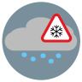
61, 63, 65 | Rain: Slight, moderate and heavy intensity |  |  | 
66, 67 | Freezing Rain: Light and heavy intensity | 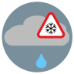 | 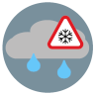
71, 73, 75 | Snow fall: Slight, moderate, and heavy intensity |  |  | 
77 | Snow grains
80, 81, 82 | Rain showers: Slight, moderate, and violent |  | 
85, 86 | Snow showers slight and heavy |  | 
95 * | Thunderstorm: Slight or moderate | 
96, 99 * | Thunderstorm with slight and heavy hail | 

(*) Thunderstorm forecast with hail is only available in Central Europe

