XH-YJ38-LJ-001-A0 Di Pan Fang Tong A - Model Analysis Report

Overview / Gai Lan
File | XH-YJ38-LJ-001-A0-底盘方通A.STEP
Model Type | 方通结构
Description | This is a square tube (fang tong) structural component. It is a long hollow rectangular profile with circular mounting holes and a central rectangular slot along its length.
Overall Size | 1101.0 x 50.0 x 40.0 mm

Three-View Drawing / San Shi Tu
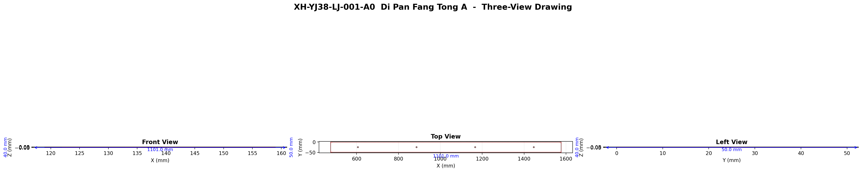

Topology / Tuo Pu Xin Xi
Type | Count
Vertices (顶点) | 384
Edges (边) | 192
Wires (线) | 40
Faces (面) | 32
Shells (壳) | 1
Solids (实体) | 1

Geometry Types / Ji He Lei Xing

Face Types
Face Type | Count
圆柱面 | 20
平面 | 12

Edge Types
Edge Type | Count
直线 | 112
圆 | 80

Dimensions / Chi Cun Xin Xi
X Size | 1101.000 mm
Y Size | 50.000 mm
Z Size | 40.000 mm
Volume | 527241.06 mm³
Surface Area | 354003.22 mm²
Center of Mass | (1026.420, -25.008, 138.990) mm

Hole Features / Kong Te Zheng
Total: 8, Regular: 8, Irregular: 0
# | Classification | Dia.(mm) | Rad.(mm) | Slot L(mm) | Slot W(mm) | Note
1 | 规则孔（多段圆弧） | 5.500 | 2.750 | - | - | (886.4, -25.0, 156.0)
2 | 规则孔（多段圆弧） | 5.500 | 2.750 | - | - | (1166.4, -25.0, 156.0)
3 | 规则孔（多段圆弧） | 5.500 | 2.750 | - | - | (1446.4, -25.0, 156.0)
4 | 规则孔（矩形/方形槽） | - | - | 1101.000 | 38.000 | -
5 | 规则孔（多段圆弧） | 5.500 | 2.750 | - | - | (886.4, -25.0, 159.0)
6 | 规则孔（多段圆弧） | 5.500 | 2.750 | - | - | (1166.4, -25.0, 159.0)
7 | 规则孔（多段圆弧） | 5.500 | 2.750 | - | - | (1446.4, -25.0, 159.0)
8 | 规则孔（矩形/方形槽） | - | - | 1101.000 | 38.000 | -

Tube Structures / Guan Zhuang Jie Gou
# | OD(mm) | ID(mm) | Wall(mm) | Length(mm)
1 | 12.000 mm | 6.000 mm | 3.000 mm | 1101.000 mm
2 | 12.000 mm | 6.000 mm | 3.000 mm | 1101.000 mm
3 | 12.000 mm | 6.000 mm | 3.000 mm | 1101.000 mm

Square Tube / Fang Tong Jie Gou
Cross-section 1: 1101.000 mm x 37.000 mm
Cross-section 2: 1101.000 mm x 47.000 mm
Cross-section 3: 37.000 mm x 47.000 mm

Wall Thickness / Bi Hou Xin Xi
# | Type | Thickness(mm)
1 | 管状结构 | 3.000 mm
2 | 管状结构 | 3.000 mm
3 | 管状结构 | 3.000 mm
4 | 内外面距离 | 3.000 mm
5 | 内外面距离 | 3.000 mm
6 | 内外面距离 | 3.000 mm

