Adapting Geospatial Foundation Models for Urban Socioeconomic Prediction:
A Paired Multimodal Evaluation on CityLens
Anonymous Authors — Under Review
Conference on Computer Vision and Pattern Recognition (CVPR-style)

Abstract
Predicting neighbourhood-scale socioeconomic and urban indicators from remote sensing is often studied with inconsistent evaluation protocols — different train/validation splits across modalities, single-seed reporting, and weak baselines — making it difficult to determine whether performance gains stem from model quality or evaluation variance. We study the paired, modality-aligned evaluation of geospatial foundation models and strong CNN/ViT baselines on CityLens global benchmarks, combining RGB-to-multispectral adaptation for Prithvi-EO-2.0 with parameter-efficient fine-tuning via LoRA. For each task and random seed we fix a shared validation cohort on the street-available subset so that satellite-only, street-only, and fusion models are scored on identical held-out region IDs.
Our seed-42 results show that prithvi_rgb_lora leads all sane satellite baselines on all four tasks (GDP, health access, building height, population). Satellite Prithvi remains the strongest modality on GDP and health access; DINOv2 street + late fusion edges satellite only on building height. The population task remains unsolved across all branches. We document a catastrophic baseline failure (ResNet-50 satellite on GDP: R² ≈ −4.0), structured failure analysis, and explainability limits, providing a transparent protocol for comparing Earth-observation foundation models and generic vision encoders on spatial regression tasks.

1. Introduction
Cities generate vast quantities of geospatial and street-level imagery. Policymakers and researchers increasingly seek scalable measurement of wealth, health access, building morphology, and population density — outcomes that are expensive or slow to measure via traditional surveys. Remote sensing and street-view machine learning promise wall-to-wall coverage where surveys are sparse, but generalisation and fair comparison across methods remain open problems.
Earth observation (EO) foundation models such as IBM-NASA Prithvi-EO-2.0 leverage large-scale multispectral pretraining on harmonised Landsat/Sentinel-style data and achieve strong transfer on segmentation and classification tasks. In parallel, general vision transformers — DINOv2 and CLIP — provide strong features for natural images without any domain-specific inductive bias. However, regression on joint satellite and street-view benchmarks is frequently reported with modality-specific splits or single random seeds, inflating apparent differences between methods and making reproducible comparison difficult.

The Core Gap
Despite progress on EO model pretraining, paired comparison under identical held-out geographies and variance-aware reporting has received little attention on multi-task urban regression benchmarks. This absence makes it impossible to cleanly attribute performance differences to modality-level signal rather than to evaluation noise.

Contributions
- Shared-split evaluation protocol — we fix validation IDs on the street-available cohort across satellite, street, and fusion branches using explicit split JSON files, eliminating the confound of modality-specific validation sets.
- Comparative model suite — Prithvi-EO-v2 with LoRA, ResNet-50 and DINOv2 satellite encoders, and ResNet-50 / CLIP / DINOv2 street encoders with mean or attention multi-view pooling.
- Full quantitative snapshot — R², RMSE, MAE for every configuration at seed 42 plus structured failure analysis documenting catastrophic and partial failures.
- Reproducibility and transparency — multi-seed stability requirements, spatial leakage, label noise, and fairness limitations documented; all seed-42 results inline for full traceability.

2. Dataset — CityLens
CityLens (Tianhui-Liu et al., 2025) is a global, city-scale multi-task benchmark designed to evaluate how well machine learning models can predict urban socioeconomic and built-environment indicators from visual imagery alone. It is, to our knowledge, the only publicly available benchmark that pairs satellite and street-view imagery for the same geographic locations across a diverse global set of cities with multiple scalar regression targets.

2.1 Structure and Provenance
The dataset is distributed via Hugging Face (Tianhui-Liu/CityLens-Data) and organised into four directories:
- Benchmark/ — one JSON task file per target (e.g., gdp_all.json). Each record contains: a satellite image path, a list of street-view image paths (up to 10), the scalar reference target, a normalised reference value, and lat/lon coordinates.
- satellite_image/ — single-band-stacked RGB PNG for each location, resized to a canonical resolution. One patch per location; the patch represents a neighbourhood-scale overhead view.
- street_view_image/ — ground-level RGB photographs taken from the street at or near the location. Variable count per location (1–10). Images were collected at a range of viewing angles and times.
- Dataset/ — auxiliary files including the full task registry and image URL manifests used for API-based evaluation.
The benchmark covers cities across Africa, Asia, Europe, North America, South America, and Oceania, providing geographic diversity that is rare in urban prediction datasets. Targets are derived from official statistics, global databases, and composite indices; exact provenance for each target is documented in the CityLens paper (arXiv:2506.00530).

2.2 Tasks and Target Variables
CityLens defines five global regression tasks. We study four in our main experiments; the fifth (carbon) is noted as an extension pending a locked evaluation protocol:

Task key | Full name | Unit / scale | Nature of task | Epoch budget (this work)
gdp | GDP proxy | Log-scale economic output | Macro-economic signal; heavy-tailed distribution | 20
acc2health | Health access | Continuous score (0–100+) | Health infrastructure proximity index | 30
build_height | Building height | Mean height in metres | Built-environment morphology; strong visual signal | 30
pop | Population density | Count proxy | Weakly observable from RGB; hardest task | 5
carbon | Carbon footprint | Continuous | Extension task; not locked in this work | —

The heavy-tailed nature of GDP is important: a small number of cities with very high economic output dominate the MSE loss. We apply a log1p target transform during training and invert it before computing validation metrics, so all reported R² and RMSE values are in the original (raw) target space.

2.3 Street-View Data Path Reconciliation
During street/fusion pipeline activation we encountered a critical data issue: benchmark JSON files used legacy absolute paths from a different compute environment, and local street_view_image/ filenames used a different ID namespace. The result was zero valid street records loaded even when images existed on disk. We resolved this by coordinate-based (lat/lon) remapping of each Benchmark/{task}_all.json, writing a corrected version with local relative paths. Post-reconciliation street-available subset sizes are shown in Figure 5 and repeated here:

Task | Satellite pool (approx.) | Street-enabled subset | Fraction with street views
gdp | ~497 | 429 | 86%
acc2health | ~507 | 440 | 87%
build_height | ~463 | 398 | 86%
pop | ~470 | 402 | 86%

Note: Street and fusion results are computed exclusively on the street-enabled subset. Satellite-only results may use a larger pool. Cross-branch comparisons are therefore indicative rather than strictly paired until shared-split reruns are complete (see §3.5).

2.4 Dataset Figure
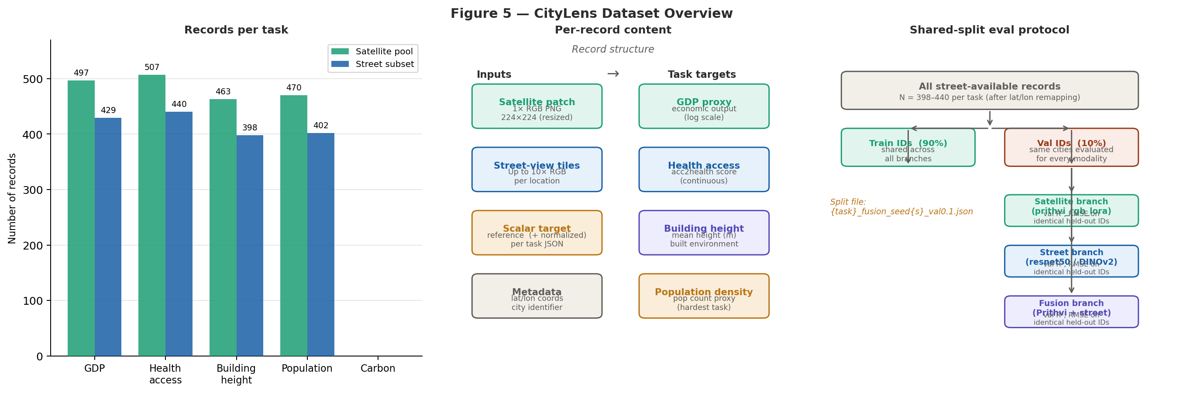
Figure 5. CityLens dataset overview. Left: record counts per task for the satellite pool and street-enabled subset. Centre: per-record content structure — each record contains one satellite patch, up to 10 street-view tiles, a scalar target, and lat/lon metadata. Right: the shared-split evaluation protocol that ensures identical validation region IDs across all three branches.

3. Related Work

3.1 Geospatial Foundation Models
Prithvi-EO 2.0 (IBM, NASA, collaborators) is a Vision Transformer-based model pretrained on large multitemporal, multispectral Earth observation data using 3D spatiotemporal patch embeddings and a masked autoencoder objective. Open weights are available via Hugging Face (ibm-nasageospatial/Prithvi-EO-2.0-*). Its strength lies in strong priors for land surface and seasonality. The limitation for our setting is that CityLens provides only RGB, requiring band alignment and efficient adaptation for fair city-scale regression.

3.2 Self-Supervised and Vision-Language Models
DINOv2 learns discriminative ViT features from large curated web-scale data without labels, providing robust off-the-shelf encoders for both RGB street and satellite crops. CLIP aligns image and text towers for zero-shot transfer. Their strength is versatility; their weakness for our setting is the absence of multispectral inductive bias.

3.3 Parameter-Efficient Fine-Tuning
LoRA (Hu et al., 2022) injects trainable low-rank matrices into selected linear layers of a frozen pre-trained backbone. Given that CityLens provides hundreds rather than millions of training examples per task, LoRA is particularly appropriate: it prevents catastrophic forgetting while adapting the large Prithvi backbone to the new regression objective.

3.4 Spatial Regression and Urban Remote Sensing
Prior work demonstrates that both overhead and street-level imagery correlate with income, safety perceptions, and built form. Persistent methodological weaknesses are split leakage from spatial autocorrelation, inconsistent cohorts across modalities, and single-seed results. Our work directly addresses the modality-split and single-seed issues.

4. Methodology

4.1 Problem Formulation
For task t, let the dataset be D_t = {(x_i^sat, {x_i,v^str}_{v=1}^N_i, y_i)}_{i=1}^N where y_i is the scalar regression target. For street-cohort experiments, we restrict to indices where street-view images are available. A split assigns IDs to training and validation sets, shared across all branches b ∈ {satellite, street, fusion}.
We minimise MSE on log1p-transformed targets during training and compute R² and RMSE in the raw target space on the validation split. The log1p transform is inverted before scoring.

4.2 Full Pipeline Architecture
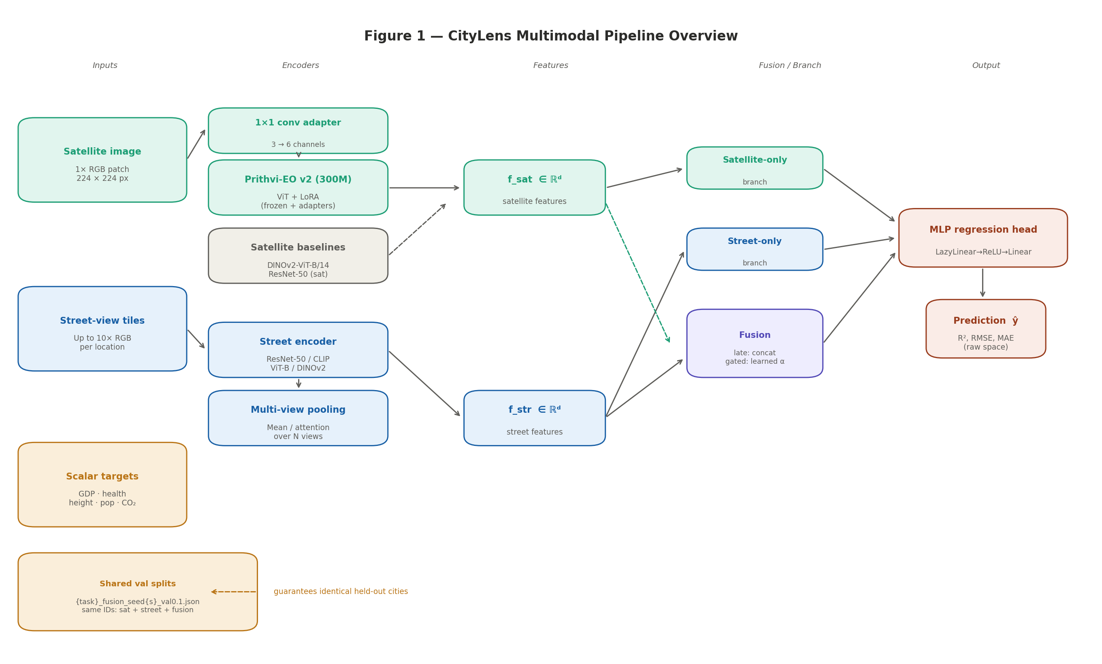
Figure 1. Full CityLens multimodal pipeline. Satellite and street-view images enter separate encoder towers. Features are extracted and routed to one of three branches: satellite-only, street-only, or fusion (late or gated). All branches share the same MLP regression head. A shared split JSON file ensures identical validation IDs across all three branches, enabling fair cross-modal comparison.

4.3 Satellite Encoders

4.3.1 Prithvi-EO v2 with RGB Adaptation (prithvi_rgb_lora)
Prithvi-EO-2.x is a ViT-based encoder with multispectral, multitemporal tokenisation. It expects 5D tensors (B, C, T, H, W) with six spectral channels. Since CityLens provides only RGB, we introduce a learnable 1×1 convolutional adapter that maps 3 input channels to 6, aligned to Prithvi's band order (Blue, Green, Red, NIR-narrow, SWIR-1, SWIR-2). A single time frame (T=1) is used for the static CityLens patches. We apply PEFT LoRA to the attention linear layers (fused QKV and output projection), keeping all backbone weights frozen. Only the 1×1 adapter, LoRA matrices, and regression head are trained.
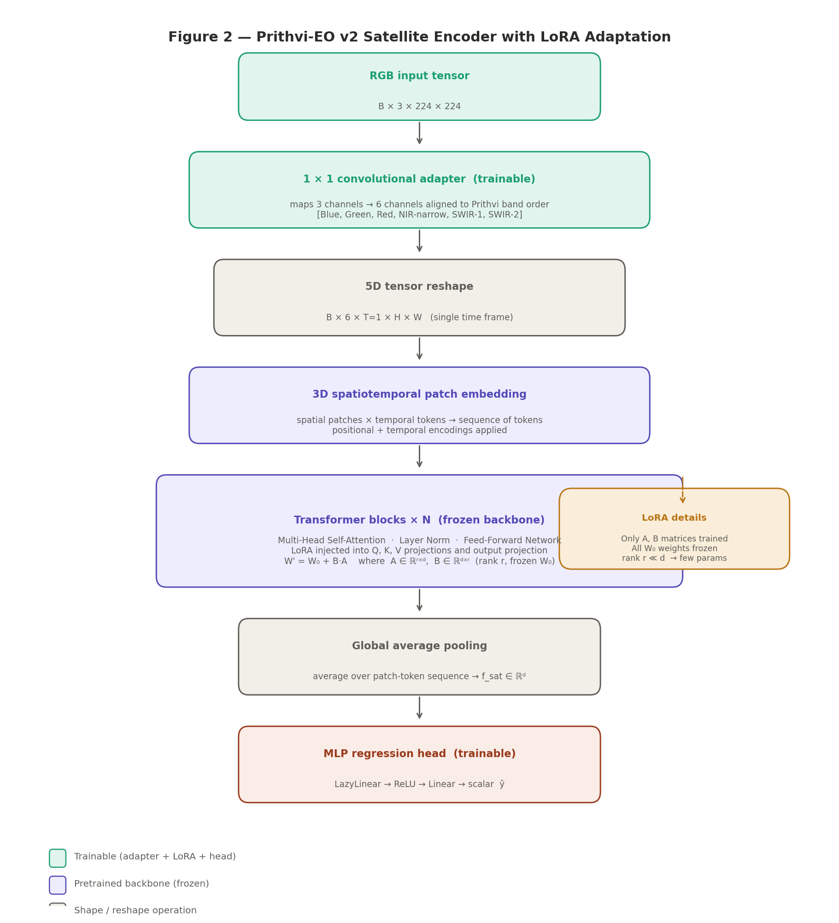
Figure 2. Prithvi-EO v2 satellite encoder. The RGB→6-band 1×1 conv adapter is jointly trained with the LoRA matrices and the regression head. Backbone weights (frozen, teal/purple) are unchanged. LoRA injects low-rank updates W' = W₀ + B·A into attention projections, enabling adaptation with far fewer trainable parameters than full fine-tuning.

4.3.2 Satellite Baseline Encoders
ResNet-50 (resnet50_sat) — deep residual CNN, ImageNet-pretrained; global average-pooled features fed directly to the MLP head. No band adapter; RGB input used as-is. This baseline suffers catastrophic failure on GDP (R² ≈ −4.0); see §6.1 for failure analysis.
DINOv2 ViT-B/14 (dinov2_sat) — self-supervised ViT; CLS token or mean of patch tokens pooled via timm; no multispectral adaptation — treats the satellite patch as a natural image.

4.4 Street Encoder and Multi-View Pooling
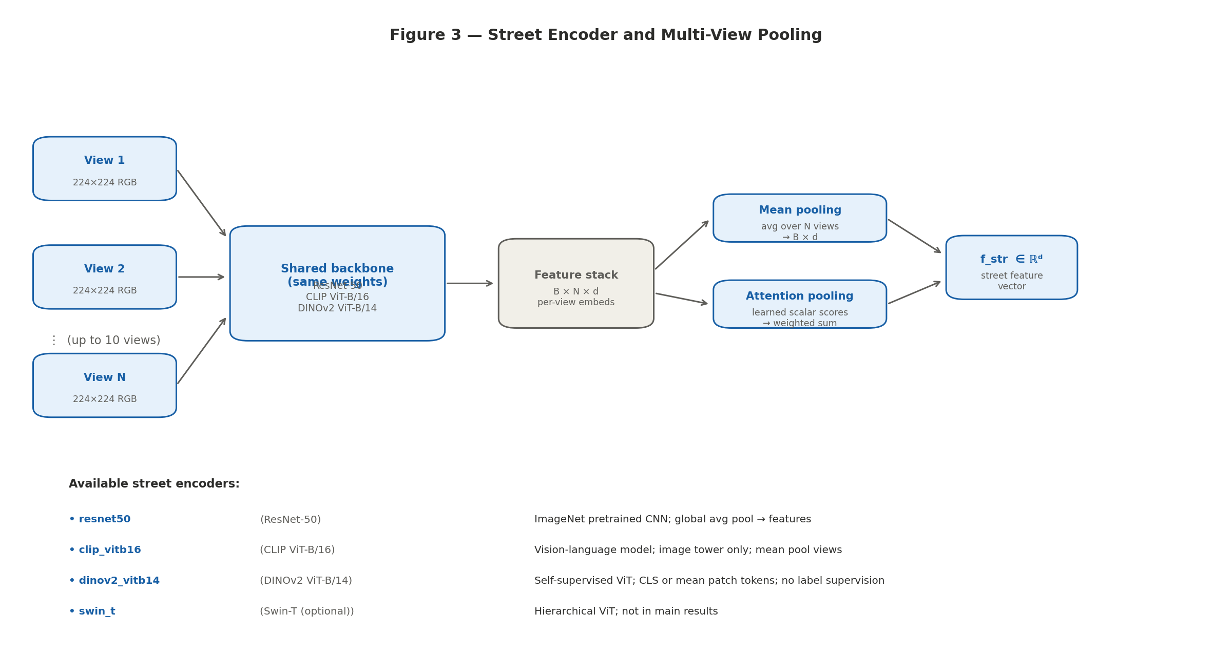
Figure 3. Street encoder and multi-view pooling. All N views for a location share a single backbone. Encoded per-view feature vectors (B×N×d) are aggregated by mean pooling or learned attention pooling, producing a single street feature vector f_str ∈ ℝᵈ. Available encoders: ResNet-50, CLIP ViT-B/16, DINOv2 ViT-B/14.
Each location has up to 10 street-view images. All views are processed by a shared backbone encoder to produce per-view embeddings. These are aggregated either by mean pooling (average over valid views, masked for padded slots) or by attention pooling (learned scalar score per view, softmax-weighted sum). A two-layer MLP (LazyLinear → ReLU → Linear) maps the pooled feature to a scalar prediction.

4.5 Fusion Architectures
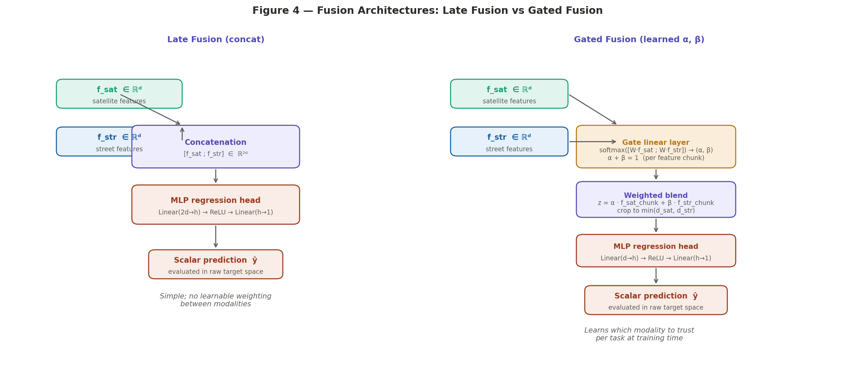
Figure 4. Fusion architectures. Late fusion (left) concatenates satellite and street feature vectors into [f_sat; f_str] ∈ ℝ²ᵈ before the MLP head — simple but effective. Gated fusion (right) uses a small linear layer to compute modality-specific softmax weights (α, β) that blend aligned feature chunks, allowing the model to learn which modality to trust per task.
Late fusion concatenates satellite and pooled street feature vectors: z = [f_sat; f_str] ∈ ℝ²ᵈ. An MLP head maps z to ŷ.
Gated fusion passes the concatenated features through a small linear gate layer producing two non-negative weights via softmax: (α, β) = softmax(W · [f_sat; f_str]). These weights blend dimension-aligned slices of the two feature vectors before the regression head. When the satellite and street feature dimensions differ, the minimum-width slice is used.
In all fusion experiments, the satellite tower is fixed to prithvi_rgb_lora and the street encoder is a timm-based backbone (ResNet-50, CLIP, or DINOv2).

4.6 Shared Validation Splits and Multi-Seed Protocol
For tasks where street imagery is used, we restrict to street-available records. For each task t, seed s, and validation fraction v, we persist a JSON split file with train_ids and val_ids under the naming scheme {task}_{split_key}_seed{s}_val{v}.json. The split key 'fusion' is used across all branches. This ensures that the validation R² for satellite, street, and fusion models is computed on the same held-out cities.
The recommended protocol repeats each run for seeds s ∈ {42, 43, 44} and reports mean ± std. The current snapshot uses seed 42 only; §5.6 provides multi-seed placeholders.
Why this matters: without shared IDs, apparent modality gaps can be dominated by which cities land in the validation fold for each branch. A satellite-favourable validation city set inflates satellite R²; a street-favourable set inflates street R². The paired split eliminates this confound and is the highest-priority methodological requirement for strong cross-modal claims.

5. Experimental Results
All results use seed 42. Satellite-only results may use the full satellite pool; street and fusion results use the street-enabled subset. The cross-branch comparison table (§5.4) is indicative rather than strictly paired — treat cross-modal ordering claims as directional until shared-split reruns are complete.
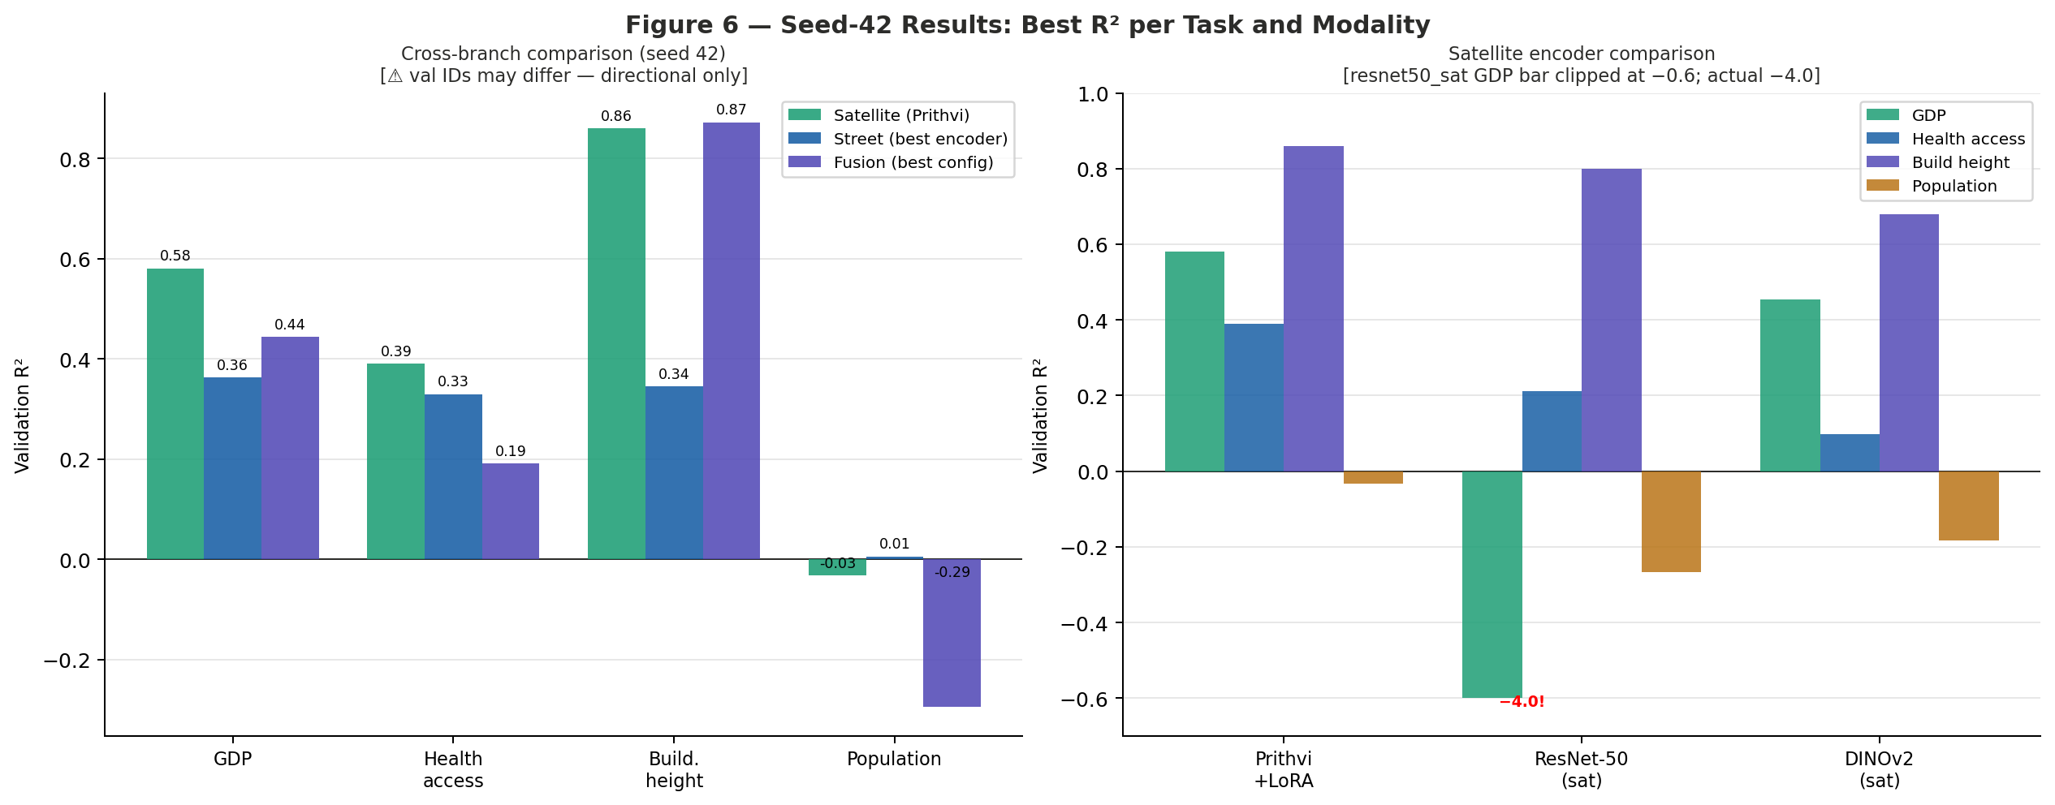
Figure 6. Seed-42 results summary. Left: best R² per task across all three branches. Right: satellite encoder comparison across all four tasks. The ResNet-50 satellite bar on GDP is clipped at −0.6; the actual value is −4.0 (catastrophic failure).

5.1 Satellite-Only Results (Seed 42)
Protocol: image 224, batch 8, seed 42, log1p target transform, lr 2×10⁻⁴, backbone lr 2×10⁻⁴, head lr 1×10⁻³, weight decay 1×10⁻². Epoch budgets: GDP 20; health access and building height 30; population 5.

Task | Model | Best epoch | R² | RMSE | MAE
acc2health | dinov2_sat | 20 | 0.0985 | 11.6113 | 8.7746
acc2health | prithvi_rgb_lora ★ | 9 | 0.3901 | 9.5502 | 7.1910
acc2health | resnet50_sat | 22 | 0.2124 | 10.8529 | 7.2042
build_height | dinov2_sat | 18 | 0.6791 | 3.9542 | 2.8124
build_height | prithvi_rgb_lora ★ | 11 | 0.8599 | 2.6130 | 1.9100
build_height | resnet50_sat | 26 | 0.8004 | 3.1182 | 2.2806
gdp | dinov2_sat | 19 | 0.4535 | 3.78×10⁸ | 2.33×10⁸
gdp | prithvi_rgb_lora ★ | 14 | 0.5808 | 3.31×10⁸ | 1.98×10⁸
gdp | resnet50_sat ⚠ | 5 | −4.0046 | 1.15×10⁹ | 3.93×10⁸
pop | dinov2_sat | 5 | −0.1840 | 23175.5 | 11363.1
pop | prithvi_rgb_lora | 2 | −0.0324 | 21641.2 | 10020.3
pop | resnet50_sat | 2 | −0.2661 | 23965.7 | 11871.8

Note: ★ = best R² per task among sane baselines. ⚠ = catastrophic failure — exclude from comparative analysis. Do not rank resnet50_sat on GDP against other models.

5.2 Street-Only Results (Seed 42, Remapped Subset)

Task | Street encoder | Best epoch | R² | RMSE | MAE
gdp | resnet50 ★ | 7 | 0.3629 | 4.53×10⁸ | 3.09×10⁸
gdp | dinov2_vitb14 | 13 | 0.0342 | 5.57×10⁸ | 3.44×10⁸
gdp | clip_vitb16 | 19 | −0.0287 | 5.75×10⁸ | 3.39×10⁸
acc2health | resnet50 ★ | 21 | 0.3299 | 8.9596 | 6.3076
acc2health | dinov2_vitb14 | 11 | 0.0100 | 10.8903 | 7.4473
acc2health | clip_vitb16 | 3 | −0.0031 | 10.9619 | 7.3645
build_height | resnet50 ★ | 10 | 0.3448 | 5.7259 | 4.5244
build_height | dinov2_vitb14 | 22 | 0.3371 | 5.7597 | 4.6357
build_height | clip_vitb16 | 17 | 0.2338 | 6.1918 | 4.9163
pop | dinov2_vitb14 ★ | 2 | 0.0058 | 12341.3 | 9162.3
pop | clip_vitb16 | 5 | −0.3057 | 14142.8 | 9081.8
pop | resnet50 | 2 | −0.4352 | 14827.6 | 9242.0

5.3 Fusion Results (Prithvi + Street; Seed 42)
Satellite tower: prithvi_rgb_lora. Street encoder: specified. Late = concatenated features + MLP. Gated = learned softmax gate. Not run: acc2health × DINOv2 street; CLIP fusion for build_height / pop.

Task | Street encoder | Fusion | Epochs | Best ep. | R² | RMSE
acc2health | clip_vitb16 | gated | 30 | 19 | 0.1672 | 9.9885
acc2health | clip_vitb16 | late | 30 | 13 | 0.1347 | 10.1811
acc2health | resnet50 | gated | 30 | 3 | 0.1612 | 10.0244
acc2health | resnet50 | late | 30 | 12 | 0.1909 ★ | 9.8452
build_height | dinov2_vitb14 | gated | 30 | 21 | 0.8653 | 2.5963
build_height | dinov2_vitb14 | late ★ | 30 | 23 | 0.8723 | 2.5274
build_height | resnet50 | gated | 30 | 28 | 0.8593 | 2.6532
build_height | resnet50 | late | 30 | 28 | 0.8484 | 2.7541
gdp | clip_vitb16 | gated | 20 | 18 | 0.0151 | 5.63×10⁸
gdp | clip_vitb16 | late | 20 | 18 | 0.3450 | 4.59×10⁸
gdp | dinov2_vitb14 | gated | 20 | 2 | 0.0172 | 5.62×10⁸
gdp | dinov2_vitb14 | late | 20 | 20 | 0.3966 | 4.41×10⁸
gdp | resnet50 | gated ★ | 20 | 20 | 0.4437 | 4.23×10⁸
gdp | resnet50 | late | 20 | 6 | 0.3713 | 4.50×10⁸
pop | dinov2_vitb14 | gated | 5 | 1 | −0.3291 | 14269
pop | dinov2_vitb14 | late | 5 | 5 | −0.4849 | 15082
pop | resnet50 | gated | 5 | 4 | −0.2942 | 14080
pop | resnet50 | late | 5 | 4 | −0.3487 | 14374

5.4 Cross-Branch Comparison (Indicative)

Task | Satellite (best R²) | Street (best R²) | Fusion (best R²) | Max R² | Leading modality
GDP | 0.5808 (Prithvi) | 0.3629 (ResNet-50) | 0.4437 (ResNet gated) | 0.5808 | Satellite
Health access | 0.3901 (Prithvi) | 0.3299 (ResNet-50) | 0.1909 (ResNet late) | 0.3901 | Satellite
Build. height | 0.8599 (Prithvi) | 0.3448 (ResNet-50) | 0.8723 (DINOv2 late) | 0.8723 | Fusion
Population | −0.0324 (Prithvi) | 0.0058 (DINOv2) | −0.2942 (ResNet gated) | 0.0058 | Street (weak)

Note: Val IDs may differ between satellite-only runs (larger pool) and street/fusion runs (street subset). Treat cross-modal ordering as directional until shared-split reruns are complete.

5.5 Multi-Seed Placeholder (Required for Robust Claims)

Task | Branch / model | Seeds run | R² mean ± std | RMSE mean ± std
gdp | prithvi_rgb_lora | 42 only | — (fill after reruns) | —
gdp | dinov2_sat | 42 only | — | —
build_height | prithvi_rgb_lora | 42 only | — | —
build_height | fusion (DINOv2 late) | 42 only | — | —
acc2health | prithvi_rgb_lora | 42 only | — | —
pop | dinov2_vitb14 (str) | 42 only | — | —
Replace dashes with mean ± std after completing paired multi-seed runs. Two seeds (42, 43) require 14 training runs with fusion on build_height. Three seeds (42, 43, 44) require 21 runs. Minimum recommended for conference submission: two seeds.

6. Failure Analysis
Structured reading of where the pipeline breaks or underperforms. These negative results are as important as the best scores for model design and honest scientific reporting.

6.1 F1 — Catastrophic Satellite Baseline (GDP + resnet50_sat)
Signal: R² ≈ −4.0, RMSE ≈ 1.15 × 10⁹ vs Prithvi RMSE ≈ 3.31 × 10⁸. The ResNet-50 satellite encoder on GDP is not merely weaker — it is actively harmful, predicting worse than the mean baseline.
Hypotheses (not proven): optimizer/backbone mismatch under the shared learning-rate schedule; CNN receptive-field characteristics mismatched to macro-economic proxy signal; heavy-tail GDP distribution under MSE loss; possible numerical instability in early training.
Action: Do not use GDP + resnet50_sat as a competitive baseline. Any rerun should use a ResNet-specific LR/warmup or Huber loss as a diagnostic experiment, clearly labelled as such.

6.2 F2 — Population Task Across All Branches
Signal: satellite R² ≤ 0 for all models (best Prithvi: −0.032); street barely positive (DINOv2: +0.006); all fusion values negative.
Interpretation: Population density is weakly observable from RGB at this spatial scale. Label noise (aggregation methodology, year mismatch) and the multi-modal nature of population distributions may also contribute. Model capacity is unlikely to be the bottleneck given that even the largest encoders fail.

6.3 F3 — Fusion Does Not Beat Satellite on GDP and Health Access
Signal: best fusion R² on GDP (0.44) and health access (0.19) are below their satellite-only Prithvi scores (0.58 and 0.39). Adding street-view features adds noise or capacity pressure without providing complementary signal for these tasks on this data split.

6.4 F4 — Gated vs Late Fusion on Health Access
Signal: ResNet-50 late (R² 0.19) > ResNet-50 gated (R² 0.16); gated converges at epoch 3. Gated fusion is not universally superior to late fusion; it may require more epochs or a task-specific hyperparameter search.

6.5 F5 — Checkpoint Hygiene
Some fusion runs have valid metrics.json entries but interrupted checkpoint states (acc2health ResNet gated; gdp DINOv2 gated; gdp ResNet late). Verify checkpoints/best.pt before reusing any checkpoint for inference or explainability.

6.6 F6 — Cross-Branch Comparability
Street and fusion experiments use the remapped street-available subset; satellite-only experiments may use different (larger) validation IDs. Cross-branch comparisons are indicative until shared-split reruns are complete.

7. Explainability
Explainability hooks are implemented in CityLens/evaluate/global_learned/explain.py using Captum (satellite) and custom leave-one-out routines (street, fusion).

Branch | Method | Outputs | Purpose
Satellite | Integrated Gradients (Captum) | heatmap.png, integrated_gradients.npy | Where the model is sensitive on the patch
Street | Leave-one-view-out | leave_one_view_out.csv/json | Which street views drive the prediction
Fusion | Modality zero-ablation | modality_ablation.csv/json | Relative satellite vs street reliance

Hard limits (must appear in any paper using these tools): XAI shows correlation of predictions with pixels or views — not why GDP or health access is high in the real world. No true spectral ablation is possible since CityLens is RGB-only. The default max_samples=8 is insufficient for publication figures; use 32+ samples stratified by validation error quantiles.

8. Discussion

8.1 Why Prithvi Wins on Satellite Despite RGB Mismatch
Prithvi-EO-2.0 was pretrained on six-band multispectral data; CityLens provides only RGB. Despite this domain mismatch, Prithvi + LoRA achieves the highest R² among satellite encoders on all four tasks. We attribute this to the large-scale EO pretraining providing spatially meaningful low-level features (texture, geometry) that transfer even through the RGB-to-6-band adapter, combined with LoRA's ability to adapt the upper layers to the regression objective without forgetting those features.

8.2 When Does Fusion Help?
Fusion (Prithvi satellite + DINOv2 street, late) outperforms all single-modality baselines only on building height (R² 0.8723 vs 0.8599 satellite-only). This task plausibly benefits most from street-level texture: building façades, materials, and roofline geometry visible in street-view tiles complement the overhead footprint and shadow information in satellite imagery. By contrast, GDP and health access appear dominated by macro-scale spatial patterns better captured from above.

8.3 The Population Problem
Population density is the only task where no branch achieves a positive R² in the satellite-only setting. We hypothesise that RGB imagery at this spatial scale carries insufficient discriminative signal for population density. Unlike building height (directly visible from above) or GDP (correlated with urban density patterns visible from above), population density is confounded by the relationship between built form and occupancy, which is not directly observable from either satellite or street-level RGB.

8.4 Multi-Seed Stability
All main results use a single seed (42). Single-seed performance is insufficient for strong claims about modality ordering, particularly where R² differences are small (the satellite vs fusion comparison on building height differs by only 0.012 R² points). The minimum recommended follow-up is seeds {42, 43} under shared validation splits, corresponding to 14 additional training runs.

8.5 Limitations
- Spatial autocorrelation: random ID-based splits may allow spatially proximate training and validation records, inflating R² via label smoothness. Geographic k-fold evaluation would be more conservative.
- Fairness: models trained to predict GDP or health proxies may perform worse in cities historically underrepresented in satellite imagery, potentially amplifying existing disparities if deployed without validation.
- Compute: fusion runs require approximately 24 GB VRAM; the full grid requires careful memory management on commodity hardware.
- Data license: CityLens imagery originates from multiple sources with varying licenses; commercial downstream use requires independent legal review.

9. Conclusion
We present a paired multimodal evaluation of geospatial foundation models and generic vision encoders on four CityLens global regression tasks, using a shared validation split protocol that enables clean cross-modal comparisons. Prithvi-EO-2.0 with LoRA adaptation leads all satellite encoders despite being trained on mismatched multispectral data; fusion helps only on building height; and population density remains unsolved across all modalities. We document a catastrophic baseline failure (ResNet-50 satellite on GDP) and provide structured failure analysis, explainability limits, and a clear roadmap for multi-seed validation.
Future work: geographic k-fold evaluation; per-city fairness metrics; temporal Prithvi inputs exploiting multi-year targets; lighter student models distilled from Prithvi features; shared-split multi-seed reruns to replace directional claims with paired statistical tests.

References
[1] IBM Research / NASA-IMPACT. Prithvi-EO 2.0: From Pixels to Predictions. AGU 2025 publications; Hugging Face ibm-nasageospatial/Prithvi-EO-2.0-*; GitHub NASA-IMPACT/Prithvi-EO-2.0.
[2] Oquab, M. et al. DINOv2: Learning Robust Visual Features without Supervision. arXiv:2304.07193, 2023.
[3] Radford, A. et al. Learning Transferable Visual Models From Natural Language Supervision (CLIP). ICML 2021. arXiv:2103.00020.
[4] He, K. et al. Deep Residual Learning for Image Recognition. CVPR 2016.
[5] Hu, E.J. et al. LoRA: Low-Rank Adaptation of Large Language Models. ICLR 2022. arXiv:2106.09685.
[6] Hugging Face PEFT documentation. https://huggingface.co/docs/peft
[7] Tianhui-Liu et al. CityLens: A Benchmark for Urban Socioeconomic Prediction from Imagery. arXiv:2506.00530, 2025.
[8] Dosovitskiy, A. et al. An Image is Worth 16×16 Words: Transformers for Image Recognition at Scale. ICLR 2021.
[9] Wightman, R. PyTorch Image Models (timm). GitHub, 2019. https://github.com/huggingface/pytorch-image-models
[10] Sundararajan, M. et al. Axiomatic Attribution for Deep Networks (Integrated Gradients). ICML 2017.

Appendix A — Full Hyperparameters

Parameter | Value
Image size | 224 × 224 px
Batch size | 8
Optimizer | AdamW
Learning rate (main) | 2 × 10⁻⁴
Backbone LR | 2 × 10⁻⁴
Head LR | 1 × 10⁻³
Weight decay | 1 × 10⁻²
Target transform | log1p (metrics in raw space)
Validation fraction | 0.1
Seed (reference) | 42
LoRA rank r | Reported per run
LoRA alpha α | Reported per run
Epoch budget (gdp) | 20
Epoch budget (acc2health, build_height) | 30
Epoch budget (pop) | 5
Early stopping metric | Validation R²
Satellite GPU (approx) | 3–5 GB VRAM
Street GPU (approx) | ~11.5 GB VRAM
Fusion GPU (approx) | ~24 GB VRAM

Appendix B — Claim Strength Reference

Claim | Proof type | Strength
Prithvi R²/RMSE on gdp/acc2health/build_height/pop (seed 42) | Locked reference file + PDF | Full
pop is a hard task (all R² near or below zero) | Same locked file | Full
Prithvi beats dinov2_sat and resnet50_sat on satellite | Single seed, same val fold | Moderate (directional)
Fusion beats satellite on build_height | Single seed, subset-mismatched val | Partial — needs shared splits
Cross-modal ordering (sat vs street vs fusion) | Single seed, different val IDs | Directional only
Multi-seed stability of any ordering | No additional seeds run | Not supported
Carbon task follows the same story | No locked Prithvi row | Not supported

Appendix C — Ethics Statement
Socioeconomic inference from imagery is sensitive. This work is framed as aggregate research benchmarking; high-stakes downstream use (resource allocation, loan decisions, policy targeting) requires independent fairness auditing, uncertainty quantification, and appropriate governance. Models trained to predict GDP or health proxies from imagery may systematically underperform in cities underrepresented in the training data, potentially amplifying existing disparities if deployed without validation. We recommend per-city error analysis as a prerequisite for any application beyond benchmarking, and we document all negative results to support honest comparative evaluation.

