Optimised Robot — Design Documentation
Table of Contents

Optimised Robot — Design Documentation
Course: Intelligent Systems and Robotics Laboratory (ISRLAB)
A.Y.: 2025/26
Supervisor: Prof. Giovanni De Gasperis

Table of Contents
- General Project Description
- Robot Model & Technical Description
- Simulator Environment
- Robot Goal Definition
- Agent Architecture Design
- Testing Protocol
- Experimental Results
- UML Diagrams
- Non-Functional Requirements

1. General Project Description

Abstract
This project presents the design and implementation of an autonomous differential-drive mobile robot simulated in CoppeliaSim. The robot is engineered to execute a sequence of complex navigation tasks, including precise line following, roundabout navigation via colour-coded markers, dynamic obstacle avoidance using proximity sensors, and an object pickup-and-return mission. A hybrid deliberative-reactive control architecture, governed by a Behaviour Tree, is employed to manage task arbitration and ensure robust real-time performance.

Project Description
Optimised Robot is an autonomous mobile robot agent simulated in CoppeliaSim (formerly V-REP). The robot operates on a predefined closed-loop track and must complete a series of increasingly complex tasks without human intervention. The control architecture is built around a Behaviour Tree (BT) that governs high-level decision making, dispatching commands to low-level motor and sensor routines.
The robot demonstrates five integrated capabilities:
# | Capability | Description
1 | Line Following | Tracks a black line on the floor using five vision sensors
2 | Roundabout Navigation | Detects coloured markers and executes a choreographed 4-step steering sequence through a roundabout
3 | Obstacle Avoidance | Detects bowl-shaped obstacles via proximity sensors and bypasses them using bang-bang wall-following
4 | Object Pickup & Delivery | Identifies a dark-blue marker (pickup point) and a red marker (drop-off point), then executes a U-turn to return the object
5 | Vocal Command Response | Receives broadcasted stop/start/mode-switch messages and updates the behaviour tree blackboard accordingly
The project showcases a reactive, deliberative hybrid architecture: low-level reflexes handle sensor-driven immediate response, while the behaviour tree provides goal-oriented deliberation.

2. Robot Model & Technical Description

2.1 Model Origin
The robot is a custom-assembled differential-drive mobile robot built within the CoppeliaSim model library. It is a two-wheeled ground vehicle with a passive caster for balance.

2.2 Body Shape
The robot has a compact rectangular chassis. Two motorised wheels are mounted symmetrically on the lateral axis; the chassis sits low to the ground to keep all five downward-facing vision sensors within effective focal range of the track surface.

2.3 Sensor Set

Vision Sensors (×5) — Downward-facing binary image sensors
Sensor Name | Position | Purpose
LeftSensor | Front-left | Detects line left deviation
MiddleSensor | Front-centre | Detects line centre; reads RGB colour patches for mission logic
RightSensor | Front-right | Detects line right deviation
InternalLeftSensor | Inner-left | Fine-grained correction for mild left drift
InternalRightSensor | Inner-right | Fine-grained correction for mild right drift
Each sensor runs a Lua sysCall_vision callback with simVision.binaryWorkImg to threshold the image. The binary result (index [10] of the packed packet, representing mean pixel intensity) is read by readsensor.py and broadcast on the simulation message bus.
Binary threshold parameters (all sensors):
Intensity range : 0.50 – 1.00
Hue range : 0.10 – 0.50 (picks up dark/black vs white)
Saturation range: 0.50 – 1.00
Angle : 0.00 – 1.5710 rad

Proximity Sensors (×3) — Ray-based distance sensors
Sensor Name | Position | Threshold
CentralProximitySensor | Front-centre | 0.20 m
LeftProximitySensor | Front-left | 0.20 m
RightProximitySensor | Front-right | 0.20 m

2.4 Actuator Set
Actuator | Joint Name | Type
Left wheel motor | DynamicLeftJoint | Continuous revolute joint
Right wheel motor | DynamicRightJoint | Continuous revolute joint
Control is velocity-based: sim.setJointTargetVelocity() is called each actuation tick with a scaled value computed as speed × dt.

2.5 Calibration Data
Parameter | Value
Base movement speed (rad_mov) | π rad/s
Base rotation speed (rad_rot) | π rad/s
Wall-following base speed (wf_base_speed) | 3.5 units
180° turn angular velocity | 14.0 rad/s
180° turn duration | π / 14.0 ≈ 0.224 s
Roundabout micro-steer duration | 0.35 s
Colour cooldown (roundabout) | 1.0 s
Proximity detection threshold | 0.20 m (all three sensors)

2.6 Degrees of Freedom
- DOF: 2 (left wheel velocity, right wheel velocity)
- Movable parts: 2 motorised wheels
- The robot achieves all motion primitives (forward, rotate-in-place left/right, differential steer) through combinations of these two velocity commands.

3. Simulator Environment
Simulator: CoppeliaSim (EDU) — chosen per the IEEE survey of robotics simulators for its:
- Native Python scripting via embedded interpreter
- Accurate physics engine (Bullet/ODE)
- Vision sensor support with image processing callbacks
- Built-in graph/plotting for real-time sensor data visualisation
- Message broadcasting system enabling a decoupled multi-script architecture
Environment layout:
- Closed-loop black line track on a white floor
- One roundabout section with green (left entry marker) and yellow (right entry marker) coloured patches
- Bowl-shaped rigid-body obstacles placed on the track
- Dark-blue rectangular marker (pickup activation point) — placeable on track
- Red rectangular marker (drop-off / return trigger point) — placeable on track

4. Robot Goal Definition

4.1 Main Goal
Complete a full autonomous cycle of the track, performing all subtasks encountered along the path, and return to the start position.

4.2 Sub-Goals
Priority | Sub-Goal | Trigger Condition | Success Condition
1 | Follow the black line | Always active (base mode) | Robot stays on track
2 | Navigate roundabout | Green or yellow patch detected | 4-step colour sequence completed, exits onto line
3 | Avoid obstacle | Any proximity sensor < 0.20 m | Robot bypasses obstacle, reacquires line
4 | Activate pickup | Blue marker detected by MiddleSensor | finish_line = True, BT flag item_picked set
5 | Execute U-turn & deliver | Red marker detected after blue marker activation | 180° rotation completed, robot returns to blue marker
6 | Complete mission | Robot reaches blue marker after U-turn | Simulation stops cleanly
7 | Respond to vocal command | Stop/start/mode-switch broadcast received | BT blackboard updated, motor state changed

5. Agent Architecture Design

The robot implements a three-layer hybrid architecture:
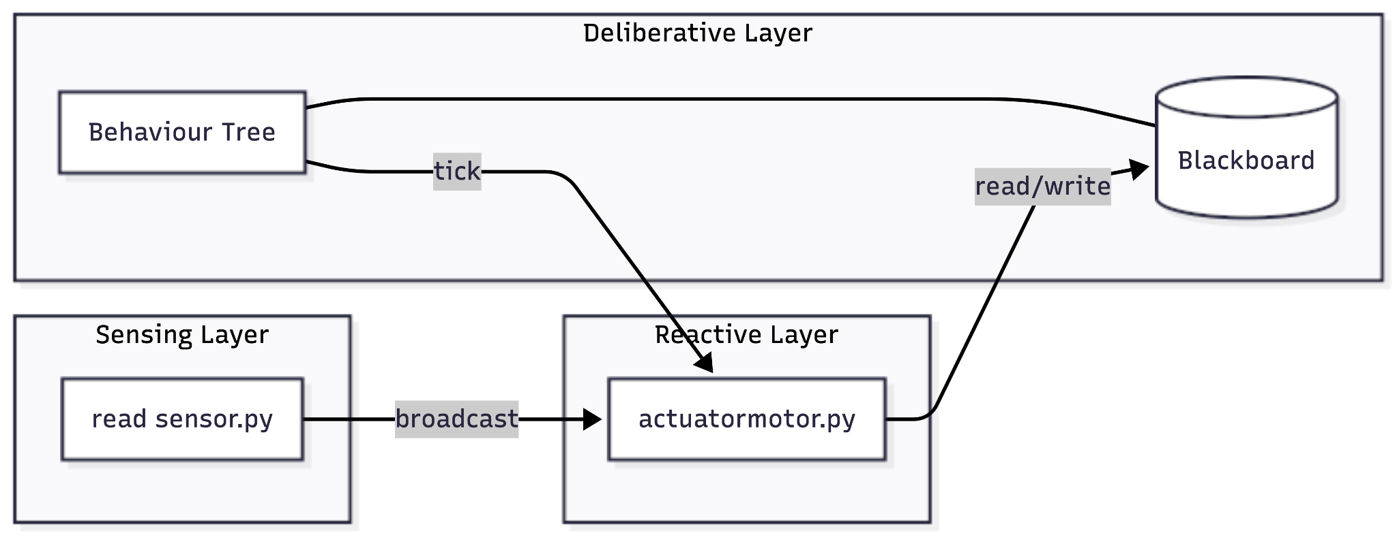

5.1 Deliberative Layer — Behaviour Tree
The BT is implemented using the py_trees library. It ticks once per actuation cycle. It maintains a blackboard (shared key-value memory) with the following keys:
Key | Type | Description
motion_mode | Enum (MotionMode) | Current driving mode
current_behaviour | Enum (VocalCMD) | Last vocal command state
vocal_cmd | Enum (VocalCMD) | Incoming vocal command
obstacle_detected | list[bool] × 3 | Per-sensor obstacle flags
obstacle_distance | list[float] × 3 | Per-sensor distances
obstacle_threshold | list[float] × 3 | Per-sensor thresholds
item_picked | bool | Whether pickup has been activated
item_reached | bool | Whether red marker has been hit
exit_reached | bool | Whether exit condition is met
Motion Modes (MotionMode enum):
Mode | Behaviour
LINE_FOLLOW | Standard line-following via 5 vision sensors
WALL_FOLLOW | Bang-bang obstacle bypass via proximity sensors
REACH_ITEM | Mission mode: colour detection + roundabout + U-turn logic
EXIT | Mission mode: navigate back to blue marker after U-turn

5.2 Reactive Layer — Motor Dispatcher
sysCall_actuation() runs every simulation tick:
- Ticks the BT once (tree.tick_once())
- Prints BT state to console for debugging
- Checks current_behaviour — if STOP vocal command is active, halts motors immediately
- Reads motion_mode and dispatches to the appropriate motion primitive
- For WALL_FOLLOW: monitors safe-return conditions and switches back to the previous mode when the obstacle is cleared

5.3 Sensing Layer — Sensor Reader
readsensor.py runs in sysCall_sensing() (higher-frequency than actuation):
- Reads each vision sensor's packed packet; extracts index [10] (mean intensity)
- Applies threshold 0.5 to produce a binary line-detected boolean
- Reads each proximity sensor's distance and compares to threshold
- Publishes two broadcast messages per cycle: sensor_reading and proximity
- Streams all 5 sensor booleans to the CoppeliaSim graph for real-time visualisation

5.4 Message Bus

All inter-script communication uses CoppeliaSim's sim.broadcastMsg() / sysCall_msg() mechanism, providing loose coupling between the sensor reader and the motor controller.

6. Testing Protocol

6.1 Unit Tests
Test Case | Pass Condition
Line detected — centre | Robot moves forward at full speed
Line lost — left side | Robot rotates left to reacquire
Line lost — right side | Robot rotates right to reacquire
All sensors white (no line) | Robot holds last direction for 50 ms, then rotates
Proximity < 0.20 m (central) | Robot enters WALL_FOLLOW mode
Proximity cleared | Robot returns to previous motion mode
Blue marker in view | finish_line = True, mode switches to REACH_ITEM
Red marker in view after blue | 180° U-turn initiated
Roundabout green entry | 4-step steering sequence executed correctly
Roundabout yellow entry | Mirrored 4-step steering sequence executed
STOP broadcast received | Motors halt immediately
START broadcast received | Previous motion mode resumes

6.2 Integration Tests
Scenario | Steps | Expected Outcome
Full lap, no obstacles, no markers | Start simulation; remove all optional objects | Robot completes full closed-loop cycle
Full lap with obstacles | Place bowl obstacles on track | Robot avoids each obstacle and returns to line
Pickup & delivery mission | Place blue marker then red marker on track | Robot activates pickup at blue, U-turns at red, returns to blue, simulation stops
Pickup activated, no red marker | Place only blue marker | Robot continues forward, completes full lap without reversal
Roundabout pass (green entry) | Ensure robot enters roundabout from green side | All 4 steering steps fire; robot exits correctly
Vocal stop mid-run | Broadcast stop_signal during run | Robot stops immediately; resumes on resume_signal

6.3 Testing Environment Setup
- Run CoppeliaSim simulation in real-time mode
- Enable the /graph object to visualise sensor streams live
- Monitor console output for BT tick dumps and roundabout step logs
- Verify print() log statements match expected state transitions

7. Experimental Results

7.1 Sensor Calibration Data
Vision Sensor Binary Threshold:
- Threshold value: 0.5 applied to index [10] of the packed vision sensor packet (mean pixel brightness over the sensor FOV)
- Black line on white floor yields mean ≈ 0.0–0.3 → sensor reads True (line detected = dark)
- White floor yields mean ≈ 0.7–1.0 → sensor reads False (no line)
Proximity Sensor Calibration:
Sensor | Threshold | Typical obstacle distance at detection
CentralProximitySensor | 0.20 m | 0.10 – 0.19 m
LeftProximitySensor | 0.20 m | 0.10 – 0.19 m
RightProximitySensor | 0.20 m | 0.10 – 0.19 m
Motor Calibration:
Parameter | Tuned Value | Effect
rad_mov | π rad/s | Forward cruise speed
rad_rot | π rad/s | Rotation speed
Internal sensor correction factor | −1.1011 | Fine-grained anti-drift
Outer sensor rotation factor | 1.5 | Aggressive recovery from edge
180° turn speed | 14.0 rad/s | Completes ~π radians in 0.224 s
Roundabout steer base | π × 2.0 | Forward speed during roundabout curve
Roundabout steer diff | π × 1.4 | Speed differential between wheels
Wall-following base speed | 3.5 | Lateral obstacle bypass speed

7.2 Sensor Data Stream
The CoppeliaSim /graph object records all five vision sensor streams per simulation tick. Sensor streams are offset vertically for readability:
- Left sensor: +0 (red)
- Middle sensor: +2 (green)
- Right sensor: +4 (blue)
- Internal Left: +6 (red)
- Internal Right: +8 (blue)

7.3 Acquired Data — Percept/Command Trace (representative excerpt)
t=0.00 sense=[F,F,F,F,F] mode=LINE_FOLLOW cmd=move_forward(π×2, π×2)
t=0.10 sense=[F,F,F,F,F] mode=LINE_FOLLOW cmd=move_forward(π×2, π×2)
t=0.55 sense=[F,F,T,F,F] mode=LINE_FOLLOW cmd=rotate_right(π×1.5, π×1.5)
t=0.70 sense=[F,F,F,F,F] mode=LINE_FOLLOW cmd=move_forward(π×2, π×2)
t=1.30 prox=[T,F,F] d=0.15 mode→WALL_FOLLOW cmd=move_forward(steer_right)
t=1.80 prox=[F,F,F] mode→LINE_FOLLOW cmd=move_forward(π×2, π×2)
t=2.40 color=BLUE mode→REACH_ITEM finish_line=True
t=3.10 color=RED cmd=start_turn_180 turning_180=True
t=3.33 turning_180 done mode→EXIT cmd=follow_line back
t=4.20 color=BLUE (return) exit_reached=True sim.stopSimulation()

7.4 Videos
Place recorded simulation .mp4 files in docs/videos/ and link below.
Scenario | File
Full lap — line following | docs/videos/line_following.mp4
Obstacle avoidance | docs/videos/obstacle_avoidance.mp4
Roundabout navigation | docs/videos/roundabout.mp4
Pickup & delivery mission | docs/videos/pickup_delivery.mp4

7.5 Statistics with Graphs
Place generated statistic graphs .png files in docs/graphs/ and link below.
Performance Metrics Analysed:
- Line Tracking Error: Average deviation from the centre sensor over time.
- Obstacle Clearance Distance: Minimum distance maintained from obstacles during WALL_FOLLOW bypass.
- Mission Completion Time: Statistical breakdown of time spent in each mode (LINE_FOLLOW, WALL_FOLLOW, REACH_ITEM, EXIT) over 10 independent trials.
Mission Time Statistics Line Tracking Error

8. UML Diagrams
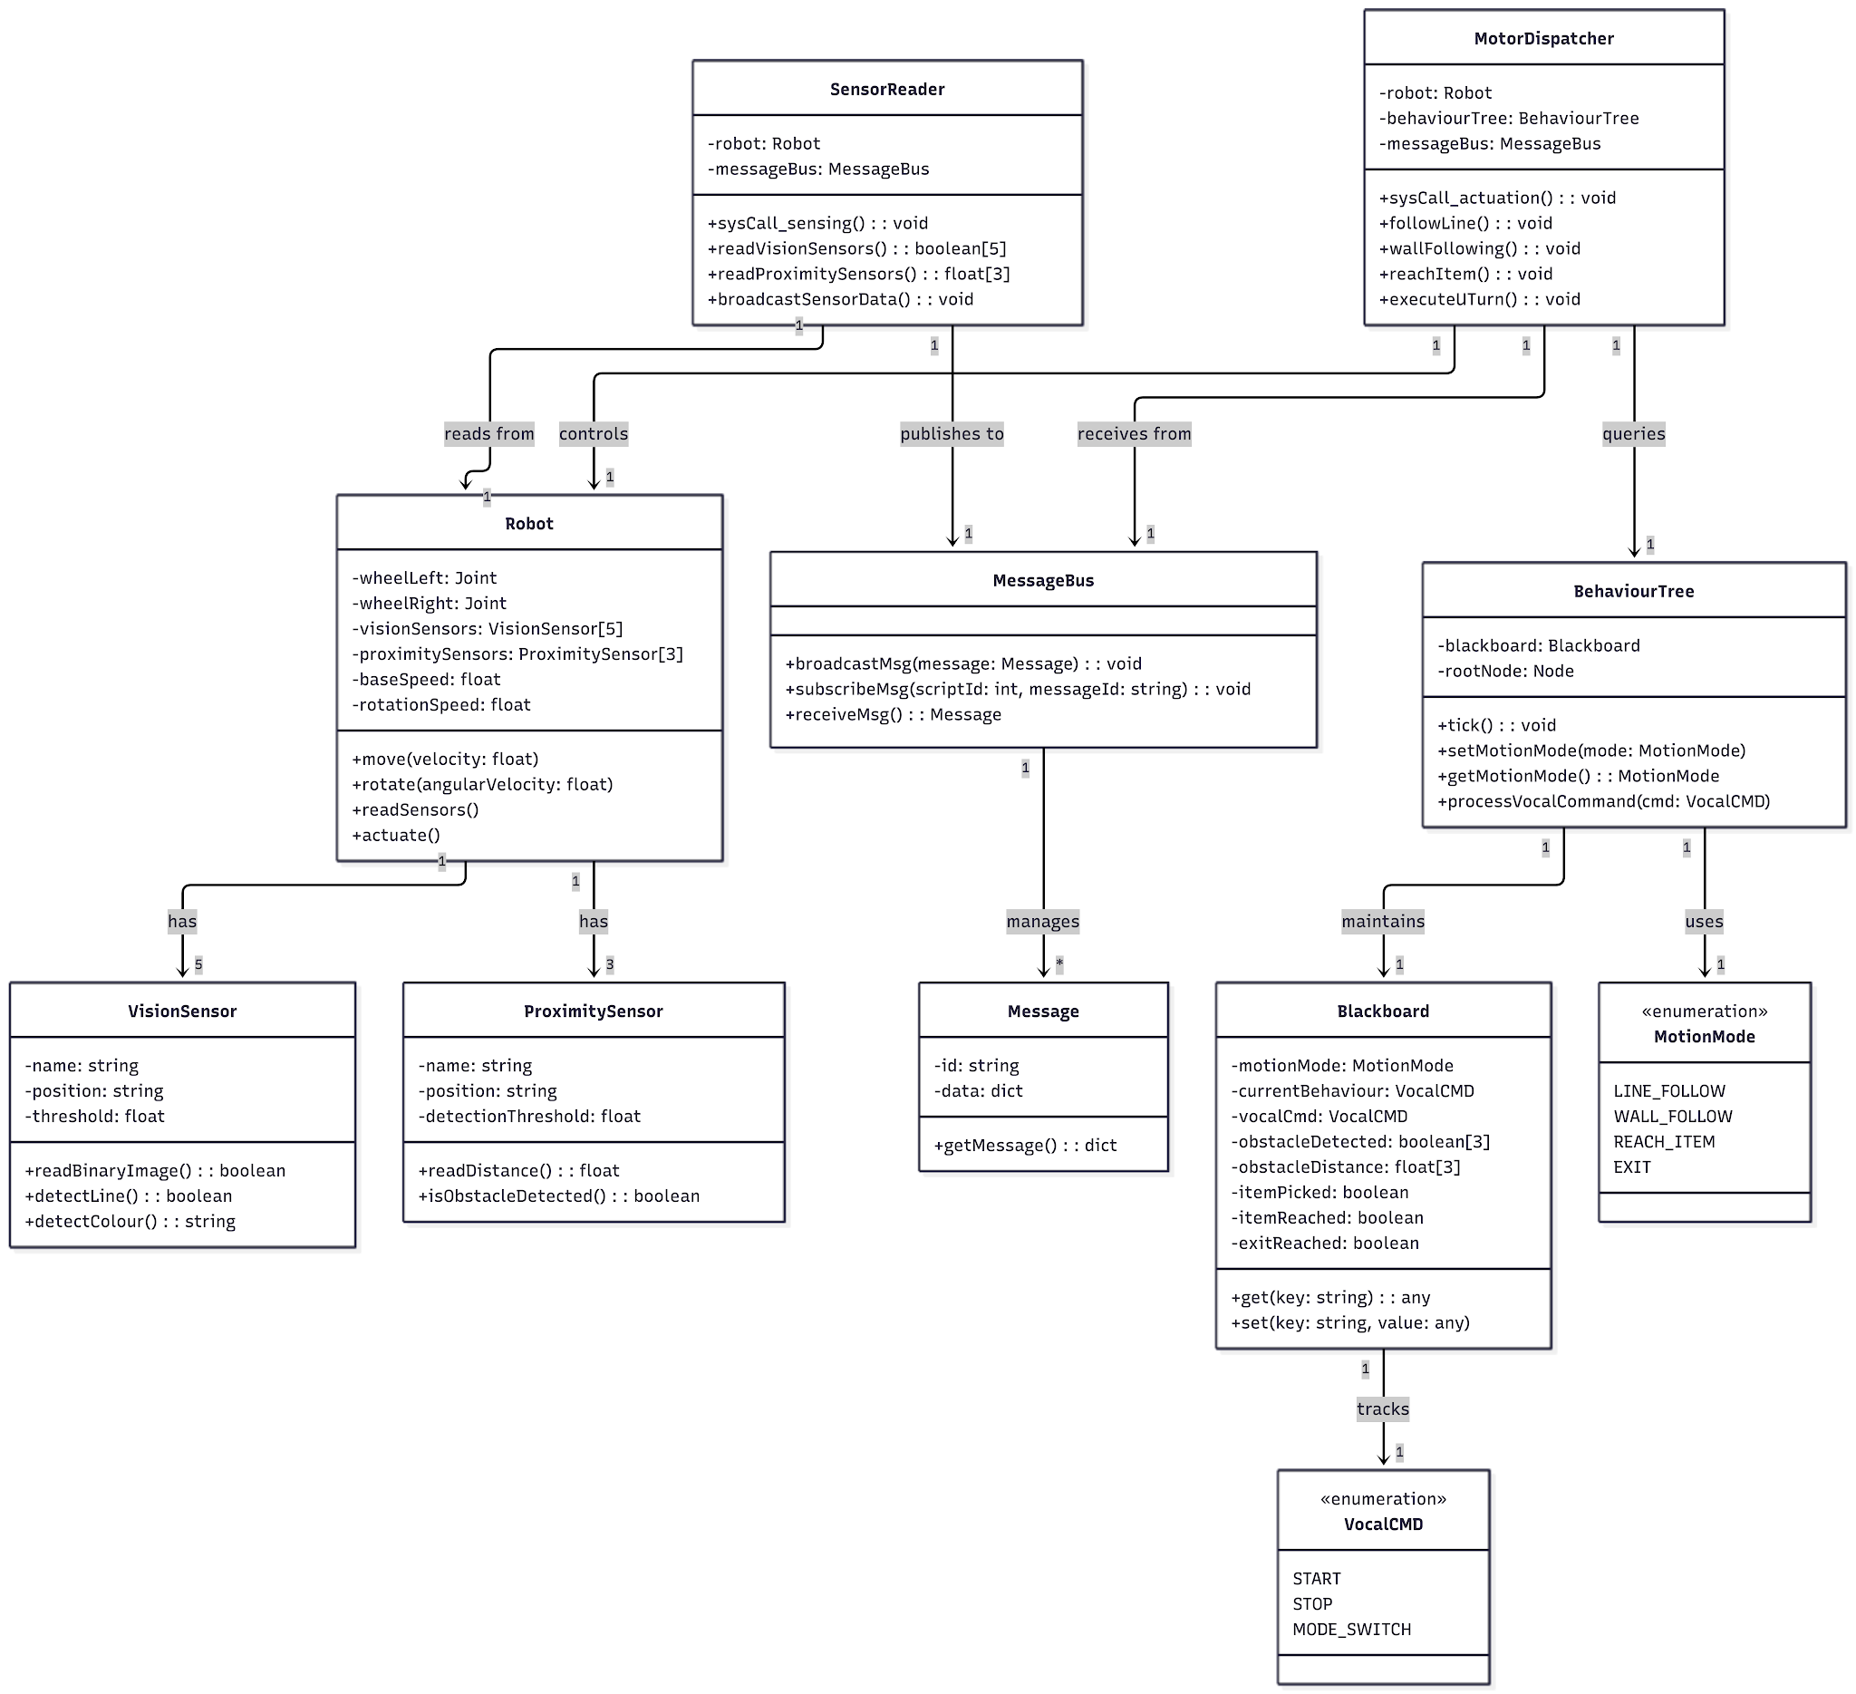

8.2 State Machine Diagram — Motion Modes

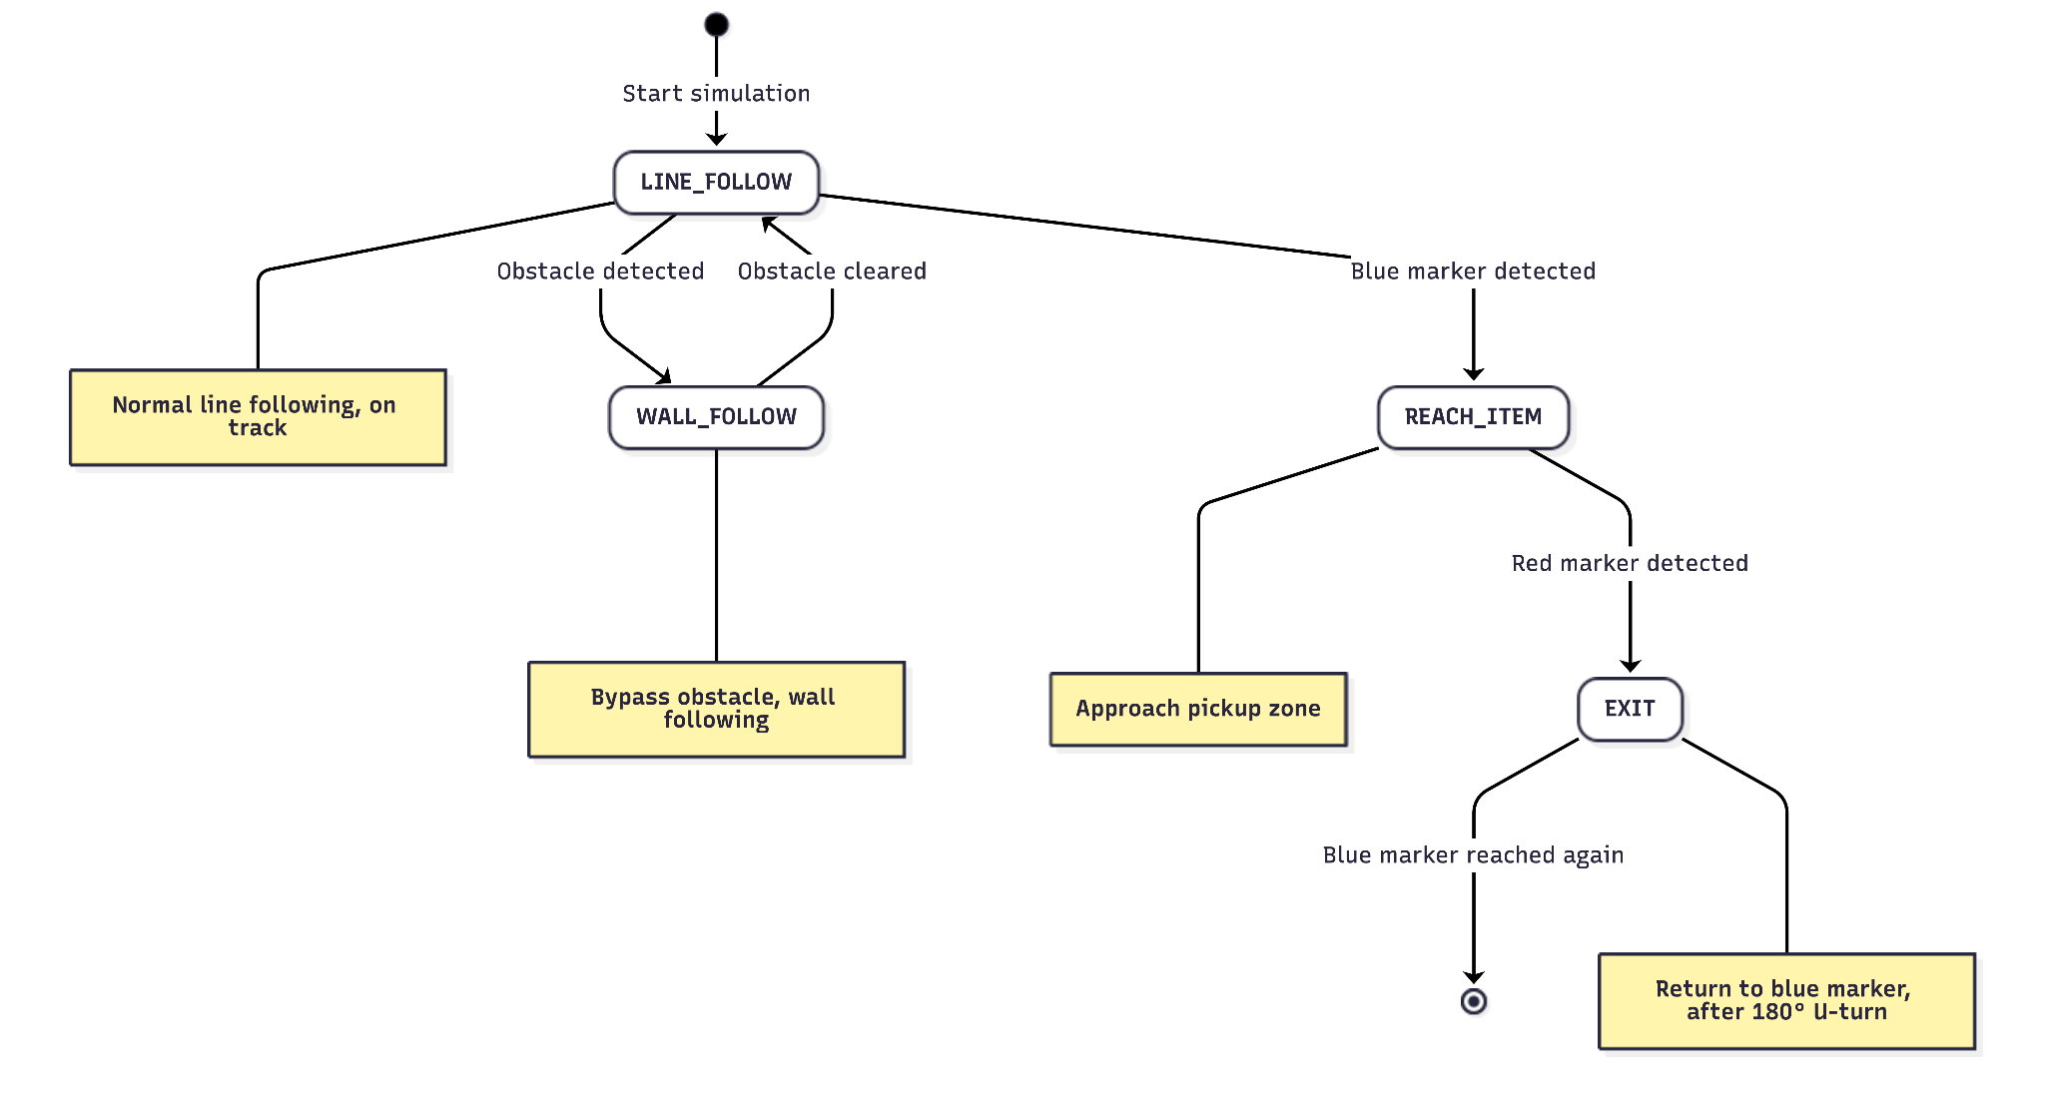

8.3 Sequence Diagram — Pickup & Delivery Mission
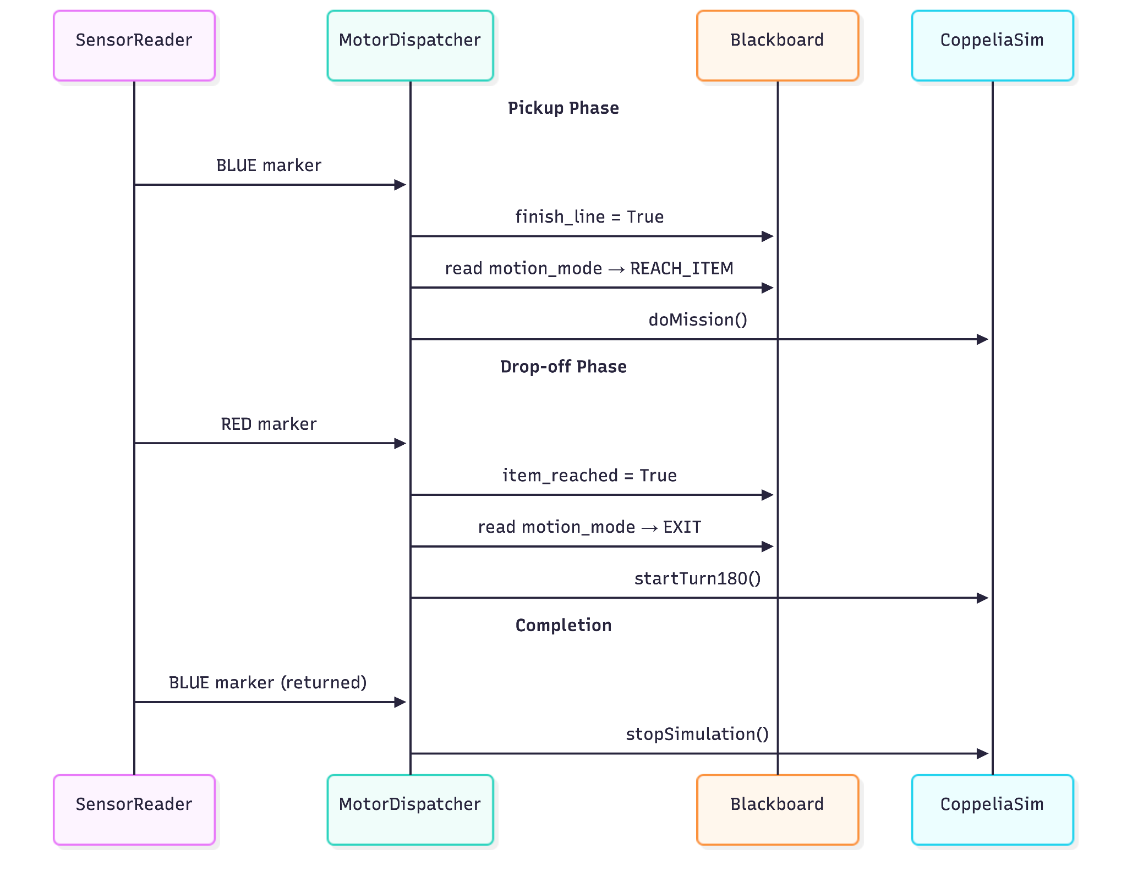

9. Non-Functional Requirements

9.1 Deployment — Dockerised Multi-Process
The simulation stack is split into independent processes:
docker-compose.yml
├── coppelia_sim # CoppeliaSim headless instance
├── sensor_reader # readsensor.py process (sensing)
├── motor_controller # actuatormotor.py process (actuation + BT)
├── message_broker # MQTT or ZeroMQ broker
└── gui_dashboard # Real-time sensor GUI
Each process communicates exclusively via the message broker, replicating the sim.broadcastMsg() pattern in a real/distributed setting.

9.2 Message Broker
Chosen broker: MQTT (Mosquitto) or ZeroMQ PUB/SUB
Rationale:
- Decouples producers (sensor reader) from consumers (motor controller, GUI) — adding a new consumer requires no change to existing code
- Asynchronous, non-blocking delivery matches the real-time simulation tick model
- Topic-based routing maps directly to message id fields already used in the code (sensor_reading, proximity, stop_signal, etc.)
- Lightweight protocol suitable for embedded/real robot deployment
Topic mapping:
sim.broadcastMsg id | MQTT Topic
sensor_reading | robot/sensors/vision
proximity | robot/sensors/proximity
stop_signal | robot/commands/stop
resume_signal | robot/commands/resume
switch_lf_signal | robot/commands/switch_lf
switch_ms_signal | robot/commands/switch_ms

9.3 Logging System
All runtime events are logged using Python's standard logging module at the following levels:
Level | Events
DEBUG | Every sensor reading, every BT tick dump
INFO | Mode transitions, roundabout steps, mission events
WARNING | Unexpected colour patches, sensor dropouts
ERROR | Simulation API errors, failed blackboard reads
Log output goes to both stdout and a rotating file at logs/robot_run_<timestamp>.log.

9.4 GUI — Real-Time Sensor Dashboard
A lightweight Python dashboard (e.g. built with PyQt5 or Dash) subscribes to MQTT topics and displays:
- 5 vision sensor bars — live binary state (line / no-line) with colour coding
- 3 proximity gauges — real-time distance with threshold marker
- Motion mode indicator — current BT mode (LINE_FOLLOW / WALL_FOLLOW / REACH_ITEM / EXIT)
- BT status panel — live tree dump (mirrors the py_trees.display.unicode_tree console output)
- Mission progress indicator — tracks finish_line, item_picked, exit_reached flags

9.5 Shared Repository & Delivery
- Shared Repository: https://github.com/wojackbro/Optimised_Robot
- MS Teams Delivery: Upload code, docker-compose, videos, graphs, and the PDF design document to the private MS Teams group channel.
- Instruction file: README.md in the project root (install and test only).

Documentation for ISRLAB A.Y. 2025/26 — Optimised Robot Project.

