**Guide Book**

How to put Event picture into Chadwick Residence Homage Banner

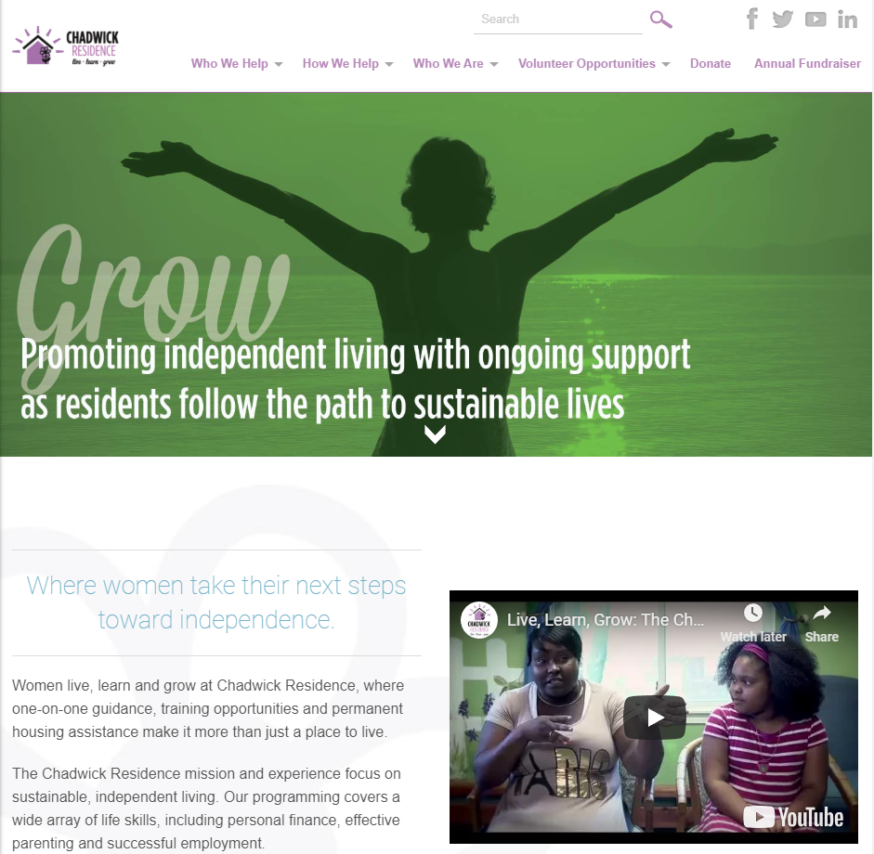

**Step1:** To add specific event image into homepage banner, first log-in to Chadwick Wordpress site.

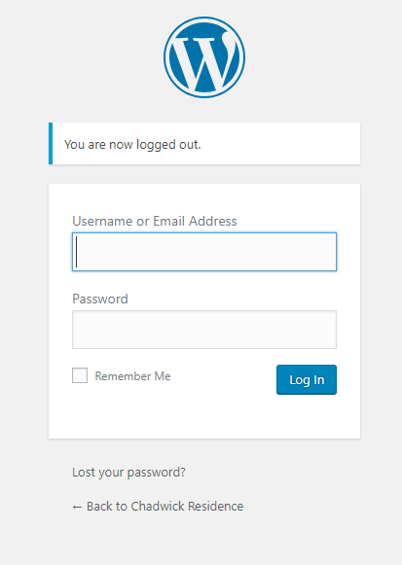

**Step2:** Move mouse cursor to “Media” tab and click the “Library”.

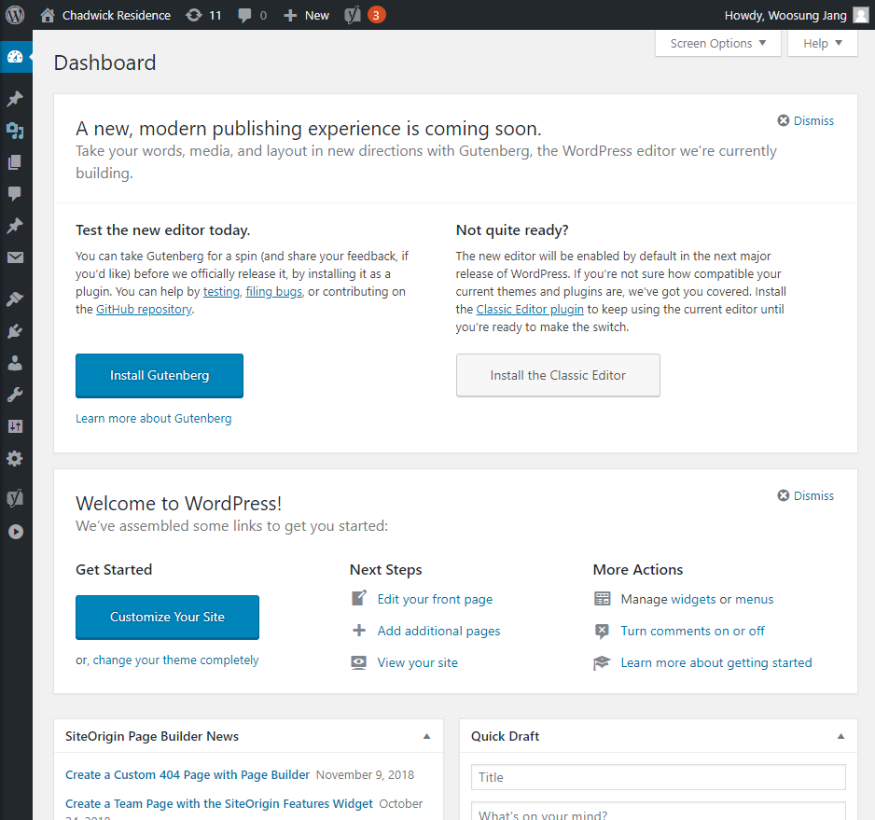

**Step3:** Click “Add New” button next of Media Library Title.

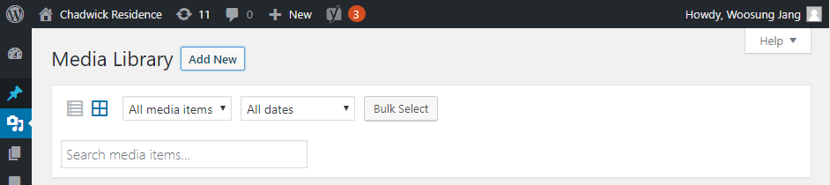

Click Select Files button after click “Add New” button.



**Step4:** Drag or Open the file to add Media Library

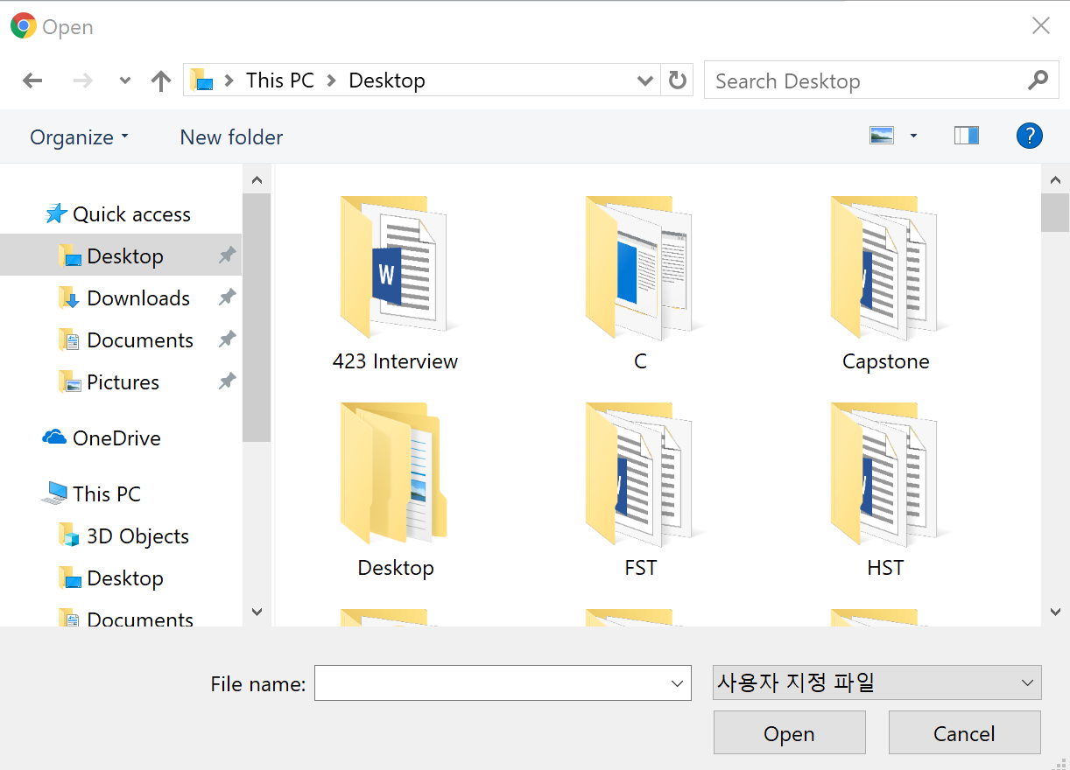

**Step5:** After uploading picture, click specific image file and copy the URL of image from /wp-content to end of URL.

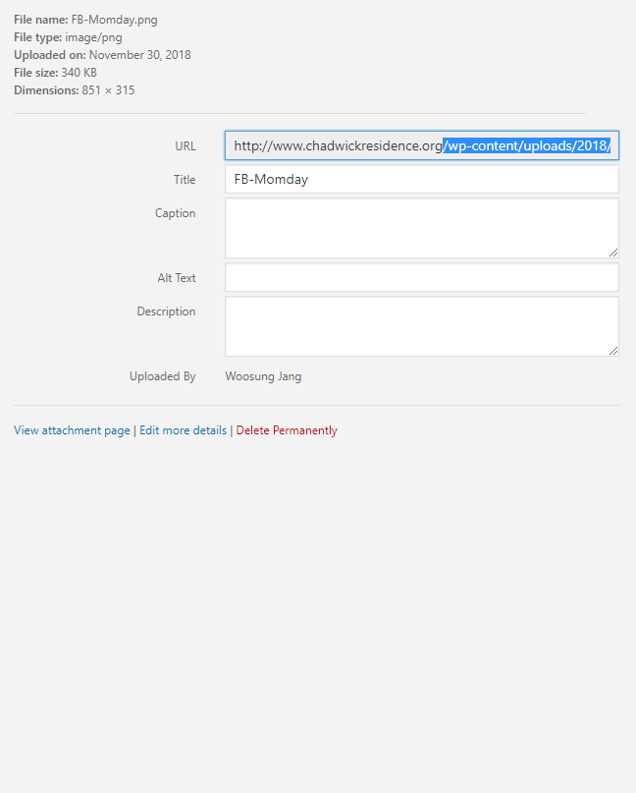

**Step6:** After copying the URL of image, click Editor option of Appearance tab in left side.

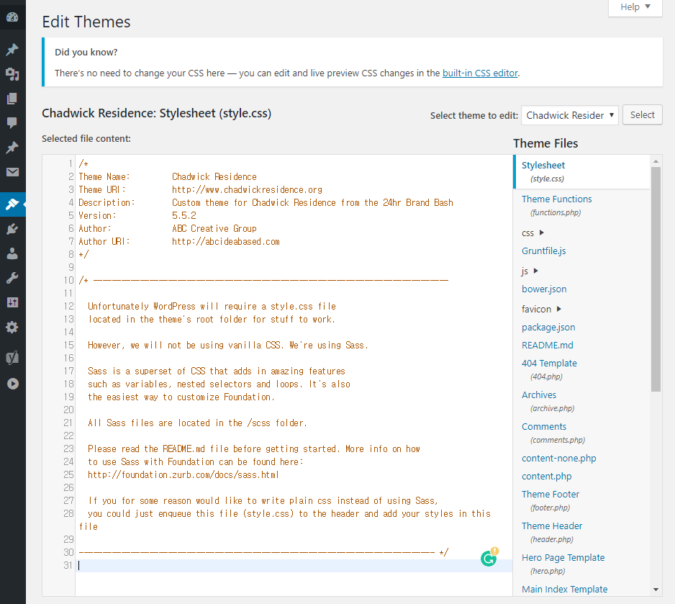

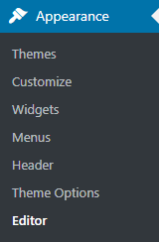

**Step7:** In the right side, there is “Theme Files” and find “page-homepage.php” and click it.

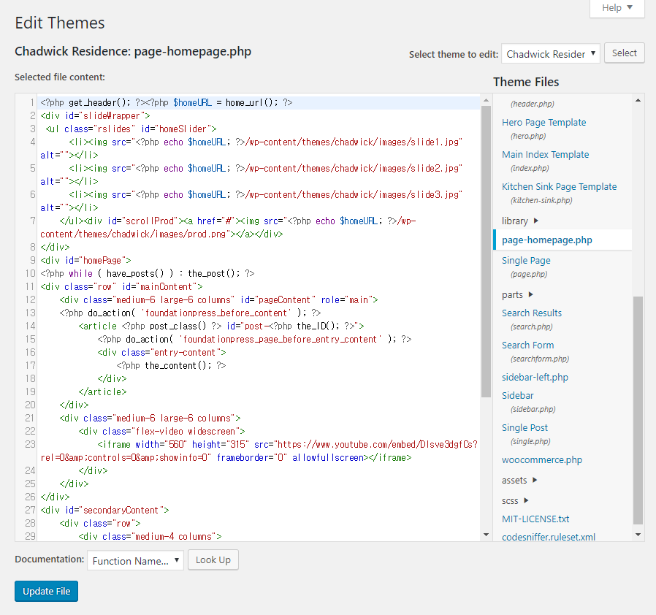

**Step8:** Write the code below into <ul class=”rslides” id=”homeSlider”>

<li><img src=”?php echo $homeURL; ?>/wp-content/themes/chadwick/images/slide1.jpg” alt=””></li>

Not only writing the code, but also, you can copy the code in “page-homepage.php” and paste it

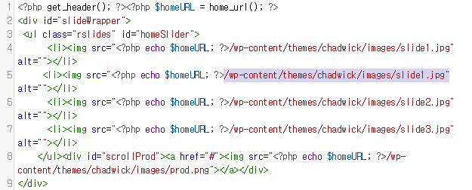

Paste URL instead of below code which already copied in **Step 5**.

/wp-content/themes/chadwick/images/slide1.jpg”

After paste URL into code, click “Update File” button as like below picture.



**Example to add picture into banner of homepage - 1**

For example, to add picture Chadwick Residence Annual Fundraiser: REDS, WHITES, AND THE BLUES image into homepage banner, first copy the URL of REDS, WHITES, AND THE BLUES



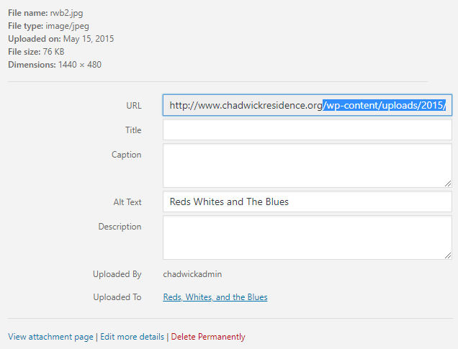

**Example to add picture into banner of homepage - 2**

Paste URL of picture Chadwick Residence Annual Fundraiser: REDS, WHITES, AND THE BLUES image into “homeSlider

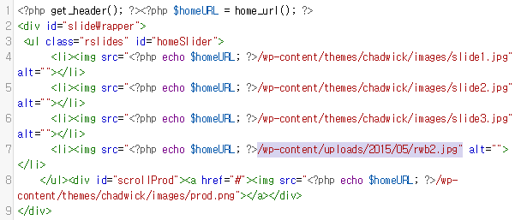

I added code to fourth slide. If you put code to the first slide as like below picture, picture Chadwick Residence Annual Fundraiser: REDS, WHITES, AND THE BLUES image will be shown in the banner firstly.

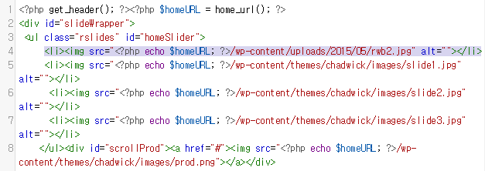

After putting code, click “Update File” button.

**Example to add picture into banner of homepage - 3**

Refresh Chadwick website (Not Wordpress site), then first slide will show picture Chadwick Residence Annual Fundraiser: REDS, WHITES, AND THE BLUES image firstly.



**How to Delete event picture after the event**

To change or delete image after the event, as like step7, go to “page-homepage.php” in the Appearance tab of Wordpress site. Delete code which you added for event as like below picture.

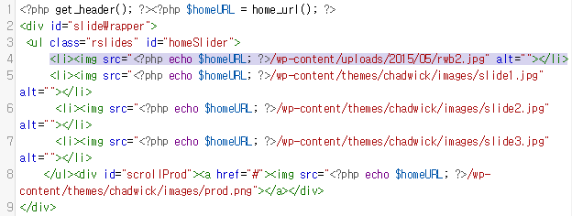

Then event picture will be deleted from banner of homepage as like below picture.



**Recommendation – Backup - 1**

Before add code into “page-homepage.php” page, please copy whole code to another text-document as like Microsoft Word document.

Copy it

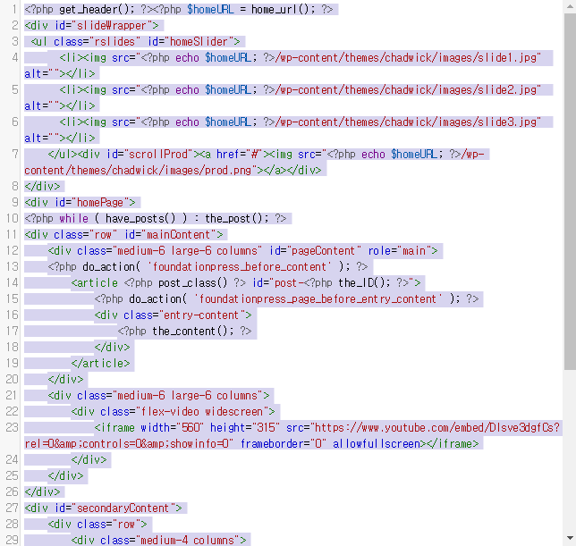

**Recommendation – Backup - 2**

Paste it to another word document for back up when error is occurred, you can just copy and paste this code into “page-homepage.php”.

