**Guide Book**

How to put Event picture into Chadwick Residence Single Page Banner

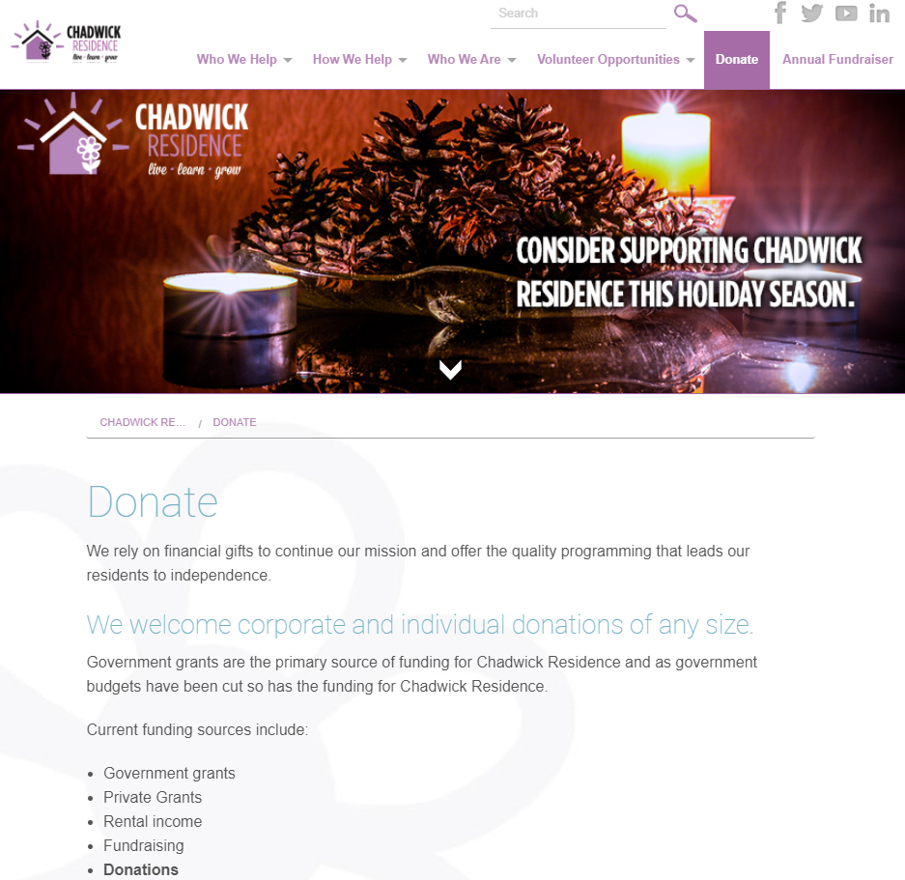

**Step1:** To add specific event image into homepage banner, first log-in to Chadwick Wordpress site.

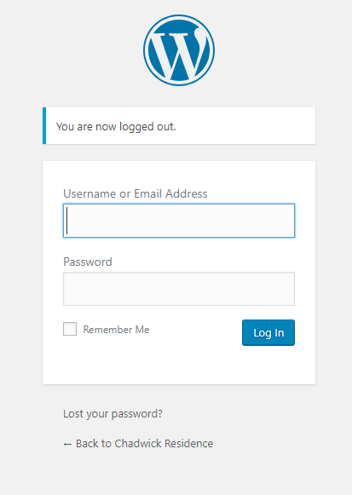

**Step2:** Move mouse cursor to “Media” tab and click the “Library”.

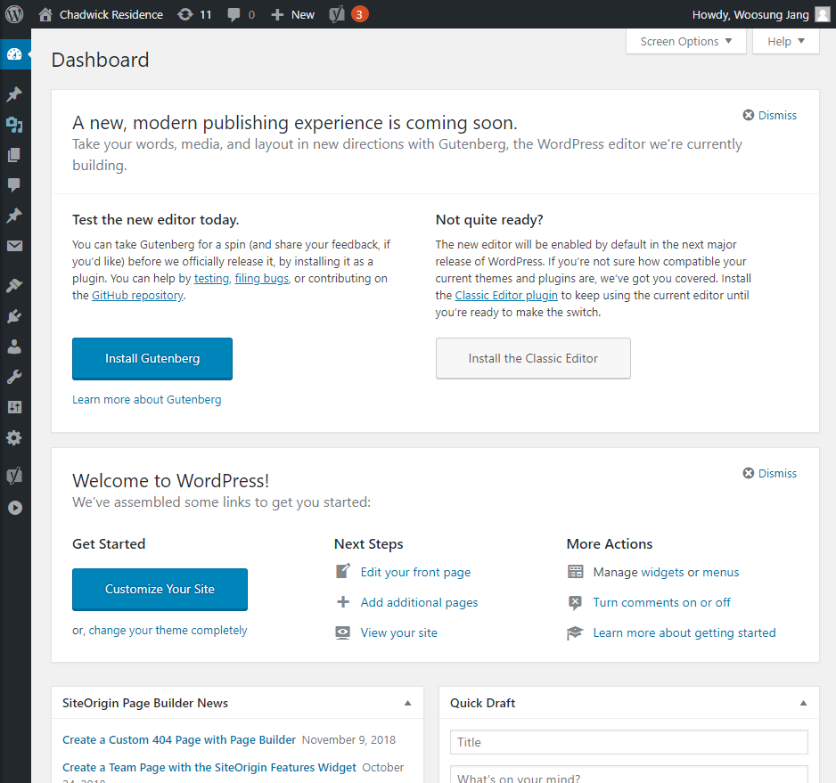

**Step3:** Click “Add New” button next of Media Library Title.

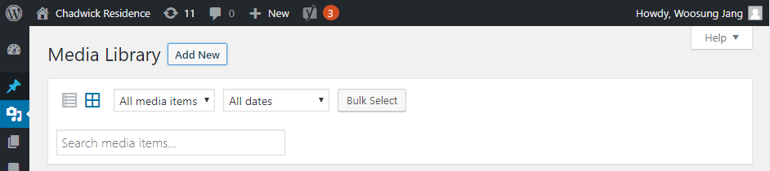

Click Select Files button after click “Add New” button.

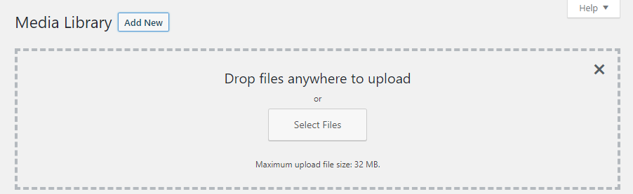

**Step4:** Drag or Open the file to add Media Library

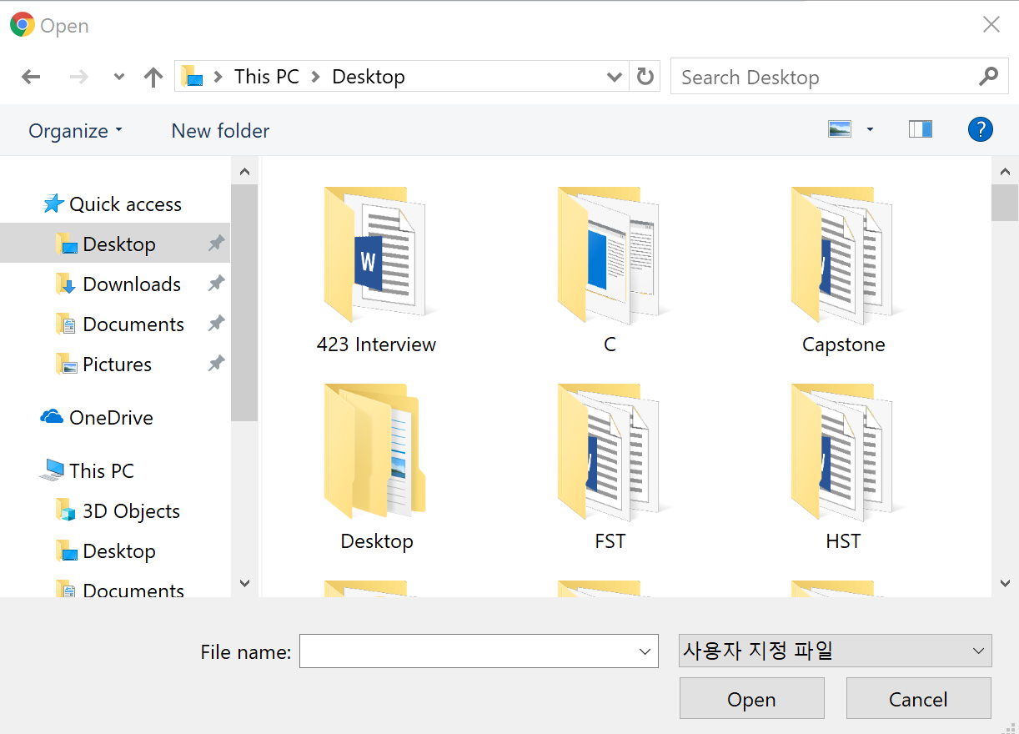

**Step5:** After uploading picture, go to “Pages” tab and click “All Pages”

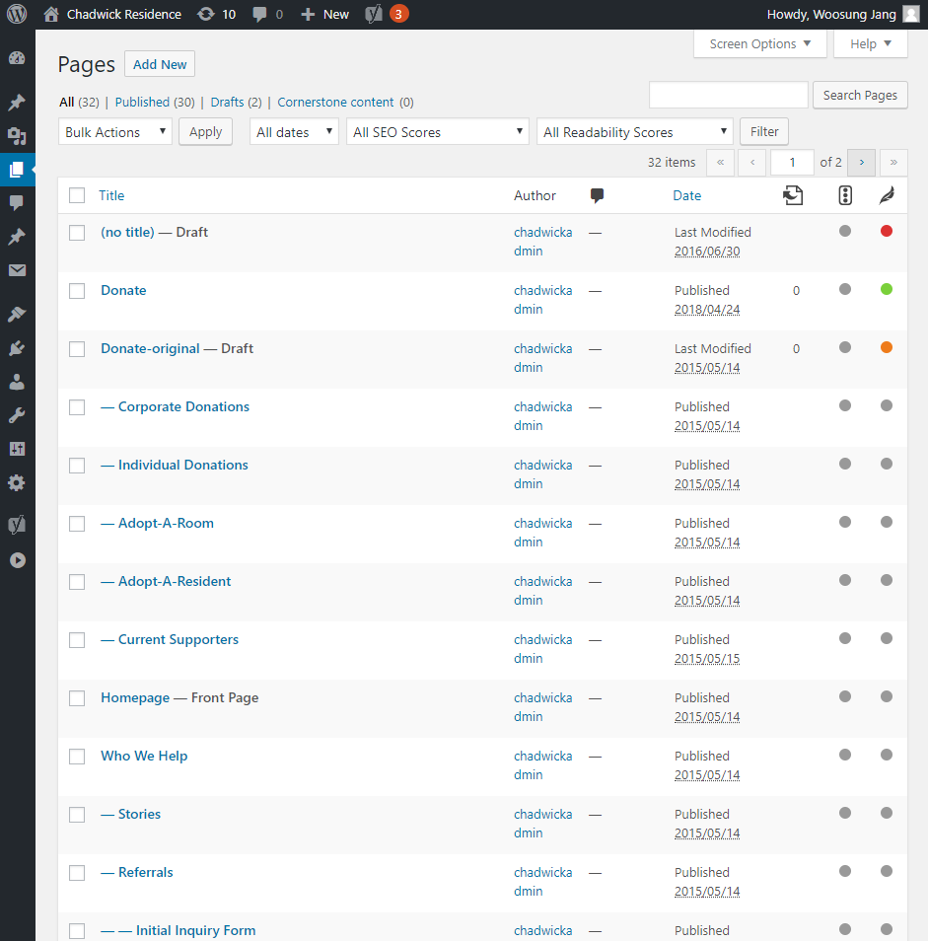

**Step6:** Click the specific page you want to change banner.

For example, here I will change Donate section image from Holiday image to REDS, WHITES, AND THE BLUES image. For changing Donate page, click Donate page. (Not Draft page).

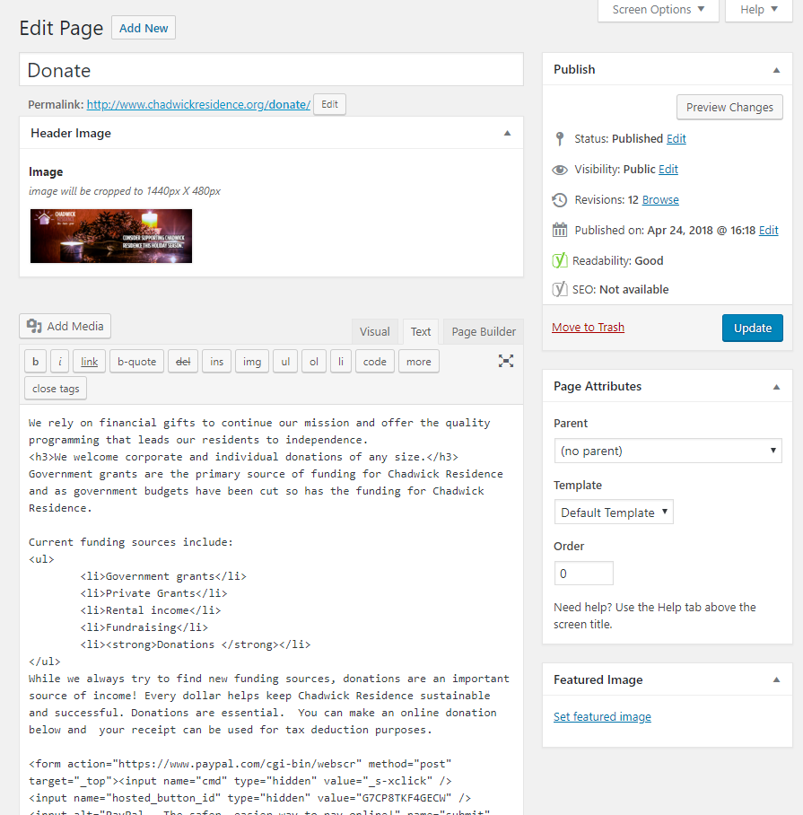

**Step7:** Click the specific page you want to change banner.

Click red X button to delete old image of banner.

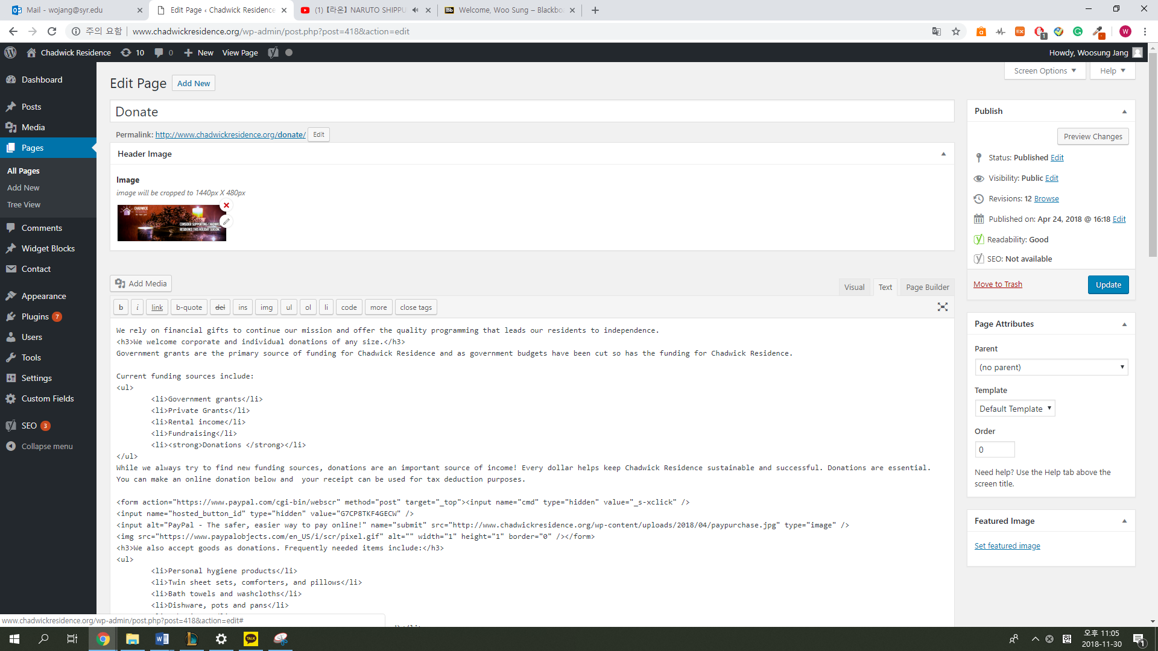

Then Header Image section will show as like below picture.

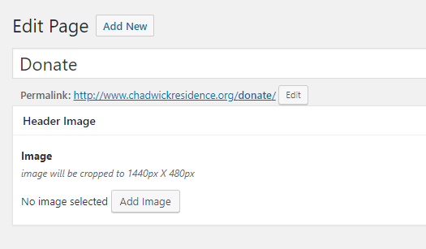

**Step8:** Click “Add Image” button.



**Step9:** Then it will show “Select Image” tab as like below picture.

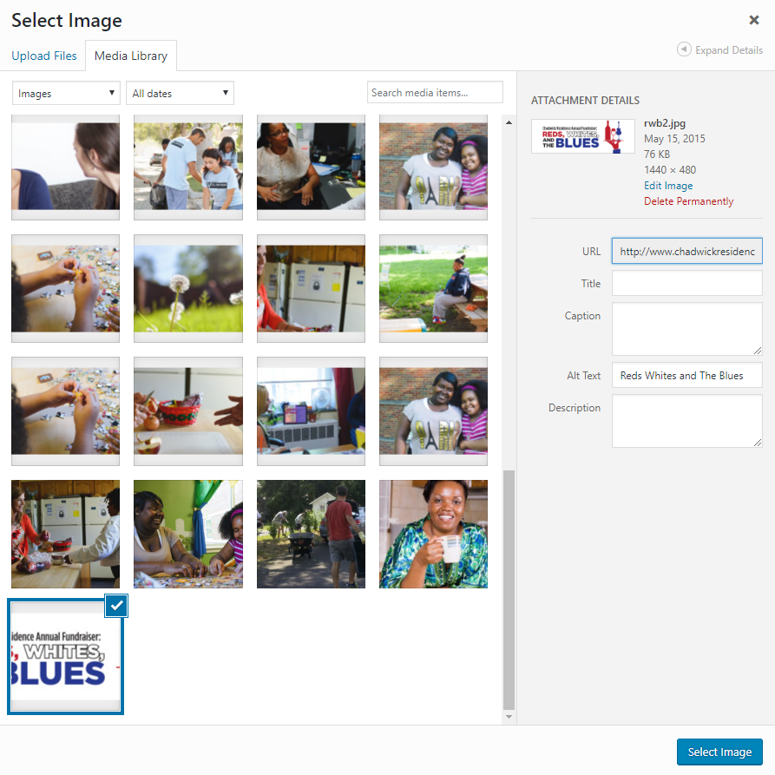

Find picture you add at **Step 4** and click “Select Image” button.

**Step9:** Then Page “Header Image” will be change as like below picture.

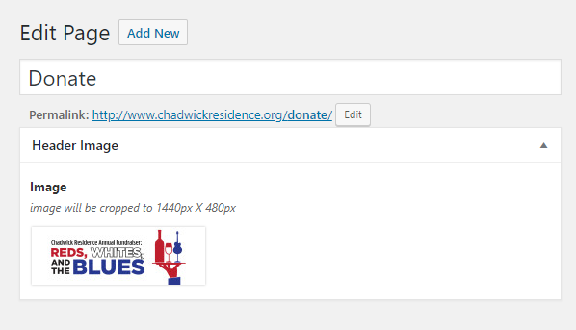

After “Header Image” changed, click “Update” button on the right side.

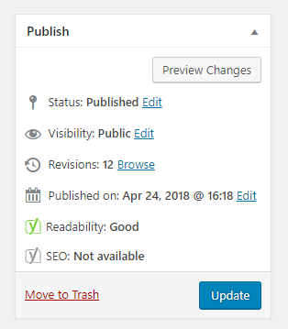

**Step10:** Refresh Chadwick Residence single page. (Not Wordpress site)

For here, I changed Donate section, so I refreshed Donate section. Then banner is change as like below picture.

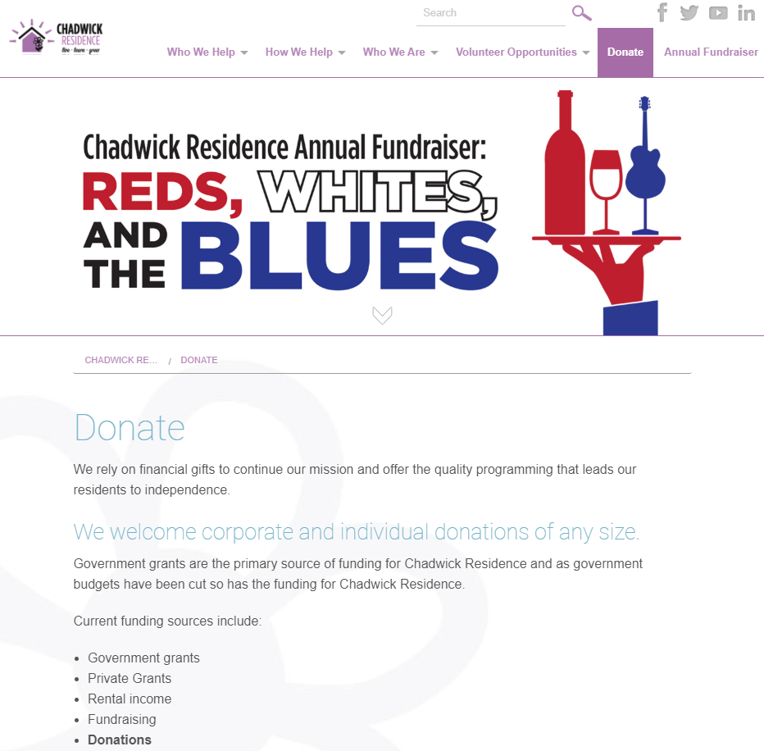

Then banner of single page will be changed. This is not only for Donate section, but also for other single page such as Volunteer Opportunities, Who We Are, and How We Help and etc… which includes banner.

Also, all single page (Not homepage) Image will be cropped to 1440px X 480px, so be careful to select image for banner.