ClickHouse Sales Report
The following report presents basic analysis of diamond sales based on data from ClickHouse.

Distribution of Total Sales Value
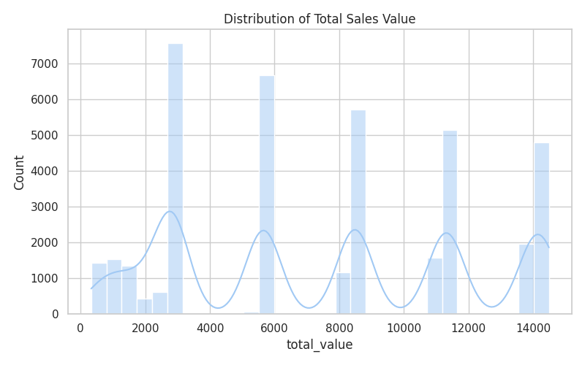
The histogram shows the distribution of sales value for all transactions.

Analysis by Cut

Count by Cut
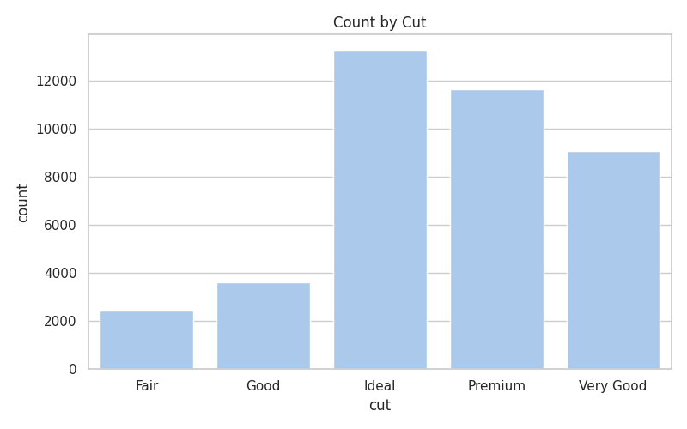
The chart displays the count of sales value broken down by cut.

Mean by Cut
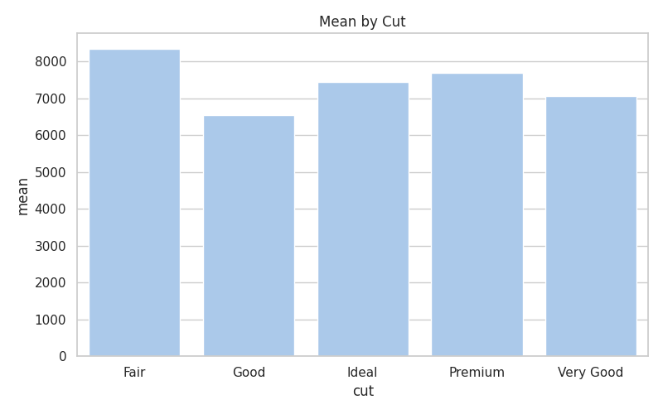
The chart displays the mean of sales value broken down by cut.

Sum by Cut
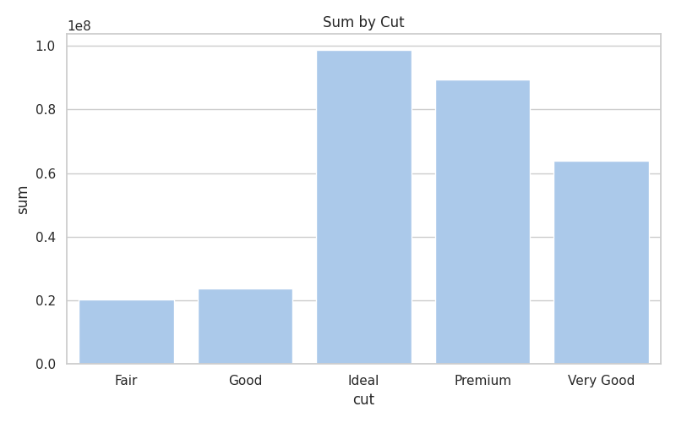
The chart displays the sum of sales value broken down by cut.

Analysis by Color

Count by Color
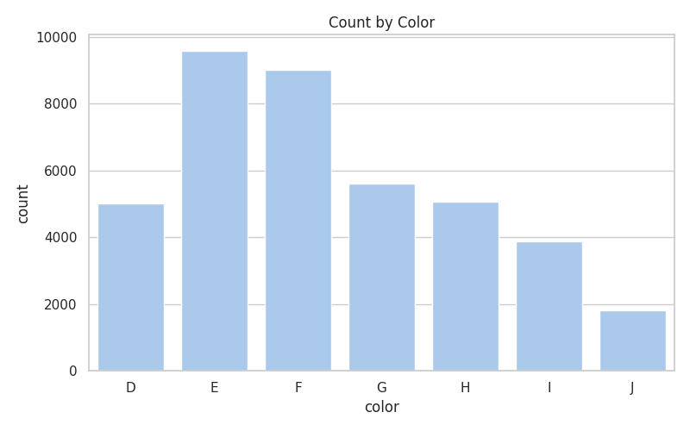
The chart displays the count of sales value broken down by color.

Mean by Color
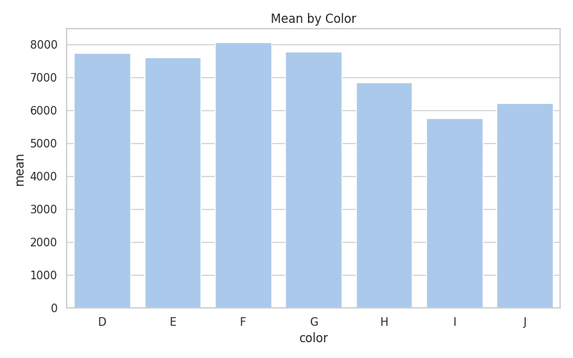
The chart displays the mean of sales value broken down by color.

Sum by Color
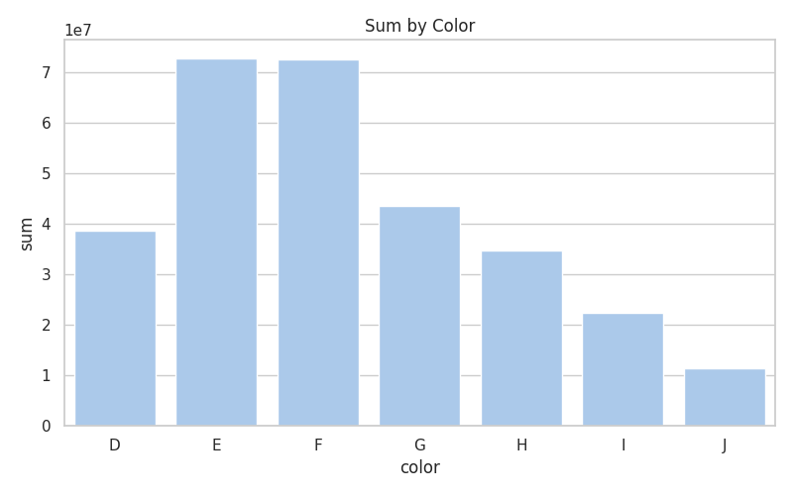
The chart displays the sum of sales value broken down by color.

Analysis by Clarity

Count by Clarity
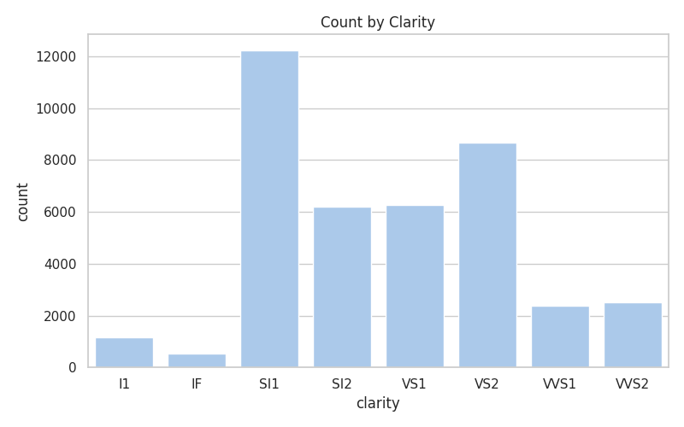
The chart displays the count of sales value broken down by clarity.

Mean by Clarity
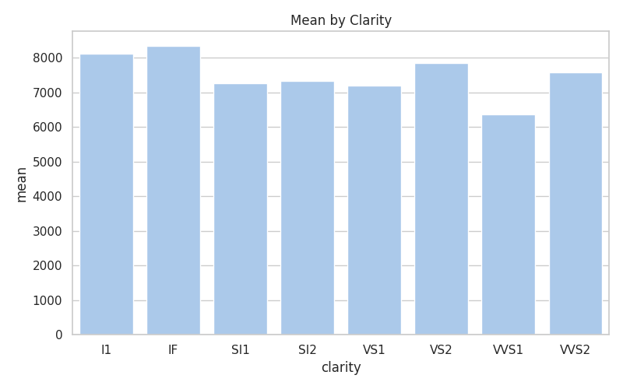
The chart displays the mean of sales value broken down by clarity.

Sum by Clarity
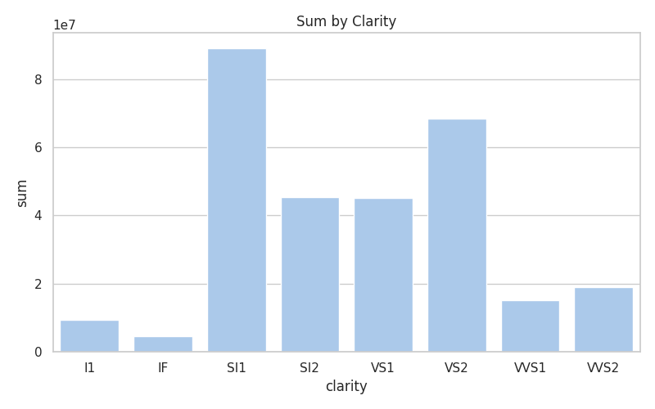
The chart displays the sum of sales value broken down by clarity.

