Can electrical stimulation replace spontaneous seizures in epilepsy surgery?
William K.S. Ojemann^{1,2}, Caren Armstrong^{3,4}, Akash Pattnaik^{1,2}, Nina Petillo^{1,5}, Mariam Josyula^{1,5}, Alexander Daum⁶, Daniel J. Zhou^{1,5}, Joshua LaRocque^{1,5,7}, Jacob Korzun⁵, Catherine V. Kulick-Soper⁵, Eli J. Cornblath^{1,5}, Sarita Damaraju^{1,8}, Russell T. Shinohara^{9,10}, Eric D. Marsh³, Kathryn A. Davis^{1,2,5}, Brian Litt^{1,2,5}, Erin C. Conrad^{1,5}

- Center for Neuroengineering and Therapeutics, University of Pennsylvania, Philadelphia, PA 19104, USA
- Department of Bioengineering, University of Pennsylvania, Philadelphia, PA 19104, USA
- Children's Hospital of Philadelphia, Division of Neurology, Philadelphia, PA 19104, USA
- Department of Neurology, University of California, Davis, Sacramento, CA, 95817, USA
- Department of Neurology, University of Pennsylvania, Philadelphia, PA 19104, USA
- Department of Neuroscience, University of Pennsylvania, Philadelphia, PA 19104, USA
- Department of Neurology, Medical College of Wisconsin, Milwaukee, WI 53226, USA
- Perelman School of Medicine, University of Pennsylvania, Philadelphia, PA 19104, USA
- Penn Statistics in Imaging and Visualization Center, Department of Biostatistics, Epidemiology and Informatics, University of Pennsylvania, Philadelphia, PA 19104, USA
- AI2D: Center for AI and Data Science For Integrated Diagnostics, University of Pennsylvania, Philadelphia, PA 19104, USA

Correspondence may also be addressed to: William K.S. Ojemann, Department of Bioengineering, University of Pennsylvania, 240 South 33rd Street, Hayden Hall, Room 301 Philadelphia, PA 19104, USA Email: wojemann@gmail.com

ORCID IDs
WKSO: 0009-0007-5166-536X
CA: 0000-0001-8010-0850
AP: 0000-0002-2474-1685
NP:
MJ: 0009-0007-4999-966X
AD:0009-0000-5447-1404
DZ: 0000-0002-0154-8348
JL: 0000-0002-3697-9965
JK: 0009-0006-9167-3244
CVKS: 0000-0002-8541-5912
EC: 0000-0002-2619-8778
SD:
RTS: 0000-0001-8627-8203
EDM:0000-0003-3264-0902
KAD: 0000-0002-7020-6480
BL: 0000-0003-2732-6927
EC: 0000-0001-8910-1817

ABSTRACT
Seizures are often induced by electrical stimulation (stim seizures) during intracranial EEG (iEEG) evaluation for epilepsy surgery, but their value for localizing seizure generating tissue remains unclear. We compared 441 low-frequency (1 Hz) stim and spontaneous seizures in a multi-center cohort of 105 patients using a novel, state-of-the-art validated automated seizure mapping algorithm. We found that stim seizures recruit a smaller, more spatially restricted network than spontaneous seizures that overlaps with their onset and propagation. Stim seizures with habitual semiology exhibited onset zones indistinguishable from spontaneous seizures. Both clinically habitual and non-habitual stim seizure onset zones were rapidly recruited during spontaneous seizures, suggesting that they arise from hyperexcitable, epileptogenic, tissue. Stim seizures preferentially originated from pathological mesial temporal structures, especially in adult-onset epilepsy. We propose that stimulation mapping has potential to supplant recording spontaneous seizures, and hypothesize that the method may identify portions of epileptic networks susceptible to seizure recurrence after focal interventions.

INTRODUCTION
One-third of patients with epilepsy have seizures that cannot be controlled by medications (Engel 2016). Surgery offers their best chance for seizure freedom (Wiebe et al. 2001). In the case of hard-to-localize epilepsy, clinicians often pursue intracranial EEG (iEEG) recordings, in which patients are monitored for 1-3 weeks with the goal of capturing multiple spontaneous seizures (King-Stephens et al. 2015). Epileptologists identify the seizure onset zone (SOZ) from these seizures, and use these data, along with ancillary information such as interictal spikes, imaging, and clinical semiology, to guide the location and type of surgery. Around 40-60% of patients have seizure recurrence following this lengthy process, suggesting that the SOZ as mapped by these techniques frequently mis-localizes the epileptogenic zone, the brain regions that must be removed to achieve seizure freedom (Noe et al. 2013; Wiebe et al. 2001). There is a great unmet need to reduce the morbidity, cost, and duration of surgical planning and to improve seizure freedom rates.
Epileptologists often perform electrical cortical stimulation in patients undergoing iEEG. Cortical stimulation can be performed both to identify eloquent cortex (Uematsu et al. 1992; Ojemann 1991; Hara et al. 1991) and to attempt to induce seizures to supplement spontaneous seizures in surgical planning (Kovac, Kahane, and Diehl 2016). There is evidence that reproducing a patient’s typical electroclinical seizure pattern with stimulation adds confidence to localizing the epileptogenic zone (Tardy 2017; Kovac, Kahane, and Diehl 2016; Bancaud and Chauvel 1987; P. Kahane et al. 1993; Chauvel et al. 1993; Landré et al. 2004; Bernier et al. 1990; Philippe Kahane et al. 2006). This hypothesis is supported by the finding that patients with clinically habitual stimulation-induced (stim) seizures—particularly those induced by low-frequency stimulation (Trebuchon et al. 2021)—have higher postoperative seizure freedom rates (Trebuchon et al. 2021; Oderiz et al. 2019; Kämpfer et al. 2020; Sivaraju et al. 2024).
Despite this supportive evidence, major questions limit the clinical utility of stim seizures in surgical planning: (1) How do we know if a stim seizure is electroclinically typical? Currently, defining whether a stim seizure is typical relies on visually examining clinical semiology and EEG spread pattern (Kovac, Kahane, and Diehl 2016; Tardy 2017), which is time-consuming for seizures with complex spread patterns and impractical for large datasets. A tool to map the electrophysiological correspondence between stimulated and spontaneous seizures would have immediate clinical utility and would also help answer important additional remaining questions about the mechanisms and clinical relevance of stim seizures. (2) How similar are stim seizures and spontaneous seizures, and what features predict similarity? Answering this question informs whether stim seizures could potentially replace spontaneous seizures in surgical planning, shortening intracranial evaluations. Finally, (3) Why does eliciting a clinically habitual stim seizure portend a good surgical outcome? Understanding if these stim seizures arise from the primary seizure generating tissue, which may vary over time, or a broader epileptogenic network could clarify their role in presurgical mapping. They might also offer an opportunity to prophylactically treat regions with a high likelihood of seizure recurrence simultaneously with an initial intervention.
To answer these questions, we examined a multi-center cohort of 105 patients who underwent low-frequency cortical stimulation during iEEG recording. We developed an automated seizure annotation algorithm to detect and localize seizure onset and spread to both stim and spontaneous seizures with near-human performance. We compared spatial patterns of seizure onset and spread, quantified electrographic similarity, and evaluated clinical and demographic predictors of concordance between stim and spontaneous seizures (Figure 1).

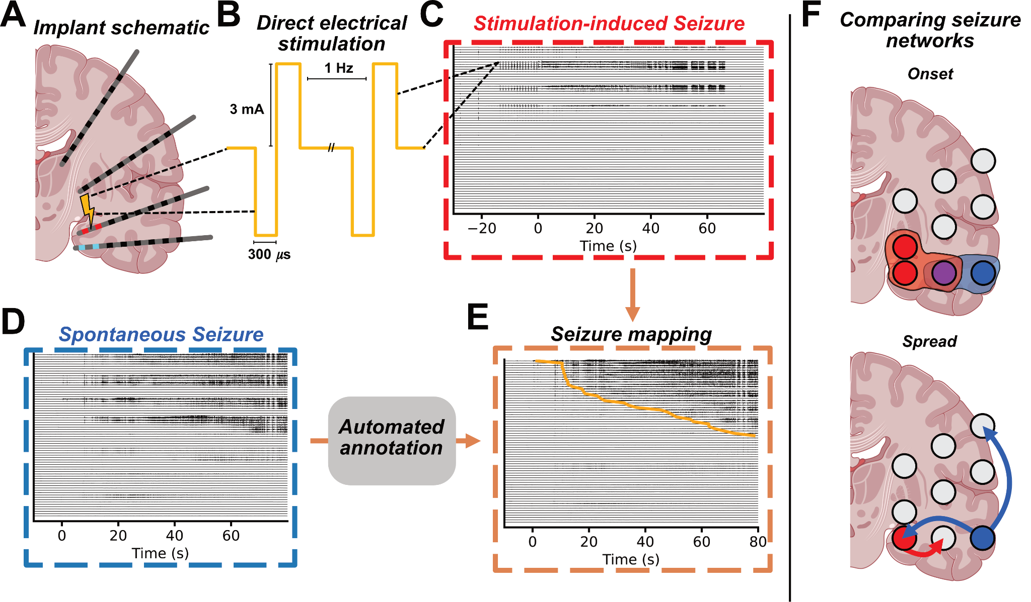
Figure 1: Quantitative analysis of stimulation induced and spontaneous seizures. A) Schematic of intracranial EEG electrodes with the stimulating bipolar pair (yellow bolt) and stim seizure onset zone (red), and spontaneous seizure onset zone (blue). B) Sample stimulation waveforms with the most frequently used set of stimulation parameters. Stimulation-induced (C) and spontaneous (D) seizures from the same patient. E) Spontaneous seizure channels sorted by our automated seizure annotation algorithm (Figure 2). F) Schematic showing comparisons between spontaneous (blue) and stimulation-induced (red) seizure networks based on overlapping (purple) onset zones (upper image) and rank-based spread pattern similarity (lower image).

METHODS

Patient population
We retrospectively analyzed 105 patients with drug-resistant epilepsy who underwent intracranial EEG (iEEG) monitoring and low-frequency electrical stimulation across two centers: the Hospital of the University of Pennsylvania (HUP, N = 55) and the Children’s Hospital of Philadelphia (CHOP, N = 50). Stimulation was performed under IRB-approved research (14 HUP patients; all CHOP patients) or clinical protocols (HUP, N = 41). SOZ localization to mesial temporal lobe epilepsy (MTLE) vs non-mesial temporal lobe epilepsy (nMTLE) was determined by the clinical team and confirmed in surgical case conference. Some patients had multifocal onsets. We defined a patient as having MTLE if any seizures began in the mesial temporal structures. One-year International League Against Epilepsy (ILAE) surgical outcomes were determined by a board-certified epileptologist (HUP: EC; CHOP: CA) (Table 1) (Wieser et al. 2001).

Intracranial recording
Patients were implanted with subdural grid, strip, and/or depth electrodes based on clinical needs (HUP: manufactured by Ad-Tech corporation, Oak Creek, WI; CHOP: manufactured by PMT corporation, MN, USA or DIXI medical, USA). Signals were recorded using a Natus Quantum system (sampling rate: 512–2048 Hz) and referenced to an electrode contact placed in presumed non-epileptogenic tissue, typically medullary bone.

Electrode registration
The post-implant head CT was co-registered to the pre-implant brain MRI and segmented using ANTsPyNet and ieeg-recon (Lucas et al. 2024; Tustison et al. 2021) (HUP) or Gardel software (Medina Villalon et al. 2018) with subsequent atlas segmentation performed in Freesurfer (Fischl 2012) (CHOP). Electrodes were then assigned to the nearest region label in the Desikan-Killiany-Tourville (DKT) atlas (Desikan et al. 2006).

Brain stimulation protocol
At HUP, stimulation was delivered at 1 Hz, with a 300–500 μs pulse width at 3 mA (11.1–18.5 μC/cm²). CHOP stimulation parameters varied from (1–2 Hz, 300–500 μs, 1–8 mA; 17.9–59.7 μC/cm²). Adjacent bipolar pairs in neural tissue were stimulated unless they demonstrated high amplitude artifact or if time constraints from clinical care necessitated sampling every other pair. Stimulation sessions typically were halted upon inducing a clinical seizure with impaired consciousness. Additional details about stimulation parameters are available in the supplementary material.

Stimulation artifact interpolation
To minimize artifacts from low-frequency stimulation, we applied a validated interpolation method (Huang et al. 2019). Stimulation pulses were detected using the SciPy peak finding function on the absolute difference of the signal from the mesial contact of the bipolar stimulating pair (Virtanen et al. 2020). Data from −50 to +100 ms around each pulse was replaced with a tapered blend of adjacent signal segments (Figure S1). Additional validation for this approach, including signal reconstruction metrics, is provided in the supplementary material.

Seizure dataset and preprocessing
Seizures were extracted with ±120 s buffers from the clinically-annotated onset time and downsampled to 512 Hz, stored in iEEG-BIDS format (Holdgraf et al. 2019). Channels registered outside the brain were excluded. Stimulation artifacts were then interpolated, the data were re-referenced in a bipolar montage, and noisy channels were removed (supplementary material).

Clinical annotation of seizure onset channels for model validation
Eighty seizures (36 stim, 44 spontaneous) from 29 patients (CHOP: 10, HUP: 19) were annotated by 1 (16), 2 (2), 3 (57), or 5 (10) trained epileptologists to validate and tune an automated annotation model. The epileptologists underwent two training sessions led by B.L. and E.C. to standardize clinical annotations. Onset time was defined as the first unequivocal electrographic change (Litt et al. 2001); onset channels were those with electrographic seizure activity within 1 second of this time. Consensus was obtained via majority vote. For seizures with more than 1 rater, inter-rater agreement was quantified using average Matthews correlation coefficient ($ϕ$), chosen for its robustness to class imbalance (Chicco and Jurman 2023; Chicco, Tötsch, and Jurman 2021). Median onset time across raters was used as ground truth.

Automated seizure annotation
We developed an algorithm called Neural Dynamic Divergence (NDD) to compute time-varying seizure likelihood per channel (Figure 1A). For each seizure, NDD models baseline activity using an autoregressive long short-term memory model trained on preictal data (−120 to −60 s) and quantifies abnormality as prediction error. Loss values were computed for each channel in 1 s windows (0.5 s overlap). For seizures not annotated per the above protocol, onset time was determined by a board-certified epileptologist as part of routine clinical care. More details about the seizure annotation algorithm are available in the supplementary material.
To classify onset channels, we swept feature value thresholds from 0–4 and compared NDD predictions to clinician consensus (Figure 1B) using the Matthew’s correlation coefficient,
$ϕ = \frac{TP × TN - FP × FN}{\sqrt{(TP + FP)(TP + FN)(TN + FP)(TN + FN)}}$,
where the positive class is a clinician annotated seizure onset channel and TP, TN, FP, and FN refer to the elements of a confusion matrix (Chicco and Jurman 2023; Chicco, Tötsch, and Jurman 2021). Per-patient thresholds were selected separately for stim and spontaneous seizures to maximize average agreement (Figure 1C). Detected seizure activity was smoothed using a 10 s moving median and majority voting over 5 s windows. Channels with seizure activity were then mapped to DKT regions. We defined a region as seizing when the seizure spread to any channel within the region.

Model validation for seizure onset channel annotation
We evaluated model agreement with clinician consensus and interrater agreement using the Matthew’s correlation coefficient, $ϕ$ (Chicco and Jurman 2023; Chicco, Tötsch, and Jurman 2021). We compared the NDD algorithm against two benchmark models using patient-tuned thresholds: a WaveNet based deep learning univariate seizure detector previously applied to seizure annotation (DL) (Revell et al. 2022) and the absolute slope of the EEG time-series, a commonly used univariate seizure onset localization feature (Schindler et al. 2007). We also compared the NDD algorithm against the inter-rater agreement on the subset of seizures annotated by more than one clinician annotator.

Electrographic seizure similarity
We quantified seizure similarity using automated annotations of onset and spread of both channels and regions. Onset similarity was computed using the Matthews correlation coefficient ($ϕ$) between the sets of channels or regions active within 1 second of electrographic onset (Figure 2A,B). For stim seizures, stimulating channels were included in the onset zone, consistent with prior work showing these regions may be epileptogenic (Oderiz et al. 2019), and because we observed that stimulation artifact can obscure early seizure activity in these channels. Spread similarity was calculated as the Spearman rank correlation (ρ) between channel or region latencies; each region was assigned the earliest latency among its channels. Channels active in only one seizure were assigned a tied rank equal to the latest latency + 1 s.
We computed all pairwise similarity values within each patient and summarized stim–spontaneous and spontaneous–spontaneous similarity using the 75th percentile. The 75th percentile was chosen to emphasize the more concordant seizure pairs in patients with multifocal seizure onsets. As a control, seizure onset similarity was also computed using clinician-annotated onsets (see Supplementary Material, Figure S2).

Modeling predictors of seizure onset similarity
To identify clinical factors associated with greater similarity between stimulation-induced and spontaneous seizure onsets, we used the 75th percentile of $ϕ$ for each stim seizure, for each participant, as the outcome. We first tested whether stim seizures with habitual semiology more closely matched spontaneous SOZs. A stim seizure was classified as clinically habitual or non-habitual by the clinical team in the Epilepsy Monitoring Unit based on their resemblance to the patient’s typical spontaneous seizures. This determination incorporated input from the patient and family, as well as visual review of video recordings, and was based on concordance with the patient’s usual seizure onset and behavior during the event (semiology). Seizures that reproduced only the habitual aura—without progressing to more severe typical symptoms—were also considered habitual, given their association with favorable surgical outcomes (Trebuchon et al. 2021). We compared onset similarity ($ϕ$) between habitual and non-habitual stim seizures directly and with a linear model including a center × habituality interaction to test if the effect varied across centers (HUP vs CHOP).
Next, given prior evidence that low-frequency stimulation preferentially elicits seizures in the mesial temporal lobe (P. Kahane et al. 1993), we tested whether stim-spontaneous similarity was higher in patients with mesial temporal lobe epilepsy (MTLE). MTLE localization was determined by a board-certified epileptologist as part of standard clinical care. We compared $ϕ$ between MTLE and nMTLE directly and with a linear model including a center x MTLE interaction. As a post-hoc analysis to identify potential biological drivers upon finding site-level differences, we assessed interactions between MTLE and age at onset, age at implant, and epilepsy duration binarized by the median value.

Quantifying seizure spread
We assessed whether the stim seizure onset zone (SOZ) was part of the early-spread network of spontaneous seizures. For each stim–spontaneous seizure pair, we measured (1) total recruitment as the cumulative percentage of stim SOZ channels active in the spontaneous seizure, and (2) recruitment latency as the median latency across those channels.
Each stim seizure was summarized using the 75th percentile of total recruitment and the 25th percentile of recruitment latency. To test if total recruitment was higher and if recruitment latency was lower in the stim SOZ than expected by chance, we studied a distribution of 100 null stim SOZs generated via random sampling of non-artifactual channels localized to brain tissue and assessed significance via permutation testing. To understand whether stim SOZs identified potentially epileptogenic tissue, we next tested whether recruitment latency to the stim SOZ was significantly lower than 10 seconds using a Wilcoxon sign-rank test, based on prior work identifying seizure spread within 10 seconds as a marker of epileptogenicity (Revell et al. 2022; Andrews et al. 2020, 2019; Spencer et al. 1990; Lieb, Engel, and Babb 1986).

Statistical methods
Values were reported as median, and 25th and 75th percentile and compared using two-tailed tests. When describing stim seizure incidence (Table 1) in our whole patient population, we employ either a chi-squared test or a Fisher’s exact test—if an element in the contingency table contained < 5 samples—of differences for categorical variables and an ANOVA for continuous variables. To minimize assumptions about our other distributions, we use the non-parametric Mann-Whitney U test and Wilcoxon signed rank test for independent and dependent groups respectively. When comparing groups with repeated measures per patient, we used linear mixed-effects models (LMEs) with a random intercept for each patient with Satterthwaite-corrected degrees of freedom. We use the same LME, random intercept, and correction to analyze differences in model performance. Comparisons between nested mixed-effects models were performed using a likelihood ratio test with Kenward-Roger corrected degrees of freedom. In the case that we observed zero variance in the random intercept (no patient effect) we then fit an ordinary least squares regression model (OLS) and compared models using an ANOVA. All LME and OLS models were fit and analyzed in R (Core Team 2020) using lme4 (Bates et al. 2015), and lmerTest (Kuznetsova, Brockhoff, and Christensen 2017) and pbkrtest (Halekoh and Højsgaard 2014) for degrees of freedom correction. When testing multiple contrasts within a linear model, we report Bonferroni-adjusted (# comparisons) to control the type 1 error rate. In all tests, we use an alpha of 0.05 to determine statistical significance. In all plots p-values are denoted using the following abbreviations: ns – p $≥$0.05 (not significant), * – p < 0.05, ** – p < 0.01, *** – p < 0.001, **** – p < 0.0001. We report p values unless p < 0.0001.

RESULTS

Demographics
Stimulation induced seizures were elicited in 36% of the 105 patients who received low-frequency stimulation across two centers, similar to previous reports of stimulation induced seizures (Trebuchon et al. 2021; Oderiz et al. 2019; Kämpfer et al. 2020; Sivaraju et al. 2024). Induction rates were not significantly associated with sex, center, presence of imaging abnormalities, focality, epilepsy duration, or percentage of stimulated sites (all p > 0.1). However, patients with a clinical diagnosis of MTLE were significantly more likely to exhibit a stim seizure ($χ$² (1, N = 99) = 8.24, p = 0.004; Table 1). Of the 38 patients with a stim seizure, 4 had no recorded spontaneous seizures while 4 patients had technical issues preventing the acquisition of their spontaneous seizure recordings. Thirty patients had ≥1 spontaneous seizure, enabling within-subject comparison of stimulation- and spontaneous-onset zones. A total of 28 had ≥2 spontaneous seizures, allowing estimation of intra-patient spontaneous seizure variability.
Among the 45 patients with surgical outcome data, 8 of 13 patients with a clinically typical stim seizure were seizure free (ILAE 1,2), while 1 of 3 patients with an atypical stim seizure and 18 of 29 patients with no stim seizure were seizure free. There was no significant association between postoperative seizure freedom and either the presence or absence of any stim seizure ($χ$²(1, N = 45) = 0.19, p = 0.66), the presence or absence of a typical stim seizure ($χ$²(1, N = 45) = 0, p = 1.00), or comparing patients with a typical stim seizure and those with an atypical stim seizure (Fisher’s exact (2x2, N = 16), OR = 3.2, p = 0.55). While prior studies report a significant association (Trebuchon et al. 2021; Oderiz et al. 2019; Kämpfer et al. 2020; Sivaraju et al. 2024), our analyses are limited by a relatively small cohort size of patients with surgical outcome data.
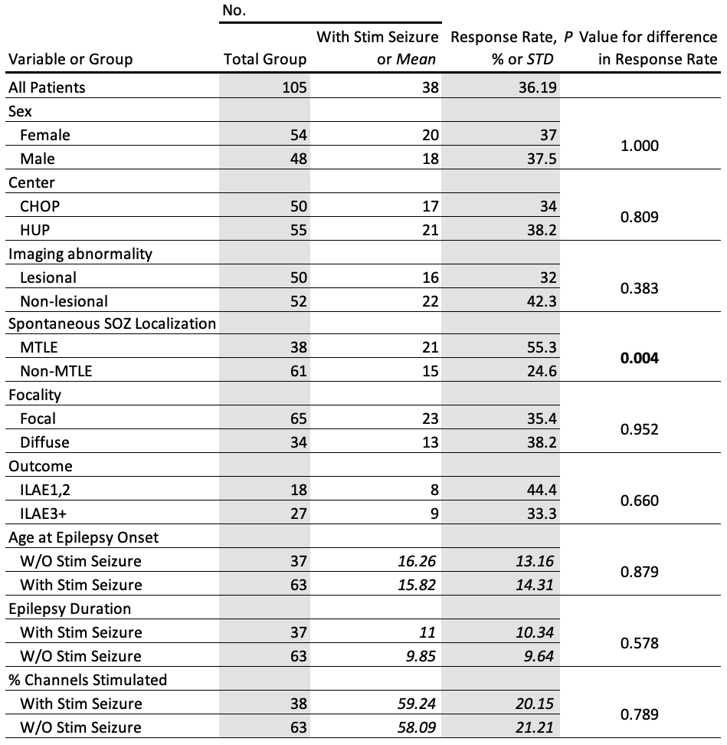
Table 1: Low-frequency stimulation induced seizure incidence rate patient table. All stim seizures, both clinically-typical and atypical, are included in this analysis. For categorical demographic variables, P values are from a chi-square test for significant differences in stim seizure incidence against a null hypothesis of a uniform distribution. For continuous variables – age at epilepsy onset, epilepsy duration, and % channels stimulated – we tested the difference in values between groups using an analysis of variance (ANOVA). Significant comparisons based on an alpha of 0.05 are in bold. Abbreviations: CHOP – Children’s Hospital Of Philadelphia, HUP – Hospital of the University of Pennsylvania, SOZ – Seizure Onset Zone, MTLE – Mesial Temporal Lobe Epilepsy, W/O – Without, STD – Standard Deviation.

Algorithmic seizure annotation validation
Due to the scale of the dataset (441 seizures from 30 patients), we employed a novel, self-supervised, automated seizure onset detector (NDD) to annotate channel-level ictal activity (Figure 2A). We optimized thresholds to maximize agreement with an expert clinician consensus (Figure 2B) for each patient separately and found that optimal thresholds were more variable for stim seizures compared to spontaneous ones (Spontaneous, Stim N = 22, 30; Levene F = 13.3, p = 0.0006; Figure 2C). To minimize overfitting, we applied a population-average spontaneous threshold across all patients for final annotations.
The seizure onset annotations generated by the NDD algorithm correlated strongly with clinician annotations with a median $ϕ$ of 0.57 [0.38, 0.70]. NDD outperformed both univariate ($ϕ$, 0.40 [0.22, 0.62]) and deep learning-based ($ϕ$, 0.44 [0.27, 0.65]) seizure detection methods in matching expert-defined SOZs (Seizures N = 81; $β$ = 0.13, SE = 0.03, t(32.17) = 4.41, p = 0.0003, and $β$ = 0.09, SE = 0.02, t(80.0) = 3.86, p = 0.0006; Satterthwaite corrected and Bonferroni adjusted (3); Figure 2D) demonstrating state-of-the-art performance. While NDD trended lower than inter-rater agreement levels ($ϕ$, 0.70 [0.48, 0.82]; Seizures N = 65; $β$ = 0.09, SE = 0.04, t(22.32) = 2.52, p = 0.06, Satterthwaite corrected and Bonferroni adjusted (3); Figure 2D), NDD performed similarly on stim and spontaneous seizures (Spontaneous, Stim N = 44, 37; $β$ = -0.02, SE = 0.05, t(71.03) = -0.324, p = 0.747, Satterthwaite corrected; Figure 2E), supporting its use for comparative analyses.
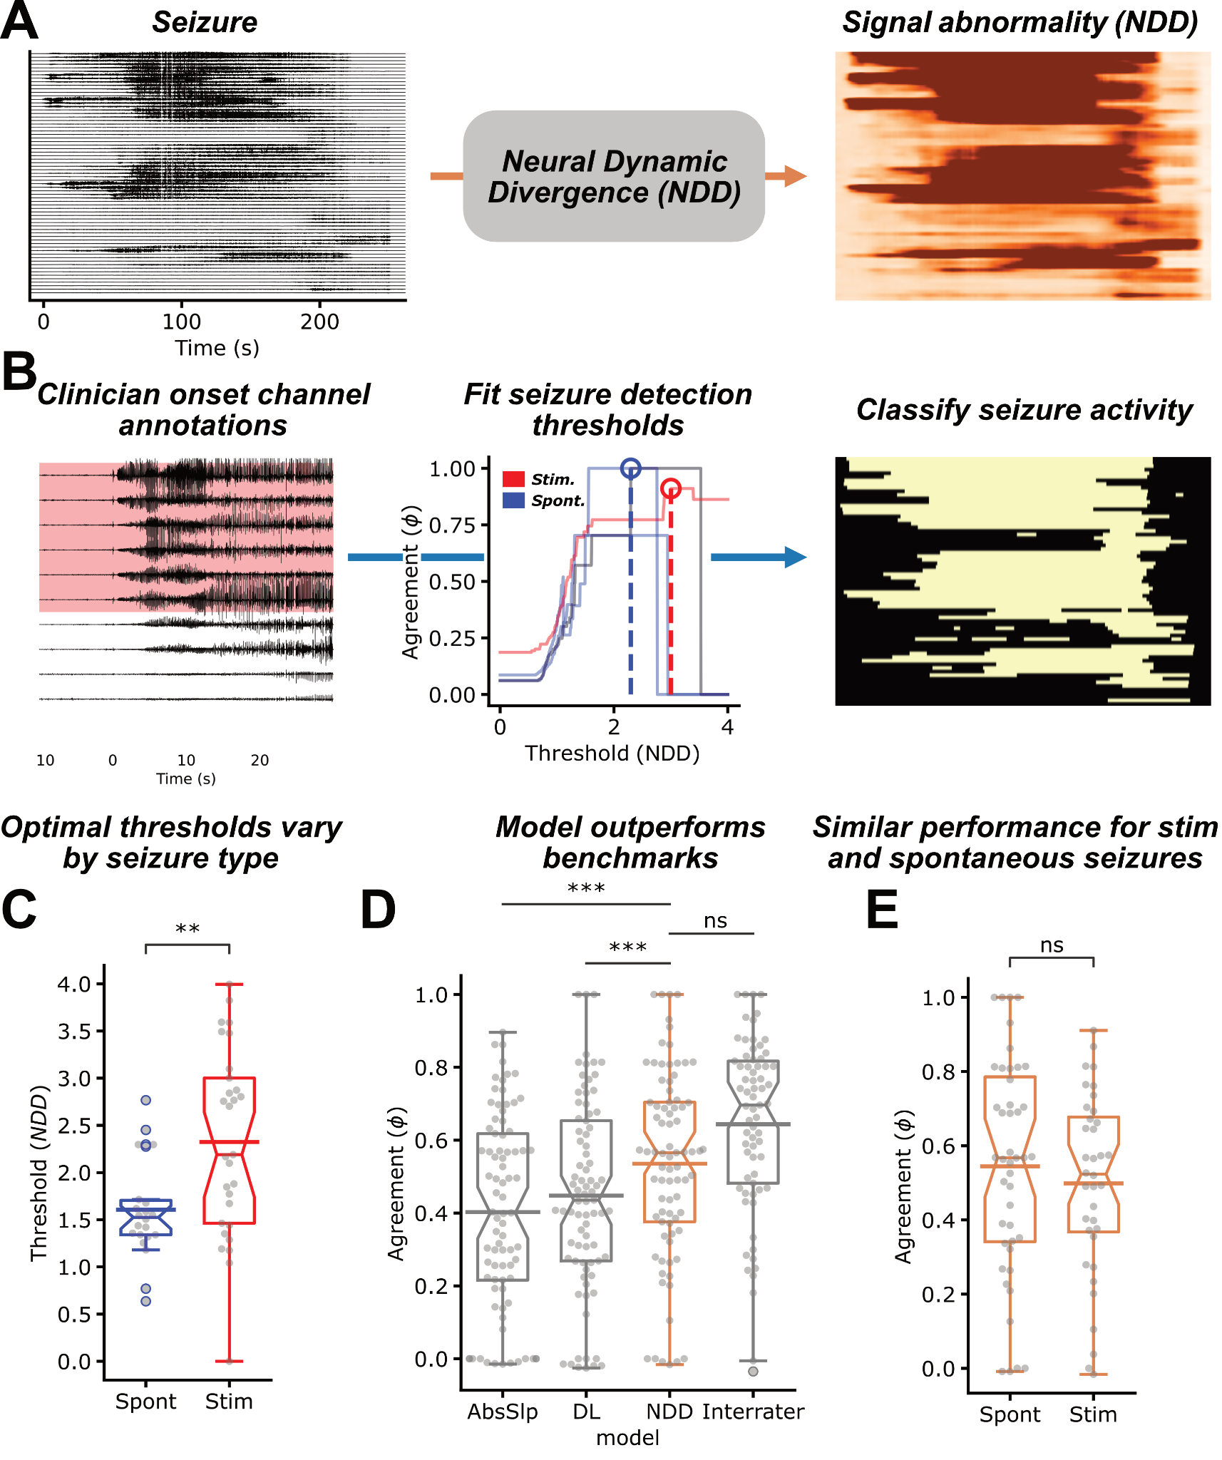
Figure 2: Automated seizure annotation. A) Focal onset seizure recorded on iEEG electrodes and the resulting seizure likelihood values generated using the NDD algorithm (orange). B) Expert clinician annotations of seizure onset channels, which were used to tune the optimal interictal-ictal boundary thresholds at a patient level. Optimal thresholds (dashed lines) are independently learned for stim (red) and spontaneous (blue) as the minimum threshold that maximizes agreement with clinician consensus annotations. C) Optimal stim thresholds were significantly higher and more variable than spontaneous ones, validating the need for independent thresholds. D) Model agreement with clinician annotations. The NDD algorithm (orange) outperformed the DL and AbsSlp benchmarks, and approached interrater agreement (gray, right). Interrater agreement was calculated as the average $ϕ$ between clinicians per seizure. Each sample represents a seizure annotated by a given model (N = 81) or by > 1 annotator (N = 65). E) No significant differences in NDD performance were detected between stim and spontaneous seizures. Abbreviations: NDD – neural dynamic divergence, Stim – stimulation induced, Spont – spontaneous, DL – deep learning, AbsSlp – absolute slope, see statistical methods for significance markers.

Stim seizures involve a smaller network than spontaneous seizures
We compared the spatial extent of stim and spontaneous seizures using automated onset and spread annotations (Figure 3A). Stim seizures tended to recruit a smaller fraction of the implanted network throughout their duration than spontaneous seizures (Stim, Spontaneous N = 43, 398; % channels: 26 [15, 38] vs. 44 [20, 71]; $β$ = 12.2, SE = 3.4, t(423.14) = 3.6, p = 0.0004, Satterthwaite corrected; Figure 3B). Despite this, stim seizures tended to involve a broader initial onset zone than spontaneous seizures (Stim, Spontaneous N = 43, 398; % onset channels: 8 [4, 16] vs 5 [2, 10]; $β$ = -5.7, SE = 1.5, t(433.33) = 3.8, p = 0.0002, Satterthwaite corrected; Figure 3C) (Oderiz et al. 2019; Trebuchon et al. 2021). However, stim seizures engaged fewer additional channels over time (Stim, Spontaneous N = 43, 398; % channels: 14 [7, 24] vs. 34 [14, 49]; $β$ = 17.6, SE = 3.28, t(424.43) = 5.4, p < 0.0001, Satterthwaite corrected; Figure 3D), suggesting that although stim seizures have broader onset, they remain more spatially confined than spontaneous seizures.
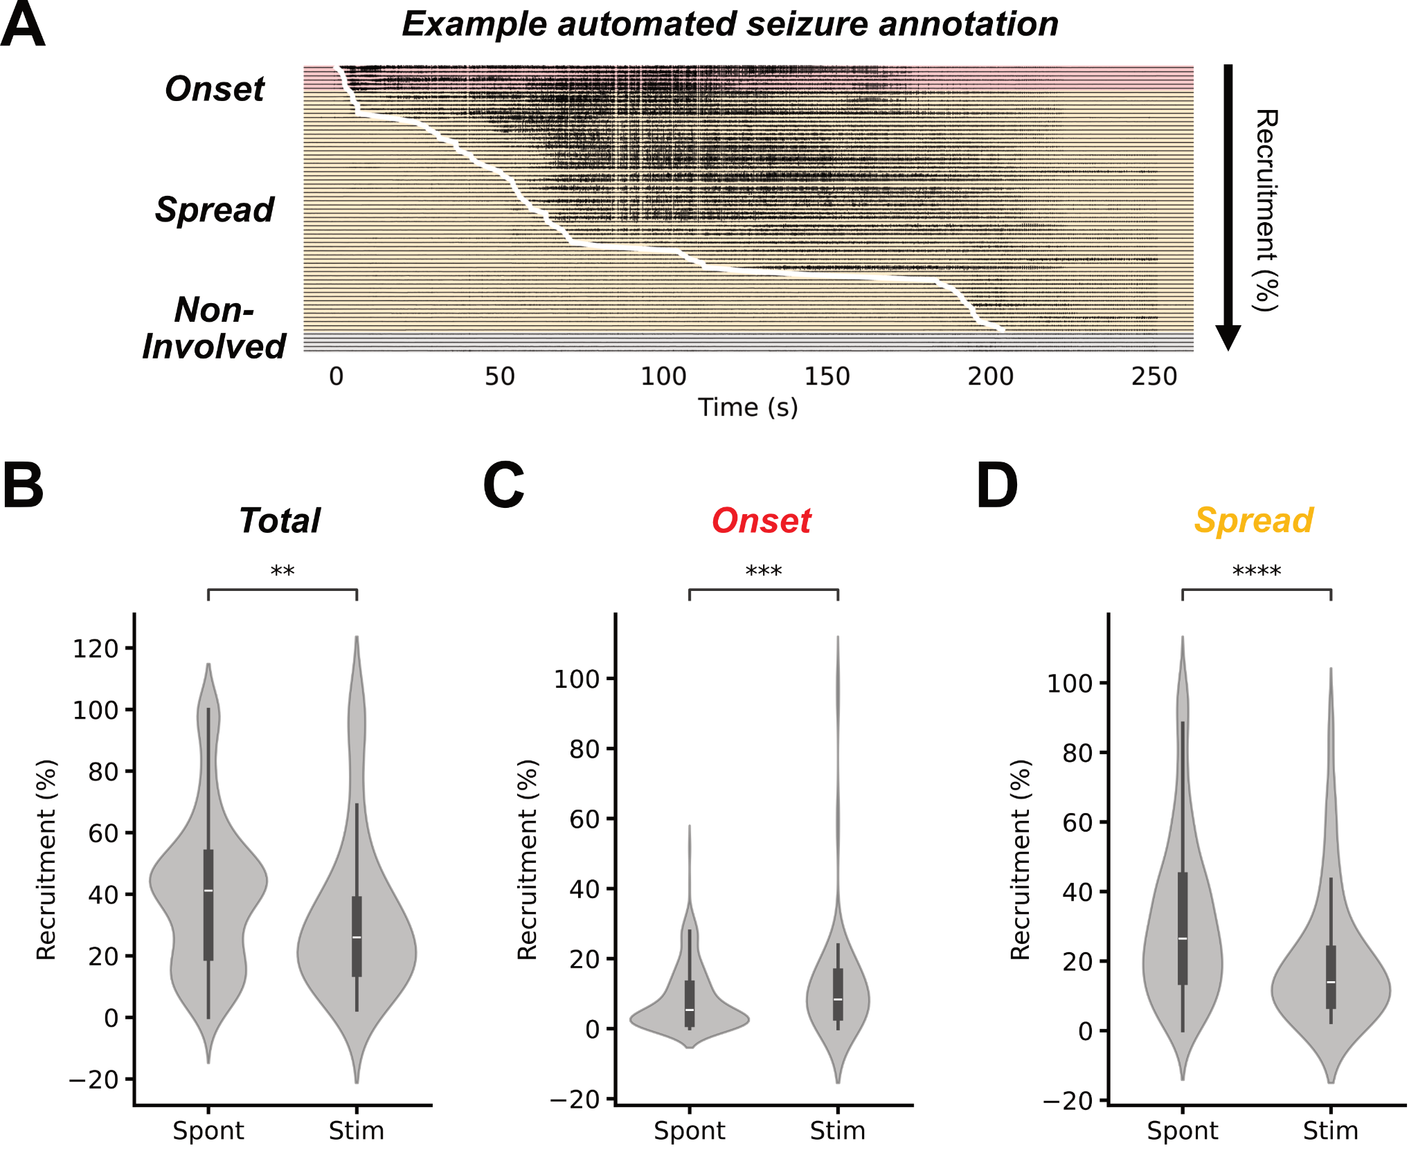
Figure 3. Quantifying seizure networks. A) Example seizure annotated using NDD algorithm. Channels are sorted by onset time determined using the patient-tuned thresholds (Figure 1C), with the white trace showing the ictal wavefront. Channels classified as onset (red) and spread (orange) are highlighted. B) Total percent of implanted neural channels recruited by each stim seizure and the median total recruitment of spontaneous seizures from that patient. Percent of implanted neural channels seizing at C) onset and D) later recruited during spread for stim and spontaneous seizures. Abbreviations: Stim – stimulation induced, Spont – spontaneous, see statistical methods for significance markers.

Stim seizures do not reliably map spontaneous onset or spread patterns
We next assessed whether stim seizures have similar onset locations as spontaneous seizures. Because spontaneous seizure onsets can themselves vary, we use each patient’s spontaneous seizure onset agreement as a positive control. For each seizure, we used the algorithmically-annotated onset channels (Figure 3A), and then calculated the onset-zone similarity using $ϕ$ (Figure 4A). Across patients, stim–spontaneous seizure onset similarity (channel $ϕ$, 0.24 [0.0, 0.53]; region $ϕ$, 0.53 [0.16, 0.68]) was significantly lower than spontaneous–spontaneous onset similarity (channel $ϕ$, 0.61 [0.48, 0.74]; region $ϕ$, 0.67 [0.50, 0.78]), both at the channel level (Patients N = 28; Wilcoxon W(28) = 42, p = 0.006; Figure 4B) and regional level (Patients N = 28; Wilcoxon W(28) = 27, p = 0.006; Figure 4C).
We observed a similar dissociation in seizure spread. Stim–spontaneous seizure pairs showed lower spread similarity (channel $ρ$, 0.55 [0.44, 0.66]; region $ρ$, 0.55 [0.39, 0.68]) than spontaneous seizure pairs (channel $ρ$, 0.78 [0.66, 0.83]; region $ρ$, 0.78 [0.60, 0.86]) at the channel (Patients N = 28; Wilcoxon W(28) = 16, p < 0.0001; Figure S3A) and regional level (Patients N = 28; Wilcoxon W(28) = 46, p = 0.0001; Figure S3C). These results suggest that, on average, stim seizures do not precisely match the spatial onset or propagation of spontaneous seizures.

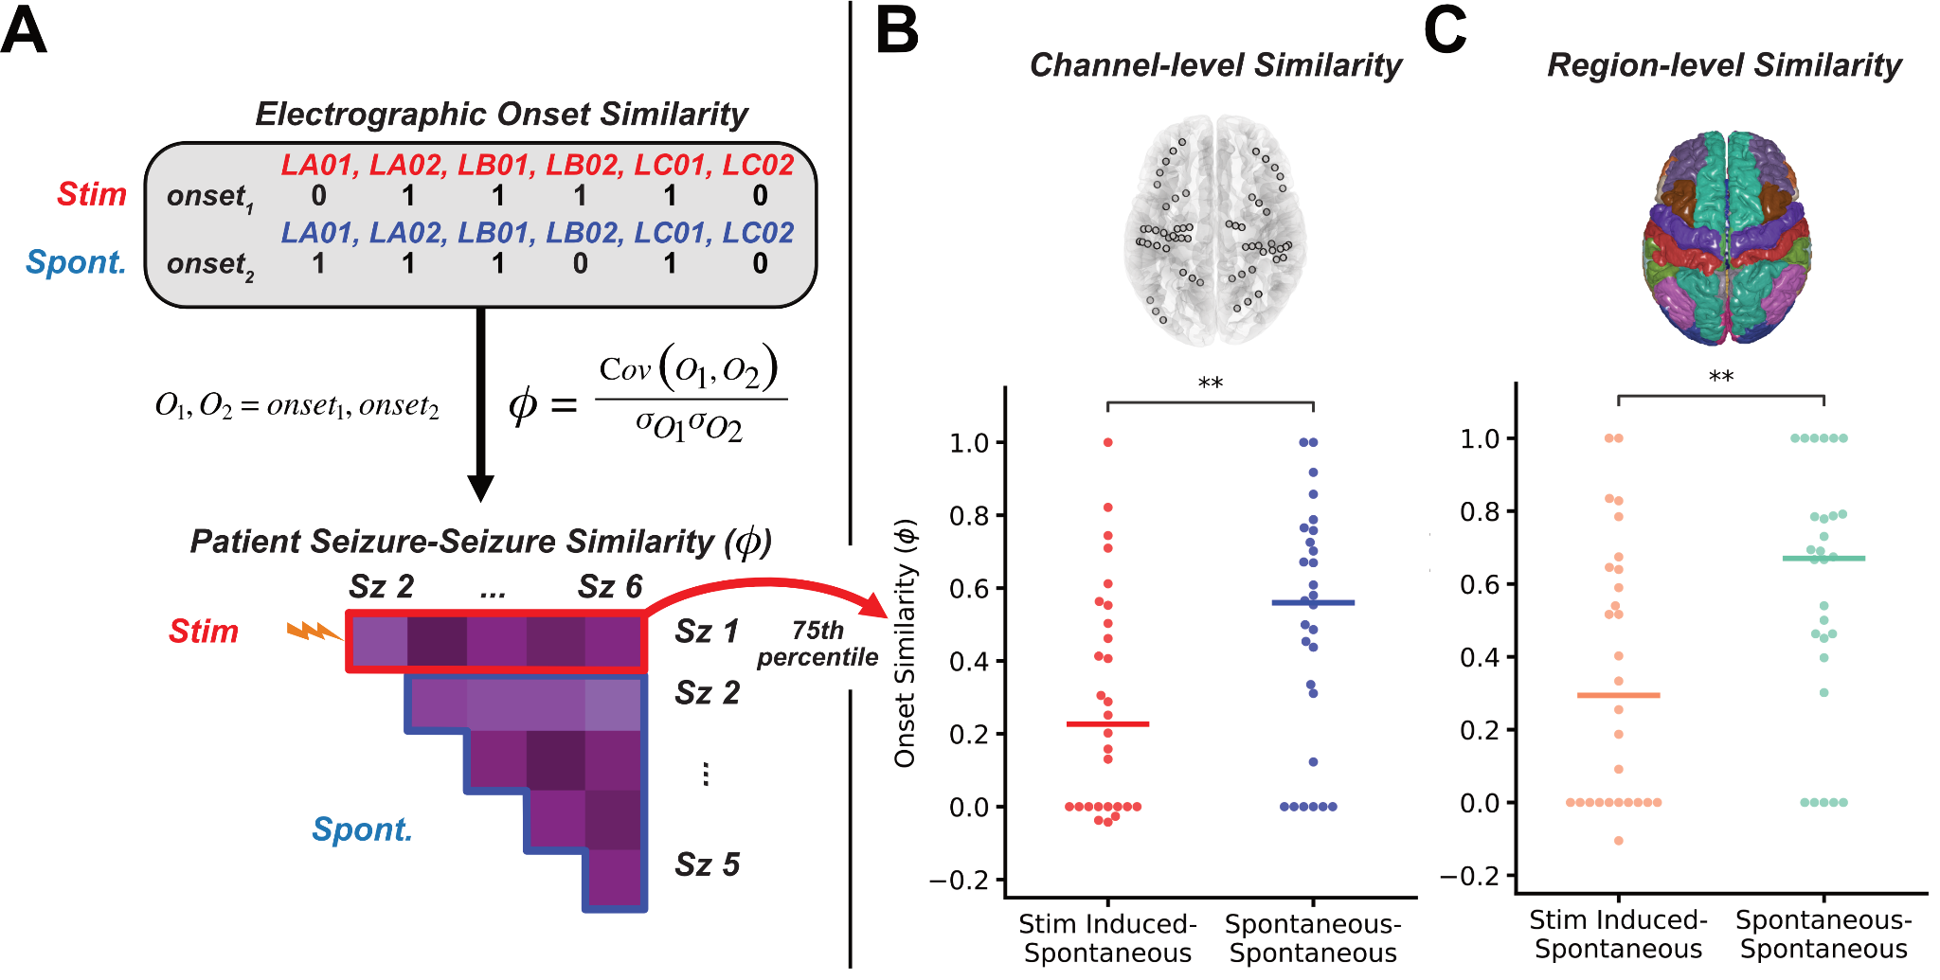
Figure 4: Electrographic seizure onset similarity. A) Example seizure onset (1) vs. non seizure onset (0) channel annotations from a stim (red) and spontaneous (blue) seizure. We then quantified seizure onset similarity between two seizures using Matthews correlation coefficient ($ϕ$); generating the example within-patient seizure similarity matrix. B) Taking the 75th percentile stim-spontaneous (red, orange) and spontaneous-spontaneous (blue, green) onset similarity for each patient we see that stim seizures do not map spontaneous onset channels or regions (C) as well as spontaneous seizures co-localize (Magnotti, Wang, and Beauchamp 2020). Abbreviations: O, onset – binary onset channel vector, Stim – stimulation induced, Spont – spontaneous, see statistical methods for significance markers.

Clinically-habitual stim seizures are electrographically similar to spontaneous seizures
Stim seizures deemed clinically habitual—those resembling the patient’s typical spontaneous seizure semiology—showed greater electrographic similarity to spontaneous events. Among habitual stim seizures, region-level onset similarity to spontaneous seizures was comparable (Patients N = 19; $ϕ$: 0.52 [0.0–0.78] vs. 0.54 [0.30–0.78]; Wilcoxon W(19) = 39, p = 0.40; Figure 4A), whereas non-habitual stim seizures were significantly less similar (Patients N = 12; $ϕ$: 0.0 [0.0–0.09] vs. 0.68 [0.40–0.79]; Wilcoxon W(12) = 0, p = 0.012; Figure 4A). This effect persists when modeled at the channel level (Supplementary Material, Figure S4). Also, habitual stim seizures more closely matched spontaneous onset zones than non-habitual ones (Habitual, Non-habitual N = 25, 18; $ϕ$: 0.55 [0.32–0.71] vs. 0.11 [0.0–0.40]; $β$ = -0.38, SE = 0.10, t(40.9) = -3.63, p = 0.001, Satterthwaite corrected; Figure 4B). Furthermore, we found no significant center:semiology interaction (Kenward-Roger F(2, 29.6) = 0.302, p = 0.74; Figure 4C, Supplementary Material).
On the other hand, both habitual and non-habitual stim seizures exhibited distinct spread patterns compared to spontaneous seizures (Patients N = 28; habitual ρ: 0.55 [0.39–0.68] vs. 0.66 [0.51–0.83], Wilcoxon W(19) = 39, p = 0.023; non-habitual ρ: 0.43 [0.36–0.49] vs. 0.76 [0.58–0.86]; Wilcoxon W(12) = 20, p = 0.001), suggesting that only onset localization—not full ictal dynamics—is reliably reproduced by a typical stim seizure (Figure S3B,D).

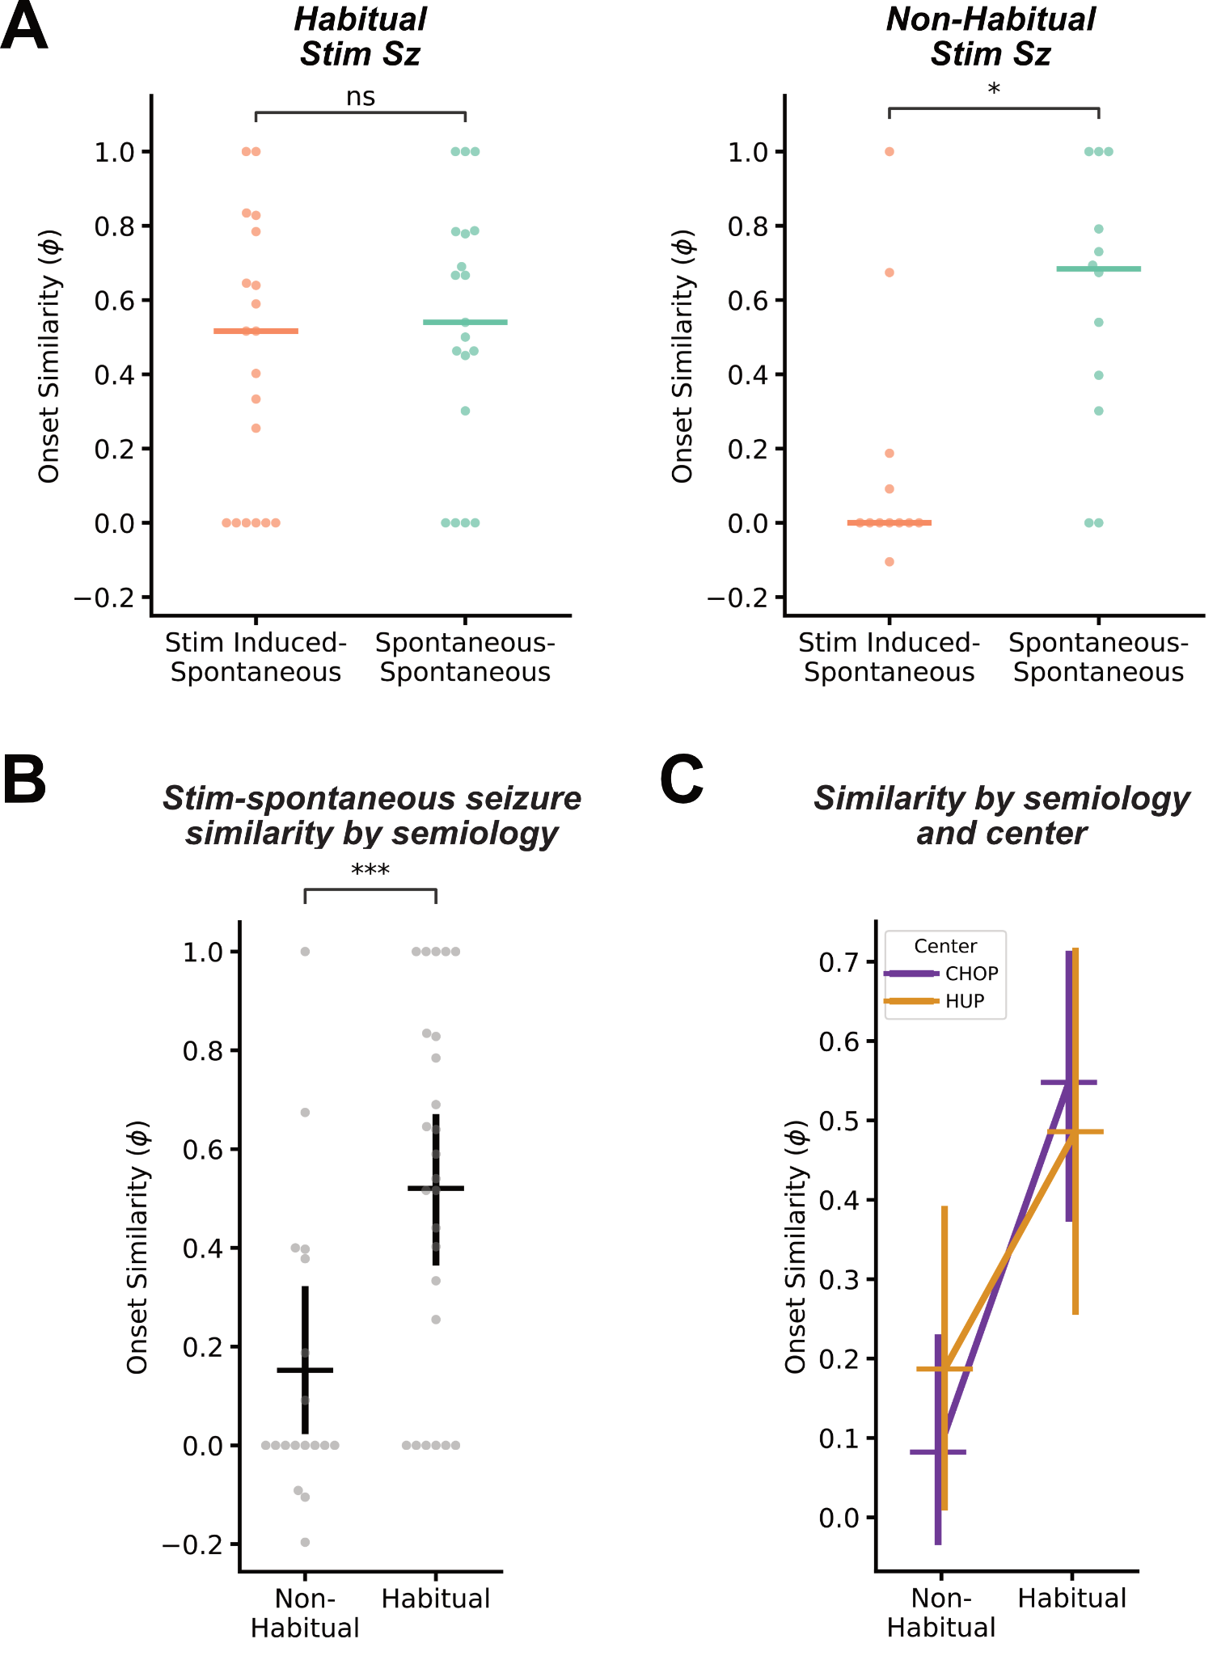
Figure 5. Semiological and electrographic similarity. A) Comparing stim-spontaneous and spontaneous-spontaneous electrographic onset region similarity by the semiology of the stim seizure. Habitual stim seizures showed similar co-localization to spontaneous seizures as spontaneous seizures did to each other, while non-habitual stim seizures tended to start in different regions than spontaneous seizures. B) Comparing stim-spontaneous seizure onset similarity by semiology at the stim-seizure level. C) Comparing stim-spontaneous seizure onset similarity by center. A linear model with a center:semiology interaction effect confirmed there was no difference between the two hospitals.

Stimulation-induced seizures engage broader epileptic networks
Although stim seizures often differ from spontaneous seizures in onset localization, we hypothesized they may still arise from hyperexcitable, and thus potentially epileptogenic, brain regions (Figure 6A). To test this, we assessed whether spontaneous seizures rapidly recruited the stim SOZ.
Spontaneous seizures almost uniformly recruited all of the stim SOZ (Seizures N = 43; median 100% [100, 100]; Figure 6B). There were similar rates of Stim SOZ recruitment for both habitual (100% [93.75, 100]) and non-habitual (100% [100, 100]) seizures (Habitual, Non-habitual N = 25, 18; $β$ = 3.58, SE = 6.11, t(41) = 0.59, p = 0.56), suggesting that they both map some part of the spontaneous seizure spread network. However, we saw no evidence for different rates of recruitment when randomly permuting null stim seizure onset zones (1000 permutations per stim seizure; median 57%; permutation test p = 0.23). Though the null effect was not as strong, this suggests eventual recruitment was not specific to the stim SOZ.
When examining the timing of spontaneous seizure spread, the stim SOZ tended to be rapidly recruited with a median of 2.75 [0, 8] seconds. Habitual stim seizures (1.5 [0, 6] seconds) were recruited slightly more rapidly than non-habitual ones (5.125 [0, 8.5] seconds), though we observed no evidence for a significant difference (Habitual, Non-habitual N = 25, 18; $β$ = 1.35, SE = 1.86, t(40.18) = 0.73, p = 0.47, Satterthwaite corrected; Figure 6C). We saw that the stim onset zone was recruited more rapidly than the permuted stim onset zones (N = 1000 permutations per stim seizure; median 18.5 seconds; permutation test p = 0.046) suggesting that spontaneous seizures start in or spread to the stim onset zone more rapidly than other parts of the implanted brain network. We also observed that the majority of stim SOZs were recruited significantly faster than 10 seconds (Seizures, N = 43; Wilcoxon W = 122, p <0.0001), a window previously associated with spread to secondary seizure generators and epileptogenic zones. This effect holds for both habitual (Seizures, N = 25; Wilcoxon W = 46.5, p = 0.001) and non-habitual stim seizures (Seizures, N = 18; Wilcoxon W = 21, p = 0.003).

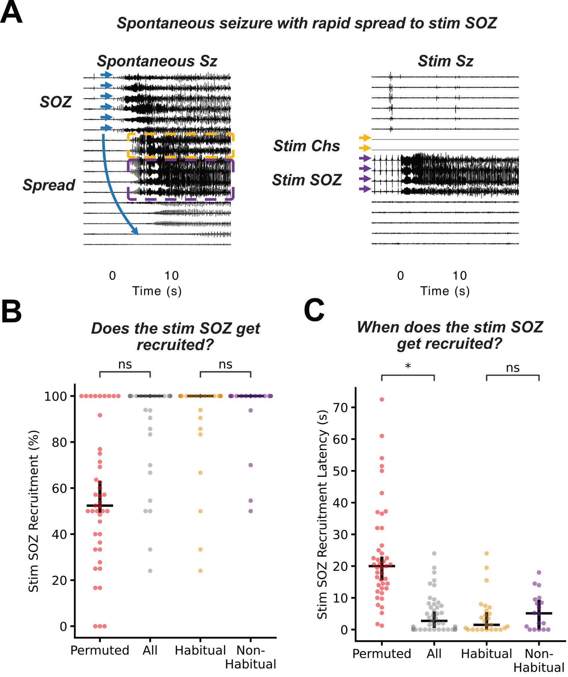
Figure 6: Spontaneous seizure spread to the stim SOZ. A) A pair of spontaneous and stimulation induced seizures from HUP224. The spontaneous seizure rapidly spreads to the stimulation induced seizure onset zone and stimulating channels around 5 seconds after onset. B) Percent of each stim seizure onset zone channels (gray) and permuted stim seizure onset zone channels (red) recruited by that patient’s spontaneous seizures. C) Median spontaneous seizure recruitment latency – seconds after seizure onset – of stim seizure onset zone channels (gray) and for permuted stim seizure onset zone channels (red). The distributions in (B) and (C) are separated by habitual and non-habitual semiology shown in gold and purple respectively.

Low-frequency stimulation preferentially induces seizures in mesial temporal structures
Given prior studies demonstrating that low frequency stimulation preferentially elicits seizures in the mesial temporal lobe (P. Kahane et al. 1993), we analysed the proportion of stim seizures occurring in the mesial temporal lobe (MTL). Stim seizures were significantly more likely to be elicited in the MTL (79%) than other structures (nMTL) (Seizures: 43; proportions z-test Z = 4.69, p < 0.0001; Figure S5). In patients from HUP, 96% of stim seizures—all but one, which arose from a parietal focal cortical dysplasia—were localized to the MTL (Seizures: 23; proportions z-test Z = 10.74, p < 0.0001; Figure S5) whereas at CHOP there was no significant difference between MTL and nMTL stim seizure rates (Seizures: 20; proportions z-test Z = 0.91, p = 0.36; Figure S5). A secondary analysis probing mechanisms underlying the center difference suggested that age of epilepsy onset drives this effect. In particular, in patients with later-onset epilepsy ($>$ 14 years at onset, median for patients with an evoked stim seizure) every stim seizure came from the MTL (Seizures 19; 100%; Figure 7A) while younger onset epilepsies had no significant difference (Seizures: 24; 71%; proportions z-test Z = 1.26, p = 0.21; Figure S5). For further description of the center interaction and age of onset analyses, see Supplementary Materials. This suggests that the MTL is inherently hyperexcitable compared to the rest of the brain, particularly in patients from the adult center and with adult-onset epilepsy.
Given the tendency of the MTL to seize (Behr et al. 2016), we next asked whether eliciting a stim seizure revealed epileptic pathology as opposed to mere physiologic hyperexcitability. We observed that stimulation-induced seizures were significantly more likely to occur in patients diagnosed with MTLE ($χ$²(1, N = 99) = 8.24, OR = 3.78, p = 0.004; Figure 7B). Consistent with our previous findings, this effect was particularly strong in patients with later-onset epilepsy ($>$ 13 years at onset, median for patients receiving stimulation; Fisher’s exact (2x2, N = 44), OR = 6.82, p = 0.012; Figure 7B), but not detectable in younger onset epilepsies ($≤$ median 13 years at onset; $χ$²(1, N = 53) = 2.05, OR = 3.38, p = 0.15; Figure S6). This suggests that inducing a stim seizure in the MTL implies pathological—not just physiological—hyperexcitability.
We next modeled stim-spontaneous seizure similarity as a function of whether the epilepsy localization was MTLE (region $ϕ$, 0.42 [0.0, 0.69]) vs nMTLE (region $ϕ$, 0.09 [0.0, 0.4]). We were unable to detect a significant association between MTLE and nMTLE localization and stim-spontaneous electrographic similarity (MTLE, nMTLE: 28, 15; $β$ = -0.18, SE = 0.12, t(41) = -1.5, p = 0.14; Figure 7C). We observed a significant center interaction ($β_{center:MTLE}$ = 0.65, SE = 0.23, t(39) = 2.90, p = 0.018, Bonferroni adjusted (3)), and thus performed separate analyses by center. There was no significant difference in stim-spontaneous similarity by MTLE vs non-MTLE localization in patients at CHOP (p = 1.0) or in those with early onset epilepsy (p = 0.93; Figure 7D). On the other hand, at HUP (p = 0.004), and in patients with late onset epilepsy (p = 0.004), stim–spontaneous similarity was substantially higher in patients with MTLE than non-MTLE. For further statistical description and the full models accounting for the effect of the interactions between MTLE, center, and age at onset on stim–spontaneous similarity, see Supplementary Materials. Together, these findings suggest that in pediatric patients, stim seizures replicate spontaneous seizure onset similarity regardless of epilepsy localization; however, in adult patients stim seizures tend to only replicate spontaneous seizure onset in patients with MTLE.
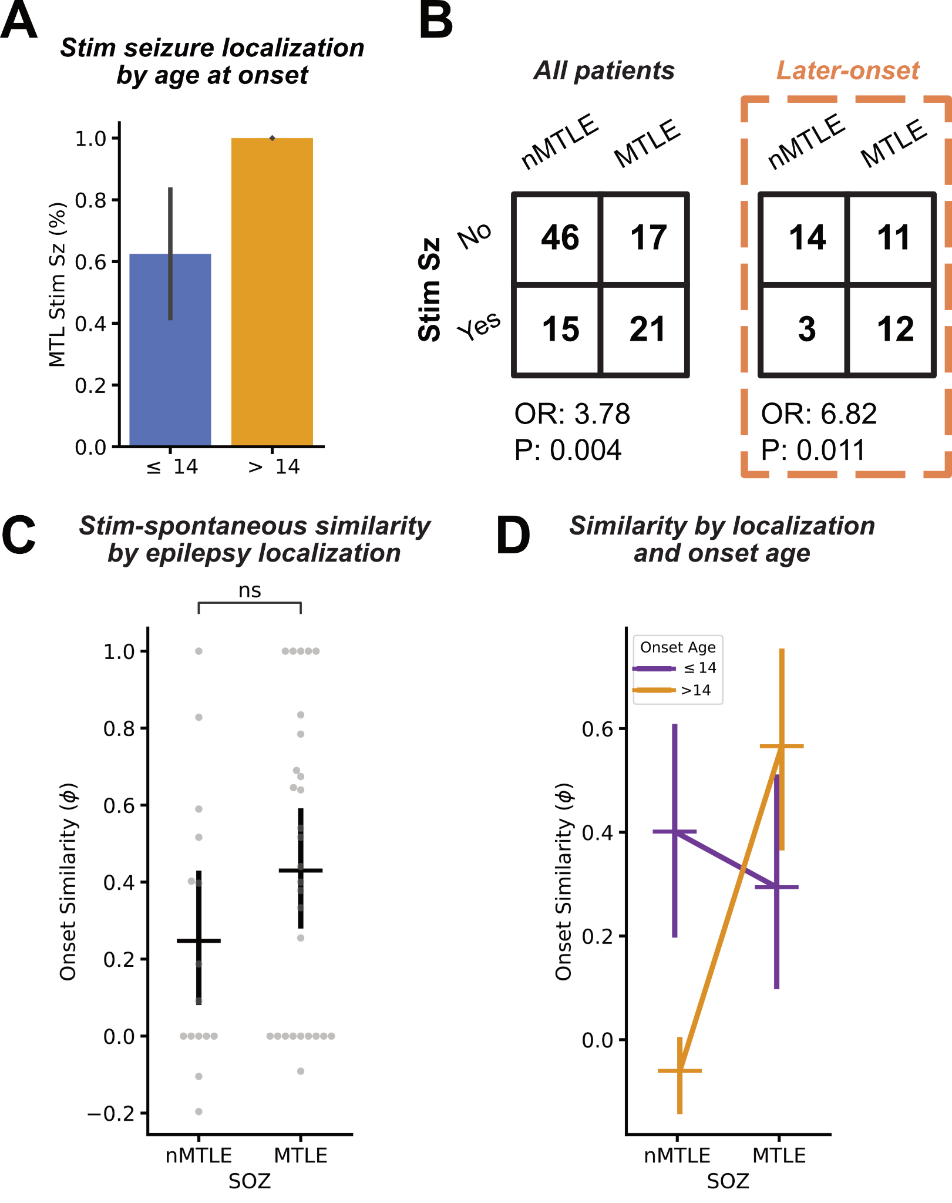
Figure 7. Hyperexcitability of mesial temporal structures. A) Fraction of stim seizures localized to the mesial temporal lobe (MTL) split by patients with younger onset epilepsy ( $≤$ 14 years at onset, the median age of patients with an elicited stim seizure, blue) and later-onset epilepsy (orange). All stim seizures in later onset patients arose from the MTL. B) Association between eliciting a stim seizure and mesial temporal lobe epilepsy (MTLE) diagnosis in the subset of our cohort with localization information (N = 99; Table 1) and in the later-onset epilepsy cohort (orange). Contingency tables show a significant relationship between stim seizures and MTLE, particularly pronounced in later-onset epilepsies. C) Stim-spontaneous seizure onset zone (SOZ) similarity separated by MTLE diagnosis. We observed slightly higher stim-spontaneous similarity in patients with MTLE, reflecting the tendency for stim seizures to occur in that patient cohort described in (B). D) stim-spontaneous SOZ similarity by epilepsy onset age. The interaction between epilepsy onset age and MTLE reflects that stim seizures are limited to localizing seizure generators in the MTL in later-onset epilepsy.

DISCUSSION
A long-standing obstacle to integrating stimulation-induced (stim) seizures into surgical mapping is the uncertain value of stim seizures for localizing epileptogenic tissue. While low-frequency stimulation is used at many centers to elicit seizures that resemble spontaneous events (Arya et al. 2025), the degree to which stim seizures replicate spontaneous seizure dynamics has remained unclear. Here, we present a multi-center analysis of over 400 seizures from 105 patients using a validated, automated seizure annotation algorithm to create a novel framework for measuring seizure similarity. We demonstrate that 1) stim seizures map subsets of the spontaneous seizure network, 2) habitual stim seizure onsets are similar to spontaneous seizure onsets, and 3) even when stim seizures diverge from spontaneous onsets, they often engage early spread regions, suggesting they may localize seizure generating tissue. Together, these findings clarify the utility—and the limitations—of stim seizures in surgical planning.
Our seizure annotation algorithm allowed us to annotate seizures at an unprecedented scale and spatio-temporal resolution. While automated seizure annotation tools for mapping seizure onset or epileptogenic tissue have existed for decades (Revell et al. 2022; Weiss et al. 2015; Vila-Vidal et al. 2017, 2020; Gascoigne, Vila-Vidal, et al. 2024), there has been little rigorous validation against the expected agreement of expert physician annotators. We found that our model achieved performance approaching expert consensus, with no evidence to suggest a difference in accuracy between stim and spontaneous seizures, enabling us to compare automated annotations between seizure types (Figure 2). The automated annotation pipeline allowed us to study the large-scale dynamics of stim and spontaneous seizures at a scale that would be infeasible with manual annotation and with confidence typically reserved for expert annotations, enabling us to quantify the intrinsic variance in each patient’s epileptic network.
We observed considerable within-patient variability in spontaneous seizure onset and spread patterns, consistent with known dynamic changes in seizure networks over time (Schroeder et al. 2020, 2023; Pattnaik et al. 2023; King-Stephens et al. 2015). This variability underscores the importance of comparing stim–spontaneous similarity against the spontaneous–spontaneous baseline. While previous work has reported imperfect stim–spontaneous seizure onset overlap (Kämpfer et al. 2020; Oderiz et al. 2019), by explicitly incorporating the spontaneous-spontaneous seizure agreement as a positive control, we provide a more rigorous benchmark for stim-spontaneous agreement.
On average, stim seizures engaged a smaller network than spontaneous seizures, despite showing broader initial onsets (Kämpfer et al. 2020; Oderiz et al. 2019) (Figure 3). This finding is also supported by the observation that incorporating seizure spread when quantifying electrographic similarity reduced stim seizure concordance with spontaneous seizures regardless of semiology (Figure S3). The spatially restricted network of stim seizures aligns with the hypothesis that low-frequency stim seizures are provoked while the brain is in an interictal (rather than preictal) state, lacking the network dynamics necessary for broad propagation (Khambhati et al. 2016). As a result, stim seizures may remain more spatially confined, and exhibit lower spread similarity—even if their onsets are valid markers of epileptogenicity.
Critically, we found that stim seizures typically had lower electrographic similarity to spontaneous seizures than spontaneous seizures had to each other (Figure 4). This finding echoes literature on afterdischarges and stim seizures elicited during functional mapping, which can arise from regions remote from the spontaneous SOZ (Blume, Jones, and Pathak 2004). Other groups found substantial variability in afterdischarge location from one stimulation to the next and hypothesized that epileptiform activity induced by stimulation depends on the specific local and temporary brain state (Lesser et al. 2008). Expanding on this, we observed that stim–spontaneous seizure similarity was also highly variable across patients. Some stim seizures closely matched spontaneous SOZs, while others showed no concordance. This variability points to a central challenge: not whether stim seizures can replicate spontaneous events, but under what conditions they do.
A common clinical heuristic is to consider stim seizures informative only if they reproduce the patient's habitual semiology (Kovac, Kahane, and Diehl 2016). In fact, several studies have linked the induction of clinically habitual stim seizures to favorable postoperative outcomes (Trebuchon et al. 2021; Oderiz et al. 2019; Kämpfer et al. 2020; Sivaraju et al. 2024). Our data support this: we found that stim seizures with a habitual semiology had similar onsets to spontaneous seizures (Figure 5). Importantly, this finding held across both centers, including both adult and pediatric patients. This finding represents a significant validation of the clinical utility of stim seizures. These results suggest that clinically-habitual stim seizures could, in some cases, replace spontaneous seizures. This is particularly useful for the ~7% of patients who do not seize during invasive monitoring (Oderiz et al. 2019; Bottan et al. 2023).
A major limitation to improving epilepsy surgery is the discordance between the spontaneous seizure onset zone—the channels where the seizure is recorded to start—and the epileptogenic zone—the neural tissue capable of generating seizures (Jaber et al. 2024). In fact, many patients go on to have continued seizures from a “secondary seizure generator” even after the primary seizure onset zone is resected (Gascoigne, Evans, et al. 2024). One characteristic of these secondary generators is rapid recruitment by spontaneous seizures after onset (Revell et al. 2022; Andrews et al. 2020, 2019; Spencer et al. 1990; Lieb, Engel, and Babb 1986), with recruitment up to 10 seconds after seizure onset suggested as a biomarker of epileptogenicity (Andrews et al. 2020). Beyond onset localization, we investigated whether stim seizures map other parts of the epileptogenic network (Figure 6). We found that the stim SOZ was nearly always recruited during spontaneous seizures, often within 10 seconds—consistent with criteria for secondary seizure generators. This rapid recruitment occurred even for stim seizures with atypical semiology, suggesting that they too may arise from epileptogenic tissue. While these findings require validation with outcome data once this is available for our full cohort, they argue for considering both habitual and non-habitual stim SOZs as potentially meaningful surgical targets.
The striking relationship between low-frequency stimulation response and epilepsy subtype in our study has important implications for understanding both the pathophysiology of epileptic networks and clinical practice. Previous studies have demonstrated diverging phenomena in adult and pediatric patient populations. In adults, low-frequency stim seizures primarily predominantly arose from the MTL (P. Kahane et al. 1993; Sivaraju et al. 2024), while recent work suggested that low-frequency stimulation at pediatric epilepsy centers can elicit extra-temporal stim seizures (Manokaran et al. 2025). In our later-onset epilepsy patient population, all stim seizures originated from mesial temporal structures regardless of spontaneous SOZ localization (Figure 7A)—suggesting that low-frequency stimulation preferentially activates the MTL in these patients. Because the presence of a stim seizure was also predictive of MTLE (Figure 7B), this likely reflects the convergence of increased mesial temporal pathology in adult-onset epilepsy (Behr et al. 2016) and age-related differences in regional excitability.
From a practical standpoint, our results suggest that low-frequency stimulation in adult patients may have low yield for inducing seizures outside the MTL (or perhaps also the insula, based on an earlier study (Sivaraju et al. 2024)). The absence of extra-temporal stim seizures in our adult cohort, even in patients with extra-temporal spontaneous seizures, indicates that current low-frequency protocols may be insufficient to probe cortical excitability in these regions. Alternative stimulation paradigms—perhaps utilizing higher stimulation intensities or frequencies—may be necessary to comprehensively map epileptic networks in adult patients. Nevertheless, the diagnostic value of MTL stimulation remains clear: eliciting a stim seizure from the MTL—even a non-habitual one—may identify mesial temporal structures as a critical node in the epileptic network, information that could guide surgical strategy even if it doesn't definitively establish primary pathology (Walker 2015; Malmgren and Thom 2012). For instance, when MTLE laterality is uncertain, a stimulation-induced seizure contralateral to the spontaneous seizures may justify extended monitoring with a chronically implanted device to refine lateralization (King-Stephens et al. 2015; Struck et al. 2015).
Taken together, these findings suggest a new framework for interpreting stim seizures: Stimulation-induced seizures map a spatially-restricted subset of the spontaneous seizure onset and spread network. Habitual stim seizures appear to localize primary seizure generators. Non-habitual stim seizures, while less specific, may still identify secondary generators or the broader extent of epileptogenic networks that may not be captured during relatively short periods of ictal recording (days to weeks). This framework supports a fundamentally novel approach, where a combination of stimulation-induced seizures, afterdischarges (Kons et al. 2024; Gollwitzer et al. 2018), evoked potentials (Cornblath et al. 2023; Smith et al. 2022; Hays et al. 2024), and high frequency oscillations (Kobayashi et al. 2017; van ’t Klooster et al. 2011) could be applied to rapidly localize seizure generating networks, both places involved in seizure onset and those capable of it, without relying on spontaneous seizures. If validated, this type of mapping could dramatically change epilepsy surgery. The technique might be used to suggest secondary surgical targets—prophylactically treating areas likely to generate postoperative seizure recurrence—or to guide patients away from destructive procedures and toward neuromodulation if their stimulation data suggests diffuse epileptic networks.
This study has several limitations. Larger, prospective studies are required to assess whether resecting atypical stim SOZs improves outcomes and to define the contexts in which stim seizures can act as surrogates for spontaneous events and reduce the burden of invasive monitoring. Most analyses relied on a quantitative seizure model. While this may introduce noise, it was necessary for scaling to large datasets (N = 441 seizures). Notably, results were similar when restricted to clinician-annotated seizures (Figure S2). Only a minority of patients had surgical outcome data, so our localization labels (e.g., MTLE) reflect expert clinical impressions at the time of surgery, rather than gold-standard outcome-based classifications. Finally, our classification of clinical habituality relied on clinician judgment and patient/family report. This process is subjective and may be influenced by participant demand (Nichols and Maner 2008), wherein patients aim to help clinicians by labeling a seizure as habitual. Establishing standardized, prospective criteria for seizure semiology (Beniczky et al. 2022) may improve consistency in future studies.
In summary, we provide a large-scale, multi-center analysis of the electrographic similarity between stim and spontaneous seizures. Our findings suggest that stimulation-induced seizures can be a valuable tool for mapping the broader seizure generating network in patients being evaluated for epilepsy surgery (Kramer and Cash 2012; Piper et al. 2022), especially when clinically habitual events are recorded. We believe that this procedure offers a valuable tool for presurgical planning. Future work should expand on these findings by linking quantitative stim seizure characteristics to surgical outcomes and integrate stim seizures into the pre-surgical evaluation pipeline to improve seizure freedom rates in drug-resistant epilepsy.

REFERENCES
Andrews, John P., Simon Ammanuel, Jonathan Kleen, Ankit N. Khambhati, Robert Knowlton, and Edward F. Chang. 2020. “Early Seizure Spread and Epilepsy Surgery: A Systematic Review.” Epilepsia 61 (10): 2163–72.
Andrews, John P., Abhijeet Gummadavelli, Pue Farooque, Jennifer Bonito, Christopher Arencibia, Hal Blumenfeld, and Dennis D. Spencer. 2019. “Association of Seizure Spread With Surgical Failure in Epilepsy.” JAMA Neurology 76 (4): 462–69.
Arya, Ravindra, Fiona M. Baumer, Patrick Chauvel, Birgit Frauscher, Prasanna Jayakar, Ammar Kheder, Bradley Lega, et al. 2025. “American Clinical Neurophysiology Society Technical Standards for Electrical Stimulation with Intracranial Electrodes for Functional Brain Mapping and Seizure Induction.” Journal of Clinical Neurophysiology: Official Publication of the American Electroencephalographic Society 42 (3): 190–200.
Bancaud, J., and P. Chauvel. 1987. “Commentary: Acute and Chronic Intracranial Recording and Stimulation with Depth Electrodes.” Surgical Treatment of the Epilepsies.
Bates, Douglas, Martin Mächler, Ben Bolker, and Steve Walker. 2015. “Fitting Linear Mixed-Effects Models Usinglme4.” Journal of Statistical Software 67 (1): 1–48.
Behr, C., M. A. Goltzene, G. Kosmalski, E. Hirsch, and P. Ryvlin. 2016. “Epidemiology of Epilepsy.” Revue Neurologique 172 (1): 27–36.
Beniczky, Sándor, William O. Tatum, Hal Blumenfeld, Hermann Stefan, Jayanti Mani, Louis Maillard, Firas Fahoum, et al. 2022. “Seizure Semiology: ILAE Glossary of Terms and Their Significance.” Epileptic Disorders: International Epilepsy Journal with Videotape 24 (3): 447–95.
Bernier, G. P., F. Richer, N. Giard, G. Bouvier, M. Mercier, A. Turmel, and J. M. Saint-Hilaire. 1990. “Electrical Stimulation of the Human Brain in Epilepsy.” Epilepsia 31 (5): 513–20.
Bhattacharya, Samayan, Alexis Bennett, Celina Alba, Kseniia Kriukova, and Dominique Duncan. 2023. “Unsupervised Seizure Detection in EEG Using Long Short Term Memory Network and Clustering.” In 2023 IEEE 33rd International Workshop on Machine Learning for Signal Processing (MLSP), 1–6. IEEE.
Blume, Warren T., Daniel C. Jones, and Parbeen Pathak. 2004. “Properties of after-Discharges from Cortical Electrical Stimulation in Focal Epilepsies.” Clinical Neurophysiology: Official Journal of the International Federation of Clinical Neurophysiology 115 (4): 982–89.
Bottan, Juan S., Ashwaq Alshahrani, Greydon Gilmore, David A. Steven, Jorge G. Burneo, Jonathan C. Lau, Richard S. McLachlan, et al. 2023. “Lack of Spontaneous Typical Seizures during Intracranial Monitoring with Stereo-Electroencephalography.” Epileptic Disorders: International Epilepsy Journal with Videotape 25 (6): 833–44.
Chauvel, P., E. Landré, S. Trottier, J. P. Vignel, A. Biraben, B. Devaux, and J. Bancaud. 1993. “Electrical Stimulation with Intracerebral Electrodes to Evoke Seizures.” Advances in Neurology 63:115–21.
Chicco, Davide, and Giuseppe Jurman. 2023. “The Matthews Correlation Coefficient (MCC) Should Replace the ROC AUC as the Standard Metric for Assessing Binary Classification.” BioData Mining 16 (1): 4.
Chicco, Davide, Niklas Tötsch, and Giuseppe Jurman. 2021. “The Matthews Correlation Coefficient (MCC) Is More Reliable than Balanced Accuracy, Bookmaker Informedness, and Markedness in Two-Class Confusion Matrix Evaluation.” BioData Mining 14 (1): 13.
Conrad, Erin C., Andrew Y. Revell, Adam S. Greenblatt, Ryan S. Gallagher, Akash R. Pattnaik, Nicole Hartmann, James J. Gugger, et al. 2023. “Spike Patterns Surrounding Sleep and Seizures Localize the Seizure-Onset Zone in Focal Epilepsy.” Epilepsia 64 (3): 754–68.
Core Team, R. R. 2020. “R: A Language and Environment for Statistical Computing.” https://citeseerx.ist.psu.edu/document?repid=rep1&type=pdf&doi=bc748aec2bcc46eb319d5446da614b37729e9dbe.
Cornblath, Eli J., Alfredo Lucas, Caren Armstrong, Adam S. Greenblatt, Joel M. Stein, Peter N. Hadar, Ramya Raghupathi, et al. 2023. “Quantifying Trial-by-Trial Variability during Cortico-Cortical Evoked Potential Mapping of Epileptogenic Tissue.” Epilepsia 64 (4): 1021–34.
Desikan, Rahul S., Florent Ségonne, Bruce Fischl, Brian T. Quinn, Bradford C. Dickerson, Deborah Blacker, Randy L. Buckner, et al. 2006. “An Automated Labeling System for Subdividing the Human Cerebral Cortex on MRI Scans into Gyral Based Regions of Interest.” NeuroImage 31 (3): 968–80.
Engel, Jerome. 2016. “What Can We Do for People with Drug-Resistant Epilepsy?” Neurology 87 (23): 2483–89.
Fischl, Bruce. 2012. “FreeSurfer.” NeuroImage 62 (2): 774–81.
Gascoigne, Sarah J., Nathan Evans, Gerard Hall, Csaba Kozma, Mariella Panagiotopoulou, Gabrielle M. Schroeder, Callum Simpson, et al. 2024. “Incomplete Resection of the Intracranial Electroencephalographic Seizure Onset Zone Is Not Associated with Postsurgical Outcomes.” Epilepsia, July. https://doi.org/10.1111/epi.18061.
Gascoigne, Sarah J., Manel Vila-Vidal, Nathan Evans, Anderson Brito Da Silva, Rhys H. Thomas, Christopher Thornton, Kevin Wilson, Peter N. Taylor, Adrià Tauste, and Yujiang Wang. 2024. “Seizure Onset Zone Localisation Algorithms with Intracranial EEG: Evaluating Methodological Variations and Targeted Features.” arXiv E-Prints, arXiv – 2410.
Gollwitzer, Stephanie, Rüdiger Hopfengärtner, Karl Rössler, Tamara Müller, David Gerhard Olmes, Johannes Lang, Julia Köhn, et al. 2018. “Afterdischarges Elicited by Cortical Electric Stimulation in Humans: When Do They Occur and What Do They Mean?” Epilepsy & Behavior: E&B 87 (October):173–79.
Halekoh, Ulrich, and Søren Højsgaard. 2014. “A Kenward-Roger Approximation and Parametric Bootstrap Methods for Tests in Linear Mixed Models - TheRPackagepbkrtest.” Journal of Statistical Software 59 (9): 1–32.
Hara, K., S. Uematsu, R. Lesser, B. Gordon, and J. Hart. 1991. “Representation of Primary Motor Cortex in Humans: Studied with Chronic Subdural Grid.” Epilepsia.
Hays, Mark A., Amir H. Daraie, Rachel J. Smith, Sridevi V. Sarma, Nathan E. Crone, and Joon Y. Kang. 2024. “Network Excitability of Stimulation-Induced Spectral Responses Helps Localize the Seizure Onset Zone.” Clinical Neurophysiology: Official Journal of the International Federation of Clinical Neurophysiology 166 (October):43–55.
Holdgraf, Christopher, Stefan Appelhoff, Stephan Bickel, Kristofer Bouchard, Sasha D’Ambrosio, Olivier David, Orrin Devinsky, et al. 2019. “iEEG-BIDS, Extending the Brain Imaging Data Structure Specification to Human Intracranial Electrophysiology.” Scientific Data 6 (1): 102.
Huang, Yuhao, Boglárka Hajnal, László Entz, Dániel Fabó, Jose L. Herrero, Ashesh D. Mehta, and Corey J. Keller. 2019. “Intracortical Dynamics Underlying Repetitive Stimulation Predicts Changes in Network Connectivity.” The Journal of Neuroscience: The Official Journal of the Society for Neuroscience 39 (31): 6122–35.
Jaber, Kassem, Tamir Avigdor, Daniel Mansilla, Alyssa Ho, John Thomas, Chifaou Abdallah, Stephan Chabardes, et al. 2024. “A Spatial Perturbation Framework to Validate Implantation of the Epileptogenic Zone.” Nature Communications 15 (1): 5253.
Kahane, Philippe, Elisabeth Landré, Lorella Minotti, Stafano Francione, and Philippe Ryvlin. 2006. “The Bancaud and Talairach View on the Epileptogenic Zone: A Working Hypothesis.” Epileptic Disorders: International Epilepsy Journal with Videotape 8 Suppl 2 (August):S16–26.
Kahane, P., L. Tassi, S. Francione, D. Hoffmann, G. Lo Russo, and C. Munari. 1993. “Electroclinical manifestations elicited by intracerebral electric stimulation ‘shocks’ in temporal lobe epilepsy.” Neurophysiologie clinique = Clinical neurophysiology 23 (4): 305–26.
Kämpfer, Christopher, Attila Racz, Carlos M. Quesada, Christian E. Elger, and Rainer Surges. 2020. “Predictive Value of Electrically Induced Seizures for Postsurgical Seizure Outcome.” Clinical Neurophysiology: Official Journal of the International Federation of Clinical Neurophysiology 131 (9): 2289–97.
Khambhati, Ankit N., Kathryn A. Davis, Timothy H. Lucas, Brian Litt, and Danielle S. Bassett. 2016. “Virtual Cortical Resection Reveals Push-Pull Network Control Preceding Seizure Evolution.” Neuron 91 (5): 1170–82.
King-Stephens, David, Emily Mirro, Peter B. Weber, Kenneth D. Laxer, Paul C. Van Ness, Vicenta Salanova, David C. Spencer, et al. 2015. “Lateralization of Mesial Temporal Lobe Epilepsy with Chronic Ambulatory Electrocorticography.” Epilepsia 56 (6): 959–67.
Klooster, Maryse A. van ’t, Maeike Zijlmans, Frans S. S. Leijten, Cyrille H. Ferrier, Michel J. A. M. van Putten, and Geertjan J. M. Huiskamp. 2011. “Time–frequency Analysis of Single Pulse Electrical Stimulation to Assist Delineation of Epileptogenic Cortex.” Brain: A Journal of Neurology 134 (10): 2855–66.
Kobayashi, Katsuya, Riki Matsumoto, Masao Matsuhashi, Kiyohide Usami, Akihiro Shimotake, Takeharu Kunieda, Takayuki Kikuchi, et al. 2017. “High Frequency Activity Overriding Cortico-Cortical Evoked Potentials Reflects Altered Excitability in the Human Epileptic Focus.” Clinical Neurophysiology: Official Journal of the International Federation of Clinical Neurophysiology 128 (9): 1673–81.
Kons, Zachary A., Vasileios Kokkinos, Amir Hadanny, William Muñoz, Nathaniel Sisterson, Mirela Simon, Alexandra Urban, and R. Mark Richardson. 2024. “Specific Afterdischarge Properties Can Enhance the Clinical Utility of Electrical Stimulation Mapping during Intracranial Monitoring.” Clinical Neurophysiology: Official Journal of the International Federation of Clinical Neurophysiology, January. https://doi.org/10.1016/j.clinph.2023.12.130.
Kovac, Stjepana, Philippe Kahane, and Beate Diehl. 2016. “Seizures Induced by Direct Electrical Cortical Stimulation--Mechanisms and Clinical Considerations.” Clinical Neurophysiology: Official Journal of the International Federation of Clinical Neurophysiology 127 (1): 31–39.
Kramer, Mark A., and Sydney S. Cash. 2012. “Epilepsy as a Disorder of Cortical Network Organization.” The Neuroscientist: A Review Journal Bringing Neurobiology, Neurology and Psychiatry 18 (4): 360–72.
Kuznetsova, Alexandra, Per B. Brockhoff, and Rune H. B. Christensen. 2017. “LmerTest Package: Tests in Linear Mixed Effects Models.” Journal of Statistical Software 82 (13): 1–26.
Landré, E., B. Turak, D. Toussaint, and S. Trottier. 2004. “Intérêt Des Stimulations électriques Intracérébrales En Stéréoélectroencéphalographie Dans Les épilepsies Partielles.” Epilepsies 16 (October):213–25.
Lesser, Ronald P., Hyang Woon Lee, W. R. S. Webber, Barry Prince, Nathan E. Crone, and Diana L. Miglioretti. 2008. “Short-Term Variations in Response Distribution to Cortical Stimulation.” Brain: A Journal of Neurology 131 (Pt 6): 1528–39.
Lieb, J. P., J. Engel Jr, and T. L. Babb. 1986. “Interhemispheric Propagation Time of Human Hippocampal Seizures. I. Relationship to Surgical Outcome.” Epilepsia 27 (3): 286–93.
Litt, B., R. Esteller, J. Echauz, M. D’Alessandro, R. Shor, T. Henry, P. Pennell, et al. 2001. “Epileptic Seizures May Begin Hours in Advance of Clinical Onset: A Report of Five Patients.” Neuron 30 (1): 51–64.
Lucas, Alfredo, Brittany H. Scheid, Akash R. Pattnaik, Ryan Gallagher, Marissa Mojena, Ashley Tranquille, Brian Prager, et al. 2024. “iEEG-Recon: A Fast and Scalable Pipeline for Accurate Reconstruction of Intracranial Electrodes and Implantable Devices.” Epilepsia 65 (3): 817–29.
Magnotti, John F., Zhengjia Wang, and Michael S. Beauchamp. 2020. “RAVE: Comprehensive Open-Source Software for Reproducible Analysis and Visualization of Intracranial EEG Data.” NeuroImage 223 (117341): 117341.
Malmgren, Kristina, and Maria Thom. 2012. “Hippocampal Sclerosis--Origins and Imaging: Hippocampal Sclerosis.” Epilepsia 53 Suppl 4 (s4): 19–33.
Manokaran, Ranjith Kumar, Ayako Ochi, Shelly Weiss, Ivanna Yau, Rohit Sharma, Hiroshi Otsubo, George M. Ibrahim, Elizabeth J. Donner, and Puneet Jain. 2025. “Stimulation-Induced Seizures in Children Undergoing Stereo-EEG Evaluation.” Journal of Clinical Neurophysiology: Official Publication of the American Electroencephalographic Society 42 (2): 126–31.
Medina Villalon, S., R. Paz, N. Roehri, S. Lagarde, F. Pizzo, B. Colombet, F. Bartolomei, R. Carron, and C-G Bénar. 2018. “EpiTools, A Software Suite for Presurgical Brain Mapping in Epilepsy: Intracerebral EEG.” Journal of Neuroscience Methods 303 (June):7–15.
Nichols, Austin Lee, and Jon K. Maner. 2008. “The Good-Subject Effect: Investigating Participant Demand Characteristics.” The Journal of General Psychology 135 (2): 151–65.
Noe, Katherine, Vlastimil Sulc, Lily Wong-Kisiel, Elaine Wirrell, Jamie J. Van Gompel, Nicholas Wetjen, Jeffrey Britton, et al. 2013. “Long-Term Outcomes after Nonlesional Extratemporal Lobe Epilepsy Surgery.” JAMA Neurology 70 (8): 1003–8.
Oderiz, Carolina Cuello, Nicolás von Ellenrieder, François Dubeau, Ariella Eisenberg, Jean Gotman, Jeffery Hall, Ana-Sofía Hincapié, et al. 2019. “Association of Cortical Stimulation–Induced Seizure With Surgical Outcome in Patients With Focal Drug-Resistant Epilepsy.” JAMA Neurology 76 (9): 1070–78.
Ojemann, G. A. 1991. “Cortical Organization of Language.” The Journal of Neuroscience: The Official Journal of the Society for Neuroscience 11 (8): 2281–87.
Paszke, Adam, Sam Gross, Francisco Massa, Adam Lerer, James Bradbury, Gregory Chanan, Trevor Killeen, et al. 2019. “PyTorch: An Imperative Style, High-Performance Deep Learning Library.” arXiv [cs.LG]. arXiv. http://arxiv.org/abs/1912.01703.
Pattnaik, Akash R., Nina J. Ghosn, Ian Z. Ong, Andrew Y. Revell, William K. S. Ojemann, Brittany H. Scheid, Georgia Georgostathi, et al. 2023. “The Seizure Severity Score: A Quantitative Tool for Comparing Seizures and Their Response to Therapy.” Journal of Neural Engineering 20 (4). https://doi.org/10.1088/1741-2552/aceca1.
Piper, Rory J., R. Mark Richardson, Gregory Worrell, David W. Carmichael, Torsten Baldeweg, Brian Litt, Timothy Denison, and Martin M. Tisdall. 2022. “Towards Network-Guided Neuromodulation for Epilepsy.” Brain: A Journal of Neurology 145 (10): 3347–62.
Revell, A. Y., A. R. Pattnaik, E. Conrad, N. Sinha, and B. H. Scheid. 2022. “A Taxonomy of Seizure Spread Patterns, Speed of Spread, and Associations With Structural Connectivity.” bioRxiv. https://www.biorxiv.org/content/10.1101/2022.10.24.513577.abstract.
Schindler, Kaspar, Howan Leung, Christian E. Elger, and Klaus Lehnertz. 2007. “Assessing Seizure Dynamics by Analysing the Correlation Structure of Multichannel Intracranial EEG.” Brain: A Journal of Neurology 130 (Pt 1): 65–77.
Schroeder, Gabrielle M., Beate Diehl, Fahmida A. Chowdhury, John S. Duncan, Jane de Tisi, Andrew J. Trevelyan, Rob Forsyth, Andrew Jackson, Peter N. Taylor, and Yujiang Wang. 2020. “Seizure Pathways Change on Circadian and Slower Timescales in Individual Patients with Focal Epilepsy.” Proceedings of the National Academy of Sciences 117 (20): 11048–58.
Schroeder, Gabrielle M., Philippa J. Karoly, Matias Maturana, Mariella Panagiotopoulou, Peter N. Taylor, Mark J. Cook, and Yujiang Wang. 2023. “Chronic Intracranial EEG Recordings and Interictal Spike Rate Reveal Multiscale Temporal Modulations in Seizure States.” Brain Communications, July, fcad205.
Sivaraju, Adithya, Imran Quraishi, Evan Collins, Hari McGrath, Alexander Ramos, Nicholas B. Turk-Browne, Hitten Zaveri, Eyiyemisi Damisah, Dennis D. Spencer, and Lawrence J. Hirsch. 2024. “Systematic 1 Hz Direct Electrical Stimulation for Seizure Induction: A Reliable Method for Localizing Seizure Onset Zone and Predicting Seizure Freedom.” Brain Stimulation 17 (2): 339–45.
Smith, Rachel J., Mark A. Hays, Golnoosh Kamali, Christopher Coogan, Nathan E. Crone, Joon Y. Kang, and Sridevi V. Sarma. 2022. “Stimulating Native Seizures with Neural Resonance: A New Approach to Localize the Seizure Onset Zone.” Brain: A Journal of Neurology 145 (11): 3886–3900.
Spencer, S. S., D. D. Spencer, P. D. Williamson, and R. Mattson. 1990. “Combined Depth and Subdural Electrode Investigation in Uncontrolled Epilepsy.” Neurology 40 (1): 74–79.
Struck, Aaron F., Andrew J. Cole, Sydney S. Cash, and M. Brandon Westover. 2015. “The Number of Seizures Needed in the EMU.” Epilepsia 56 (11): 1753–59.
Tardy, N. 2017. “Electro-Clinical Correlation between Seizures Induced by Direct Electrical Cortical Stimulation and Spontaneous Seizures: Relevance to Define the ….” MD Thesis. Grenoble-Alpes University.
Trebuchon, Agnes, Renata Racila, Francesco Cardinale, Stanislas Lagarde, Aileen McGonigal, Giorgio Lo Russo, Didier Scavarda, et al. 2021. “Electrical Stimulation for Seizure Induction during SEEG Exploration: A Useful Predictor of Postoperative Seizure Recurrence?” Journal of Neurology, Neurosurgery, and Psychiatry 92 (1): 22–26.
Tustison, Nicholas J., Philip A. Cook, Andrew J. Holbrook, Hans J. Johnson, John Muschelli, Gabriel A. Devenyi, Jeffrey T. Duda, et al. 2021. “The ANTsX Ecosystem for Quantitative Biological and Medical Imaging.” Scientific Reports 11 (1): 9068.
Uematsu, S., R. Lesser, R. S. Fisher, B. Gordon, K. Hara, G. L. Krauss, E. P. Vining, and R. W. Webber. 1992. “Motor and Sensory Cortex in Humans: Topography Studied with Chronic Subdural Stimulation.” Neurosurgery 31 (1): 59–71; discussion 71–72.
Vila-Vidal, Manel, Carmen Pérez Enríquez, Alessandro Principe, Rodrigo Rocamora, Gustavo Deco, and Adrià Tauste Campo. 2020. “Low Entropy Map of Brain Oscillatory Activity Identifies Spatially Localized Events: A New Method for Automated Epilepsy Focus Prediction.” NeuroImage 208 (116410): 116410.
Vila-Vidal, Manel, Alessandro Principe, Miguel Ley, Gustavo Deco, Adrià Tauste Campo, and Rodrigo Rocamora. 2017. “Detection of Recurrent Activation Patterns across Focal Seizures: Application to Seizure Onset Zone Identification.” Clinical Neurophysiology: Official Journal of the International Federation of Clinical Neurophysiology 128 (6): 977–85.
Virtanen, Pauli, Ralf Gommers, Travis E. Oliphant, Matt Haberland, Tyler Reddy, David Cournapeau, Evgeni Burovski, et al. 2020. “SciPy 1.0: Fundamental Algorithms for Scientific Computing in Python.” Nature Methods 17 (3): 261–72.
Walker, Matthew Charles. 2015. “Hippocampal Sclerosis: Causes and Prevention.” Seminars in Neurology 35 (3): 193–200.
Weiss, Shennan A., Athena Lemesiou, Robert Connors, Garrett P. Banks, Guy M. McKhann, Robert R. Goodman, Binsheng Zhao, et al. 2015. “Seizure Localization Using Ictal Phase-Locked High Gamma: A Retrospective Surgical Outcome Study.” Neurology 84 (23): 2320–28.
Wiebe, S., W. T. Blume, J. P. Girvin, M. Eliasziw, and Effectiveness and Efficiency of Surgery for Temporal Lobe Epilepsy Study Group. 2001. “A Randomized, Controlled Trial of Surgery for Temporal-Lobe Epilepsy.” The New England Journal of Medicine 345 (5): 311–18.
Wieser, H. G., W. T. Blume, D. Fish, E. Goldensohn, A. Hufnagel, D. King, M. R. Sperling, and H. Lüders. 2001. “Proposal for a New Classification of Outcome with Respect to Epileptic Seizures Following Epilepsy Surgery.” Epilepsia 42:282–86.

ACKNOWLEDGEMENTS

Funding
This work was funded by National Institute of Neurologic Disorders and Stroke (CA, DJZ: 5T32NS091008; RTS: R01MH112847, R01NS112274; EDM: P50HD105354; KAD: R01NS116504, BL: DP1NS122038, R01NS125137; EC: K23NS12140101A1), the National Science Foundation (WKSO: NSF GRF DGE-1845298), the Burroughs Welcome Fund (EC), the Small Lake Foundation, Neil and Barbara Smit, and Bonnie and Jonathan Rothberg and Family (BL).

Author contributions
WKSO: Conceptualization, Methodology, Software, Formal analysis, Investigation, Data Curation, Writing - Original Draft, Visualization, Supervision, Project administration. CA: Investigation, Data Curation, Resources. AP: Methodology, Software. NP: Data Curation. MJ: Data Curation. AD: Software, Validation, Formal analysis. DZ: Investigation, Data Curation. JL: Investigation, Data Curation. JK: Investigation, Data Curation. CVKS: Investigation, Data Curation. EJC: Conceptualization, Supervision. SD: Data Curation. RTS: Conceptualization, Formal analysis, Visualization, Supervision. EDM: Resources, Funding acquisition, data collection.. KAD: Conceptualization, Resources, Supervision, Funding acquisition. BL: Conceptualization, Resources, Writing - Original Draft, Supervision, Project administration, Funding acquisition. EC: Conceptualization, Investigation, Data Curation, Writing - Original Draft, Visualization, Supervision, Project administration, Funding acquisition. All authors contributed to Writing - Review & Editing.

Competing interests
RTS has received consulting income from Octave Bioscience and compensation for scientific reviewing from the American Medical Association. All other authors have no relevant conflicts to report.

Data availability
To promote reproducibility all code used in the analyses we describe is made publicly available as a GitHub repository (https://github.com/penn-cnt/stim-seizures) and all required intermediate data structures required to replicate this study will be made publicly available on pennsieve.io upon publication, while raw iEEG data will be made available upon reasonable request.

