Acetaminophen Overdose Summary

## First Name Last Name (MRN: 0)

Date of ingestion: 05-04-2016

### Patient and acetaminophen information

|  |  |
| --- | --- |
| **Characteristic** | **Value** |
| Age (years) | 36.3 |
| Weight (kg) | 70 |
| Gender | Male |
| Estimated amount ingested (g) | 25 |
| Product category ingested | Acetaminophen alone |
| Single-dose activated charcoal (SDAC) | Not administered |
| Time of SDAC administration (hours since ingestion) | NA |

### Sampled plasma acetaminophen concentrations (PAC)

|  |  |
| --- | --- |
| **Time Since Acute Ingestion (hours)** | **Concentration (mg/L)** |
| 1: 1 | 500 |
| 2: 8 | 150 |
| 3: NA | NA |
| 4: NA | NA |

### Individual acetaminophen concentration-time profile

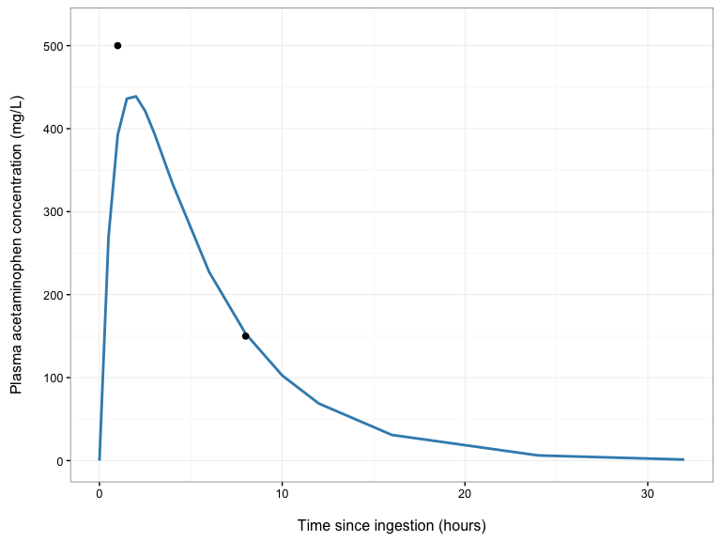

### N-acetylcysteine administration recommendations

|  |  |
| --- | --- |
| **Risk-Stratification Tool** | **Decision** |
| Rumack-Matthew Nomogram | Yes |
| Revised Rumack-Matthew Nomogram (Treatment Line) | Yes |
| Empirical Decision Rule | Yes |

Give N-acetylcysteine according to the Empirical Decision Rule

Date of report: 05-04-2016